IoT framework for brain tumor detection from MRI based on optimized modified ResNet 18 (OMRES)

Abstract: Brain tumors constitute a grave health concern, significantly impacting individuals' lives. The severity lies in their potential to be either benign or malignant, with malignancies having the potential to be life-threatening if not accurately diagnosed. Recent analyses of human healthcare systems reveal a stark increase in the number of brain tumor cases, positioning it as the 10th leading cause of death. Consequently, early detection of brain tumors holds the potential to greatly enhance a patient's chances of complete recovery and successful treatment. The advancement of information and communication technology has propelled the Internet of Things (IoT) to a transformative phase within modern healthcare. This study conducts an in-depth exploration of methodologies for detecting brain tumors, presenting two distinct detection scenarios. Firstly, one scenario entails the direct application of a deep convolutional neural network to brain images. Conversely, the second scenario introduces an IoT-centered framework employing a multiuser detection system. This system uploads images to the cloud for early brain tumor detection, ensuring accessibility from anywhere for accurate categorization. The proposed convolutional neural network architecture is a refined iteration of the pre-trained ResNet18 CNN. Additionally, pivotal hyper parameters are employed to fine-tune the OMRES model. The initial phase tests diverse optimizers with varying learning rates, batch sizes, and a consistent number of epochs. Subsequently, the influence of altering dropout rates is assessed. Lastly, a comparison between the OMRES model and traditional pre-trained models is expounded upon. Simulation results reveal that the RMSProp algorithm, coupled with a dropout rate of 0.5, yields the most favourable outcomes when juxtaposed with other algorithms. The suggested model attains remarkable enhancement, achieving a peak accuracy rate of 98.67%, surpassing conventional CNNs.
Keywords: Brain tumor, Magnetic resonance imaging, Internet of things, Convolutional neural networks
1 Introduction
The widespread integration of the Internet of Things (IoT) has found its way into various applications, significantly impacting our daily lives. This transformation is equally evident in the healthcare sector, where IoT technology is being harnessed to optimize patient services [1]. The realm of healthcare faces a formidable challenge in addressing brain tumors, necessitating the incorporation of modern technological solutions in the detection and classification processes. The accurate and swift classification of brain tumors is of paramount importance, as the choice of effective treatment methodologies is heavily reliant on the precise identification of the tumor's pathological type. However, the traditional approach to identifying and categorizing brain tumors in magnetic resonance imaging (MRI) scans primarily depends on human observation. Radiologists analyse and interpret image attributes, often resulting in inaccuracies in diagnosis. The adoption of computer-aided diagnostic methods is being actively pursued to mitigate these concerns [2]. Brain tumors manifest as undesirable masses of irregular brain cells, classified into two categories: noncancerous and malignant tumors [3]. Noncancerous (benign) tumors exhibit slower growth and do not infiltrate surrounding tissues or organs, in contrast to the more aggressive progression of malignant tumors [4]. Moreover, malignant tumors are further categorized into primary tumors originating within the brain and secondary tumors, referred to as brain metastasis tumors, which spread from other locations. The timely and precise determination of the grade of brain tumors profoundly impacts not only early-stage diagnosis but also treatment decisions and ongoing assessment of tumor growth for patients. The complexity of tumor classification arises from the diverse characteristics of tumor cells, including size, shape, contrast, and location. Tumor grading spans from I to IV, distinguishing between benign and malignant tumors. Medical images such as MRI, ultrasound, computed tomography (CT), X-rays, play a pivotal role in disease diagnosis and treatment planning. CT and MRI are the most prevalent modalities for assessing and diagnosing brain malignancies. Of these, MRI takes precedence due to its superior resolution, particularly in brain imaging [5].
  - Related work
The most important issue in brain tumor disease is the early diagnosis of the brain tumor so that adequate therapy could be implemented. The most appropriate therapy, whether radiation, surgery, or chemotherapy, can be determined based on this information. As a result, a tumor-infected patient’s odds of survival can be greatly improved if the tumor is detected appropriately in its early stages. Many researchers have discussed various methods for detecting tumor areas in MRI scans based on traditional ML and DL methods as illustrated in Table 1. Zacharaki et al. [6] suggested a system to identify different grades of glioma using support vector machines (SVMs) and K-nearest neighbours (KNN), in addition to a binary classification for high and low grades. The accuracy for multi-classification is 85 percent, while the accuracy for binary classification is 88 percent. Cheng et al. formed a method to enhance brain tumor identification performance by expanding the tumor area through picture dilatation and then separating it into subspaces [7], ultimately hitting the highest accuracy of 91.28 percent by combining ring form splitting in addition to tumor region expansion. In [8], Shree and Kumar classified brain MRIs as normal or abnormal, they used GLCM to extract features, while a probabilistic neural network (PNN) classifier was used to classify the brain MR image and achieved 95% accuracy. Deep learning techniques have grown in relevance among artificial intelligence approaches for all computing applications. Deep convolutional neural networks (DCNNs) are one of the most extensively utilized deep learning networks for any practical purpose. The accuracy is generally great, and the human feature extraction method is not required in these networks.
However, excellent accuracy comes at a considerable computational expense. Researchers employed various CNN models such as Google Net, Inception V3, DenseNet-201, Alex Net, and ResNet-50 and obtained good accuracies.
Deep CNN architecture was developed by M. K. AbdEllah et al. to detect brain tumors in MRI images [9]. They enhanced their model by developing a new CNN architecture obtaining an accuracy of 97.79%. Deepak and Ameer [10] employed deep CNN and a pre-trained Google Net to extract features from brain MR images and classify three types of brain tumors with 98 percent accuracy. In [11], Saxena et al. utilized Inception V3, ResNet-50, and VGG-16 models with transfer learning approaches. The ResNet-50 model achieved the best accuracy rate of 95%. Hemanth et al. [12] used a modifed DCNN. They made a change to the fully connected layer of the traditional DCNN. Then they determined the weights in the fully connected layer through an allocation mechanism. Researchers changed a pre-trained ResNet-50 CNN by eliminating its last 5 levels and adding new 8 layers, and this model achieved 97.2 percent accuracy [13]. Khwaldeh et al. [14] suggested a CNN model for classifying the brain MR images, as well as high-grade and low-grade glioma tumors. They adapted the Alex Net CNN model and used it as the foundation of their network design, achieving 91 percent accuracy. The authors of [15] successfully applied transfer learning for several variant architectures of CNN to the classification of MRI images with and without tumors, and an accuracy of 92%, 91%, and 88% was achieved for MobileNetV2, InceptionV3, and VGG19, respectively.
In summary, the accuracy gained by utilizing deep learning with CNN network design to classify brain MRI is substantially greater than that obtained by using old traditional techniques, as shown in the research above. Deep learning models, on the other hand, require a vast quantity of data to train to outperform typical machine learning techniques.

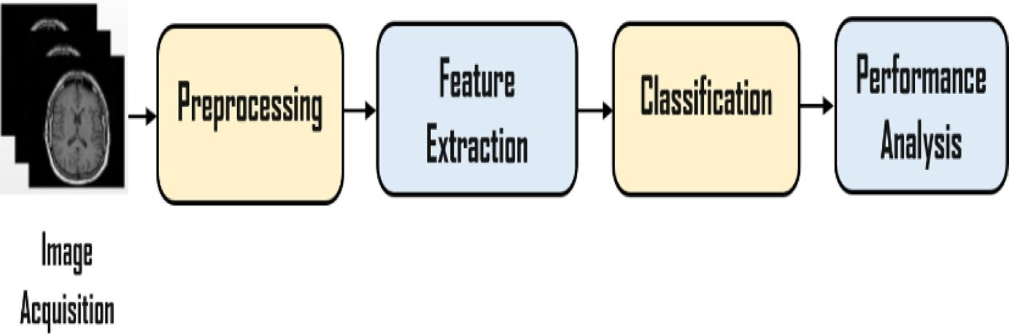
Fig. 1 Brain tumor detection system
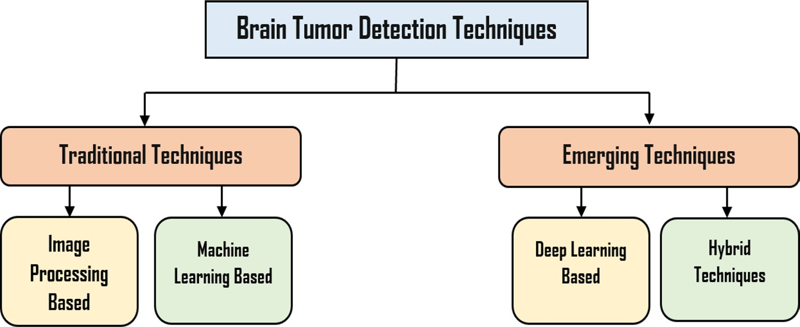

Fig. 2 Categorization of detection techniques

- Classification of brain tumor detection techniques
The detection system of brain tumors comprises image acquisition, pre-processing, segmentation process, feature extraction stage, classification algorithm, and finally, the performance analysis and the module testing as shown in Fig. 1. These systems can be categorized under one of the two main categories, which are traditional techniques and emerging techniques as illustrated in Fig. 2. The traditional techniques can be divided into image processing-based algorithms and machine-based algorithms, while the emerging techniques are categorized into deep learning-based and hybrid algorithms between the traditional and the emerging methods.

Categories of Brain Tumor Detection Techniques:
Traditional Techniques:
Image Processing-based Algorithms: These algorithms focus on using various image processing techniques like edge detection, thresholding, morphological operations, etc., to identify and characterize tumor regions.
Machine-based Algorithms: These are typically machine learning algorithms that involve training a model on extracted features and then using this model for classification. Examples include decision trees, support vector machines, and random forests.
Emerging Techniques:
Deep Learning-based Algorithms: These techniques use deep neural networks to automatically learn and extract features from the images. Convolutional Neural Networks (CNNs) are commonly used for this purpose, as they excel at image analysis tasks.
Hybrid Algorithms: These approaches combine elements of traditional techniques with emerging methods. For instance, a hybrid model might use traditional image processing for pre-processing and feature extraction, followed by a deep learning-based classification algorithm.
It's important to note that the field of medical image analysis, including brain tumor detection, is rapidly evolving. Deep learning techniques have shown promising results due to their ability to automatically learn complex patterns from data. However, traditional techniques still play a role, especially in scenarios where data is limited or interpretability is crucial. Hybrid approaches can leverage the strengths of both traditional and deep learning methods.

2.1 Image processing-based techniques
1. Region-Based Techniques: In region-based techniques, similar feature regions (pixels) are grouped. Region growth is considered the most straightforward region based as introduced in [16, 17].
2. Thresholding-Based Techniques: Using these methods, pixels are partitioned based on their intensity values based on comparing their intensity values with one or more predefined intensity value(s). Various types of thresholding methods are presented in [18, 19].
3. Edge-Based Techniques These strategies rely on determining the boundaries of the Region of Interest. Watershed Segmentation [20] is an example of an edge-based approach.

2.2 Machine learning-based techniques
Machine learning techniques are categorized as unsupervised (clustering) and supervised (classification). In supervised techniques, there is a relationship between the labels and the features derived from the use of the labelled information during the training. Then, unlabelled information becomes labelled information based on the estimated features during the testing process. Several studies have utilized learning for brain tumor identification such as self-organized maps (SOM) [21], fuzzy c-means (FCM) [22], K-means [23], support vector machine (SVM), and artificial neural networks (ANN) [24], which are illustrated as follows:
1. One of the easiest grouping techniques is the K-nearest neighbour (KNN). It is used to achieve high stability and accuracy for MR image data, but it is noted that a high execution time is needed.
2. The artificial neural network (ANN) creates an image by connecting a network of neurons, which are referred to as pixels. ANN views detection as an energyminimization problem and aims to estimate not only connection but also weights between nodes during training.
3. Clustering is the classification of brain tissues as regions with the same label. Fuzzy c-means, self-organized map (SOM), and K-means are some well-known clustering techniques.
4. Support Vector Machine (SVM) is a supervised learning model that analyses data in regression and classification analysis.

2.3 Deep learning-based techniques
DL is considered a subset of machine learning with high performance. The complicated features are extracted from the query image using this learning model. There are different deep learning techniques, namely convolutional neural networks (CNNs) [25], deep neural networks (DNN), and deep convolutional neural networks (DCNNs) [26, 27]. Recently, DL has shown significant performance in the medical image classification process by using DCNN [28]. CNNs are unusually multilayer neural networks. Its most applications are in image classification and object recognition. It includes a parameter sharing a property that reduces the parameter numbers needed for the model compared to ANN (Artificial Neural Network). There are many state-of-the-art powerful network architectures such as GoogleNet, AlexNet, Residual Network (ResNet) 50, Inception V3, and ResNet 18.

2.4 Hybrid techniques
These methods combine two or more techniques to produce better outcomes by contrasting them with those obtained by individual techniques. Three key categories for the term ‘hybrid’ about detection systems are presented, segmentation-segmentation, classification -classification, and segmentation-classification. A technique that combines wavelets separately with SVM and SOM is presented in [29] to identify brain MR images. [30] Proposes a hybrid approach for classifying brain tumors as normal, benign, or malignant utilizing a genetic algorithm (GA) and SVM. Enhanced possibilistic fuzzy c-means (EPFCM) is a region-based technique for resolving initialization and bad boundary constraints [31]. FKM is combined with SOM to provide a tumor detection method [32, 33] proposed brain tumor segmentation based on morphological operations and hybrid clustering, which consists of adaptive Wiener filtering for DE noising and morphological operations for removing no cerebral tissues.

- The proposed system architecture
This section presents two different Scenarios for the early detection of brain tumors, whereas the first scenario is based on the presence of the patient in the same place as the data center where a direct diagnosis of images is made by applying the images directly to the DCNN. The second scenario is done by sending the brain images to the cloud where the data center is existed to detect the tumor cells, this scenario enables multiusers to make the diagnosis of their images anywhere in the same city as shown in Fig. 3.

- Scenario I: deep CNN architecture
Scenario I is based on deep CNN for extracting image features. First, most brain datasets contain images of varying sizes, so the image is loaded and resized to 224×224 pixels to ensure that all images in the dataset have the same size to be inserted into CNN. After that, the pre-processing procedure raises the picture quality of brain tumor MR images and prepares them for further analysis by clinical experts or imaging modalities. It also aids in the enhancement of MR image characteristics. Improving the signal-to-noise ratio and visual appearance of MR images, removing irrelevant noise and unwanted background portions, smoothing internal portion areas, and preserving relevant edges are among the essential parameters in the image preparation process. Then, the process of obtaining quantitative information from an image, such as color properties, texture, shape, and contrast, is known as feature extraction. Here, the deep feature extraction method is then carried out using CNNs. Finally, the classification algorithm determines whether the input image is normal or abnormal based on the final feature descriptor. The input data are converted into a 1D vector by the fully connected layer. The SoftMax layer then computes the class scores.
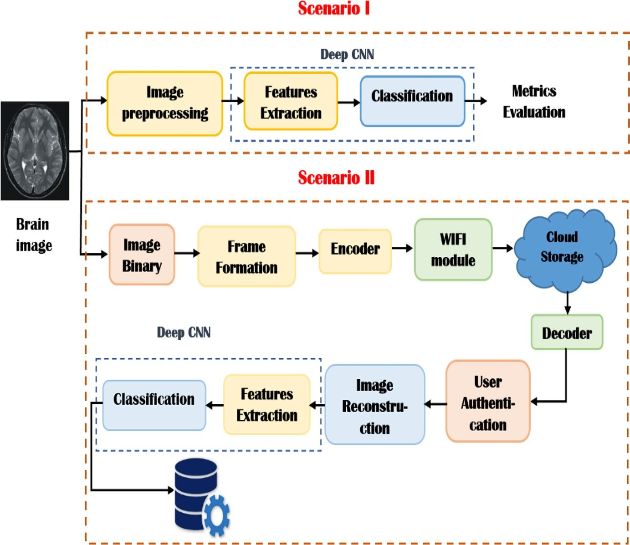
Fig. 3 The architecture flow for brain tumors detection

- Scenario II: proposed IoT system architecture
Scenario II is based on an IoT system where the brain images are transmitted to the cloud to be classifed as shown in Fig. 4. This architecture is considered a multiuser access system, in which multiple people can access the cloud at the same time. For all users, there is only one common receiver. For the categorization of brain tumors, an IoT system with cloud management was developed. The cloud is the greatest answer for a medical system that allows doctors to access data more readily because it is a distributed environment [34]. Our proposed IoT framework aims to reduce mortality rates through early detection of tumor cancers and consists of four main phases: (1) data collection, (2) image processing and classification, (3) Diagnosis, and (4) user interface.
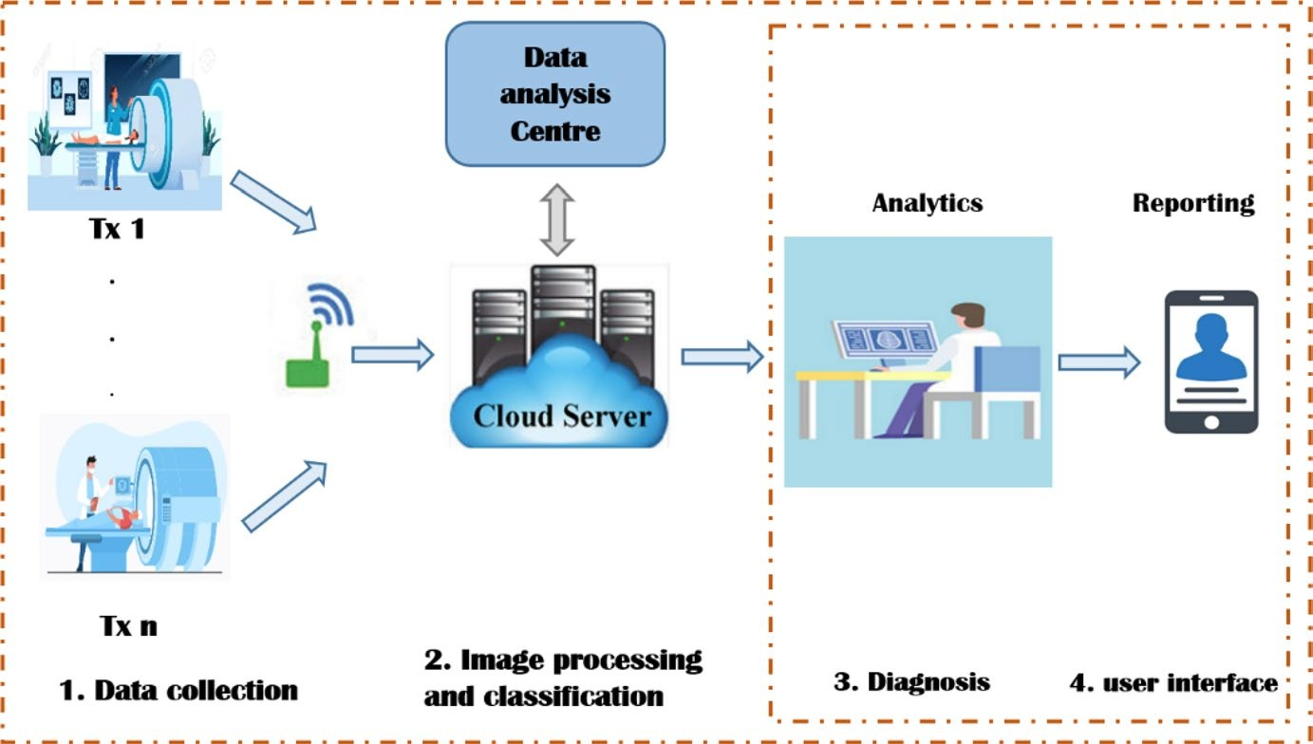
Fig. 4 Proposed IoT system architecture

The proposed IoT system is an integrated system that starts by collecting brain images that are done at the phase of data collection using MRI devices. Then, these images are transmitted via the WIFI module to the cloud where the pre-processing and classification phase is in which the MRI images are processed and scaled to fit the proposed CNN model (OMRES) that extracts features from the processed images and uses a SoftMax classifier to detect brain cancers. In the analytics phase, the patient can access his database to determine the classification results. A radiologist can detect a tumor type (if there is one) simply by uploading an MRI and obtaining classification findings in a matter of seconds. In the final phase, the report is forwarded to the patient’s doctor, who will decide on the best course of action.
For each user, the system consists of the transmitter and the receiver part. The transmitter is responsible for preparing the scanned image of the patient to be transmitted over the could, while the receiver is responsible for decoding the received image and extracting its features for early detection of brain tumors.
At the transmitter, the patient’s brain image is firstly scanned using a magnetic field and computer-generated radio waves to create high-quality images. Then, it is converted into binary data for transmission. After that, the binary data vector is created by adding the patient Identifier (ID) as a header. After that, the data frame is encoded to be transmitted using convolutional codes with a code rate r of 2∕3. The code rate r can be defined as follows [35]:
r = k/n ------ (1)
where k is the number of the parallel input bits and n is the number of the parallel output encoded bits at a one-time interval. The data flow of the transmitter part is shown in Fig. 5.

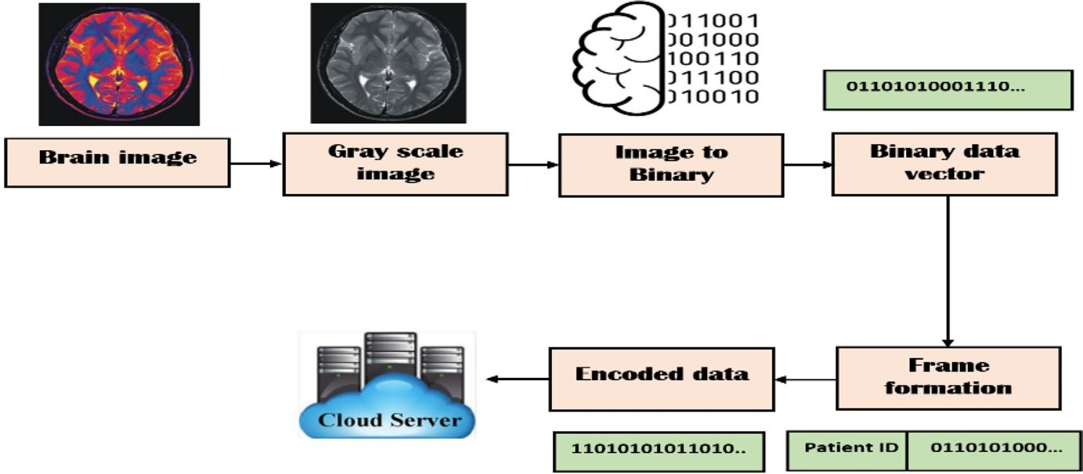

Fig. 5 Proposed system data flow

At the receiver, there are two modes which are the “Registration mode” and the “Operation mode” as shown in Fig. 6.
Registration Mode: The registration mode is used once for any new user. As the patient is firstly registered, so that he/she can easily access his/her account in the system using his/her ID number.
Operation Mode: In this mode, the authentication process is first applied to identify the registered user. After that, image preparation is performed to prepare the image for the next stages. The Weiner filter is used to reduce noise. The data are then scaled to fit the suggested CNN model. Following that, the suggested CNN model extracts feature from the processed images, and the SoftMax classifier is used to detect brain cancers. Finally, the patient can use his or her database to identify the classification results.

4. The proposed CNN model approach
4.1 Residual network (ResNet18)
He et al. have developed a deep resident network (ResNet) model, based on deep architectures that demonstrate good affinity and accuracy. ResNet was designed by several of the remaining stacked units and has been formed with different layers numbers: 18, 34, 50, 101, 152, and 1202. Though the number of operations can vary based on the various architectures, ResNet 18 is a good compensation between performance and depth. Table 2 demonstrates the architecture of Resent 18.

4.2 The OMRES model architecture
The suggested model is considered a modified version of ResNet18 architecture and is called OMRES. The OMRES network architecture consists of a preparation module, six blocks of Module A, three blocks of Module B, and an output module distributed as shown in Fig. 7.
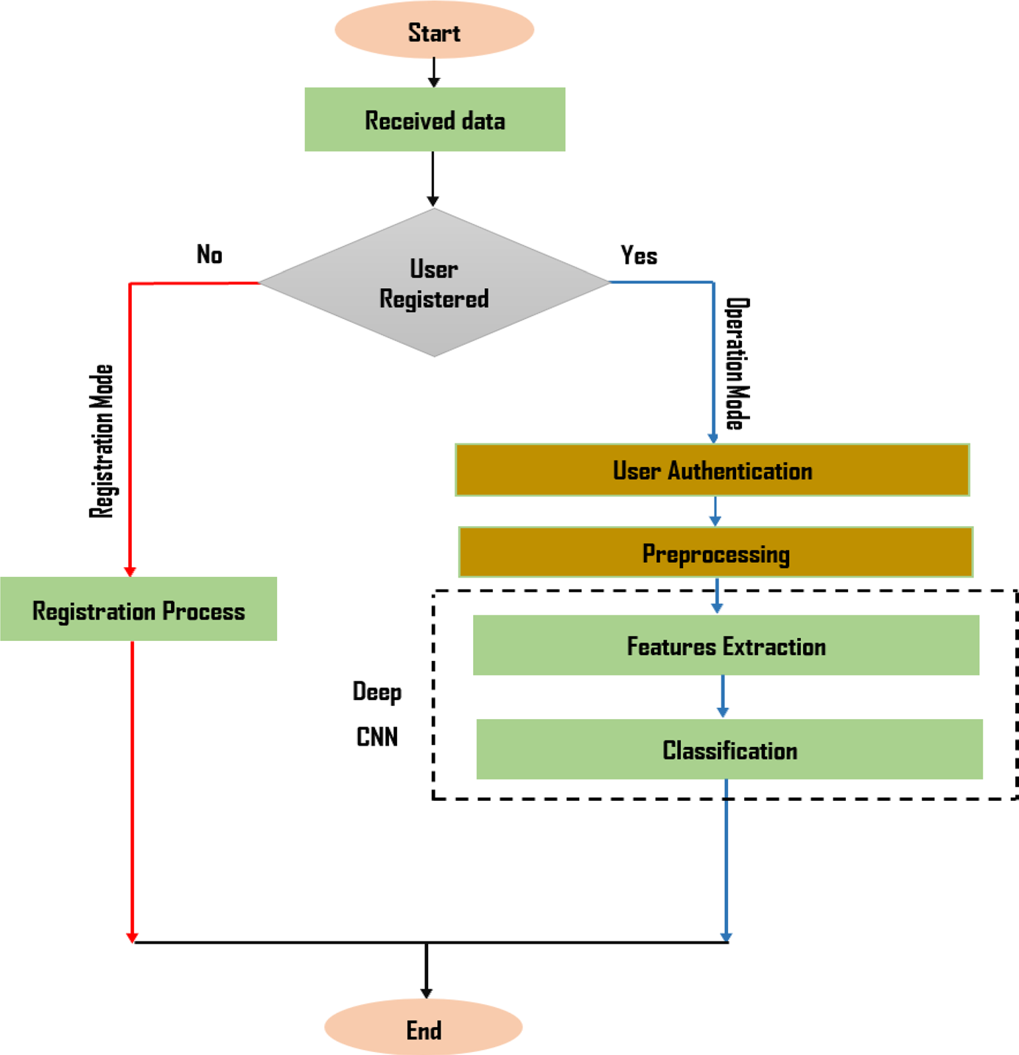

Fig. 6 Receiving mode flowchart

Table 2 ResNet 18 architecture
Layer name | Output size | Resent 18
Conv1 | 112 × 112 × 64 | 7 × 7, 64, stride 2
Conv3 | 28 × 28 × 128 | 128 3 × 3 convolutions
Conv4 | 14 × 14 × 256 | 256 3 × 3 convolutions
Conv5 | 7 × 7 × 512 | 512 3 × 3 convolutions
Avg. pool | 1 × 1 × 512 | 7 × 7 average pool
FC | 2 | 512 × 2 fully connections
SoftMax | 2

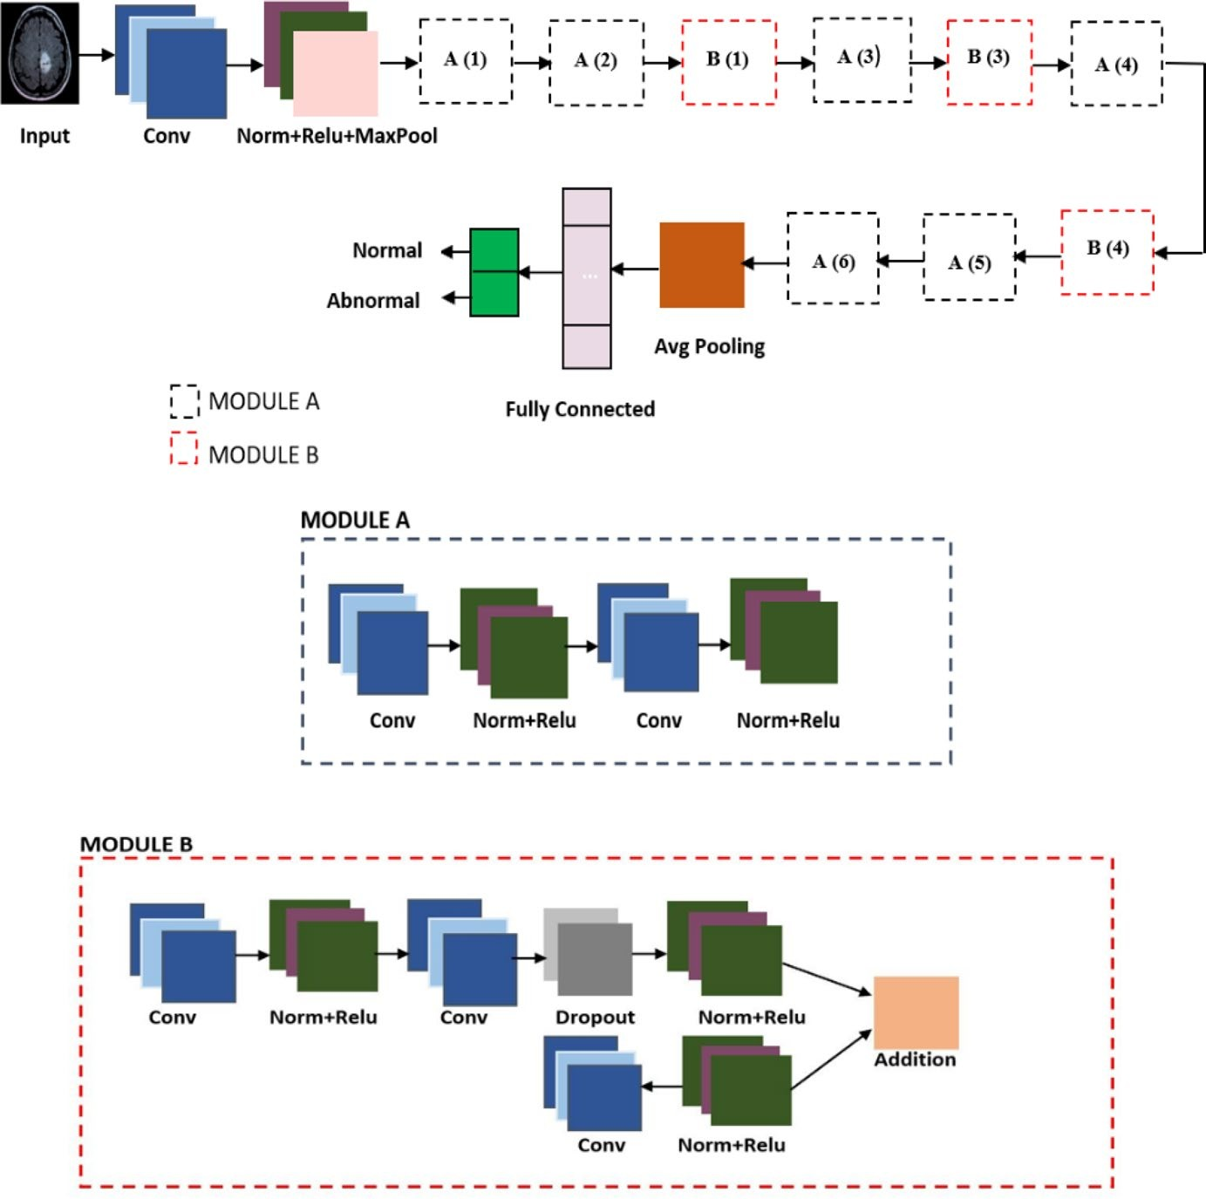
Fig. 7 Schematic representation of proposed architecture

The preparation module is made up of a convolutional layer, a batch normalization layer, a ReLU activation layer, and a max-pooling layer with a size of 3×3 and a stride of 2. Module A is made up of a convolutional layer, a batch normalization layer, and a ReLU activation layer. Then, the output of the ReLU is entered into another convolutional layer and finally added with the previous max-pooling through an additional layer. Module B is recommended to improve network accuracy and prevent over-fitting. In this module, the Dropout layer [36] is added to produce a more generalized output with an increased regularization. This layer is used to substitute the batch normalization and to perform better in generalization. Additionally, a convolutional process is added followed by a ReLU activation layer and a batch normalization layer.
The proposed network architecture consists of a preparation module, six blocks of Module A, three blocks of Module B, and an output module distributed as shown in Fig. 7. Finally, the additional layer is used to merge the two outputs. The classification block is made up of two layers: a fully connected (FC) layer and a SoftMax layer. The whole network architecture consists of 82 layers. Table 3 shows the configuration in detail of the proposed architecture.
4.3 Performance metrics
The system performance is determined using accuracy, confusion matrix, recall, specificity, precision, F1-score, and ROC curve. A Confusion matrix is used to determine the accuracy and correctness of the model. The accuracy measures the percentage of the correctly classified samples as
Accuracy = $\frac{TP+TN}{TP+FN+FP+TN}$ --------- (2)

where TP represents the real positive in the case of malignancy and TN represents the real negative in benign tumor cases, while FP and FN represent the inaccurate model predictions. The precision assesses the predictive power of the algorithm, and it shows how “accurate” the model is. It is expressed as
Precision = $\frac{TP}{TP+FP}$ ----------- (3)

The effectiveness of the algorithm can be evaluated using sensitivity (recall) and specificity in one class as demonstrated below
Sensitivity = $\frac{TP}{TP+FN}$ ----------- (4)
Specificity = $\frac{TN}{TN+FP}$ ---------- (5)

Table 3 Proposed CNN architecture

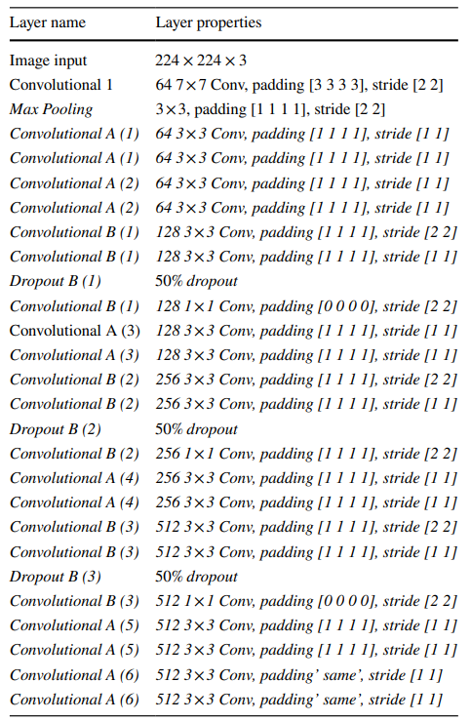

F1-score is focused on the analysis of the positive classes. It can be calculated as the harmonic average of recall and precision as

F1 Score = $2×\frac{Precision × Recall}{Precision + Recall}$ --------- (6)

The Receiver Operating Characteristic Curve (ROC) is the true positive rate versus the false positive rate for different breakpoints. The area under the curve (AUC) measures the classifier’s ability to distinguish between classes. For optimum performance, different dropout rates and different optimizers are applied where these optimizers are algorithms that are used to update network parameters and minimize loss function by taking incremental steps in the negative gradient direction (convergence) [37].
For the suggested model, four main optimizers will be tested:
• Stochastic Gradient Descent with Momentum (SGDM)
It is one of the most widely used optimizers where the SGD optimizer has been improved. The momentum in each dimension is estimated using the current gradient and previous momentum. It also adds up the gradient of previous steps to determine which way to travel.
• Adaptive Moment (ADAM)
It is a Stochastic Optimization Method where momentum and RMSprop are combined in ADAM. Exponential weighted moving averages (also called leak averages) are a fundamental component of ADAM, as they estimate both the gradient’s momentum and second-order moment.
• Root-Mean-Square Propagation (RMSProp)

- Result discussions and analysis
This study experimented with an MRI image dataset which can be found at [38]. The dataset consists of 253 images in two categories, normal and abnormal. First, the input images are resized to 224 × 224. After that, they are converted to a gray scale image in the pre-processing stage. Then, these images are randomly divided into 70% for training and 30% for testing.
  - Results of scenario I
As discussed before, the performance of the system is measured in terms of precision, recall, accuracy, and F1-score. To achieve the optimum performance of the system, different optimizers will be tested with different learning rates, different batch sizes, and a fixed number of periods.
Optimization algorithms
The impact of utilizing several optimizers will be investigated (ADAM, RMSProp, ADAS, or SGDM) with Mini- Batch sizes (32 or 64), learning rate (LR) (0.001 or 0.0001), and a maximum number of epochs 32 as illustrated in Table 4. Better performance results will be obtained by tuning the hyper-parameters using the RMSProp algorithm for optimization learning rate=0.0001, mini batch size=64, and a number of epochs=32).

Table 4 Performance of the OMRES Model for 32 Epochs
Optimization Algorithm | MB. Size | LR | Accuracy | Precision | Recall | F1-score
ADAM | 32 | 0.001 | 84.12 | 83.92 | 85.02 | 84.21
 | 32 | 0.0001 | 86.51 | 88.63 | 86.32 | 87.52
 | 64 | 0.001 | 85.21 | 84.93 | 83.24 | 84.76
 | 64 | 0.0001 | 88.93 | 89.92 | 91.12 | 90.42
RMSProp | 32 | 0.001 | 89.32 | 89.47 | 87.70 | 89.41
 | 32 | 0.0001 | 93.42 | 91.74 | 91.38 | 92.81
 | 64 | 0.001 | 95.94 | 93.43 | 94.5 | 95.21
 | 64 | 0.0001 | 98.67 | 94.66 | 100 | 98.82
SGDM | 32 | 0.001 | 89.32 | 87.12 | 88.42 | 89.34
 | 32 | 0.0001 | 93.32 | 90.52 | 92.31 | 92.83
 | 64 | 0.001 | 91.07 | 90.96 | 89.31 | 90.51
 | 64 | 0.0001 | 93.42 | 91.43 | 92.93 | 92.97
ADAS | 32 | 0.001 | 86.62 | 85.81 | 87.28 | 86.73
 | 32 | 0.0001 | 89.41 | 87.32 | 88.18 | 90.21
 | 64 | 0.001 | 90.13 | 89.92 | 89.06 | 90.78
 | 64 | 0.0001 | 93.67 | 92.89 | 91.23 | 93.91
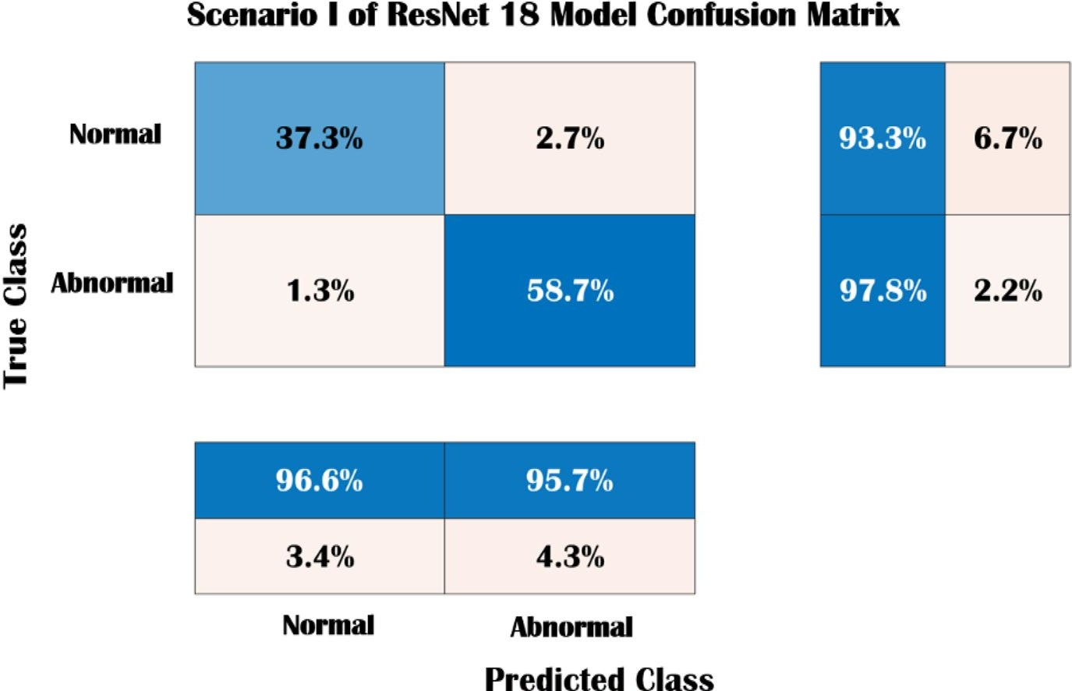

Fig. 8 Scenario I for Resnet18 confusion matrix

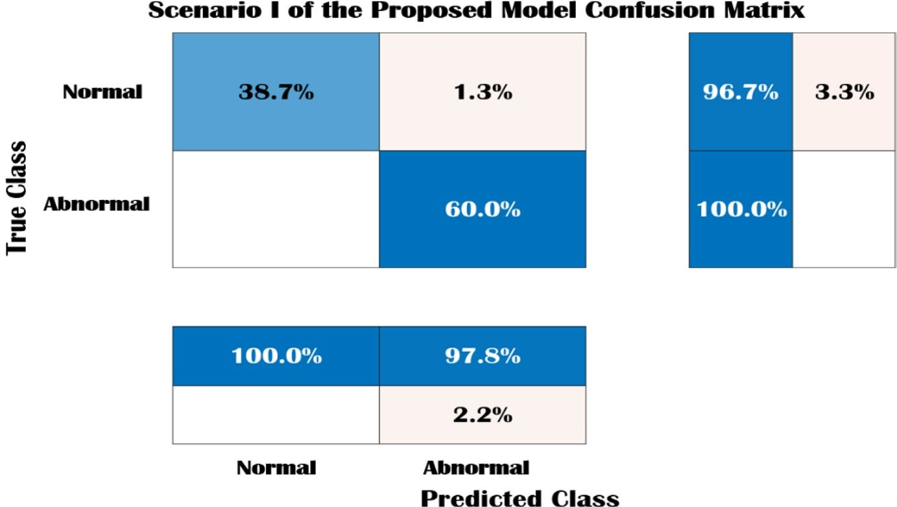

Fig. 9 Scenario I for OMRES model confusion matrix

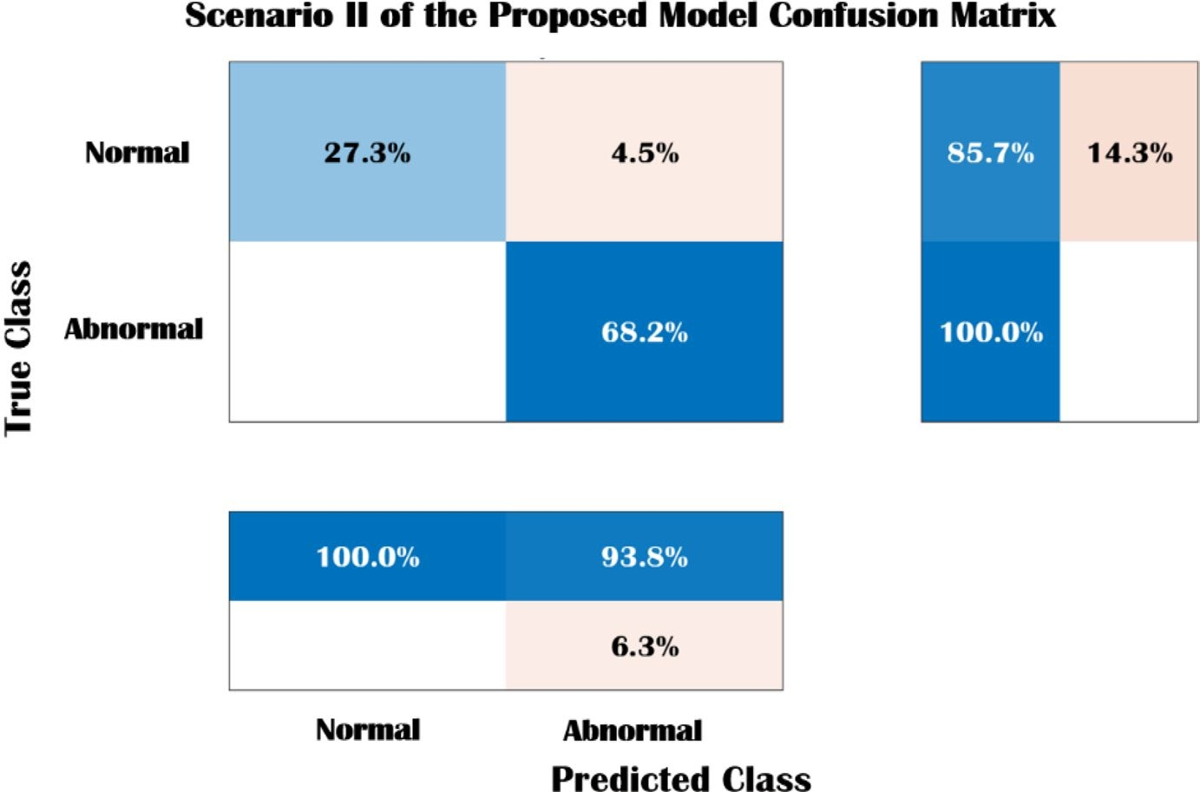
Fig. 10 Scenario II for OMRES model confusion matrix

Figure 8 presents the confusion matrices for the ResNet l8, whereas Fig. 9 illustrates the confusion matrix of Scenario I of the OMRES model. The matrix column represents the expected class, while the row presents the true class, and the diagonal of this matrix includes the correctly classified case by the networks. As analysed, the probability that the normal class is correctly identified as normal is 37.3%, while the probability of an abnormal class being correctly identified as a is 58.7%. Furthermore, the probability of the normal class being incorrectly identified as abnormal is 2.7% and the probability of an abnormal class being incorrectly identified as normal is 1.3%.

Similarly, for Scenario I for the OMRES model, the probability of the normal class being correctly identified as normal is 38.7%, while the probability that an abnormal class is correctly identified as abnormal is 60%. Besides, the probability that the normal class is incorrectly identified as abnormal is 1.3% and the probability that an abnormal class is incorrectly identified as normal is 0% which means that scenario I for the proposed model is more efficient in predicting abnormal tumors.
Finally, the OMRES model second scenario is shown in Fig. 10, the probability of the normal class being correctly identified as normal is 27.3%, while the probability that an abnormal class is correctly identified as abnormal is 68.2%. Furthermore, the probability of the normal class being incorrectly identified as abnormal is 4.5% and the probability of an abnormal class being incorrectly identified as normal is 0%

- Conclusions and future work
This paper introduced a different study for various brain tumors detection techniques. A deep learning model based on CNN has been accomplished in two different scenarios to detect tumors. This model can be considered a modified version of the ResNet18 network and is called OMRES. Additionally, the first scenario is done by applying the brain image directly to the suggested model. The second scenario presents an IoT-based framework that relies on a multiuser detection system by sending images to the cloud for the early detection of brain tumors. This makes the system accessible to anyone, anywhere for accurate classification of brain tumors. Furthermore, three optimization algorithms have been discussed. Additionally, the proposed model is compared with other pre-trained models in terms of F1-score, precision, recall, specificity, confusion matrix and accuracy. In comparison with conventional CNNs, the proposed model (In the first Scenario) offered superior performance by attaining a maximum sensitivity of 100% and accuracy of 98.67%, while the proposed model (In the second Scenario) provided an accuracy of 95.53% and sensitivity of 94.2%. Accordingly, the accuracy attained by the second scenario is a relatively acceptable if we consider the ability of the system to be accessible to anyone, anywhere. Generally, these values clearly portrayed the effectiveness of our proposed model in the detection and classification of MRI brain images.
In future work, we will focus on multi-class categorization for brain cancers. Furthermore, Multistage DL models for feature extraction will also be examined to improve classification performance on huge medical datasets. A single image superresolution stage can also be tested to improve classification performance.

References
1. Mohammadi M et al (2018) Deep learning for IoT big data and streaming analytics: a survey. IEEE Commun Surv Tutor 20:2923–2960. https://doi.org/10.1109/COMST.2018.2844341
2. Abbas S, Mahmoud AM (2020) Deep learning-aided brain tumor detection: an initial experience based cloud framework. Indones J Electr Eng Inform (IJEEI) 8:770–780. https://doi.org/10. 52549/ijeei.v8i4.2436
3. Kapoor L, Thakur S (2017) A survey on brain tumor detection using image processing techniques. In: 7th International Conference on Cloud Computing, Data Science & EngineeringConfuence, pp 582–585. https://doi.org/10.1109/CONFLUENCE.2017.7943218
4. Kothari A, Indira B (2015) A study on classifcation and detection of brain tumor techniques. Int J Comput Eng Technol 6(11):30–35. https://doi.org/10.1007/s13735-020-00199-7
5. Goel N, Yadav A, Singh BM (2016) Medical image processing: a review. In: Second International Innovative Applications of Computational Intelligence on Power, Energy and Controls with their Impact on Humanity (CIPECH), pp 57–62. https://doi.org/10.1109/CIPECH.2016. 7918737
6. Zacharaki E, Wang S, Chawla S, Soo Yoo D, Wolf R, Melhem E, Davatzikos C (2009) Classifcation of brain tumor type and grade using MRI texture and shape in a machine learning scheme. Magn Reson Med 62(6):1609–1618. https://doi.org/10.1002/mrm.22147
7. Cheng J, Huang W, Cao S, Yang R, Yang W, Yun Z, Wang Z, Feng Q (2015) Correction: enhanced performance of brain tumor classifcation via tumor region augmentation and partition. PLoS ONE 10(12):e0144479. https://doi.org/10.1371/journal.pone.0140381
8. Shree NV, Kumar TNR (2018) Identifcation and classifcation of brain tumor MRI images with feature extraction using DWT and probabilistic neural network. Brain Inform 5:23–30. https://doi.org/ 10.1007/s40708-017-0075-5
9. Abd-Ellah M, Awad AI, Khalaf AAM, Hamed H (2020) Deep convolutional neural networks: foundations and applications in medical imaging. pp 233–260. https://doi.org/10.1201/9781351003 827-9
10. Deepak S, Ameer PM (2019) Brain tumor classifcation using deep CNN features via transfer learning. Comput Biol Med 111:103345. https://doi.org/10.1016/j.compbiomed.2019.103345
11. Saxena P, Maheshwari A, Maheshwari S (2019) Predictive modeling of brain tumor: A deep learning approach. arXiv 2019, arXiv:1911.02265. https://doi.org/10.1007/978-981-15-6067-5_30
12. Hemanth DJ, Anitha J, Naaji A, Geman O, Popescu DE (2018) A modifed deep convolutional neural network for abnormal brain image classifcation. IEEE Access 7:4275–4283. https://doi.org/10. 1109/ACCESS.2018.2885639
13. Çinar A, Yildirim M (2020) Detection of tumors on brain MRI images using the hybrid convolutional neural network architecture. Med Hypotheses. https://doi.org/10.1016/j.mehy.2020.109684
14. Khawaldeh S et al (2017) Noninvasive grading of glioma tumor using magnetic resonance imaging with convolutional neural networks. Appl Sci. https://doi.org/10.3390/app8010027
15. Tazin T, Sarker S, Gupta P (2021) A robust and novel approach for brain tumor classifcation using convolutional neural network. Comput Intell Neurosci. https://doi.org/10.1155/2021/2392395
16. Ge C, Gu IY, Jakola AS, Yang J (2018) Deep learning and multi-sensor fusion for glioma classifcation using multistream 2D convolutional networks. In: 40th Annual International Conference of the IEEE Engineering in Medicine and Biology Society (EMBC), pp 5894–5897. https://doi.org/10. 1109/EMBC.2018.8513556
17. Ilunga-Mbuyamba E, Avina-Cervantes JG, Cepeda-Negrete J, Ibarra-Manzano MA, Chalopin C (2017) Automatic selection of localized region-based active contour models using image content analysis applied to brain tumor segmentation. Comput Biol Med 91:69–79. https://doi.org/10. 1016/j.compbiomed.2017.10.003
18. Fan J, Yau DK, Elmagarmid AK, Aref WG (2001) Automatic image segmentation by integrating color-edge extraction and seeded region growing. IEEE Trans Image Process 10(10):1454–1466. https://doi.org/10.1109/83.951532
19. Bhattacharyya D, Kim T-H (2011) Brain tumor detection using MRI image analysis. In: International Conference on Ubiquitous Computing and Multimedia Applications, pp 307–314, Springer. https://doi.org/10.1007/978-3-642-20998-7_38
20. Mittal K, Shekhar A, Singh P, Kumar M (2017) Brain tumour extraction using otsu based threshold segmentation. Int J Adv Res Comput Sci Softw Eng. https://doi.org/10.23956/ijarcsse/V7I4/0145
21. Oo SZ, Khaing AS (2014) Brain tumor detection and segmentation using watershed segmentation and morphological operation. Int J Res Eng Technol 3(3):367–374. https://doi.org/10.15623/ijret. 2014.0303068
22. Mei PA, de Carvalho Carneiro C, Fraser SJ, Min LL, Reis F (2015) Analysis of neoplastic lesions in magnetic resonance imaging using self-organizing maps. J Neurol Sci 359(1–2):78–83.
https://doi. org/10.1016/j.jns.2015.10.032
23. Karthik R, Menaka R, Chellamuthu C (2015) A comprehensive framework for classifcation of brain tumor images using SVM and curvelet transform. Int J Biomed Eng Technol 17(2):168–177. https://doi.org/10.1504/IJBET.2015.068054
24. Kim J, Lee S, Lee G, Park Y, Hong Y (2016) Using a method based on a modifed k-means clustering and mean shift segmentation to reduce fle sizes and detect brain tumors from magnetic resonance (MRI) images. Wirel Pers Commun 89(3):993–1008. https://doi.org/10.1007/ s11277-016-3420-8
25. Madhusudhanareddy P, Prabha IS (2013) Novel approach in brain tumor classifcation using artifcial neural networks. Int J Eng Res Appl 3(4):2378–2381
26. Reddick WE, Glass JO, Cook EN, Elkin TD, Deaton RJ (1997) Automated segmentation and classification of multispectral magnetic resonance images of brain using artificial neural networks. IEEE Trans Med Imaging 16(6):911–918. https://doi.org/10.1109/42.650887
27. Havaei M, Davy A, Warde-Farley D, Biard A, Courville A, Bengio Y, Pal C, Jodoin PM, Larochelle H (2017) Brain tumor segmentation with deep neural networks. Med Image Anal 35:18–31. https:// doi.org/10.1016/j.media.2016.05.004
28. El-Feshawy SA, Saad W, Shokair M, Dessouky M (2021) Brain tumour classifcation based on deep convolutional neural networks. In: 2021 International Conference on Electronic Engineering (ICEEM), pp 1–5. https://doi.org/10.1109/ICEEM52022.2021.9480637
29. Vaishnavee K, Amshakala K (2015) An automated MRI brain image segmentation and tumor detection using SOM-clustering and proximal support vector machine classifer. In: IEEE International Conference on Engineering and Technology (ICETECH), pp 1–6. https://doi.org/10.1109/ICETE CH.2015.7275030
30. Kharrat A, Gasmi K, Messaoud MB, Benamrane N, Abid M (2010) A hybrid approach for automatic classifcation of brain MRI using genetic algorithm and support vector machine. Leonardo J Sci 17(1):71–82
31. Rajendran A, Dhanasekaran R (2013) Enhanced possibilistic fuzzy c-means algorithm for normal and pathological brain tissue segmentation on magnetic resonance brain image. Arab J Sci Eng 38(9):2375–2388. https://doi.org/10.1007/s13369-013-0559-4
32. Chahal PK, Pandey S (2020) An efcient hybrid approach for brain tumor detection in MRI images using Hadoop-MapReduce. In: International Conferences on Internet of Things (iThings) and IEEE Green Computing and Communications (GreenCom) and IEEE Cyber, Physical and Social Computing (CPSCom) and IEEE Smart Data (SmartData) and IEEE Congress on Cybermatics (Cybermatics), pp 926–931, https://doi.org/10.1109/iThings-GreenCom-CPSCom-SmartData-Cybermatic s50389.2020.00144
33. Zhang C, Shen X, Cheng H, Qian Q (2019) Brain tumor segmentation based on hybrid clustering and morphological operations. Int J Biomed Imaging. https://doi.org/10.1155/2019/7305832
34. Darwish A, Hassanien AE, Elhoseny M, Sangaiah A, Muhammad K (2019) The impact of the hybrid platform of internet of things and cloud computing on healthcare systems: opportunities, challenges, and open problems. J Ambient Intell Hum Comput 10:4151–4166. https://doi.org/10. 1007/s12652-017-0659-1
35. Grami A (2015) Introduction to digital communications. Springer, Cambridge
36. Srivastava G, Hinton A, Krizhevsky IS, Salakhutdinov R (2014) Dropout: a simple way to prevent neural networks from overftting. J Mach Learn Res 15(1):1929–1958
37. Bottou L (2010) Large-scale machine learning with stochastic gradient descent. In: Proceedings of COMPSTAT. Physica-Verlag HD, pp 177–186. https://doi.org/10.1007/978-3-7908-2604-3_16
38. https://www.kaggle.com/navoneel/brain-mri-images-for-brain-tumordetection accessed June 10, 2019
39. Vishnuvarthanan G, Rajasekaran MP, Subbaraj P, Vishnuvarthanan A (2016) An unsupervised learning method with a clustering approach for tumor identifcation and tissue segmentation in magnetic resonance brain images. Appl Soft Comput 38:190–212. https://doi.org/10.1016/j.asoc.2015. 09.016
40. Ullah Z, Farooq MU, Lee SH, An D (2020) A hybrid image enhancement based brain MRI images classifcation technique. Med Hypotheses. https://doi.org/10.1016/j.mehy.2020.109922
41. Siddiaue MAB, Sakib S, Khan MMR, Tanzeem AK, Chowdhury M, Yasmin N (2020) Deep convolutional neural networks model-based brain tumor detection in brain MRI images. In: Proceedings of the Fourth International Conference on I-SMAC (IoT in Social, Mobile, Analytics and Cloud) (ISMAC), IEEE, Palladam, India, November 2020. https://doi.org/10.1109/I-SMAC49090.2020. 9243461
42. Francisco JP, Mario ZM, Miriam RA (2021) A deep learning approach for brain tumor classifcation and segmentation using a multiscale convolutional neural network. Healthcare 9:153. https://doi. org/10.3390/healthcare9020153
43. Sultan HH, Salem NM, Al-Atabany W (2019) Multi-classifcation of brain tumor images using deep neural network. IEEE Access 7:69215–69225. https://doi.org/10.1109/ACCESS.2019.2919122
44. Pashaei A, Ghatee M, Sajedi H (2020) Convolution neural network joint with mixture of extreme learning machines for feature extraction and classifcation of accident images. J Real-Time Image Process 17:1051–1066. https://doi.org/10.1007/s11554-019-00852-3
45. Kaplan K, Kaya Y, Kuncan M, Ertunç HM (2020) Brain tumor classifcation using modifed local binary patterns (LBP) feature extraction methods. Med Hypotheses 139:109696. https://doi.org/10. 1016/j.mehy.2020.109696
46. El-Feshawy S, Saad W, Shokair M, Dessouky M (2022) Proposed Approaches for Brain Tumors Detection Techniques Using Convolutional Neural Networks. Int J Telecommun IJT’2022 2(1):1– 14. https://ijt-adc.org/articles/2805-3044/165806

