“Life is what happens when you're busy making other plans.”
- John Lennon
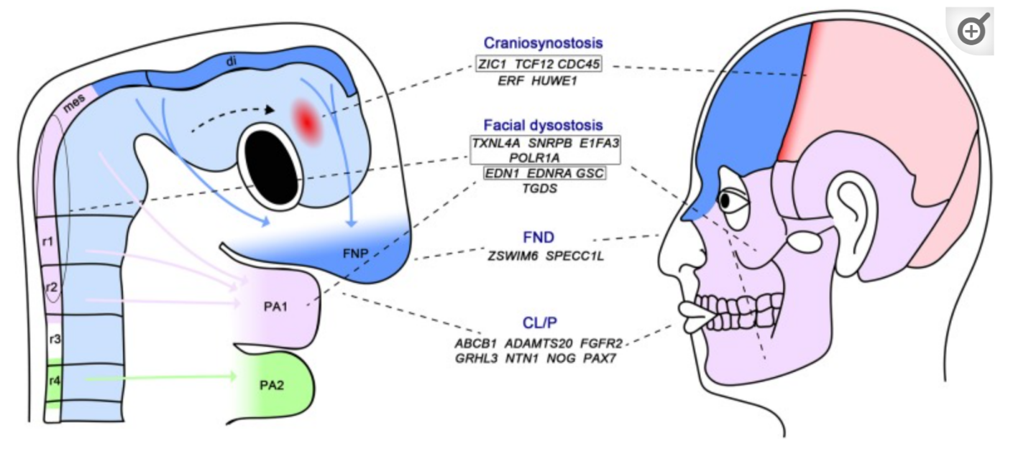
The body's most intricate structure is found in the cranium. Along with connective tissue, muscle, vasculature, and accompanying innervation, the skull, which includes bones that surround and protect the brain and sensory organs, serves as a structure for the face to support the activities of eating and breathing. Endoderm, mesoderm, ectoderm, and cranial neural crest cells (CNCCs) and their offspring together give rise to these tissues.^{[1]} Signaling between these cellular components and to the craniofacial mesenchyme (formed primarily by CNCCs with a mesodermal contribution) provides positional cues and regulates growth and differentiation.^{[1]} Fig 8.1
Fig 8. 1 Growth Of The Head And Face, As Well As Freshly Discovered Craniofacial Genes

TREACHER COLLINS SYNDROME (TCS)
Mandibulofacial dysostosis, or Treacher Collins syndrome (TCS), is an autosomal dominant disorder with varying degrees of expressivity. In individuals with fully developed TCS, the facial profile may display a retrusive mandible and chin, a prominent nasal dorsum, and a horizontally deficient convex appearance. The palpebral fissure in the area around the eyes has an antimongoloid slope because of colobomata, abnormal development of the eye and surrounding area unevenness of the orbit and hypoplasia of the inferolateral orbit. Hair growth with tongue-like structures is common in the preauricular area. ^{[2]} Hearing is compromised due to varying degrees of external auditory canal hypoplasia and middle ear ossicles that are hypoplastic. The external ears are missing, deformed, or malposed. Hypoplastic development of the malar bones, frequently accompanied with cleft across the alveolar and palatal bones and restricted zygoma growth, glenoid fossa component growth deformity, is a distinctive feature. ^{[3]} The temporomandibular joints (TMJs), muscles of face playing role in expression and mastication are all impacted differently by the hypoplastic characteristics of the maxilla and mandible bones. It's interesting to note that TCS does not reveal hypoplastic formation of the soft tissues of the face in the middle.^{[4]} In general, the maxillomandibular complex is steeply rotated clockwise and there is an anterior open-bite malocclusion along with Angle Class II molar relation. The lower face height in the front is longer than the lower facial height in the back. The jaws' clockwise rotation is consistent. But it is unpredictable to have a cleft palate with or without cleft of surrounding areas.
The categorization of Mandibular Malformation and Temporomandibular Joint falls into several classifications ^{[5,6]}
Type I TMJ– Minimal hypoplasia of the glenoid fossa and the condyle- ascending ramus on either side characterizes mandibular deformity. The skeletal components are all present.
Type IIA TMJ little degree of glenoid fossa and condyle-ascending ramus hypoplasia are present in TMJ-mandible malformation.
Type IIB Condyles suffer from significant hypoplasia in mandibular deformity.
Type III A mandibular defect known as glenoid fossa-mandibular malformation. Mandible is positioned backwardly is prevented from stopping against the skull base.
Staging of Skeletal Reconstruction: Timing and Techniques
- Zygomatic and Orbital Reconstruction
- Maxillomandibular Reconstruction
- Nasal Reconstruction
- Facial Soft-Tissue Reconstruction
- External Ear Reconstruction
To address the exclusive malformations in Treacher Collins, is the reconstruction and rehabilitation process including the following aspects:
1) the zygomatic and orbital region.
2) the maxillomandibular region.
3) the nasal region.
4) the soft-tissue envelope.
5) the external ears.
6) the external auditory canal.
7) the middle-ear structures.
The orbit and zygoma Reconstruction
Studies have suggested that sculpted full thickness calvaria bone grafts used in a 3-D approach can be a viable strategy for repairing malar defects and orbit defects in people with varying degrees of Treacher Collins syndrome. The neo-zygoma is subsequently fixed with a microplate and screws to support it. Without the necessity for further periorbital incisions, a coronal scalp incision provides exposure for the reconstruction. ⁽⁷⁾ Fixed split-thickness autogenous cranial bone can be utilized to reconstruct the deficient areas of the orbital floor. After removing cranial vault as a donor, the affected sites can be reconstructed using either split cranial grafts of the same individual or synthetic materials. A titanium mesh base attached to the adjacent skull is a preferred option for small cranial donor sites using non autogenous grafts. A replacement for bone is then used to fill in the mesh. To attach to the new lateral orbital rim, The lateral less invasive treatment that employs invisible stitches to realign and reinforce the outer eye is completed and fastened via scalp incision. CT scanning pre and post-surgery in our investigation showed that individuals with TCS had significantly longer lateral orbital walls (depth), wider lateral orbital rims, wider interzygomatic arches, and longer zygomatic arches. The changes made to address the zygomatic and orbital deformities in TCS have been shown to persist in postoperative scans taken after a year. Different surgeons have suggested various techniques and schedules for treating these anomalies. According to some experts, the use of full-thickness autogenous cranial bone to construct the entire zygomatic complex is deemed more efficient in preserving volume and contour, as opposed to onlay grafts, which have been linked to less favorable outcomes. Despite the use of onlay autogenous bone grafts from different donor sites (such as skull, hip, or rib) to reconstruct various regions in the craniofacial area, they have displayed significant and unanticipated resorption over time. Also, it shouldn't be anticipated that the graft would develop or expand in volume at a rate that corresponds to that of the underlying bone, such as the zygoma.
The idea that "even if the graft partially resorbs, at least something has been achieved" should be disregarded since it frequently leads to surface abnormalities that worsen the underlying abnormality.
Maxillomandibular Reconstruction
Clarifying any unique airway requirements is a key factor in deciding when and how to do a jaw restoration. If first stage early lower jaw reconstruction is required before growth complition, this will determine if it is essential. The amount of TMJ-mandibular deformity is the second factor to be taken into account. Abnormalities of Type I and IIA do not necessitate the construction of glenoid fossa or condyle. Patients with these diseases have sufficient TMJ architecture, allowing for mandibular reconstruction using ramus osteotomies while yet maintaining a functional TMJ. ^{[8]}
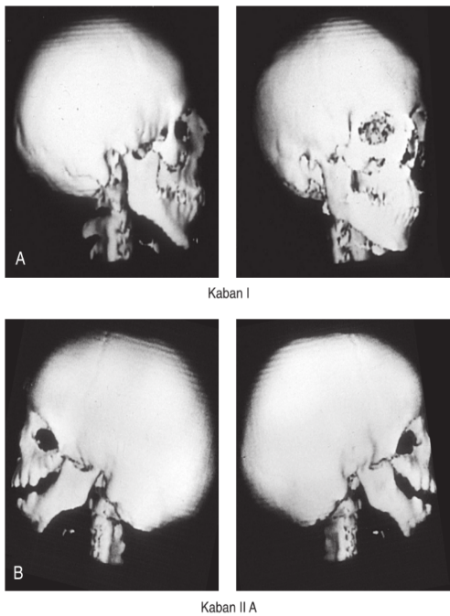
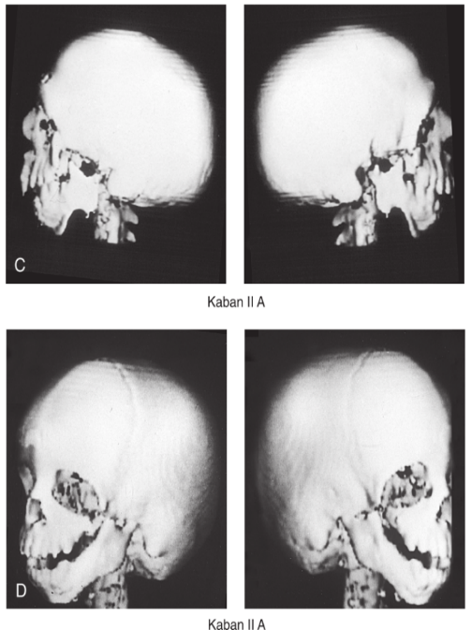
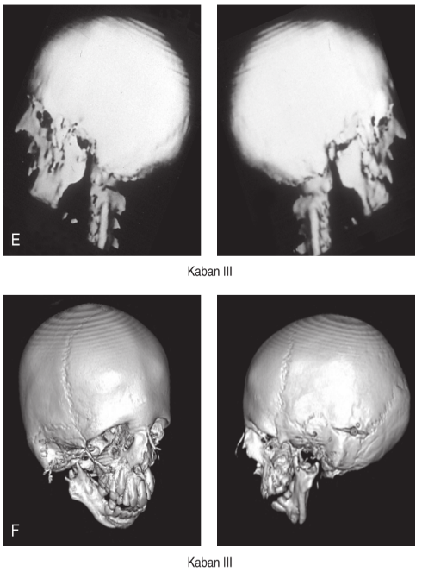
Fig 8.2: The Level Of TMJ-Mandibular Deformitys With Hemifacial Microsomia, Kaban And Colleagues Developed A Categorization System.
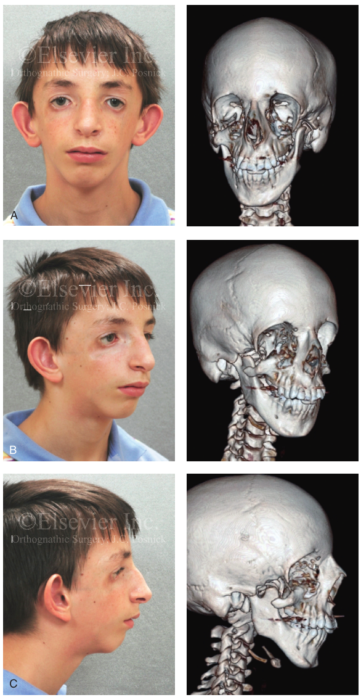
Individuals diagnosed with TCS may require reconstruction of the maxillomandibular complex due to three primary dysmorphologies: Modifications in facial dimensions that lead to heightened anterior lower facial height while concurrently reducing posterior facial height have been observed. Notably, the lack of a horizontal jawline is most conspicuous in the mandibular region, although occurrences within the maxillary area are also documented. Moreover, instances of chin dysplasia manifest, marked by an augmentation in vertical extension coupled with a sagittal retrusion. When seen in profile, these abnormalities cause the maxillomandibular complex to rotate too much clockwise and to have an undesirable A-point-to-B-point connection. An Angle class II anterior open-bite malocclusion is the most common kind. It's interesting that some people will exhibit a Class III or Class I connection. For the airway room to be increased, the deformity of occlusion to be fixed, and the facial equilibrium to be restored, the maxillomandibular complex must be rotated anticlockwise.^{[9]}
Fig8.3: Treacher Collins Syndrome Is Completely Exhibited in An 11-Year-Old Kid.
The most favorable cosmetic outcomes are typically observed in patients who receive definitive reconstructive jaw surgery after attaining early maxillofacial skeletal maturity (usually after the age of 13-15 years), and when this surgery is combined with effective orthodontic treatment during the permanent dentition. To correct the inclination of anterior teeth, decompress the occlusion, and alleviate dental root crowding caused by orthodontic treatment, mandibular and, in some cases, maxillary premolar extractions are often required to properly reposition the jaws for aesthetic and airway purposes.
The condyle that is congenitally absent must be surgically constructed in cases of type IIB mandibular abnormalities. Osteotomies by themselves—with the skeletal segments' immediate or progressive DO—will not be sufficient. Despite its inherent drawbacks, mandibular reconstruction with a costochondral graft is still favoured for treating the Type IIB abnormality. In order to attain facial equilibrium and a sufficient airway, the entire maxillomandibular complex must be rotated anticlockwise. To achieve reliable and effective repair, new condylar construction, followed by maxillary and mandibular osteotomies near or at skeletal maturity, represents the only dependable approach. The comprehensive approach to jaw reconstruction encompasses intranasal interventions aimed at improving airway patency, such as septoplasty, inferior turbinate reduction, and reshaping of the nasal floor and walls.
To address the Type III TMJ-mandibular deformity, the non-existent glenoid fossa and condyle present since birth must be reconstructed surgically. Incorporating the new glenoid fossa into the zygomatic and orbit reconstruction is desirable since it is an essential component.^{[10]}

Indications for First-Stage Mandibular Reconstruction in the Newborn
Treacher Collins syndrome (TCS) is a congenital disorder that affects the first and second branchial arches on both sides of the face, resulting in a range of upper airway anomalies that can be recurrent and variable. One of the syndrome's consistent yet variable elements is hypoplasia of the jaw. Studies have revealed that sleep apnea affects over 25% of individuals with TCS and is a risk factor for the disorder. In cases where OSA patients are dependent on tracheostomy, sagittal advancement of the mandible may be used as an alternative therapy approach to create additional space in the oral cavity, push the tongue forward, and open the retromandibular airwayFor the past 20 years, DO methods have been used to improve the airway by carefully relocating and then maintaining the mandibular segments until they are consolidated. Many writers described the use of this procedure as an efficient way to decannulate people who would otherwise be tracheostomy-dependent using TCS. Over the last two decades, DO techniques have been utilized to enhance the airway by gently repositioning and retaining the mandibular segments until consolidation takes place.
Anderson and colleagues reported long-term outcomes of lower jaw lengthening with a DO method that was performed during the youth of the patient to treat airway obstruction in individuals with TCS. During the distraction period, the patient's minimum cross-sectional airway increased in size, but it remained below the normal levels for their age, according to their findings. Number of scans performed afterward for a period of a decade of progressive growth showed minimum size of the airway did not increase. Furthermore, they illustrated through the analysis of three-dimensional CT images that the mandibular development followed the dysmorphic TCS pattern similar to the pre-distraction intervention.
As a result, the mandibular plane angle was excessively steep and turned clockwise. The authors come to the conclusion that opening the retromandibular airway in a kid with TCS who is having OSA may be helped by a mandibular DO surgery. Yet, throughout chronologic development, the upper airway's early improvement was not sustained. Despite more than 20 years of international experience, further studies on long-term outcomes are required to determine the role of mandibular distraction osteogenesis in the treatment protocol for infants and children with treacher collins syndrome. In the absence of trustworthy data, it is recommended to exercise caution and discretion while using mandibular osteotomies and lengthening techniques through any method during infancy and adolescence. ^{[11]}
Indications for First-Stage Mandibular Reconstruction during the Mixed Dentition.
If a Type IIB condylar deformity requires a first-stage mandibular reconstruction, it is advisable to wait until the child is between 7 to 10 years old and undergo the procedure only after the permanent first molars in the mandible have emerged. Sadly, the mandibular and other maxillofacial abnormalities cannot be permanently corrected with a first-stage early lower jaw reconstruction. Reconstructive surgeons are still plagued by issues like infection and TMJ ankylosis, among others, costochondral graft overgrowth, undergrowth, and asymmetrical growth. During early skeletal maturity, the maxillary jaw, mandibular jaw, and chin area will all need their final orthognathic correction. The argument holds true for patients with typical dentofacial deformities, as well as those with associated syndromes or cleft lip and palate jaw deformity. It is suggested to delay the correction of maxillomandibular deformity until early skeletal maturity, which typically occurs between the ages of 13 to 15 years. It is not advisable to undergo mandibular surgery during mixed dentition due to various reasons. Firstly, it may cause damage to the developing permanent dentition and inferior alveolar nerves, leading to long-term harm. Secondly, delaying the surgery until a later age may prevent cutaneous scarring. Thirdly, postponing the surgery could limit perioperative airway and infection complications. Fourthly, delaying the surgery may also help in preventing negative psychosocial memories in the patient. Lastly, performing mandibular surgery during mixed dentition could lead to iatrogenic mandibular and TMJ deformation, making it challenging to achieve a successful long-term restoration.
Also, due to the location of the growing teeth and anticipated induced development limits, bone surgeries in the deformed maxillary jaw and chin are rarely performed in childhood. The literature has now established that Le Fort I osteotomy does not results continuing horizontal maxillary development. Moreover, it is not practical to surgically position the jaws in a way that would guarantee long-term functional occlusion and improved aesthetics during the mixed dentition. A Le Fort I osteotomy is necessary in TCS patients to treat the vertical, horizontal, and transverse maxillary abnormalities. When pitch direction needs to be corrected, the maxillomandibular complex invariably benefits from anticlockwise rotation. In most cases, anterior maxilla intrusion is required to create a more typical contact between the top lip and the teeth while smiling and when the mouth is relaxed. The posterior maxillary height may need to be lengthened, but more often than not, it can stay in a position that is quite near to neutral. In order to achieve the appropriate anticlockwise rotation of the mandible and chin, a maxillary plane change is performed, which is also referred to as pitch orientation. The primary objectives of orthognathic surgery are to achieve the following three goals. Firstly, to restore the normal anterior facial height. Secondly, to improve the upper airway by increasing the space for better airflow. Lastly, to improve the cosmetic appearance by enhancing the connection between the A and B points when the patient is viewed from the side. By achieving these goals, orthognathic surgery can help patients achieve better oral function, improved breathing, and enhanced facial aesthetics. In 1993, Rosen published research on the long-term stability of the lower jaw's anticlockwise rotation when it is necessary to do so in order to improve face aesthetics and function in people with mandibular micrognathia. Similar clinical trials conducted by others have supported the mandibular anticlockwise rotation's long-term skeletal stability when used in an orthognathic repair. In most cases, bilateral intraoral sagittal split osteotomies are considered the preferred ramus procedures for Type I and IIA mandibular malformations. These procedures can effectively achieve horizontal advancement, anticlockwise rotation of the mandible, and sufficient bone contact across each osteotomy site without the need for lengthening the posterior facial height. Titanium plates and screws are used as necessary to stabilize each mandibular osteotomy site. When necessary, an interposed corticocancellous bone graft (such as an autogenous iliac graft) is employed. Splitting in the ramus area at the time of final reconstruction is desirable when possible for Type IIB and Type III rib or fibula graftconstructed mandibles that were developed earlier throughout the patient's life. With the advancement of the distal mandible, there is often just a little amount of bone contact across the osteotomy site. It is best to prepare for the potential necessity for an interpositioned corticocancellous bone transplant (such as an autogenous iliac). As compared to traditional osteotomies, DO osteogenesis approaches have often failed to show lower morbidity or better soft-tissue response in patients with TCS. Results show that when the treatment is done during childhood, there is no continuous jaw development and a considerable amount of relapse occurs during the consolidation phase of DO methods. The use of curvilinear DO for the repair of complicated mandibular abnormalities in severe types of TCS is still being improved by Kaban, colleagues, and others. Despite best efforts when applying DO procedures, achieving the desired proportions and symmetry of osteotomized skeletal segments through reliable three-dimensional vector control remains a work in progress. For these reasons, we choose the traditional orthognathic correction of the maxillomandibular lack of balance should be considered when practical, while improvements in DO technology and its clinical applications are pending.
Nasal Reconstruction
Adults with treacher collins syndrome frequently have a mild to moderately wider nasal bridge, they almost always have a mid-dorsal hump. The nose's length is often normal, but it seems longer because the upper and bottom skeleton thirds of the face are out of harmony. Moreover, the tip frequently droops and lacks the desired projection. It is preferable to hold off on the rhinoplasty until after successful orthognathic surgeries have been completed in order to attain the optimum cosmetic effects. Exposure is given via an open approach (a columella-splitting incision).
Facial Soft-Tissue Reconstruction
Although surgeons have made well-intentioned attempts for decades to address soft-tissue deficits of the eyelid-adnexal areas in individuals with TCS, there are only a few recorded cases of cosmetically appealing soft-tissue eyelid reconstructive outcomes. From a technical perspective, transferring pedicled upper eyelid skin and muscle flaps to underdeveloped lower eyelid areas is not a complicated procedure. However, the resulting adnexal scarring often produces an artificial or "operated" appearance that cancels out the potential benefits.
Another commonly cited alternative is to apply full-thickness skin grafts to the lower eyelids. It leaves a predictable "patchy" appearance and should only be used on people with stubborn corneal exposure issues. To address the inferior displacement of the lateral canthi caused by both orbital dystopia and hypoplasia of eyelid structural components, correcting orbital dystopia and performing direct lateral canthopexies is often necessary. However, these procedures may not fully correct the multilayer soft-tissue hypoplasia of specialised adnexal structures such as skin, cartilage, eyelashes, ligament, fascia, and tendon. Hence, even relatively straightforward eyelid surgeries for individuals with TCS should always be discussed with a qualified oculoplastic surgeon.
To summarize, the temporal fossa's hollowing is a common feature seen in individuals with TCS, which can be attributed to the hypoplasia of various structures such as the epidermis, temporoparietal fascia, temporalis muscle, and reduced bitemporal breadth of the anterior cranial vault. The treatment for subcutaneous deficit in the temporal or adnexal region is limited to using transposed peri cranial or temporoparietal flaps, due to the congenital hypoplasia of these areas.
When the treatment is carefully planned and executed, using microvascular reanastomosis to transfer soft-tissue flaps from other parts of the body is a viable option for repairing TCS. Since Dos Santos originally described parascapular free flaps, they have been the go-to procedure when this amount of face soft tissue restoration is necessary. According to Siebert and colleagues, the parascapular flap is effective in correcting contour defects in the lateral areas of the face by providing vascularized soft tissue in the subcutaneous plane and minimizing scarring. This improves cosmetic outcomes in certain patients with TCS. It is fortunate that patients with TCS do not have deficiencies in the centrally located soft tissues of the face, such as the forehead, nose, upper and lower lips, chin, and submental area. Techniques such as adipose tissue grafts, autologous fat injections, and other methods for augmenting soft tissue are now frequently employed. Soft-tissue augmentation techniques are becoming more common. The outcomes of autogenous fat injection are unpredictable and thought to be technique-dependent, yet they are typically positive and obviously promising. Tanna et al. investigated the effectiveness of serial autologous fat grafting for soft-tissue contour restoration in individuals with hemifacial microsomia. The study involved two groups of patients with moderate to severe hemifacial microsomia. Group I received microvascular free-flap repair using inframammary extended circumflex scapular flaps, while Group II underwent multiple stages of autogenous fat grafting. Both groups received microvascular free-flap reconstruction. The pre-reconstruction face symmetry ratings for the two patient groups were similar (74% and 75%, respectively) as were their OMENS values (2.4 and 2.3, respectively). The microvascular free-flap group had a face symmetry score of 121% at the final evaluation, while the fat-grafting group received a score of 99%. Likewise, neither the patient nor the doctor's assessment of overall satisfaction between the fatgraft and microvascular groups was significantly different. It is reasonable to extrapolate these study results to the person with Treacher Collins Syndrome.
External Ear Reconstruction ^{[12]}
A meticulous step-by-step approach, executed by proficient experts, is essential for the successful surgical reconstruction of the auricle. The methodologies pioneered by Brent have become the benchmark in the realm of external ear restoration. A pivotal element in achieving a favorable outcome in auricular reconstruction lies in the precision of crafting the cartilage framework. Brent's insights reveal that, typically, by the age of 6, most children possess ample rib cartilage suitable for reconstruction. The substantial cartilaginous foundation required for shaping the ear's structure is subsequently sourced from the synchondrotic region of ribs 6 and 7, procured from the opposite side of the developing ear. Following precise measurements and a premade template, a minute preauricular incision is executed to determine the ear's placement. Superfluous cartilage is excised, optimizing functionality. Extending the dissection beyond the earmarked auricular contour ensures a tension-free skin envelope, resulting in the creation of a delicately thin-skinned pocket. Brent's approach involves staggering the harvesting of cartilage grafts for each ear by several months in patients with bilateral microtia, mitigating the challenges associated with simultaneous repair—like bilateral chest incisions and potential respiratory complications. Additional stages of auricular construction encompass lobule transposition, skin graft-assisted auricular detachment, meticulous hairline management, and the intricate task of tragus reconstruction. Brent prescribes a sequential series of five procedures, spaced at three-month intervals, for addressing bilateral microtia.

Prospective interventions involving the middle ear and external auditory canal in individuals with TCS necessitate strategic consideration during microtia repair's final stages. Sequentiality is imperative, with any middle-ear procedure linked to auricle formation taking precedence. The skin envelope's susceptibility to scarring post-canal opening underscores the significance of arranging the sequence. Brent proposes an enlarged concha for the cartilaginous framework, a foresightful move that accommodates future surgically constructed canals when middle-ear surgery becomes feasible.

Apart from autogenous rib cartilage sculpting, alternatives like alloplastic and homologous frameworks merit attention for external ear restoration. The current repertoire includes silicone and Medpor materials, albeit these implanted substances remain susceptible to infection, soft tissue complications, and vulnerability to minor trauma, even after long-term recovery. Promising strides in tissue engineering involve cultivating bovine cartilage cells within a biodegradable synthetic ear structure, later implanted beneath the skin of a mouse with an intact immune system. While this avenue holds promise, the unresolved immunogenic challenges mean that sculpted autogenous rib cartilage continues to be the preferred material for surgical ear repair. Nonetheless, realizing aesthetically pleasing results hinges on the expertise of the auricular reconstructive surgeon in sculpting autogenous rib cartilage.

Recognizing the unique and diverse presentations of TCS is paramount; not all patients necessitate or stand to benefit from reconstructive surgery. In certain instances, a prosthetic external ear represents a viable alternative. The decision to embark on reconstruction or opt for a prosthetic solution demands a personalized assessment, thoughtfully considering the patient's distinct circumstances and preferences.
External Auditory Canal And Middle-Ear Reconstruction.
Hearing impairment in individuals with TCS arises not only from external auditory canal stenosis or atresia but also from underdeveloped middle-ear cavities and the presence of ankylosed or absent ossicles, contributing to an average hearing loss of 44 dB. The impact of ankylosed or non-functional ossicles on hearing conduction mirrors that of their absence. Patients with TCS who undergo middle ear reconstruction can anticipate improvements in hearing. However, persistent middle ear dysmorphology, even after ossicle mobilization, often results in residual hearing loss, necessitating some form of amplification.

Jahr Doerfer documented the outcomes of TCS patients undergoing hearing improvement surgery, highlighting the limited success of long-term "non-aided" hearing. For effective amplification in most patients, including those who have undergone reconstruction and those who haven't, a bone-conduction hearing aid becomes essential. These aids come in various forms, such as traditional devices with adjustable amplification, modified amplification systems, or bone-anchored devices.

Brent underscores the selective nature of middle ear surgery for TCS patients. Only individuals with bilateral or unilateral microtia, high personal motivation, favorable radiological evidence of middle ear development, and a skilled otologist's expectation of positive outcomes should undergo such procedures. The benefits must outweigh potential risks and complications. Collaboratively, an auricular/reconstructive surgeon and an otologist with expertise in ear-canal atresia, middle-ear deformities, and microtia correction need to strategize and plan the procedure. The auricular/reconstructive surgeon initiates middle ear surgery by preserving the framework's underside connective tissue and overall blood supply before carefully detaching the rebuilt ear. Subsequently, the otologist performs ossiculoplasty, creates a bony external auditory canal, and restores the tympanic membrane using a temporal fascia graft. The auricular/reconstructive surgeon then harvests a skin graft to line the newly created external auditory canal.

Addressing TCS-related deformities involves a staged reconstruction approach aligned with facial growth patterns, visceral function (like breathing, eating, chewing, and swallowing), and psychosocial needs. A precise morphological analysis of each patient and the recognition of the need for a tiered reconstructive strategy aid in clarifying goals for both medical teams and families at each stage. By continually establishing a rationale for surgical, medical, and dental interventions, and objectively evaluating head and neck function, facial aesthetics, and psychosocial outcomes, the prospects for individuals with TCS can be significantly enhanced.
HEMIFACIAL MICROSOMIA
Dysmorphology Associated with Hemifacial Microsomia
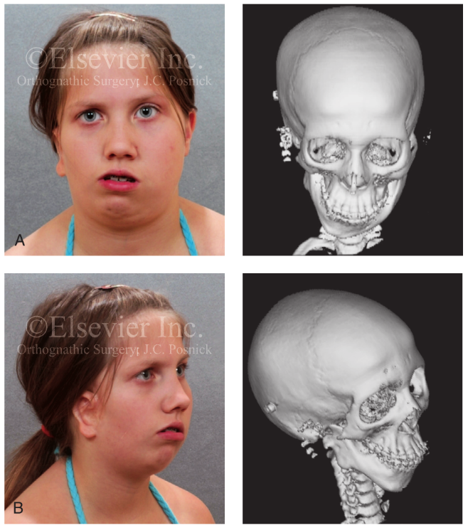
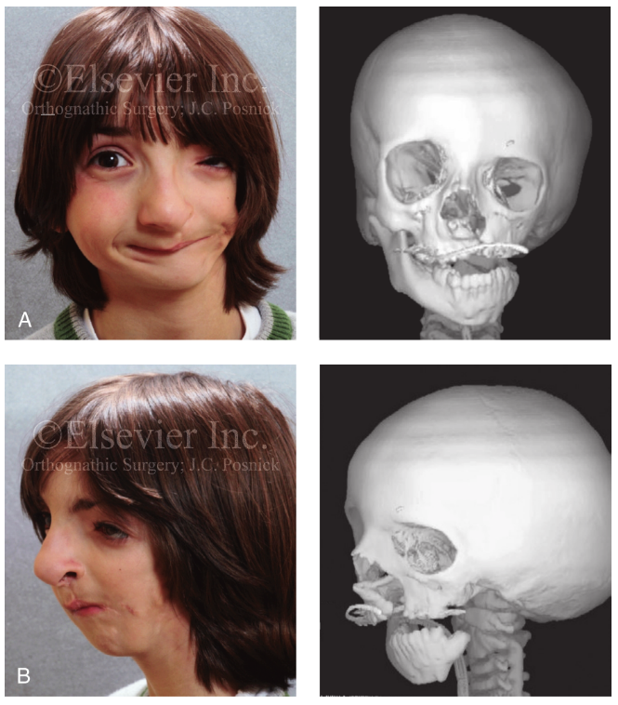
Fig 8.5: A 14-Year-Old Female With External Auditory Canal Absence And Right-Sided Hemifacial Microsomia, Including Microtia.
Fig 8.4: 9-Year-Old Kid Who Was Born With Unilateral Cleft Lip And Palate And Left-Sided Hemifacial Microsomia.

Facial Soft Tissues
Clinically speaking, the external ear, eyelid-adnexal structures, preauricular-cheek-lip soft tissues, and temporal fossa are the four anatomical areas of the head and neck that are thought to be affected by the soft-tissue abnormalities linked to HFM. The majority of the cutaneous and subcutaneous tissue, the volume of fat, the muscles of mastication and facial expression, the cranial nerves, and the parotid and submandibular glands are among the soft tissues within each area that may be lacking or dysmorphic. According to Kane and colleagues' research, the degree of hypoplasia in particular mastication muscles in individuals with HFM typically predicts the degree of dysplasia in the osseous origin and insertion of those muscles.^{[13]}
The coronoid process will be lacking if the temporalis muscle is hypoplastic. The gonial area of the jaw will be lacking if the masseter muscle is hypoplastic. The condylar head is missing or nonexistent when the lateral pterygoid muscle is gone. Soft tissue thickness and skin surface area in the preauricular-cheek region are typically correlated with skeletal deficits. Little remnants of epithelial tissue known as skin tags are often located near the breach between the first and second arches. Little cartilaginous residues that are present in the subcutaneous tissue are usually linked to skin tags. If the sinus passages are blocked, inclusion cysts may develop or an infection may develop. ^{[14]}
Macrostomia: Clefting or failure of the first branchial arch and the maxillary and mandibular processes to fuse are referred to as macrostomia. This causes a cleft to form directly through the oral commissure, separating the orbicularis oris muscle from the surrounding skin and mucosa. ^{[15]}
Also possible are anophthalmia and microphthalmia. Colobomata of the iris or eyelids are frequently found without eyelashes. Ptosis of the upper eyelid, caused by dysfunction of the levator palpebral muscle, is frequently observed together with constriction of the vertical palpebral fissure. It is typical to have lateral canthi deficiencies with a narrowed horizontal fissure. The majority of patients have epibulbar dermoid cysts, which are solid, yellowish or pinkish-white, ovoid masses that can range in size from the size of a pinhead to 8 to 10 mm in diameter. The inferotemporal region of the limbus is where cysts are most frequently seen. It often has a smooth surface and many fine hairs. ^{[16]}
These cysts may be mobile or attached to the dermis, and they can develop anywhere on the planet or in the orbit. Several lesions may develop in each eye, and most individuals experience unilateral epibulbar dermoid cysts. On rare occasions, encroachment on the pupillary axis or lipid infiltration of the cornea might impair vision. The external ear frequently exhibits abnormalities, which can vary from anotia to a moderately dysmorphic ear. Inability to show a connection between the degree of microtia and the severity of skeletal deformity was a problem for Farkas and James.
The External Auditory Canal, the Middle- and Inner-Ear Structures, and Audiologic Findings
Patients with modest external ear deformities often have a small external auditory canal, although atretic canals are anticipated in more severe instances. On occasion, a little external ear with a typical middle-ear structure is visible. The kind of hearing loss will be determined by audiometry; 15% of patients will likely have conductive loss and, less commonly, sensorineural loss. It's possible for the ossicles to hypoplasia or agenize. In a thorough investigation, 57 individuals with hemifacial microsomia were assessed using air and bone conduction audiometry and temporal bone tomography. The authors were unable to link hearing function to the severity of auricular (external ear) malformation. The best method for documenting the anatomy of the middle ear is focused temporal bone CT scanning. ^{[17]}
Maxillomandibular Region
The first and second branchial arches' skeletal structures will experience varying degrees of hypoplasia. As a result, the damaged side's anteroposterior, transverse, and vertical dimensions are reduced, and the opposite side develops secondary abnormalities. Particularly in the maxillomandibular area.
Cranio–Orbito–Zygomatic Region
It is common to discover the zygomatic complex to have varying degrees of hypoplasia. Clinical manifestations of zygomatic hypoplasia include orbital dystopia, maxillary hypoplasia, glenoid fossa deficiency, and squamous aspect of the temporal bone deficit. A three-dimensional reconstruction of a craniofacial CT scan is the most effective way to see this. The asymmetry of the malformation makes it challenging to pinpoint constant, repeatable markers in the upper face. As a result, quantifying the skeletal deformity is challenging and inaccurate.
STAGING OF SKELETAL RECONSTRUCTION: TIMING AND TECHNIQUES
The patient's face rehabilitation should focus on the specific and distinctive aspects of the HFM, which may include the following: the external ear, the auditory canal, the zygomatic and orbital areas, the maxillomandibular regions, the facial soft tissues, and the middle ear structures.
Zygomatic and Orbital Reconstruction

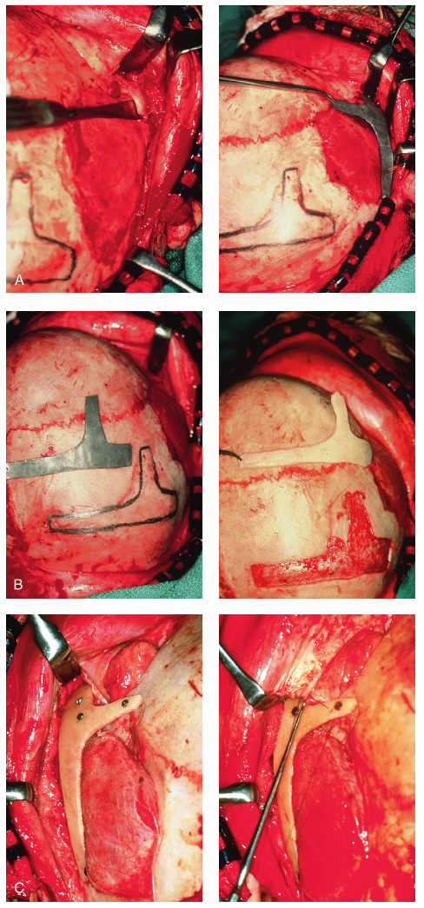
According to this source, unless a functional handicap calls for it, repair of the cranial vault, malar, and orbital defects before the age of seven is not recommended. The cranio-orbito-zygomatic skeletal development is nearly complete by the time the patient reaches this age. When necessary, an adult-sized anterior cranial vault, orbit, and zygomatic complex may be built and matched with the opposite normal side with minimal consideration for how further growing may change the findings obtained. Because bicortical cranial bone makes it easier to divide the inner and outer tables for effective reconstruction after the age of 7, donor site skull reconstruction is likewise simpler after that age than it is in younger children. The posterior skull's graft donor site may also be rebuilt using artificial bone material. Several techniques and timeframes for reconstructing the upper face skeletal abnormalities caused by HFM have been suggested by other surgeons. Posnick and colleagues verified that full-thickness autogenous cranial bone creation of the entire zygomatic complex preserves volume and form better than onlay grafts, which had proven universally unsatisfactory. Onlay autogenous bone grafts from all attempted donor sites (e.g., skull, hip, rib) that have been implanted in the craniofacial area (e.g., supraorbital ridge, zygoma, anterior maxilla, angle of mandible, chin) over time have shown considerable and unexpected resorption. Also, it shouldn't be anticipated that the graft would develop or expand in volume at a rate that corresponds to that of the underlying bone, such as the zygoma. Others argue that even if the onlay graft partially resorbs, at least something has been accomplished. This viewpoint, however, has to be rejected since surface imperfections generate secondary deformities that worsen the initial deformity.
Fig 8.6: A 7-year-old child's intraoperative images illustrate the zygomatic-orbital reconstructive method covered in this chapter.
Maxillomandibular Reconstruction
Understanding the presenting TMJ-mandibular anatomy is crucial when deciding on the when and technique for maxillomandibular reconstruction. The TMJ-lower jaw deformation categorization, discussed previously, is applicable and improves conveing. The fundamental maxillomandibular skeletal asymmetry and dysmorphology that needs repair in the patient with HFM and either a Type I or Type IIA malformation include the following: Reduced posterior facial height on the ipsilateral side is indicative of
1) degrees of changed facial height.
2) lessened horizontal projection.
3) decreased facial breadth.
This deformity frequently lead to canting (or roll) of the pyriform apertures, the upper jaw, and the angles of mandible; shifting (or yaw) of the midlines of jaw away from the midline of the face; clockwise rotation (or pitch) of the occlusal plane; and an asymmetric class II malocclusion frequently with an anterior open-bite malocclusion. (18) A patient who has a Category IIB deformity needs to have a neocondyle built, in accordance with the categorization system given. Moreover, the creation of a neo-glenoid fossa is required for the person who additionally has a Type III deformity. Individuals undergoing conclusive reconstructive interventions targeting the maxillary, mandibular, and chin domains subsequent to the attainment of jaw maturation, typically around 13 to 15 years of age in the context of HFM patients, commonly experience optimal, enduring enhancements in functional aspects such as speech articulation, swallowing, mastication, and respiration, alongside noticeable ameliorations in facial esthetics. This should be done in conjunction with efficient orthodontic treatment after the permanent teeth have erupted and before the patient graduates. Similar with other dentofacial abnormalities, extractions may be necessary to correct the inclination of the anterior teeth and to reduce orthodontic dental root crowding in order to prepare the jaws for surgical relocation.
The optimal time to restore type I and type IIA mandibular abnormalities is when all permanent teeth have erupted and orthodontic objectives have been met. Sagittal split ramus osteotomies of the mandible, together with Le Fort I osteotomies (typically performed in segments), and osseous genioplasty, can be used to achieve surgical goals. This combination uses conventional methods and does not call for bone transplants. By orthognathic operations, mirrorimage symmetry and Euclidian proportions of the skeleton must be roughly approximated for the reconstruction to be successful. Notwithstanding its drawbacks, this surgeon continues to favour costochondral graft restoration of the defective condyle ascending ramus at the time of skeletal maturity for Type IIB mandibular deformities (see the section to follow concerning condylar reconstruction with the use of costochondral graft). On the opposite side, a sagittal split ramus osteotomy is finished in order to derotate the distal mandible. This is paired with an osseous genioplasty and a Le Fort I osteotomy (typically performed in parts). To prevent relocation of the distal mandible, the contralateral side of the jaw must first have a ramus osteotomy. To achieve the desired lower jaw reorientation, the distal mandible is then fixed to the maxilla using intermaxillary fixation with a specially made acrylic splint. Before moving the distal mandible, the ipsilateral coronoid process may need to be removed. After that, biocritical screws are used to tightly anchor the contralateral ramus osteotomy. The autogenous costochondral transplant is used to repair the ipsilateral proximal mandible. The finest shape for mandibular repair comes from harvesting the costal graft from the opposing chest wall. A titanium miniplate and 2.0-mm or 2.3-mm screws are used to secure the rib transplant to the natural distal mandible.
The fixation plate runs along the inferior border of the mandibular body from the graft onward (fig. 7). Before attaching the graft, it is typically essential to recontour (with a bur on a rotary drill) the distal mandible's outer cortex. A Risdon neck incision made outside of the mouth is frequently used for graft implantation and fixation. With this treatment, avoiding intraoral incisions in the ipsilateral mandibular ramus area may reduce the risk of infection. Successful reconstruction depends on the neocondyle being properly seated in the glenoid fossa. Depending on the severity of the underlying soft-tissue and skeletal deficiencies, some patients may benefit more from a vascularized fibula composite flap than from a costochondral transplant.
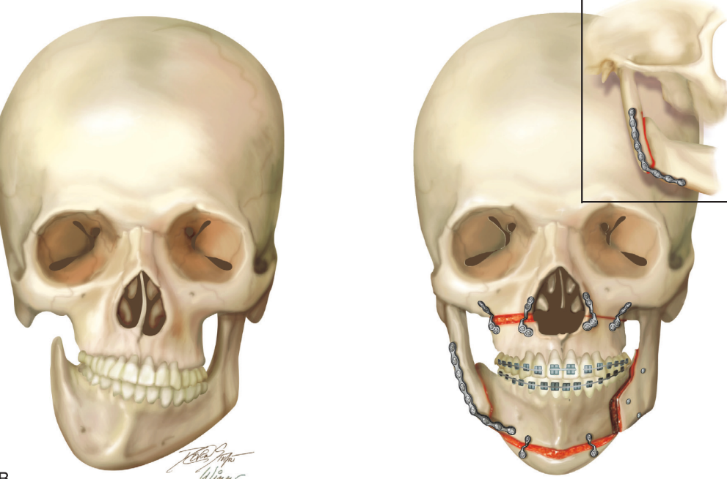
The surgical reconstruction of the congenitally absent portions is necessary for the Type III glenoid fossa-mandibular deformity. With the Type IIB deformity, the mandibular repair is often performed as previously described. The zygomatic complex will need to be constructed whenever the glenoid fossa does (i.e., when there is a Type III deformity). Prior to embarking on mandibular reconstruction, specifically when the patient has attained a minimum age of 7 years (as detailed in the preceding section encompassing orbito-zygomatic reconstruction), it is judicious to conduct distinct procedures for glenoid fossa-zygoma and orbital reconstruction. In the realm of mandibular reconstruction, opting for a vascularized fibula composite flap proves more beneficial than resorting to a costochondral graft. This preference is rooted in its ability to address deficiencies not only within the condyle-ascending ramus complex but also in the adjoining soft tissue framework.
Fig 8.7: skeletal abnormalities, as well as the reconstruction that was performed
Facial Soft-Tissue Reconstruction
Several well-intentioned surgical attempts have been made to treat the soft-tissue deficits of the eyelid adnexal areas in HFM patients. The translation of a pedicled upper eyelid skin-muscle flap to the atrophic area of the lower eyelid is not technically challenging, but the adnexal scarring that ensues inevitably gives the surgery a surgical appearance that usually overshadows any benefits. For this reason, even modest eyelid surgical treatments for the kid with HFM may benefit from the patient and family consulting a skilled paediatric oculoplastic surgeon. Based on ocular function and eyelid aesthetics, decisions on removing epibulbar or bulbar dermoid cysts from the adnexal area are made. In a patient with HFM, the inferior displacement of the lateral canthus is a reflection of both orbital dystopia and hypoplasia of the lateral canthi and other eyelid structural components. Osteotomies, bone grafting, and direct lateral canthopexy completion are useful and need to be performed when necessary, although these treatments won't completely reverse hypoplasia of the lateral canthal complex. When the temporoparietal fascia, the temporalis muscle, and the squamous component of the temporal bone all exhibit multilevel hypoplasia, there is a clinically apparent hollowing of the temporal fossa in the HFM patient. Local pericranial or temporoparietal flap attempts to replace the soft-tissue deficit are typically unsuccessful since these tissues constitute a component of the shortfall. The temporoparietal fascia and the temporalis muscle are these flaps, and their inherent hypoplasia explains why they are only marginally useful for adnexal area subcutaneous augmentation.^{[19]}
In order to enhance the bulk of the soft tissues (i.e., the skin, subcutaneous tissue, and muscle), proponents of the DO approach for mandibular reconstruction in patients with HFM had hoped. Unfortunately, clinical trials have not shown evidence of this hoped-for benefit. The fact that good skeletal reconstruction, regardless of the method, will positively affect the soft-tissue envelope's aesthetics while without directly increasing the volume of the soft tissues, is crucial. ^{[20]}
Dermal fat grafts, autologous fat injections, and other soft-tissue augmentation techniques are becoming more and more common. Although the outcomes of autogenous fat injection might vary and are thought to be technique-dependent, they are often positive and definitely beneficial. Tanna and associates looked at the use of repeated autologous fat grafts to improve soft-tissue shape in HFM patients. The microvascular free-flap group had a face symmetry score of 121% at the final evaluation, whereas the fatgrafting group received a score of 99%. Additionally, neither the patient nor the doctor reported any statistically significant differences in the overall satisfaction ratings between the microvascular and fat graft groups. ^{[21]}
External Ear Reconstruction
A phased approach can be successfully used for surgical reconstruction of the external ear in the hands of a select group of specialists. The techniques Brent outlined remain the gold standard for auricular reconstruction. 10-15 The basis for an effective auricle repair is the installation of a well-sculpted autogenous cartilage structure. As most children's rib cartilage is sufficient for the restoration by the time they are at least 6 years old, Brent likes to wait till that time. The substantial cartilage block needed to create the ear's structure will then be found in the synchondrotic area of the sixth and seventh ribs. ^{[22,23,24]} The position and size of the ear are selected, and a tiny preauricular incision is created using a prefabricated template of the contralateral ear and measurements of the face taken prior to surgery. The detachment of the ear with a skin graft, hairline management, and tragus building are additional phases of auricular construction. Alloplastic and homologous frameworks are further choices for external ear restoration. Currently used alloplastic materials include silicone and medpor (Porex Surgical, Inc, College Park, Ga). Even decades after repair, these alien substances are more prone to infection, soft tissue wound dehiscence, and mild trauma. Bovine cartilage cells can be produced in the lab and seeded on a synthetic, biodegradable ear template that is then implanted beneath the skin of an immunocompetent mouse as part of tissue engineering techniques that are still being evaluated. Regrettably, sculpted autogenous rib cartilage will continue to be the material of choice for the surgical restoration of the ear until tissue engineering advances past the currently encountered immunogenic issues.^{[25]}
A determination must be made regarding the ultimate goal of middle ear surgery prior to concluding microtia repair. Every middle-ear surgery should be followed by auricular construction because, once an atretic ear canal is opened, scarring of the soft-tissue envelope significantly reduces the likelihood of a successful auricular reconstruction. Moreover, the requirement for condyle-ascending ramus restoration should be taken into account (i.e. Type IIB and Type III malformations). The location of each donor site becomes even more crucial if CCJ/rib graft harvesting is also necessary.
External Auditory Canal and Middle-Ear Reconstruction
Neurosensory hearing loss may occasionally be present in patients with HFM, however most hearing loss is caused by external auditory canal stenosis or atresia, middle ear cavity hypoplasia, or ankylotic or absent ossicles. Hearing conduction is restricted to the same degree if ankylotic or non-functioning ossicles were absent. For HFM patients, efforts to restore the middle ear's bones and the external auditory canal are often not made. Clinical issues often solely concern the patient's ability to pinpoint the source of the sound as long as adequate hearing is available in the contralateral ear. The majority of patients experience persistent conductive hearing loss as a result of efforts to restore middle-ear function, making "stereo" hearing uncommon.^{[26]}
Most cases of hemifacial microsomia are random and lack a family trend. Variable deficits of the skeletal and soft-tissue components inside the first and second branchial arches, particularly on one side, are its defining features. Airway, eating, hearing, vision, and the need for psychological family support are all things that are taken into account during infancy and the early years of childhood. The level of deformity in the patient with HFM at birth is thought to be comparatively constant and nonprogressive with age.^{[27]}
Nowadays, the reconstruction is staged to correspond with face growth patterns, visceral functions, and psychosocial development in order to repair the abnormalities linked to HFM. The goals of each stage and manner of therapy are made clear to the physicians and the family by a detailed morphologic study of each patient's abnormalities followed by a comprehensive reconstructive plan. We will enhance the outlook for those who are impacted by HFM as we continue to outline our justification for the timing, strategies, and scope of therapies before objectively assessing the functional, morphologic, and psychosocial results.^{[28]}

REFERENCES:
- Arystas M, Shprintzen RJ: Craniofacial morphology in Treacher Collins syndrome. Cleft Palate Craniofac J 28:226, 1991.
- Baas EM, Horsthuis RBG, Lange JD: Subjective alveolar nerve function after bilateral sagittal split osteotomy
- Beaune L, Forrest CR: Adolescents’ perspectives on living and growing up with Treacher Collins syndrome: A qualitative study. Cleft Palate Craniofac J 41:343, 2004.
- Brent B: Auricular repair using autogenous rib cartilage grafts: Two decades of experience with 600 cases. Plast Reconstr Surg 90:355, 1992.
- Kaban LB, Moses ML, Mulliken JB: Surgical correction of hemifacial microsomia in the growing child. Plast Reconstr Surg 82:9, 1980.
- Kaban LB, Seldin EB, Kikinis R, et al: Clinical application of curvilinear distraction osteogenesis for correction of mandibular deformities. J Oral Maxillofac Surg 67:996–1008, 2009.
- Jahrsdoerfer RA, Aquilar EA, Yeakley JW, et al: Treacher Collins syndrome: An otologic challenge. Ann Otol Rhinol Laryngol 98:807, 1989.
- James D, Ma L: Mandibular reconstruction in children with obstructive sleep apnea due to micrognathia. Plast Reconstr Surg 100:1131, 1997.
- Janssen RM, Hong P, Chadha NK: Bilateral bone-anchored hearing aids for bilateral permanent conductive hearing loss: a systematic review. Otolaryngol Head Neck Surg 147:412–422, 2012.
- Poswillo DE: Otomandibular deformity: pathogenesis as a guide to reconstruction. J Maxillofac Surg 2:64, 1974.
- Poswillo DE: The pathogenesis of the Treacher Collins syndrome (mandibulofacial dysostosis). Br J Oral Surg 13:1, 1975.
- Pron G, Galloway C, Armstrong D, Posnick JC: Ear malformation and hearing loss in patients with Treacher Collins syndrome. Cleft Palate Craniofac J 30:97–103, 1993.
- Altug-Atac AT, Grayson BH, McCarthy JG: Comparison of skeletal and soft tissue changes following unilateral mandibular distraction osteogenesis. Plast Reconstr Surg 121:1751, 2008.
- Anderson PJ, McLean NR, David DJ: Modified costochondral graft osteotomy in hemifacial microsomia. Br J Plast Surg 56(4):414–415, 2003.
- Aoe T, Kohchi T, Mizuguchi T: Respiratory induced cyanosis plethysmography and pulse oximeter in the assessment of upper airway patency in a child with Goldenhar syndrome. Can J Anesth 37:369, 1990.
- 4. Baas EM, Horsthuis RBG, Lange JD: Subjective alveolar nerve function after bilateral sagittal split osteotomy or distraction osteogenesis of mandible. J Oral Maxillofac Surg 70:910–918, 2012.
- Baek SH, Kim S: The determinants of successful distraction osteogenesis of the mandible in hemifacial microsomia from longitudinal results. J Craniofac Surg 16(4):549–558, 2005.
- Batra P, Ryan FS, Witherow H, Calvert ML: Long-term results of mandibular distraction. J Indian Soc Pedod Prev Dent 24:30, 2006.
- Beichman K: Response of muscles to altered skeletal morphology and functional rehabilitation of severely malformed mandibles in hemifacial microsomia [thesis], San Francisco, Calif, 1990, University of California School of Dentistry.
- Bennun RD, Mulliken JB, Kaban LB, Murray JE: Microtia: A microform of hemifacial microsomia. Plast Reconstr Surg 76(6):859–865, 1985.
- Bergmann C, Zerres K, Peschgens T, et al: Overlap between VACTERL and hemifacial microsomia illustrating a spectrum of malformations seen in axial mesodermal dysplasia complex (AMDC). Am J Med Genet A 121A(2):151–155, 2003.
- Brent B: The correction of microtia with autogenous cartilage grafts: I. The classic deformity. Plast Reconstr Surg 66:11, 1980.
- Brent B: The correction of microtia with autogenous cartilage grafts: II. Typical and complex deformities. Plast Reconstr Surg 66:13, 1980.
- Brent B: Auricular repair using autogenous rib cartilage grafts: Two decades of experience with 600 cases. Plast Reconstr Surg 90:355, 1992.
- Brent B: Advances in ear reconstruction with autogenous rib cartilage grafts: Personal experience with 1200 cases. Plast Reconstr Surg 104:319; 1999.
- Brent B: The team approach to treating the microtia atresia patient. Otolaryngol Clin North Am 33:1353, 2000.
- Brent B: Microtia repair with rib cartilage grafts: a review of personal experience with 1000 cases. Clin Plast Surg 29:257, 2002.
- Burstein FD, Cohen SR, Scott PH, et al: Surgical therapy for severe refractory sleep apnea in infants and children: Application of the airway zone concept. Plast Reconstr Surg 96:34, 1995.

