ECO DESIGN: WHERE CREATIVITY MEETS CONSERVATION
Kalpana Jha, UG Scholar, Department of Botany,
Gargi College, University of Delhi
7439907332, kalpanaj296@gmail.com

ABSTRACT
Eco design, a transformative approach that integrates creativity with conservation, has gained prominence in response to increasing environmental concerns. The concept was pioneered by historical figures such as van der Ryn, Cowan, McDonough, and Braungart and gained popularity in the early 21st century. This chapter explores eco design's significance, guiding principles and real-world examples such as green roofs, Adidas Parley etc. Further, the chapter presents a brief overview about the hurdles encountered by Companies and individuals during implementation of eco-design models followed by the regulations and policies like green incentives involved in encouraging eco-design.

Keywords: Ecological Design, Zero Energy Buildings, Slow Fashion, Extended Producer Responsibility (EPR), Circular Economy

I. INTRODUCTION:
Environmental concerns have taken the centre stage in the current era. With an increasing awareness about the planet’s wellbeing, eco design stands out as an innovative approach. Ecodesign or ecological design is the method of designing products and services while taking care of the environmental impacts of that product over its entire lifecycle. It takes into account all the phases in the manufacture of a product right from choosing the correct raw material to the process of production, transportation and even its disposal. Hence, it is a holistic approach that seeks to prioritise sustainability, efficiency, environmental responsibility and maximise planetary wellbeing. This chapter delves into the historical evolution of ecodesign, explores its guiding principles, presents real-world examples, examines its role in shaping policies, addresses challenges, and discusses the crucial element of awareness in driving its adoption.

II. HISTORICAL BACKGROUND:
The term "ecological design" was introduced in a 1996 publication by Sim van der Ryn and Stewart Cowan. In this work, the authors explained the merging of human actions with natural systems, aiming to mitigate harmful effects on the environment. Following this, William McDonough and Michael Braungart presented their manifesto, "From Cradle to Cradle," in 2002. This book suggested the adoption of a circular economic model as a replacement for the traditional linear approach of "cradle to grave." The book inspired production models which were implemented by a number of companies, organisations, and governments across the globe, and has also become a registered trademark and a product certification [1].

III. RELEVANCE OF ECODESIGN
“There's something wrong about a society that uses 7,500 litres of water — the amount drunk by a person in seven years — to manufacture a pair of jeans.” This fact, published by the UN in 2019, is the tip of an iceberg that needs solutions like eco-design. Designing using sustainable materials ensures that products within the circular economy retain their viability for new purposes at the end of their primary usage, in contrast to the conventional 'linear' economy characterised by purchase, use, and disposal. Adopting eco design can offer a large number of benefits and advantages, such as environmental conservation, resource efficiency, waste reduction, reduced overall cost due to increased efficiency and less waste management costs, innovative and competitive advantage, and opportunity to grow in the market by catering to the needs of environmentally conscious consumers (Fig. 1). Ecodesign reflects a sense of global responsibility, acknowledging that decisions made by every single individual can have far-reaching consequences.

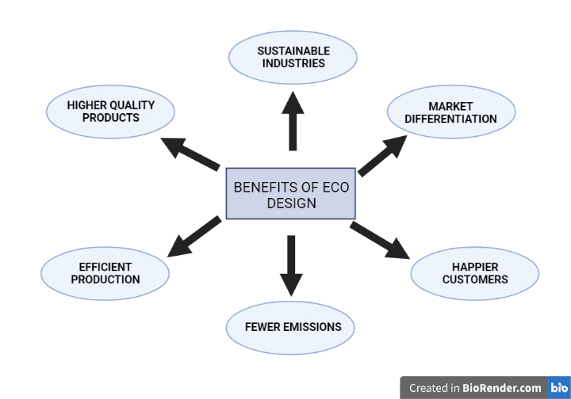

Figure 1. Benefits of Ecodesign. (Source: made using Biorender.com)

IV. PRINCIPLES OF ECODESIGN
The principles of ecodesign revolve around creating products, systems, and environments that prioritise sustainability, efficiency, and minimal environmental impact. These principles guide designers and innovators in integrating eco-conscious practices into their work (Fig. 2):
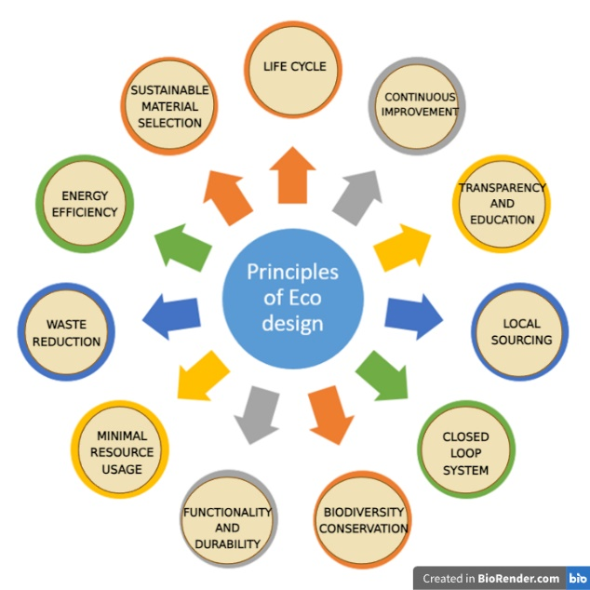

Figure 2. Principles of ecodesign (Source: Made using Biorender.com)

A. Life Cycle:
Ecodesign considers the entire life cycle of a product, right from raw material extraction and production to use, maintenance, disposal and even logistics and distribution, as William McDonough and Michael Braungar named it, “From Cradle to Grave”. This approach acknowledges that a product's impact on the environment is not limited to its immediate use but extends across its entire life cycle. It aims to minimise the overall environmental footprint by regulating every phase. A study carried out by Rocio Lopez et. al[2] quantified the environmental effects associated with the life cycle of an enzymatic multipurpose cleaner. The study employed life cycle assessment (LCA) methodology with primary data and established a functional unit of 1 kg of detergent in its container for future comparisons. Environmental impacts were categorised into upstream, core, and downstream phases, with seven impact categories assessed. Notably, the degreaser 3-butoxy-2-propanol exerted the greatest environmental load during the upstream phase. In the core phase, electricity, natural gas, and raw material transportation contributed significantly. Downstream, road transport is the key contributor in six out of seven categories. Calculating a cradle-to-grave boundary, the cleaner resulted in a CO2-equivalent footprint of 0.76 kg per kg of packaged detergent, primarily influenced by energy consumption and transportation. The study proposed five Eco designed scenarios to mitigate the cleaner's environmental footprint, with larger packaging and railway transportation demonstrating the most effective impact reduction.

B. Sustainable Material Selection:
Choosing the correct raw material is one of the most crucial steps in ecodesign. Ecodesign emphasises choosing materials with lesser environmental impact and carbon footprint thus favouring renewable, recycled, or biodegradable materials over resource-intensive alternatives. If the materials can be recycled, it is important to assess what recycling facilities are available, and if the material can be clearly marked to help people recycle it [3].
C. Energy Efficiency:
Designers strive to choose the right technology and energy sources to reduce energy consumption during production, use, and disposal. This can involve incorporating energy-efficient technologies, optimising processes, employing renewable energy sources, incorporating smart technologies that manage energy usage intelligently and minimise energy wastage. By prioritising energy efficiency, eco design reduces greenhouse gas emissions and conserves natural resources.
D. Waste Reduction:
Ecodesign seeks to minimise waste generation through practices such as designing for disassembly, enabling recycling, and promoting the circular economy. Design for Disassembly (DFD) concept not only reduces transportation costs for the companies but also aids in easy disassembly, recycling and efficient reuse. Additionally, practices such as designing with the circular economy in mind, where materials are reused and repurposed, play a crucial role in waste reduction [4]. By addressing waste at every stage – from material selection and production to use and end-of-life management – eco design contributes to a more sustainable and efficient approach to manufacturing, fostering a culture of mindful consumption and responsible waste handling [3].
E. Minimal Resource Consumption:
The aim is to reduce the consumption of water, raw materials, and other resources by optimising product design, manufacturing processes, and user behaviour [3].
F. Functionality and Durability:
Ecodesign prioritises creating products that are functional, reliable, and durable. This reduces the need for frequent replacements and conserves resources in the long run. According to a report published by Environmental Coalition on Standards (ECOS, an international NGO) in April 2021 [5], which says “use for longer to protect the planet”, applying material efficiency aspects to textiles can benefit the environment. Mainly, increasing the longevity of textiles allows for prolonged usage and reuse of products. The specialists from the UK-based nonprofit organisation WRAP emphasise that creating resilient textile products represents the most significant potential for reducing environmental effects associated with greenhouse gas emissions, water usage and the generation of textile waste. Moreover, research conducted by WRAP highlights that:
- Prolonging the lifespan of clothing by an additional nine months can result in a reduction of carbon emissions, water usage, and waste footprint by 20 to 30%. (Table 1)
- A 5% reduction in new garment production achieved through prolonging first-use duration, reusing, and repair efforts would yield environmental benefits equivalent to mitigating 20 tonnes of greenhouse gas emissions.
- Doubling the number of times, a garment is worn could lead to approximately 44% fewer greenhouse gas emissions compared to producing a new garment. (Fig. 3)
- Additionally, improved material efficiency contributes to lowering textile waste volume and its disposal in landfills.

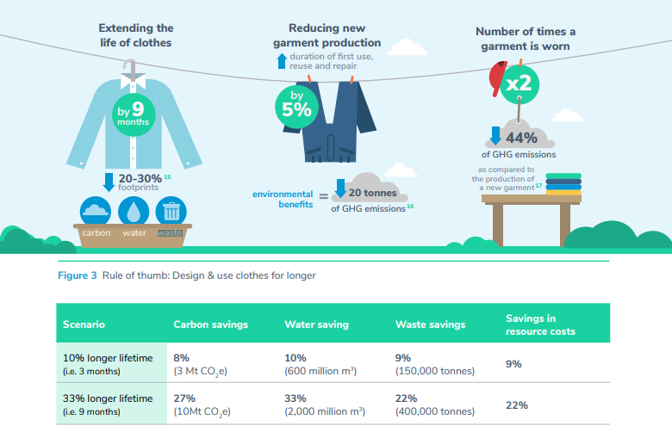
Figure 3. Design and use clothes for longer. (Source: ECOS)

Table 1. Using clothes for a longer time could potentially reduce our footprint and prompt savings in resource costs. (Source: WRAP) [6]

In essence, products with enhanced durability and lifespans generally offer superior environmental advantages compared to recycling practices [7].

G. Biodiversity and Ecosystem Consideration:
Ecodesign takes into account the impact of products on ecosystems and biodiversity, promoting practices that safeguard natural habitats and species. This involves using sustainable materials to prevent resource depletion, minimizing pollution and toxic substances to protect aquatic and terrestrial environments, and ensuring that manufacturing processes do not lead to habitat destruction. Ecodesign also encourages incorporating elements that enhance local biodiversity or minimizing disruption to surrounding ecosystems. Ultimately, by integrating biodiversity and ecosystem considerations, ecodesign not only ensures the protection of natural ecosystems but also contributes to the overall health of the planet and its inhabitants [8].

H. Closed-Loop Systems:
Ecodesign promotes closed-loop systems where waste from one process becomes a resource for another. It is mainly about reusing what we already have, upcycling, and devising ways to keep our belongings in circulation.This contributes to resource efficiency and reduces environmental impact [9].
I. Local Sourcing:
Whenever and wherever possible, designers opt for locally sourced materials and manufacturing processes to minimise transportation-related emissions and support local economies. It also leads to a deeper understanding of the environmental and social conditions of the region where materials are obtained. Additionally, local sourcing provides a number of benefits to the business such as greater control and flexibility, more revenue and faster product launch [10].
J. Transparency and Education:
Transparency is encouraged by disclosing information and communicating the environmental impact of products to consumers, empowering them to make informed choices. It involves describing where the materials are sourced, whether they're recycled, sustainable, or responsibly harvested, and their associated impact on ecosystems. It also explains to the users how to use and dispose off the product properly such that there is minimum damage to the environment [8].
K. Continuous Improvement:
Sustainability goals can change with time. Ecodesign is a dynamic process that involves continuous evaluation and improvement to adapt to changing technological advancements and sustainability goals [11].

By adhering to these principles, ecodesign creates a framework for responsible innovation that considers the well-being of the planet and its inhabitants while nurturing innovation

V. ECO DESIGN IN REAL WORLD:

A. Green Roofs:
Green roofs, also known as eco roofs are rooftops with a growing layer of vegetation. They consist of a vegetation layer, followed by a growing medium, drainage layer and a waterproofing layer at the base. They absorb rainwater, reducing stormwater runoff and decreasing the burden on urban drainage systems. Green roofs provide insulation, reducing heating and cooling costs. They mitigate the urban heat island effect by absorbing heat and releasing it gradually, helping to regulate temperatures [12]. Green roof temperatures can be 30–40°F lower than those of conventional roofs and can reduce city-wide ambient temperatures by up to 5°F. The vegetation and growing medium on green roofs absorb sound, making them particularly effective in reducing noise pollution in urban areas. Moreover, green roofs are aesthetically pleasing as well as environmentally beneficial [13].
B. Adidas Parley:
The Adidas Parley collection is a collaboration between Adidas and Parley for the Oceans, an organisation that works to combat pollution of ocean waters due to plastics. They launched their first collection in 2015. (Fig 4.) Through this partnership, Adidas creates products using recycled plastic waste collected from beaches and coastal communities. This innovative approach not only raises awareness about the critical issue of ocean pollution but also provides a tangible solution by transforming harmful plastics into high-performance sportswear and footwear. The Adidas Parley collection embodies the power of collaboration and design innovation in addressing environmental challenges while offering consumers an opportunity to contribute to a more sustainable future through their choices. Adidas developed Parley swimwear by utilising recycled plastic transformed into Econyl, a proprietary yarn fibre. Econyl is crafted from a minimum of 50% salvaged fishing nets and post-consumer carpets, providing the same attributes as conventional nylon typically employed in swimwear production. Moreover, 76% of the collection integrates recycled polyamide [14].

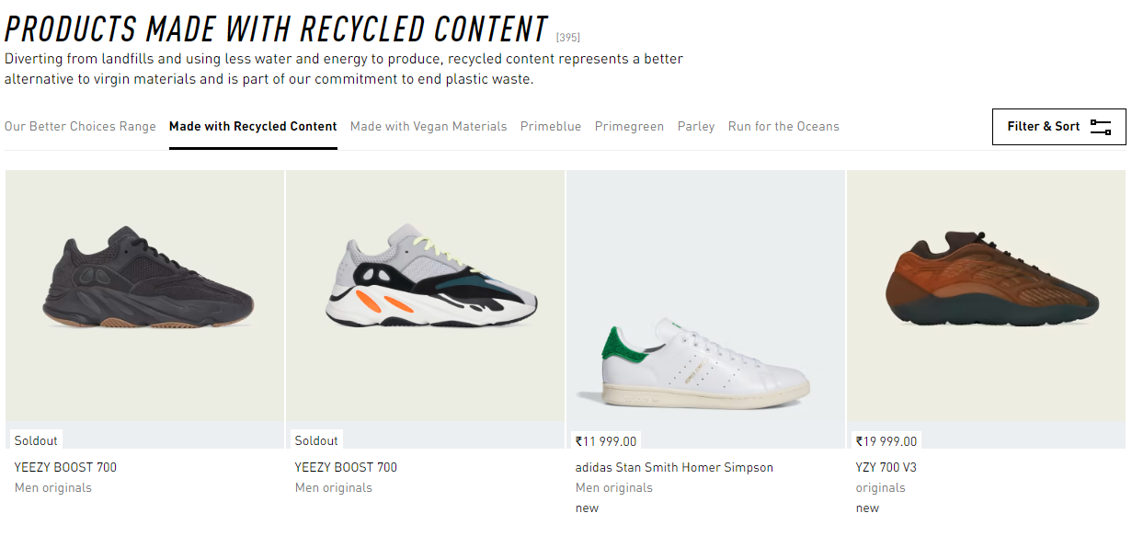
Figure 4. Adidas Parley Collection made with recycled ocean waste.
(Source: https://www.adidas.co.in/parley-shoes)

C. Zero Energy Buildings:
Most buildings today use a lot of energy- to keep the lights on, cool the air, heat water, and power personal devices. Even installing solar systems will not significantly counter the heavy energy load. There are, however, some buildings that strike a balance; or even tip the scales the other way. These are called zero energy buildings.[15] Zero energy buildings are designed in a way so as to have zero net energy consumption. Through features like efficient insulation, solar panels, and rainwater harvesting, they generate as much energy as they consume. Some structures based on this concept include:

- The Unisphere, Maryland, U.S.A:
It is the world’s largest office building that works on the concept of zero-energy. At the heart of the system are 52 geo-exchange wells, each drilled to a depth of 500 feet into the ground, which operate like heat pumps. These water-filled pipes extract warmth from the earth during winter to heat the building and subsequently transfer excess heat from the building into the ground during summer for cooling. Moreover, the majority of occupied spaces are generously illuminated by natural daylight. This ensures offices are supplied with 100% fresh outdoor air and natural lighting. During daylight hours, any surplus energy generated by the building's extensive systems, including nearly 3,000 solar panels, is redirected to the power grid. Conversely, in the evenings, minimal energy is drawn from the grid. Altogether, the Unisphere sells more power than it buys [16].

- National Renewable Energy Laboratory, Colorado, (NREL) U.S.A:
The structure incorporates various setups, including a 2.5-megawatt rooftop photovoltaic system and transpired solar collectors, producing an equal amount of energy to what the building consumes. Within NREL, innovative water conservation systems like dual-flush water closets, low-flow toilets, and roof drainage for garden irrigation are employed for easy maintenance and design. In essence, these environmentally conscious design measures not only set an example for achieving net-zero construction but also establish ecologically friendly practices [16].
- La Jolla Commons, San Diego, California:
The on-site fuel cells use methane for electricity conversion through a non-combustion process. Methane obtained from sources like landfills, wastewater plants, etc., serve as an inspirational solution for the industry to follow [16].
- Indira Paryavaran Bhawan, Ministry of Environment and Forest, New Delhi, India:
Built in 2014, this structure is the first of its kind in India. More than 50% of the outer area is covered with appropriate vegetation, 75% of build floor space uses daylight, thus reducing the need for artificial lighting sources. The structure employs methods to efficiently manage water consumption, such as reusing wastewater. Additionally, a geothermal heat exchange system, comprising 180 vertical boreholes reaching a depth of 80 metres across the building area, collaboratively generates 160TR of heat dissipation, supported by a cooling tower. The building design also integrates a chilled beam system and a photovoltaic system integrated into the architecture, contributing to its achievement of net-zero energy classification [16].
- Avasara Academy, Lavale, Pune, India:
The building roofs encompass solar panels that generate electricity for illuminating classrooms, dormitories, and faculty residences, along with powering ceiling fans. By utilising earth ducts, vertically integrated structural cavities, and solar chimneys to facilitate airflow within each section, the indoor temperature is reduced by 5-9̊C, providing natural ventilation throughout the campus [16].

D. SLOW FASHION
Fashion is a highly polluting industry, consuming vast amounts of raw materials, causing pollution, leaving a significant carbon footprint, and generating alarming levels of waste. The textile industry contributes to 17-20% of global industrial water pollution, and its waste water often contains dangerous dyes and chemicals. Synthetic fibres like polyester, rayon, and nylon have a slow decomposition rate, and microfibers make up 85% of human-made debris on ocean shorelines. The following pointers give an estimate about the Environmental Footprint of Fast Fashion [17].
- The equivalent of one garbage truck full of clothes is burned or dumped in a landfill every second (UNEP, 2018)
- Approximately 60% of all materials used by the fashion industry are made from plastic (UNEP, 2019)
- 500,000 tons of microfibers are released into the ocean each year from washing clothes — the equivalent of 50 billion plastic bottles. These microfibers contaminate the water thus posing a threat to aquatic life. Often, they end up in human food chains as well. (Ellen MacArthur Foundation, 2017)
- The fashion industry is responsible for 10% of humanity’s carbon emissions – more than all international flights and maritime shipping combined (UNEP, 2018). If the fashion sector continues on its current trajectory, that share of the carbon budget could jump to 26% by 2050 (Ellen MacArthur Foundation, 2017)
- Some 93 billion cubic metres of water – enough to meet the needs of five million people – is used by the fashion industry annually, contributing significantly to water scarcity in some regions (UNCTAD, 2020)
- Around 20% of industrial wastewater pollution worldwide originates from the fashion industry (WRI, 2017)
On the opposite end of the spectrum from the fast fashion model of production, Kate Fletcher (2007) founded the slow fashion movement by drawing inspiration from the “slow food” movement, which emphasises responsibility in food production and consumption.[18] Slow fashion, a healthier alternative to the fast-paced, disposable nature of conventional fashion, depicts a profound example of eco-design principles in practice. Rooted in sustainability, slow fashion emphasises on quality, durability, and ethical production processes. It stands in stark contrast to the prevalent "fast fashion" culture that encourages rapid consumption and frequent disposal of clothing. Slow fashion promotes responsible material choices, fair labour practices, and a reduced environmental footprint. Garments produced under this concept are often designed to be timeless and versatile, encouraging extended use and reducing the frequency of replacements. This intentional design strategy aligns with the eco-design principle of extending product life cycles, minimising waste, and conserving resources. However, the movement faces challenges due to limited availability and awareness from cheap, knock-off designs. To level the playing field, government policies, supply chain reorientation, and consumer engagement are necessary.

VI. CHALLENGES IN ECODESIGN:
Along with the promising benefits of ecodesign, there are an equal number of challenges faced by companies and individuals trying to implement it. In a case study by Dekoninck et. al. (2016), nine manufacturing companies from five different countries were sampled for challenges faced during implementation of sustainable designs. The study categorised the challenges into five classes: strategy, tools, collaboration, management, and knowledge. Out of these, management was found to be most abundantly mentioned by the companies, such as managing the intricate balance between ecodesign and other considerations such as costs, and resistance from internal stakeholders towards eco design initiatives. Additionally, challenges persisted at practical levels involving collaboration, tools, and knowledge. Internally, challenges encompassed tool integration (including Life Cycle Assessment or LCA), evolving tool requirements, internal communication, and disseminating essential internal knowledge and expertise for ecodesign [19].
Ecodesign often requires upfront investments that can yield long-term benefits. Convincing stakeholders to prioritise long-term sustainability over short-term profits can be challenging. Products designed with sustainability in mind may be perceived as less aesthetically appealing or less functional by consumers, impacting market acceptance. In another study (Bey et al., 2013) it was revealed that the main hindrance in implementation of ecodesign was lack of information on environmental impacts and lack of expert knowledge, and lack of allocated resources (manpower and time) [20].

VII. ECODESIGN AWARENESS
It refers to the level of understanding and recognition among individuals, businesses, and communities about the principles and benefits of ecodesign. As awareness grows, individuals and organisations become more conscious of the environmental consequences of their choices and actions. They actively seek information about ecodesign strategies, life cycle assessments, and sustainable alternatives. Ecodesign awareness encourages consumers to make eco-conscious purchasing decisions, prompts businesses to adopt greener practices, and fosters a general mindset of responsibility toward the environment. Promoting eco design awareness involves educational initiatives, social media campaigns, public campaigns, industry collaborations, and policy support [21].

VIII. REGULATIONS AND POLICIES DRIVING ECO DESIGN
Regulations and policies play a significant role in the implementation and progress of new concepts like eco design.
A. Mandatory Standards:
Many governments enforce mandatory standards that specify environmental criteria for product design, materials, energy efficiency, and emissions. These standards ensure that products meet certain eco-friendly benchmarks before they can enter the market.
B. Eco Labels and Certifications:
Eco Labelling schemes, like the Energy Star label or the EU Ecolabel and other certifications guide consumers towards products with lower environmental impacts. Again, these labels incentivize manufacturers to meet certain criteria for design, production, and performance [22].
C. Extended Producer Responsibility (EPR):
Another strategy is EPR policy. It is based on adding all the environmental expenses linked to a product over its entire lifecycle to the product's market price. This approach is primarily implemented in waste management contexts. Extended producer responsibility (EPR) regulations significantly propel the uptake of remanufacturing initiatives, as they emphasise managing consumer product disposal and aim to amplify product recovery while reducing waste material's environmental impact. Transferring accountability to producers as polluters is the most effective way to elevate environmental benchmarks within product design [23].
D. Green taxes and Incentives:
Additionally, Governments may offer tax incentives or subsidies to businesses that adopt eco design practices. These financial benefits motivate companies to invest in sustainable materials, processes, and technologies. These are also known as Green Incentives. In India, the government provides tax incentives for purchasing energy efficient appliances under the Bureau of Energy Efficiency Star rating program. There is exemption from registration fees, road tax and GST on electric vehicles. As per the 2019 Union Budget, the Indian Government is providing a tax relief for the acquisition of electric vehicles, valid for both electric cars and electric two-wheelers. The administration has introduced Income Tax Section 80 EEB, designed to offer tax benefits to purchasers of electric cars. This section grants electric vehicle buyers the privilege of tax exemption, allowing for up to Rs 1.5 lakh deduction on the loan sum [24].
E. Global Harmonization:
International agreements and standards, such as the Paris Agreement [25], a legally binding international treaty on climate change and the Basel Convention [26], foster global cooperation in promoting sustainable design practices.

IX. FUTURE OF ECODESIGN
The future of ecodesign holds exciting prospects as societies increasingly prioritise sustainability and environmental consciousness. Ecodesign will integrate diverse fields such as fashion [27], engineering, architecture [28], ecology, and social sciences. Collaborative efforts can lead to holistic solutions that consider environmental, economic, and social dimensions. Tools like artificial intelligence,[29] virtual reality, and data analytics may enhance the design process, enabling precise modelling and simulations for environmental impact assessment. The search for sustainable materials will intensify, leading to the development of innovative alternatives to conventional resources. Biomaterials, upcycled materials, and biodegradable substances will gain prominence. As sustainable practices become an important part of designing processes, the products and spaces of the future will reflect a commitment to a healthier planet and a more resilient future.

X. CONCLUSION
The thorough analysis of the guiding principles and real-life examples of Ecodesign confirm that in a world brimming with environmental challenges, ecodesign emerges as a potent force. It can act as a one stop solution to a plethora of problems like waste management, increasing carbon footprint, resource depletion, climate change and excessive energy consumption. Despite its benefits, ecodesign is not devoid of challenges, it has been found that businesses encounter challenges when attempting to alter conventional design methodologies and are often reluctant to allocate additional time and energy for sustainable strategies. However, suitable regulatory policies from concerned authorities can encourage industrialists as well as consumers to switch to ecodesign. In essence, ecodesign stands as an emblem of hope and transformation for a sustainable future.

REFERENCES:

[1] Lydia K., History of Ecological Design, Oxford Encyclopedia of Environmental Science. 2018.
DOI: https://doi.org/10.1093/acrefore/9780199389414.013.144
[2] Rocío L., Ortzi A, Blanca U., Maider I., Rikardo M., Erlantz L. Ecodesign coupled with Life Cycle Assessment to reduce the environmental impacts of an industrial enzymatic cleaner. Sustainable Production and Consumption. 2022, Volume 29, Page 718-729
DOI: https://doi.org/10.1016/j.spc.2021.11.016
[3] Ecodesign in product and service development: How to choose raw materials for Ecodesign?
Available from: https://www.nibusinessinfo.co.uk/content/how-choose-raw-materials-ecodesign#:~:text=Using%20fewer%20materials%20overall%20can,easier%20to%20recycle%20your%20products.
[4] Design for Disassembly in the Age of Circularity. Available from: https://www.3ds.com/sustainability/circular-economy/design-for-disassembly
[5] Valeria Bott, Ivo Cabral. Durable, repairable and mainstream: How ecodesign can make our textiles circular. ECOS. 2021.
https://ecostandard.org/wp-content/uploads/2021/04/ECOS-REPORT-HOW-ECODESIGN-CAN-MAKE-OUR-TEXTILES-CIRCULAR.pdf
[6] Tim Cooper, Hellen A., Julia K., Katherine T., Michelle H. Design for Longevity Guidance on increasing the active life of clothing. WRAP (Waste & Resources Action Programme). 2013.
https://www.researchgate.net/publication/313479112_Design_for_Longevity_Guidance_on_Increasing_the_Active_Life_of_Clothing
[7] Bjørn Bauer et al. Potential Ecodesign Requirements for Textiles and Furniture. Nordic Council of Ministers. 2018. DOI: https://doi.org/10.6027/TN2018-535
[8] Fan Shu-Yang, Bill F., Raymond C. Principles and practice of ecological design. Environmental Reviews. 2011. Volume 12(2): Pages 97-112. https://doi.org/10.1139/a04-005
[9] Amanda Winstead. How A Closed-Loop Economy Could Lead to a Sustainable Future. 2022.
Available from: https://www.unsustainablemagazine.com/closed-loop-economy-sustainability/
[10] Top Benefits of Local Sourcing. 2022 https://evanstd.com/blog/local-sourcing-benefits/
[11] Denis Noonan. Achieving sustainability objectives is a process of continuous improvement. Available from: https://greenomy.io/blog/sustainability-objectives
[12] Santamouris, M. “Cooling the cities – A review of reflective and green roof mitigation technologies to fight heat island and improve comfort in urban environments,” Solar Energy. 2014. Volume 103. Pages 682-703.
DOI: https://doi.org/10.1016/j.solener.2012.07.003
[13] “The Benefits and Challenges of Green Roofs on Public and Commercial Buildings”. A Report of the US General Service Administration. 2011.
[14] “Adidas and Parley for the Oceans unveil swimwear made from ocean plastic”. 2017. Alice Morby.
https://www.dezeen.com/2017/02/02/adidas-parley-for-the-oceans-unveil-recycled-plastic-swimwear-collection/
[15] Guidance on creating energy-efficient buildings and districts that can meet their energy needs with renewables. Office of Energy Efficiency and Renewable Energy. Available from:
https://www.energy.gov/eere/buildings/zero-energy-buildings-resource-hub
[16] 5 Net Zero Buildings Around the World. Sustainable Architecture.
https://www.re-thinkingthefuture.com/sustainable-architecture/a3289-5-net-zero-buildings-around-the-world/
[17] The Environmental cost of fashion. Environmental Sustainability in the Fashion Industry. Available from: https://www.genevaenvironmentnetwork.org/resources/updates/sustainable-fashion/
[18] Mark K Brewer; Slow fashion in a fast fashion world: Promoting Sustainability and Responsibility. The New Frontiers of Fashion Law. 2019.
DOI: https://doi.org/10.3390/laws8040024
[19] Elies A. et al. Defining the challenges for ecodesign implementation in companies: Development and consolidation of a framework. Journal of Cleaner Production. 2016. Volume 135. Pages 410-425.
DOI: https://doi.org/10.1016/j.jclepro.2016.06.045
[20] Niki B, Michael Z. ,Tim C. Drivers and barriers for implementation of environmental strategies in manufacturing companies. CIRP Annals - Manufacturing Technology. 2013. Volume 62. Pages 43-46.
DOI: 10.1016/j.cirp.2013.03.001
[21] How important is sustainability to shoppers and consumers? (2023)
https://sparkemotions.com/2023/06/06/how-important-is-sustainability-to-shoppers-and-consumers/
[22] Eco-labelling – A new way to display the environmental impact of food. (2021) https://sparkemotions.com/2021/10/01/eco-labelling-a-new-way-to-display-the-environmental-impact-of-food/
[23] Wikipedia contributors. (2023, August 1). Extended producer responsibility. In Wikipedia, The Free Encyclopedia. Retrieved 10:51, August 20, 2023, from https://en.wikipedia.org/w/index.php?title=Extended_producer_responsibility&oldid=1168240552
[24] Tax Benefits of Buying an Electric Vehicle: How EVs Can Help You Save on Income Tax.
Available from: https://www.bajajallianz.com/blog/motor-insurance-articles/maximize-tax-savings-with-electric-vehicles-benefits-of-buying-an-ev.html#:~:text=EV%20Tax%20Exemption%20Section&text=The%20government%20has%20introduced%20Income,lakh%20on%20the%20loan%20amount.
[25] Paris Agreement, 2022 https://sustainabledevelopment.un.org/frameworks/parisagreement
[26] Our sustainable future: the role of the Basel Convention
https://www.basel.int/Portals/4/Basel%20Convention/docs/pub/broch090508.pdf
[27] Barbara C., Giampaolo C., Laura C.Eco Design and Sustainable Manufacturing in Fashion: A Case Study in the Luxury Personal Accessories Industry.
Procedia Manufacturing. 2017. Volume 8. Pages 393-400. ISSN 2351-9789,
https://doi.org/10.1016/j.promfg.2017.02.050
[28] Sipahi S., Kulözü-Uzunboy N. A study on reducing the carbon footprint of architectural buildings based on their materials under the guidance of eco-design strategies. Clean Technologies and Environmental Policy. 2021.
Volume 23, Pages 991–1005. https://doi.org/10.1007/s10098-020-02009-4
[29] Gerassis, Saki, Eduardo G., Pazo-Rodríguez M., Ángeles S., and Javier T. AI Approaches to Environmental Impact Assessments (EIAs) in the Mining and Metals Sector Using AutoML and Bayesian Modeling. Applied Sciences. 2021. Volume 11, Issue no. 17: 7914. https://doi.org/10.3390/app11177914

