Review of Supercapacitor Applications based on electrochemical materials and devices
S. Prabakaran¹, S.Usha¹, M. Karunakaran^{1*}, N.Ganeshwari¹, and K. Kasirajan²
¹Thin Film and Nanoscience Research Lab, PG and Research Department of Physics, Alagappa Government Arts College (Affiliated to Alagappa University, Karaikudi), Karaikudi 630 003, Tamilnadu, India.
²Division of Advanced Materials Engineering, Kongju National University, Budaedong 275, Seobuk-gu, Cheonan-si, Chungnam 31080, Republic of Korea
Corresponding Author e-mail: tvdkaruna@gmail.com
Abstract:
Super-capacitors (SCs) are important because of their unique characteristics, such as long cycle life, high strength, and environmental friendliness. They share similar fundamental equations with traditional capacitors and use electrode materials with thinner dielectrics and higher specific surface areas to achieve high capacitance. The creation of three different forms of SCs—electrochemical double-layer capacitors (EDLCs), pseudocapacitors, and hybrid supercapacitors—as well as the most recent developments in material production and modification are covered in this article. The paper's conclusion covers current advancements in supercapacitor technology. The primary focus has been on materials such as carbon-based nanomaterials, metal oxides, conducting polymers and their nanocomposites, as well as certain unique materials such as metal-organic frameworks, MXenes, metal nitrides, covalent organic frameworks, and black phosphorus. The performance of the composites was evaluated using metrics such as capacitance, energy, cycle performance power, and rate capability, which also provides information on the electrolyte materials.
Keywords: TMOs, EDLC, Pseudocapacitor, Power density (P_{d}), Energy density (E_{d}), CV, GCD.
Introduction:
The abundant consumption of fossil fuels and the degree of concentration of greenhouse gases in the atmosphere is always increasing. On the other hand, there is expeditious growth in industrialization leads to Ecological disturbance factors such as Global warming, climatic change, raising sea levels, and poor rainfall. In addition, Global warming also leads to increased intensity of heat waves ^{[1]}. We know that every human action is reliant on the nature environment. A stable and healthy climate is the precious resource of the world. In this ambiance, there is a thirst for energy storage devices. The speedy requirement is material for electrochemical storage with high-geared performance ^{[2]}. Our study is focused on supercapacitors within energy storage systems. In other to utilize energy efficiently, supercapacitors are superior devices capable of directing high power rates. Despite supercapacitors having the great capability to give 100 to 1000 times higher rate power in the same volume, the supercapacitors are not able to store the same charge density as batteries do (i.e.,) 3-30 times lower^{[3]}.
Figure 1 shows a Ragone plot comparing conventional capacitors, fuel cells, batteries, and hybrid supercapacitors as various energy storage devices in terms of power density (P_{d}) and Energy Density (E_{d}), with hybrid supercapacitors exhibiting a significant feature of P_{d} in comparison to batteries and fuel cells but a significantly lower P_{d} than conventional capacitors.
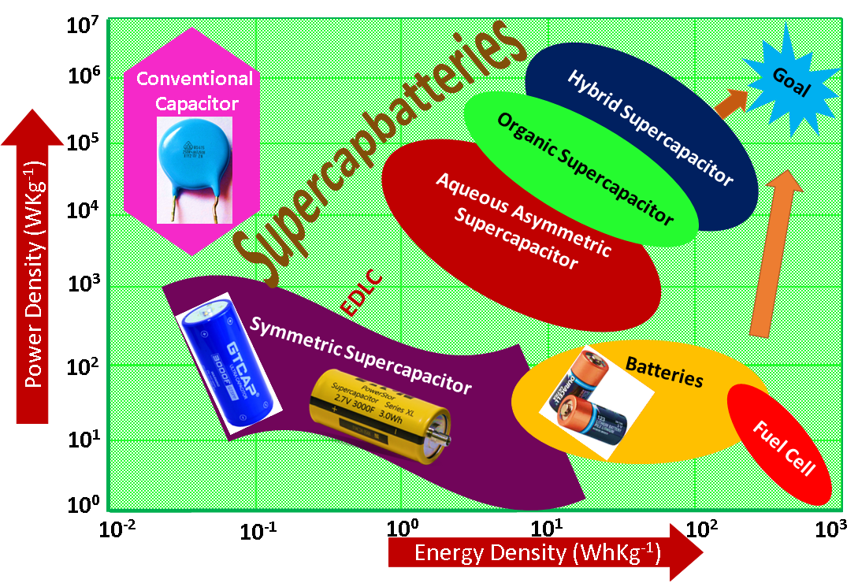
Figure 1. A Ragone plot of the power-energy density range for different electrochemical energy storage devices ^{[4]}.
The supercapacitor's cyclic voltammetry (CV) curve (Figure 2a) remains rectangular throughout the charge and discharge operation, indicating that the current is almost constant. Furthermore, the GCD curve of this device (Figure 2c) is normally inclined with a constant slope. Except when it is near to 100% charged/discharged, a battery maintains a constant voltage; the GCD curve shows a rather flat charge-discharge platform. During the charge and discharge processes, a battery shows Faradaic reactions, and its CV curve has a redox peak.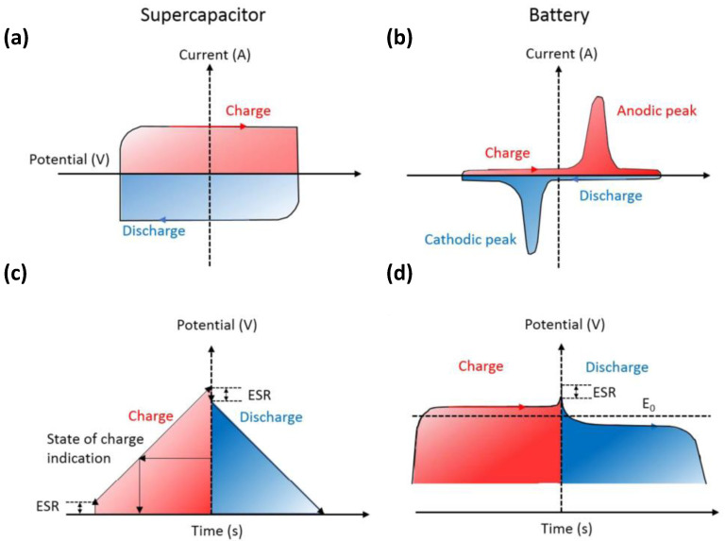
Fig. 2(a,b) cyclic voltammetry (CV) curves and (c,d) galvanostatic charge-discharge (GCD) curves of supercapacitors and batteries. Reproduced with permission ^{[5]}.
Researchers have attention to supercapacitors because of their high-range power capabilities and the life cycle is the main reason for utilizing a supercapacitor as a device for energy storage. The rechargeable batteries can store the electrical energy that arises from the chemical reaction through the redox process at the anode and cathode electrodes ^{[6]}. Supercapacitors are also referred to as electrochemical capacitors, have become an electrochemical reaction that can be stored in the form of electrical energy. They possess salient features, such as their high theoretical capacitance, long cyclic life, high power density, ultrafast charge/discharge cycles, and large surface area ^{[7]}. Electric Double Layer Capacitors (EDLC), Pseudocapacitors, and Hybrid capacitors are the three basic forms of supercapacitors ^{[8]}.
EDLC is the energy storage system that depends on both charging and discharging. Normally, EDLC predominantly employs carbon electrode materials. The carbon electrode material may be activated carbon, graphene, carbon fibers, carbon aerogels, amorphous carbon, and carbon nanotubes (SWCNT & MWCNT) ^{[9]}. The main purpose of employing carbon electrode material is for the accumulation of charge through reversible absorption/desorption of ions at the electrode/electrolyte hookup. The dielectric behavior of conventional (electrostatic) capacitors is equivalent to the process of both charging/discharging in EDLC ^{[10]}. The dielectric in the capacitor plays the role of reducing the strength of the electric field inside the capacitor. As a result, for a given charge, there is a lower voltage between the plates. In addition, there is no faradaic process that occurs during the energy storage process. The main attributes of EDLC are (i) efficient electrical conductivity, (ii) excellent mechanical stability, and (iii) high cycle efficiencies. The key Pro of EDLC are (i) feasible to charge/discharge, (ii) its long life cycle because of the absorption/desorption of electrolyte ions, (iii) Nowadays, EDLC is used as a memory backup power source for electric devices, because of their lightness. The researcher has kept an eye on EDLC, only because of the large specific surface area (SSA) ^{[11]}.
Pseudocapacitor also called a redox capacitor. Reverse faradaic reactions, which are electrochemically quick and efficient, can be used to store energy in this substance. Pseudocapacitors are consists of transition metal oxides and conducting polymers. Transition metal oxides such as RuO₂ ^{[12]}, TiO₂ ^{[13]}, V₂O₅ ^{[14]}, MnO₂ ^{[15]}, Co₃O₄ ^{[16]}, MoO₂ ^{[17]}, NiO ^{[18]}, Fe₃O₄ ^{[19]}, etc. These materials are used in superconductors due to high specific capacitance and specific energy density. The conducting polymer can be used as a superconductor because of its superior properties like good intrinsic conductivity ^{[20]}. Conducting polymers such as PPy, PANI, and PVDF, to improve the electrochemical performance^{[21]}.
Although, supercapacitors tolerate low energy density. Therefore, a supercapacitor to enhance the specific energy and power density is to develop asymmetric (or hybrid) supercapacitors using two electrodes ^{[22]}. Supercapacitors are normally classified as symmetric supercapacitors and asymmetric supercapacitors. In the symmetric type, both electrodes (Positive and negative) are suppressed in the same type of electrode material ^{[23]}. One electrode of the asymmetric type supercapacitor is made of activated carbon, which is porous, and the other electrode is made of a battery material ^{[24]}.
In recent years Two dimensional (2D) sheets-like structure dichalcogenides supercapacitor materials such as WS₂, MoS₂, and VS₂ are widely used in energy storage applications due to their extensive surface area for double-layer charge storage to enhance the better electrochemical charging/discharging performance. Pure MoS2 supercapacitor materials show only moderate performance as electrode materials due to the relatively poor electronic conductivity and stability. In addition, MoS₂@ZIF-67 composites have been used as one of the most effective ways to increase their conductivity and electrochemical properties. Finally, we have developed in this work to synthesize MoS2@ZIF-67 composites through the hydrothermal method ^{[25]}.
Electrochemical Performance for EDLC Type Supercapacitor Materials:
Carbon materials:
Carbon materials are the electrode materials with the best possibilities for industrialization. They are non-poisonous, have a large specific surface area, outstanding conductivity, strong chemical stability, a wide operating temperature range, enormous natural reserves, low cost, and ease of processing ^{[26]}. An electrochemical double layer formed at the electrode-electrolyte interface serves as a storage mechanism for carbon compounds. Therefore, the surface area that is accessible to electrolyte ions has a major role in determining capacitance. Electrochemical performance is significantly influenced by a variety of factors, including specific surface area, pore shape and structure, pore size distribution, surface functionality, and electrical conductivity ^{[27]}. The capacity for charge accumulation at the electrode-electrolyte interface is higher for carbon materials with a high specific surface area. When it comes to enhancing specific capacitance for carbon materials. Carbon materials such as activated carbon (AC), carbon aerogels, carbon nanotubes (CNTs), carbon nanofibres, and others are used. With a theoretical capacitance of 100⁓300 F g⁻¹, conventional alternating current has high cycling stability in a variety of electrolytes. However, due to double-layer capacitance processes, the specific capacitance cannot be greatly enhanced. At the moment, the combination of carbon material with pseudocapacitive material can have a synergistic effect, resulting in high electrochemical performance for the total system ^{[28]}.
Activated carbon (AC):
Porous activated carbon (AC) has long been acknowledged as one of the most prominent and often utilized electrode materials among the numerous forms of Electrochemical Double Layer Capacitors (EDLCs). The excellent qualities that make it suitable for energy storage in supercapacitors are the main cause of this. Due to its exceptional electrochemical stability, activated carbon can withstand multiple charge-discharge cycles without suffering significant deterioration. This quality is essential for the durable and dependable operation of supercapacitors ^{[29]}. Activated carbon possesses an extensive internal surface area, often measured in thousands of square meters per gram. This high surface area provides ample space for electrolyte ions to adsorb, resulting in a higher capacitance and energy storage capacity. The porous structure of activated carbon further enhances its capacity to store charge. The presence of numerous small and interconnected pores increases the available active sites for the electrochemical double-layer formation, leading to higher capacitance values. Efficient charge transport is crucial for rapid charge and discharge in supercapacitors ^{[30]}. Activated carbon possesses good electrical conductivity, ensuring fast ion diffusion and electron transfer within the electrode material. Due to these advantageous properties, activated carbon-based electrodes have found wide applications in various energy storage systems, especially supercapacitors. When it comes time to discharge the stored energy, activated carbon makes it possible to do so quickly and without major energy loss, restoring optimal capacity to the supercapacitor cell. This indicates that the battery's performance won't be affected by thousands of charges and discharges ^{[31]}.
Graphene:
Graphene plays a crucial role in supercapacitor applications due to its exceptional properties, making it an ideal material for enhancing the performance of supercapacitors. Graphene possesses an extremely high surface area per unit mass due to its single-layered carbon atom arrangement ^{[32]}. This large surface area provides ample sites for storing electrical charge, enhancing the energy storage capacity of supercapacitors. Graphene is an excellent conductor of electricity, with electrons moving through its lattice with minimal resistance. Supercapacitors can quickly store and release energy owing to their high electrical conductivity, which permits fast charge and discharge rates. Graphene is an incredibly lightweight material, which is beneficial in supercapacitors as it contributes to their high-power density. The low mass of graphene allows for fast movement of charge carriers, resulting in high power output ^{[33]}. Graphene exhibits outstanding mechanical strength, which is essential for maintaining the structural integrity of supercapacitor electrodes during charge and discharge cycles. Its durability ensures a longer lifespan and better cycling performance for supercapacitors. Graphene can be combined with other materials, such as metal oxides or conductive polymers, to form graphene-based composites. These composites can further improve the specific capacitance and overall energy storage capabilities of supercapacitors. Graphene is composed solely of carbon atoms, making it environmentally friendly compared to certain materials used in traditional energy storage devices, such as lithium-ion batteries, which can contain heavy metals and other hazardous materials ^{[34]}. Graphene and graphene-based materials have attracted a lot of interest in developing of next-generation supercapacitors with higher energy density, power consumption, and cycling stability as a result of these outstanding features. As research continues, we can expect further advancements in supercapacitor technology with graphene playing a central role in making energy storage devices more efficient and sustainable ^{[ 35]}.
Pseudocapacitor:
Pseudocapacitors are also called faradaic supercapacitors. Pseudocapacitors are electronic components that differ from EDLCs in that they have electrodes constructed of redox-active substances. Through a distinct mechanism, these gadgets use electrical charge to store energy. When an electrode is being charged, the activation of the redox pair is made easier by the introduction of external potential ^{[36]}. The redox-active surface groups redirect to their initial state upon discharge, which is the opposite of this process.
The movement of charge across the double layer, which results in faradic current flowing through the electrode material of the supercapacitor, occurs in a pseudocapacitor when a voltage is applied, undergoing both reduction and oxidation of the electrode material, leading to higher specific capacitance and energy densities than in EDLCs. ^{[37]}.
When compared to non-Faradic processes, faradic processes are thought of as having comparatively sluggish reactions. Pseudocapacitors have a low power density as a result. Reversible adsorption processes, transition metal oxide reactions, and electrochemical doping reactions (reversible) are three general classifications for the redox reactions that occur in this supercapacitor ^{[38]}.
Transition Metal Oxides (TMO):
Metal oxide is one type of pseudocapacitive material that displays quick and reversible redox reactions outside of the electrode materials. Because of this material's low resistance and high specific capacitance, it is simple and efficient to build supercapacitors. They offer a higher specific capacitance than carbon-based materials and better cycle stability than conductive polymers because metal oxides made of transition metal families store charges through quick and reversible redox processes ^{[39]}. To enhance the electrochemical capabilities of supercapacitors, transition metal oxides are therefore particularly appealing electrode materials. For better energy densities in aqueous asymmetric supercapacitor devices, metal oxides can be employed as cathode and anode materials. Metal oxides have been extensively studied as electrode materials for aqueous asymmetric supercapacitor devices in recent years. These metal oxides primarily include single metal oxides such as Fe₂O₃, V₂O₅, RuO₂, MnO₂, MoO₃, and WO₃, bimetallic oxides such as conversion-type MN₂O₄, where M or N = Ni, Co, Zn, Mn, Fe, Cu, etc., and intercalation-type such as LiCoO₂, LiMn₂O₄ ^{[40]}. The following introduces various electrode materials based on Fe, V, Ru, Mn, and Co, as well as single metal oxides. RuO₂ is regarded as the most promising metal oxide among them all due to its high specific capacitance (720 F g⁻¹), high price, and high electrical conductivity ^{[41]}.
Fe-based Iron Oxide Supercapacitor Materials:
Iron-based substances, such as Fe₂O₃, Fe₃O₄, FeOOH, FeOx, CoFe₂O₄, and MnFe₂O₄, have recently drawn a lot of interest as extremely promising electrode materials for SCs because of their high theoretical specific capacitances, abundance in nature, low cost, and non-toxicity ^{[42]}. However, the bulk of these Fe-based SC electrodes exhibit inadequate conductivity and/or electrochemical instability, limiting their application as high-performance SC electrodes. To address these problems, significant attempts have been made to increase their cycle stability and conductivity, and wonderful methods have been accomplished ^{[43]}.
Vanadium Based materials:
Vanadium-based oxides, such as VO₂, V₂O₃, and V₂O₅, possess several advantageous properties, including high power density, natural abundance, and high theoretical specific capacity. These features make them promising materials for various applications, particularly in energy storage systems. However, their practical use has been hindered by certain limitations, primarily related to structural stability and poor electrical conductivity ^{[44]}.
One of the key challenges with vanadium oxides is their poor electrical conductivity. To address this issue, researchers have employed carbon-based materials as anchors to improve the electrical conductivity of vanadium oxides. This approach has shown promise in enhancing the performance of these materials ^{[45]}.

Ru based
Ruthenium-based materials, such as ruthenium metal (Ru), ruthenium dioxide (RuO₂), hydrated ruthenium dioxide (RuO₂·xH₂O), and various ruthenium compounds, have been identified as highly promising traditional electrode materials for various electrochemical applications ^{[46]}.
RuO2's increased rate capacity, better electrical conductivity, excellent cycling stability, and outstanding charge-carrying characteristics have all contributed to its exceptional capacitive performance ^{[47]}. However, its high cost has been a limiting factor in its widespread commercialization as an electrode material in supercapacitors. As inexpensive substitutes to RuO₂, vanadium (V₂O₅), manganese (MnO₂ and Mn₃O₄), cobalt (CoO and Co₃O₄), nickel (NiO and Ni₂O₃), copper (Cu₂O and CuO), and zinc (ZnO) oxides are employed as active electrode materials. The electrochemical properties of transition metal oxides could be improved further by using binary (CoMn₂O₄ and NiCo₂O₄) and ternary (CoNiFeO₄) metal oxides, which introduce additional redox states and improve electrical conductivity ^{[48]}.
Conducting Polymer:
Conducting polymers have been extensively studied and used for supercapacitor applications due to their unique properties, such as high electrical conductivity, processability, mechanical flexibility, electrochemical stability, and large surface area ^{[49]}. Some of the commonly known electrical CPs include polyaniline (PANI), polypyrrole (PPy), polythiophene (PTh), Poly(3,4-ethylenedioxythiophene) (PEDOT), polyacetylene (PA), and Poly(3,4-propylenedioxythiophene) (PProDOT) ^{[50]}. These CPs have received a lot of interest because of their high pseudocapacitance, conductivity, and ease of manufacture and processing. Polyaniline is one of the most extensively studied and widely used conducting polymers for supercapacitors. It exhibits good redox reversibility and has the potential for high specific capacitance ^{[51]}. Polypyrrole is another popular conducting polymer used in supercapacitors. It offers good mechanical stability and high electrical conductivity when doped with suitable dopants. Polythiophene is another conducting polymer that has been considered for supercapacitor applications due to its electrochemical properties and stability. PEDOT is a conducting polymer with high stability and good electrochemical properties. It can be used in various supercapacitor configurations. Similar to PEDOT, PProDOT is a conducting polymer with promising properties for supercapacitor applications. These conducting polymers can be employed in various electrode configurations, such as in the form of thin films, composites with other materials, or as part of hybrid systems. The choice of conducting polymer depends on factors such as the desired specific capacitance, voltage window, and the overall performance requirements of the supercapacitor device ^{[52]}.
Hybrid Supercapacitor:
A hybrid supercapacitor, also known as an asymmetric or combination supercapacitor, is an energy storage device that combines the characteristics of both supercapacitors and batteries. Furthermore, the hybrid capacitors were a previously unattainable combination of performance properties. They are also combining the best features of pseudo-capacitors and EDLCs into a unified Supercapacitor ^{[53]}. It aims to provide higher energy densities than conventional supercapacitors while maintaining their advantageous high-power density and long cycle life. These devices (EDLC) store energy through the charge separation at the electrode-electrolyte interface. In supercapacitors, ions are adsorbed onto the surface of high-surface-area electrodes, resulting in high power density and rapid charge/discharge capabilities. These components (pseudocapacitors or batteries) utilize fast, faradaic redox reactions that occur at the electrode surface to store energy. Unlike supercapacitors, the energy storage in pseudocapacitors involves reversible redox reactions, leading to higher energy densities but usually with a slower response time compared to EDLCs ^{[54]}.
Electrochemical Performance:
Cyclic Voltammetry:
Indeed, Cyclic Voltammetry (CV) is a common electrochemical technique used to study the redox behavior and charge storage mechanisms of electrode materials. As described, it involves applying a potential to the working electrode concerning a reference electrode and measuring the resulting current response. By performing two linear potential sweeps in opposite directions, valuable information about the electrochemical processes and charge storage mechanisms can be obtained ^{[55]}.
When analyzing the shape of the cyclic voltammogram, it can typically exhibit two common types of shapes: rectangular and quasi-rectangular.
- Rectangular CV: In this type of CV (Fig.3a), the current response shows a well-defined rectangular shape. This shape is often indicative of a charge storage mechanism dominated by electrical double-layer capacitance (EDLC). EDLC is related to the reversible adsorption and desorption of ions at the electrode-electrolyte interface, resulting in a capacitive response. Electrodes that mainly store charge through EDLC usually have high specific surface areas and are commonly associated with materials like activated carbons and some other conductive porous materials ^{[56]}.
- Quasi-Rectangular CV: The quasi-rectangular CV shape is characterized by sloping or curved lines at the edges of the rectangular region. This indicates the presence of pseudocapacitance in addition to EDLC. Pseudocapacitance arises from redox reactions occurring at or near the electrode surface. These redox reactions involve faradaic processes and are not solely based on surface adsorption/desorption. Common materials that exhibit pseudocapacitance behavior are transition metal oxides and conducting polymers ^{[57]}.
By analyzing the area enclosed by the rectangular region in the CV, it is also possible to estimate the specific capacitance of the electrode material. Specific capacitance quantifies the ability of a material to store charge and is an important parameter in evaluating its performance for energy storage applications.
In summary, the shape of the cyclic voltammogram provides valuable insights into the underlying charge storage mechanism, whether it’s dominated by electrical double-layer capacitance (EDLC) or involves pseudocapacitance. This information is essential for studying the electrochemical behavior of electrode materials and their possible application in different energy storage technologies, such as supercapacitors. The specific capacitance (C_{sp}, F g⁻¹) of the electrode material can be determined from the cyclic voltammogram using this equation.
$$C_{sp}=\frac{\int_{v_{1}}^{v_{2}}{Idv}}{m×v×∆v}$$
where $\int_{v_{1}}^{v_{2}}{Idv}$ is calculated by integrating the area under the CV. It should be emphasized that the previous equation may only be used to calculate capacitance if the CV is rectangular or nearly so ^{[58]}.
Galvanostatic charge and discharge:
Two common techniques used to characterize the performance of supercapacitors, also known as electrochemical capacitors or ultracapacitors, are galvanostatic charge and discharge. These techniques involve applying a constant current during the charging and discharging processes (Fig. 3b), respectively, to analyze the behavior of the supercapacitor ^{[59]}.
Galvanostatic Charge: During galvanostatic charge, a constant current is applied to the supercapacitor, and the voltage across the device is measured as a function of time. This process leads to the accumulation of charge on the electrodes and the formation of an electric double layer at the electrode-electrolyte interface. The charge stored in the supercapacitor increases linearly with time during this process.
The galvanostatic charge process is typically used to determine the capacitance of the supercapacitor. The capacitance value can be calculated using the equation ^{[60]}:
$$C_{sp}=\frac{i×t}{m×∆v}$$

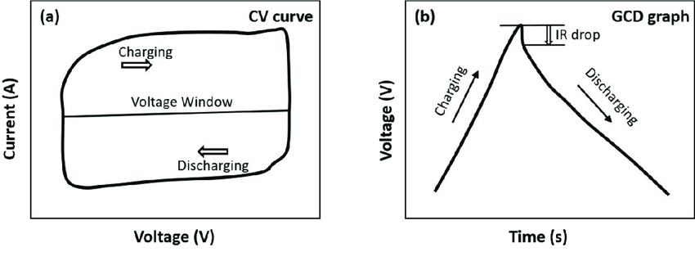

Figure 3.Typical profiles of a) CV, and b) GCD,

Conclusion:
Electrochemical SCs are emerging as promising energy storage devices. This review provides a detailed description of electrode materials based on carbon materials, CPs, MOs, and their composites. Supercapacitors with a large amount of energy, significant voltage resistance, and extreme/low temperature resistance will be the subject of long-term research. Electrode materials and electrolytes must be optimized in order to create high-performance supercapacitors with a greater energy density, power utilization, and cycle life. The electrochemical identifiers of EDLC, pseudocapacitive, and hybrid (battery) materials, including CVs and GCDs, have been investigated. High specific surface area, superior chemical and thermal stability, and low electrical resistance make carbonaceous materials promising electrodes; yet, their low energy density, brought on by surface or quasi-surface energy storage, prevents their employment on a broad scale. Because of their variety, excellent specific capacitance, and environmental friendliness, TMOs such as RuO₂, V₂O₅, and MnO₂ performed exceptionally well as electrode materials (both cathode and anode). The advancements in material technology discussed in this article, as well as overcoming application hurdles, improving efficiency, and lowering prices, appear to be the biggest obstacles to the widespread adoption of SCs.
Reference:

1. Santhi Maria Benoy, Mayank Pandey, Dhrubajyoti Bhattacharjya, Binoy K. Saikia, Recent trends in supercapacitor-battery hybrid energy storage devices based on carbon materials,https://doi.org/10.1016/j.est.2022.104938.
2.K. HANJALIC, R. VAN DE KROL, A. LEKIC, Sustainable Energy Technologies, ISBN 978-1-4020-6723-5 (HB) ISBN 978-1-4020-6724-2 (e-book).
3.Xuli Chen, Rajib Paul, Liming Dai, Carbon-based supercapacitors for efficient energy storage,National Science Review, Volume 4, Issue 3, May 2017, Pages 453–489, https://doi.org/10.1093/nsr/nwx009.
4. Noori, A.; El-Kady, M.F.; Rahmanifar, M.S.; Kaner, R.B.; Mousavi, M.F. Towards establishing standard performance metrics for batteries, supercapacitors and beyond. Chem. Soc. Rev. 2019, 48, 1272–1341. [Google Scholar] [CrossRef]
5. Shao Y., El-Kady M.F., Sun J., Li Y., Zhang Q., Zhu M., Wang H., Dunn B., Kaner R.B. Design and Mechanisms of Asymmetric Supercapacitors. Chem. Rev. 2018;118:9233–9280. doi: 10.1021/acs.chemrev.8b00252.

6.BinoyK. Saikia, SanthiMaria Benoy, Mousumi Bora, Joyshil Tamuly, Mayank Pandey, Dhurbajyoti Bhattacharya,A brief review on supercapacitor energy storage devices and utilization of natural carbon resources as their electrode materials,https://doi.org/10.1016/j.fuel.2020.118796.

7.MuhammadAmirulAizat MohdAbdah, NurHawaNabilah Azman, Shalini Kulandaivalu, Yusran Sulaiman,Review of the use of transition-metal-oxide and conducting polymer-based fibers for high-performance supercapacitors,https://doi.org/10.1016/j.matdes.2019.108199.
8.Manoj K. Singh, Sujeet K. Chaurasia, in Smart Supercapacitors, 2023, Recent progress on materials, architecture, and performances of hybrid battery-supercapacitors, Fundamentals, Structures, and Applications2023, Pages 477-500, https://doi.org/10.1016/B978-0-323-90530-5.00024-1.

9.Sumaiyah Najib and Emre Erdem,Current progress achieved in novel materials for supercapacitor electrodes: mini-review,DOI: 10.1039/C9NA00345B.
10. Vignesh Kumaravel and Suresh C. Pillai Parnia Forouzandeh, ReviewElectrode Materials for Supercapacitors: A Review ofRecent Advances,Catalysts 2020, 10, 969.
11.Xiangyu You Manjusri Misra Stefano Gregori, and Amar K. Mohanty, Preparation of an Electric Double Layer Capacitor (EDLC) Using Miscanthus-Derived Biocarbon,https://doi.org/10.1021/acssuschemeng.7b02563.
12.T Liu, WG Pell, BE Conway - Electrochimica Acta, 1997 – Elsevier, Self-discharge and potential recovery phenomena at thermally and electrochemically prepared RuO2 supercapacitor electrodes, https://doi.org/10.1016/S0013-4686(97)81190-5.

13.G Wang, ZY Liu, JN Wu, Q Lu - Materials Letters, 2012 – Elsevier, Preparation and electrochemical capacitance behavior of TiO2-B nanotubes for hybrid supercapacitor, https://doi.org/10.1016/j.matlet.2011.12.036.

14.SM Lee, YJ Park, JH Kim, K Lee - Applied Surface Science, 2020 – Elsevier, Effects of annealing on electrochemical performance in graphene/V2O5 supercapacitor, https://doi.org/10.1016/j.apsusc.2020.145626.

15.T Yue, B Shen, P Gao - Renewable and Sustainable Energy Reviews, 2022 – Elsevier,Carbon material/MnO2 as conductive skeleton for supercapacitor electrode material: A review, https://doi.org/10.1016/j.rser.2022.112131.
16.J Xu, L Gao, J Cao, W Wang, Z Chen - Electrochimica Acta, 2010 – Elsevier,Preparation and electrochemical capacitance of cobalt oxide (Co3O4) nanotubes as supercapacitor material, https://doi.org/10.1016/j.electacta.2010.09.092.

17.J Rajeswari, PS Kishore, B Viswanathan… - Electrochemistry …, 2009 – Elsevier,One-dimensional MoO2 nanorods for supercapacitor applications, https://doi.org/10.1016/j.elecom.2008.12.050.

18.GA Babu, G Ravi, T Mahalingam-Dalton, 2015 - pubs.rsc.org,Influence of microwave power on the preparation of NiO nanoflakes for enhanced magnetic and supercapacitor applications, DOI.https://doi.org/10.1039/C4DT03483J.

19.J Chen, K Huang, S Liu - Electrochimica Acta, 2009 – Elsevier,Hydrothermal preparation of octa decahedron Fe3O4 thin film for use in an electrochemical supercapacitor, https://doi.org/10.1016/j.electacta.2009.04.017.
20.Sonika, Sushil Kumar Verma, Siddhartha Samanta, Ankit Kumar Srivastava , Sonali Biswas , Rim M. Alsharabi, and Shailendra Rajput, Conducting Polymer Nanocomposite for Energy Storage and Energy Harvesting Systems, https://doi.org/10.1155/2022/2266899.
21.K Wang, H Wu, Y Meng, Z Wei - Small, 2014 - Wiley Online Library,Conducting polymer nanowire arrays for high performance supercapacitors, https://doi.org/10.1002/smll.201301991.

22.Mohsin Ali Raza, Zaeem Ur Rehman, Muhammad Gulraiz Tanvir, Muhammad Faheem Maqsood, Metal oxide-conducting polymer-based composite electrodes for energy storage applications, https://doi.org/10.1016/B978-0-323-85155-8.00008-X.
23.Lei Zhang, Shi Xue Dou, Hua Kun Liu,, Yunhui Huang, and Xianluo Hu,Symmetric Electrodes for Electrochemical Energy‐Storage Devices, https://doi.org/10.1002/advs.201600115.
24.Dr. N. Choudhary, J. Moore, Dr. C. Li, Prof. L. Zhai, Prof. Y. Jung, Prof. J. Thomas, Asymmetric Supercapacitor Electrodes and Devices, DOI: 10.1002/adma.201605336.
25.Binglong Rui Jiahui Li Limin Chang Hairui Wang Li Lin Yu Guo *Engineering MoS2 Nanosheets Anchored on Metal Organic Frameworks Derived Carbon Polyhedra for Superior Lithium and Potassium Storage, https://doi.org/10.3389/fenrg.2019.00142.
26.Zuozhao Zhai, Lihui Zhang, Tianmin Du, Bin Ren, Yuelong Xu, Shasha Wang, Junfeng Miao, Zhenfa Liu, A review of carbon materials for supercapacitors,https://doi.org/10.1016/j.matdes.2022.111017.
27.Jing Shi, Bailing Jiang, Zheng Liu, Cong Li, Fangyuan Yan, Xiansheng Liu, Hongtao Li, ChaoYang, Dan Dong,Effects of specific surface area of electrode and different electrolyte on capacitance properties in nano porous-structure CrN thin film electrode for supercapacitor,https://doi.org/10.1016/j.ceramint.2021.03.177.
28.Oluwaseye Samson Adedoja, Emmanuel Rotimi Sadiku andYskandar Hamam,An Overview of the Emerging Technologies and Composite Materials for Supercapacitors in Energy Storage Applications, https://doi.org/10.3390/polym15102272.
29.Mahmoud Maher, Sameh Hassan, Kamel Shoueir, Bedir Yousif, Mohy Eldin A. Abo-Elsoud, Activated carbon electrode with promising specific capacitance based on potassium bromide redox additive electrolyte for supercapacitor application,https://doi.org/10.1016/j.jmrt.2021.01.080.

30.Swati Sharma, Prakash Chand,Supercapacitor and electrochemical techniques: A brief review,https://doi.org/10.1016/j.rechem.2023.100885.

31.F. Naseri, S. Karimi, E. Farjah, E. Schaltz, Supercapacitor management system: A comprehensive review of modeling, estimation, balancing, and protection techniques,https://doi.org/10.1016/j.rser.2021.111913.

32.Rajan Lakra, Rahul Kumar, ParasantaKumar Sahoo, Dhirendranath Thatoi, Ankur Soam,Amini-review: Graphene based composites for supercapacitor application, https://doi.org/10.1016/j.inoche.2021.108929.
33.M. I. A. Abdel Maksoud, Ramy Amer Fahim, Ahmed Esmail Shalan, M. Abd Elkodous, S. O. Olojede, Ahmed I. Osman, Charlie Farrell, Ala’a H. Al-Muhtaseb, A. S. Awed, A. H. Ashour & David W. Rooney, Advanced materials and technologies for supercapacitors used in energy conversion and storage: a review, Environmental Chemistry Letters volume 19, pages375–439 (2021).
34.Santosh,Tiwari, Sumanta Sahoo, Nannan Wang, Andrzej Huczko, Graphene research and their outputs: Status and prospect,https://doi.org/10.1016/j.jsamd.2020.01.006.
35.Qingqing Ke, John Wang,Graphene-based materials for supercapacitor electrodes – A review,https://doi.org/10.1016/j.jmat.2016.01.001.
36.Y. Liu, S.P. Jiang, Z. Shao, Intercalation pseudocapacitance in electrochemical energy storage: recent advances in fundamental understanding and materials development, https://doi.org/10.1016/j.mtadv.2020.100072.

37.Thibeorchews Prasankumar, Jemini Jose, Sujin Jose and Sreeja P. Balakrishnan,Pseudocapacitors,DOI: 10.5772/intechopen.98600.
38.Mayuresh Khot, Amirkianoosh Kiani, A review on the advances in electrochemical capacitive charge storage in transition metal oxide electrodes for pseudocapacitors,https://doi.org/10.1002/er.8763.

39.Bharathi Arumugam,Gopiraman Mayakrishnan,Suresh Kumar Subburayan Manickavasagam,Seong Cheol Kim, and Ramkumar Vanaraj,An Overview of Active Electrode Materials for the Efficient High-Performance Supercapacitor Application,https://doi.org/10.3390/cryst13071118.

40.Lanyi Wang,Shengran Zhou,Mengxia You,Di Yu,Chunlei Zhang,Siyu Gao ,Xuehua Yu andZhen Zhao,Research Progress on Metal Oxides for the Selective Catalytic Reduction of NO_{x} with Ammonia, https://doi.org/10.3390/catal13071086.
41.Ruibin Liang,Yongquan Du,Peng Xiao,,Junyang Cheng,Shengjin Yuan,Yonglong Chen,Jian Yuan and Jianwen Chen,Transition Metal Oxide Electrode Materials for Supercapacitors: A Review of Recent Developments, https://doi.org/10.3390/nano11051248.
42.YinxiangZeng,MinghaoYu,YueMeng,Pingping Fang, Iron-Based Supercapacitor Electrodes: Advances and Challenges,DOI:10.1002/aenm.201601053.
43.Mujahid Mustaqeem, GowharA. Naikoo, Masoud Yarmohammadi, MonaZ. Pedram, Hamed Pourfarzad, Riyaz A. Dar, Safeya A. Taha, Israr U. Hassan, Md. Yasir Bhat, Yang-Fang Chen, Rational design of metal oxide based electrode materials for high performance supercapacitors – A review,https://doi.org/10.1016/j.est.2022.105419.
44.Huizhen Qina ,Shunfei Liang, Lingyun Chen, Yang Li , ZiyangLuo , Shaowei Chen , Recent Advances in Vanadium-based Nanomaterials and Their Composites for Supercapacitors, 14-Jul-2020.

45.Huizhen Qin,ShunfeiLiang,LingyunChen,Yang Li, Recent Advances in Vanadium-based Nanomaterials and Their Composites as High-performance Electrode Materials for Supercapacitors,DOI:10.1039/D0SE00897D.
46.Bo-Kyung Choi , Jae-Kyoung Ko , Byoung-Suhk Kim,, Min-Kang Seo,, Electrochemical Supercapacitors Based on Hydrous RuO2/ oxidized Multi-walled Carbon Nanotube Composites, J Nanotechnol Nanomaterials. 2022;3(2):90-96.

47.Ramesh K. Guduru, Juan C. Icaza, Sandeep Kumar Pudi, Electrochemical characterization of RuO₂ and activated carbon (AC) electrodes using multivalent Ni(NO₃)₂ electrolyte for charge storage applications,https://doi.org/10.1016/j.est.2020.102170.
48.K. C. Seetha Lakshmi, and Balaraman Vedhanarayanan, ,High-Performance Supercapacitors: A Comprehensive Review on Paradigm Shift of Conventional Energy Storage Devices, Batteries 2023, 9, 202. https://doi.org/ 10.3390/batteries9040202.
49.Namsheer K and Chandra Sekhar Rout ,Conducting polymers: a comprehensive review on recent advances in synthesis, properties and applications,DOI:https://doi.org/10.1039/D0RA07800J.

50.Van At Nguyen¹ and Christian Kuss^{2,1},Review—Conducting Polymer-Based Binders for Lithium-Ion Batteries and Beyond,DOI 10.1149/1945-7111/ab856b.

51.Huanhuan Wang, Jianyi Lin, Ze Xiang Shen,Polyaniline (PANi) based electrode materials for energy storage and conversion,https://doi.org/10.1016/j.jsamd.2016.08.001.

52.Indrajit Shown, Abhijit Ganguly, Li-Chyong Chen, Kuei-Hsien Chen,Conducting polymer-based flexible supercapacitor, https://doi.org/10.1002/ese3.50.
53.Marin S. Halper James C. Ellenbogen, Supercapacitors: A Brief Overview,http://www.mitre.org/tech/nanotech.
54.Sivakumar Rajagopal,Rameez Pulapparambil Vallikkattil,M. Mohamed Ibrahim and Dimiter Georgiev Velev,Electrode Materials for Supercapacitors in Hybrid Electric Vehicles: Challenges and Current Progress, https://doi.org/10.3390/condmat7010006.
55.Hui Shao, ZifengLina, Kui Xu, Pierre-Louis Taberna, Patrice Simona, Electrochemical study of pseudocapacitive behavior of Ti3C2Tx MXene material in aqueous electrolytes, https://doi.org/10.1016/j.ensm.2018.12.017.

56.Jilei Liu, Jin Wang, Chaohe Xu, Hao Jiang, Chunzhong Li, Lili Zhang, Jianyi Lin, and Ze Xiang Shen, Advanced Energy Storage Devices: Basic Principles, Analytical Methods, and Rational Materials Design,doi: 10.1002/advs.201700322.
57.Junshen Li, Chunxia Zhao, Yunxia Yang, Tony Hollenkamp, Xiaoyun Lv, Tao Xie and Wen Chen,Fabrication and electrochemical properties of well-dispersed molybdenum oxide nanoparticles into nitrogen-doped ordered mesoporous carbons for supercapacitors,DOI 10.1088/2053-1591/ab3dfb.
58.Chengcheng Xiang, Ming Li, Mingjia Zhi , Ayyakkannu Manivannan , and Nianqiang Wu, A Reduced Graphene Oxide/Co3O4 Composite for Supercapacitor Electrode.
59.Imtiaz Ahmed Khan, Litty Thekkekara, Sania Waqar, Nauman Choudhry and Sabu John, Supercapacitors Fabrication and Performance Evaluation Techniques, DOI: 10.5772/intechopen.101748.
60.Vijeth H. Ashokkumar S. P., Yesappa L., Niranjana M., Vandana M. and Devendrappa H.,Flexible and high energy density solid-state asymmetric supercapacitor based on polythiophene nanocomposites and charcoal,DOI: 10.1039/C8RA06102E.

