IoT Embedded System, Sensors, Actuators
Rishabh Singh
Department of Mechanical Engineering with specialization in Mechatronics
Vel Tech Rangaragan Dr. Sagunthala R&D Institute
of Science and Technology Avadi, Chennai-600062
Email:

Abstract:
The Internet of Things (IoT) has a whole new concept of virtualization of objects as the world is developing smart objects, smart applications and smart cities are being developed which change the whole scenario. In this particular subject, the significance is based on sensors, actuators, and most probably embedded systems. IoT signifies connectivity, and this might be combined with a network that links every thing and its application worldwide. However, in order to accomplish this, the objects need a medium for communication that supports diverse and ubiquitous items, a network with more traffic between objects than between people but one that is required for both types.This paper would describe the detailed connectivity for sensors and actuators presenting a small project in this chapter with explanation and will be helpful for a person to their mobile with Robot through wifi. This leads who wants to initiate a new project in this field.

Introduction:
IoT, in its simplest form, refers to the idea of tethering any gadget to the internet and other connected devices. To gather and share data, every instrument in the network engages in inter-instrument communication. IoT is a popular tool utilised nowadays to lighten the load on people. Smart homes, wearables (watches and bracelets), smart automobiles, smart farming, smart retail, smart grids, smart cities, and smart healthcare are just a few of the businesses that are using IoT.

The IoT's future appears more promising than ever with such a wide range of applications. The top IoT projects for 2020 are presented in this article about internet of things initiatives. If you're a student, you might think about using them for academic reasons or just for fun.

Control System:
Residents have identification cards that transmit information to readers wirelessly or using tiny sensors. Credentials come in a variety of shapes and sizes, from wireless smartphone apps to internet-enabled cards and keychains. There are different types of controller to control the devices. Here the controller are classified as two, such as micro-controller and a macro-controller.

Microprocessor: A microprocessor is a type of computer processor that may either improve up to 8 integrated circuits or block the operations of a central processing unit on a single integrated circuit (IC). The microprocessor is a versatile processing device that accepts binary as input, has a user interface, and outputs results as analogue or digital signals. ALU processes the information obtained from the memory or an input device using mathematical and logical operations. The registers in a register array are denoted by the letters B, C, D, E, H, and accumulator.
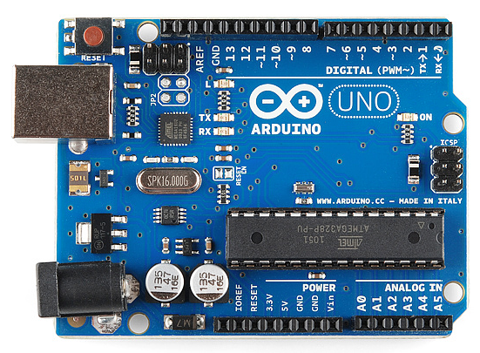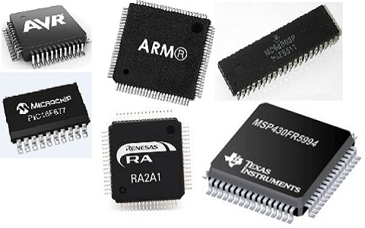
Microprocessor
Arduino Micro-Controller

Microcontroller: A microprocessor is a form of computer processor that has the ability to either enhance up to 8 integrated circuits or restrict a central processing unit's (CPU) functions on a single integrated circuit (IC). The microprocessor is a multifunctional processing tool that accepts binary as input, has a user interface, and produces results as analogue or digital signals. ALU performs logical and mathematical operations on the data it receives from the memory or an input device. The letters B, C, D, E, H, and accumulator stand in for the registers in a register array.

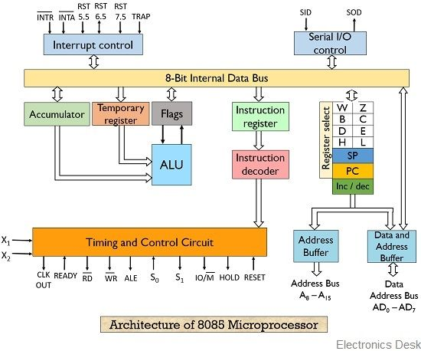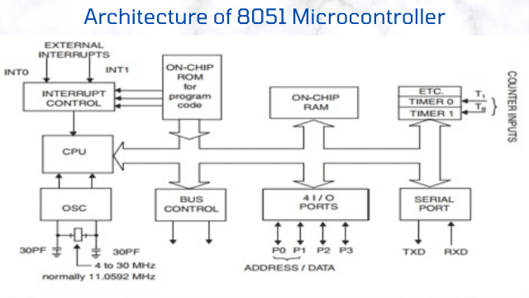

Henceforth will be covering sensors and actuators.

Sensors: These objects ranging from 1mm to 100mm depending upon their usage are the most impeccable part of a machine. They provided with an architecture such that there aren't any loopholes in the data perceived.

Some illustration for better understanding:

MQ-6 Sensor- This is a gas-detecting sensor that can detect gases such as propane, butane, LPG, etc. The sensor module has four pins: VCC, GND, AO, and DO. VCC is the positive power supply pin, typically connected to a voltage between 2.5V and 5V. GND is the ground pin, connected to the negative power supply. AO(analog output) pin gives the sensor’s output voltage, which can be read using an ADC. DO(digital output) pin can be used to get a digital output from the sensor.

Thermal sensors: The voltage across the diode terminals is the fundamental operating mechanism of the temperature sensors. When the voltage rises, the temperature rises as well, which is followed by a voltage drop between the base and emitter transistor terminals of a diode.
The following formula can be used to calculate the frequency, which is proportional to temperature and, in turn, to the tension in the wire:

f=1/2[sg/r]/2l Hz

Where, s, r, g, and l are tension, density, acceleration, and length respectively.
Other temperature sensors comprise thermostats, thermistors, and RDLs.

Motors: Motors that are electrically commuted are known as Brushless DC Motors (BLDC). Current is carried through the channel of rotor locations in these motors, which lack brushes on the rotor. Phase windings are inserted in slots or can be wound around the stator, which is the stationary component, to create a magnetic field and power the motor. The permanent magnets' magnetization and location on the rotor are selected so that the back-EMF shape is trapezoidal. This makes it possible to employ a rotational field with little torque ripple by using a three-phase voltage system with a rectangular shape. The magnet of a BLDC motor rotates while the wire remains stationary, making them similar to inverted DC commutator motors in this regard.

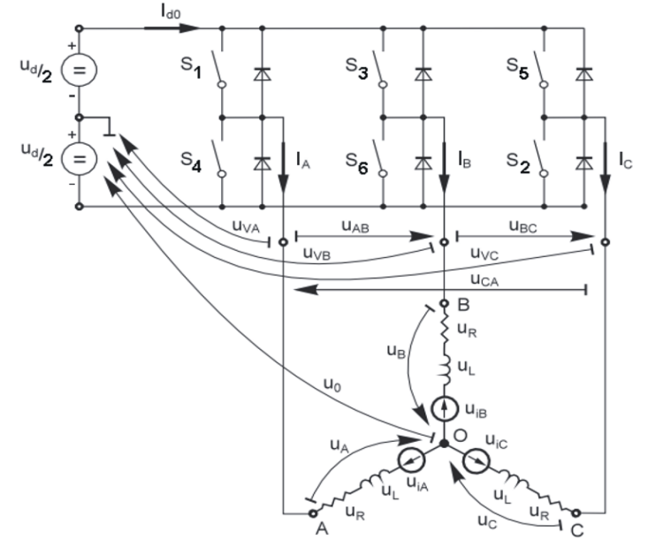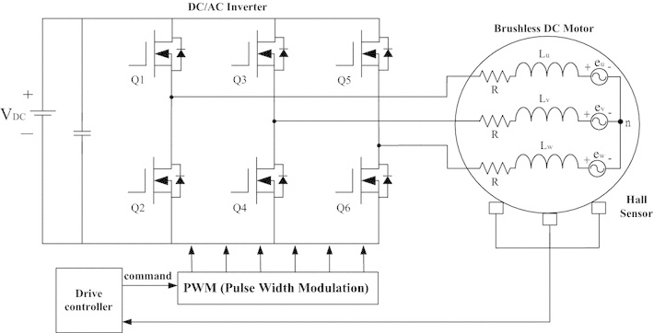

The brushless DC motor circuit shown in the image above has a higher torque-to-size ratio than a traditional DC motor, which makes it beneficial in applications where weight and space are important considerations. The waveform of the back-EMF mostly influences the torque in BLDC motors.

Compared to brushed DC motors and induction motors, BLDC motors have a number of benefits, including:

1. Better speed versus torque characteristics.
2. High Dynamic response.
3. High efficiency.
4. Long operation life.

Robot connect Mobile:
In this chapter the work presented under robot connect mobile through WiFi is described as follows.
Characteristic of Sensors:
Below you could see two circuit diagrams depicting their connectivity. Figure A is purely designed on sensors where as FigureB describes the connectivity with mechanical parts. It would be seen that the heart of this whole body is Arduino which helps you to control various sensors and motors in this whole mechanism.

This robot is first of all install with three sensors each having its specific purpose and to do its obligation. The first sensor is a temperature sensor which detects the temperature of a cave and rest two sensors are used for gas sensors which will detect harmful gases which are easily mixed with the blood and make a person unconscious.

After sensors, we have a camera by which we can closely monitor the conditions and do surveillance, and make an appropriate decision.

Working of sensors:

We have three sensors here, two gas sensors, and another temperature sensor. These are connected to Arduino UNO where the coding necessary for controlling these sensors has been stored. The gas sensors have an in-built led which glow whenever the concentration of Methane gas goes above 200ppm indicating the presence of harmful gases at higher concentration.

Working of Motors and Cameras:

In this circuit, we have a microcontroller ESP32 module, an L298N Driver Module, and 4 BLDC with wheels. The ESP32 Module has an OV2640 Camera Module with a built WiFi capability.

ESP32 holds the information to control the Driver Module. It will allow a person to connect his mobile to the robot with the help of WiFi. I have made a particular IP address of ‘192.168.4.1’, if we just put that in Chrome we can directly control the car. Having Maximum features as you to move and control basically everything.

Link for further access:

https://drive.google.com/file/d/1QjdXPoemsbSGmW8lvDhSi2TDnBMMaiuw/view?usp=sharing

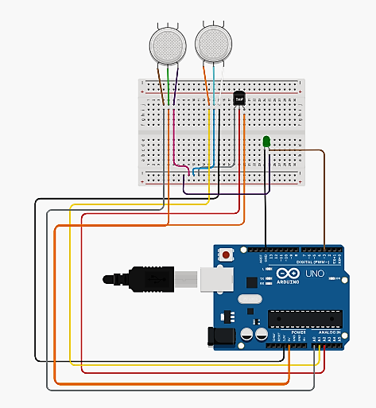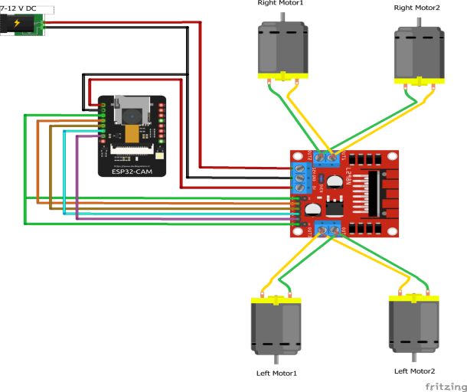
Figure B:Motors Connectivity
Figure A:Sensors Connectivity

Conclusion: This chapter described the connectivity for sensors and actuators in robot connect mobile through WiFi is expalined in detail. It will helpful for a person to control by using their mobile with Robot through wifi.

References:

- Balogh Tibor, Viliam Fedak, Frantisek Durovsky Dept. Of Electrical Engineering and Mechatronics, FEI TU of Kosice, Slovak Republic.
- Sensor Technology Advances and Future Trends by Olfa Kanon and Hans-Rolf Trankler Chemnitz University of Technology Germany.
- Prof. Rohini Rathod, Vickey Pawar, Shivam Mandal, Vikas Iyer Mitra Road, Thane, Maharashtra, Department of Electronics Engineering Shree L.R. Tiwari College of Engineering, Mumbai, India.
- T. Takemoto et al., “Evolution of Information and Control Systems for Water and Sewerage,” Hitachi Hyoron, 95, pp. 528–533 (Aug. 2013) in Japanese.
- Y. Tachibana, “Overview of Amendments to Flood Protection and Other Laws,” Journal of Japan Sewage Works Association, 52, 634, pp. 56–63 (Aug. 2015) in Japanese. Japan Sewer Optical Fiber Technological Association, http://www.softa.or.jp/ in Japanese.
- H. Kawakami et al., “Development of Technology for Connecting Sewer Optical Fiber with Various Sensors,” Proceedings of 53rd Japan Annual Technical Conference on Sewerage (Jul. 2016) in Japanese.
- T. Fujimori et al., “Digitization of Field Asset Visual Inspections,” Hitachi Review, 66, pp. 100–105 (Aug. 2017).
- H. Kawakami et al., “Development of Hands-free Inspection System that Uses ICT Technology,” Proceedings of 52nd Japan Annual Technical Conference on Sewerage (Jul. 2015) in Japanese

