"Empowering Wound Care Strategies: Best Practices for Effective Wound Healing"

Dhanishta Vilas Attarde¹ and Neelu Nawani¹*
¹Microbial Diversity Research Centre, Dr. D. Y. Patil Biotechnology & Bioinformatics Institute,
Dr. D. Y. Patil Vidyapeeth, Pimpri, Pune, Maharashtra, India.
Email ID: dhanishta.attarde@dpu.edu.in
*Corresponding author: Dr. Neelu Nawani neelu.nawani@dpu.edu.in

Abstract:
Wound healing is a complex biological process that the body undergoes to repair damaged or injured tissue. It involves a series of intricate and coordinated events that aim to restore the structural and functional integrity of the affected area. Wound healing requires proper care to ensure optimal outcomes and minimize the risk of complications. Wound care stands as a critical aspect of healthcare, encompassing an array of diverse wound types, patient demographics, and evolving medical technologies. The realm of wound care strategies focuses on the most effective practices to empower successful wound healing. Through a comprehensive analysis of various wound types, patient considerations, and emerging medical advancements, this synthesizes a compendium of best practices. Covering vital areas such as wound assessment, infection mitigation, moisture control, and cutting-edge therapies, this contribution equips healthcare providers with actionable insights. By amalgamating evidence-based methodologies with innovative approaches, it offers an invaluable resource for medical professionals invested in elevating wound care standards, fostering improved healing outcomes, and ultimately enhancing patient quality of life.

Keywords: Wound healing, wound care, infection, inflammatory response, growth factors

- Introduction:
A wound is a physical injury or disruption to the body's normal anatomical structure, particularly involving the skin and underlying tissues. Wounds can result from various causes, such as trauma, cuts, burns, surgical procedures, or underlying medical conditions (Abazari, M., et al., 2022). They can vary in severity and type, including open wounds (where the skin is broken) and closed wounds (where the skin remains intact but damage occurs beneath the surface). Wounds trigger the body's natural healing processes to repair damaged tissue, prevent infection, and restore functional integrity. This complex biological process helps the body repair damaged tissue. It involves a series of overlapping phases that work together to close and restore the injured area (Gushiken, L. F. S. et al., 2021). Fig. 1 has shown the wound-healing process is divided into four main stages:
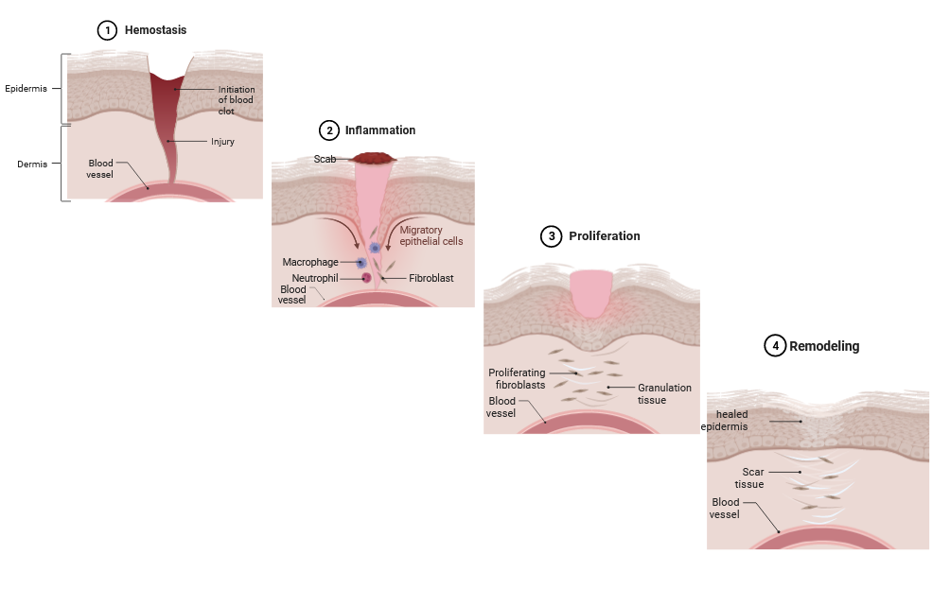
Fig. 1: Process of wound healing
1) Haemostasis: Haemostasis is a crucial process in wound healing that involves the initial steps taken by the body to control bleeding after an injury. It is the body's mechanism for maintaining the integrity of the circulatory system by preventing excessive blood loss from damaged blood vessels. It is based on Vasoconstriction, Platelet Adhesion and Activation Platelet Aggregation, Fibrin Formation, Coagulation Cascade, Clot Retraction and Repair, and Anticoagulant Regulation (Wilkinson, H. N., & Hardman, M. J., 2020). Once the damaged blood vessel has had an opportunity to heal and the repair process is underway, the clot will gradually dissolve through the fibrinolytic system. Plasminogen is converted into plasmin, an enzyme that breaks down fibrin and helps to dissolve the clot, allowing blood flow to resume normally (Tottoli, E. M., et al., 2020).
2) Inflammation: When a wound occurs, whether it's a cut, burn, or any form of tissue damage, the body initiates an inflammatory response to protect itself from potential harm and to facilitate the repair process (Fui, L. W. et al., 2019). The inflammatory response is characterized by a series of events that involve changes in blood flow, immune cell activation, and the release of various signaling molecules. The mechanism of inflammation in wounds includes; Recognition of Injury, Vasodilation, Increased Vascular Permeability, Migration of Immune Cells, Phagocytosis, Release of Inflammatory Mediators, Activation of Macrophages, Resolution of Inflammation, and Initiation of the Proliferation Phase. While it is essential for clearing infections and initiating tissue repair, excessive or prolonged inflammation can impede the healing process and lead to chronic wounds. Therefore, a balance between the inflammatory response and subsequent phases of wound healing is crucial for successful tissue repair (Abazari, M., et al., 2022).
3) Proliferation: The proliferation phase is a crucial stage in wound healing where the body focuses on rebuilding damaged tissue and restoring the wound site to its normal structure and function. This phase follows the initial inflammatory phase and is characterized by various cellular processes and events that contribute to tissue regeneration (Wilkinson, H. N., & Hardman, M. J., 2020).
During the proliferation phase, various types of cells, including fibroblasts, endothelial cells, and keratinocytes, play essential roles. Fibroblasts are responsible for producing collagen, which provides structural support to the wound. Collagen helps to fill the wound gap, bridging the edges of the wound and providing a foundation for tissue regeneration. Endothelial cells contribute to the formation of new blood vessels (angiogenesis), and keratinocytes help in re-epithelialization, forming a new layer of skin over the wounds (Fui, L. W. et al., 2019).
Endothelial cells within existing blood vessels proliferate and migrate towards the wound site in response to growth factors like vascular endothelial growth factor (VEGF) released during the inflammatory phase. These endothelial cells then form new capillaries that extend into the wound area. Afterward, Granulation tissue is a highly vascularized connective tissue that forms at the wound site. Keratinocytes cover the wound surface and migrate across the wound bed, guided by growth factors such as epidermal growth factor (EGF) and transforming growth factor-beta (TGF-β) (Eskens, O., & Amin, S., 2021). Myofibroblasts, specialized fibroblasts with contractile properties, contribute to wound closure by contracting the wound edges. This process reduces the wound size and helps to bring the wound edges closer together, promoting faster healing. As tissue regeneration progresses, the initial extracellular matrix synthesized by fibroblasts is gradually remodeled (Gushiken, L. F. S. et al., 2021).
4) Remodelling: The remodeling phase is the final stage of wound healing, following the inflammation and proliferation phases. During this phase, the tissue undergoes further structural reorganization and refinement to strengthen the healed area and restore its function as closely as possible to its original state. One of the key processes in the remodeling phase is the remodeling of the ECM, which is the intricate network of proteins and carbohydrates that provide structural support to tissues. Fibroblasts and other cells continue to produce collagen during this phase, but the type of collagen changes from type III to type I collagen, which is stronger and more resilient (Tottoli, E. M., et al., 2020). Matrix metalloproteinases (MMPs) play a crucial role in this phase by breaking down excess collagen and other ECM components, allowing for the restructuring of tissue. Collagen fibres produced during the proliferation phase are cross-linked, which increases their tensile strength and stability. This cross-linking is mediated by enzymes, which help to strengthen the collagen framework. Afterward, the granulation tissue formed in the wound area is gradually replaced by scar tissue (Karppinen, S. M., et al., 2019).
However, scar tissue is often less flexible and functional compared to the original tissue. As the wound healing process progresses, the inflammation gradually resolves. Macrophages shift from the pro-inflammatory (M1) phenotype to the anti-inflammatory (M2) phenotype, helping to dampen the immune response and promote tissue repair (Wilkinson, H. N., & Hardman, M. J., 2020). Myofibroblasts, specialized contractile cells that are present in the wound area, contribute to tissue contraction. This contraction helps to reduce the wound size and bring the wound edges closer together, aiding in wound closure. As tissue healing progresses, the newly formed blood vessels undergo maturation and refinement. Over time, the scar tissue continues to remodel and mature (Karppinen, S. M., et al., 2019). This maturation involves ongoing adjustments in collagen deposition and organization to optimize tissue strength and function. While the tissue’s structure and function are restored to a significant extent during the remodeling phase, it's important to note that the regenerated tissue might not fully replicate the original tissue's properties. The remodeled tissue might have differences in elasticity, strength, and other mechanical properties (Fui, L. W. et al., 2019).

Overall, normal cutaneous wound healing is a dynamic and coordinated process involving multiple cellular and molecular mechanisms. Disruptions in any of these processes can lead to delayed or impaired wound healing, emphasizing the importance of understanding these mechanisms to develop effective interventions and treatments for various wound types. Factors that can influence wound healing include age, overall health, nutrition, chronic diseases (like diabetes), infection, and the size and location of the wound (Fui, L. W. et al., 2019).
Proper wound care can significantly impact the healing process and minimize complications. In some cases, wound healing might be impaired due to various reasons, leading to chronic wounds. These require specialized medical attention and treatments. Chronic wounds are wounds that do not heal within the expected timeframe, typically within three months (Singer, A. J., 2022).
These wounds can persist for an extended period due to various factors that hinder the normal wound-healing process. They are a significant healthcare challenge and can lead to serious complications if not managed properly. Some common types of chronic wounds include Pressure ulcers (bedsores), Diabetic foot ulcers, Venous ulcers, etc. Factors that contribute to the development of chronic wounds such as Poor blood circulation, Infection, Diabetes, Immune system disorders, Pressure and friction, Malnutrition, etc. Identifying and addressing the underlying cause, such as improving blood circulation or managing diabetes, is also crucial for successful wound healing (Huang, S. M. et al., 2019). When wounds become infected, it subsequently leads to sepsis (Evelhoch, S. R., 2020).
Wounds, especially those that are open, deep, or surgical in nature, can become portals for infection. Bacteria, fungi, and other microorganisms can enter the wound and proliferate in a warm and moist environment, especially if the wound is not properly cleaned, dressed, or managed (Babalska, Z. Ł., et al., 2021). When microorganisms multiply within a wound, a local infection can develop. This can lead to signs of infection at the wound site, such as increased redness, swelling, warmth, pain, and the presence of pus or discharge. Local infections can be treated with appropriate wound care and, if necessary, antibiotics (Ibberson, C. B., & Whiteley, M., 2020).
If the infection in a wound is not effectively controlled, the microorganisms can enter the bloodstream, leading to bacteremia. Bacteremia is a critical step in the development of sepsis. When microorganisms and their toxins enter the bloodstream, the body's immune system responds by releasing a cascade of inflammatory molecules. This immune response is intended to fight the infection, but in sepsis, the response becomes dysregulated and can lead to widespread inflammation. The inflammatory response triggered by sepsis can affect multiple organs throughout the body. It can lead to impaired blood flow, oxygen delivery, and organ function. This can result in organ dysfunction, which can range from mild to severe. If the inflammatory response is not adequately controlled, sepsis can progress to severe sepsis, which involves organ dysfunction, and then to septic shock, which is characterized by a significant drop in blood pressure and insufficient blood flow to vital organs (Ibberson, C. B., & Whiteley, M., 2020). Many different types of microorganisms such as Staphylococcus aureus, Escherichia coli, Pseudomonas aeruginosa, Enterococcus species, Candida albicans, etc. can cause infections that lead to sepsis. Sepsis can develop from infections originating in wounds, the respiratory tract, the urinary tract, the bloodstream, and other areas of the body. Proper wound care, including thorough cleaning, appropriate dressing selection, and monitoring for signs of infection, is essential in reducing the risk of wound-related sepsis (Wilkinson, H. N. et al., 2020).

- Importance of Wound care with various treatments:
Wound care stands as a critical aspect of healthcare, encompassing an array of diverse wound types, patient demographics, and evolving medical technologies (Moore, Z., et al., 2019). Wound care is crucial for several reasons, as it plays a vital role in promoting proper wound healing and preventing complications. Proper wound care, including cleaning and dressing the wound, helps reduce the risk of infection, which can lead to serious complications and delay healing (Ibberson, C. B., & Whiteley, M., 2020). Wound care can create an optimal environment for the body's natural healing processes. Keeping the wound clean and moist, using appropriate dressings, and managing factors like inflammation can help speed up the healing process. Wound care can involve various treatments, depending on the type of wound, its severity, and individual patient factors (Moore, Z., et al., 2019).

Wound care treatments include:
- Cleaning the wound:
Cleaning the wound with the application of antiseptic agents is a initial step in wound care, crucial for preventing infection and promoting healing. The process begins by gently irrigating the wound using a sterile solution to remove debris, dirt, and contaminants. Antiseptic agents, such as hydrogen peroxide or povidone-iodine, may then be applied to the wound area to further disinfect and reduce the microbial load. These agents help eliminate harmful bacteria and pathogens that could impede the healing process (Babalska, Z. Ł., et al., 2021).
However, it's important to use antiseptics judiciously, as excessive use can disrupt the natural healing process by damaging healthy cells and delaying wound closure. Careful consideration of the wound type, depth, and level of contamination guides the choice of antiseptic and the frequency of application (Babalska, Z. Ł., et al., 2021). This combined approach of cleaning the wound and utilizing antiseptics establishes a hygienic foundation for effective wound management, safeguarding against infections, and nurturing an environment conducive to optimal healing (Evelhoch, S. R., 2020).

- Dressings:
Wound dressings play an indispensable role in the realm of wound care, assuming a multifaceted role as both protectors and facilitators of the body's innate healing mechanisms. Their significance stems from their ability to create an environment conducive to the intricate process of tissue regeneration and recovery. The selection of a specific dressing type hinges upon the nuanced interplay of factors including the wound's distinct characteristics, its phase of healing, and the individual patient's requirements. The diverse array of wound dressings available caters to this complexity, providing tailored solutions that address varying scenarios (Sheokand, B., et al, 2023).
Fig. 2 shows different types of dressings; Sterile gauze dressings, constructed from simple yet versatile materials such as woven cotton or cotton blends, offer absorbency and protection, rendering them particularly suitable for wounds that exude fluids. Their versatility extends to customization, as they can be tailored to fit wounds of varying sizes, and secured with medical tape or bandages (Gardikiotis, I., et al., 2022).
Non-adherent dressings, in contrast, prioritize delicate healing tissue by minimizing adhesion to the wound bed. This aspect proves vital for wounds that are highly sensitive or prone to damage upon dressing removal (Kanikireddy, V., et al., 2020).
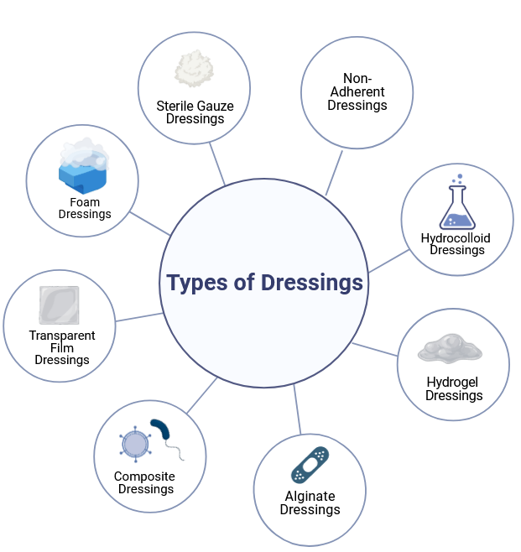
Fig. 2: Various types of dressing for wounds
Hydrocolloid dressings introduce a unique strategy, forming a gel-like barrier that not only shields the wound but also interacts with the exudate to foster a healing-conducive moist environment. In situations involving moderate exudate, these dressings are especially advantageous (Holmes, S. P., et al., 2022).
Hydrogel dressings, enriched with water, maintain the ideal moisture level crucial for efficient healing, serving as a soothing solution for wounds in need of hydration or those that are inherently painful (Chen, J., et al., 2022).
Foam dressings, lauded for their absorbency, cater to wounds manifesting diverse exudate levels, promoting a balanced healing environment while effectively managing excess fluids (Xie, F., et al., 2022).
Alginate dressings, derived from seaweed, display remarkable absorbent capabilities that prove invaluable for wounds burdened with heavy exudate. Their role extends to supporting autolytic debridement, enabling the body's natural process of dead tissue removal (Varaprasad, K., et al., 2020).
Transparent film dressings emerge as an innovative choice, offering visibility to wound healing progression. Their thin, adhesive composition makes them fitting for superficial wounds or as secondary protection to underlying dressings (Gardikiotis, I., et al., 2022). Composite dressings exhibit versatility through their layered composition, combining diverse materials to offer comprehensive functions such as exudate absorption, moisture maintenance, and guarding against external contaminants (Kanikireddy, V., et al., 2020). Wound dressings are a testament to the meticulous consideration given to the intricate demands of wound care, reflecting a commitment to healing optimization and patient well-being (Nuutila, K. et al., 2021).

- Antibiotics:
In managing infected wounds or wounds susceptible to infection, the administration of topical or systemic antibiotics plays a pivotal role in both curbing the infection and fostering the healing process. The choice of antibiotic depends on the nature and severity of the wound, with a range of options tailored to specific scenarios (El-Salamouni, N. S., et al., 2021).
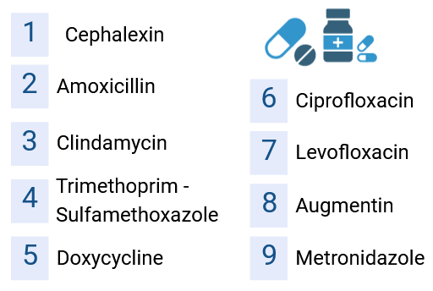
Fig. 3: List of antibiotics used for wound healing
Amoxicillin is often utilized for minor cuts, scrapes, and abrasions, while cephalexin addresses cellulitis and mild to moderate infected wounds (Cederwall, I., 2022). Clindamycin finds its purpose in treating deep or infected wounds and abscesses, (McKeown, K. E., et al., 2022). and Trimethoprim-Sulfamethoxazole (TMP-SMX) is employed for wound infections stemming from various bacteria, including the notorious MRSA (Fukuta, Y., et al., 2023). Doxycycline, on the other hand, is well-suited for burns, puncture wounds, animal bites, and infected wounds, while ciprofloxacin targets deep or complex wound infections, as well as surgical site infections (Hu, Y., et al., 2023). Levofloxacin's efficacy extends to diabetic foot ulcers with infections and deep skin infections (El-Salamouni, N. S., et al., 2021), whereas Augmentin (Amoxicillin-Clavulanate) is reserved for infected wounds boasting mixed bacterial flora and severe skin and soft tissue infections (Khalil, B., et al., 2023). Metronidazole takes on the task of combating wound infections caused by anaerobic bacteria. The strategic application of these antibiotics underscores a comprehensive approach to wound care, enabling infection management and facilitating the intricate process of wound healing (Ramalingam, R. et al., 2020).

- Debridement:
Debridement, a fundamental aspect of wound care, entails the meticulous removal of dead or contaminated tissue from wounds, thereby fostering an environment conducive to effective healing. Several techniques are employed to achieve this objective, each tailored to specific wound characteristics (Nazarko, L., 2023).
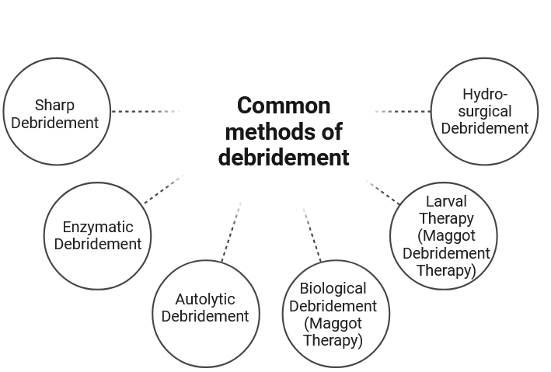
Fig. 4: Common methods of debridement that are used on wounds

Fig. 4 shows common methods of debridement that are used on wounds. It is suggested that Sharp debridement, the most common method, employs surgical instruments to expertly eliminate necrotic tissue, making it suitable for wounds abundant in non-viable material and typically conducted by trained healthcare professionals. Enzymatic debridement deploys agents like collagenase to dissolve necrotic tissue, primarily for wounds with specific necrotic types. Autolytic debridement relies on the body's enzymes and moisture to break down necrotic tissue, facilitated by a moist wound environment through proper dressings (Moore, S. A., & Moore, A. Y., 2021).
Biological debridement or maggot therapy employs medical-grade maggots to feed on necrotic tissue, particularly in cases unsuitable for other methods (Baig, M. S., et al., 2023). Larval therapy, a variant of maggot therapy, employs sterile maggots for precise dead tissue removal (Nazarko, L., 2023).
Lastly, hydro-surgical debridement, employing high-pressure water jets, excels in removing necrotic tissue from debris-laden wounds. These techniques collectively underscore the significance of debridement in optimizing wound healing outcomes (Ramalingam, R. et al., 2020).

- Negative Pressure Wound Therapy (NPWT):
Negative Pressure Wound Therapy (NPWT), also recognized as vacuum-assisted closure, stands as a dynamic approach in wound management through its application of controlled negative pressure to the wound site. This technique orchestrates a symphony of benefits that collectively orchestrate accelerated healing (Kim, P. J., et al., 2020).
By inducing controlled negative pressure, NPWT induces a cascade of effects that fundamentally transform wound healing dynamics. Blood flow amplification becomes evident, fostering enhanced oxygen and nutrient delivery to the wound, thus nurturing a hospitable environment for tissue regeneration. Concurrently, swelling is curtailed, relieving pressure on delicate tissues and diminishing the risk of ischemia (Paolini, G., et al., 2022).
Yet perhaps most remarkable is NPWT's capacity to instigate the growth of healthy tissue, an attribute indispensable for optimal healing outcomes. From the realm of pressure ulcers, NPWT assumes the role of a catalyst in tissue granulation, exudate reduction, and wound contraction, thereby spearheading the journey toward healing. Diabetic foot ulcers, notorious for their non-healing nature, are no match for NPWT's prowess, as it not only hastens healing but also curbs infection risk and navigates wound complexities. Post-surgical wounds, particularly those arising from intricate procedures, find NPWT as a trustworthy ally in navigating the complexities of wound closure while mitigating the looming threat of infection (Lim, X., et al., 2021).
In the outcome of accidents, injuries, or burns, NPWT demonstrates its remarkable ability to accelerate healing and temper scarring (Abazari, M., et al., 2022). Chronic wounds, seemingly resistant to conventional healing strategies, meet their match in NPWT, which harnesses tissue stimulation to orchestrate closure in cases such as venous leg ulcers and arterial ulcers. The success of grafts and flaps finds its partner in NPWT, whose augmentation of blood flow and tissue vitality enhances the odds of prosperous outcomes (Faust, E., et al., 2023).
When wounds lay bare bone, tendon, or muscle, NPWT's protective embrace becomes paramount, nurturing these vulnerable structures while catalyzing healing. Even in the realm of inflammatory skin conditions as severe as necrotizing fasciitis or pyoderma gangrenosum, NPWT proves its mettle as a versatile tool in the management of complex skin pathologies. NPWT emerges as a beacon of hope in wound care, transforming challenges into opportunities and rewriting the narrative of wound healing (Orlov, A. et al., 2023).

- Wound Irrigation:
Wound irrigation, a fundamental component of wound care, entails the methodical flushing of wounds using a sterile solution. This approach serves a paramount role in purging the wound of contaminants and bacteria, a pivotal step in mitigating the risk of infection and cultivating an environment conducive to optimal healing (Lewis, K., & Pay, J. L., 2023). Firstly, it acts as a potent agent of debris removal, effectively washing away a gamut of foreign particles, dirt, harmful microorganisms, and necrotic tissue that could impede the healing process. This elimination of extraneous elements serves as the foundation for unencumbered recovery. Secondly, wound irrigation assumes the mantle of infection prevention, achieving this through its diligent expulsion of contaminants. By mitigating the presence of potential pathogens, irrigation acts as a vanguard against infection, safeguarding the wound's integrity and bolstering the potential for uncomplicated healing (Saeg, F., et al., 2021).
Lastly, the therapeutic potential of wound irrigation extends to its capacity for stimulating the body's innate healing mechanisms. Through the creation of a pristine wound bed, irrigation invigorates the natural processes of tissue regeneration, promoting an environment conducive to healing at an optimal pace (Lewis, K., & Pay, J. L. (2023). Wound irrigation represents a multifaceted intervention that not only purifies the wound site but also underpins the foundational principles of infection control and accelerated healing (Ramalingam, R. et al., 2020).

- Growth factors:
Growth factors play a critical role in wound healing by regulating various processes that contribute to tissue repair and regeneration. Growth factors can be delivered topically, in gel or cream form, or through more advanced methods like wound dressings impregnated with growth factors some of them are mentioned in Fig. 5 (Viaña‐Mendieta, P., et al., 2022).
They are often used in chronic wounds, burns, and other situations where the natural healing process is impaired. These key factors include Epidermal Growth Factor (EGF), driving epidermal cell division and migration (Eskens, O., & Amin, S., 2021), Platelet-derived Growth Factor (PDGF), inducing cell proliferation, angiogenesis, and collagen production, and Transforming Growth Factor-Beta (TGF-β), governing cell growth and tissue repair, promoting collagen synthesis, and aiding wound contraction (Viaña‐Mendieta, P., et al., 2022).
Fibroblast Growth Factor (FGF) stimulates fibroblast proliferation, collagen synthesis, and angiogenesis, while Vascular Endothelial Growth Factor (VEGF) promotes angiogenesis for improved blood vessel growth and oxygen supply (Goswami, A. G., et al., 2022).
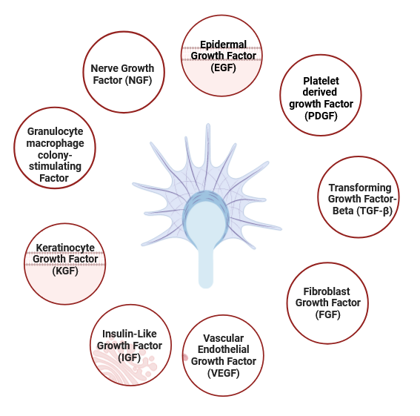
Fig. 5: Growth factors involved in wound healing
Insulin-like growth Factor (IGF) spurs cell proliferation, collagen synthesis, and tissue repair, and Keratinocyte Growth Factor (KGF) specifically aids in keratinocyte growth and migration, vital for epidermal regeneration (Garoufalia, Z., et al., 2021).
Granulocyte-macrophage colony-stimulating Factor (GM-CSF) fosters white blood cell growth and differentiation (Ead, J. K., & Armstrong, D. G., 2023), while Nerve Growth Factor (NGF) facilitates nerve regeneration in wounds involving nerve damage. These growth factors contribute to wound healing, forming an environment primed for successful tissue regeneration and repair (Ramalingam, R. et al., 2020).
The application of growth factors requires careful consideration and should be performed under the guidance of a healthcare professional to ensure appropriate dosing and monitoring (Öhnstedt, E. et al., 2019).
- Hyperbaric Oxygen Therapy (HBOT):
Hyperbaric Oxygen Therapy (HBOT) emerges as a medical intervention encompassing the inhalation of pure oxygen within a specially designed chamber, operating at higher atmospheric pressures than usual. This treatment strategy capitalizes on two pivotal mechanisms: escalated oxygen levels and enhanced oxygen dissolution (Lucero Ortega, K. E., 2022).
By delivering elevated oxygen concentrations to bodily tissues, including wounds, HBOT aims to stimulate healing and combat infections. Its efficacy spans diverse medical conditions, particularly certain types of wounds. HBOT manifests through various forms, each tailored to specific requirements (Tejada, S., et al., 2019).
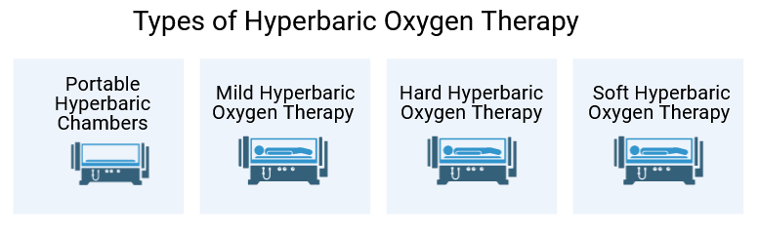
Fig. 6: Common Types of Hyperbaric Oxygen Therapy Use for wound healing
Fig. 6 has mentioned Some common Types of Hyperbaric Oxygen Therapy Used for Wound Healing. Portable hyperbaric chambers, more accessible in size and cost, find utilization in wellness centers and alternative medicine practices, though their pressure levels are generally lower than clinical-grade counterparts. Mild Hyperbaric Oxygen Therapy (mHBOT) requires oxygen inhalation at slightly above standard atmospheric pressure, often applied for wellness and sports-related purposes (Fadol, E. M., et al., 2021).
In contrast, hard HBOT entails inhaling 100% oxygen at pressures exceeding 1.5 ATA, suitable for conditions like decompression sickness, carbon monoxide poisoning, and severe infections. Soft HBOT, skin-to-hard HBOT but at pressures below 1.5 ATA, is typically associated with wellness centers, fostering overall health and well-being (Oley, M. H. et al., 2023).

- Bioengineered skin substitutes:
Bioengineered skin substitutes represent a remarkable leap forward in wound care, offering a diverse array of artificial materials tailored to expedite tissue regeneration and wound closure (Tavakoli, S., & Klar, A. S., 2021). Among these, Cellular Skin Substitutes exhibit the extraordinary potential of living cells, meticulously cultured within laboratory settings before being applied to wounds. This category encompasses an array of specialized cells, including keratinocytes responsible for skin structure, fibroblasts that compose collagen production, and other cell types pivotal for healing (Oualla-Bachiri, W., et al., 2020).
In contrast, Acellular Skin Substitutes usher in a unique approach devoid of living cells, instead relying on extracellular matrix components and bioactive elements like growth factors (Kopecký, A., et al., 2021). This composition effectively orchestrates the construction of a scaffold that supports new tissue growth and expedites the intricate process of wound healing. Then further expands with Composite Skin Substitutes, ingeniously merging living cells with acellular components to capitalize on the dual strengths of cellular activity and scaffold support (Tavakoli, S., & Klar, A. S., 2021).
The choice among these treatments’ rests upon an intricate interplay of variables, spanning wound type, potential infection, patient health status, and the stage of wound healing. Ultimately, these bioengineered skin substitutes stand as a testament to the confluence of cutting-edge science and compassionate care, propelling the boundaries of wound management to new horizons (Zidarič, T. et al., 2023).

- Challenges:
Many challenges that researchers, medical professionals, and patients might encounter when implementing effective wound care strategies and treatment. Some of these challenges include:
Types of Wounds: Different types of wounds, such as acute wounds, chronic wounds, surgical wounds, and pressure ulcers, require tailored approaches to treatment (Falcone, M., et al., 2021).
Developing strategies that address the unique characteristics of each wound type can be challenging. Infection Control, Wounds are vulnerable to infections, which can significantly delay the healing process and lead to severe complications (Moore, Z., et al., 2019). Implementing infection control measures while also promoting wound healing requires a delicate balance. Patients may struggle with adhering to wound care regimens due to factors like discomfort, inconvenience, or lack of understanding. Educating patients about the importance of proper wound care and finding ways to enhance compliance can be difficult. Underlying Health Conditions: Patients with underlying health conditions like diabetes, and immunosuppression may experience delayed wound healing. Tailoring wound care strategies to address these underlying issues is essential for successful outcomes. Pain Management in Wound care procedures can be painful, which can lead to patient discomfort and anxiety. Balancing effective wound care with pain management is an ongoing challenge (Arif, M. M., et al., 2021).
For patients with limited mobility, the prevention of pressure ulcers is crucial. However, achieving this goal requires consistent repositioning and specialized support surfaces, which might not always be readily available. Wound care often involves collaboration between various healthcare professionals such as physicians, nurses, wound care specialists, and nutritionists (Mahmoudi, M., & Gould, L. J., 2020). Coordinating efforts and ensuring effective communication among these professionals can be a challenge. The elderly are more prone to chronic wounds due to age-related changes in the skin and underlying health conditions. Developing wound care strategies that are suitable for this population's unique needs can be demanding (Falcone, M., et al., 2021).

- Future perspective and conclusion:
The convergence of medical breakthroughs, technology integration, and patient-centered care promises a new era of healing possibilities. With an aging population and an increasing prevalence of chronic diseases, the demand for effective wound care strategies will only grow. As such, continuous research, innovation, and education will remain essential to stay at the forefront of advancements in wound care. In the years to come, wounds will be treated with precision therapies, monitored intelligently, and empowered by patients themselves. The journey to recovery will be guided by data-driven insights, delivered through telehealth platforms, and aided by regenerative interventions.
Its multidimensional approach not only enriches the existing understanding of wound care best practices but also underscores the ever-evolving nature of this critical healthcare domain. As we continue to unravel the complexities of wound healing, this compilation serves as a beacon of guidance, fostering a holistic and patient-centric approach that has the potential to reshape the future of wound care practices. The journey to effective wound healing is evolving, and the best practices of tomorrow are paving the way for a healthier, more empowered world.

References:
- Fui, L. W., Lok, M. P. W., Govindasamy, V., Yong, T. K., Lek, T. K., & Das, A. K. (2019). Understanding the multifaceted mechanisms of diabetic wound healing and therapeutic application of stem cells conditioned medium in the healing process. Journal of tissue engineering and regenerative medicine, 13(12), 2218-2233.
- Wilkinson, H. N., & Hardman, M. J. (2020). Wound healing: Cellular mechanisms and pathological outcomes. Open biology, 10(9), 200223.
- Gushiken, L. F. S., Beserra, F. P., Bastos, J. K., Jackson, C. J., & Pellizzon, C. H. (2021). Cutaneous wound healing: An update from physiopathology to current therapies. Life, 11(7), 665.
- Huang, S. M., Wu, C. S., Chiu, M. H., Wu, C. H., Chang, Y. T., Chen, G. S., & Lan, C. C. E. (2019). High glucose environment induces M1 macrophage polarization that impairs keratinocyte migration via TNF-α: An important mechanism to delay the diabetic wound healing. Journal of dermatological science, 96(3), 159-167.
- Öhnstedt, E., Lofton Tomenius, H., Vågesjö, E., & Phillipson, M. (2019). The discovery and development of topical medicines for wound healing. Expert opinion on drug discovery, 14(5), 485-497.
- Nuutila, K., & Eriksson, E. (2021). Moist wound healing with commonly available dressings. Advances in wound care, 10(12), 685-698.
- Ramalingam, R., Dhand, C., Mayandi, V., Leung, C. M., Ezhilarasu, H., Karuppannan, S. K., ... & Arunachalam, K. D. (2021). Core–shell structured antimicrobial nanofiber dressings containing herbal extract and antibiotics combination for the prevention of biofilms and promotion of cutaneous wound healing. ACS applied materials & interfaces, 13(21), 24356-24369.
- Oley, M. H., Oley, M. C., Durry, M. F., Adam, R. N., Gunawan, D. F., & Faruk, M. (2022). Fostering a faster post-operative wound healing process with hyperbaric oxygen therapy in a rare case of squamous odontogenic tumor. International Journal of Surgery Case Reports, 90, 106718.
- Zidarič, T., Kleinschek, K. S., Maver, U., & Maver, T. (2023). Bioengineered Skin Substitutes. In Function-Oriented Bioengineered Skin Equivalents: Continuous Development Towards Complete Skin Replication (pp. 11-43). Cham: Springer International Publishing.
- Orlov, A., & Gefen, A. (2022). The potential of a canister‐based single‐use negative‐pressure wound therapy system delivering a greater and continuous absolute pressure level to facilitate better surgical wound care. International Wound Journal, 19(6), 1471-1493.
- Singer, A. J. (2022). Healing mechanisms in cutaneous wounds: Tipping the balance. Tissue Engineering Part B: Reviews, 28(5), 1151-1167.
- Abazari, M., Ghaffari, A., Rashidzadeh, H., Badeleh, S. M., & Maleki, Y. (2022). A systematic review on classification, identification, and healing process of burn wound healing. The International Journal of Lower Extremity Wounds, 21(1), 18-30.
- Chen, J., He, J., Yang, Y., Qiao, L., Hu, J., Zhang, J., & Guo, B. (2022). Antibacterial adhesive self-healing hydrogels to promote diabetic wound healing. Acta biomaterialia, 146, 119-130.
- Tottoli, E. M., Dorati, R., Genta, I., Chiesa, E., Pisani, S., & Conti, B. (2020). Skin wound healing process and new emerging technologies for skin wound care and regeneration. Pharmaceutics, 12(8), 735.
- Karppinen, S. M., Heljasvaara, R., Gullberg, D., Tasanen, K., & Pihlajaniemi, T. (2019). Toward understanding scarless skin wound healing and pathological scarring. F1000Research, 8.
- Ibberson, C. B., & Whiteley, M. (2020). The social life of microbes in chronic infection. Current opinion in microbiology, 53, 44-50.
- Evelhoch, S. R. (2020). Biofilm and chronic nonhealing wound infections. Surgical Clinics, 100(4), 727-732.
- Moore, Z., Dowsett, C., Smith, G., Atkin, L., Bain, M., Lahmann, N. A., ... & Jaimes, H. (2019). TIME CDST: an updated tool to address the current challenges in wound care. Journal of wound care, 28(3), 154-161. PMID: 30840549, DOI: 10.12968/jowc.2019.28.3.154
- Babalska, Z. Ł., Korbecka-Paczkowska, M., & Karpiński, T. M. (2021). Wound antiseptics and European guidelines for antiseptic application in wound treatment. Pharmaceuticals, 14(12), 1253.
- Sheokand, B., Vats, M., Kumar, A., Srivastava, C. M., Bahadur, I., & Pathak, S. R. (2023). Natural polymers used in the dressing materials for wound healing: Past, present and future. Journal of Polymer Science.
- Gardikiotis, I., Cojocaru, F. D., Mihai, C. T., Balan, V., & Dodi, G. (2022). Borrowing the features of biopolymers for emerging Wound Healing Dressings: a review. International Journal of Molecular Sciences, 23(15), 8778.
- Kanikireddy, V., Varaprasad, K., Jayaramudu, T., Karthikeyan, C., & Sadiku, R. (2020). Carboxymethyl cellulose-based materials for infection control and wound healing: A review. International Journal of Biological Macromolecules, 164, 963-975.
- Varaprasad, K., Jayaramudu, T., Kanikireddy, V., Toro, C., & Sadiku, E. R. (2020). Alginate-based composite materials for wound dressing application: A mini review. Carbohydrate polymers, 236, 116025.
- Xie, F., Zou, L., Xu, Z., Ou, X., Guo, W., Gao, Y., & Gao, G. (2022). Alginate foam gel modified by graphene oxide for wound dressing. International Journal of Biological Macromolecules, 223, 391-403.
- Holmes, S. P., Rivera, S., Hooper, P. B., Slaven, J. E., & Que, S. K. T. (2022). Hydrocolloid dressing versus conventional wound care after dermatologic surgery. JAAD international, 6, 37-42.
- Cederwall, I. (2022). Topical formulation of antimicrobials for wound care.
- McKeown, K. E., Baker, R. B., & Bell, T. (2022). Staphylococcal scalded skin syndrome, identification, and wound care: a case report series. Advances in Neonatal Care, 22(4), 325-332.
- Hu, Y., Yu, B., Jia, Y., Lei, M., Li, Z., Liu, H., Haishui Huang , Feng Xu , Jing Li & Wei, Z. (2023). Hyaluronate-and gelatin-based hydrogels encapsulating doxycycline as a wound dressing for burn injury therapy. Acta Biomaterialia, 164, 151-158. PMID: 37088160, DOI: 10.1016/j.actbio.2023.04.021 .
- Fukuta, Y., Chua, H., Phe, K., Poythress, E. L., & Brown, C. A. (2022). Infectious Diseases Management in Wound Care Settings: Common Causative Organisms and Frequently Prescribed Antibiotics. Advances in Skin & Wound Care, 35(10), 535-543.
- El-Salamouni, N. S., Gowayed, M. A., Seiffein, N. L., Abdel-Moneim, R. A., Kamel, M. A., & Labib, G. S. (2021). Valsartan solid lipid nanoparticles integrated hydrogel: A challenging repurposed use in the treatment of diabetic foot ulcer, in-vitro/in-vivo experimental study. International Journal of Pharmaceutics, 592, 120091.
- Hollingshead, C., & Simman, R. (2023). Successful use of amoxicillin-clavulanate acid in a patient with severe wound infection with wound communication secondary to Actinomyces. Wounds: a Compendium of Clinical Research and Practice, 35(2), E88-E89. Khalil, B.,
- Nazarko, L. (2023). Managing Leg Ulcers in a Primary Care Setting. Independent Nurse, 2023(5), 20-25.
- Baig, M. S., Banu, A., Zehravi, M., Rana, R., Burle, S. S., Khan, S. L., Fahadul Islam, Falak A. Siddiqui, Ehab El Sayed Massoud, Md. Habibur Rahman, & Cavalu, S. (2022). An overview of diabetic foot ulcers and associated problems with special emphasis on treatments with antimicrobials. Life, 12(7), 1054. doi: 10.3390/life12071054.
- Moore, S. A., & Moore, A. Y. (2021). The Role of Biofilms and the Microbiome. In Overcoming Antimicrobial Resistance of the Skin (pp. 203-213). Cham: Springer International Publishing.
- Paolini, G., Sorotos, M., Firmani, G., Gravili, G., Ceci, D., & Santanelli di Pompeo, F. (2022). Low-vacuum negative pressure wound therapy protocol for complex wounds with exposed vessels. Journal of Wound Care, 31(1), 78-85. PMID: 35077217, DOI: 10.12968/jowc.2022.31.1.78 .
- Lim, X., Zhang, L., Hong, Q., Yong, E., Neo, S., Chandrasekar, S., Glenn Wei Leong Tan & Lo, Z. J. (2021). Novel home use of mechanical negative pressure wound therapy in diabetic foot ulcers. Journal of Wound Care, 30(12), 1006-1010. PMID: 34882000, DOI: 10.12968/jowc.2021.30.12.1006 .
- Faust, E., Opoku-Agyeman, J. L., & Behnam, A. B. (2021). Use of negative-pressure wound therapy with instillation and dwell time: an overview. Plastic and reconstructive surgery, 147(1S-1), 16S-26S.
- Kim, P. J., Attinger, C. E., Constantine, T., Crist, B. D., Faust, E., Hirche, C. R., ... & Téot, L. (2020). Negative pressure wound therapy with instillation: international consensus guidelines update. International Wound Journal, 17(1), 174-186.
- Saeg, F., Schoenbrunner, A. R., & Janis, J. E. (2021). Evidence-based wound irrigation: separating fact from fiction. Plastic and reconstructive surgery, 148(4), 601e-614e.
- Lewis, K., & Pay, J. L. (2023). Wound irrigation. In StatPearls [Internet]. StatPearls Publishing.
- Viaña‐Mendieta, P., Sánchez, M. L., & Benavides, J. (2022). Rational selection of bioactive principles for wound healing applications: Growth factors and antioxidants. International Wound Journal, 19(1), 100-113.
- Eskens, O., & Amin, S. (2021). Challenges and effective routes for formulating and delivery of epidermal growth factors in skin care. International Journal of Cosmetic Science, 43(2), 123-130.
- Goswami, A. G., Basu, S., Huda, F., Pant, J., Ghosh Kar, A., Banerjee, T., & Shukla, V. K. (2022). An appraisal of vascular endothelial growth factor (VEGF): The dynamic molecule of wound healing and its current clinical applications. Growth Factors, 40(3-4), 73-88.
- Garoufalia, Z., Papadopetraki, A., Karatza, E., Vardakostas, D., Philippou, A., Kouraklis, G., & Mantas, D. (2021). Insulin-like growth factor-I and wound healing, a potential answer to non-healing wounds: A systematic review of the literature and future perspectives. Biomedical Reports, 15(2), 1-5.
- Ead, J. K., & Armstrong, D. G. (2023). Granulocyte‐macrophage colony‐stimulating factor: Conductor of the wound healing orchestra?. International Wound Journal, 20(4), 1229-1234.
- Tejada, S., Batle, J. M., Ferrer, M. D., Busquets-Cortés, C., Monserrat-Mesquida, M., Nabavi, S. M., ... & Sureda, A. (2019). Therapeutic effects of hyperbaric oxygen in the process of wound healing. Current pharmaceutical design, 25(15), 1682-1693.
- Fadol, E. M., Suliman, H. M., Osman, B., Abdalla, S. A., Osman, W. J., Mohamed, E. M., & Abdoon, I. H. (2021). Therapeutic outcomes evaluation of adjuvant hyperbaric oxygen therapy for non-healing diabetic foot ulcers among sudanese patients. Diabetes & Metabolic Syndrome: Clinical Research & Reviews, 15(4), 102173.
- Lucero Ortega, K. E. (2022). Hyperbaric Oxygen Therapy and Wound Healing.
- Tavakoli, S., & Klar, A. S. (2021). Bioengineered skin substitutes: Advances and future trends. Applied Sciences, 11(4), 1493.
- Kopecký, A., Němčanský, J., Kratky, V., Rokohl, A. C., & Heindl, L. M. (2021). Bioengineered Dermal Substitutes for Periocular Defects. Ann. Eye Sci, 6(16), 10-21037.
- Oualla-Bachiri, W., Fernández-González, A., Quiñones-Vico, M. I., & Arias-Santiago, S. (2020). From grafts to human bioengineered vascularized skin substitutes. International journal of molecular sciences, 21(21), 8197.
- Arif, M. M., Khan, S. M., Gull, N., Tabish, T. A., Zia, S., Khan, R. U., Sayed Muhammad Awais & Butt, M. A. (2021). Polymer-based biomaterials for chronic wound management: Promises and challenges. International Journal of Pharmaceutics, 598, 120270. doi: 10.1016/j.ijpharm.2021.120270.
- Falcone, M., De Angelis, B., Pea, F., Scalise, A., Stefani, S., Tasinato, R., Orazio Zanetti & Dalla Paola, L. (2021). Challenges in the management of chronic wound infections. Journal of global antimicrobial resistance, 26, 140-147.
- Mahmoudi, M., & Gould, L. J. (2020). Opportunities and challenges of the management of chronic wounds: a multidisciplinary viewpoint. Chronic Wound Care Management and Research, 27-36. DOI:10.2147/CWCMR.S260136.
- Images Created with BioRender.com

