FORMULATION AND SHELF-LIFE ASSESSMENT OF WATERMELON (CITRULLUS LANATUS) SEEDS CHIKKI

Sujitha V¹, Uthira L ² and Padmapriya V³

Post Graduate student¹, Associate Professor², Research Scholar³

*^{1,2,3}Department of Nutrition and Dietetics, PSG college of arts and science – Coimbatore

ABSTRACT

Food production and consumption generate a significant amount of processing waste, with fruit waste accounting for a large portion. Cucurbits with thick rinds, such as watermelons, musk melons, and pumpkins, produce large amounts of waste during their consumption. However, using natural 'food waste,' such as seeds and peels, which are high in vital nutrients, is being promoted as a long-term solution to food insecurity. Watermelon seeds was chosen for this study because they are the most discarded fruit seed. The procured watermelon seed was analysed for its proximate composition which is composed of good amounts of protein and fat (28.3g and 47.2g/100g). Three different varieties of Chikkis were made from watermelon seeds, but Variation II is the one used for the proximate analysis of Chikkis because it had the highest mean score during the organoleptic evaluation. The carbohydrate and protein contents of the watermelon seed Chikkis were 52.5g and 14.1g per 100g respectively. Chikkis were packed in an air tight container and stored at room temperature to evaluate moisture loss or gain over a period of 50 days. Overall, the results suggest that the utilization and consumption of watermelon seeds can promote and preserve health and the use of watermelon seeds for consumption will be a step forward for sustainable development to reduce food waste.

KEYWORDS

Fruit waste, food insecurity, watermelon seeds, Chikkis, Food sustainability

1.INTRODUCTION

Over the past few decades, the use of supplements in the form of functional foods and nutraceuticals to address vitamin insufficiency has gained widespread acceptance (1). Consequently, there has been a greater emphasis on the exploitation of food waste and underutilized agricultural products with high nutritional value. This type of application can aid in the efficient use of available resources of the development for new food products with improved nutritional and sensory qualities. Citrullus lanatus, also known as watermelon, is a tropical fruit that belongs to the gourd family and is native to the Kalahari Desert in Southern Africa. Water melon is a monoecious fruit that is cultivated for its large and juicy edibility. The most commonly thrown oil seeds are those from watermelon. Seeds, like soybeans, sunflowers, and ground nuts, offer nutritional properties that are typically compared favorably (13). The rind of the Citrullus lanatus fruit is smooth (green, yellow and sometimes white and a juicy, sweet interior flesh). The rind is used to produce pickles, preserves, jellies, and conserves (2,3).
Citrullus lanatus can be used to make smoothies, sorbets, or granite, depending on how smooth or coarse the texture is. The rind is also edible and has been eaten as a vegetable in the past (11). They're stir-fried, stewed, or, more commonly, pickled in China. Watermelon Seeds can be crushed into coarse flour or oil extracted, and mature fruit can be cooked and eaten as summer squash in Africa (10). Watermelon seeds have shown that they can be used in the food business after the pulp and peel have been removed (4). The seeds also contain nutritionally important lipids, such as phytosterols, particularly stigmasterol and beta-sitosterol, as well as a high concentration of unsaturated fatty acids (4).
Watermelon seeds are underappreciated oil seeds that are high in proteins, minerals, and unsaturated fatty acids. Because it contains high amounts of protein and oil, the watermelon seeds which remains as waste in huge quantities after the pulp is removed, can be used to produce value -added products. India is a large watermelon producer in Asia, producing 4,31,930 tonnes and 4,320 tonnes of seeds annually (7). Watermelon seed oil has shown to be high in polyunsaturated fatty acids (PUFA) and monounsaturated fatty acids (MUFA), both of which are beneficial to human health (5). It also has high mineral content, including calcium, magnesium, iron and zinc (4). Watermelon seeds contain a higher amount of Vitamin B3 (niacin), an important nutrient that helps lower cholesterol, ease arthritis, and boost brain function as well as functions in the digestive, skin, and nervous systems. Crude proteins would act as enzymatic catalysts, influence cell responses, and regulate cell development and differentiation (12). Watermelon seeds have been used in various value-added food products such as cookies, biscuits, roti, laddu and toffee, but have not been used in the development of Chikkis. This study aims to develop Chikkis by replacing the groundnuts which are traditionally used.

2.MATERIALS AND METHODS

Dehulled watermelon seeds was procured from the local market of Hosur, Tamil Nadu. Jaggery, palm jaggery, granular jaggery and cardamom was procured from the local market of Tirupur, Tamil Nadu.

Preparation of Chikki

Chikkis were prepared in three formulations which differs by the type of sugar in each formulation. For Formulation I, watermelon seeds were dry roasted, granular jaggery syrup was heated until the temperature reaches to 112 ℃, immediately the roasted seeds and cardamom powder were added then mixed thoroughly till the seeds coat with the syrup. Hot mass was poured into the ghee greased plate. The product was then spread uniformly by rolling it with the help of a roller. By using mould ring the product was made into spherical pieces and allowed to cool for 30 minutes and stored. For Formulation II, the same procedure was repeated and instead of jaggery granules, Jaggery was used. For Formulation III, Palm jaggery is used for this formulation with the same procedure as above.

Figure 1: Process Flowchart of Watermelon Seeds Chikkis

Sensory evaluation

The organoleptic evaluation with respect to colour, hardness, crispiness, sweetness, flavor and overall acceptability was evaluated by 25 semi-trained panel members using nine hedonic scales.

Figure 2: Formulated Watermelon Seeds Chikki

Nutrient analysis

Proximate compositions such as moisture, ash, carbohydrate, energy, protein and fat were determined using standard procedures of the AOAC (ASSOCIATION OF OFFICIAL ANALYTICAL CHEMIST) method.

Statistical analysis

Sensory data were assessed for analysis of variance (ANOVA) at 5% level of significance and a value of P<0.05 was considered statistically significant using IBM SPSS program (version 20.0).

Storage studies

The Chikkis was packed in an airtight container and maintained at room temperature. The stability of the product was evaluated based on moisture gain/loss. The self-life study was conducted for 50 days.

RESULTS AND CONCLUSION

Sensory analysis

Table 1: Mean Score of Sensory Characteristics

CHARACTERISTICS | VARITAION I | VARIATION II | VARIATION III | P  VALUE
COLOUR | 7.52±0.822 | 8.12±0.781 | 7.64±0.952 | 0.037
HARDNESS | 7.68±0.852 | 7.8±0.816 | 7.4±0.866 | 0.236
CRISPINESS | 7.52±0.918 | 7.76±0.879 | 7.4±0.912 | 0.363
SWEETNESS | 7.76±0.969 | 8.16±0.687 | 7.76±1.090 | 0.222
FLAVOUR | 7.72±0.936 | 8±0.707 | 7.4±1.040 | 0.071
OVERALL  ACCEPTABILITY | 7.62±0.881 | 8.06±0.617 | 7.44±1.157 | 0.053

Taste is a basic quality parameter important for the product approval. It was found that Chikki prepared using formulation II had an overall quality score of 8.06, which was higher than that of other variations (Table 1). Based on the above results it can be concluded that Variation II was the most acceptable Chikki. Data were analyzed using analysis of variance (ANOVA). The analysis of variance revealed that there was a significant difference only between the colour of the three groups and the other parameters such as hardness, crispiness, sweetness, flavor and overall acceptability showed low significant difference

Proximate Analysis

Table 2: Proximate analysis of Watermelon Seeds and Watermelon Seeds Chikki

PARAMETERS | WATERMELON SEEDS  (100g) | WATERMELON SEEDS  CHIKKI (100g)
Energy (Kcal) | 595.9 | 440.81
Carbohydrate (g) | 15.5 | 52.5
Total protein (g) | 28.3 | 14.1
Fat (g) | 47.2 | 19.2
Total ash (g) | 3.92 | 5.91
Moisture (g) | 5.07 | 8.33

Table 2 shows the nutritive value of the procured watermelon seeds and the formulated watermelon seed chikki (variation II). The energy value was higher in seeds and chikki. The amounts of carbohydrates, total ash and moisture were higher in chikki than in raw seeds while total protein and fat content decreased in chikki compared to raw seeds. A similar trend was observed by (6) who studied the composition of watermelon seeds per 100g as moisture 5.1g, protein 28.3g, fat 47.4g and carbohydrate 15.3g.

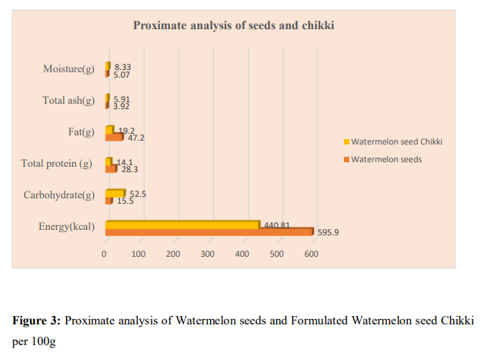

Storage Studies

Watermelon seeds may also be stored for a long time, with both the oil and fatty acid content remaining stable after six months (8).
A shelf-life study is an objective, methodical means to determine how long a food product can reasonably be expected to stay for, without any appreciable change in quality. A separate study must be conducted for each type of product. In the present study, Chikkis were stored in airtight container at room temperature. The direct method of shelf – life study was carried out to estimate the moisture loss or gain in the formulated Chikkis under stored conditions. The moisture content of the chikki for 10g was estimated using a moisture analyzer and monitored once in every 25 days for a storage period of 50 days.

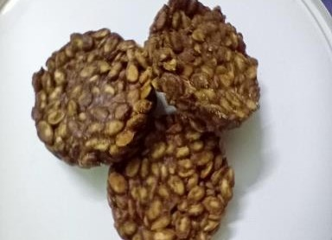
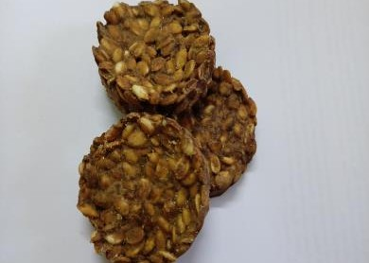
0th day 25th day
50TH day

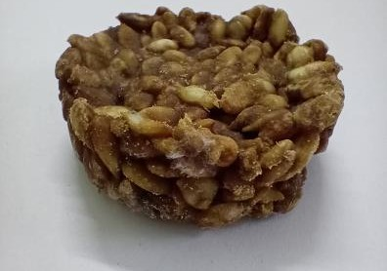

50th day

Figure 4: Shelf- Life Study on Watermelon Seeds Chikkis

Table 3: Moisture Analysis of Formulated Chikki

Category | Initial (0th day) | 25 days | Final (50th day)
Moisture content | 0.833 % M | 1.98%M | 5.25%M  (Mould Growth was seen)

The moisture content of chikki is critical as it determines the quality and stability of the product. The moisture content of chikki increased in the sample during storage. Crisp texture was observed up to 25 days after which the chikki lost its crisp and crunchy texture. A moisture content of 5% rendered the product soft and mold growth was observed in 50th day of storage. Observation on 30th ,35th ,40th ,45th day also did not reveal any mold growth. For commercialization, permitted additives can be added to increase shelf-life and maintain the texture of Chikkis.

CONCLUSION
The seed, which is a byproduct of watermelon processing, can be used to make nutritious, palatable, and health-promoting chikki. It can also be utilized by persons who are allergic to peanuts. Food processors are looking into ways to improve the nutritional value of traditional foods as consumer awareness of health and nutritious diets grows. This study sheds light on the use of watermelon seeds in a variety of goods. Watermelon seed popularization and commercialization can result in food product value addition. Awareness about the health benefits of watermelon seeds to reduce the disposal of seeds after utilization
Conflict of interest- There is no conflict of interest

REFERENCES

- Agyei, D., Potumarthi, R., & Danquah, M. K. Food-derived multifunctional bioactive proteins and peptides: Sources and production. Biotechnology of bioactive compounds. Sources and applications, (2015). 483-506.
- Dane, F. & Liu, J, Genet Resource Crop Evolution, 2007, (54)1255-1265.
- Dane, F. Lang & P., Bakhtiyarova, R, Theoretical Applied Genetics,2004, (108)958- 966. 79
- de Conto LC, Gragnani MA, Maus D, Ambiel HC, Chiu MC, Grimaldi R, Gonçalves LA. Characterization of crude watermelon seed oil by two different extractions methods. Journal of the American Oil Chemists' Society. 2011 Nov;88(11):1709-14.
- El-Adawy, T. A., & Taha, K. M. Characteristics and composition of different seed oils and flours. Food chemistry, 74(1), (2001) 47-54.
- E. Erhirhie and NE. Ekene. Medicinal Values on Citrullus lanatus (watermelon): Pharmacological Review. (OCT-DEC 2013).
- Faostat, F. A. O. Available online: http://www. fao. org/Faostat/en/# data. QC (accessed on January 2018). (2017)
- Jarret RL, Levy IJ. Oil and fatty acid contents in seed of Citrullus lanatus Schrad. Journal of agricultural and food chemistry. 2012 May 23;60(20):5199-204.
- Kaul, P. Nutritional potential, bio accessibility of minerals and functionality of watermelon (Citrullus vulgaris) seeds. LWT-Food Science and Technology, 44(8), (2011). 1821-1826.
- U S Department of Agriculture and U S Department of Health and Human service dietary guidelines for Americans, Washington, DC: U S government printing office2003 and 2006 respectively
- Wada, M, Biochemistry,1930, 2(4)221-229.
- Whitney, E. N., & Rolfes, S. R. (2005). Understanding Nutrition. 10th Edn., Thomson.
- Van der Vossen, H.A.M., Denton, O.A. and El Tahir, I.M., (2004). Citrullus lanatus (Thunb)Matsum&Nakai[Internet]RecordfromProtabase.

