ABSTRACT:
Synthetic biology is often misunderstood to involve the creation of artificial life or new biological systems based on principles that differ from those of existing organisms in our environment. The main aim of synthetic biology is to speed up, reduce the cost, and make the engineering of biological systems more predictable, while adhering to secure and sound development guidelines. Synthetic biological circuits, which carry out the activities of sensing input, processing logic, and producing output functions, are central to designed organisms. By using the 'design, build, test, and learn' (DBTL) cycle from traditional engineering disciplines, these new systems are created. This DBTL cycle leads to the development of a product, or in the case of synthetic biology, an engineered biological system, at the highest level. This cycle includes defining the desired output, or what needs to be designed and created, predicting how to build the output using biological knowledge and principles, building computational models with applied machine learning, and biological design, testing the output of the design and build phases, and finally learning from observed results of the output and tweaking the process if necessary to run another cycle iteration.

Keywords: - Synthetic Biology, DBTL, Bio Brick, Genomics, Bio Trade

- INTRODUCTION

A branch of research known as synthetic biology combines biology, chemistry, computer science, and engineering to create biological systems with traits that they naturally lack. In a broader sense, it can be understood as engineering biological systems to carry out a specific activity for a goal that has been predetermined by the user (such as the manufacture of a chemical or antibody, or novel bioremediation techniques), or even as the creation of a living system.[1] Due to this definition's inclusiveness, it can be used to create new creatures or biological systems to fulfill a variety of demands and objectives.[2] Although many of the goals laid out by the development community have been achieved, there is still work to be done on speed, predictability, and the cost of human capital [3] Numerous underlying technologies support the DBTL process. The first is DNA synthesis technology, which has improved in recent years to enable the synthesis of longer and longer sections of DNA de novo, enabling the production of large amounts of synthetic DNA. [4] Recombinant DNA technology enables the construction of longer (chromosome and genome length) synthetic DNA constructions by joining separately produced lengths of DNA. [5] The creation of several genes that work in concert to achieve a desired biological function is made possible by this linking mechanism. DNA sequencing can be used to verify that the produced and recombined DNA is exactly what the researcher intended. [6] Currently, 2% of the American economy is made up of goods derived from genetically modified organisms and other forms of synthetic biology. [7] Biotechnology, a further advancement and an additional aspect of modern science, incorporates science, technology, and engineering to hasten and make easier the comprehension, design, re-design, production, and/or alteration of genetic materials, living organisms, and biological systems.[8] The rational re-writing, editing or complete novel design of whole genomes.[9]

Key figures of early synthetic biology and their contributions:
Paul Berg, Herbert Boyer, and Stanley Cohen were among the main contributors in the early development of synthetic biology whose contributions established the groundwork for the field's quick development.

1. Paul Berg
One of the men credited with creating synthetic life is Paul Berg. He was one of the pioneering researchers who applied DNA recombination successfully, laying the groundwork for the advancement of genetic engineering and synthetic biology. Berg joined two bits of DNA from various sources to produce the first genetically recombinant DNA molecule in the 1960s using restriction endonucleases and DNA ligases.[35]
2. Herbert Boyer
Another influential creator of synthetic biology is Herbert Boyer. In collaboration with Stanley Cohen, he developed recombinant genetic methods and used this technology to create biomolecules with novel functionality. This study started a brand-new era for synthetic biology and genetic engineering.[36]
3. Stanley Cohen
Another significant creator of synthetic biology is Stanley Cohen. He collaborated on the development of recombinant gene technology with Herbert Boyer and used it to create biomolecules with novel functions. Cohen also created a method of gene transfer known as "transformation" that is crucial in the introduction of DNA into cells. Cohen and Boyer's findings provided the groundwork for the advancement of genetic engineering and synthetic biology.[37

A Research by other early synthetic biologists
Along with the three essential individuals previously mentioned, several other early synthetic biologists also made significant contributions. For instance, the phenomena of bacterial gene transfer was identified by Joseph Lederberg and Edward Tatum.[38] This served as a crucial theoretical foundation for subsequent genetic engineering and synthetic biology. Additionally, early synthetic biology benefited from the contributions of David Blair and Allen Oppenheim.[39]

B Convergence of systems biology and synthetic biology:
Prior to 2000, the majority of synthetic biology research was devoted to building gene networks and examining the control of gene expression. And since 2000, with the advancement of technology and the confluence of disciplines, synthetic biology has further developed into a type of interdisciplinary research field, combining basic biology, engineering, and computer science. It is now a frontier area for creating novel biological systems and exploring biology. In this time, discoveries in systems biology and improvements in synthetic biology have intermingled, leading to new research avenues and methodologies as well as effective applications in a variety of fields. Applications that are common include: Artificial biological systems A method for designing and building artificial biological systems employing well-known metabolic and reaction pathways in order to accomplish specified biological functions has been made possible by the merging of systems biology and synthetic biology. For instance, researchers have created an artificial synthetic biological system that can synthesize high value-added molecules like butene and butadiene from simple components like methane and carbon dioxide using synthetic biology techniques.[40-42]

Network controller design: Gene networks with specified functionalities can be designed and built using synthetic biology techniques, and the mechanisms behind these networks' operation can be investigated using systems biology approaches. To obtain precise control of biological processes, effective network controllers can be built by methodically examining the structural and dynamic features of these gene networks. As an illustration, scientists have developed a gene network using this strategy that can accurately control the metabolic pathways of brewer's yeast, allowing the regulation of ethanol production.[ ] Metabolic engineering: The reconfiguration and optimization of metabolic pathways can also be accomplished using a combination of synthetic biology and systems biology. While systems biology approaches can be used to examine the structural and dynamic features of metabolic networks to achieve fine regulation of metabolic pathways, synthetic biology techniques can be used to build and optimize metabolic pathways. For instance, using this strategy, researchers were able to optimize the ethanol metabolic pathway in brewer's yeast, which led to a roughly 10-fold increase in ethanol production.[43-44]

SECTORAL USES OF SYNTHETIC BIOLOGY

Food and Agriculture | Energy and Climate | Chemicals and Manufacturing | Health and Medicine
- Genetically engineered plants and animals  - Food additives  - Cell-based meats | - Biofuels  - Bioremediation  - Carbon technologies | - Chemicals  - Plastics | - Vaccines  - Drugs and medicines  - Protein therapeutics

A Food and Agriculture:
The most well-known products and developments in synthetic biology are genetically modified plants and animals. Plants will be able to get more powers as a result of synthetic biology. Impossible Foods, a manufacturer of meat substitute foods, is a well-known example of this technology. It uses a synthetic biology-based cellular technique to create a protein that "tastes like meat" in their meat substitutes. [10]

B Energy and the Environment:
In conclusion, Synthetic Biology provides the chance to alter the way energy is used, from a centralized system to a more decentralized one. This shift is advantageous to fighting climate change, increasing energy availability, and more. [10]

C Manufacturing and Chemicals:
Researchers in the fields of science and industry are exploring the possibilities of synthetic biology for the manufacture of chemicals, textiles, drugs, and plastics. As an example, SynBio can be employed to generate fatty acids that are not found in nature, such as branched chain, odd chain, or with specialized qualities that can be utilized in the production of cleansing agents, oil and lubricants. [11]

- SYNTHETIC BIOLOGY APPROACHES:

A Bio Brick engineering:
The Bio Brick standard for physical composition of genetic parts has been the most widely accepted technical standard in the synthetic biology community. The main objective of synthetic biology is to streamline the engineering of biological systems. [12] The DNA encoding for each Bio Brick standard biological part is stored and propagated in plasmid-based vectors derived from Escherichia coli. [13]
B Genome engineering:
Synthetic biology research is directed towards the genome being considered as the 'causal engine' of the cell in this area. [14]
C Metabolic engineering:
The directed modification of metabolic pathways for the microbial synthesis of various products.[15]
3.2.1. Genome engineering:
The entirety of genetic material within the nucleus, and potentially other cellular organelles such as mitochondria, of living cells is typically referred to as a genome and is stored as deoxyribonucleic acid (DNA).[16] Genome engineering necessitates the 'calculated alteration, correction or fresh conception of entire genomes..”[17] In 2017, the AHTEGSB noted that the advancement of genetic engineering technologies based on the synthesis of whole genomes and chromosomes had significant implications on the way organisms are modified, as compared to the earlier technologies of recombinant DNA, which were only intended to make limited alterations to particular genes and thus were less consequential for the organism.[18] 'Two prevailing approaches - genome synthesis and genome editing - are driving it.'”[19]
The combination of 'de novo DNA synthesis, large-scale DNA assembly, transplantation, and recombination' through whole-genome synthesis allows for the custom creation of double-stranded DNA spanning the entirety of a genome.[20]
3.3.1. Metabolic engineering:
Including Metabolic Engineering in the Synthetic Biology toolbox is a common practice. The field concentrates on devising, engineering, and optimizing pathways to manufacture a range of products.[21].To impact the economy, Synthetic Biology's commercial future is heavily reliant on the metabolic engineering of microorganisms for the production of small organic molecules that can be used in fuel, chemical, materials, and pharmaceutical applications, which is one of the most promising opportunities to have an economic impact.[22]

- . IMPLICATIONS FOR BIO TRADE AND ABS:

These Syn Bio tools and approaches evidently have implications for both Bio Trade and ABS. Metabolic engineering with the use of genome engineering technologies, such as genome sequencing, genome editing, gene synthesis and bio foundries, will have an impact on products currently used in Bio Trade, as organisms can be designed that produce the same biochemical compounds as those found in Bio Trade value chains, accelerated through the use of artificial intelligence (machine learning) approaches, as demonstrated in the case study section below.[23]
Metabolic engineering: The reconfiguration and optimization of metabolic pathways can also be accomplished using a combination of synthetic biology and systems biology. While systems biology approaches can be used to examine the structural and dynamic features of metabolic networks to achieve fine regulation of metabolic pathways, synthetic biology techniques can be used to build and optimize metabolic pathways. For instance, using this strategy, researchers were able to optimize the ethanol metabolic pathway in brewer's yeast, which led to a roughly 10-fold increase in ethanol production.[45-47]

- DISCIPLINES:

A Principles of Synthetic Biology:
Enough advancements in the underlying technology were required for the field to become established. During the vast, international Human Genome Project of the 1990s, DNA sequencing technology evolved. Investment in synthetic biology has increased dramatically in recent years, which is a measure of how important this science will be to the globe. According to reports, the industry attracted over $7.8 billion in private and state investment in 2020, more than twice the amount invested in it in any of the two years prior, 2019 or 2018. Additionally, it is anticipated that by 2026, the value of the worldwide synthetic biology market will surpass $14 billion. [48]
Synthetic biology has applications in healthcare, including better illness diagnostics and the development of novel therapies. Making drugs with fewer side effects is a critical component of creating new therapeutics. Even while just a tiny portion of these binding sites are required for a medicine to exert its disease- or infection-fighting properties, side effects or "off-target" consequences are more likely to occur if it binds to numerous distinct cells and proteins in the body. Synthetic biology can be used to create medicines that are only directed at the disease's site, curing the illness itself without having any unwanted consequences. [49]

Mathematical modeling and 'omics' technologies like transcriptomics, proteomics, and metabolomics have advanced alongside the field of systems biology, which has adopted a 'holistic' approach to understanding how cells and organisms function. This means that, as we shall see, it looks at networks of interactions or systems as a whole rather than focusing on just one or two component parts.[50]

Cells can absorb energy from their surroundings through metabolic pathways (see earlier article in this series on "Metabolism", and it is this energy that cells utilize to establish and maintain order. A cell is not a closed system, thus the more energy it draws from its surroundings, the more chaos it releases into the environment in the form of heat and waste products.Additionally, Schrödinger was the first to suggest that living cells have a form of codescript. He called this codescript a "aperiodic crystal" and predicted that its atoms would be well-ordered. He believed that this crystal would be able to store enough knowledge to be able to predict a person's whole pattern of future development. It is now evident that the Schrodinger's proposed aperiodic crystal in DNA. James Watson and Francis Crick revealed the DNA structure in April 1953. Although the atoms are well-ordered, they fluctuate along the length of the DNA molecule since "aperiodic" implies "not regular."WealsonowunderstandthatDNAisessentialtolife.Without DNA, organisms cannot produce messenger RNA (mRNA), one of its chemical components. They are unable to produce proteins, reproduce, or evolve. They are unable to produce fresh lipidmembranes or replace worn-out, dated, and outdated organelles and parts of the cell. A cell will perish from minutes to days if its genetic information is lost. Only red blood cells, which lack a nucleus and mitochondria, may function without DNA, but the body must frequently replenish red blood cells. Despite the fact that DNA is necessary for life, DNA in a tube by itself is not living. To demonstrate the characteristics of life—to metabolize, grow and reproduce, differentiate, communicate, move, and evolve—a cell must have its environment, including all of the metabolic processes that take place around it. Similar to this, a virus is not alive; in order to multiply and eventually evolve itself, it needs to enter a cell.[51]

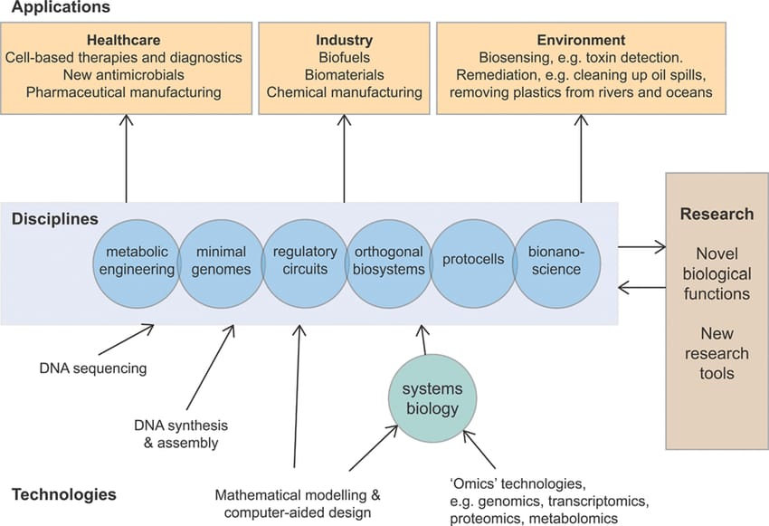

B Research on synthetic cells and biosensor
Additionally, significant advancements have been achieved in the research of synthetic cells and biosensors. Researchers can thoroughly investigate a variety of biological processes that take place within cells by building synthetic cells, and this work can also generate fresh concepts for cell engineering and medical research. For instance, synthetic cells can be used to synthesize medicines and biochemicals, as well as to identify environmental toxins and compounds. The qualities of organisms that react to chemical, physical, and biological elements in the environment are also used to create new forms of sensors called biosensors, which combine biology, physics, chemistry, and other fields. These sensors can be used in biomedicine, environmental monitoring, and other sectors because of their high sensitivity, high selectivity, and quick response.[52-53]

C Application of metabolic engineering and biotransformation:
Synthetic biology is currently focusing a lot of attention on metabolic engineering and biotransformation. The production of several new biological substances and medications can be achieved by reconstructing metabolic pathways and optimizing enzyme catalysis using synthetic biology techniques. Synthetic biology is used by Amyris, a biotechnology business, to create a range of high-value products. Squalane, a premium oil used in cosmetics and skin care that is popular for hydrating and softening the skin, is one of them. Squalane is traditionally mostly harvested from the livers of sharks, which not only harms sharks ecologically but also raises the price of squalane. As a result, Amyris has created a novel process for producing squalane that it refers to as the "squalane route."[54]
Using non-pathogenic yeast (Saccharomyces cerevisiae), this route's manufacturing is based on synthetic biology techniques. Glucose is first turned to farnesene, which is then changed into squalane. This method not only eliminates reliance on sharks but also makes it possible to produce high-quality squalane on a big scale, which lowers production costs. Through this technique, Amyris has created a number of other high value-added compounds and biofuels in addition to squalane. These chemicals and biofuels are employed in a wide range of applications, including fragrances, medications, paints and coatings. This approach has established its viability and sustainability in actual use and has emerged as a leading example of emerging biotechnologies. On the other hand, scientists have been successful in employing synthetic biology to produce paclitaxel precursors, an important anti-cancer medication, in yields of up to 600 mg/L. Additionally, synthetic biology offers fresh approaches to the production of environmentally beneficial chemicals and biofuels.[55-56]

D Development of novel biomaterials and bioenergy
The creation of innovative biomaterials and biofuels is also made possible by synthetic biology. Synthetic biology techniques can be used to create novel biomaterials with unique qualities. For instance, by altering the
structure of a protein, materials with self-healing capabilities can be created.[57] Furthermore, synthetic biology offers fresh approaches and strategies for the creation of bioenergy. For instance, biomass can be transformed into renewable fuels by creating novel microbes or enhancing microbial metabolic pathways.[58] Synthetic biology is currently being used widely in a variety of industries and is constantly evolving. The growth of synthetic biology will confront more opportunities and challenges in the future, such as how to better govern and control complex biological systems and how to deal with their spatial and temporal dynamics. Future research in synthetic biology will therefore place a greater emphasis on multidisciplinary integration and innovation to create biological systems that are more effective, intelligent, and controlled as well as to produce new technologies and solutions for the sustainable advancement of human society.[59]
E NOVEL CHEMICAL SYNTHESIS:
Synthetic biology, which uses microorganisms or cell factories to create chemicals through metabolic pathways, offers us a green, effective, and ecologically friendly technique of biosynthesis in the field of chemical synthesis. As a major organic chemical raw material that is widely utilized in polyester, polyurethane, solvents, etc., pentanediol has a new enzymatic method. Traditional pentanediol synthesis techniques frequently call for the employment of toxic chemicals, high temperatures, and high pressures, which not only seriously harm the environment but also make it difficult to regulate the quality of the end products. In contrast, the synthesis of pentanediol using synthetic biology technology can not only avoid the afore mentioned drawbacks but also be more efficient, effective, and controllable. Substrate dehydrogenase and reductase are the main catalytic enzymes in the pentanediol enzymatic pathway. The quantity and quality of pentanediol can be increased by genetically designing and fine-tuning the substrate dehydrogenase and reductase to increase their catalytic efficiency, stability, and selectivity. Additionally, systems biology and metabolic engineering can be used to modify the metabolic pathways of microorganisms in order to boost substrate consumption and pentanediol output.[60]

- CASE STUDIES ON NATURAL PRODUCTS, SYNTHESIZATION AND SYNTHETIC BIOLOGY:

The production of flavors and scents created through biotechnology has significantly grown in the last few years.[24] This trend is primarily driven by the aspiration to create cost-effective production systems that are more environmentally friendly than the traditional organic chemical synthesis-based methods [25].
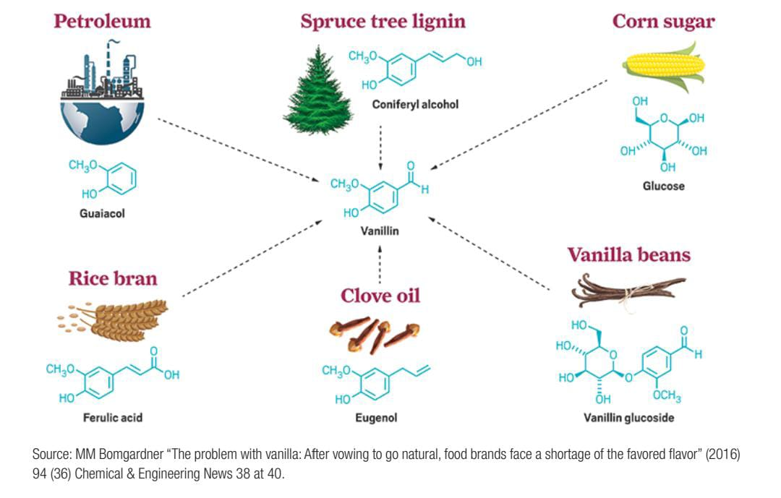
B Pharma and phytopharmaceuticals
Qing hao (Artemisia annua or sweet wormwood), an annual shrub, is the source of Artemisinin.[26] At least 2,000 years ago, Traditional Chinese Medicine was aware of the medicinal benefits of this plant. [27] A. annua leaf tablets in dried form have been found to be an effective form of phytomedicine, and the traditional preparation of it is still being used worldwide for the treatment of malaria (as seen in Figure A).[28] Some have argued that the traditional preparation is better than the isolated molecule because of the combined effect of multiple active ingredients.[29]

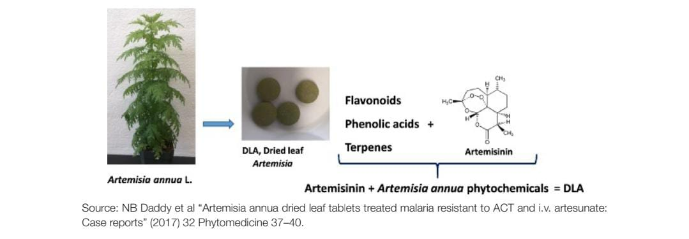
Fig A: - Dried leaf Artemisia Phytomedicine

- Synthetic Biology Design tools:

The goal of Synthetic Biology is to minimize laboratory experimentation and scientific investigation as much as possible in order to make it a more predictable technology that is suitable for engineering and industrialization.[30] The development of effective Computer-Aided Design (CAD) software environments for biology (aka BioCAD) is an important tool that can help achieve this goal.[31] Brocade programs treat DNA sequences of parts or devices as modules that can be virtually assembled through a 'drag and-drop' environment. Through simulation, the performance of the virtual assemblies in varying conditions can be evaluated until an optimal design is achieved. Once this happens, the parts list and full DNA sequence required to make the design are provided, along with instructions on how to assemble and test it in a laboratory setting or by using a robotic platform.[32]

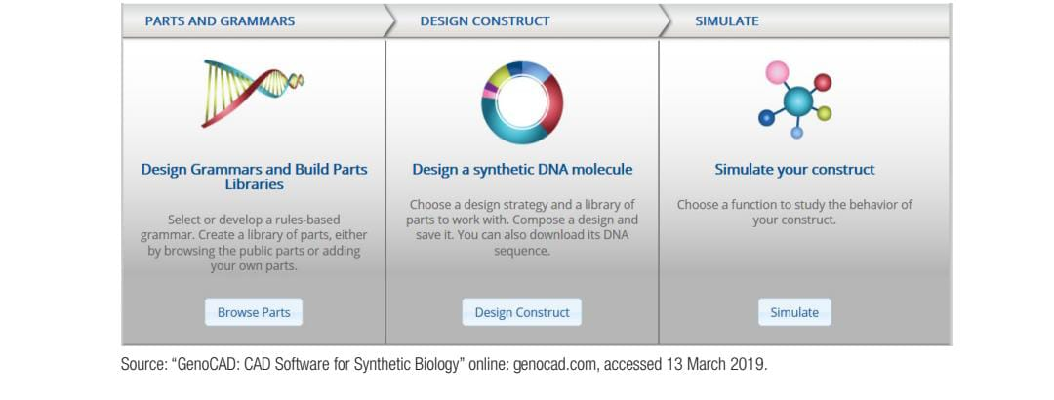

- Patenting synthetic biology:

Some view existing intellectual property (IP) law as inappropriate for rapidly developing biotechnologies. The main challenge is providing a framework to encourage investment without stifling research/restricting benefits.[33] For synthetic biology, patent protection can be applied:
• to methods, techniques or technologies
• to specified sequences of DNA.[33]

- Importance And Impact of Synthetic Biology On Society And Ecosystem:

- Synthetic biology's contribution to scientific and technological progress
Synthetic biology's quick development has aided in the advancement of science and technology by encouraging the interdisciplinary collaboration of numerous domains, including computer science, physics, chemistry, and life science. Our understanding of the nature and principles of living systems has improved because to synthetic biology, which has also given us fresh perspectives and instruments to address more complex scientific and societal issues.
- Impact of synthetic biology on economic and industrial development

Many new industries and technologies, including synthetic biology pharmaceuticals, biomanufacturing, and bioenergy, have emerged as a result of synthetic biology's quick development. The advancement of synthetic biology also offers new opportunities for economic expansion and innovation catalysts for the long-term improvement of society.
- Challenges and opportunities of synthetic biology for human and ecological environment
Synthetic biology's quick progress has also given rise to several fresh prospects and difficulties. The use of synthetic biology technology must adhere to moral, ethical, and ethical norms while also considering the safety and interests of people and the environment. In addition, synthetic biology offers fresh prospects and fixes for many issues affecting people and the environment.

- Conclusion:

Synthetic Biology has the potential to benefit society and biodiversity in a number of ways, including by finding "cures for many diseases, providing stable supplies of therapeutic compounds, and enabling the creation of new organisms and products that are limited only by human imagination."[33] Applications of Synthetic Biology seek to "convert 'low-value' agricultural and forest products into feedstocks."[34] This will probably be a sector-specific choice. The natively obtained product will not be the favored choice if a cost-benefit analysis shows that the 'natural' Synthetic Biology product is adequate for the manufacturer's needs.[35]

References
- National Human Genome Research Insitute. “Policy Issues in Genomics: Synthetic Biology”. Available online. https://www.genome.gov/aboutgenomics/policy-issues/Synthetic-Biology
- Presidential Commission for the Study of Bioethical Issues. “New Directions: The Ethics of Synthetic Biology and Emerging Technologies.” December 2010. https://bioethicsarchive.georgetown.edu/pcsbi/synthetic-biology-report.html
- DARPA ISAT. “Synthetic Biology Study.” 2003. http://dspace.mit.edu/handle/1721.1/38455
- Hughes, Randall and Ellington, Andrew. “Synthetic DNA Synthesis and Assembly: Putting the Synthetic in Synthetic Biology”. Cold Spring Harb Perspect Biol. January 9, 2007.
- Ibid.
- Bueso, Tensi and Tangney, Mark. “Synthetic Biology in the Driving Seat of the Bioeconomy.” Trends in Biotechnology, May 2017
- Carlson, Robert. “Estimating the biotech sector’s contribution to the U.S. economy.” Nature Biotechnology, March 2016
- Heme + The Science Behind Impossible. Impossible Foods. Available online. https://impossiblefoods.com/heme/
- National Academies of Sciences, Engineering, and Medicine, supra note 15.
- Application of Synthetic Biology in Chemicals Industry.” Applications of Synthetic Biology in Chemicals Industry. Accessed 2020. https://www.genscript.com/chemicals-industry.html.
- Voigt CA: Genetic parts to program bacteria. Curr Opin Biotechnol2006,17(5):548-57. 10.1016/j.copbio.2006.09.001
- Cohen SN, Chang AC, Boyer HW, Helling RB: Construction of biologically functional bacterial plasmids in vitro. Proc Natl Acad Sci USA 1973,70(11):3240-4. 10.1073/pnas.70.11.324
- O’Malley et al. 2007 https://www.cbd.int/ts/cbd-ts-82-en.pdf
- Hans-Jörg Rheinberger & Staffan Müller‐Wille, The Gene: From Genetics to Postgenomics, revised translation ed (Chicago University Press, 2017) at 2–3.
- Geoff Baldwin, Synthetic Biology - A Primer, revised ed (Imperial College Press, 2016) at 164
- Secretariat of the Convention on Biological Diversity, Second Report of the Ad Hoc Technical Expert Group on Synthetic Biology, United Nations Doc. UNEP/CBD/SYNBIO/AHTEG/2017/1/3, para 15(b)
- National Academies of Sciences, Engineering, and Medicine, supra note 15 at 16.
- Ibid.
- Overview of Work Done in Response to Decision XIII/17 and Background Information to Facilitate Deliberations by the Ad Hoc Technical Expert Group on Synthetic Biology, United Nations Doc. UNEP/ CBD/SYNBIO/ AHTEG/2017/1/2, para 44 (a).
- National Academies of Sciences, Engineering, and Medicine, supra note 15 at 16.
- Pablo Carbonell et al, “An automated Design-Build-Test-Learn pipeline for enhanced microbial production of fine chemicals” (2018) 1:1 Communications Biology 66.
- NJ Gallage & BL Møller, “Vanillin—Bioconversion and Bioengineering of the Most Popular Plant Flavor and Its De Novo Biosynthesis in the Vanilla Orchid” (2015) 8 Molecular Plant 40 at 40.
- Stephanopoulos, supra note 49 at 515.
- Sanne de Ridder, Frank van der Kooy & Robert Verpoorte, “Artemisia annua as a self-reliant treatment for malaria in developing countries” (2008) 120:3 Journal of Ethnopharmacology 302. 132
- Ibid; “Artemisinin” (2014) 20:7 Emerging Infectious Disease journal 1217. 133
- Nsengiyumva Bati Daddy et al, “Artemisia annua dried leaf tablets treated malaria resistant to ACT and i.v. artesunate: Case reports” (2017) 32 Phytomedicine 37; Pamela J Weathers et al, “Dried-leaf Artemisia annua: A practical malaria therapeutic for developing countries?” (2014) 3:4 World Journal of Pharmacology 39.
- Frank van der Kooy & Shaun Edward Sullivan, “The complexity of medicinal plants: The traditional Artemisia 34 SYNTHETIC BIOLOGY annua formulation, current status and future perspectives” (2013) 150:1 Journal of Ethnopharmacology 1; Mostafa A Elfawal et al, “Dried whole plant Artemisia annua as an antimalarial therapy” (2012) 7:12 PloS one e52746.
- Baldwin, supra note 40 at 56. Secretariat of the Convention on Biological Diversity, Analysis against the criteria set out in paragraph 12 of decision IX/29, United Nations Doc. CBD/SBSTTA/22/INF/17.
- Secretariat of the Convention on Biological Diversity, Analysis against the criteria set out in paragraph 12 of decision IX/29, United Nations Doc. CBD/SBSTTA/22/INF/17.Ibid.
- The Parliamentary Office of Science and Technology, 7 Millbank, London,
- SW1P 3JA
- Bagley, supra note 68.
- Presidential Commission for the Study of Bioethical Issues, supra note 4 at 137.
- National Research Council, supra note 8 at 56.
- Berg, P., & Cohen, S. N. (1972). Some recombinant DNA molecules derived from the joining of DNA fragments from different sources. Proceedings of the National Academy of Sciences of the United States of America, 69(12), 3440-3444.
- Boyer, H. W., & Cohen, S. N. (1973). DNA restriction and modification mechanisms in bacteria. Annual Review of Microbiology, 27(1), 115–138.
- Cohen, S. N. (1973). DNA cloning: A personal view after 40 years. Proceedings of the National Academy of Sciences of the United States of America, 110(39), 15521–15529
- Lederberg, J. and E. L. Tatum. "Gene recombination in Escherichia coli." Nature, vol. 158, no. 4016, 1946, pp. 558-558
- Blair, D. "Synthetic biology, then and now." Journal of the History of Biology, vol. 48, no. 2, 2015, pp. 153-176.
- Yan, Y., Liao, J.C., and Engineering Metabolic Systems for Production of Advanced Biofuels. Trends Biotechnol. 2016, 34(7): 492-501.
- Liang, X., Liu, R., and Chen, J. Synthetic biology and metabolic engineering of Corynebacterium glutamicum for bio-based production of chemicals. J. Ind. Microbiol. Biotechnol. 2020, 47(6): 365-379.
- Singh, R., Kumar, V., Singh, R.P., and Gupta, N. Synthetic biology in the development of microbial biocatalysts for the production of biofuels and value-added chemicals. Biotechnol. Lett. 2021, 43(1): 43-62
- Lee, S.Y., Kim, H.U., and Chae, T.U. Cho J.S. Metabolic engineering of microorganisms: general strategies and drug production. Drug Discov. Today 2009, 14(15-16): 78-88.
- Xiao, Y., Bowen, C.H., and Liu, D. Exploiting nongenetic cell-to-cell variation for enhanced biosynthesis. Nat. Chem. Biol. 2016, 12(5): 339-344.

- Kocharin, K., Chen, Y., and Siewers, V. Engineering of Saccharomyces cerevisiae for the production of isobutanol and 3-methyl-1-butanol. Appl. Microbiol. Biotechnol. 2013, 97(19): 7121-7130.
- Liu, J.J., Zhang, W., and Du, G.C. Metabolic engineering of Saccharomyces cerevisiae for efficient production of 1-hexadecanol. Metab. Eng. 2016, 36: 33-41.
- Wang, Y., Chen, J., and Shen, Y. Engineering Saccharomyces cerevisiae for high-level synthesis of fatty acids and derived products. Metab. Eng. 2016, 38: 85-93
- Wisser, S. (2021) Synesc biology investment reached a new record of nearly $8 billion in 2020 - what does this mean for 2021? 2020 symbol market report. https://synbiobeta.com/synthetic-biology-investment-act-a-carty-8-billion-record-in-2020-what-does-this-mean-for-2021/Accessed 24/06/2021
- Judge, A. and Dockd, M.S. (2020) Metabolism. Essays Biochem, 64, 607-647, https://doi.org/10.1042/EBC20199041
- Wisser, S. (2021) Synesc biology investment reached a new record of nearly $8 billion in 2020 - what does this mean for 2021? 2020 symbol market report. https://synbiobeta.com/synthetic-biology-investment-act-a-carty-8-billion-record-in-2020-what-does-this-mean-for-2021/Accessed 24/06/2021
- Judge, A. and Dockd, M.S. (2020) Metabolism. Essays Biochem, 64, 607-647, https://doi.org/10.1042/EBC20199041
- Brenner, K., Karig, D. K., Weiss, R., & Arnold, F. H. (2007). Engineered bidirectional communication mediates a consensus in a microbial biofilm consortium. Proceedings of the National Academy of Sciences, 104(38), 17300-17304.
- Kortmann, H., Scrima, A., & Plum, G. (2011). Synthetic biology approaches in cancer research. Journal of cellular and molecular medicine, 15(2), 241-247Kortmann, H., Scrima, A., & Plum, G. (2011). Synthetic biology approaches in cancer research. Journal of cellular and molecular medicine, 15(2), 241-247
- Keasling, J. D., Paddon, C. J., & Keasling, J. D. (2006). Production of the antimalarial drug precursor artemisinic acid in engineered yeast. Science, 307(5714), 1464-1468. doi:10.1126/science.1105404
- Keasling, J. D. (2010). Manufacturing molecules through metabolic engineering. Science, 330(6009), 1355-1358.
- Leonard, E., Lim, K. H., & Koffas, M. A. (2007). Engineering central metabolic pathways for high-level flavonoid production in Escherichia coli. Applied and environmental microbiology, 73(13), 3877-3886
- Chao R, Yuan Y, Zhao H. Recent advances in DNA assembly technologies. FEMS yeast research. 2015;15(1):1-9.
- Schmidt M, Pei L, Synatschke CV, et al. DNA-based architectures for advanced applications. Chemical Society Reviews. 2018;47(17):6480-6516.
- Jeong, D.-E., Park, S. J., Pan, J. G., & Kim, Y. H. (2012). Microbial production of 1,5-pentanediol via reduction of 2-ketoglutarate coupled with acetoin reduction. Applied and Environmental Microbiology, 78(15), 5494-5502. doi:10.1128/AEM.01037-12
- Jeong, D.-E., Park, S. J., Pan, J. G., & Kim, Y. H. (2012). Microbial production of 1,5-pentanediol via reduction of 2-ketoglutarate coupled with acetoin reduction. Applied and Environmental Microbiology, 78(15), 5494-5502. doi:10.1128/AEM.01037-1

