A Low-Cost Arduino - Based Data Logging System to Monitor Environmental Parameters
G. Sindhuja
College of Agricultural Engineering
Kandi, Sangareddy, India

Dr. K.Charith Kumar
Assistant Professor
Dept. of RNEE
College of Agricultural Engineering
Kandi, Sangareddy, India

Abstract

Different storage conditions like Modified Atmosphere Packaging and Controlled Atmosphere Packaging provides best environment for storage but the cost makes it unavailable for small and marginal farmers so as to record the environmental parameters, development of the sensor for measuring the fruit respiration one can get to know the various parameters such as Temperature, Humidity, and the Level of Carbon dioxide which could be useful in assessing the possible storage conditions. In the first objective, the module is developed with the assemblage of different sensors such as MQ135 and DHT22 and the values have been recorded with the help of a data logger. In the second objective the values are calibrated with the actual working sensor and are made to be in line with it. In the third objective the actual experiment is carried out to measure the various parameters such as temperature, humidity, carbon dioxide. The acquired values are used in the assessment of post-harvest condition and come to the necessary conclusions, the values of temperature and humidity are on par with the values that are acquired with the commercial sensors (Campbell) installed at the greenhouse of soil and water conservation engineering. But the carbon dioxide values have shown deviation.
Key words: Modified Atmosphere Packaging, Controlled Atmosphere Packaging, Temperature, Humidity, Carbon dioxide and Sensors.

- INTRODUCTION

The respiration is a normal process not only for animals but also for plants and its produce and the rate of respiration has been a direct influencer on the rate of ripening which causes the decrease in the longevity which is an important factor for the food wastage every year in million tonnes. The only gas that actuates the ripening process (majorly) is ethylene in the case of fruits especially BANANA and the gas that inhibits the production of ethylene is carbon dioxide, so there is a direct relationship established. When the storage of the perishable produce is considered, its environmental parameters are to be kept in account so that one can know the conditions prevailing. The increased levels of carbon dioxide suppress the synthesis of ethylene and their by decreasing the levels of ripening.
The sensor module is the set of three sensors which are economically consistent and reliable than most of the sensors available in the market, the total sensor set is available at much economical prices and the added advantage of the sensor is it records the values of different time frames and frequencies in preference to the user. Bananas, plantains, and cooking bananas play a crucial role in ensuring food security for millions in developing nations. People across tropical regions, spanning all continents, directly or indirectly rely on Musa crops for sustenance and income. Recognized for their nutritional value, bananas and plantains are rich in carbohydrates (around 35%) and fiber (6-7%), serving as vital sources of potassium, magnesium, phosphorus, calcium, iron, and vitamins A and C. Although not grown in every country, bananas are remarkably widespread. As the world's most popular fruit, they constitute approximately 75% of tropical fruit trade, with over a hundred billion harvested annually. Bringing ripe bananas to market involves a surprisingly complex process. Specialized facilities within the industry meticulously manage the ripening stage, ensuring bananas are the perfect shade of green or yellow based on consumer preferences before they reach stores. Cultivated in tropical and subtropical regions globally, bananas are botanically categorized as berries. The term "banana" originates from the Arabic word "banan," which translates to "finger."
Ripening is a natural fruit process that enhances their palatability. Typically, fruits become sweeter, less green, and softer as they ripen. Despite the increase in acidity during ripening, the fruit doesn't taste tangier, a phenomenon explained by the Brix-Acid Ratio. Underripe fruits are fibrous, less juicy, and have a tougher outer flesh compared to their ripe counterparts.Microcontrollers serve as the central component in every electronics project, directing instructions to various parts and responding to their inputs. The effectiveness of an entire project hinges on the microcontroller's capacity to swiftly process information and execute commands. Arduino boards have gained trustworthiness because of their versatility and real-world usability. They find applications not only among hobbyists but also in industrial settings, controlling tasks like programming microcontrollers for heavy machinery and assessing air quality for safety purposes.
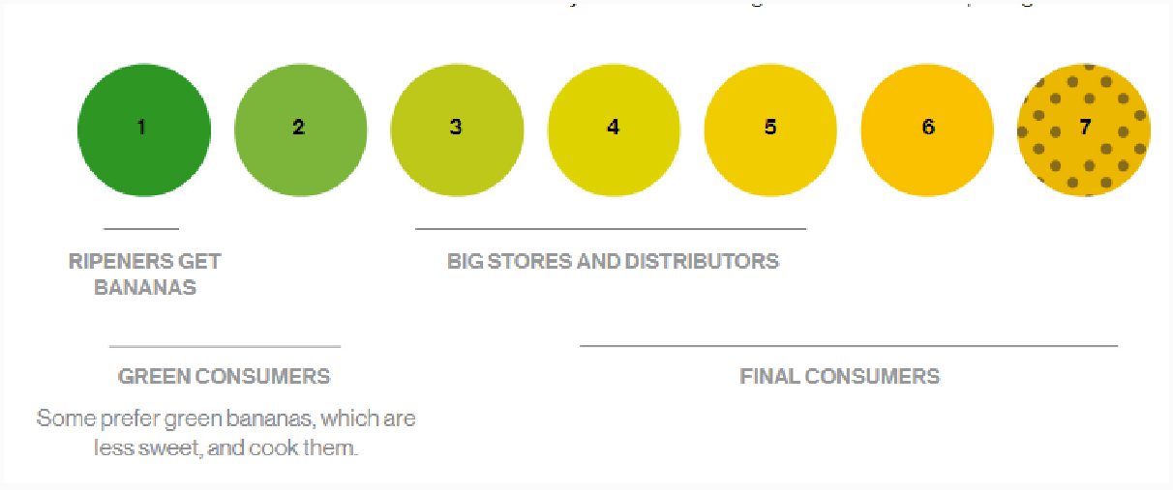
Fig 1. Ripening seven stage standard chart used in industry

- OBJECTIVES

- To develop an arduino based data logger with different sensors to measure environmental parameters.
- To calibrate the sensor developed against a commercially available working sensor.
- To experiment with the developed system in a confined chamber to study the different environmental parameters.

- REVIEW OF LITERATURE

Jaime González-Buesa and Salvador in 2019 crafted a modular device, leveraging open-source software, for gauging the respiration rates of enclosed produce. This innovative system boasts simplicity, versatility, and cost-effectiveness. It continuously tracks CO2 concentration, barometric and differential pressures, as well as temperature, facilitating the calculation of CO2 production and prediction of O2 consumption and respiratory quotient without an O2 sensor. To validate the device's efficacy, they determined O2 and CO2 respiration rates for three products. Encouragingly, the close agreement between respiratory quotient and differential pressure hints at the potential use of differential pressure data as a direct indicator of respiratory quotient progression. Such data might also prove valuable for monitoring shifts in metabolism.
In their 2019 paper titled "IOT based Air Quality Monitoring System Using MQ135 and MQ7 with Machine Learning Analysis," Sai et al. focus on measuring air quality using MQ135 and MQ7 sensors. They emphasize the importance of monitoring air quality for the well-being of future generations and mention the Government of India's efforts to reduce pollution. The authors aim to raise awareness by implementing an IoT-based system using platforms like Thingspeak or Cayenne, providing public access to real-time air quality data and enhancing understanding through machine learning analysis while reducing component costs.
In their 2020 study, Abbas et al. employed an Arduino Uno and the MQ-135 gas sensor to monitor air quality. The MQ-135 sensor, based on SnO2 semiconductor technology, is adept at detecting various harmful gases such as CO, CO2, Ethanol, NH4, Toluene, and Acetone in the surrounding air. The authors emphasize the need for cost-effective and low-power solutions to address the rising air pollution resulting from human activities and the importance of monitoring to relax pollution control measures.
In 2019, Yang et al. developed a cost-effective and portable device for measuring methane content in biogas. This device featured an MQ-4 methane sensor, humidity, temperature, and pressure sensors, all enclosed in an airtight glass container and operated using a programmable Arduino Uno clone for data logging. The sensor demonstrated sensitivity down to 400 ppm and a linear response from approximately 4000 to 110,000 ppm, with an average absolute error of 0.69% when compared to gas chromatograph measurements for biogas samples from an anaerobic digester, making it reliable for measuring methane content as low as 18% by volume with a 10 ml sample and as low as 2.4% with a 90 ml sample.
In their study in 2019, Pachiyannan et al. introduced an affordable Arduino-based automatic irrigation system utilizing a soil moisture sensor. This system relies on the soil moisture sensor's output, which responds to soil conditions and is controlled by an Arduino. Given agriculture's paramount importance in the economy and the critical role of water in plant growth, this low-cost Arduino-based solution addresses the need for efficient irrigation, utilizing an Arduino-UNO with an integrated ADC converter, a soil moisture sensor to assess soil moisture levels, a 16×2 LCD display for visualizing soil conditions, and a motor for delivering water to plants and crops, enhancing farming practices.

- MATERIALS AND METHODS

4.1 Arduino
Arduino, an open-source hardware and software venture, fosters a community dedicated to crafting single-board microcontrollers and kits for constructing digital devices. Their hardware adheres to the CC-BY-SA license, while software abides by either the GNU Lesser General Public License (LGPL) or the GNU General Public License (GPL), permitting wide manufacturing and distribution. These Arduino boards are accessible through the official website and authorized distributors and boast diverse microprocessors and controllers. These boards include sets of digital and analog input/output (I/O) pins for interfacing with expansion boards ('shields') or breadboards during prototyping. Furthermore, they offer serial communication interfaces, including Universal Serial Bus (USB) on certain models, for program loading. Programmers can employ C and C++ languages, facilitated by a standard API referred to as the "Arduino language." To enhance development, Arduino supplies an integrated development environment (IDE) and a command line tool called arduino-cli, developed in Go.
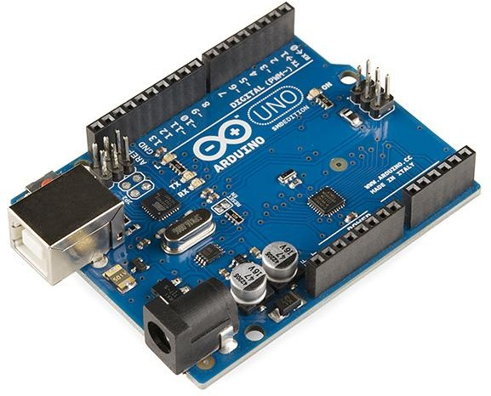
Fig 2. Arduino

4.2 MQ 135 Gas Sensor
The MQ-135 Gas sensor is employed in air quality control systems for detecting or measuring NH3, NOx, Alcohol, Benzene, Smoke, and CO2. It features both a Digital Pin, allowing standalone operation, and an Analog Pin for precise gas concentration measurement in ppm. When powered with 5V, the power LED lights up, and the digital output pin remains low when no gas is detected. The sensor requires a pre-heating period before becoming functional. When exposed to Carbon Dioxide, the digital pin goes high, indicating gas presence, and can be adjusted using the potentiometer. Alternatively, analog pins can be utilized to obtain proportional gas concentration values (0-5V). The MQ-135 sensor employs SnO2 as its gas-sensing material, which exhibits higher resistance in clean air, reducing as it detects polluting gases. To determine PPM, refer to the (Rs/Ro) vs. PPM graph from the MQ135 datasheet.
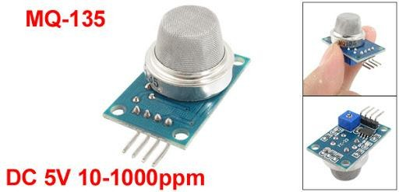

Fig 3. MQ-135 Gas sensor

4.3 DHT22 – Temperature and Humidity Sensor
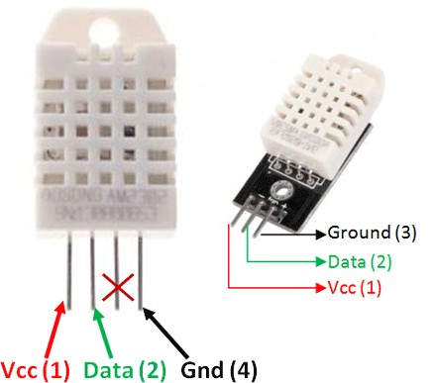
The DHT22 is a widely used temperature and humidity sensor equipped with a dedicated NTC for temperature measurement and an 8-bit microcontroller for serial data output of temperature and humidity values. It comes factory calibrated, simplifying its integration with other microcontrollers. This sensor can accurately measure temperatures from -40°C to 80°C and humidity from 0% to 100%, with an accuracy of ±1°C and ±1%. If your application falls within this range, the DHT22 is a suitable choice. The DHT22 is an upgraded version of the DHT11 module, available as either a standalone sensor or a module. The performance remains consistent regardless of the choice. The sensor typically has four pins, but only three are used, while the module comes with three pins, including an inbuilt filtering capacitor and pull-up resistor. In contrast, for the sensor, you may need to use these components externally if necessary. While the module is slightly more expensive than the DHT11, it offers a broader measuring range and slightly improved accuracy.

Fig 4. DHT22 Temperature and humidity sensor
  - Data Logger
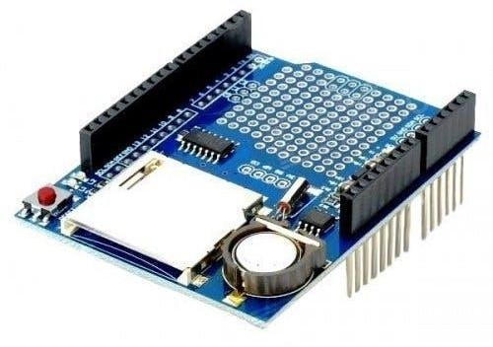
Data storage constitutes a fundamental aspect of every project, with various methods available based on data type and size. Among these options, SD and micro SD cards stand out as practical choices, frequently employed in devices like mobile phones and minicomputers. Ultimately, the plan involves measuring environmental temperature hourly and saving this data onto the SD card.
Fig 5. Data logger
  - Breadboard
A breadboard is a rectangular board equipped with numerous mounting holes, serving as a platform for establishing electrical connections between electronic components and single-board computers or microcontrollers like Arduino and Raspberry Pi. These connections are not permanent and can be removed and repositioned. This flexibility allows components to be replaced, enabling customization of a project or the transition to an entirely different one while utilizing the same breadboard. The breadboard features vertical columns known as terminals and horizontal long rows referred to as power rails, primarily used for connecting the power supply to the breadboard.
4.6 Campbell sensor system
Sensors transform various phenomena into measurable electrical signals by modulating voltage, current, resistance, status, or pulse outputs. Accurate and precise sensors accomplish this task effectively. Supported sensor types include Analog, Voltage, Current, Thermocouples, Resistive bridges, Pulse, High frequency, Switch closure, Low-level AC, Period average, Vibrating wire, and Smart sensors. The CR1000 has the capability to measure almost any sensor with an electrical response. It translates electrical signals into engineering units, conducts calculations, and condenses data into statistical values. In most cases, storing every individual measurement isn't necessary. Instead, these measurements can be consolidated into statistical or computational summaries. The CR1000 stores data in its memory, awaiting transfer to a PC via an external storage device or telecommunication device.

4.7 Wiring of arduino with different sensor components
The arduino has to be connected with various components so as to complete the sensor construction, initially the bread board is taken where the parallel row which is interconnected is used for powering the sensors. Arduino has 14 digital input and output pins, 6 analog input or output pins in which the MQ135 sensor has three working pins where ground pin-GND is connected to the ground pin of arduino, power pin-VCC is connected to 5V pin of arduino via breadboard, analog pin-A0 is connected to A1 of arduino. DHT22 sensor module has three pins where the firs pin is positive pin-VCC is connected to 5V pin of arduino via breadboard, second pin is connected to DATA PIN which is connected to the data pin 2 of the arduino, third pin is ground pin- GND is connected to ground pin of arduino.
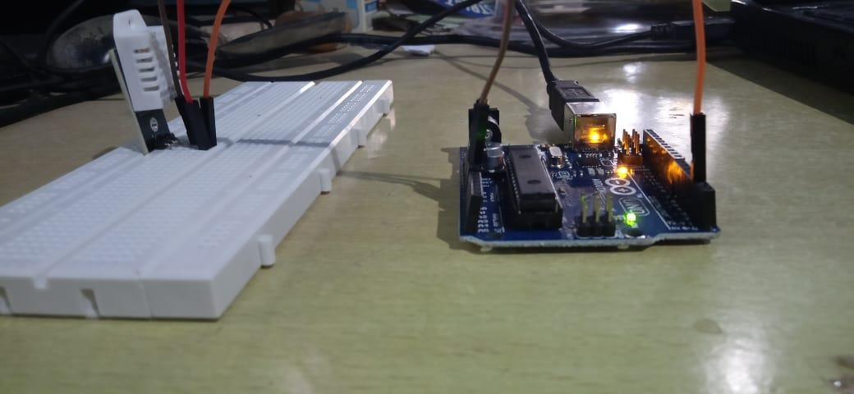
Fig 6. Connection of different sensors with arduino
Data Logger has an equal number of pins as an arduino, where the two components are combined as one with the help of insertion and the construction is carried out similarly as in the case of an arduino. And it is an optional component since it logs or stores data collected with the help of a sd card which could be used for further references. And source code was uploaded to Arduino.
4.8 Cost of different components used for the development of a data logging system
Component | Cost (rs.)
Arduino with USB cable | 380.00
MQ135 Sensor | 135.00
DHT22 | 280.00
Data logger | 250.00
Bread board | 65.00
Jumper wires | 100.00
Adaptor | 100.00
SD Card | 250.00
Total | 1560.00

- RESULTS AND DISCUSSIONS
The fabricated module using microcontroller arduino uno which is equipped with different sensors is calibrated against a commercial sensor (Campbell). The values are simultaneously recorded to compare and calibrate for making the sensor reliable. The recorded values and their pictorial representation in form of graphs are presented below
Table 1. Temperature humidity and co₂ values recorded with time
Time | Temperature  -campbell sensor (℃) | Temperature  - arduino sensor (℃) | Humidity- campbell  (%) | Humidity - arduino  sensor (%) | CO2-campbell (ppm) | CO₂-arduino sensor(ppm)
15:00 | 36.21 | 36.2 | 24.77 | 28 | 12.42 | 162
16:00 | 35.42 | 35.4 | 27.01 | 32.9 | 17.5 | 185
17:00 | 34.47 | 34.5 | 27.57 | 28.5 | 16.2 | 167
18:00 | 31.51 | 31.5 | 34.2 | 34.1 | 17.2 | 216
19:00 | 28.01 | 28 | 43.93 | 41 | 16.46 | 279
20:00 | 25.5 | 25 | 48.56 | 48.4 | 14.66 | 288
21:00 | 23.84 | 23.8 | 48.1 | 49.8 | 17.38 | 408
22:00 | 23.48 | 23.5 | 53.97 | 54 | 23.28 | 400
23:00 | 22.76 | 22.8 | 56 | 56.8 | 23.52 | 408
24:00 | 22.1 | 22.1 | 62.47 | 62.6 | 23.61 | 489
1:00 | 20.8 | 20.9 | 67.42 | 67.1 | 23.12 | 507
2:00 | 19.98 | 19.9 | 70.33 | 71.9 | 26.07 | 597
3:00 | 19.56 | 19.6 | 70 | 72.6 | 18.56 | 593
4:00 | 19.57 | 19.57 | 69.95 | 72.3 | 22.33 | 507
5:00: | 19.21 | 19.3 | 69.44 | 73.1 | 23.81 | 570
6:00 | 18.82 | 18.9 | 70.58 | 72.9 | 21.45 | 597
7:00 | 18.31 | 18.6 | 74.23 | 75.6 | 22.66 | 593
8:00 | 18.55 | 18.8 | 70.74 | 74.6 | 22.99 | 597
9:00 | 22.27 | 22.4 | 44.21 | 63.7 | 21.99 | 611
10:00 | 26.55 | 26.8 | 37.88 | 41.8 | 26.29 | 440
11:00 | 29.77 | 29.8 | 31.05 | 39.9 | 11.84 | 422
12:00 | 32.57 | 32.6 | 26.96 | 34.9 | 13.96 | 392
13:00 | 35.08 | 35.1 | 26.36 | 32.3 | 17.05 | 360
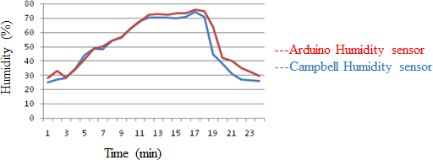
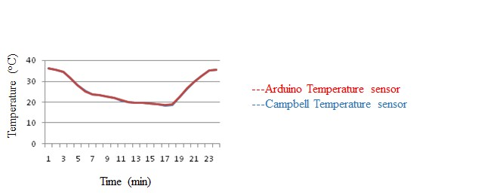

Fig 9. Temperature vs time graph
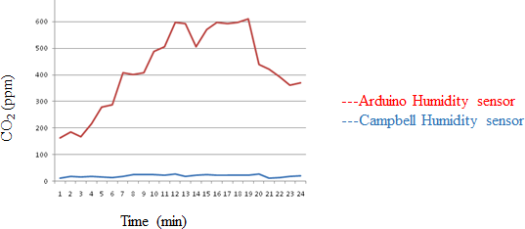
Fig 10. Carbon dioxide vs time graph
- SUMMARY AND CONCLUSION
The DHT22 Sensor gives us more precise values even compared with most of the sensors available in the market, the above temperature graph shows there is a very minimal or no variation in values when compared with the Campbell sensor. This is also the same in the case of humidity measurement. The DHT11 Sensor is comparatively less-accurate with the DHT22 Sensor.
The MQ-135 Sensor which is used for measuring carbon dioxide in the module developed is said to measure carbon dioxide as mentioned in its specifications but, its accuracy is not much reliable and therefore, some or more errant values can be observed which could possibly give the wrong results. This can be inferred from the tables of calibration with campbell sensor.
The MQ 135 sensor is connected to the arduino with the help of analog pin 1 and DHT sensor is connected with the help of digital pin 2 and all other power connections are similar to the sensors and the module is fabricated, now the sensor is calibrated against the senor campbell in greenhouse conditions at the greenhouse of Soil and Water Conservation Engineering Department in College of Agricultural Engineering, Kandi, Sangareddy. The calibrated sensor is now put forward for experimentation and the desired values of Temperature, Humidity, and Carbon dioxide are noted down to analyse the environment.

- REFERENCES

González-Buesa, J. and Salvador, M.L. 2019. An Arduino-based low-cost device for the measurement of the respiration rates of fruits and vegetables. Computers and Electronics in Agriculture.162:14-20.
Sai, K.B.K., Subbareddy, S.R. and Luhach, A.K. 2019. IOT based air quality monitoring system using MQ135 and MQ7 with machine learning analysis. Scalable Computing: Practice and Experience. 20(4):599-606.
Abbas, F.N., Saadoon, I.M., Abdalrdha, Z.K. and Abud, E.N. 2020. Capable of gas sensor MQ-135 to monitor the air quality with Arduino Uno. International Journal of Engineering Research Technology. 13(10):2955-2959.
Yang, S., Liu, Y., Wu, N., Zhang, Y., Svoronos, S. and Pullammanappallil, P. 2019. Low-cost, Arduino-based, portable device for measurement of methane composition in biogas. Renewable Energy, 138:.224-229.
Pachiyannan, M., PVS, D.D., and Pravallika, G. 2019. A low-cost Arduino based automatic irrigation system using soil moisture sensor: design and analysis. In 2019 2nd International Conference on Signal Processing and Communication (ICSPC).104-108.

