Chapter 25
Advanced Drug Delivery System

INTRODUCTION
Drug delivery through oral administration is a complicated process. A drug must withstand the digestive processes and penetrate through the gastrointestinal (GI) barrier into the bloodstream. Drugs absorbed from the GI tract travel through portal veins to the liver, where they are subjected to first-pass metabolism by the hepatic enzymes before entering the systemic circulation [1]. The oral route of drug administration is traditionally known as the most preferred route for systemic drug delivery, even though there are disadvantages, such as unpredictable and erratic absorption, gastrointestinal intolerance, incomplete absorption, degradation of drug in GI contents, and presystemic metabolism, mostly resulting in reduced bioavailability.
The primary functions of the GI tract are the absorption and digestion of food, as well as the secretion of various enzymes or fluids [2]. The gastrointestinal mucosa forms a barrier between the body and a luminal environment that contains not only nutrients but also potentially hostile microorganisms and toxins. The normal function of the GI barrier, which refers to the properties of the gastric and intestinal mucosa, is essential for disease prevention and the overall maintenance of health. The major challenge in drug delivery through the GI tract is to achieve efficient transport of nutrients and drugs across the epithelium while rigorously excluding the passage of harmful molecules and organisms into the body.
Advanced drug delivery systems are improved methods for delivering the drug molecule to the targeted site in a more controlled manner. These methods are being developed to improve the efficacy ratio of the currently available drugs. Delivering drugs at a controlled rate through slow and targeted delivery for onsite drug release and absorption is the basis for developing advanced drug delivery systems.
Importance of advanced drug delivery systems
Advanced drug delivery systems (DDS) present indubitable benefits for drug administration. Over the past three decades, new approaches have been suggested for the development of novel carriers for drug delivery. In this review, we describe general concepts and emerging research in this field based on multidisciplinary approaches aimed at creating personalised treatment for a broad range of highly prevalent diseases (e.g., cancer and diabetes). This review is composed of two parts. The first part provides an overview of currently available drug delivery technologies, including a brief history of the development of these systems and some of the research strategies applied. The second part provides information about the most advanced drug delivery devices using stimuli-responsive polymers. Their synthesis using a controlled-living radical polymerization strategy is described. In the near future, it is predictable to see the appearance of new, effective, tailor-made DDS resulting from knowledge of different interdisciplinary sciences from the perspective of creating personalised medical solutions.

The Purpose of the paper

Drug delivery is the method or process of administering a pharmaceutical compound to achieve a therapeutic effect in humans or animals. For the treatment of human diseases, nasal and pulmonary routes of drug delivery are gaining increasing importance. These routes provide promising alternatives to parenteral drug delivery, particularly for peptide and protein therapeutics. For this purpose, several drug delivery systems have been formulated and are being investigated for nasal and pulmonary delivery. These include liposomes, proliposomes, microspheres, gels, prodrugs, and cyclodextrins, among others. Nanoparticles composed of biodegradable polymers show assurance in fulfilling the stringent requirements placed on these delivery systems, such as the ability to be transferred into an aerosol, stability against forces generated during aerosolization, biocompatibility, targeting of specific sites or cell populations in the lung, release of the drug in a predetermined manner, and degradation within an acceptable period of time.

Overview of microneedles

Definition

Microneedles (MN) are micron-sized needles, ranging from 25 to 2000 m in height, made of a variety of materials and shapes. Application of MNs to the skin can create micron-sized transport pathways that allow enhanced delivery of a wide range of drug molecules.
The concept of microneedles was first proposed in 1970.
combines the benefits of hypodermic needle injections and transdermal patches.
Microneedles are typically hundreds of microns long, 1 to 50 m wide at the tip, and approx. 50–300 m at the base.

Characteristics of microneedles

Microneedles are considered a noval smart injection system that causes significantly low skin invasion upon puncturing due to the micron-sized dimensions that pierce into the skin painlessly.
The aim of microneedles is to create large pathways of microscope dimensions using an array of microscopic needles attached to a metal or polymer base.

Types of Microneedles

Since their conceptualization in 1998, several advances have been made in terms of the variety of types of microneedles that can be fabricated. The five main types of microneedles are solid, hollow, coated, dissolvable, and hydrogel-forming.

Solid

This type of array is designed as a two-part system; the microneedle array is first applied to the skin to create microscopic wells just deep enough to
penetrate the outermost layer of skin, and then the drug is applied via a transdermal patch. Solid microneedles are already used by dermatologists in collagen induction therapy, a method that uses repeated puncturing of the skin with microneedles to induce the expression and deposition of the proteins collagen and elastin in the skin.

Hollow

Hollow microneedles are similar to solid microneedles in material. They contain reservoirs that deliver the drug directly to the site. Since the delivery of the drug is dependent on the flow rate of the microneedle, there is a possibility that this type of array could become clogged by excessive swelling or a flawed design. This design also increases the likelihood of buckling under pressure and therefore failing to deliver any drugs.

Coated

Just like solid microneedles, coated microneedles are usually made from polymers or metals. In this method, the drug is applied directly to the microneedle array instead of being applied through other patches or applicators. Coated microneedles are often covered in other surfactants or thickening agents to assure that the drug is delivered properly. Some of the chemicals used on coated microneedles are known irritants. While there is a risk of local inflammation in the area where the array was, the array can be removed immediately with no harm to the patient.

Dissolvable

In a more recent adaptation of the microneedle design, dissolvable microneedles encapsulate the drug in a nontoxic polymer that dissolves once inside the skin. ^{[1]} This polymer would allow the drug to be delivered into the skin and could be broken down once inside the body. Pharmaceutical companies and researchers have begun to study and implement polymers such as fibrin, a silk-based protein that can be moulded into structures like microneedles and dissolved once in the body.

Hydrogel forming

With hydrogel-forming microneedles, medications are enclosed in a polymer. The microneedles can penetrate the stratum corneum and draw up interstitial fluid, leading to polymer swelling. Drugs enter the skin through the swollen matrix.

Advantages

There are many advantages to the use of microneedles, the most prominent being the improved comfort of patients. Needle phobia can affect both adults and children, and sometimes it can lead to fainting. The benefit of microneedle arrays is that they reduce the anxiety that patients have when confronted with a hypodermic needle. [In addition to improving psychological and emotional comfort, microneedles have been shown to be substantially less painful than conventional injections.] Some studies recorded children's views on blood sampling with microneedles and found patients were more willing when prompted with a less painful procedure than traditional sampling with needles. Microneedles are beneficial to physicians as well, since they produce less hazardous waste than needles and are generally easier to use. Microneedles are also less expensive than needles as they require less material, and the material used is cheaper than the materials in hypodermic needles.
Microneedles present a new opportunity for home and community-based healthcare. One of the biggest drawbacks of traditional needles is the hazardous waste that they produce, making disposal a serious concern for doctors and hospitals. For patients who require regular administration of medication at home, disposal can become an environmental concern if needles are placed in the trash. Dissolvable or swelling microneedles would provide those who are limited in their ability to seek hospital care with the ability to safely administer drugs in the comfort of their homes, although disposal of solid or hollow microneedles could still pose a needle-stick or blood-borne pathogen infection risk.
Another benefit of microneedles is their lower rates of microbial invasion into delivery sites. Traditional injection methods can leave puncture wounds for up to 48 hours post-treatment. This leaves a large window of opportunity for harmful bacteria to enter the skin. Microneedles only damage the skin to a depth of 10–15 m, making it difficult for bacteria to enter the bloodstream and giving the body a smaller wound to repair. Further research is required to determine the types of bacteria that are able to breach the shallow puncture site of microneedles.

Disadvantages

There are some concerns about how physicians can be sure that all of the drug or vaccine has entered the skin when microneedles are applied. Hollow and coated microneedles both carry the risk that the drug will not properly enter the skin and will not be effective. Both of these types of microneedles can leak onto a person's skin either through damage to the microneedle or incorrect application by the physician. This is why it is essential that physicians are trained on how to properly apply the arrays.
Another concern is that incorrectly applied arrays could leave foreign material in the body. Although there is a lower risk of infection associated with microneedles, the arrays are more fragile than a typical hypodermic needle.
needle due to their small size and thus have a chance of breaking off and remaining in the skin. Some of the materials used to construct the microneedles, such as titanium, cannot be absorbed by the body, and any fragments of the needles would cause irritation.
There is a limited amount of literature available on the subject of microneedle drug delivery, as current research is still exploring how to make effective needles.

Application of microneedles in drug delivery

- Transdermal drug delivery
The transdermal drug delivery system is a technique that provides drug absorption via the skin. The system has many advantages over conventional administration routes such as intravenous or oral administration for systemic and local drug delivery with simple administration.
A transdermal drug delivery system, also known as a transdermal patch or skin patch, delivers a specific dose of medication to the systemic circulation. It is a medicated adhesive patch. Morphological, biophysical, and physicochemical properties of the skin are to be considered when therapeutic agents are delivered through the human skin for systemic effects (Patel and Kavitha, 2011). The transdermal patch of scopolamine was the first transdermal patch approved by the FDA in 1981. Transdermal delivery systems of scopolamine are used for the prevention of motion sickness (TransdermScop, ALZA Corp.) and nitroglycerine for the prevention of angina pectoris associated with coronary artery disease (Transderm Nitro).
Patches applied to the skin eliminate the need for vascular access by syringe or the use of pumps, and today there exist a number of patches for drugs such as clonidine, fentanyl, lidocaine, nicotine, nitroglycerin, oestradiol, oxybutinin, scopolamine, and testosterone. There are also combination patches for contraception as well as hormone replacement. Depending on the drug, the patches generally last from one to seven days. Transdermal drug delivery systems (TDDS) are topically applied "patches" designed to deliver a therapeutically effective dose of a drug across the patient’s skin at a controlled rate for systemic effect.

Table-1: Some marketed Transdermal Products.
PRODUCT | DRUG | MANUFACTURER | INDICATION
Alora | Estradiol | Thera Tech/ Porctol and Gamble | Postmenstrual syndrome
Androderm | testosterone | Theratech/  GalxosmithKline | Hypogonadism in males
Catapres-TTS | clonidine | ALZA/Boehinger Ingelheim | Hypertension
Climaderm | Estradiol | EthicalHoldings/Wyeth-Ayerest | Postmenstrual syndrome

- Vaccine delivery system
Vaccines are the preparations given to patients to evoke immune responses leading to the production of antibodies (humoral) or cell-mediated responses that will combat infectious agents or noninfectious conditions such as malignancies. Alarming safety profile of live vaccines, weak immunogenicity of sub-unit vaccines and immunisation, failure due to poor patient compliance to booster doses which should potentiate prime doses are few strong reasons, which necessitated the development of new generation of prophylactic and therapeutic vaccines to promote effective immunisation. Attempts are being made to deliver vaccines through carriers as they control the spatial and temporal presentation of antigens to immune system thus leading to their sustained release and targeting. Hence, lower doses of weak immunogens can be effectively directed to stimulate immune responses and eliminate the need for the administration of prime and booster doses as a part of conventional vaccination regimen. This paper reviews carrier systems such as liposomes, microspheres, nanoparticles, dendrimers, micellar systems, ISCOMs, plant-derived viruses which are now being investigated and developed as vaccine delivery systems. This paper also describes various aspects of "needle-free technologies" used to administer the vaccine delivery systems through different routes into the human body.
- Localised drug delivery
Local drug delivery aims to deliver the minimum amount of drug locally to the affected tissues over a desired period. Effective local drug delivery systems can suppress off-target side effects, attenuate metabolism or clearance, reduce administration frequency, and improve patient compliance. These features are particularly attractive when the conditions require long-term medication, as in chronic inflammation. Therefore, several local drug delivery systems have been developed and marketed over the years to treat inflammatory diseases. The diversity of the marketed products and experimental approaches reflect the advances in biomaterials and drug delivery technology as well as the complexity of diseases. The primary intention of this article is to review various local drug delivery products adopted in the therapy of chronic inflammatory diseases and understand the status quo. As we collect the literature and analyse the findings, it has also become clear that numerous challenges remain despite technical advances in drug delivery and that the technology is underutilised in some applications. Therefore, this review article aims to showcase local drug delivery systems in different inflammatory diseases, including the targets well-known to drug delivery scientists (e.g., joints, eyes, and teeth) as well as the other applications with untapped opportunities (e.g., sinus, bladder). and colon) and discuss the current status, challenges, and future directions.
Uveitis
Uveitis, derived from the Latin words uva or uvae (grape) and itis (inflammation), describes an inflammation of the uveal tract of the eye that includes the iris, ciliary body, and choroid. Clinically, uveitis refers to inflammations of all parts of the eye, including the anterior, middle, and posterior segments. Uveitis is broadly classified into three types based on the site of inflammation. Anterior uveitis refers to the inflammation of the iris (iritis) and anterior ciliary body (anterior cyclitis).
Periodontal diseases
Periodontal diseases (PD) are a group of destructive inflammatory diseases of periodontal tissues, including gingivitis and periodontitis, with undesirable impacts on oral functions and overall quality of life. PD begins with the inflammation of gingival tissues and progresses into pocket formation, which favours the growth of anaerobic microorganisms, leading to bone loss, tooth mobility, and exfoliation . While mechanical approaches are the mainstay of PD therapy, local or systemic

- Combination therapies
Combination therapy, or polytherapy, is therapy that uses more than one medication or modality. Typically, the term refers to using multiple therapies to treat a single disease, and often all the therapies are pharmaceutical (although it can also involve non-medical therapy, such as the combination of medications and talk therapy to treat depression). 'Pharmaceutical' combination therapy may be achieved by prescribing or administering separate drugs or, where available, dosage forms that contain more than one active ingredient (such as fixed-dose combinations).

Uses
Conditions treated with combination therapy include tuberculosis, leprosy, cancer, malaria, and HIV/AIDS. One major benefit of combination therapies is that they reduce the development of drug resistance since a pathogen or tumour is less likely to have resistance to multiple drugs simultaneously. Artemisinin-based monotherapies for malaria are explicitly discouraged to avoid the problem of developing resistance to the newer treatment.
Combination therapy may seem costlier than monotherapy in the short term, but when it is used appropriately, it causes significant savings: a lower treatment failure rate, lower case-fatality ratios, fewer side effects than monotherapy, a slower development of resistance, and thus less money needed for the development of new drug

Implantable drug delivery systems

Introduction

Most of the drugs, about 90%, are given through the oral route of drug administration, but the oral drug delivery of the drugs leads to unpredictable plasma concentrations in the human body; some drugs also get degraded in the acidic pH of the stomach; some drugs irritate the gastrointestinal tract; and these drugs also show first-order metabolism, which leads to a reduced drug concentration in the blood (1). Because the oral route of drug administration also having disadvantages and difficulties, several drugs cannot be administered through the oral route of administration. This may be due to the degradation of the drug either at an acidic or alkaline pH, or it may also be degraded by the gastric juice or gastric enzymes (2). A wide range of experiments and research is going on across the world to find the best system for drug delivery in the human body. It is important to find out the system of drug delivery that has controlled and sustained release of the drug in plasma and at the site of action (target site) (3). A novel drug delivery system comes from the advancement at national and international levels by researchers in the field of drug delivery systems to deliver the drug in a safe and efficacious manner in the human body, and that particular system can deliver a drug in such a manner that it can overcome the problems of the traditional or conventional drug delivery system (4). The novel drug delivery system is designed in such a way that it helps deliver the drug to the targeted site or organ where localization of action is required (5). Implantable drug delivery systems became popular in 1938 when two scientists named Deansby and Parkes implanted a compressed pellet by subcutaneous route of drug administration. An implantable drug delivery system is defined as a system in which the implant is inserted into the body by surgery. IDDS has emerged as a medical accomplishment that aims to maximise the medication's beneficial quality and thereby reduce the risk of life-threatening conditions such as tumours, ischemic heart attacks, brain strokes, and aids (6). For the number of medications that the digestive tract Antibiotics, including NSAIDS, are mostly contraceptives, etc. (7). cannot be delivered by oral administration, IDDS seems to be a very strong drug delivery system for medications that are less bioavailable by There is a large population of people and animals who would greatly benefit from the ability to have an implanted drug delivery device. Several delivery systems have also been created; however, several have seen common medical applications due to the broad scale needed. Drug delivery systems have long been utilised to supply patients with sufficient drug dosing over prolonged periods. Implantable devices have the benefit of ensuring consistency with treatment response and precision of delivery, as well as the ability to produce high local medicament quantities such as those occurring with chemotherapeutic drugs.

Ideal requirements of implantable drug delivery systems

•Environmentally stable. • Biocompatible. • Sterile. • Biostable. • Improve patient compliance by reducing the frequency of drug administration over the entire period of treatment. • Release the drug in a rate-controlled manner that leads to enhanced effectiveness and reduction in side effects. • Readily retrievable by medical personnel to terminate medication. • Easy to manufacture and relatively inexpensive.

The benefits of an implantable drug-delivery system.

• Improved efficiency • Very effective. • A small dose is sufficient to elicit the action. For example, progesterone 2–8 mg • Reduced side effects • On-spot delivery • Convenient therapy • Provide linear delivery for long periods of time, from a few weeks to many months. • Plasma drug levels are continuously maintained in a therapeutically desirable range.

The implantable drug delivery system has limitations.

• Possible toxicity • Need for microsurgery to implant the system • Possible pain • Difficulty shutting off release if necessary Drug release depends upon: • diffusion of the drug through the polymer; • nonbiodegradable polymers used to prepare dosage forms, for example, polymethylsiloxane; • dissolution of the drug; and • the usage of biodegradable polymers, for example, polylactic acid and polyglycolic acid.

Types of implantable devices

- Implantable pump systems

Many different drugs require external control of delivery rate and volume. Such control cannot be obtained when using biodegradable or nondegradable delivery systems, with the exception of magnetic-type delivery systems. Pump systems have been used to provide the control needed in these situations. Recently, due to the availability of advanced microtechnology, it has been possible to create pump systems small enough to implant subcutaneously for drug delivery. This allows the patient to maintain control over drug release without the need for an external pump system. In recent advances, insulin implantable pump systems have been invented and used for the control of type 1 diabetes, as shown in Figure 1. Pump systems differ from other implantable systems due to their mechanism of drug delivery. Pump systems release drugs through a pressure difference-generated gradient that results in the bulk flow of a drug at controllable rates. To date, five different types of implantable pump systems have been tested, including infusion pumps, peristaltic pumps, osmotic pumps, positive displacement pumps, and controlled release micropump systems.

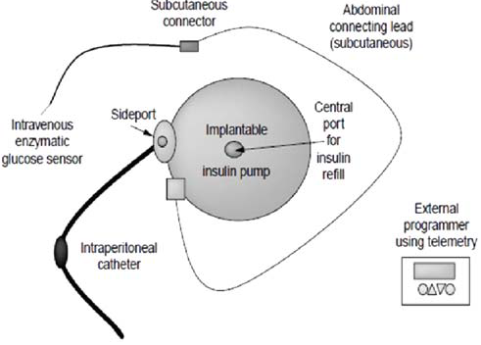

Figure 1: Schematic of an insulin implantable pump

2. Osmotic pumps
Osmotic pumps have proven to be the most popular type of implantable drug delivery system. The osmotic pump, also known as Oros or the gastrointestinal therapeutic system, was first described by Theeuwes and Yum and released for use by Alza Corporation. This pump consists of a drug reservoir surrounded by a semipermeable membrane. The surrounding membrane allows a steady influx of water and biological fluid into the reservoir through the process of osmosis. The hydrostatic pressure built up from this influx causes a steady release of the drug from an opening in the membrane called the drug portal. The rate of drug release is constant or zero-order until the drug within the reservoir is completely depleted. Changing the rate of drug administration in these systems can only occur by changing the structure of the semipermeable membrane, which requires removal of the system. Osmotic pump systems containing hydromorphone have been subcutaneously implanted for pain management. Results have shown that Alzet’s osmotic pumps release 262 mg/h of hydromorphone to produce stable plasma concentrations of approximately 30–40 mg/mL over a 2-week period. This type of delivery system is advantageous over other systems since the "initial burst effect," seen in other forms of degradable or nondegradable matrix systems, does not occur. The prolonged release of drugs at a constant rate has been shown to be effective in the treatment and management of chronic pain. Therefore, such systems may be used more extensively in the future.

3. Positive displacement pumps
Positive displacement pumps have been developed to provide continuous insulin delivery to diabetic patients. Most of these systems utilise piezoelectric disc benders affixed to flexible tubing. Such pumps are made by first exposing the discs to certain voltages so that they form spherical surfaces. The bellow-type system is then connected to a drug reservoir via a three-way solenoid-driven
valve. When exposed to electrical pulses, the valves in the pump open or close depending on the direction of the pulse. This action causes the release of drugs in a controlled manner based on the rate of the electrical pulse. Other types of positive displacement pumps using similar designs are currently being developed for the delivery of insulin.
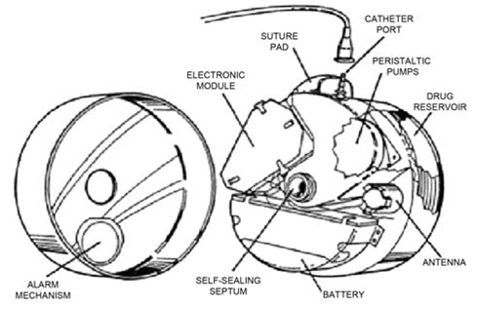
Figure 2: Cross-sectional view of an implantable peristaltic pump showing
all important components

Advantages:
The advantages of implantation therapy include
A. Convenience:-
Drug concentrations in the bloodstream can be maintained for long periods of time by methods such as continuous intravenous infusion or frequent injections. However, under these regimens, patients are often required to stay in the hospital during administration for continuous medical monitoring. A short-acting drug exacerbates the situation, as the number of injections or the infusion rate must be increased in order to maintain a therapeutically effective level of the drug. In contrast, implantation therapy permits patients to receive medication outside the hospital setting with minimal medical surveillance. Implantation therapy is also characterised by a lower incidence of infection-related complications in comparison to indwelling catheter-based infusion systems.
B. Compliance:
By allowing a reduction, or complete elimination, of patient-involved dosing, compliance is greatly increased. A person can forget to take a tablet, but drug delivery from an implant is largely independent of patient input. Some implantable systems involve periodic refilling, but despite this factor, the patient has less involvement in delivering the required medication.
C. Potential for controlled release:
Implants are available that deliver drugs through zero-order controlled release kinetics. Zero-order-controlled release offers the advantages of
(a) Avoiding the peaks (risk of toxicity) and troughs (risk of ineffectiveness) of conventional therapy;
(b) reducing the dosing frequency;
(c) Increasing patient compliance
D. Potential for intermittent release:
Externally programmable pumps can facilitate intermittent release. Intermittent release can facilitate drug release in response to such factors as:
(a) Circadian rhythms;
(b) Fluctuating metabolic needs
(c) The pulsatile release of many peptides and proteins
E. Potential for bio-responsive release:
Bio-responsive release from implants is an area of ongoing research.
F. Improved drug delivery:
Using an implant system, the drug is delivered locally or to systemic circulation with minimal interference by biological or metabolic barriers. For example, the drug moiety passes through the gastrointestinal tract and the liver. The bypassing effect is particularly beneficial for drugs that are either poorly absorbed or easily inactivated in the gastrointestinal tract and/or liver before systemic distribution.
G. Flexibility:
Considerable flexibility is possible with these systems in the choice of materials, methods of manufacture, degree of drug loading, drug release rate, etc.
A commercial implantable dosage form diversifies the product portfolio of a given drug. From a regulatory perspective, it is regarded as a new drug product and can extend the market protection of the drug for an additional 5 years (for a new drug entry) or 3 years (for existing drugs).

Disadvantages:
The disadvantages of implantation therapy include such factors as:
A. Invasive:
Either a minor or major surgical procedure is required to initiate therapy. It requires the appropriate surgical personnel and may be traumatic and time-consuming. Some scar formation at the site of implantation and in a very small portion of patients may result in surgery-related complications. The patient may also feel uncomfortable wearing the device.
B. Termination:
Non-biodegradable polymeric implants and osmotic pumps can also be surgically retrieved at the end of treatment. Although a biodegradable polymeric implant does not require surgical retrieval, Its continuing biodegradation makes it difficult to terminate drug delivery. or to maintain the correct function at the end of its lifetime.
C. Danger of device failure:
There is no concomitant danger with this therapy that the device may, for some reason, fail to operate. which again requires surgical intervention to correct.
D. Limited to potent drugs:
The size of an implant is usually small in order to minimise patients discomfort. Therefore, most systems have a limited loading capacity, so often only quite potent drugs such as hormones are used. May be suitable for delivery by implantable devices.
E. Possibility of adverse reactions:
The site of implantation receives a high concentration of the drug delivered by an implant. This high local drug concentration may trigger adverse reactions.
F. Biocompatibility issues:
Concerns over body responses to a foreign material often raise the issue of the biocompatibility and safety of an implant.

Applications of implantable drug delivery systems

A. Long-term drug delivery for chronic conditions

Chronic diseases, also known as chronic non-communicable diseases, have complex causes. They are usually incurable, require continual medical management, and often deteriorate with time. ¹ In recent years, chronic diseases have contributed to 73.4% of all deaths globally and thus form a substantial medical and economic burden on society. According to data released by the Chinese Resident Nutrition and Chronic Disease Report in December 2020, chronic diseases caused 88.5% of total deaths in China in 2019. ² These data demonstrate that chronic diseases have become the primary threat to human health.
Targeted drug delivery systems can concentrate the active ingredient of a medicine at the site of a lesion or anatomical target and keep the drug at an effective concentration in the targeted organ for a longer duration of time, enabling patients to be prescribed medicines at a lower dose. Targeted therapy is a treatment approach that aims to deliver the therapeutic drug to pathogenic organs or sites of required action at a cellular or molecular level. Targeted therapy can help eliminate and reduce drug-related adverse effects, thus improving safety and helping patients continue taking their prescribed medicines at the prescribed dose and intended dosing frequency without being dissuaded or impeded from doing so by adverse effects. For these reasons, targeted agents are being widely applied in the field of pharmacy. In the past decade, ground-breaking progress has been made in developing targeted therapies for the treatment of chronic diseases. Here, we review research advances in the development of targeted drugs for chronic diseases and their delivery systems.

The role of targeted therapies in chronic respiratory diseases Targeted treatment of chronic obstructive pulmonary disease (COPD)
COPD is a common, severe chronic pulmonary disease that affects over 250 million people around the world and is the third-leading cause of death in the world. COPD, like other respiratory diseases such as acute respiratory distress syndrome, chronic pulmonary fibrosis, and lung cancer, is associated with long-term oxidative stress. Currently, therapeutic strategies for COPD can only ameliorate symptoms. Targeted therapies could provide new treatment options for patients with COPD and could form important adjuvant treatments for COPD. New targeted drugs based on the pathogenesis of COPD have been developed, including cytokine inhibitors, chemokine receptor antagonists, phosphodiesterase 4 inhibitors, nuclear factor B (NF-B) inhibitors, and protease inhibitors. Compared with oral administration, lung administration of targeted therapies offers a number of advantages, including a faster absorption rate, a concentrated distribution of metabolic enzymes throughout the lung, and lower rates of degradation of the active ingredient. The manner in which drugs are deposited in the respiratory system is mainly influenced by the diameter of the particles used to deliver the drug (Fig.3 ). Studies have found that drug delivery systems that produce a higher proportion of drug particles with a diameter between 1.0 and 3.0 m result in more drug settling in the alveoli and bronchioles, leading to better therapeutic effects. New drug delivery systems that could enable this include liposomes, nanoparticles, solid lipid nanoparticles, microspheres, and microemulsions.

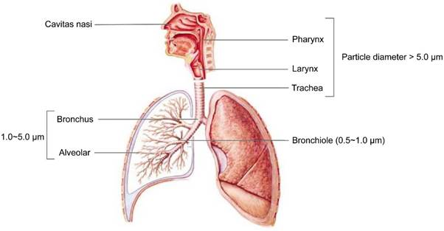
Fig. 3: Schematic diagram of particulate deposition in the human respiratory system

B. Targeted drug delivery to specific tissues or organs

The goal of a targeted drug delivery system is to prolong, localise, target, and have a protected drug interaction with the diseased tissue. The conventional drug delivery system involves the absorption of the drug across a biological membrane, whereas the targeted release system releases the drug in a dosage form.
The need for TDD over conventional DSs is fourfold: unsatisfactory performance of drugs in terms of pharmacodynamic, pharmacokinetic, pharmaceutical, and pharmacotherapeutic features with conventional delivery, as shown in Figure 4. Targeting drugs to a particular area through optimised DD methods is not only important to enhance therapeutic effectiveness but also to reduce the toxicity associated with a small therapeutic index and high doses. Targeting is needed to achieve solutions to these constraints and the innate disadvantages of conventional DDSs. Parenteral delivery is highly invasive; oral administration cannot be used for protein- or peptide-derived drugs; and topical creams and ointments are limited to local effects. Furthermore, the effectiveness of drug-target interactions is compromised unless the drug is delivered to its site of action at a dosage and rate that produce minimal side effects while maximising therapeutic effects. In addition, simpler drug-administration procedures, decreased drug quantity, which reduces therapeutic costs, and the potential to sharply increase drug concentration in target compartments without adverse effects on nontarget compartments are promising benefits of TDD. Generally, drug targeting results in increased efficacy, modulated pharmacokinetics, controlled biodistribution, increased specificity of localization, decreased toxicity, a reduced dose, and improved patient compliance.
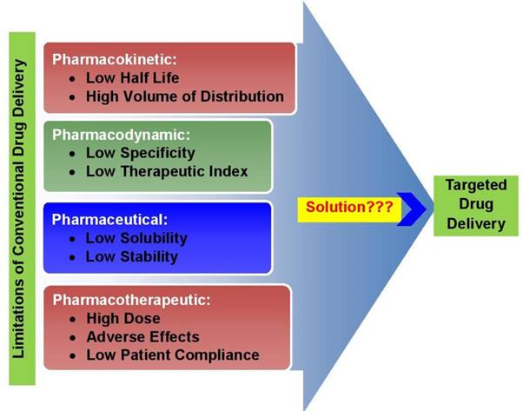
Figure 4 The need for targeted drug delivery

Basic Principles and Applications of Targeted Drug Delivery Systems

The basic principle behind drug targeting is delivering a high concentration of drug to the targeted site while minimising its concentration in the nontargeted region. This principle aids in optimising the drug’s therapeutic effects while decreasing the side effects due to multitarget interactions, higher doses, and nontarget concentrations. Targeting also ameliorates unwanted interactions of the drug with bioenvironmental factors that affect drug access to targeted sites in the body, as shown in Figure 5. Drug targeting comprises coordinated drug behaviour, targeting sites, and pharmaceutical carriers. The target is the specific organ, cell, or group of cells in a chronic or acute condition demanding treatment with which the drug is going to interact. The carrier is a specially engineered molecule or system essential for effective transportation of the loaded drug towards preselected sites. Ideally, a drug-targeting complex is expected to be atoxic, nonimmunogenic, biochemically inert, biodegradable, biocompatible, and physicochemically stable in vivo and in vitro. It should also have a predictable and controllable pattern of drug release, be reasonably simple, reproducible, and cost-effectively prepared, be easily and readily eliminated from the body, and have minimal drug leakage during transit.
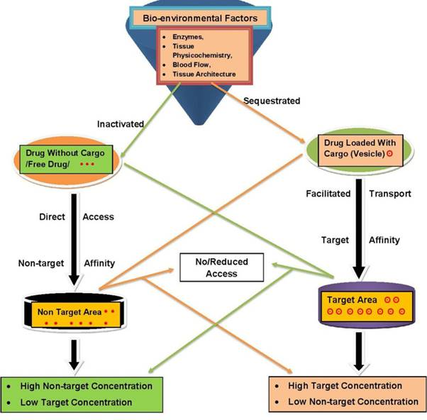 Figure 5 Principles of drug targeting.

C . Controlled release of drugs

Controlled drug delivery systems can include the maintenance of drug levels within a desired range, the need for fewer administrations, optimal use of the drug in question, and increased patient compliance. While these advantages can be significant, the potential disadvantages cannot be ignored, like the possible toxicity or non-biocompatibility of the materials used, undesirable by-products of degradation, any surgery required to implant or remove the system, the chance of patient discomfort from the delivery device, and the higher cost of controlled-release systems compared with traditional pharmaceutical formulations. The ideal drug delivery system should be inert, biocompatible, mechanically strong, comfortable for the patient, capable of achieving high drug loading, safe from accidental release, simple to administer and remove, and easy to fabricate and sterilise.

Reference
- Danckwerts M, Fassihi A. Implantable controlled release drug delivery systems: A Review. Drug Dev Ind Pharm 1991;17:1465–502.
- Available from: http://www.pharmainfo.net/pppc06/implantable-drugdelivery-system. [Last accessed on November 1, 2010]
- Costantini LC, Kleppner SR, McDonough J, Azar MR, Patel R. Implantable technology for long-term delivery of nalmefene for the treatment of alcoholism Int J Pharm 2004;283:35-44
- Ranade V. Drug Delivery Systems Implants in drug delivery J Clin Pharm 1990;30:871-89
- Baker R. Controlled Release of Biologically Active Agents New York: John Wiley; 1987. p. 40–56
- Juni K., Ogata J., Nakano M., Ichihara T., Mori K., and Akagi M. Preparation and evaluation in vitro and in vivo of polylactic acid microspheres containing doxorubicin. Chem Pharm Bull 1985;33:313–8.
- Alekha KD, Greggrey CC. Therapeutic applications of implantable drug delivery systems. J Pharmacol Toxicol Methods 1998;40:1–12.
- Higuchi T., Rate of release of medicaments from ointment bases containing drugs in suspension. J Pharm Sci 1961;50:874–879
- Lewis DH. Controlled release of bioactive agents from lactide and glycolide polymers. In: Chasin M., Langer R., editors Biodegradable Polymers as Drug Delivery Systems New York: Marcel Dekker; 190. p. 1–41
10. Wood DA. Biodegradable drug delivery systems Int J Pharm 1980;7:1–18.
- Zaheer S., Lehman J., and Stevenson G. Capsular contracture around silicone implants: The role of intraluminal antibiotics Plast Reconstr Surg. 1982;69:809–12.
- Langer R. Implantable controlled release systems In: Ihler GM, editor. Methods of Drug Delivery New York: Pergamon Press; 1986. p. 121–37
- Graham, NB. Polymeric inserts and implants for the controlled release of drugs Br Polymer J 1978;10:260–6.
- Wang X, Chen T, Yang Z, and Wang W. Study on the structural optimum design of implantable drug delivery microsystems Simultaneous Modelling Practise Theory 2007;15:47–56.
- Sershen1 S, West J. Implantable, polymeric systems for modulated drug delivery Adv Drug Deliv Rev 2002;54:1225–35
16. Kimura H, Ogura Y, Hashizoe M, Nishiwaki H, Honda Y, and Ikada Y a new vitreal drug delivery system using an implantable biodegradable polymeric device. Invest Ophthalmol Vis Sci 1994;35:2815–9.
- Brown LR, Wei CL, and Langer R. In vivo and in vitro release of macromolecules form polymeric drug delivery systems. J Pharm Sci 1983;72:1181–5.
- Rhine W, Hsieh DS, and Langer R. Polymers for sustained macromolecule release: Procedures to fabricate reproducible delivery systems and control release kinetics J Pharm Sci 1980;69:265-70.
- Barrera D, Zylstra E, Lansbury PT, Langer R. Synthesis and RGD peptide modification of a new biodegradable copolymer: Poly(lactic acid-colysine). J Am Chem Soc 1993;115:11010-1
20. Dagani R. Biodegradable copolymer eyed as tissue matrix Chem Eng News 1993;22:5-8.
- Cao L, Mentell S, and Polla D. Design and simulation of an implantable medical drug delivery system using microelectromechanical systems technology. Sens Actuators A Phys 2001;94:117-25
- Renard E. Implantable closed-loop glucose sensing and insulin delivery: The future for insulin pump therapy Curr Opin Pharmacol 2002;2:708–16.
- Blackshear PJ, Rhode TH. Artificial devices for insulin infusion in the treatment of patients with diabetes mellitus. In: Burk SD, editor. Controlled Drug Delivery, Clinical Applications, Vol. 2, Boca Raton, FL: CRC Press; 1983, p. 11.
- Dash AK, Suryanarayanan R. An implantable dosage form for the treatment of bone infections Pharm Res 1992;9:993-1002.
- Sefton MV. Implantable pumps CRC Crit Rev Bioeng 1987;14:201–40.

