1.HYDROELECTRIC POWER

Hydroelectric energy, , is a form of energy that harnesses the power of water in motion to generate electricity and also called as hydroelectric power or hydroelectricity This force have been used by people for millennia. The flowing water had been used by Greece people to turn the wheel of their mill to ground wheat into flour over 2,000 years ago,

1.1 How Does Hydroelectric Energy Work?
The hydroelectric power plants have a water reservoir, valve or gate to control the water flow out of the reservoir, and an outlet (place where the water ends up after flowing downward). The potential energy is gained by water before it spills over the top of a dam or flows down a hill. The potential energy is converted into kinetic energy as water flows downhill. The blades of a turbine are turned by using water energy to generate electricity, which is distributed to the customers.

1.2 Types of Hydroelectric Energy Plants
The hydroelectric energy plants consist of
- Impoundment facility
- Diversion facility
- Pumped-storage facility
Impoundment facility
In an impoundment facility, the flow of water stored in a pool or reservoir is controlled by using a dam. If more energy is required, water is released from the dam. Once water is released, the water flows downward through a turbine due to gravity. As the blades of the turbine rotates, a generator generates power.
Diversion facility
This type of plant is unique as it will not use a dam. Instead, a series of canals are used to channel flowing river water toward the generator-powering turbines.
Pumped-storage facility
This plant collects the energy produced from solar, wind, and nuclear power and stores it for future use. The plant stores energy by pumping water from a pool to dam in uphill at a lower elevation to a reservoir located at a higher elevation. When there is high demand for electricity, water is released for power generation from reservoir. As this water flows back down to the lower reservoir, it turns a turbine to generate more electricity.

1.3 How Widely Is Hydroelectric Energy Used Around the World?
The most commonly-used renewable source of electricity is Hydroelectric energy. The largest producer of hydroelectricity is China. Other top producers of hydropower around the world include the United States, Brazil, Canada, India, and Russia.

1.4 What Is the Largest Hydroelectric Power Plant in the World?
The largest hydroelectric dam in the world is three Gorges Dam in China, which holds back the Yangtze River, in terms of electricity production. The dam is 2,335 meters (7,660 feet) long and 185 meters (607 feet) tall, and it generators the 22,500 megawatts of power. The Figure shows the Dam of Hydro Electric Power Plant

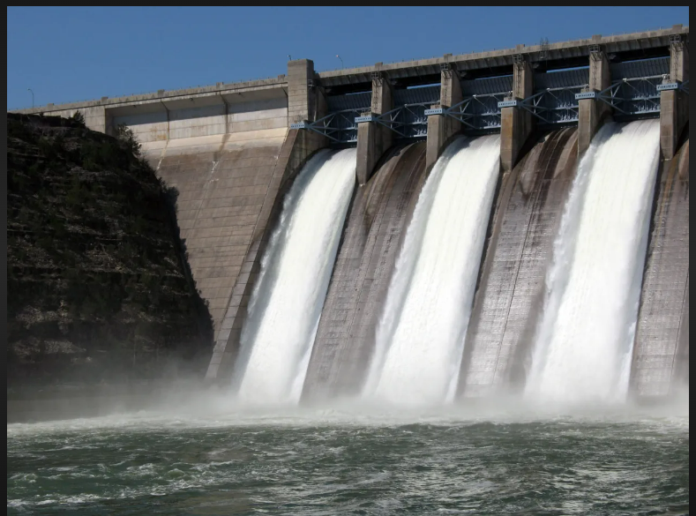
Figure 1: Dam of Hydro Electric Power Plant

The moving water makes the hydroelectric energy . Hydro comes from the Greek word for water.
Hydroelectric energy are in use for thousands of years.
Water mills provide another source of hydroelectric energy. Water mill which has large wheels were located on the banks of moderately flowing rivers until the Industrial Revolution. Water mills generate energy that powers such diverse activities as grinding grain, cutting lumber, or creating hot fires to create steel. The first hydroelectric power plant was built in U.S on the Fox River in 1882 in Appleton, Wisconsin. Two paper mills and one home had been powered by this plant.

1.4 Harnessing Hydro electricity
The water flow must be controlled to harness the energy from water. Usually damming a river is done to create an artificial lake, or reservoir. Water is channelled through tunnels in the dam. The turbines are rotated by the energy of water flowing through the dam's tunnels. The generators will be made to run by the rotation of turbines. Generators are machines that produce electricity.
The amount of water through the dam is controlled. by engineers. This water flow is controlled by the process which is called the intake system. Most of the tunnels are open, when a lot of energy is required and millions of gallons of water flow through them. When less energy is needed, the intake system is slow down by engineers by closing some of the tunnels.
During floods, the intake system is helped by a spillway. The water is allowed to flow by a spillway structure into the river or other body of water below the dam, bypassing all tunnels, turbines, and generators. Spillways prevent the dam and the community from being damaged. Spillways, which look like long ramps, are empty and dry most of the time.
1.5 From Water Currents to Electrical Currents
The most hydroelectricity is produced by large, fast-flowing rivers. The Columbia River forms part of the border between the U.S. states of Washington and Oregon. It is a big river that produces massive amounts of hydroelectric energy. The Bonneville Dam (on the Columbia River) has 20 turbines and generate more than a million watts of power every year. This energy is enough
for supplying the power the hundreds and thousands of homes and businesses. The huge amounts of energy can be created by hydroelectric power plants near waterfalls . Water crashing over the fall line is full of energy. A best example is the hydroelectric plant at Niagara Falls,which spans the border between the United States and Canada.
Hydroelectric energy generated by using the Niagara Falls is split between the Canadian province of Ontario and U.S. state of New York. Engineers At Niagara Falls, the falls couldn’t be turned off by the Engineers. The intake and control the amount of water rushing over the waterfall are limited
very strictly by the engineers
1.6 Hydroelectric Energy and the Environment
Hydroelectricity relies on water, which is a clean, renewable energy source. A renewable source of energy is one that will not run out. Renewable energy comes from natural sources, like sunlight rain , wind, tides, and geothermal energy (the heat produced inside Earth). Non- renewable energy sources are oil, natural gas and coal.
Water is renewable because the water cycle is continually recycling itself. The clouds are formed by water evaporation and then rains down on Earth, starting the cycle again. Reservoirs are created by dams can provide large, safe recreational space for a community. Many reservoirs are also stocked with fish. The area around a reservoir is often a protected natural space, allowing
campers and hikers to enjoy the natural environment.
Using water as a source of energy is generally a safe environmental choice. Hydroelectric power plants require a dam and a reservoir. Dams flood river banks, destroying wetland habitat for thousands of organisms. The cranes and ducks are often at risk, as well as plants that depend on the marshy habitat of a riverbank. Operating the power plant may also raise the temperature of the water in the reservoir. Plants and animals near the dam have to adjust to this change or migrate elsewhere.
The O'Shaughnessy Dam on the Tuolumne River in the U.S. state of California was one of the first hydroelectric energy projects to draw widespread criticism for its impact on the environment. The dam, constructed in 1913, flooded a region called Hetch Hetchy Valley. Environmental coalitions opposed the dam, citing the destruction of the environment and the habitats it provided. However, the power plant provided affordable hydroelectric energy to the booming urban area around San Francisco.
There are limits to the amount of hydroelectric energy a dam can provide. The most limiting factor is silt that builds up on the reservoir's bed. This silt is carried by the flowing river, but prevented from reaching its normal destination in a delta or river mouth by the dam. Hundreds of meters of silt build up on the bottom of the reservoir, reducing the amount of water in the facility. Less water means less powerful energy to flow through the systems turbines. Most dams must spend a considerable amount of money to avoid silt build-up, a process called siltation.
1.7 Global Level Hydroelectric Energy
Billions of people depend on hydroelectricity every day. It powers homes, offices, factories, hospitals, and schools. Hydroelectric energy is used to bring affordable electricity to rural areas. The hygiene, education, and employment opportunities are improved with the help of hydroelectricity. Dozens of Dams have been built by China and India recently, as they have quickly industrialized.
The United States depended on hydroelectric energy to bring electricity to many rural or poor areas. Most of this construction taken place during the 1930s. Dams were a huge part of the New Deal, a series of government programs that put people to work and brought electricity to millions of its citizens during the Great Depression. The Shasta Dam on the Sacramento River ,Bonneville Dam on the Columbia River, , and the Hoover Dam on the Colorado River are some dams constructed as part of the New Deal.
The most famous hydroelectric power project of the New Deal is probably the Tennessee Valley Authority (TVA). The TVA constructed a series of dams along the Tennessee River and its tributaries. Today, the TVA is the largest public power company in the U.S., providing affordable electricity for residents in the states of Alabama, Georgia, Kentucky, Mississippi, North Carolina Tennessee and Virginia.
However, hydroelectricity often comes at a human cost. The huge dams required for hydroelectric energy projects create reservoirs that flood entire valleys. Homes, communities, and towns may
be relocated as dam construction begins.
1.8 HYDRO POWER IN INDIA
In 1947, hydropower capacity in India was about 37 percent of the total power generating capacity and over 53 percent of power generation. In the late 1960s, growth in coal-based power generation initiated the decline in hydropower’s share in both capacity and generation. In 2022, hydropower capacity of 46,512 MW (megawatts) accounted for roughly 11.7 percent of total capacity. Approximately 12 percent of power generation obtained from hydropower in 2020-21.
In the first two decades since independence (1947-67), hydropower capacity addition grew by over 13 percent and power generation from hydro stations grew by 11.8 percent. In the following two decades (1967-1987) hydropower generation capacity grew by over 18 percent but hydro power generation grew only by 5.6 percent. In 2007-2019, hydropower capacity addition grew by just over 1 percent and power generation from hydro-stations grew by under 1 percent. Specific generation or power generated per unit of capacity (a measure of economic efficiency) declined from over 4.4 in the 1960s to less than 2.5 in the early 2000s. Specific generation has improved since then reaching 3.4 in 2019-20.
India's economically exploitable and viable hydroelectric potential is estimated to be 148,701 MW. An additional 6,780 MW from smaller hydro schemes (with capacities of less than 25 MW) is estimated as exploitable. 56 sites for pumped storage schemes has installed with capacity of 94,000 MW.

India stands in 5th position globally for installed hydroelectric power capacity. As of 31 March 2020. Additional smaller hydroelectric power units with a total capacity of 4,683 MW (1.3% of its total utility power generation capacity) have been installed. India's hydroelectric power potential is estimated at 148,700 MW at 60% load factor. The total hydroelectric power generated in India was 156 TWh (excluding small hydro) with an average capacity factor of 38.71% in the year 2019–20
The hydroelectric power plants had been established at Darjeeling and Shivanasamudra in 1898 and 1902, respectively. They were among the first in Asia and India has been a dominant player in global hydroelectric power development.^{[5]} India also imports surplus hydroelectric power from Bhutan.
Brahmaputra has highest potential in terms of generating Hydroelectricity followed by Indus, Ganga. East following rivers have largest potential as compared to west following rivers and central Indian basins
The public sector accounts for 92.5% of India's hydroelectric power production. The Northeast Electric Power Company (NEEPCO), the National Hydroelectric Power Corporation (NHPC), THDC, Satluj Jal Vidyut Nigam (SJVNL), and NTPC-Hydro are some of the public sector companies producing hydroelectric power in India. The private sector is also expected to grow with the development of hydroelectric energy in the Himalayan mountain ranges and in the northeast of India. The hydropower projects in Bhutan, Nepal, Afghanistan have been cimplemented by Indian companies
Bhakra Beas Management Board (BBMB), a state-owned enterprise in north India, has an installed capacity of 2.9 GW. The generation cost after four decades of operation is about 27 paise (0.34¢ US) per kWh. BBMB is a major source of peaking power and black start capability to the northern grid in India and its large reservoirs provide wide operational flexibility. BBMB reservoirs also supply water for the irrigation of 12.5 million acres (51,000 km²; 19,500 sq mi) of agricultural land in partner states, enabling the green revolution in the northern India.

The International Hydropower Association estimates that the total hydropower potential in India is 660,000 GWh/year,. But 540,000 GWh/year (79%) is still undeveloped.

1.9 Local environmental costs
In the last two decades the most significant policy push for hydropower was the 2003 plan for developing 50,000 MW of hydropower capacity. Under the plan, preliminary feasibility reports (PFRs) for 162 new hydro-electric projects were prepared. More than half the capacity was identified in Arunachal Pradesh. As of 2021, only one project of The capacity of 100 MW has been commissioned in Sikkim and about 4345 MW capacity is under construction. Forty projects of capacity 13633 MW have been delayed due to local opposition to the projects rooted in local environmental concerns. 66 projects are yet to be allotted and Seven projects are under survey and investigation;

High precipitation in the Himalayas, coupled with the sudden fall in altitude in the mountains of that region results in large volume of water gushing down river channels. Construction of hydro projects and related infrastructure such as roads often aggravate this phenomenon.

1.10 Global benefits
In 2020, hydropower contributed to 4,370 Terawatt-hours (TWh) of global electricity generation, the highest contribution by a renewable and low carbon energy resource. Hydropower makes the largest low carbon energy contribution to the global primary energy basket. It is 55 percent higher than that of nuclear power and larger than all other renewable energy (RE) combined. By the end of 2020, there was 160 GW (gigawatts) of pumped storage hydropower installed globally, comprising 95 per cent of all total installed energy storage. Reservoir-based hydropower projects also provide flood control and a dependable water supply for drinking and irrigation purposes.
Many hydropower plants can ramp their electricity generation up and down very rapidly as compared with other power plants such as nuclear, coal, and natural gas. Hydropower plants can also be stopped and restarted relatively smoothly. This high degree of flexibility enables them to adjust quickly to shifts in demand and to compensate for fluctuations in supply from RE sources. The hydropower plants account for almost 30 percent of the world’s capacity for flexible electricity supply.

1.11 Push for Hydropower
The hydro-industry in India pressed for financial incentives from the government to match those received by the RE sector in India given that hydropower was both low carbon and renewable. Hydropower generation will vary based on the water source to follow load, meet peak demand, and make up for intermittent generation from RE sources. The system stability is maintained by regulating the grid frequency through continuous modulation of active power, the provision of spinning reserves and control of voltage through the supply of reactive power. The inertia of the grid will be decreased by increasing the sharing of Renewable energy in the Indian grid. Hydropower demonstrated these capabilities on the 5th of April 2020 when most households in India switched off electrical lights for nine minutes. The anticipated electricity demand reduction was 12-14 GW but the actual demand loss was over 32 GW for 49 minutes, more than double the demand loss anticipated. Hydro generation will be increasing and then decreasing supply within few minutes.

In March 2019, the government gave approval to promote hydropower development in India. This included (i) Inclusion of large hydro power projects as RE sources (ii) Hydro-purchase obligation (HPO) as a separate category in the non-solar renewable purchase obligation (RPO). The annual targets set based on capacity addition plans were to be notified by the Ministry of Power (MOP) and necessary modifications were to be introduced in the tariff policy; (iii) Tariff rationalization measures (including providing flexibility to the developers) to determine tariff by back loading tariff after increasing project life to 40 years. It increases debt repayment period to 18 years with introduction of escalating tariff of 2 percent (iv) Budgetary support for funding flood moderation component of hydropower projects on case-to-case basis for enabling infrastructure. The roads and bridges on case to case basis as per actual, limited to ₹15 million/MW for up to 200 MW projects and INR10 million/MW for above 200 MW projects.
1.12 Terms and Definitions
a. Precipitation
It may be defined as the total condensation of the moisture that reach the earth surface in any from i.e. ice, hail. Sleet dew & forestation etc.
b. Evaporation
The process by which all the rainfall is return to the atmosphere from the land & water surfaces called evaporation.
Evaporation includes evaporation from land & water surfaces. Evaporation by transmission & atmospheric evaporation
c. Runoff
It may be defined as the pat of precipitation which is available as stream flow i.e.
Runoff =Total precipitation – Total evaporation
d.Hydro graph:
It is graphical representation of discharge or flow with the time. Here flow is in ordinates in height number of m3/sec X km3 or KW & time as abscissa In hour, day, week, month or year.
E.Flow duration curve:
It is the graph between flows & length of time during which they are available.
f.Mass curve:
The curve which indicates the total volume of run-off in M3 of to a certain time.
g.Storage:
Generally water flows excess during one seasons & less during another. So it is made to provide water constantly.
h.Pondage:
The water storage if present at far away from power plant then a small pond is required near the power plant to provide hourly changes in power demand.

1.13 Classification of Hydro Power Plant
Depending on the capacity, hydel power plants are divided into the following categories:

Category | Capacity | Application
Large Hydel Plant | 50 MW to 1000 MW | Large Cities
Small Hydel Plant | 1 MW to 50 MW | Small Cities to Town
Mini Hydel Plant | 100 KW to 1000 KW | Towns
Micro Hydel Plant | $<$ 1000 KW | Rural Community
Pico Hydel Plant | $<$ 5Individual home KW

1.14 Selection of Site for Hydro Electric Power Plant
These are some factors which are taken in to consideration for the selection of site for hydro electric power plant i.e.
1. Availability of water :
Hydro electric power plant should be built where there adequate water available at goof head or huge quantity of water is flowing across a given point
2.Water storage:
For continuous supply of water. The water storage in suitable reservoir at height or building of dam across the river is essential so convenient accommodation for the erection of a dam per Reservoir must be available.
3.Water head:
It has a considerable effect on the cost & economy of power generation i.e. an increasing effective head reduces the quantity of storage water & handle by pen stock screens & turbine resulting reduction in cost.
4.Distance from load centre:
Generally these plant locate far away from load center so roots & distances affects on economical transmission.
5.Accessibility of size:
It requires adequate transportation facilities for easy transportation required equipment & machine
6.Availability of land:
The land available most be cheap & rocky to with stand large building & machinery.

1.15 Constructional details of Hydro Power Plant
Depending on the capacity, hydel power plants are divided into the following categories Hydro Power Plant is an electricity-producing plant in which the water is an essential fuel, the potential energy is being converted into kinetic energy and kinetic energy is further converted into mechanical and into electrical energy with the help of a turbine and motor.
We will understand how it works in very detail. So now let’s study construction. The Figure 2 shows the Layout of Hydel power plant
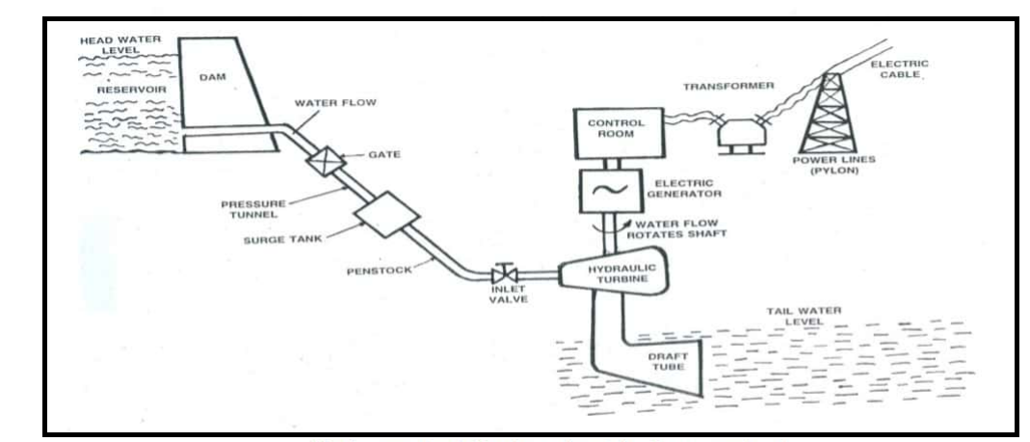
Figure 2. Layout of Hydel power plant
.

Hydro Power Plant Layout or Construction:
The following Construction or Layout of Hydro Power Plant:
- Head pond or Reservoir
- Control gate
- Penstock
- Turbine
- Draft Tube
- Tail Race
- Transmission Line
- Generator
- Transformer
- Power House

Headpond:
There is one reservoir which is having a large area in which A huge amount of water is being stored here. So the energy here is in the form of Potential energy.

Control Gate:
There are having multiple control gates in a single hydro power plant. The work of control gate is to regulate the flow of water. When the control gate is fully opened the speed of water flowing is maximum.

Penstock:
The penstock is also called Pipe. The water stored at the dam or head pond is being released by the control gate, the water starts moving to the turbine. The Head pond is having high heights and the Turbine is situated below.
So the speed of water gets increased because of gravitational force. The material of the penstock is hard steel being used.

Valve and Nozzle:
The valve work is similar to the control gate and Nozzle work is striking water in a specific direction [Pressure is high] that is a turbine blade.

Surge tank:
Surge tank is an additional and essential component which is used to accumulate the water which is in pipe when we want to close the turbine working. Or you can say it is used for avoiding the pipe burst.

Turbine:
Turbine is a device which is used for generation of electricity. Turbine work is, the fluid having kinetic energy is being converted into rotational energy.
The high kinetic energy water comes through the penstock to the nozzle and strikes the turbine blades. The turbine blades start rotating. So the rotational energy can also be called mechanical energy.

Draft Tube:
Drat tube is mechanical component which is used for enlarging the area of pipe for sending maximum fluid to the other side.

Tail Race:
Tailrace carries water away from the plant. Hence the water is sent to the river.

Transmission Line:
The transmission line carries power from the power unit or transformer and transfers or supplies from one source to another. It is made up of conductor.

Generator:
When the turbine buckets starts rotating, the turbine shafts also rotating. the motors are attached to the turbine shafts which is also rotating and generator is attached to them which generates electricity.

Transformer:
The transformer is attached to the generator. The electricity generated is now controlled by the transformer. The work of transformer is to set up or set down the voltage.

Power House:
The name power house means there is a house in which the power is being stored ]and released to the transformer and so on.

1.16 Pumped storage unit

India has transformed from an electricity deficit state to an electricity surplus state. Peak load shortages can be met making use of pumped storage schemes which store surplus power to meet peak load demands. The pumped storage schemes also contribute secondary, seasonal power at no additional cost when rivers are flooded with excess water. India has already established nearly 4,800 MW pumped storage capacity with the installation of hydropower plants. In a tropical country like India, abundant water for agriculture is needed due to a very high annual evaporation rate. Pumped storage units can also be used as pumping stations to supply river water for upland irrigation, industrial needs, and drinking water. The amount of water necessary to meet this demand can be harnessed from India's rivers via pumped storage units

Principle of Operation

The pumped storage plant consists of two ponds, one at a high level and other at a low level with powerhouse near the low-level pond. The two ponds are connected through a penstock. The pumped storage plant is shown in Figure .
When the plants are not producing power, they can be used as pumping stations which pump water from tail race pond to the head race pond (or high-level reservoir). In this pumping cycle case, generator/turbine assembly works as pump/motor.

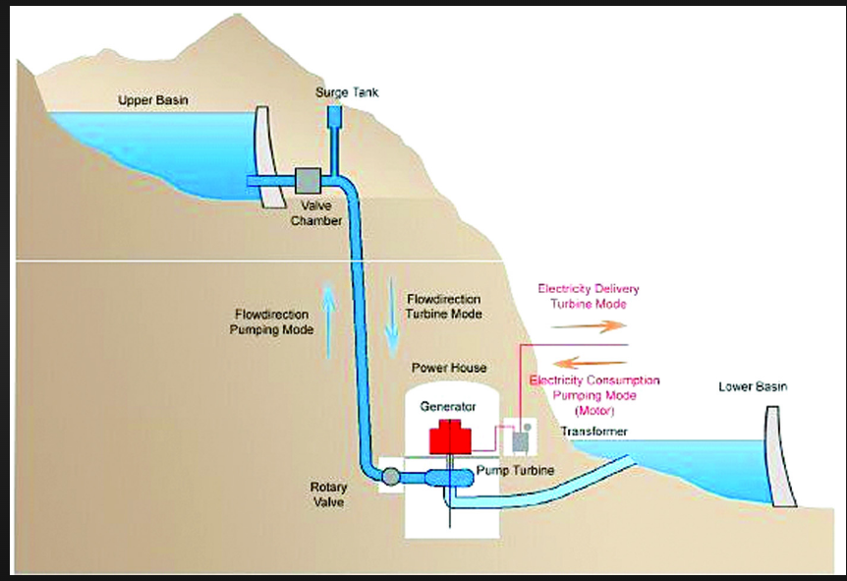

Figure 3. Pumped Storage Hydro Plant

When there’s a sudden demand for power, the “head gates” are opened, and water rushes down the tunnels to drive the turbines, which drive the powerful generators. This is called generation cycle. The water then collects in the lower reservoir, ready to be pumped back up later. Water is pumped up to the top reservoir at night when demand for power across the country is low.
It is an igneous way of conserving the limited water resources on the one hand and balancing the load on the distribution system, on the other hand. The plant operates as a source of electrical energy during system peak hours and as a sink during off-peak hours.

1.17 Benefits of pumped storage plants
Large-scale: This is the attribute that best positions pumped hydro storage which is especially suited for long discharge durations for daily or even weekly energy storage applications.
Cost-effectiveness: thanks to its lifetime and scale, pumped hydro storage brings among the lowest cost of storage that currently exist.
Reactivity: the growing share of intermittent sources reduces the inertia of the grid, which increases its instability. Reactivity, then, is key to avoid incidents, and hydropower production and storage can provide inertia and load balancing services to the grid. The current technologies provide response times that are counted in seconds or even milliseconds in the case of variable speed technology.
Mature technology: for decades, pumped hydro storage has offered a cost-effective way to provide large-scale balancing and grid services, with predictable cost and performance. New hydro storage technologies, such as variable speed, now give plant owners even more flexibility, output, efficiency, reliability and availability.
Renewable and Sustainable: Hydropower uses the force of water that can be pumped uphill and turbined downhill as much as needed. pumped hydro storage plants have a lifetime of more than 40 years for the electromechanical equipment and 100 years for the dam. Closed-loop pumped hydro storage present minimal environmental impact as they are not connected to existing river systems. In addition, they do not need to be located near an existing river and can therefore be located where needed to support the grid.
Multi-functional: water management, irrigation control for agriculture, water distribution and water waste control.
Higher flexibility and reactivity
Innovative variable speed solutions for extra flexibility

1.18 Different Types of Turbine used in Hydropower Plant
The turbines are used to convert the kinetic energy of water into mechanical energy. According to the available water head and flow or volume of water, the hydropower turbine is selected. The hydropower turbines are classified into two types;
- Impulse turbine
- Reaction turbine

1.18.1 Impulse Turbine:
As the name suggests, this turbine works on the principle of impulse. It uses the head of water and converts the pressure of water into kinetic energy with the help of nozzles.
In some plants, one or more nozzles are constructed near the runner. This will increase the velocity of the water. And this high-velocity water impinges on the turbine. The turbine has a number of buckets fixed on the outer periphery of the wheel.
The bucket is used to change the direction of jet flow if required. The momentum of water is used to convert kinetic energy into mechanical energy. The impulse turbine is shown in Figure 4.

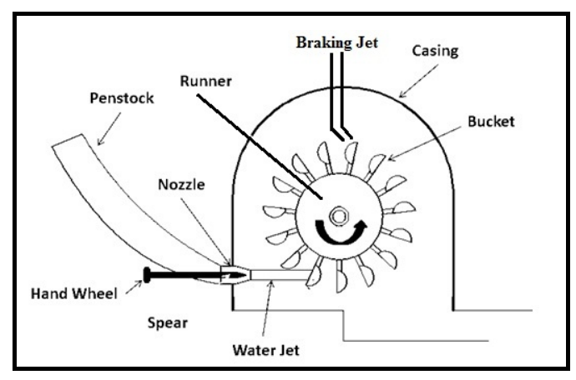
Figure 4. Impulse Turbine

The pressure of water remains constant at atmospheric while passes through the runner. An example of impulse turbine is Pelton turbine, cross-flow turbine;

1.18.2 Pelton Turbine
In a Pelton turbine, the blades are as spoon-shaped and the water is allowed to strike via a nozzle to the blade of a turbine. The blade of the Pelton turbine is also known as a bucket. Sometimes, the Pelton turbine is also known as the Pelton wheel.
In some cases, instead of one nozzle, a set of nozzles are used to split into a number of streams. These streams flow along the inner curve of the blade and pass in the opposite direction. This creates an impulse on the blade of the turbine and generates high torque by which the turbine starts rotating.
Generally, Pelton turbines are used in a hydroelectric power plant for the high head and low flow. The Pelton wheel is used in plants which have available water head more than 985 feet and have a reservoir of water. The Pelton wheel is shown in Figure 5.

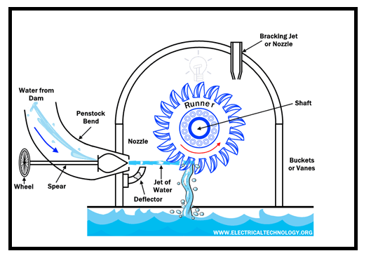
Figure 5. Pelton Wheel

1.18.3 Cross-flow Turbine
The shape of the cross-flow turbine is similar to the drum and water wheel. This turbine is also known as the Ossberger turbine. The water strikes the rotor of the turbine. For the first time, pressured water transfers impulse force inside the drum, and water leaves the turbine rotor at ambient pressure. The Figure 4.6. shows the cross flow turbine.

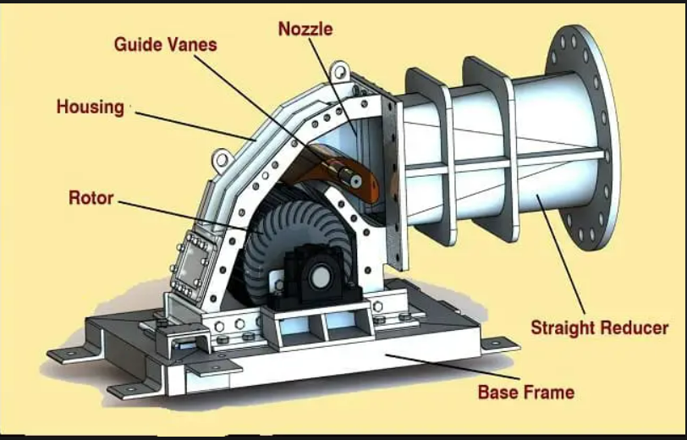
Figure 6. Cross Flow Turbine

After that, the cross-flow turbine changes the water pressure and converts it into mechanical energy. The pressure of water is reduced and increase the efficiency of the turbine in increased. It produce high torque that rotates the turbine and produce mechanical energy.

1.18.4 Reaction Turbine
In a reaction turbine, first, the pressure energy of water is converted into kinetic energy before supplied to the runner. So, entered water has partially kinetic energy and partially pressure energy. After that, both energies are reduced simultaneously while passing over the runner. The cross sectional view of Reaction turbine is shown Figure 7

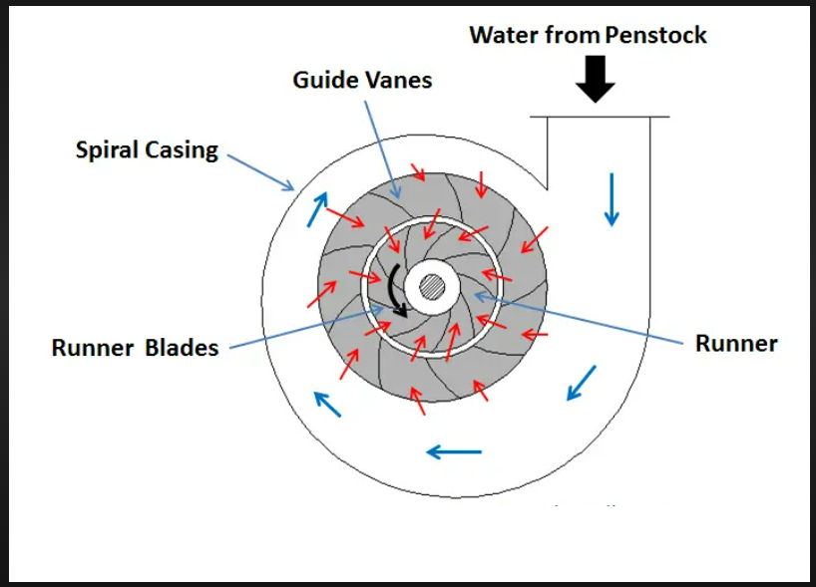
Figure 7. Cross sectional view of Reaction Turbine

Hence, this turbine works on the principle of impulse reaction. The runner of this turbine is under pressure (above atmospheric pressure). Therefore, the blade of this turbine is filled with water in all conditions. Examples of reaction turbines are Francis, Kaplan, and Propeller turbines.

1.18.5 Propeller Turbine
The propeller turbines are used in low-head plants. This type of turbine has a fixed or adjustable propeller. The diameter of the propeller is large which results in slow rotational speed.
A propeller turbine looks like a large propeller of ships and submarines. The turbine has adjustable guide vanes. The water flow of the turbine is controlled by the vanes. To transfer the energy of water, the vanes move the water into a runner. The Figure 8 shows the Propeller Turbine

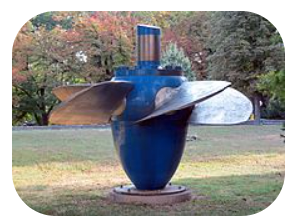
Figure 8. Propeller Turbine

The Kaplan turbine is also a type of propeller turbine. There are many other types of turbine-like; bulb turbine, tube turbine, straflo turbine, etc. But out of these turbines, the Kaplan turbine is widely used in hydroelectric power plants

1.18.6 Kaplan Turbine
Kaplan turbine is a propeller-type turbine. It has adjustable blades. It was introduced by Australian professor Viktor Kaplan in 1913. The Kaplan turbine is an evolution version of the Francis turbine.
A Kaplan turbine can be used for low-head power plants. This is not possible in the case of the Francis turbine. The Kaplan turbine works efficiently with the water head ranges between 33 to 230 feet and the output of the plant between 5 to 200 MW.
The runner diameter lies between 2 to 11 meters. The Kaplan turbines are widely used in high-head and low-head hydroelectric plants. The Kaplan Turbine is shown in Figure 9.

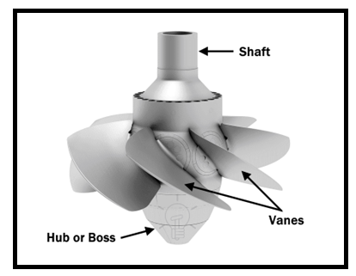
Figure 9. Kaplan Turbine

1.19 Hydro Power Plant Site Selection:
The factor which includes for selection of Hydro Power plant are:
- Environmental effect
- The water availability
- Water storage
- Head of water
- Site accessibility
- Distance from the load center
- Types of the land of the site
- Water Pollution
- Geological Investigation
Now let’s discuss each in detail.

Environmental effect:
Environmental effect is one of major problem which should be not occur so the place can be choose which is free from hazards and chemical effects and so on.

The water availability:
In Hydro Plant water is an essential fuel. Water availability is needed to plant for the rotating turbine blade and generating electricity.

Water storage:
After the availability of water, we must store the water in a dam So we can constantly provide water to the turbine and with high-pressure energy as I explained above.

Head of water:
To increase the flow of water from Dam to turbine blades.

Site Accessibility:
It is also one of an important factor. The power generated from the plant that can be utilized easily. It should have transportation facility be road or train.

Distance from the load center:
If there is more distance between power plant to the load center then transmission cable is used more and hence cost will be increased an so on.

Types of the land of the site:
The Power plant needs more space and it should be kept in mind that land cost must be cheap.

Water Pollution:
Water pollution is one of the major factor. The plants should be free from water pollution. If there is water pollution then chances of loss of equipment is much.

Geological Investigation:
Plant construction should be strong and stable. This construction can withstand natural calamities like thunderstorms and earthquakes, etc.

1.20 Advantages of Hydro Power plant

- The operating cost of the hydroelectric plant including auxiliaries is considerably low when compared with thermal plants. The annual operating and maintenance cost of a thermal plant is approximately 5- 6 times that of a hydro plant of equal capacity
- Hydro-generation has a unique and significant role to play particularly in the operation of interconnected power systems.
- The cost of power generation is less.
- . The life expectancy of a hydroelectric power plant is more. The useful life of a thermal plant is 20-25 years as against 100-125 years for the hydro plants
- These are simple in design easy to maintain, pollution-free with zero fuelling cost.
- The fuel needed for the thermal plant has to be purchased, whereas in Hydro-plant the fuel cost is totally absent.
- The rapidly fluctuating loads are served most economically by Hydro-plant.
- There is no problem with handling the fuel and ash and no nuisance of smoke exhaust gases and spots and no health hazards due to air pollution.
- In a hydroelectric plant, there are no standby losses, whereas these are unavoidable for thermal plants and the number of operations required is considerably small compared with the thermal power plant.
- Hydroelectric plants are quick to respond to the change of load compared with thermal Power Plant or nuclear plants.
- The machines used in hydel plants are more robust and generally run at low speeds at 300-400 RPM, whereas the machines used in thermal plants run at a speed of 3000- 4,000 RPM.
- The efficiency of the hydro plants does not change with age, but there is a considerable reduction in the Efficiency of thermal as well as a nuclear power plant with age.
- It does not contribute to air and water pollution to the greenhouse effect
- Usually, the hydro station is situated away from the developed area therefore the cost of land is not a major problem.

Disadvantages:
The following disadvantages of Hydro Power plant are:
- The capital cost (cost per kilowatt capacity) installed) of the hydro plant is considerably more than the thermal plant.
- It takes a considerable long time for its erection compared with thermal plants.
- Power generation by the hydro plant is only dependent on the quantity of water available which in turn depends on the natural phenomenon of rain. The dry year is more serious for the hydroelectric project.
- The site of Hydroelectric station is selected on the criterion of water availability at economical head such sites are usually away from the load center.
- The transmission of power from the power station to the load center requires along transmission lines. Therefore investment required for long transmission lines and loss of power during transmission is an unfavourable factor for the economical selection of hydro plants.

1.21 Measuring Flow
The flow should be measured during the worst case condition. During the rainy season, the flow will be high and will provide high power output. However, during the dry season, the flow will be low. It should be estimated whether the load requirement will be met even during the worst case dry seasons. Therefore, the flow measurement should be done during the dry seasons.
Three simple methods of flow measurements are
1.Bucket method
2.Float method
3.Salt Gulp Analysis Bucket Method
Take a 15 liter bucket or any container with known volume. If the volume of the container is not known then it can be found out by filling the container with water from a 1litre bottle. Count the number of liter which has been added. This is giving the volume of the container. The most challenging task in this method is to find a location in the stream where the water can be directed into the bucket. It is important as little as possible escapes. This is done by placing the bucket at the bottom of a natural narrow fall in the stream path or by building a simple weir by using a wooden channel or a corrugated sheet such that the stream water flows through this weir during measurement. Now, using a stopwatch, record the time it takes to fill the bucket. Repeat the experiment three times and take the average. The volume of the bucket divided by the average time it takes to fill the bucket gives the flow rate of the water.
1.22 Measuring Head
Three popular methods for head measurement are
1.Water filled plastic tube
2.Altimeter
3. Abney level

1.22.1 Water filled plastic tube
This is the most inexpensive method of head measurement. It requires a piece of transparent plastic tube about 20m long and a diameter of 10mm. Fill the tube with water so that when the two ends are held together, the water level is about 300mm from the top. The water inside the tube will always find the same level on either side. A plastic funnel will help to pour in the water.
One person holds one end of the tube at the water level of the reservoir/forebay tank. The second person moves downhill till his eyes are in level with the water level of the fore bay tank. His end of the tube is adjusted till the water level in the tube is in level with his eyes. Now record that one reading has been taken. After this the tube is lowered such that the water level in the tube is in line with the soles of his feet.
Now the first person moves downhill till his eye level is in line with the soles of the feet of the first person. He now raises the tube till the water level is in line with his eye. Now record that a second reading has been taken. This process is repeated till the location of the turbine. The number of readings taken is summed up. This is multiplied with the average height to eye level of the two people who took the measurements. This gives the total head. This procedure should be repeated two to three times to obtain good accuracy.
A variation of this method is to connect one end of the tube with a pressure gauge. The pressure at each measuring point is recorded and the sum of the total pressures can be used to calculate the overall head.
1.22.2 Altimeters
Altimeters are an instrument to measure the head. Height is calculated using changes in air pressure. All that the user had to do is to record one reading at the expected fore bay location. Then he has to record the second reading at the turbine in order to determine the head. The second reading should be taken as quickly as possible to prevent any atmospheric changes to affect the reading.
1.22.3 Abney level
The Abney level is a hand- held sighting meter. With this method, the angle of the slope (θ) is measured. The linear distance (L) is also measured. The head is H is given by
H = L. sin (θ)
Two posts are driven into the ground one at the position of the proposed fore bay and the other at a position that is 20m to 30m downhill. A clear line of site between the top of the posts is required. The angle between the tops of the two posts is measured using the Abney level and the distance between them is also recorded. The head is measure between these two posts using the above relationship. Now, the first post is shifted further downhill as compared to the second post and the measurement recorded. This process is repeated till the position of the proposed turbine is reached. The heights are all added up to obtain the overall head.

1.23 Challenges
The hydro industry is hopeful that new financial incentives will add momentum to the hydropower sector. By 2026, roughly 12,340 MW of hydropower capacity addition is planned. Barring a few small projects in central and southern India, most are in the North and North-eastern states. This means reinvigoration of local agitations over environmental compromises. This is justified given that the massive flash floods in Uttarakhand in 2013 caused 5000 deaths, destroyed homes and damaged hydropower projects. There have been many such incidents since then. The 12th plan cautioned that “hydro-power projects on the Himalayan Rivers may not be viable even if they are looked at from a narrow economic perspective”. The Himalayas are relatively young mountains with high rates of erosion. There is little vegetation in the upper catchment to bind soil. High sediment load reduces productive life of power stations through heavy siltation. Judicial intervention following the 2013 floods led to setting up of a committee to investigate future environmental risk recommended cancellation of 23 hydro-projects in the region. Members of the committee from the Central Water Commission, and Central Electricity Authority refused to endorse conclusions of the report from the committee. The enthusiasm for hydropower given its technical capabilities in addressing the challenge of intermittency from the growing share of RE in the grid and in reducing global carbon emissions is understandable. This does not mean local environmental compromises can be dismissed as environmental fundamentalism or anti-developmentalism. The trade-off between the local and global environmental benefits of hydropower are real. The costs are local, and the benefits are global and to some extent national. It is important that the government policy, in its enthusiasm to contribute to the global public good of carbon reduction, does not ignore the cost imposed on the local environment and populations dependent on it.

1.24 Modern Concepts and Future Role
Hydropower does not discharge pollutants into the environment; however, it is not free from adverse environmental effects. Considerable efforts have been made to reduce environmental problems associated with hydropower operations. Example for environmental problem is that providing the improved water quality and safe fish passage in the past decade at both Federal facilities and non-Federal facilities licensed by the Federal Energy Regulatory Commission. To improve the environment Efforts, the additional opportunities have been provided by computer technologies to ensure the safety of dams. Yet, many unanswered questions remain about how best to maintain the economic viability of hydropower in the face of increased demands to protect fish and other environmental resources. Reclamation actively pursues research and development (R&D) programs to improve the operating efficiency and the environmental performance of hydropower facilities. Hydropower research and development today is primarily being conducted in the following areas: Fish Passage, Behavior and Response Turbine-Related Projects
Monitoring Tool Development, Hydrology, Water Quality, Dam Safety Operations & Maintenance Water Resources, Management Reclamation continues to work to improve the reliability and efficiency of generating hydropower. Today to increase production and efficiency, engineers want to make the most of new and existing facilities. Existing hydropower concepts and approaches include: Uprating existing power plants ,Developing small plants (low-head hydropower), Peaking with hydropower pumped storage, Tying hydropower to other forms of energy. The uprating of existing hydroelectric generator and turbine units at power plants is one of the most immediate, cost-effective, and environmentally acceptable means of developing additional electric power. Since 1978, Reclamation has pursued an aggressive uprating program which has added more than 1,600,000 kW to Reclamation's capacity at an average cost of $69 per kilowatt. This compares to an average cost for providing new peaking capacity through oil-fired generators of more than $400 per kilowatt. Reclamation's uprating program has essentially provided the equivalent of another major hydroelectric facility of the approximate magnitude of Hoover Dam and Power plant at a fraction of the cost and impact on the environment when compared to any other means of providing new generation capacity.
Low-head Hydropower :A low-head dam is one with a water drop of less than 65 feet and a generating capacity less than 15,000 kW.
Large, high-head dams can produce more power at lower costs than low-head dams, but construction of large dams may be limited by 12 lacks of suitable sites, by environmental considerations, or by economic conditions. In contrast, there are many existing small dams and drops in elevation along canals where small generating plants could be installed. New low-head dams could be built to increase output as well. The key to the usefulness of such units is their ability to generate power near where it is needed, reducing the power inevitably lost during transmission.

