Impact of MWCNT on Metal – Organic Contact of Rose Bengal and Safranin –T Dye Based Organic Device

Sudipta Sen*, N. B. Manik
Condensed Matter Physics Research Centre, Department of Physics
Jadavpur University, Kolkata-700032, India
*Corresponding Author’s Email: sagnike000@gmail.com

Abstract:
Carbon-based nanomaterials (CBN) have gained significant attention in various research disciplines due to their exceptional characteristics, including an excellent aspect ratio, substantial surface area, and superior thermal and electrical conductivity. In this study, Multi walled carbon nanotubes (MWCNT) have been selected from an array of carbon-based nanomaterials. This study focuses on exploring the use of MWCNT within the realm of organic electronics. Organic dye-based devices possess distinct advantages in comparison to their inorganic counterparts, a fact well acknowledged in the field. However, there exist certain drawbacks associated with the utilization of organic dyes in the context of being positioned between two metallic electrodes, hence establishing metal-organic interface. The charge injection process during formation of metal-organic junction is influenced by the presence of a high concentration of traps and a high injection barrier at the contact region. The improvement in charge flow at the junction and the enhancement of conductivity, as well as the reduction in threshold voltage, can be achieved by decreasing these values. From this standpoint, the inclusion of MWCNT has been implemented within the device. In the process of fabricating organic dye-based devices, two distinct organic dyes, namely Rose Bengal (RB) dye and Safranin - T dye, have been selected. Four devices were developed, with two devices being made without the inclusion of MWCNT, while the other two devices incorporate MWCNT. This study aims to examine the impact of trap energy and injection barrier on the movement of charge carriers at the interface between metal and organic materials. Additionally, it seeks to investigate any alterations in these parameters when MWCNTs are present.

Keywords: Injection Barrier; MWCNT; Rose Bengal Dye; Safranin – T Dye; Threshold Voltage;
Trap Energy

1. Introduction

In the past few decades, the study on the physics and chemistry of nanostructures is getting significant attention after the discovery of fullerenes, carbon nanotubes and graphenes. The atypical properties of carbon nanostructures are due to the size effects, which can be seen in zero-dimensional carbon quantum dots, one-dimensional carbon nanotubes, and two-dimensional grapheme layers [1-2]. These nanoscale materials have certain properties such as higher strength, lighter weight, increased control of light spectrum, and greater chemical reactivity than their larger-scale counterparts [3]. For carbon nanotubes, the classification can be done on the basis of chirality and also on the basis of number of graphene sheets. In terms of graphene sheets, the carbon nanotubes can be distinguished as single walled carbon nanotubes (SWCNT), double walled carbon nanotubes (DWCNT) and multi walled carbon nanotubes (MWCNT) [4].

In this present work, we have chosen MWCNT from the family of carbon based nanomaterials (CBN). MWCNT has good electrical conductivity, a large aspect ratio, low mass density and excellent thermal properties [5]. Organic dye based devices have certain excellent attributes such as cost effectiveness, light weight, flexibility and large area device fabrication [6-7]. Despite these attributes, when these organic dyes are sandwiched between two metallic electrodes, the charge flow at the metal – organic contact gets hindered. Poor charge injection can be caused by several factors. Organic devices are predisposed to traps [8]. High trap energy is a significant factor which hampers the flow of charges at the junction area. Injection barrier contributes to lowering of active carrier flow in device. To improve the device performance in terms of lowering of the threshold voltage and enhanced conductivity, reduction of both of these parameters is very much necessary. In this perspective, we have incorporated MWCNT in the organic device, to observe and study its effect on both trap energy and injection barrier. We have selected two organic dyes namely Rose Bengal (RB) dye and Safranin – T dye. As electrodes, we have chosen Indium Tin Oxide (ITO) coated glass substrate and Aluminium (Al). A total of four devices have been prepared with and without MWCNT. Current flow in the prepared devices has been characterized by steady- state current voltage (I –V) plot and it has been analyzed by using Richardson – Schottky (R-S) thermionic emission process [9].

2. Experimental Details

2.1 Materials and Sample Preparation

RB dye is an anionic dye of xanthenes organic compound [10]. Chemical Abstracts Service (CAS) number and molecular weight of this dye are 632-69-9 and 1017.64 g/mol respectively [11-12]. Safranin - T dye is a cationic azine dye [13]. CAS number and molecular weight of this dye are 477-73-6 and 350.84 g/mol respectively [14]. Empirical formula of this dye is C₂₀H₁₉ClN₄ [15]. Fig.1 (a) and Fig.1 (b) illustrate structures of both RB dye and Safranin - T dye. Both these dyes have been bought from Sigma- Aldrich.

The Multi-walled Carbon Nanotube (MWCNT) is classified as a carbon-based substance that exhibits exceptional physiochemical, thermo-mechanical, and electrochemical characteristics [16]. MWCNT is of 10 µm length and 12 nm of outer diameter. The surface area of MWCNT is 220 m² /g. The carbon content of MWCNT is more than 98%. CAS number of MWCNT is 308068-56-6 [17]. Fig.1 (c) shows the structure of MWCNT. It has been also bought from Sigma- Aldrich.

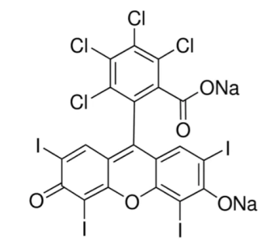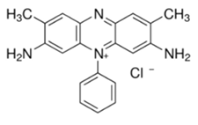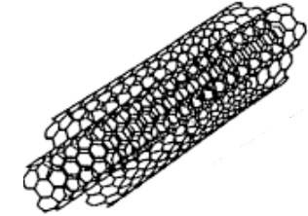
(a) (b) (c)

Fig. 1 Schematic Structures of (a) Rose Bengal (RB) Dye, (b) Safranin –T dye and (c) Multi – Walled Carbon Nanotube (MWCNT)

Preparation of PVA solution is mentioned in one of our previously published works [18]. PVA acts as an inert binder. RB dye solution is formed by adding 2 mg of RB dye with the prepared PVA solution. After that this RB dye solution is kept in two beakers. In one beaker, there is only RB dye solution and in another, 2 mg of MWCNT is prepended to form the solution with MWCNT and this solution is stirred for one hour. Spin coating process is also mentioned in one of our published works [19]. Organic Device comprising of Safranin –T dye with and without MWCNT has been done by using the similar processes. Fig. 2 shows the structure of organic device. Measurement techniques are similar to one of our published works [20].

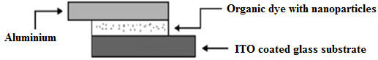
Fig. 2 Structure of Organic Device
3. Results and Discussions

Current (I) due to Richardson-Schottky (R-S) thermionic emission can be expressed as
$I=I_{0}$ (exp ($\frac{qV}{nkT})$ -1) (1)
$I_{0}=$ $AA^{*}T^{2}$ exp ($-\frac{qϕ_{b}}{kT}$) (2)
The above used symbols carry their usual meaning [21-23].
$ϕ_{b}=\frac{kT}{q}ln⁡(\frac{AA^{*}T^{2}}{I_{0}})$ (3)

Fig. 3 (a) and Fig. 3 (b) show the dark I – V characteristics of both RB dye and Safranin – T dye based organic devices with and without MWCNT. With MWCNT, the current flow of RB dye and Safranin – T dye based devices has been increased about 4 times and 3.5 times respectively. Aspect ratio of MWCNT will have paramount effect on both electrical and mechanical properties when it is incorporated in these organic devices. MWCNT acts as conductive fillers of traps resulting in better flow of charge carriers in both of these organic devices.

For estimating injection barrier of these organic devices, semi logarithmic I – V characteristics have been plotted in Fig. 4. Fig. 4 (a) and Fig. 4 (b) show the semi logarithmic I – V plots of both RB dye and Safranin- T dye with and without MWCNT respectively. The value of saturation current ($I_{0})$ can be estimated from the semi logarithmic I – V plots and by putting the value of $I_{0}$, in equation (3), the injection barriers of both RB and Safranin – T dye based devices in absence and in presence of MWCNT can be estimated.

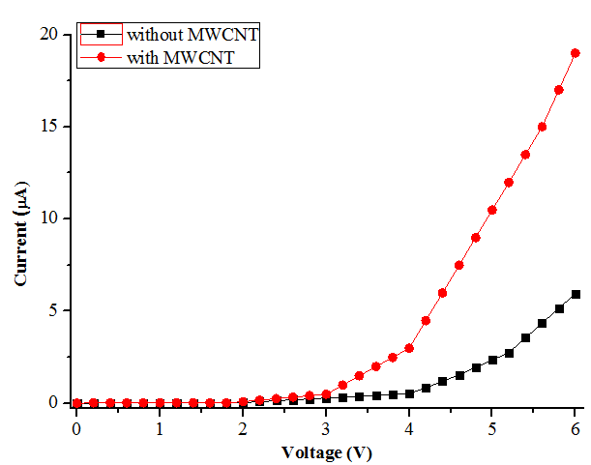
(a)

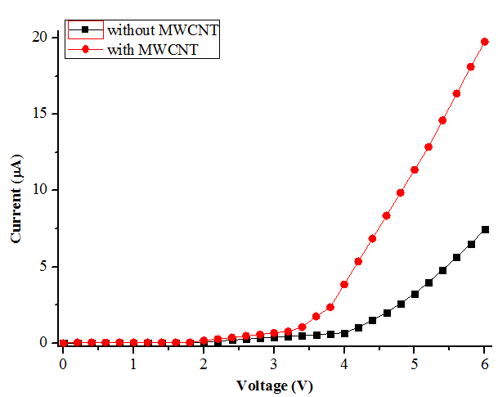
(b)
Fig. 3 Dark I-V Plots of Devices Comprising of (a) RB dye and (b) Safranin –T dye with and without MWCNT

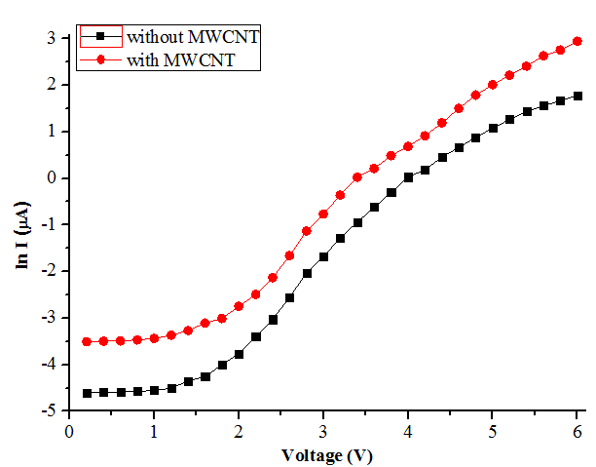
(a)

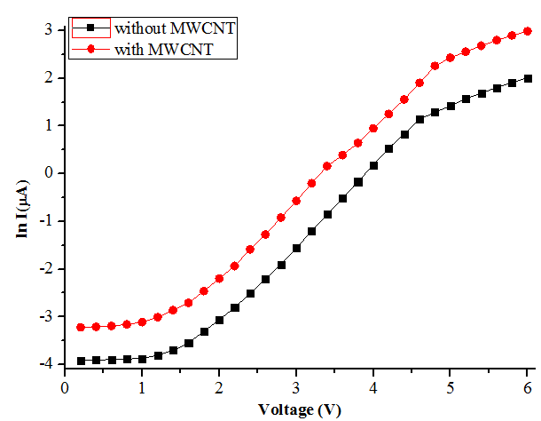
(b)
Fig. 4 ln I – V Plots of Devices Comprising of (a) RB dye and (b) Safranin –T dye with and without MWCNT

The trap concentration can be estimated by using equation (4)

$E_{t}$=$mkT$ (4)

Symbols used here have their usual meaning [24] and m is calculated from both the double logarithmic plot of I -V characteristics of the RB dye based devices and Safranin – T dye based devices with and without MWCNT, which have been shown in Fig. 5.

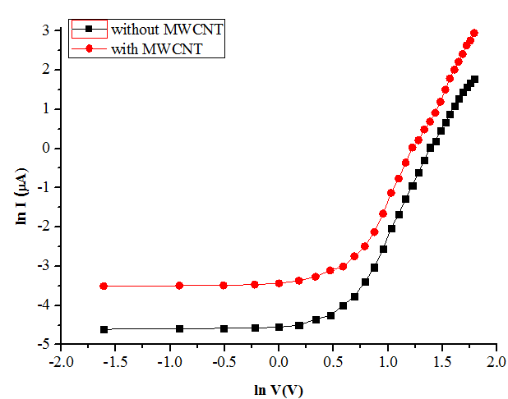
(a)

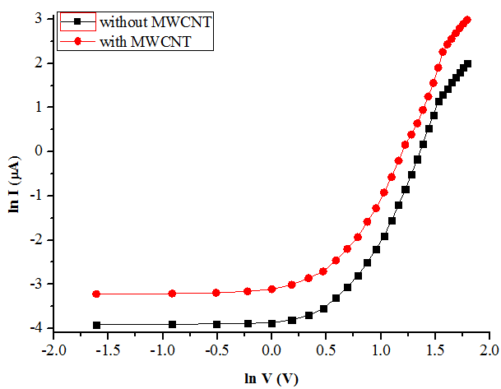
(b)
Fig. 5 ln I- ln V Plots of Devices Comprising of (a) RB dye and (b) Safranin –T dye with and without MWCNT

The estimation of threshold voltage, trap energy and injection barrier of both the devices in absence and in presence of MWCNT are shown in Table 1.

Table 1: Estimation of Threshold Voltage, Trap Energy, Injection Barrier for RB dye and Safranin –T Dye Based Devices without and with MWCNT

Organic Device | Threshold Voltage (V) | Trap Energy (eV) | Injection Barrier from Steady State  I –V characteristics  (eV)
RB Dye | 4.00 | 0.087 | 0.920
RB Dye + MWCNT | 3.00 | 0.075 | 0.860
Safranin –T Dye | 4.00 | 0.059 | 0.810
Safranin –T Dye + MWCNT | 3.50 | 0.047 | 0.790

Table 1 shows that, for RB dye, threshold voltage, trap energy and injection barrier estimated from
steady – state I – V characteristics have been reduced to 25%, 13.79% and 6.52 % respectively in presence of MWCNT. For Safranin – T dye also, threshold voltage, trap energy and injection barrier estimated from steady – state I – V characteristics have been reduced to 12.5%, 20.33% and 2.47% respectively with MWCNT. High aspect ratio of MWCNT allows lowering of percolation threshold of electrical conductivity resulting in improving of the device performance by reducing both trap energy and injection barrier at metal – organic contact.

4. Conclusions

In this present work, influence of MWCNT on parameters influencing charge conduction process mainly trap energy and injection barrier has been studied. Both the parameters have been decreased significantly with MWCNT. Lowering of both of these parameters will improve the charge flow at the junction area resulting in better conductivity and the devices will be turned on at lower voltages. For both RB dye and Safranin – T dye, incorporation of MWCNT provides more conductive pathways by reducing the trap concentration and injection barrier at metal – organic contact. This present work will be informative to observe and study one of the applications of MWCNT regarding the improvement of charge conduction process of organic device.

References

[1] T. C. Dinadayalane and J. Leszczynski, “Remarkable diversity of carbon–carbon bonds: structures and properties of fullerenes, carbon nanotubes, and graphene”, Structural Chemistry, 2010, 21, 1155-1169

[2] D. Maiti, X. Tong, X. Mou and K. Yang, “Carbon – Based Nanomaterials for Biomedical Applications: A Recent Study”, Frontiers in Pharmacology, 2019, 9, 1-16
[3] G. S. Dhakad, R. Aich, M. S. Kushwah and J. S. Yadav, “Nanotechnology: Trends and Future Prospective”, Global Journal of Bio - Science and BioTechnology, 2017, 6, 548-553

[4] M. Youssry, M. Al-Ruwaidhi, M. Zakeri and M. Zakeri, “Physical functionalization of multi-walled carbon nanotubes for enhanced dispersibility in aqueous medium”, Emergent Materials, 2020, 3, 25-32

[5] V. S. Aigbodion, P. A. Ozor and N. I. Sukdeo, “New Insights in Decoration of Carbon Nanotube for Improved Electrical Conductivity and Thermomechanical Properties of Polymer Nanocomposites”, Proceedings of the International Conference on Industrial Engineering and Operations Management Nsukka, Nigeria, 5 - 7 April, 2022, 1251-1257

[6] Q. Zhang, W. Hu, H. Sirringhaus and K. Müllen, “Recent Progress in Emerging Organic Semiconductors”, Advanced Materials, 2022, 34, 1-4

[7] S. R. Forrest, “The path to ubiquitous and low-cost organic electronic appliances on plastic”, Nature, 2004, 428, 911-918
[8] H. F. Haneef, A. M. Zeidell and O. D. Jurchescu, “Charge carrier traps in organic semiconductors: a review on the underlying physics and impact on electronic devices”, Journal of Materials Chemistry C, 2020, 8, 759-787
[9] S. M. Sze and K. K. Ng, “Physics of Semiconductor Devices”, 2007, [3rd ed.], John Wiley & Sóns, New York, 159-181

[10] P. Argüeso , A. Tisdale, S. S. -Michaud, M. Sumiyoshi and I. K. Gipson, “Mucin characteristics of human corneal-limbal epithelial cells that exclude the rose bengal anionic dye”, Investigative Opthalmology & Visual Science, 2006, 47, 113-119

[11] Y. B. Tambe, R. Ameta and S. Kothari, “Use of N-Doped Zinc Oxide for Photocatalytic Degradation of Rose Bengal”, Journal of Applicable Chemistry, 2016, 5, 1199-1207

[12] M. A. Rauf, J. P. Graham, S. B. Bukallah, M. A. S. Al-Saedi, “Solvatochromic behavior on the absorption and fluorescence spectra of Rose Bengal dye in various solvents”, Spectrochimica Acta Part A: Molecular and Biomolecular Spectroscopy, 2009, 72, 133-137

[13] V. K. Gupta, A. Mittal, R. Jain, M. Mathur and S. Sikarwar, “Adsorption of Safranin-T from wastewater using waste materials — activated carbon and activated rice husks”, Journal of Colloid and Interface Science, 2006, 303, 80 - 86

[14] Y. Shi, X. Wang, X. Wang, K. Carlson and Z. Li, “Removal of Toluidine Blue and Safranin O from Single and Binary Solutions Using Zeolite”, Crystals, 2021, 11, 1181-1-1181-15

[15] S. Sen, P. K. Das and N. B. Manik, “Study on Effect of Single Walled Carbon Nanotubes on Junction Properties of Safranin – T Dye Based Organic Device”, Journal of Physics Communications, 2021, 5, 045004-1- 045004-9

[16] N. Baig, I. Kammakakam and W. Falath, “Nanomaterials: a review of synthesis methods, properties, recent progress, and challenges”, Materials Advances, 2021, 2, 1821-1871

[17] M. Zgrzebnicki, N. Krauze, A. G. -Puchalska, J. K. - Kozar, E. Piróg and A. Jwdrzejewska et al., “Impact on CO₂ Uptake of MWCNT after Acid Treatment Study”, Journal of Nanomaterials, 2017, 2017, 1-11

[18] S. Sen and N. B. Manik, “Modification of Barrier Height and Depletion Layer Width of Methyl Red (MR) Dye - Based Organic Device in Presence of Single - Walled Carbon Nanotubes (SWCNT)”, Indian Journal of Physics, 2022, 96, 385-390

[19] S. Saha and N. B. Manik, “Effect of different concentration of TiO₂ nanoparticles in phenosafranin dye-based organic photovoltaic device”, Indian Journal of Physics, 2015, 89, 907-913

[20] S. Sen and N. B. Manik, “Effects of Two Different Solvents on Schottky Barrier of Organic Device”, Journal of Physics Communications, 2021, 5, 1-10

[21] M. Yildirim, “Determination of Contact Parameters of Au/n-Ge Schottky Barrier Diode with Rubrene Interlayer”, Journal of Polytechnic, 2017, 20, 165-173

[22] F. Muhammad, M. Tahir, M. Zeb, M. N. Kalasad, S. M. Said and M. R. Sarker et al., “Synergistic enhancement in the microelectronic properties of poly- (dioctylfuorene) based Schottky devices by CdSe quantum dots”, Scientific Reports, 2020, 10, 1-13

[23] N. A. Roslan, A. Supangat and S. Sagadevan, “Investigation of Charge Transport Properties in VTP: PC71BM Organic Schottky Diode”, Electronics, 2022, 11, 1-10

[24] A. Haldar, S. Maity and N. B. Manik, “Effect of back electrode on photovoltaic properties of crystal-violet-dye-doped solid-state thin film”, Ionics, 2008, 14, 427-432

