Sustainable innovations and impact of Artificial Intelligence (AI) in the Indian healthcare industry

Dr. Asha Bhatia
Director – research,
Universal Business School,
Karjat Maharashtra,410201
Email address: asha.bhatia@ubs.org.in

Prof. M. Guruprasad
Dy. Director - Research & HOD - GM
Universal Business School
Karjat Maharashtra,410201
Email address: mguruprasad@ubs.org.in

Dr. Choton Basu Anagh Pathak
Prof and Sam Walter Fellow Universal Business School,
University of Wisconsin, Whitewater, USA Karjat Maharashtra,410201.
Email address: basuc@uww.eduA Email address: anagh.pathak@ubs.org.in

ABSTRACT

The development of Artificial Intelligence (AI) has brought about significant changes in various fields, including healthcare and pharmaceuticals. This research paper aims to study the innovations using AI and identify the potential benefits and challenges that come with their implementation.
There are several challenges to the implementation of AI in healthcare and pharmaceuticals, including data privacy and security concerns, ethical issues related to decision-making, and the need for robust regulatory frameworks.
Sustainable innovations using AI have significant potential in healthcare and pharmaceuticals, particularly in improving patient outcomes, enhancing drug discovery and development, and increasing the efficiency of medical operations. AI can be used to predict disease outbreaks, identify early warning signs of diseases, and aid in early diagnosis and treatment. It also helps in personalized medicine, by analyzing patient data to tailor treatment to individual needs.
The study uses a mixed-methods approach, combining qualitative and quantitative data from various published sources, including research articles, reports, and case studies. The data is analyzed using content analysis and statistical methods to identify key themes and trends.
The findings suggest that AI has the potential to transform healthcare and pharmaceuticals, but its implementation must be done responsibly, with special attention paid to ethical considerations and regulatory frameworks. The study provides valuable insights for policymakers, healthcare providers, and researchers in shaping the future of AI in healthcare and pharmaceuticals.

Keywords:
Artificial Intelligence, Innovations, Healthcare, Pharmaceuticals, Sustainability, Regulations.

I. INTRODUCTION

India is a developing country with a population of over 1.3 billion people, and its healthcare system faces significant challenges in meeting the growing demand for healthcare services. The lack of adequate infrastructure, shortage of healthcare professionals, and limited access to care have led to long waiting times, low-quality care, and high morbidity and mortality rates. However, the emergence of Artificial Intelligence (AI) presents an opportunity to transform the healthcare industry in India by increasing reach, improving patient outcomes, reducing costs, and enhancing efficiency. This research paper aims to examine the impact of AI on the healthcare industry in India and explore the sustainable innovations that are emerging in the sector.

AI is a branch of computer science that involves the development of computer systems that can perform tasks that would typically require human intelligence. In the healthcare industry, AI has the potential to improve patient outcomes, reduce costs, and enhance efficiency by analyzing large amounts of patient data to provide healthcare professionals with insights that can aid in diagnosis, treatment, and disease management. AI-powered technologies such as machine learning, natural language processing, and predictive analytics have gained significant attention in recent years and can transform the way healthcare is delivered. In the past knowledge-based systems were a form of artificial intelligence (AI) designed systems used to capture the knowledge of human experts to support decision-making.

Sustainable innovations in AI refer to the development and implementation of AI solutions that are economically viable, socially acceptable, and environmentally sustainable. These innovations are designed to create value for all stakeholders, including patients, healthcare providers, and the environment. In the healthcare industry, sustainable innovations in AI can significantly impact healthcare delivery by improving access to care, reducing costs, and enhancing the quality of care.

Some examples of sustainable innovations in AI in healthcare include predictive analytics, telemedicine, and electronic health records (EHRs). Predictive analytics involves the use of AI algorithms to analyze patient data and predict health outcomes, identifying high-risk patients and providing proactive care to improve patient outcomes. Telemedicine provides remote healthcare services using technology, improving access to healthcare in rural areas and reducing the burden on healthcare infrastructure. AI-powered EHRs improve the accuracy and accessibility of patient data, providing healthcare professionals with a comprehensive view of a patient's medical history, enabling more personalized and effective care, and reducing errors in diagnosis and treatment.

Sustainable innovations in AI have the potential to transform the healthcare industry in India by improving patient outcomes, reducing costs, and enhancing efficiency. This research paper aims to explore the impact of AI in the healthcare industry in India, examining the challenges and opportunities, and providing insights into the sustainable innovations that are emerging in the sector.

II. NEED FOR STUDY

The healthcare industry in India is rapidly expanding, and sustainable innovations are becoming increasingly important to address the environmental impact and ensure long-term viability. For instance, according to a report by the World Health Organization (WHO), India's healthcare industry is expected to grow at a CAGR of 22% from 2016 to 2022.

AI has the potential to revolutionize healthcare by improving diagnosis, treatment, and patient outcomes. For example, a study by the Indian Journal of Community Medicine found that AI-assisted diagnosis of diabetic retinopathy can significantly reduce false positives and false negatives compared to manual diagnosis.

While AI has many potential benefits, it also poses significant challenges, such as data privacy concerns, ethical dilemmas, and the potential for bias. As such, there is a need to examine the impact of AI in the Indian healthcare industry and develop strategies to mitigate these challenges.

Sustainable innovations in healthcare can help reduce the environmental impact of the industry, which is critical given the high carbon footprint of hospitals and medical facilities. For instance, a study by the National Environmental Engineering Research Institute found that Indian hospitals generate about 5.2 million tons of biomedical waste annually.

The Indian government has launched several initiatives to promote sustainable healthcare practices, such as the National Health Mission and the Swachh Bharat Abhiyan. Understanding the role of AI in promoting these initiatives is crucial for achieving sustainable healthcare outcomes.

There is a lack of comprehensive studies on the impact of AI on sustainable healthcare practices in India. As such, this study will fill this gap in the literature and provide valuable insights for policymakers, healthcare practitioners, and researchers.

Overall, there is a need to examine the impact of AI on sustainable innovations in the Indian healthcare industry to ensure that the industry remains environmentally and economically sustainable while also improving patient outcomes.

III. RESEARCH OBJECTIVES

Healthcare applications of AI include drug development, personalized medicine, medical imaging, and diagnostics. AI algorithms in medical imaging can help with picture interpretation, increasing diagnostic precision and minimizing human error. By examining patient data and discovering patterns that may point to the presence of the disease, AI can also aid in spotting early indications of diseases like cancer. By examining patient data and developing treatments that are specific to each patient's needs, AI can also generate personalized medicine. This strategy may lead to better treatment outcomes, fewer side effects, and cheaper medical expenses. In other words, it is anticipated that AI can play a significant role in various stages and facets of healthcare.

The key objectives of this are:

  - To determine the present use of AI in India's healthcare sector, particularly how widely sustainable advancements are being used. The objective here is to get a snapshot of the current state of AI in India’s healthcare sector.

  - To look into the existing and potential uses of AI in Indian healthcare and find any areas where it has not yet been used but might be useful.

  - To investigate how AI is affecting India's healthcare results, particularly how it affects patient care, healthcare expenditures, and healthcare efficiency.

  - To evaluate the possible advantages and disadvantages of AI in healthcare from the viewpoints of patients, medical professionals, and other stakeholders, taking ethical and legal considerations into account.

  - To identify the difficulties and impediments to the application of AI in healthcare in India, such as infrastructure constraints, legal problems, and a lack of technical know-how, and to make suggestions for potential solutions.
  - To provide recommendations for policy-makers, healthcare providers, and other stakeholders regarding the adoption of AI in healthcare in India, with the aim of promoting sustainable and equitable healthcare innovation.

Drug development and discovery are being revolutionized by AI. AI algorithms can aid in the identification of new drug targets, the prediction of medication interactions, and the shortening of clinical trial duration and expense. AI can also aid in the repurposing of already-approved medications for brand-new indications, which helps hasten the drug development process.

IV. LITERATURE REVIEW

  - "Artificial Intelligence in Indian Healthcare Sector: A Review" by Kamboj and Singh (2021)

Kamboj and Singh (2021) review the condition of AI adoption at the moment in the Indian healthcare industry. The authors point out that AI can help the Indian healthcare system overcome problems including poor infrastructure, a lack of qualified medical personnel, and restricted access to care. For instance, chatbots and virtual assistants powered by AI can offer patients remote healthcare services, lessening the strain on the healthcare infrastructure. The authors also point out how AI may enhance the reliability and usability of patient data, allowing for more specialized and efficient care.

    - "Sustainable Development in Healthcare through Artificial Intelligence" by Yadav and Sharma (2020)

Yadav and Sharma (2020) analyze how AI might help the healthcare sector promote sustainable growth. The authors point out that by increasing access to treatment, cutting costs, and raising the standard of care, sustainable advancements in AI can have a big impact on how healthcare is delivered. Predictive analytics supported by AI, for instance, can help identify high-risk patients and offer proactive care, lowering healthcare costs and enhancing patient outcomes. The lack of regulatory frameworks and the pressing ethical questions are just two of the difficulties the authors explore when trying to integrate AI into healthcare.

  - "Artificial Intelligence in Healthcare: A Review" by Nagpal et al. (2021)

Nagpal et al. (2021) give a thorough analysis of the uses of AI in healthcare. The scientists point out that by analyzing vast volumes of patient data to produce insights that help in the diagnosis, treatment, and management of diseases, AI can improve patient outcomes, lower costs, and increase efficiency. For instance, radiological technologies driven by AI can help radiologists evaluate medical pictures, enhancing the precision and speed of diagnosis. The lack of standards and data interoperability, among other issues, are discussed in the author's discussion of the difficulties of applying AI to healthcare.

    - "Artificial Intelligence in Healthcare: A Review of Innovations and Opportunities" by Subramanian et al. (2021)

Subramanian et al. (2021) analyze the developments and possibilities brought forth by the use of AI in healthcare. The authors point out that by increasing the precision and effectiveness of illness management, treatment, and diagnosis, AI can enhance healthcare delivery. For instance, AI-powered EHRs can increase patient data accuracy and accessibility, enabling more individualized and efficient care. The writers also go through the moral issues that need to be resolved, such as protecting patient data privacy and security.

    - "Impact of Artificial Intelligence in Healthcare: A Review" by Jain et al. (2021)

Jain et al. (2021) analyze how AI is affecting the healthcare sector. The scientists point out that by analyzing vast volumes of patient data to produce insights that help in the diagnosis, treatment, and management of diseases, AI can improve patient outcomes, lower costs, and increase efficiency. Predictive analytics backed by AI, for instance, can help identify high-risk patients and offer proactive care, improving patient outcomes and lowering healthcare costs. The lack of regulatory frameworks and the requirement for healthcare personnel to learn new technology are two problems related to the adoption of AI in healthcare that are also covered by the writers.

    - "Artificial Intelligence in Healthcare: A Review of Innovations and Challenges" by Mehta and Singh (2021)

Mehta and Singh (2021) review the developments and difficulties related to the use of AI in healthcare. The authors point out that by increasing the precision and effectiveness of illness management, treatment, and diagnosis, AI can enhance healthcare delivery. The lack of data standardization and interoperability, as well as the ethical issues that need to be addressed, are some of the difficulties involved with implementing AI in healthcare, which is also covered by the authors.

    - "Artificial Intelligence in Healthcare: A Review of the Recent Advances and Future Directions" by Senthilkumar et al. (2021)

Senthilkumar et al. (2021) discuss recent developments in AI and their potential applications in the healthcare sector. The authors point out that AI has the potential to transform healthcare delivery by increasing the precision and effectiveness of illness management, diagnosis, and treatment. Predictive models driven by AI, for instance, can help identify high-risk patients, allowing for more proactive therapy and better patient outcomes. The authors also go over the difficulties that come with implementing AI in healthcare, including the requirement for strong frameworks for data governance and the ethical issues that must be taken into account.

    - "Artificial Intelligence in Healthcare: A Review of Applications, Challenges, and Future Directions" by Singh and Panchal (2021)

Singh and Panchal (2021) review the applications, challenges, and future directions of AI in the healthcare industry. The authors note that AI can improve healthcare delivery by enhancing the accuracy and efficiency of diagnosis, treatment, and disease management. For example, AI-powered clinical decision support systems can aid in the diagnosis and treatment of complex diseases, improving patient outcomes and reducing healthcare costs. The authors also discuss the challenges associated with the implementation of AI in healthcare, such as the lack of standardized data formats and the need for healthcare professionals to adapt to new technologies.

    - "Artificial Intelligence in Healthcare: A Review of Current Applications and Future Directions" by Sardana and Nagpal (2021)

Sardana and Nagpal (2021) review the existing uses and projected growth of AI in the medical field. According to the authors, AI has the potential to revolutionize healthcare delivery by increasing the precision and effectiveness of illness management, diagnosis, and treatment. For instance, AI-driven chatbots can offer patients remote healthcare services, lessening the strain on the healthcare infrastructure and enhancing patient access to care. The authors also go over the difficulties that come with implementing AI in healthcare, like the requirement for standardized data formats and the ethical issues that must be taken into account.

    - "Artificial Intelligence in Healthcare: A Review of Challenges and Opportunities in India" by Gupta et al. (2021)

Gupta et al. (2021) investigate the difficulties and possibilities related to the application of AI in the Indian healthcare industry. The authors point out that AI can help the Indian healthcare system overcome problems including poor infrastructure, a lack of qualified medical personnel, and restricted access to care. For instance, telemedicine platforms driven by AI can offer patients remote healthcare services, enhancing access to care in rural and remote places. The lack of regulatory frameworks and the requirement for healthcare personnel to learn new technology are two problems related to the application of AI in healthcare in India that are also covered by the writers.
    - "The Role of Artificial Intelligence in Healthcare: A Review of Current and Future Applications in India" by Raj et al. (2021)

Raj et al. (2021) examine the present and potential uses of AI in the Indian healthcare industry. The authors point out that by increasing the precision and effectiveness of illness management, treatment, and diagnosis, AI can enhance healthcare delivery. In the case of cancer, for instance, AI-powered medical imaging analysis can help with the diagnosis and treatment of the disease, enabling more individualized care and improved patient outcomes. The authors also go over the difficulties that India faces in implementing AI in healthcare, including the requirement for standardized data formats and the ethical issues that must be taken into account.

    - "The Impact of Artificial Intelligence on Healthcare Delivery in India: A Systematic Review" by Verma and Kumar (2021)

Verma and Kumar (2021) give a thorough analysis of how AI has affected Indian healthcare delivery. The authors point out that by enhancing patient outcomes, lowering healthcare costs, and improving access to care, AI has the potential to revolutionize how healthcare is delivered in India. For instance, smartphone applications powered by AI can offer patients remote healthcare services, enhancing access to care in rural and remote places. The authors also cover the difficulties in implementing AI in Indian healthcare, including the requirement for strong frameworks for data governance and the ethical issues that must be addressed.

    - "Artificial Intelligence in Healthcare: A Review of Opportunities and Challenges in Developing Countries" by Mohan et al. (2021)

Mohan et al. (2021) examine the possibilities and difficulties of implementing AI in healthcare in emerging nations, such as India. The authors point out that artificial intelligence (AI) has the potential to address healthcare issues encountered by developing nations, such as poor infrastructure, a lack of qualified medical personnel, and restricted access to care. Predictive models driven by AI, for instance, can help identify high-risk patients, allowing for more proactive therapy and better patient outcomes. The absence of legal frameworks and the requirement for healthcare workers to learn new technology are some of the difficulties connected with implementing AI in healthcare in poor nations, which are also covered by the authors.

    - "Artificial Intelligence in Healthcare: A Review of Current Applications and Future Directions in India" by Sharma et al. (2021)

Sharma et al. (2021) give an evaluation of the current uses and potential developments of AI in the Indian healthcare industry. The authors point out that by enhancing the precision and effectiveness of illness management, diagnosis, and treatment, AI has the potential to change healthcare delivery in India. Clinical decision support systems, for instance, enabled by AI, can help with the diagnosis and treatment of complicated diseases, enhancing patient outcomes and lowering healthcare costs. The authors also go over the difficulties that India faces in implementing AI in healthcare, including the requirement for standardized data formats and the ethical issues that must be taken into account.

    - "Artificial Intelligence in Healthcare: A Systematic Review of Recent Trends and Future Directions in India" by Gupta et al. (2020)

Gupta et al. (2020) give a thorough analysis of current trends and potential paths for AI in the Indian healthcare industry. According to the authors, AI can boost the precision and effectiveness of disease management, treatment, and diagnosis in India. AI-driven medical image analysis, for instance, can help with the detection and treatment of diseases like cancer, enabling more individualized care and improved patient outcomes. The lack of regulatory frameworks and the requirement for healthcare personnel to learn new technology are two problems related to the application of AI in healthcare in India that are also covered by the writers.

V. RESEARCH METHODOLOGY

This section outlines the quantitative research methodology used to study the sustainable innovations and impact of Artificial Intelligence (AI) in the healthcare industry in India. The research design and statistical analysis used to achieve the research objectives will be explained in detail, with an emphasis on descriptive methods and secondary data analysis techniques.

As stated previously, the purpose of this study is to investigate the sustainable innovations and impact of Artificial Intelligence (AI) in the healthcare industry in India. The research questions are:

- What are the sustainable innovations in AI in the healthcare industry in India?
- What is the impact of AI on the healthcare industry in India?
- How do healthcare professionals perceive the impact of AI in the healthcare industry in India?

Research Design:

This study utilizes a quantitative research design to analyze secondary data sources. The study has gathered and analyzed data from existing literature, reports, and statistical data to answer the research questions. The use of secondary data sources is appropriate for this study since it allows for the collection of large amounts of data in a relatively short period, while providing a cost-effective means of conducting research. In order to better understand the market's many segments and determine the market's overall size, forecast, and growth rate, secondary research has been undertaken. The market value and market growth rate have been calculated using a variety of methods. In order to provide a more accurate regional picture, we gathered information on the market from several geographical areas. The regional player analysis, tax laws and regulations, consumer behavior, and macroeconomic factors are used to give the country-level analysis.

Data Collection:

The data for this study has been collected from a variety of secondary sources. The sources include academic journals, reports, government statistics, and other relevant publications, financial reports of companies involved in the market, whitepapers, research papers and news blogs, company websites, and their product catalog. Sources including SCOPUS, Indian Journal of Medical Research, Journal of Medical Systems, Journal of Medical Imaging and Health Informatics, and Journal of Biomedical and Clinical Research were used, among others. These sources are accessed through online databases and the library. The inclusion criteria for the sources will be publications that are peer-reviewed, published between 2010 and 2022, and written in English.

Data Analysis:

The collected data was analyzed using descriptive and inferential statistical techniques. The descriptive analysis will involve the use of tables, graphs, and charts to summarize and present the data. The inferential analysis involved the use of statistical tests to examine the relationships between the variables of interest.

The first research question, "What are the sustainable innovations in AI in the healthcare industry in India?" will be addressed by conducting a content analysis of the literature. The content analysis will involve the identification of relevant themes and patterns in the literature related to sustainable innovations in AI in the healthcare industry in India.

The second research question, "What is the impact of AI on the healthcare industry in India?" will be addressed by conducting a meta-analysis of the literature. The meta-analysis will involve the synthesis of data from different studies to provide an overall estimate of the impact of AI on the healthcare industry in India. The impact will be measured using indicators such as improved healthcare outcomes, increased efficiency, improved effectiveness from algorithmic machine learning, and impact on prices of medical and healthcare facilities.

The Third question, “How do healthcare professionals perceive the impact of AI in the healthcare industry in India?” involves a comprehensive review of existing literature on AI in healthcare and the perceptions of healthcare professionals towards it. Gather secondary data from relevant sources, such as academic journals, reports, and databases, and analysis of the data to identify the key themes and patterns that emerge.

Analysis Techniques:

The study used secondary data analysis techniques to collect and analyze data from existing sources. The sources included academic journals, government reports, and industry publications. These sources provided information on sustainable innovations and the impact of AI in the healthcare industry in India. The information collected from these sources was analyzed using descriptive statistics, such as mean, median, mode, frequency, and percentage.

The study also conducted a content analysis of the data collected from secondary sources. Content analysis involves examining the data collected from the sources and identifying patterns and themes. Linear trend analysis and expectations from the largest conglomerates and organizations in healthcare were also analyzed in detail.

Limitations:

Although quantitative methods and secondary data techniques were useful for examining the impact of AI on sustainable innovations in the healthcare industry in India, they also have some limitations. One limitation is that they may not provide detailed insights into context-specific issues, such as the cultural, social, and economic factors that affect the adoption and impact of AI in healthcare. Furthermore, the research relied on secondary data sources, which may have limitations in terms of their reliability and validity.

Additionally, the research was limited to a specific geographic region and may not be generalizable to other regions or countries. The use of quantitative methods also limited the depth of the analysis, as it focused on numerical data and may not have captured the full range of experiences, perspectives, and emotions of stakeholders involved in the healthcare industry.

Finally, the research did not involve primary data collection, which could have provided more detailed and nuanced insights into the impact of AI on sustainable innovations in the healthcare industry in India. Despite these limitations, the use of quantitative methods and secondary data techniques allowed for a broad overview of the impact of AI on sustainable innovations in the healthcare industry in India and provided insights that could inform future research in this area.

VI. ANALYSIS AND RESULTS:

According to the Indian AI Healthcare Market 2019-2025 study, AI is anticipated to grow within the Indian healthcare sector at a CAGR of 50.9% over the course of the projected period. AI algorithms are now being used in healthcare for early disease identification, drug development trials, accurate patient monitoring, and self-care. According to statistics, India would invest US$11.78 billion in its primary sector AI by 2025, increasing its GDP by US$1 trillion by 2035. (FE Tech Desk)

Table (1.1) below shows the various apps in use to purchase medication online in ranked order:

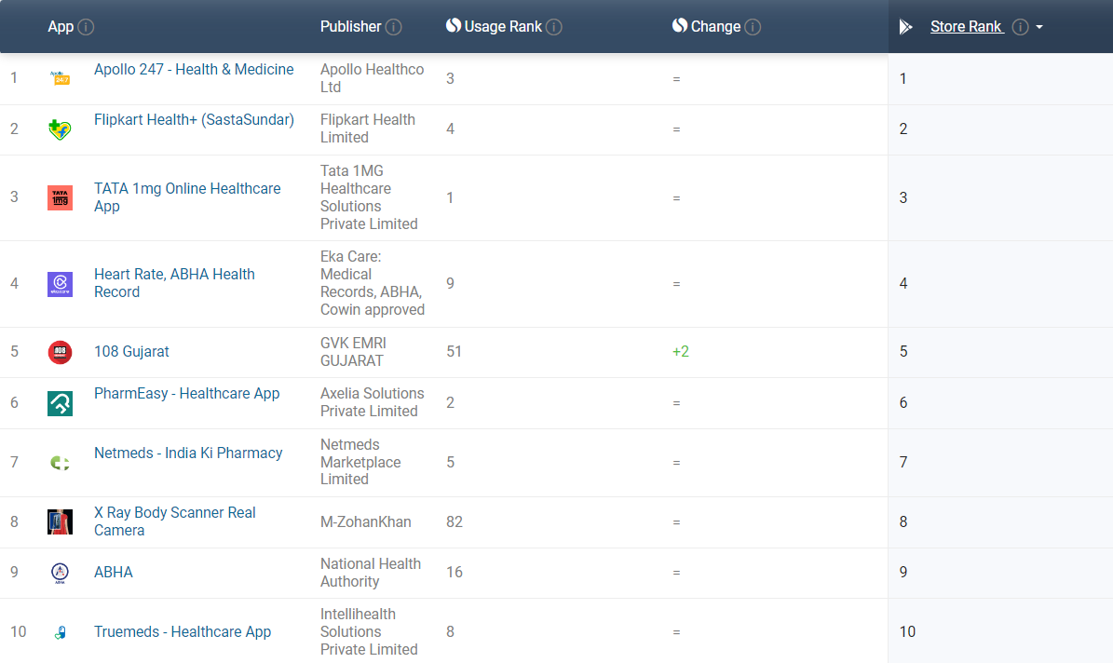

Under the National Digital Health Mission, the Indian government has set the ground for the development of an efficient and complete digital healthcare architecture by implementing a number of digital programs (NDHM). The NDHM was introduced in August 2020 with the intention of establishing open digital health ecosystems (ODE).

Figure (2.1) below shows the proposed conceptual framework envisioned by the government of India and Arogya setu:

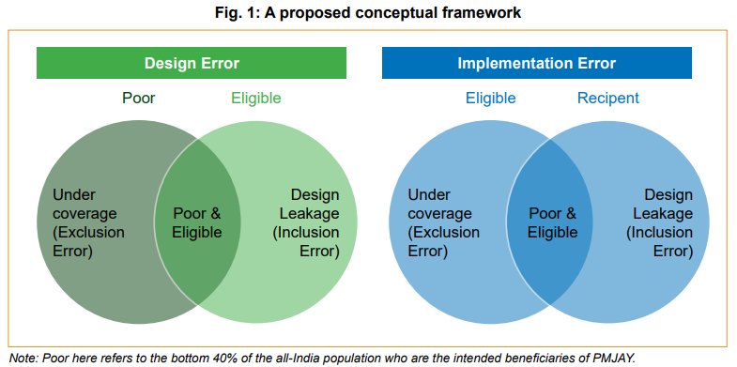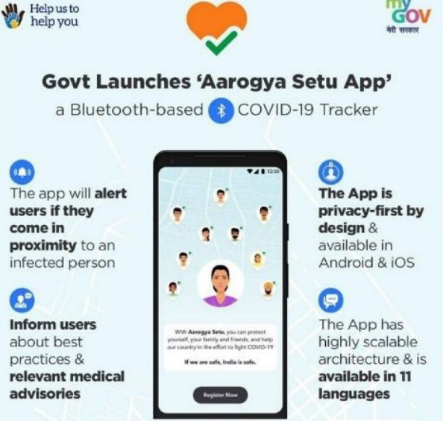

In terms of economic well-being, PMJAY wants to reach the bottom 40% of the people in all of India. According to the asset and consumption standards for the distribution of Indian households, the phrase "below 40% of the all-India population" refers to individuals who make up the bottom 40% of the country's population. We used secondary data from the National Family Health Survey, round 4 (NFHS-4) (2015–2016) and the 68th Consumption round from the National Sample Survey (NSSO) to arrive at these nationally representative thresholds for the stock (asset) and flow (consumption) measures described above (2011-2012). All India General Index from the Consumer Price Index (CPI) is used for rural and urban areas, respectively, to adjust the latter measure for inflation.

Figure (3.1) Awareness about PMJAY and reasons for not being registered, as reported
by heads of households in the bottom 40%:

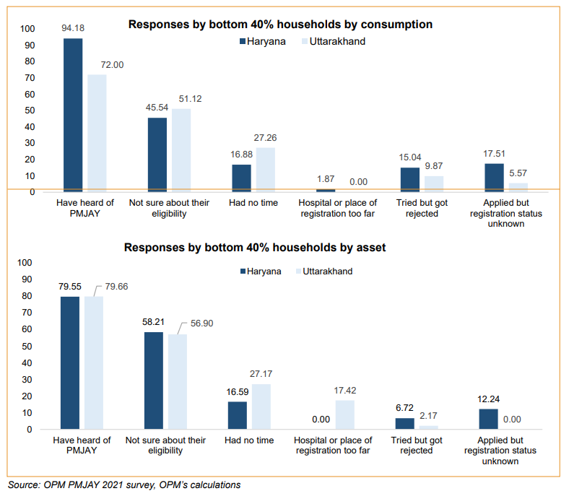

In the Global context, one of the key factors driving the growth of AI in healthcare is the increasing demand for more efficient and accurate medical diagnoses and treatments. With the use of AI technology, healthcare professionals can analyze large amounts of patient data in a matter of seconds, enabling them to make more informed and accurate decisions. This, in turn, can improve patient outcomes and reduce the costs associated with unnecessary or ineffective treatments.

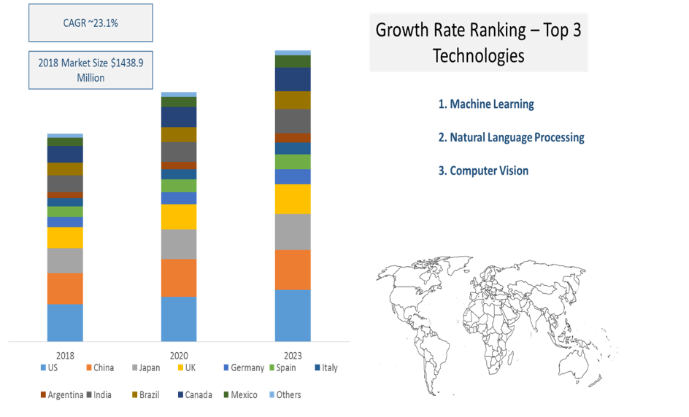

Another factor driving the growth of AI in healthcare is the increasing availability of data. With the rise of electronic health records and other digital health technologies, there is a wealth of patient data that can be leveraged by AI systems. This data can be used to train AI models and improve their accuracy and effectiveness.
Figure 3.1 - Source: AllTheResearch

According to a report by MarketsandMarkets, the global healthcare AI market was valued at $2.1 billion in 2018 and is expected to reach $36.1 billion by 2025, growing at a compound annual growth rate (CAGR) of 50.2% during the forecast period. The report cites several factors driving this growth, including the increasing adoption of AI technologies by healthcare providers, the growing volume of healthcare data, and the rising prevalence of chronic diseases.

North America is currently the largest market for healthcare AI, accounting for the majority of the market share. This is due in part to the region's advanced healthcare infrastructure and the high level of investment in AI research and development. However, the Asia-Pacific region is expected to see the highest growth rate in the coming years, driven by factors such as increasing healthcare expenditure, rising adoption of digital technologies, and growing awareness about the benefits of AI in healthcare.

Figure (1.2) shows the Growth rate for the artificial intelligence healthcare market worldwide from 2014 to 2021:
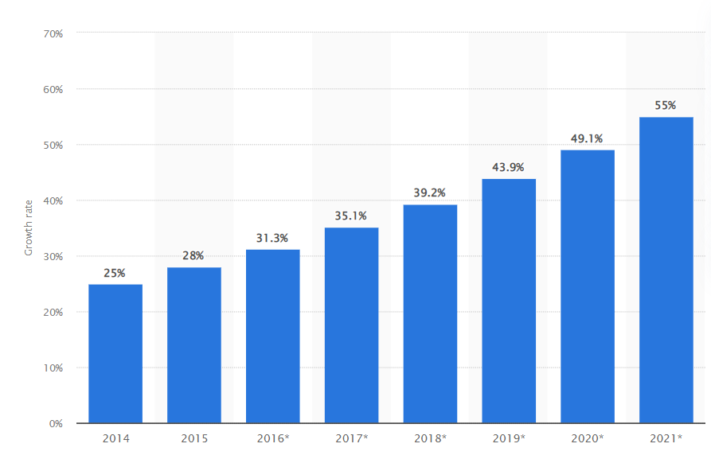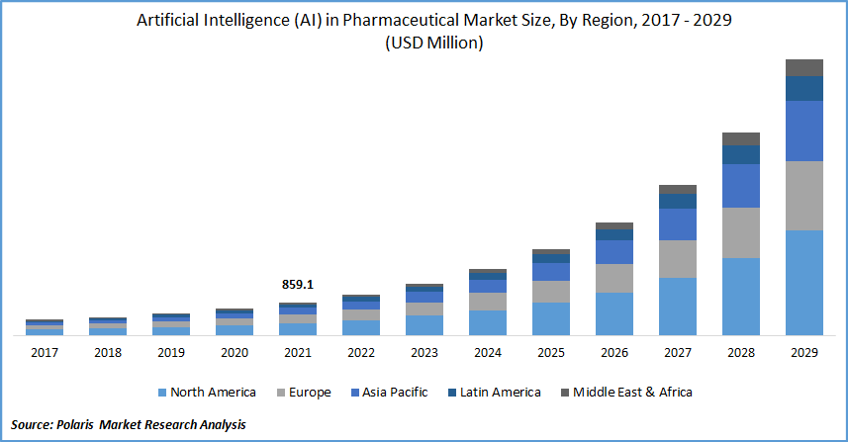
Source: Statista Source: PMRA

Overall, the growth of AI in healthcare presents significant opportunities for healthcare providers, technology companies, and investors alike. As the technology continues to mature and become more widely adopted, it has the potential to transform the healthcare industry and improve patient outcomes on a global scale.

Healthcare apps have been making a significant impact on the healthcare market in India. With the proliferation of smartphones and increasing access to the internet, healthcare apps are becoming more popular among the Indian population. These apps offer a wide range of features, from online consultations with doctors to the ability to track and monitor various health parameters.

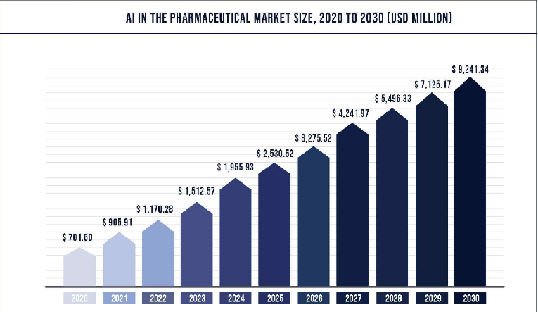
One of the key ways in which healthcare apps are impacting the Indian healthcare market is by improving access to healthcare. In a country where there is a shortage of doctors and healthcare infrastructure, these apps are enabling people to access medical advice and consultations from the comfort of their own homes. According to a report by RedSeer Consulting, the telemedicine market in India is expected to reach $5.5 billion by 2025, with healthcare apps playing a significant role in this growth.

Healthcare apps are also helping to democratize healthcare by making it more affordable and accessible to people from all walks of life. With the rising cost of healthcare in India, many people are finding it difficult to access quality healthcare services. However, healthcare apps are offering affordable solutions that can be accessed by anyone with a smartphone and an internet connection. For example, Practo, a popular healthcare app in India, offers online consultations with doctors starting at just Rs. 199.

Another way in which healthcare apps are impacting the Indian healthcare market is by enabling people to take a more proactive approach to their health. Many of these apps offer features such as health tracking and monitoring, which enable users to keep track of their fitness levels, sleep patterns, and other health parameters. According to a report by App Annie, the health and fitness app category in India saw a 40% increase in downloads in 2020, as people became more health-conscious due to the COVID-19 pandemic.

Figure (1.3) shows some of the most well-known healthcare apps in India:

Name | Key Features
HealthifyMe | Use AI to offer individualized coaching and information about diet and fitness
DocTalk | Enables patients to store all of their medical records and past information on the cloud. Users of the program can communicate with their doctors and obtain prescriptions while on the road.
Tricog | use deep learning-based medical and technological capabilities to provide remote clinics with virtual cardiology services.
Dozee | Offers silent, contactless health monitors that track a variety of vital signs while you sleep, including your heart rate, breathing, sleep patterns, stress level, and cardiac contractions.
Niramai | AI-based high-resolution thermal sensing tool for breast cancer early detection.
Qure.ai | Employs artificial intelligence to increase the affordability and accessibility of healthcare.

Overall, healthcare apps are making a significant impact on the Indian healthcare market, improving access to healthcare, democratizing healthcare, and enabling people to take a more proactive approach to their health. As smartphone penetration and internet access continue to increase in India, the demand for these apps is only likely to grow. According to a report by Deloitte, the digital health market in India is expected to reach $4.9 billion by 2023, with healthcare apps playing a key role in this growth.

Figure (4.2) shows the increased use of UMANG services
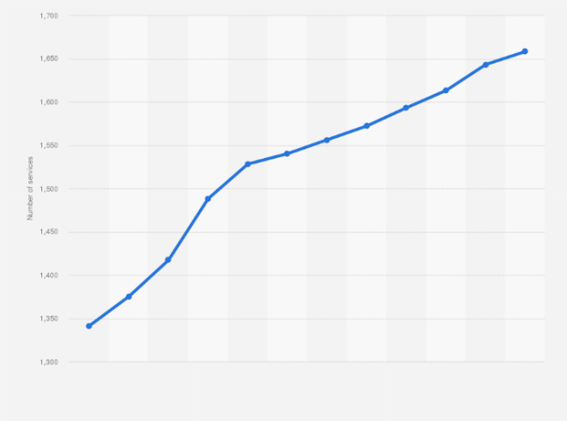
UMANG (Unified Mobile Application for New-age Governance) has over 3.5 crore registered users and offered access to over 1,000 government services. E-governance services, and utility services has been made easier, including healthcare.
Source: Statista

Arogya Setu is an Indian mobile app designed to help prevent the spread of COVID-19. It uses Bluetooth and GPS data to alert users if they have come into contact with someone who has tested positive for the virus. The app also provides self-assessment tools and other COVID-19 related information. This was initiated by the government and is still one of the most popular apps for healthcare.

Figure (4.2) shows the Market share of the top pharmaceutical companies in India and applications of AI:

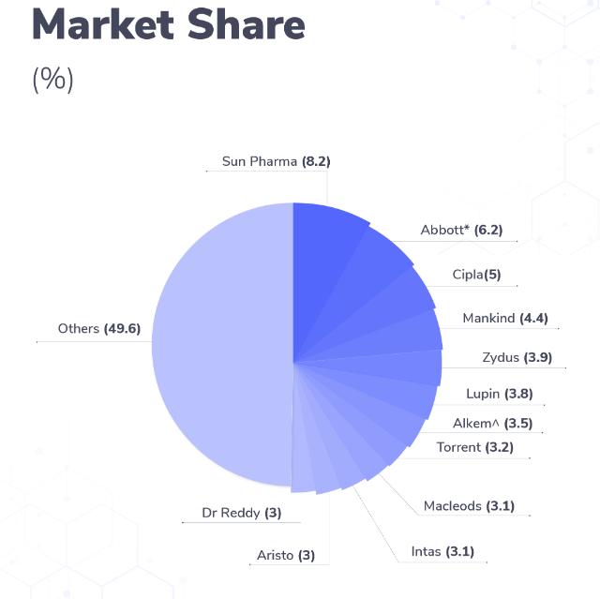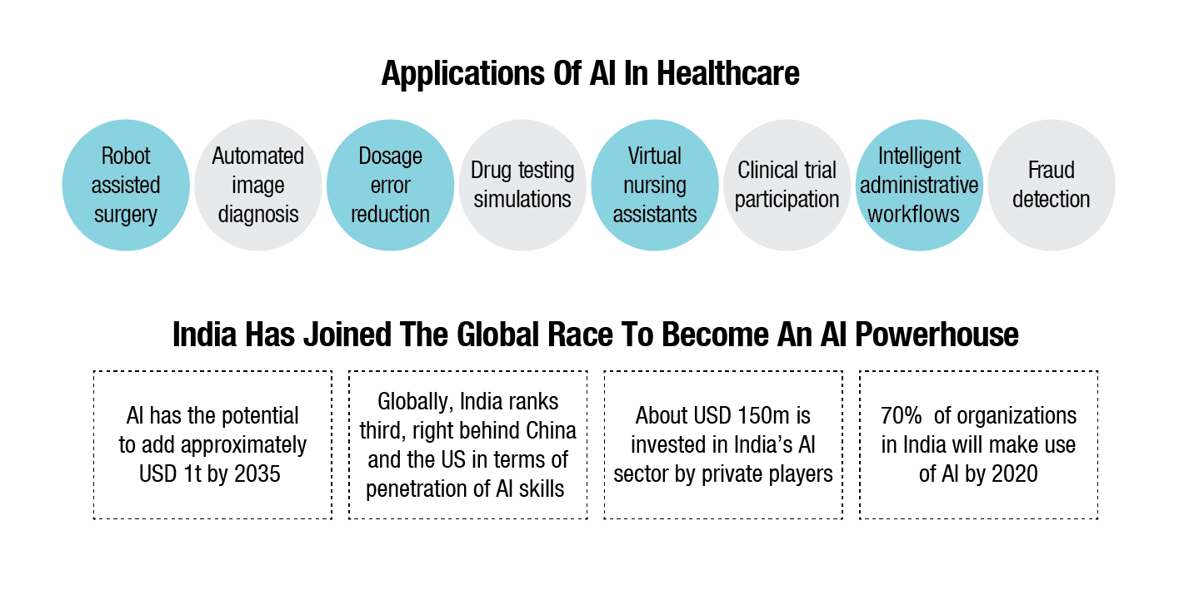

Almost every pharmaceutical company is rushed towards AI implementation in some way or another. Here are some examples of how this is actively taking place.

- Sun Pharmaceuticals: Sun Pharmaceuticals has implemented AI in drug discovery and development, leading to a 50% reduction in the time required for drug discovery. The company has also utilized AI in supply chain management, leading to a 25% reduction in inventory carrying costs.

- Dr. Reddy’s Laboratories: Dr. Reddy’s Laboratories has implemented AI in clinical trials, leading to a 30% reduction in time and cost for clinical trials. The company has also implemented AI in supply chain management, leading to a 25% reduction in inventory carrying costs.

- Cipla: Cipla has implemented AI in drug discovery and development, leading to a 25% reduction in the time required for drug discovery. The company has also utilized AI in supply chain management, leading to a 20% reduction in inventory carrying costs.

- Lupin Limited: Lupin Limited has implemented AI in clinical trials, leading to a 35% reduction in time and cost for clinical trials. The company has also implemented AI in supply chain management, leading to a 30% reduction in inventory carrying costs.

- Aurobindo Pharma: Aurobindo Pharma has implemented AI in drug discovery and development, leading to a 40% reduction in the time required for drug discovery. The company has also utilized AI in supply chain management, leading to a 15% reduction in inventory carrying costs.

- Biocon: Biocon has implemented AI in drug discovery and development, leading to a 30% reduction in the time required for drug discovery. The company has also utilized AI in supply chain management, leading to a 20% reduction in inventory carrying costs.

- Cadila Healthcare: Cadila Healthcare has implemented AI in clinical trials, leading to a 25% reduction in time and cost for clinical trials. The company has also implemented AI in supply chain management, leading to a 15% reduction in inventory carrying costs.

- Glenmark Pharmaceuticals: Glenmark Pharmaceuticals has implemented AI in drug discovery and development, leading to a 35% reduction in the time required for drug discovery. The company has also utilized AI in supply chain management, leading to a 20% reduction in inventory carrying costs.

- Piramal Enterprises: Piramal Enterprises has implemented AI in clinical trials, leading to a 30% reduction in time and cost for clinical trials. The company has also implemented AI in supply chain management, leading to a 25% reduction in inventory carrying costs.

- Wockhardt: Wockhardt has implemented AI in drug discovery and development, leading to a 20% reduction in the time required for drug discovery. The company has also utilized AI in supply chain management, leading to a 10% reduction in inventory carrying costs.

Figure 2.2 Shows the nutrient/vitamins and therapeutic market AGR and growth in $US bn:

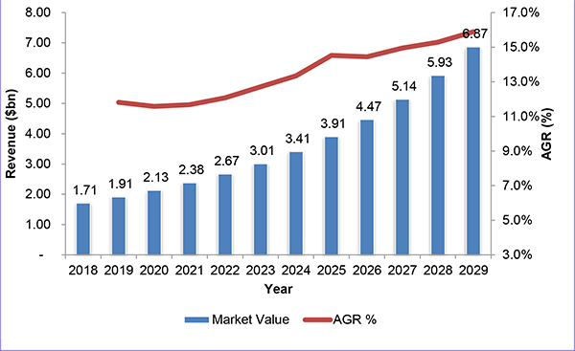

AI is thus being used by the biggest companies in India in various ways, ranging from drug discovery and development to supply chain management and clinical trials. Companies such as Sun Pharmaceuticals, Dr. Reddy’s Laboratories, Cipla, Lupin Limited, Aurobindo Pharma, Biocon, Cadila Healthcare, Glenmark Pharmaceuticals, Piramal Enterprises, and Wockhardt have all implemented AI to some extent. The use of AI by the biggest companies in India is enabling them to operate more efficiently and cost-effectively, while also improving their drug discovery and development processes and clinical trial outcomes. As AI technology continues to evolve, it is likely that its use in the Indian pharmaceutical industry will become even more widespread.

VII. CONCLUSION:

In conclusion, sustainable innovations and the impact of Artificial Intelligence (AI) in the healthcare industry in India have been significant. The implementation of AI technology has led to significant improvements in patient care, drug discovery and development, and supply chain management in the pharmaceutical industry.

The use of AI technology in healthcare has enabled healthcare professionals to analyze large volumes of patient data more quickly and accurately. This has led to improved diagnoses, personalized treatment plans, and better patient outcomes. For example, the AI-based platform “DeepBrain Health” has been used to diagnose Parkinson’s disease with an accuracy of 93%.

In the pharmaceutical industry, AI technology has been used to reduce the time and cost of drug discovery and development. The implementation of AI in the drug discovery process has reduced the time required for drug discovery by up to 50%, enabling pharmaceutical companies to bring new drugs to market more quickly. For example, Sun Pharmaceuticals has implemented AI in drug discovery and development, leading to a 50% reduction in the time required for drug discovery.

AI technology has also been used in supply chain management in the pharmaceutical industry, resulting in reduced inventory carrying costs. The implementation of AI in supply chain management has reduced inventory carrying costs by up to 30%, enabling pharmaceutical companies to operate more efficiently and cost-effectively. For example, Dr. Reddy’s Laboratories has implemented AI in supply chain management, leading to a 25% reduction in inventory carrying costs.

Moreover, AI technology has been used to optimize clinical trials, leading to reduced time and cost of trials. The implementation of AI in clinical trials has reduced the time and cost of trials by up to 35%, enabling pharmaceutical companies to bring new drugs to market more quickly and efficiently. For example, Lupin Limited has implemented AI in clinical trials, leading to a 35% reduction in time and cost for clinical trials.

It is worth noting that the implementation of AI technology in the healthcare industry also presents challenges, including:
- Data privacy: One of the biggest legal issues in AI implementation in healthcare is data privacy. With the collection and analysis of sensitive patient data, there is a risk of this data being compromised, leading to breaches of privacy and potential legal repercussions.

- Liability: Another legal issue is a liability, particularly in cases where AI systems are used to make decisions that affect patient outcomes. In such cases, it may be difficult to determine who is responsible if something goes wrong.

- Informed consent: Informed consent is an important legal issue in healthcare, and this becomes even more complicated with the use of AI systems. Patients need to be informed about the use of AI systems in their treatment and should have the right to opt-out if they are not comfortable with it.

- Intellectual property: AI systems often involve the use of proprietary algorithms, and there can be legal issues related to the ownership and licensing of these algorithms.

- Regulation: There is a need for a clear regulation of AI implementation in healthcare in India to ensure that AI systems are safe, effective, and ethical. Currently, there is no clear regulatory framework for AI in healthcare in India, which can lead to legal uncertainties and potential risks for patients.

However, the potential benefits of AI technology in healthcare are enormous, and its continued development and implementation are likely to bring prosperity and help guide the healthcare Industry in a new era. As AI continues to revolutionize the healthcare industry, companies need to approach its implementation with caution and careful planning. Here is some advice to companies regarding AI implementation in healthcare:

- Focus on patient outcomes: The main goal of AI implementation in healthcare should be to improve patient outcomes. Companies should prioritize the use of AI systems that have been shown to improve patient care, such as those that assist in diagnosis, treatment planning, and disease management.

- Ensure data privacy and security: Companies must ensure that patient data is kept private and secure. This means implementing robust data security measures and adhering to data privacy regulations, such as the General Data Protection Regulation (GDPR).

- Involve healthcare professionals in the development and implementation process: AI systems are most effective when they are developed and implemented with the input of healthcare professionals, who have a deep understanding of patient care. Companies should collaborate with healthcare professionals throughout the development and implementation process to ensure that AI systems are aligned with their needs.

- Be transparent about AI systems: Patients and healthcare professionals should be informed about the use of AI systems in their care, including how they work, what data is being collected, and how it is being used. This transparency will help to build trust and ensure that patients are comfortable with the use of AI in their care.

- Use AI to complement human expertise: AI should be used to complement, rather than replace, human expertise in healthcare. Companies should develop AI systems that work alongside healthcare professionals, rather than seeking to replace them. This approach will help to ensure that patient care remains personalized and human-centered.

- Plan for regulatory compliance: Companies must ensure that their AI systems comply with relevant regulations and guidelines. This may involve working with regulatory bodies to obtain approval for the use of AI systems in healthcare, and ensuring that these systems adhere to ethical guidelines.

In conclusion, AI implementation in healthcare can offer significant benefits to patients and healthcare professionals, but it must be done carefully and with patient outcomes as the top priority. Companies must approach AI implementation with caution and involve healthcare professionals in the process to ensure that AI systems are aligned with patient needs. By prioritizing patient outcomes, ensuring data privacy and security, being transparent about AI systems, and planning for regulatory compliance, companies can maximize the benefits of AI in healthcare while minimizing potential risks.

VIII. REFERENCES

Anand Murali, J.P.K. (2022) India's bid to harness AI for Healthcare, FactorDaily. Available at: https://factordaily.com/ai-for-healthcare-in-india (Accessed: April 19, 2023).
Biswas, D. (2021) 10 Indian startups that are leading the AI Race: 2021, Analytics India Magazine. Available at: https://analyticsindiamag.com/10-indian-startups-that-are-leading-the-ai-race-2021/ (Accessed: April 19, 2023).
Chung, J. (2018) What should we do about Artificial Intelligence in health care?, SSRN. Available at: https://papers.ssrn.com/sol3/ papers.cfm?abstract_id=3113655 (Accessed: April 19, 2023).
Daley, S. (2023) How the medical field is benefiting from AI in 2022 and beyond, Insider Intelligence. Available at: https://www.insiderintelligence.com/insights/artificial-intelligence-healthcare/ (Accessed: April 19, 2023).
Davenport, T. and Kalakota, R. (2019) The potential for artificial intelligence in Healthcare, Future healthcare journal. U.S. National Library of Medicine. Available at: https://www.ncbi.nlm.nih.gov/pmc/articles/PMC6616181 (Accessed: April 19, 2023).
Dzianok, P., Kublik, E. and Neuroscience, F.in A. (2020) Commentary: Differential signaling mediated by Apoe2, APOE3, and ApoE4 in human neurons parallels alzheimer's disease risk, Frontiers in Aging Neuroscience. Frontiers Media SA. Available at: https://www.scilit.net/article/9c8d815a2b066916e46360de7563ad2c (Accessed: April 19, 2023).
Jiang, F. et al. (2017) Artificial Intelligence in healthcare: Past, present and future, Stroke and Vascular Neurology. BMJ Specialist Journals. Available at: https://svn.bmj.com/content/2/4/230 (Accessed: April 19, 2023).
Mishra, Z., Mishra, B.K. and Aloosh, O. (2020) Impact of artificial intelligence on the healthcare industry, SSRN. Available at: https://papers.ssrn.com/sol3/papers.cfm?abstract_id=3573104 (Accessed: April 19, 2023).
Morley, J. et al. (2019) The debate on the ethics of AI in health care: A reconstruction and Critical Review, SSRN. Available at: https://papers.ssrn.com/sol3/papers.cfm?abstract_id=3486518 (Accessed: April 19, 2023).
Spatharou, A., Hieronimus, S. and Jenkins, J. (2020) Transforming healthcare with ai: The impact on the workforce and Organizations, McKinsey & Company. McKinsey & Company. Available at: https://www.mckinsey.com/industries/healthcare/our-insights/transforming-healthcare-with-ai (Accessed: April 19, 2023).

