A Band-Notched MIMO Antenna with Compact Size and Microstrip-fed for UWB Applications

A small multiple-input–multiple-output (MIMO) structure is presented for ultra-wideband (UWB) applications with band-notched function. This structure is consisting of two offset microstrip-fed radiating elements with ultra-wide band characteristics. To attain more isolation characteristics and polarization in diversity, the antenna structures are positioned perpendicular to each other. The radiating elements are separated by a parasitic T-shaped strip. It acts as a decoupling arrangement to reduce the mutual coupling between the elements. Along with this, the notched bandwidth at 5.5 GHz is achieved by impression with a pair of L-shaped slits on the ground. The radiating prototype with a small size of 38.5 x 38.5 mm² has been invented and measured. Experimental results show that the antenna has an impedance bandwidth of 3.08 - 11.8 GHz with reflection coefficient less than -10 dB, except the rejection band of 5.03-5.97 GHz. Besides, port isolation, envelope correlation coefficient and radiation characteristics are also investigated. The results indicate that the MIMO antenna is suitable for band-notched UWB applications.
- Antenna Configuration

Fig. 1 illustrates the geometry of the proposed band-notched UWB MIMO antenna. The designed antenna with an overall size of 38.5 × 38.5 mm 2 is printed on an FR4 substrate with a thickness of 1.6 mm and a relative dielectric constant of 4.4. It consists of two orthogonal microstrip-fed lines, a parasitic T-shaped strip, and a ground plane etched with a rhombic slot and a pair of L-shaped slits. Both the microstrip-fed lines at an offset distance from the center have three stages for impedance transforming. The parasitic strip placed between the antenna elements plays an important role in isolation improvement. It consists of two major parts: a strip along the diagonal and the other perpendicular to the diagonal. The ground plane is designed on the other side of the substrate. The slits etched on the ground are used to produce a notched band at 5.5 GHz. The numerical analysis and geometry refinement of the antenna structure were carried out by using electromagnetic simulation software HFSS from ANSYS. The optimal parameters are recorded as follows (in millimeters): W = L = 38.5, W1 = L1 = 25.2, W2 = 4, W3 = 1.5, W4 = 3, L2 = 20.4, L3 = 12, L4 = 7.4, D1 = 8, D2 = D3 = 19.25, D4 = 12.35, D5 = 12.6, D5 = 7.8, G1 = 0.5, G2 = 0.3, S1 = 11.5, S2 = 4.15, S3 = 7.3, S4 = 1.3, and θ = 45°.

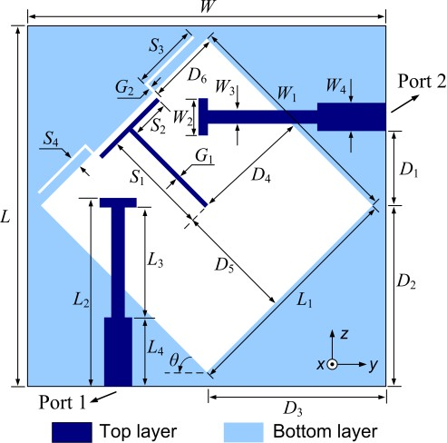

- Design of UWB Antenna Element
Fig. 2 shows the design evolution of UWB antenna elements with different feeding structures. Compared with the center-fed printed antenna with a rhombic slot (denoted as Ant. 1), good impedance matching over a wider frequency range can be achieved by adopting an offset microstrip-fed line (denoted as Ant. 2). This is due to the fact that the electromagnetic coupling between the feed line and the ground improves as the microstrip line is shifted from the center, and thereby enhances the impedance bandwidth of the antenna. The offset distance D1 has a significant influence on the impedance enhancement of the antenna element, and an optimum value D1 = 8 mm is selected in this design. The feed lines of Ant. 1 and 2 both have the same widths of 3 mm corresponding to 50-Ω characteristic impedance. Then a three-stage feed line is employed as an impedance transformer to adjust the impedance matching at 5-8 GHz (denoted as Ant. 3). Finally, an impedance bandwidth of larger than 3.1-10 GHz can be obtained to meet the bandwidth requirement for UWB operation.
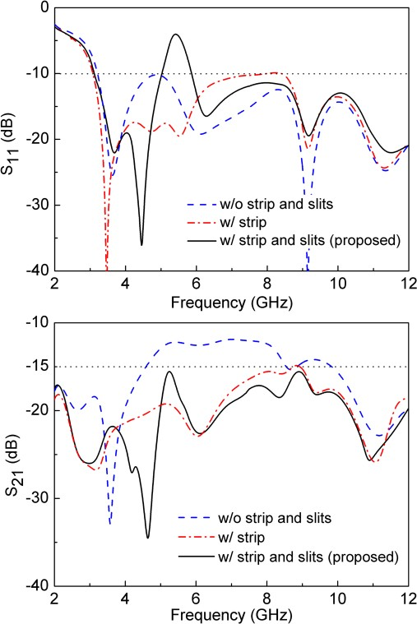
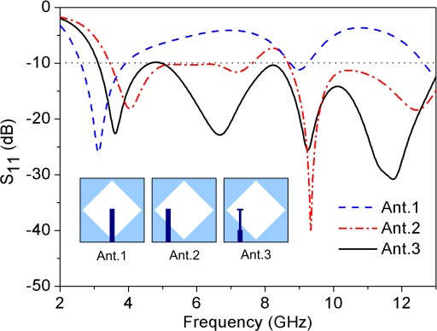

- Effects of Parasitic Strip and Etched Slits
The simulated S-parameters of the MIMO antennas with different configurations are given in Fig. 3. As can be seen, the basic UWB-MIMO antenna with orthogonal feeding structures achieves port isolation of better than -10 dB in the UWB spectrum. To further improve the isolation, a parasitic T-shaped strip is added between the antenna elements as a decoupling structure. The strip acts as a parasitic resonator, which provides an additional coupling path to counteract the current coupled directly from one antenna element on the other [5], [6].
To investigate the influence of the T-shaped strip, the surface current distributions at 6.0 GHz are shown in Fig. 4, in which Port 1 is excited and Port 2 is terminated with a 50-Ω load. Without the strip, strong coupled current can be observed on the right antenna element, which flows in the direction opposite to that of the current along the left antenna element. With a total length of 15.6 mm (S1+S2), the strip can excite a half-wavelength resonant mode at about 6.0 GHz. By adopting the parasitic structure, larger surface current is induced along the strip and an additional coupling path is created between the adjacent elements through the strip. Since this coupling path can produce reverse current to cancel out the original coupling. The current coupled on the right antenna element decreases substantially and hence the mutual coupling at 4.6-8.5 GHz is reduced to less than -15 dB with little effect on the impedance matching.
The pair of open-ended slits etched on the ground are employed to generate band-notched function. The notched band can be controlled by adjusting the lengths of the slits. It is found that the total length of each slit is taken as 8.6 mm (S3+S4), which is about a quarter of the guided wavelength at 5.5 GHz. Therefore, a notched band of 5-5.9 GHz can be generated to reject the 5.2/5.8-GHz WLAN operation.

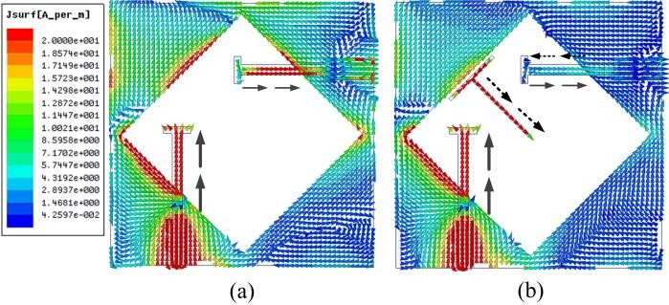

- RESULTS AND DISCUSSIONS
The antenna prototype shown in Fig. 5 was measured with the Agilent N5244A vector network analyzer. Fig. 6 presents the simulated and measured S-parameters against frequency. Measured results show that the antenna provides an impedance bandwidth (S11 & S22 ≤ -10dB) from 3.08 to 11.8 GHz except the notched band of 5.03-5.97 GHz. Thus, the bandwidth requirement for UWB applications is satisfied, and band-notched function is achieved to avoid the potential interference of 5.2/5.8-GHz WLAN operation. It also can be seen that the measured port isolations (S21 & S12) are below -15 dB throughout the whole UWB band. Due to the effects of manufacturing tolerance and measurement environment, measured port isolation is slightly worse than the simulation at lower frequencies from 3 to 5.5 GHz. In MIMO systems, mutual coupling of better than -15 dB is considered to be acceptable for practical applications.
The radiation characteristics of the proposed antenna have been measured with Port 1 or 2 excited. Measured radiation patterns (xoy-, xoz-, and yoz-planes) at 3.5, 7.5, and 9.5 GHz are plotted in Fig. 7. Since the MIMO antenna consists of two identical elements located perpendicular to each other, the patterns of Port 1 and 2 are almost similar with a 90°rotation. As observed, the radiation patterns are quasi-omnidirectional in the H-plane (xoy-plane of Port 1 and xoz-plane of Port 2). The asymmetric antenna structure contributes to the high-level cross polarizations of the radiation patterns. However, the MIMO antenna can still achieve orthogonal patterns to mitigate the effect of coupling between the adjacent elements. Fig. 8 shows the measured peak gains and radiation efficiencies of the antenna with one port excited. Measured peak gains range from 1.4 to 3.6 dBi throughout the entire band except the notched point where it drops to -4.5 dBi. The radiation efficiencies are above 75% in the UWB spectrum, while it drops to about 34% at the notched frequency of 5.5 GHz.

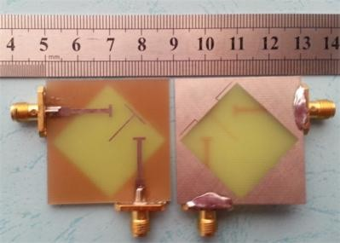

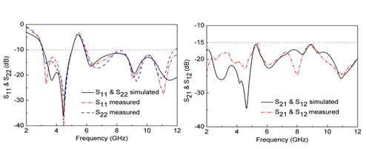
A UWB MIMO antenna with band-notched characteristics is presented. The offset microstrip-fed lines are employed to feed the antenna with wideband impedance matching. Port isolation is improved by using a simple decoupling structure. Measured results show that the proposed antenna achieves an impedance bandwidth of larger than 3.1–10.6 GHz except sharp rejection band of 5.03-5.97 GHz. Besides, low mutual coupling of better than -15 dB and low envelope correlation coefficient of less than 0.02 can also be obtained through the whole UWB band. With the features mentioned above and a compact size, the proposed antenna can be a promising candidate for MIMO/diversity systems.
The geometry of the proposed MIMO antenna, as illustrates in Fig. 1, has two identical radiating elements with a common ground plane. The overall dimensions of the proposed antenna are only 18×34 mm2 = 612 mm2 or about 0.18λ0×0.34λ0 where λ0 is the free-space wavelength at the desired first resonant frequency 3.0 GHz. However, the basic need for the UWB antenna is to obtain lower cut-off frequency i.e. 3.1 GHz while maintaining the compactness of the design. The preliminary design of the antenna starts with selecting the antenna structure and their dimensions to meet the operating frequency requirements. Monopole structure is selected for a miniaturized design of a UWB antenna and the fundamental lower resonant frequency of a proposed monopole could be approximated by the following equation [22].

$$f=\frac{14.4}{l_{1}+ l_{2}+g+ \frac{A_{1}}{2π\sqrt{∈_{r} + 1}}+\frac{A_{2}}{2π\sqrt{∈_{r} + 1}}}$$

where A1 and A2 denote the area of the ground plane and radiation patch, l1 and l2 denote the length of the ground plane and radiation patch, g denotes the gap between the ground plane and radiation patch, respectively, l1 , l2 , g, A1 , and A2 all in millimetres.
The proposed radiator is designed with a combination of rectangular (Lp1 × Wp1 ) and triangular (altitude 4 mm and base 5.15 mm) stubs to form a novel polygon shape. The polygon-shaped radiator is fed with a tapered microstrip of size Lf × Wf connected at the lower edges of each radiator. Ground plane for the proposed antenna is composed of rectangular shaped and T-shaped stubs. Further, it is modified by etching a rectangular-shaped slot to form a novel inverted L-shaped ground plane to enhance the isolation between two antennas as shown in Fig.1. The proposed MIMO antenna is fabricated with the MITS-Eleven Lab PCB machine on the FR4 dielectric substrate (thickness = 1.6mm, relative permittivity = 4.4 and dielectric loss tangent of 0.02).

Geometry of the proposed MIMO antenna.

Antenna A Antenna B Antenna C

Fig. 2. Different shapes of radiator used in the evolution of final antenna

Different geometries used in the evolution of the final design are shown in Fig.2. In (Antenna A) a tapered fed line with a polygon-shaped radiator on one side and inverted L-shaped ground plane (as shown in fig.1) on the other side of the substrate are proposed for UWB performance. After achieving the UWB performance characteristics the antenna is further modified as Antenna B to suppress interference at WLAN band. A simple L- shaped slit is etched in the upper portion of the radiator to suppress the WLAN band (5.09–5.8 GHz) in the UWB band as shown in Fig.3. Finally to suppress the interference at higher frequencies of IEEE INSAT/Super-Extended C-band (6.3–7.27GHz), an L-shaped slit (see Antenna C) is etched in the lower portion of the radiator as shown in Fig.2. The simulated S11 for all the geometries used in the evolution of the final design are shown in Fig. 3. Furthermore, Eq.(1) is used in design of the single element, where l₁ =L_{g1} +L_{g2} , l₂ =L_{p1} , g=L_{f} -L_{g}, A₁ = 2[(L_{g2}+L_{g1} -L_{g})W_{g2} +W_{g1} L_{g3} ] +W_{g} L_{g} -W_{g3} (L_{g} -L_{g1} ), A₂ = L_{p1} W_{p1} +1/2[W_{p2}(L_{p1} -L_{p2})]+L_{f}W_{f} . As the data given in Table II, the calculated frequency f_{r} is 3.4 GHz, which is almost close to the simulated result in Fig.4

B. Effect of Ground Plane
The ground plane plays a significant role in the performance of the proposed antenna. It not only account for better impedance matching of the antenna elements but also for enhancing the isolation between them. Fig.5 shows the evolution steps of the ground plane for the proposed MIMO antenna. As both the antenna elements are identical, the S11 and S12 will be similar to S22 and S21 as illustrated in Fig.6a- 6b. It can be seen from Fig.6a that S11 for Ground 1 has the lower cut off frequency at 4.5 -GHz (S11 <-10) whereas the requirement for UWB is 3.1 GHz. The isolation between two antennas is also very poor. However, the inclusion of two vertical rectangular strips in the ground plane (Ground 2) shifts the resonance to 3.7 GHz, but the mutual coupling for Ground 2 in the frequency band below 4 GHz is very poor as shown in Fig.6b. Further, by employing inverted L- shaped strips in the ground plane as shown in the Ground 3, the lower resonance frequency shift down to 3.2 GHz with a lowest cut-off frequency at 2.9 GHz. This inverted L-shaped strips significantly suppress the mutual coupling throughout the band (2.9-20 GHz). An isolation of less than -22 dB is obtained which is significantly low and is good enough for MIMO performance.

Ground 1 Ground 2 Ground 3

Evolution geometry of the ground plane

TABLE II: DE S I G N PA R A M E T E R S O F T H E P RO P O S E D UW B MIMO A N T E N NA SH OW N I N FI G . 1

Parameters | W_{g} | W_{g1} | W_{g2} | W_{g3} | L_{g1} | L_{g2} | L_{g}
Units (mm) | 34 | 6 | 1.35 | 3.8 | 1.25 | 16.75 | 5
Parameters | L_{g3} | W_{p1} | W_{p2} | W_{p3} | W_{p4} | W_{p5} | W_{f}
Units (mm) | 1 | 3.75 | 4 | 6.1 | 4.2 | 0.2 | 1.6
Parameters | L_{p1} | L_{p2} | L_{p3} | L_{p4} | L_{p5} | W_{f1} | L_{f}
Units (mm) | 5.5 | 0.35 | 2.75 | 3.25 | 0.25 | 1 | 6.5

Fig.7 (a)-(c) illustrates the effectiveness of ground plane as a decoupling structure. It is clearly seen in Fig.7(a) without L- strips that when port 1 is excited and port 2 is terminated, the coupling current exists on whole ground plane towards port 1 and port 2 as well. Fig.7(b) shows the current distribution with I-slits when port 1 is excited and port 2 is terminated, the surface current mainly occurs on the ground plane towards port 1 i.e. decreases power flow from port 1 to port 2 but some portion of the current is still coupled to port 2 which is turn causes poor isolation. Further, modification of I-strip to inverted L-strip [see Fig.7(c)] greatly increased (S12 and S21 are more than -20 dB throughout the entire operating band) the isolation between port 1 and port 2 as shown in Fig. 6b.

C. Effect of L-slits

The dual band-notched characteristic in the proposed UWB MIMO antenna is achieved by etching two L-shaped slits in each radiator. These L-shaped slits introduce impedance mismatch between the feed line and radiating patch due to that band-notched characteristics are obtained. The upper L- shaped slit etched in the radiator provides WLAN band (5.09–
5.8 GHz) with the centre frequency of 5.45 GHz and the lower L-shaped slit etched in the radiator provides (6.3–7.27GHz) IEEE INSAT/Super-Extended C-band with the centre frequency of 6.6 GHz. Thus, the notched band can be tuned by varying the dimensions of the L-slits. Further, the effect of the L-slits can also be verified by plotting the vector surface currents at (a) 5.45 GHz (b) 6.6 GHz to achieve rejection as shown in Fig.8. It is clearly seen in Fig.8(a) and (b), surface current is mainly concentrated on respective L-slits i.e. at 5.45 GHz the surface current is concentrated on upper L-slit of the radiator and at 6.6 GHz the surface current is concentrated

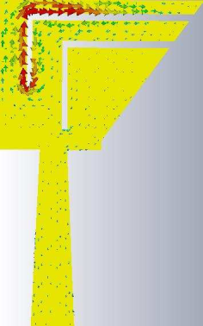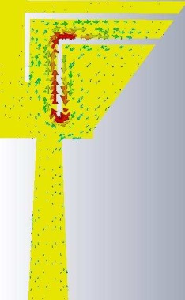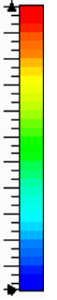
Fig. 8. Current distributions of the proposed MIMO antenna at (a) 5.45 GHz (b) 6.6 GHz

on lower L-slit of the radiator. Here the vector currents along the slit are in opposite directions on top and bottom sides for both the cases. Hence radiation from one side current will be cancelled by the other side current. Therefore, no radiation occurs, and return loss is poor. These current distributions show that the proposed antenna can effectively provide band- notched at WLAN and IEEE INSAT/Super-Extended C bands.
1) WLAN Band: The upper L-shaped slit etched in the radiator is responsible for WLAN band. For the band-notched design, this slit acts as a half-guided-wavelength resonator, the length of L-shaped slit can be calculated as:
$$L_{n1}=2(L_{p3}+L_{p5}+W_{p3}+ W_{p5})$$
Fig.9 shows the S-parameters for the variation of length L_{p3} while other parameters are kept constant as in table II. It is observed that as the value of L_{p3} increases from 1.75 to 4.75 mm, the centre of notched frequency band shifts from 5.98 to 4.59 GHz. The resonant frequency f_{n1} may be empirically approximated by:
$$f_{n1}=\frac{c}{2L_{n1}\sqrt{∈_{reff}}}r^{2}$$

Where Ɛ_{reff} is the effective dielectric constant and c is the speed of light. Here the effective dielectric constant can be approximated to half of the dielectric constant of the FR4 material, due to the lack of ground plane. Therefore, the effective dielectric constant is 2.2. Thus, for the WLAN band, the calculated length L_{n1} is 18.6 mm. The design equation is also verified by calculating the WLAN resonance frequency for the values given in Fig.9. In Table -III, WLAN frequency for different values of Lp3 of the upper L- strip is compared with the design equation values.
L_{p3} (mm) | L_{n1} (mm) | Resonant Frequency (GHz)
 |  | Design equation | Full wave simulation
1.75 | 16.6 | 6.09 | 5.98
2.75 | 18.6 | 5.43 | 5.45
3.75 | 20.6 | 4.90 | 5.03
4.75 | 22.6 | 4.47 | 4.59

2) IEEE INSAT/Super-Extended C-Band: The band- notched characteristics centred at 6.6 GHz of the antenna is produced by lower L-shaped slit etched in the radiator. Fig.10 shows the simulated S parameters for different values of Lp4 with the other parameters being the values listed in Table II. It can be seen that when the L-strip length increases from 0.75 to 4.5 mm, the centred notched frequency decreases from 9.16 to 5.26 GHz. The length of lower L-shaped slit can be calculated as:
L_{n2} = 2 (L_{p4} + L_{p5} + W_{p4} + W_{p5}) (4)
The centre of the rejected frequency is empirically approximated by:
$$f_{n2}=\frac{c}{2l_{n2}\sqrt{∈_{reff}}}$$

where ǫref f is the effective dielectric constant, and c is the speed of light in free space. For notch band the length of L-shaped slit is 15.8 mm. The length of the L-shaped slit is optimized to achieve the band notch characteristic at IEEE INSAT/Super-Extended C-band. The design equation is also verified by calculating the resonance at 6.6 GHz frequency for the values given in Fig.10. In Table -IV, frequency for different values of Lp4 of the lower L-slit is compared with the design equation values.
L_{p4} (mm) | L_{n2} (mm) | Resonant Frequency (GHz)
 |  | Design equation | Full wave simulation
0.75 | 10.8 | 9.36 | 9.16
2.00 | 13.3 | 7.60 | 7.69
3.25 | 15.8 | 6.40 | 6.60
4.50 | 18.3 | 5.52 | 5.26

III. RESULT S AND DISCUSSION

Agilent N5230A vector network analyzer was used to validate the simulated results obtained for the proposed MIMO antenna. It is observed from the Fig. 11 that the measured and simulated S11 and S21 are identical to the S22 and S12, respectively. The proposed antenna offers an impedance band- width of 17.07 GHz from (2.93 to 20 GHz) with isolation between two antenna elements better than -22 dB for the entire operating band. The proposed antenna shows dual-band notch characteristics to suppress interference at WLAN-band (5.09- 5.8 GHz) and IEEE INSAT/Super-Extended C-band (6.3-7.27GHz). The centre frequency for WLAN and C-band has a value of S11 = -1.5 dB which is high enough to show effective suppression. The measured results are in good agreement with simulated results.
Fig. 12 shows the 2-D radiation patterns at (a) 3.0 GHz (b) 5.45 GHz (c) 6.6 GHz and (d) 10 GHz (e) 16 GHz and (f) 19 GHz for the proposed MIMO antenna, in the xz, yz and the xy- planes. The proposed antenna shows a nearly omnidirectional radiation pattern over the desire operating band and the gain of the antenna is reduced at the band-notched frequencies. Furthermore, Fig.12 shows that the radiation pattern deteriorates at the higher frequencies due to the splitting of the radiation lobes.

In this paper, a novel compact four-element ultra-wideband (UWB) multiple-input multiple output (MIMO) antenna with triple band-notched characteristics is proposed. The proposed antenna is composed of four slot antenna elements with a common rhombic slot, each feeding by a microstrip-fed line to greatly reduce the overall size of the antenna. It has a compact size of 34 mm_34 mm_1.6 mm. The high isolation and polarization diversity are achieved by placing the four microstrip-fed lines perpendiculars to each other, while a parasitic strip is employed as a decoupling structure between adjacent microstrip-fed lines to further improve isolation. Moreover, the proposed antenna can achieve triple band-notched characteristics by embedding L-shaped and C-shaped slots on each radiator and loading electromagnetic band gap (EBG) structures next to micro-strip feeders respectively. As a result, the proposed antenna obtains three notched bands of 3.3-3.9 GHz, 5-6 GHz, and 7.4-8.5 GHz, which are in good agreement with the interference bands of WiMAX (3.3-3.7 GHz), WLAN (5.15-5.875 GHz) and X-band (7.3-8.5 GHz), respectively. The antenna prototype has been fabricated and measured. The results show that the antenna has an impedance bandwidth of 2.5-12 GHz (except for the three notched bands). Besides, the isolation among the elements, envelope correlation coefficient, radiation characteristics, efficiency, realized gain, and total active rejection coefficient are also investigated. The experimental results indicate that the proposed antenna can be a good candidate for UWB-MIMO wireless communication applications.

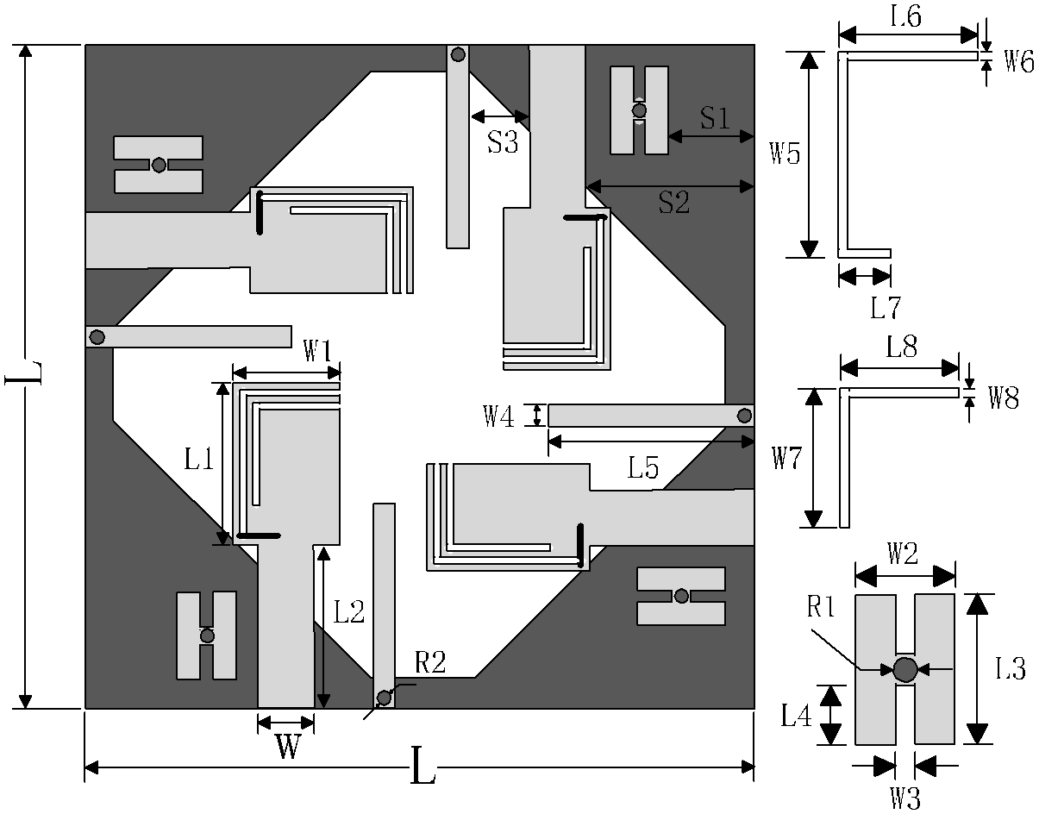
The geometry of the proposed UWB-MIMO antenna

The geometry with parameters of the proposed UWB-MIMO antenna is illustrated in Fig. 1. The proposed antenna with an overall size of 34 mm _ 34 mm _ 1.6 mm is printed on an FR4 substrate with a relative dielectric constant of 4.4. It consists of four orthogonal microstrip-fed lines etched with two slits, four parasitic strips, four EBG structures, and a rhombic slot etched in the ground plane. The optimized design parameters are carried out by using electromagnetic simulation software HFSS.

- DESIGN OF UWB-MIMO ANTENNA ELEMENT

The design of the evolution of UWB-MIMO antenna elements is shown in Fig. 2. Initially, a ide-slot antenna with a rotated slot is designed in Fig. 2 (a). In, the impedance bandwidth of the antenna can be enhanced by etching a wide slot and then rotating the wide slot. Moreover, a wider impedance bandwidth can also be achieved by adopting an offset microstrip-line. That's because the antenna can generate multiple resonances to widen the impedance bandwidth. The simulation curve of the return loss S of antenna 1 is shown in Fig. 3. Antenna 1 generates two resonance points around 4 GHz and 5.5 GHz, which widen the impedance bandwidth of antenna 1. To make antenna 1 work. in the UWB band, a two-stage microstrip-line is used as an impedance transformer to improve the impedance matching at the low and high-frequency band (denoted as antenna 2). Finally, a 4-port UWB-MIMO antenna is formed by placing the four microstrip lines perpendiculars to each other, as shown in Fig. 2 (c). The size of the 4-port antenna is not increased and is the same as the size of antenna 2. Further- more, in Fig. 3, the impedance bandwidth of the antenna is broadened at a lower frequency. This is mainly due to the addition of other microstrip-lines, which act as parasitic resonators to change the impedance matching and shift the resonance points.

- DECOUPLING STRUCTURE DESIGN

Although the isolation can be improved by placing the four microstrip-lines perpendiculars to each other, the size of the antenna is so compact that the mutual coupling between the antenna elements is still strong. Then, to further reduce the mutual coupling, a parasitic strip is added between the adjacent microstrip-fed lines, as shown in Fig. 4. Usually, the parasitic strips are added on the ground as a reflection plate to suppress the mutual coupling among the antenna elements.
Since the proposed antenna in this paper is a slot antenna, adding parasitic strips on the ground will change the structure of the rhombic slot and greatly affect the impedance matching of the antenna. Therefore, the parasitic strips are placed on the top layer of the substrate, and they are connected to the ground by using vias. Fig. 5 illustrates the simulated S-parameters of the antenna with/without the parasitic strips. It’s shown in Fig. 5 (a) that the addition of the decoupling structures will affect the impedance matching of the antenna in low and high-frequency bands. S-parameters S12 and S13 of the antenna are illustrated in Fig. 5 (b). After the parasitic strips are added, the isolation between the two adjacent antenna elements at 4-6 GHz is improved by about 5 dB and at 5-8 GHz, the isolation is increased by about 4 dB.
Fig. 6 shows the surface current distributions at 5 GHz when Port 1 is excited. Without the parasitic strips, the surface current is mainly concentrated on microstrip-lines and ground, and there is also a strong coupled current on adjacent microstrip-lines. By adding the parasitic strips, a larger surface current is induced along the parasitic strips, and the coupled current on adjacent microstrip-lines decreases substantially. Therefore, the mutual coupling between the antenna elements can be reduced by adopting the parasitic strips.

- MULTIPLE NOTCHED BANDS DESIGN

To reject the interference with other wireless communication systems, the triple band-notched characteristic is achieved by etching two slits on each radiating patch and adding an EBG structure next to each microstrip-line.
- DESIGN OF ETCHING SLITS
Firstly, two notched bands of 3.3-3.9 GHz, 5-5.9 GHz are obtained by etching a C-shaped slit and an L-shaped slit on each radiator. The design evolution is shown in Fig. 7. The slits act as a quarter-wavelength resonator, the length of slits and resonant frequency can be calculated as
L_{S1} = L₆ + L₇ + W₅
$$f_{s1}=\frac{c}{4L_{s1}\sqrt{∈_{reff}}}$$

where LS 1 is the total length of the C-shaped slit, fs1 is the resonant frequency of the first notched band, ε_{reff} is half of the dielectric constant of the FR4, due to the lack of ground, c is the speed of light. The length of LS 1 is 13.6 mm and the resonant frequency fs1 is at 3.7 GHz by calculating. It can be seen from Figure 8 that when the C-shaped slit is etched, the antenna generates a notched band around 3.6 GHz, which is similar to the calculation result.
The length of the L-shaped slit and the second resonant frequency can also be calculated as
$$L_{s2}=L_{8}+W_{7}$$
$$f_{s2}=\frac{c}{4L_{s2}\sqrt{∈_{reff}}}$$

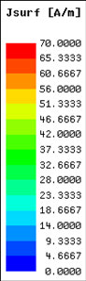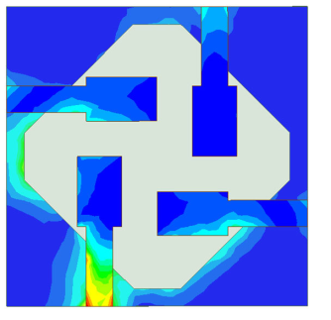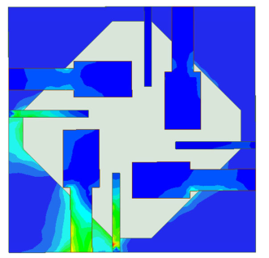

The surface current distribution of the antenna when Port 1 is excited at 5 GHz. (a) without decoupling structure, (b) with decoupling structure.

The design evolution of multiple notched bands. (a) antenna A, (b) antenna B, (c) antenna C.

The length of L_{S2} is 8.8 mm and the second resonant frequency f_{s2} is at 5.7 GHz by calculating. It can be seen from Figure that the second resonant frequency is around 5.5 GHz, which is similar to the calculation result. Figure shows the effect of the length of the two slits on the center frequency of the notched bands. Figure shows when the total length LS 1 of the C-shaped slit is reduced from 14.8 mm to 12.4 mm, the center frequency of the first notched band is increased from 3.5 GHz to 4.2 GHz. It can be seen from Figure that when the total length LS 2 of the L-shaped slit is reduced from 9.5 mm to 7.9 mm, the center frequency of the second notched band is increased from 5.4 GHz.

The proposed 4-port UWB-MIMO antenna is fabricated and measured to verify the simulation results. S-parameters, the radiation patterns, radiation efficiency, and peak gain are the primary measurement parameters. When one of the antenna ports is excited during the measurement, the other ports are connected to a 50  matching load. The S-Parameters of the antenna were measured by the vector network analyzer, and the radiation pattern and gain performance of the antenna was tested in a microwave anechoic chamber.

A. S-PARAMETERS
The antenna is fabricated on an FR4 dielectric substrate with a relative permittivity of 4.4 and a loss tangent angle of 0.025. The size of the 4-port antenna is 34 mm × 34 mm × 1.6 mm. Fig. 16 shows the physical diagram of the antenna and shows the S-parameters of the antenna. Fig. 17 (a) are the return loss curves of the four ports of the antenna. Due to the symmetry of the antenna, the S11 curves of the four ports are the same. It can be seen from Fig. 17 (a) that the S11 < −10 dB at 2.7-12 GHz. Meanwhile, three stop bands are generated at 3.4-4.1 GHz, 5-5.8 GHz, and 7.6 to 8.6 GHz. Due to the manufacture tolerance in the size of the EBG structure, the center frequency of the third stop band is shifted. Fig. 17 (b) shows the isolation curves between diagonally opposite antenna elements. It can be seen from Fig. 17 (b) that the isolation degree of the antenna is higher than −15 dB in the whole UWB frequency band. the four ports of the antenna. S12 is the isolation curve between adjacent antenna elements, and S13 is the isolation curve between

B. THE RADIATION PATTERNS
Fig. 18 shows the normalized two-dimensional radiation pat- terns of the UWB-MIMO antenna on the E-plane and H-plane when Port 1 is excited at 3 GHz, 5 GHz, 7 GHz, and 9 GHz, respectively. The solid lines are the simulation patterns of the antenna, and the dashed lines are the test patterns of the antenna. Due to the symmetry of the antenna structure, the radiation characteristics of Port 2-4 are the same as those of Port 1, which is not given here. As shown in Fig. 18, the radiation pattern of the antenna at low frequency is relatively stable. In the middle and high-frequency bands, the radiation patterns of the antenna change because of the notch structure. Fig. 18 shows that the test results of the antenna radiation patterns are consistent with the simulation results.

C. RADIATION EFFICIENCY AND PEAK GAIN
The peak gain and radiation efficiency of the antenna are shown in figure. The gain of the antenna is between 2.5-5.5 dBi in the entire UWB frequency band (excluding the notched band). In the notched band around 3.5 GHz, the gain is below 0 dBi, and the lowest value is −3.3 dBi. In the notched bands of 5.2 GHz and 8 GHz, the gain is the lowest around 0 dBi. This proves that the antenna has a good signal sup- pression effect in the notched band. The radiation efficiency of the antenna is between 75% and 90% in the entire UWB frequency band (excluding the notched band). In the triple notched frequency bands, the radiation efficiency of the antenna is below 50%. Moreover, the radiation efficiency of the antenna is only 15% at around 3.5 GHz.

D. DIVERSITY PERFORMANCE
The diversity performance of MIMO antennas is figured out by the envelope correlation coefficient(ECC) and the total active reflection coefficient(TARC). ECC is to measure the degree of correlation between adjacent antenna elements of MIMO antennas. The lower ECC, lower the correlation between the antenna elements, which is usually required to be lower than 0.5. ECC can be calculated from the radiation field function of each antenna element, for a two-element.

In this paper, a miniaturized UWB-MIMO antenna with triple band-notched characteristics in size of 34 × 34 × 1.6 mm³ has been designed successfully. The antenna is miniaturized by sharing rhombic slot radiation with four microstrip feeders, and the notched characteristics of the three frequency bands are realized by opening C-slot, L-slot, and adding an H-shaped EBG structure. Measured outcomes show that the designed antenna exhibits S11 < −10 dB, high isolation better than 40 dB, peak gain varies 2.5 dBi to 5.5 dBi, radiation efficiency varies 75% to 90%, ECC < 0.05 and TARC < −40 dB over the UWB band except for three notched bands at
3.3 to 3.9 GHz, 5 to 6 GHz and 7.4 to 8.5 GHz. Besides, the antenna elements of the proposed antenna are placed according to an orthogonal rotation scheme, which involves a simple and straightforward manufacturing process. All the measured, simulated, and calculated results indicate the proposed 4-port MIMO antenna is a good candidate for UWB applications.

