Design and simulation of Voltage Source Converter based HVDC Transmission

¹Shri Harsha J, ²Dr. L Sanjeev Kumar, ³Thejaswini R.
¹Associate Professor, Rajeev Institute of Technology, Hassan,Karnataka, India, ²Professor, E&EE Department, SSIT, Tumakuru, Karnataka, India, ³Assitant Professor, MLE Department, SSIT, Tumakuru, Karnataka, India,

¹shriharsha86j@gmail.com,

Abstract
Voltage source converter-based high voltage direct current systems (VSC- HVDC), particularly for offshore wind farms and distant power sources, are becoming a more practical option for long-distance transmission. Because they don't need a rectified voltage from the associated AC mains, VSCs are good at powering isolated remote loads. VSC-HVDC may in the future rank among the most crucial elements of power systems as a result of these benefits. The possibilities of employing VSC-based HVDC transmission to transmit power will be discussed in this article.

Keywords: VSC, PI, MLI and Harmonics.

1. INTRODUCTION
In order to meet the nation's high power demand, private engagement in power generation is encouraged. As a result, a significant number of independent power producers (IPP) are building thermal power plants with pit heads. IPPs are frequently obliged to enter into agreements with the state energy board, which has control over the producing plant's site. These agreements typically specify that the plant's installed capacity must be used to supply a particular percentage of the state grid, with the remainder power being sold to other parties. In these situations, a transmission line between the IPP's generating station and the state grid substation where the contracted power is to be supplied needs to be handled cautiously. There also needs to be a strategy in place for evacuating the leftover power to a nearby state grid substation. If the generation is less than 300 MW, all generated power needs to be supplied; if the generation exceeds 300 MW, 300 MW of power must be transmitted to the state grid. This is applicable if the IPP has 500 MW of installed capacity. Eventhough, only AC transmission lines are required for power evacuation, accurate power controllability is difficult to establish. To manage power precisely, an HVDC transmission system based on VSC can be employed.

VSC HVDC System:
A VSC-HVDC system is constructed using the components depicted in Figure 1 [8]: ac filters, transformers, converters, phase reactors, dc capacitors, and dc cables.
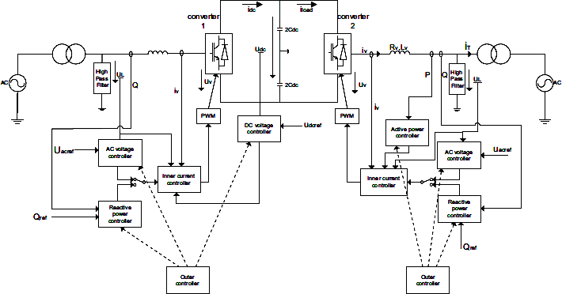

Figure. 1 Conﬁguration of a VSC-HVDC system.

Conventional HVDC and VSC-HVDC function in distinct ways, with the latter being simpler to manage. Although there aren't many installations using PWM in modern technology, VSC HVDC[3],[7] offers the ability to control active and reactive power independently. The reactive power controller will automatically adjust the AC grid's voltage where the transmitted active power remains constantThe active power flow between the converter and the network can be controlled by varying the phase angle (𝜕) between the voltage on the bus (Vs) and the fundamental frequency voltage (Vr) generated by the converter. Equation (1) is used to compute the power under the assumption of a lossless reactor (Xr).

𝑃 = 𝑉𝑠 𝑠𝑖 1
𝑋𝑟

The width of the converter bridge's pulses controls the amplitude of Vr, which in turn controls the reactive power flow. Equation (2)[12] is used to compute the reactive power. The dc voltage determines the greatest fundamental voltage that can be output by the converter.
[Type here]

𝑄 = 𝑉𝑠 𝑐𝑜𝑠𝜕−𝑉𝑟 𝑉𝑟 2
𝑋𝑟

Instantaneous active power P(abc) and reactive power Q(abc) communicated in the three-phase system on the ac side of the VSC, as well as the power Pdc sent on the dc side, are expressed as
P (abc) = uLa iva + uLb ivb+ uLc ivc 3
Q_{(abc)}= (u_{La}− u_{Lb}) i_{vc}+ (u_{Lb}− u_{Lc}) iva + (u_{Lc} − u_{La} ) i_{vb} 4
Pdc = udc idc 5
the three-phase voltages are balanced in normal operation condition, the u_{Lan}, u_{Lbn}, u_{Lcn}, are equal to zero, so the uLαn ,uLβn in the αβ-frame and uLdn, u_{Lqn} in the dq-frame are equal to zero. So the u_{Ldp}, u_{Lqp} can be described as:
u_{Ldp}= 0 u_{Lqp}=U 6
Pac(dq) and Qac(dq), the instantaneous active and reactive power in the dq-frame
Pac(dq)= u_{Lqp} i_{vqp} 7
Qac(dq)=u_{Lqp}i_{vdp} 8

The active power controller
An open-loop controller is a straightforward way to regulate the active power. The active current's reference is:
𝑖∗
𝑣𝑑𝑝
= ∗ 9
𝑢𝐿𝑞𝑝

Where P* is reference active power and u_{Lqp} positive sequence voltage on secondary side of the transformer.

Combining an open loop and a feedback loop will allow for more accurate control over the active power. (8)The structure of the resulting active power controller is depicted in Figure 2.
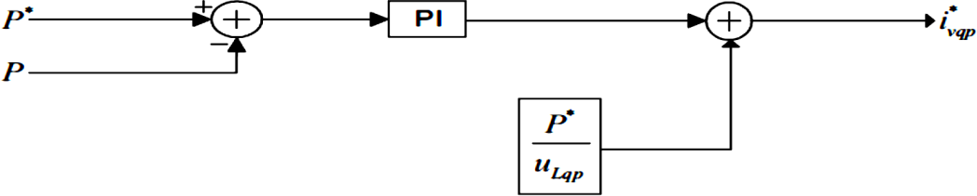

Figure. 2 Active power controller.

The reactive power controller
There is a similarity between the reactive and active power controllers. An open-loop controller is constructed using equation 4.2, where uLqp is the positive sequence voltage on the secondary side of the transformer and Q* is the reference reactive power.
𝑖∗

𝑣𝑑𝑝
= ∗ 10
𝑢𝐿𝑞𝑝

Combining an open loop and a feedback loop is an additional technique[17]. Figure 3 shows the reactive power controller's block diagram.

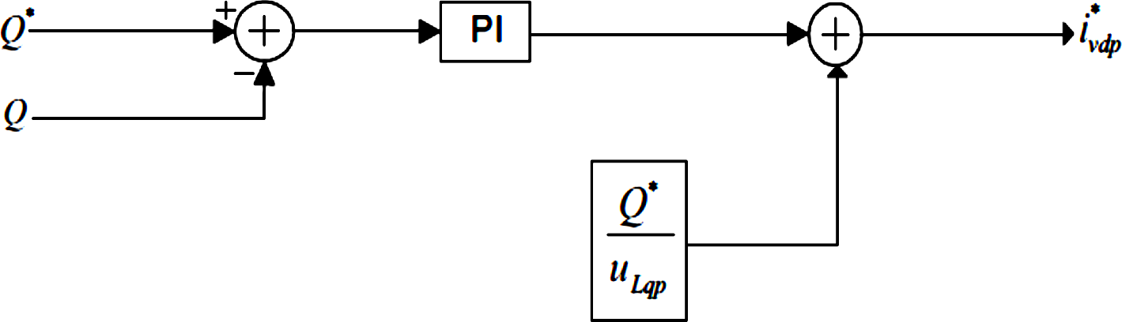

Figure. 3 Reactive power controller.

- SIMULATION RESULTS:
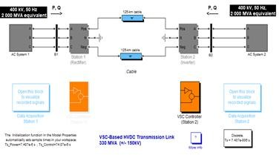
Figure. 4 VSC-Based HVDC Transmission Link 315 MVA (+/- 150kV)

MATLAB/SIMULINK software is used to simulate the system depicted in Figure 4 in order to test the reaction of the designed control system. Three level MLI has been used for the entire simulation. Ideal switches are used to represent the converter bridge values. Neglect is shown to switching losses and state losses [16]. The transformers and phase reactors are linear. In the table, system parameters are displayed.
[Type here]

Table. 1 VSC HVDC system parameters
Constant | Actual Value | Value in P.U
Rated AC Voltage  (Sending End) | 400kV | 1 P.U
Rated AC Voltage  (Recieving End) | 400kV | 1 P.U
Rated DC Voltage | 150 kV | 1 P.U
Rated DC Power | 300MW | 1 P.U
Line length | 125km
Reactor Inductance | 0.2546H | 0.15 P.U
Reactor Resistance | 8Ω | 0.015 P.U
DC capacitors | 70µF
AC System Frequency | 50 Hz
Switching frequency | 1350 Hz

For the best voltage conversion grounded/delta converter transformers are employed. The inverter's third harmonics are suppressed by the way the current windings are configured. The chosen magnification results in a modulation factor of around 0.85. (transformer ratio is 0.915 on the rectifier side and 1.015 on the inverter side), AC filters are a crucial component of the plan since they help AC systems satisfy their harmonic requirements. These will be attached to the converter side or the AC side of the converter transformer as shunt components. The Shunt filtering is relatively insignificant in comparison to the converter's performance because there are only high frequency harmonics. The 27th and 54th high pass matched 78.5 Mvar shunt AC filter revolves around two significant harmonics. According to the aforementioned simulation results, switching from an AC transmission line to a VSC HVDC transmission line reduces reactive power on the receiving side and maintains the receiving voltage at 1pu without the need for correction.
The VSC-HVDC can regulate the ac voltage, reactive power flow, and active power flow when the load is an established ac system. There are two distinct approaches to control.
Stratagy1:
Converter1: regulates the reactive and active power
Converter2: regulates reactive power and DC voltage
Stratagy2:
Converter1: regulates both the ac and dc voltages Converter2: regulates the reactive power and ac voltage
Here we are using the control strategy 1.

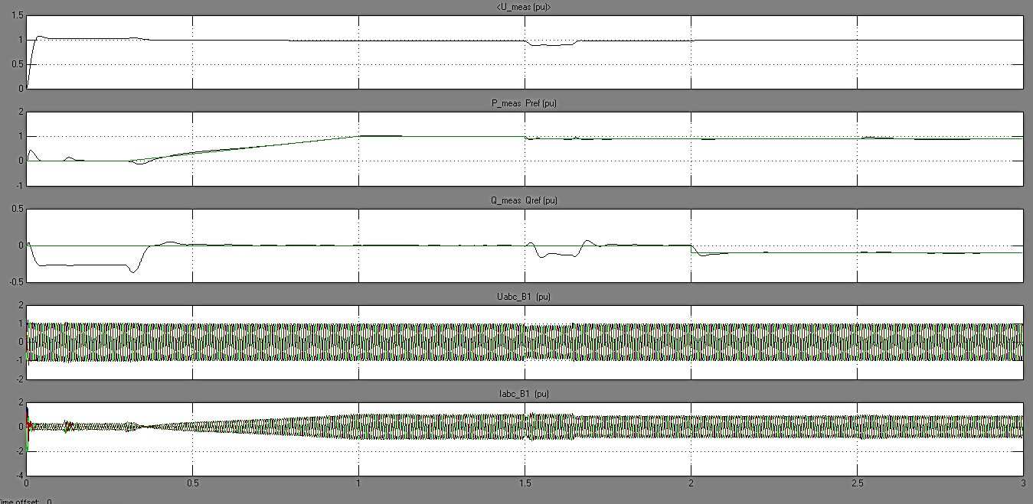

Figure. 5 Sending end AC parameters

[Type here]

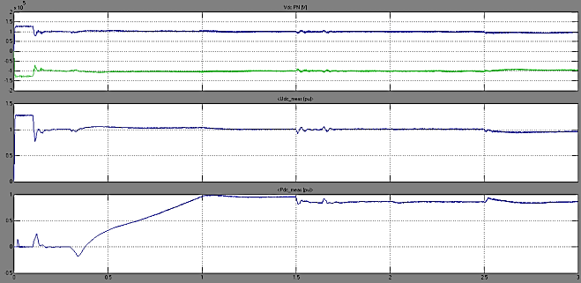

Figure. 6. Sending end DC parameters

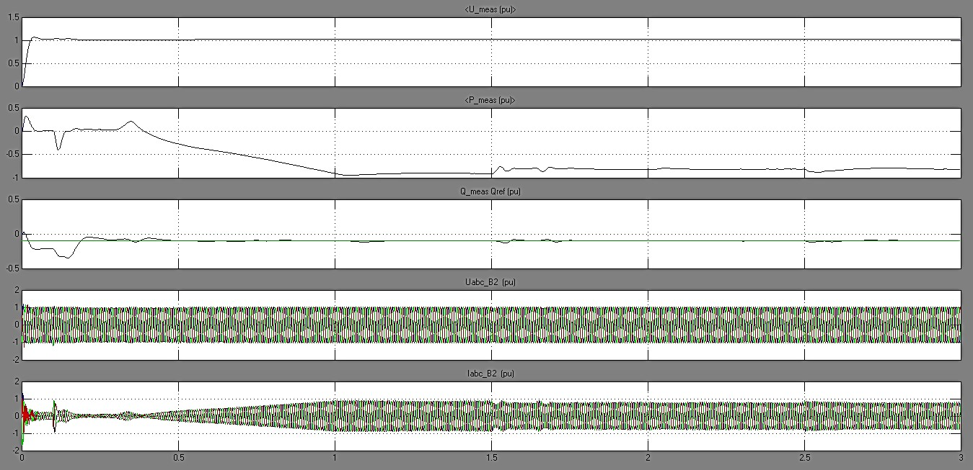

Figure. 7. Recieving end AC parameters
[Type here]

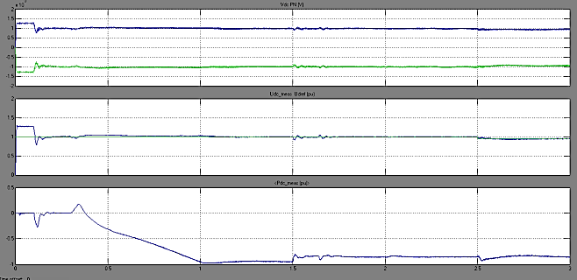
Figure. 8. Recieving end DC parameters

Table.2 Simulation results.

Vs | Vr | Active power at  Sending End | Active power at  Receiving End | Reactive power at  Receiving End
(PU) | (PU) | (PU) | (PU) | (PU)
1.00 | 1.00 | 0.94 | 0.9 | 1.00

Phase A's receiving end side has a single phase failure at 2.1 seconds, which is cleared at 2.5 seconds. The voltage at the defective phase a on the receiving end side increases from one p.u. to ground and returns to its normal value once the fault is cleared. The imbalanced voltage at the receiving end side has no effect on the voltages at the sending end side. There is a slight decrease in value at the other side and an increase in phase currents at the fault side [5]. After the fault is cleared, the faulty side's active and reactive power drop and then return to normal. As long as the corresponding active power and reactive power at the transmitting end stay constant, there are small oscillations at the beginning and conclusion of the fault. An ac side flaw lowers the amount of power that can be introduced into the air conditioning system. As a result, the DC capacitors will be charged, increasing the DC voltage on both the sending and receiving ends while the issue is being fixed and returning to normal thereafter.

CONCLUSION:

This article presents the steady-state performance of an HVDC transmission system based on VSC. The details of the three-level VSC modelling of the HVDC system are presented. The results of the simulation show that the system reacts fast, that it is possible to generate high-quality ac voltages and currents, and that it is possible to control active and reactive power independently in both directions. Additionally, the proposed technique ensures that the voltage at the receiving end is maintained at 1 pu without any modifications. The steady-state operation of an HVDC transmission system based on VSC is reported in this study. The three-level VSC modeling for the HVDC system is described in detail. The system's quick reaction time, capacity to deliver high-quality ac voltages and currents, and two-way independent active and reactive power management are all demonstrated by the simulation results. The suggested approach also ensures that the voltage at the receiving end stays constant at 1 pu.

REFERENCES:
- Asplund G., Application of HVDC Light to power system enhancement, IEEE Power Engineering Society Winter Meeting., 2000, 4, p. 2498-2503.
- Lie Xu, Andersen B. R.; Cartwright P., Control of VSC transmission systems under unbalanced network conditions, Transmission and Distribution Conference and Exposition, 7-12 Sept, 2003 IEEE PES, 2003, 2, pp. 626-632.
- K. R. Padiyar and N. Prabhu, "Modelling, control design and analysis of VSC based HVDC transmission systems," 2004 International Conference on Power System Technology, 2004. PowerCon 2004., 2004, pp. 774-779 Vol.1, doi: 10.1109/ICPST.2004.1460096.
- N. Flourentzou, V. G. Agelidis and G. D. Demetriades, "VSC-Based HVDC Power Transmission Systems: An Overview," in IEEE Transactions on Power Electronics, vol. 24, no. 3, pp. 592-602, March 2009, doi: 10.1109/TPEL.2008.2008441.
- H. Patel and V. K. Sood, "Modeling of Voltage Source Converter based HVDC system in EMTP-RV," 2010 IEEE Electrical Power & Energy Conference, 2010, pp. 1-6, doi: 10.1109/EPEC.2010.5697215.
- H. Khader, A. Massoud and A. Gastli, "Study of voltage source converter- based HVDC system during DC side faults," 2013 7th IEEE GCC Conference and Exhibition (GCC), 2013, pp. 210-213, doi: 10.1109/IEEEGCC.2013.6705777.
- M. A. Hannan et al., "Advanced Control Strategies of VSC Based HVDC Transmission System: Issues and Potential Recommendations," in IEEE Access, vol. 6, pp. 78352-78369, 2018, doi: 10.1109/ACCESS.2018.2885010.
- M. I. Ahmad and M. Yousif, "System Design and Control of VSC based HVDC System and its Performance Evaluation," 2020 IEEE 23rd International Multitopic Conference (INMIC), 2020, pp. 1-6, doi: 10.1109/INMIC50486.2020.9318167.
- Guanjun Ding, Guangfu Tang, Zhiyuan He and Ming Ding, "New technologies of voltage source converter (VSC) for HVDC transmission system based on VSC," 2008 IEEE Power and Energy Society General Meeting - Conversion and Delivery of Electrical Energy in the 21st Century, 2008, pp. 1-8, doi: 10.1109/PES.2008.4596399.
- S. S. Biswal, D. R. Swain and P. K. Rout, "VSC based HVDC Transmission System using Adaptive FPI Controller," 2021 International Conference in Advances in Power, Signal, and Information Technology

(APSIT), 2021, pp. 1-6, doi: 10.1109/APSIT52773.2021.9641283.
- N. Flourentzou, V. G. Agelidis and G. D. Demetriades, "VSC-Based HVDC Power Transmission Systems: An Overview," in IEEE Transactions on Power Electronics, vol. 24, no. 3, pp. 592-602, March 2009, doi: 10.1109/TPEL.2008.2008441.
- M. A. Hannan et al., "Advanced Control Strategies of VSC Based HVDC Transmission System: Issues and Potential Recommendations," in IEEE Access, vol. 6, pp. 78352-78369, 2018, doi: 10.1109/ACCESS.2018.2885010.

- Taoxi Zhu, Chao Wang and Jing Zhang, "Influence of the AC system faults on HVDC system and recommendations for improvement," in Proc. IEEE Power &Energy Society General Meeting (PES 2009), pp. 1-6, 26-30 July 2009.

- Craciun, B.-I.; da Silva, R.; Teodorescu, R.; Rodriguez, P., "Multilink DC transmission for offshore Wind Power integration," Industrial Electronics (ISIE), 2012 IEEE International Symposium on, vol., no., pp.1894,1899, 28-31 May 2012.
- J. Candelaria, J. Park, "VSC-HVDC system protection: a review of current methods," IEEE/PES Power Systems Conference and Exposition (PSCE), 2011, pp. 1-7.
- Jin Yang; Fletcher, J.E.; O'Reilly, J., "Short-Circuit and Ground Fault Analyses and Location in VSC-Based DC Network Cables," Industrial Electronics, IEEE Transactions on, vol.59, no.10, pp.3827,3837, Oct. 2012.
- Adam, G.P.; Ahmed, K.H.; Finney, S.J.; Bell, K.; Williams, B.W., "New Breed of Network Fault-Tolerant Voltage-Source-Converter HVDC Transmission System," Power Systems, IEEE Transactions on, vol.28, no.1, pp.335,346, Feb. 2013.
- Guo-Jie Li, T. T. Lie, Yuan-Zhang Sun, Si-Ye Ruan, Ling Peng and Xiong Li, "Applications of VSC-based HVDC in power system stability enhancement," 2005 International Power Engineering Conference, 2005, pp. 1-376, doi: 10.1109/IPEC.2005.206937.

[Type here]

