Ethosomes: A Novel Drug Delivery System
Prateeksha Pawar*, Vaishnavi More, Simran Chaudhari, Pranali Borse, Neetu Khatri
Dr. D.Y. Patil College of Pharmacy, Akurdi, Pune-44

Introduction
The body's largest and most accessible organ, the skin, can be used as a potential medication delivery route for systemic effects. The skin is an external, multilayered organ that serves as both a permeability barrier and a protective tissue, keeping outside molecules from entering the body.[4] Therefore, the stratum corneum, the skin's outermost layer, acts as the most reliable barrier against drug penetration, reducing the bioavailability of medications when given topically.[1] Therefore, special carriers are needed to get beyond the skin's natural barrier and get medication molecules with different physicochemical qualities into the bloodstream.[4] Transdermal drug delivery system (TDDS), a less invasive method of pharmaceutical administration that offers regulated drug distribution, less frequent dosage, patient compliance, and prevention of first-pass metabolism, was consequently established.[1] These systems use liposomes, other vesicles, prodrugs, supersaturated systems, penetration enhancers, and other vesicles.[2] Ethosomal systems are newer lipid vesicular carriers that have been around for 20 years, but over that period they have grown significantly as a means of transdermal drug delivery.
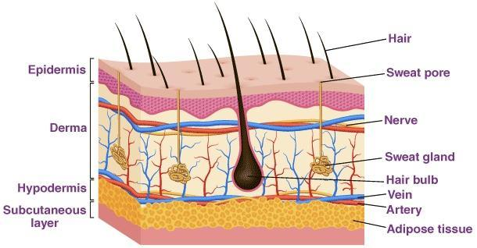
Fig No. 1 Structure of Skin[10]

Vesicular Systems
1. Liposomes
They are tiny, water-containing vesicles that resemble the structure of skin's phospholipid bilayer in structure and, in rare situations, the phospholipid chain from soy or egg yolk and cholesterol. Mezei took the initiative to use liposomes as delivery vehicles. No direct absorption is accomplished, addressing the need for advanced characteristics, and it merely assists in getting the medication to the reservoir in the top layer of the skin. Studies using liposomes revealed enhanced miconazole nitrate deposition with minimal penetrability in the upper layers of the skin.[7]

2. Nisosomes
Except for the non-ionic surfactants used, they are composed similarly to conventional liposomes but are more stable and less expensive. The mechanisms rely on the drug's physico-chemical characteristics, the type of vesicle, and the lipids utilized. Thin-film hydrated fluconazole nisosomes with spans of 60, 40, and 72 showed prolonged drug release and excellent cutaneous retention. Another medicine that was found to be more effectively administered in a different trial is ciclopirox.[7]

3. Transfersomes
Due to their higher flexibility and deformability, they are often referred to as ultra-deformable vesicles or liposomes. Phospholipids and various types of surfactants give a flexible and effective delivery mechanism for transdermal and topical delivery of medications, genetic material, and vaccinations. The better efficiency of ethosomes as a vesicular
delivery system was subsequently demonstrated by research on clotrimazole-loaded ethosomes, which revealed that the drug flux was more significant in the system than that of typical transfersomes.[7]

4. Ethosome
Another innovative lipid carrier, the ethosome, was recently created by Touitou et al. (2000) and exhibited improved skin delivery. Water, ethanol, and phospholipid make up the ethosomal system. Depending on the manner of preparation and the use of procedures like sonication, the size of ethosomes can range from a few nanometers to micrometres.[7]
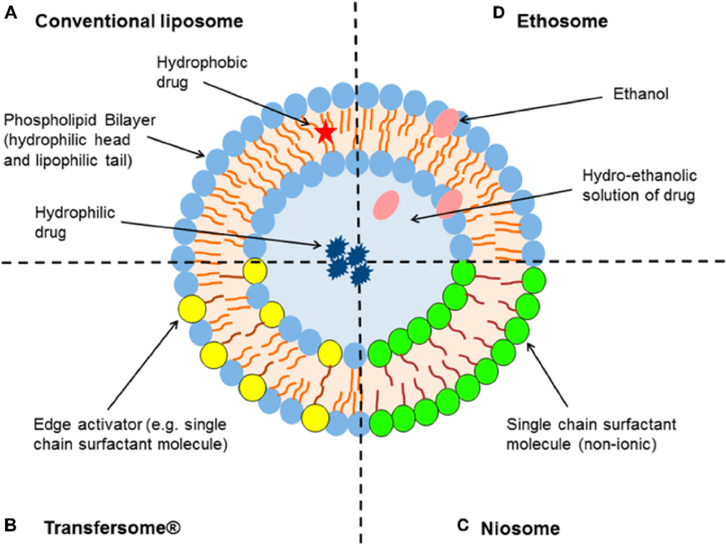
Fig No. 2 Schematic Illustration of (A) Liposome, (B) Transferosome, (C) Nisosome and (D) Ethosomes[12]

5. Pharmacosomes
Potential replacements for traditional vesicular systems include pharmacosomes. Pharmacon is short for "drug and carrier. They are colloidal dispersions of drugs that are covalently bonded to lipids. Depending on the nature of the drug-lipid complex, they may take the shape of hexagonal, micellar, or ultrafine vesicular aggregates. Certain medications that contain an active hydrogen or carboxyl group can be esterified to create a system with an amphiphilic prodrug. It is a self-assembled nanoparticle system that allows for the loading of greater amounts of medication and has a lower interfacial tension and a higher contact area, both of which increase bioavailability.[7]
6. Virosomes
Virosomes are globular, unilamellar, bilayered phospholipid vesicles that contain virus-derived proteins that allow them to merge with target cells. For influenza virus resistance, lipids are intercalated with membrane proteins, including haemagglutinin and neuraminidase, enabling them to transmit the medication to the target cell cytoplasm. The nucleocapsid and genetic material of the source virus are integrated into the envelope. The vesicles hold the viral surface glycoprotein, which has a size range of 120–180 nanometers.[7]
7. Colloidosomes
They are emulsion droplet interface-based coagulated or fused particles in hollow-shelled microcapsules. As their membrane offers higher potential in manipulating the permeability of entrapped species, assuring selective and timed medication release, they have highly flexible applications. As broader utility is rare, the system is still in its early stages of development.[7]

8. Aquasomes
It is a three-layered self-assembled nanoparticle system with a glassy cellobiose coating over a ceramic carbon nanocrystalline particulate core that aids in molecular shielding and precise targeting.[7]
9. Cubosomes
These are devices that have been employed in an experimental setting to distribute herbal medications for the drug KIOM-MA 128, used to treat atopic dermatitis. Compared to the suspension form, M-A 128's permeability feature was improved using cubosomes. [7]
10. Sphingosomes
They are concentric bilayer vesicles with a size range of 0.05 to 0.45 micrometres, and the aqueous compartment is fully surrounded by a bilayered membrane made of natural or synthesized sphingolipids. As they are only formed of amide and ether connections and have fewer double bonds than lecithin, they are more stable and have longer circulation times than typical vesicular systems. They are perfect for investigations on immunology, gene delivery, and targeting tumours. According to Saraf et al., in 2001, it was utilized in the treatment of cancer. Sphingosomes are created utilizing cholesterol derived from sphingomyelin, which gives them properties including resistance to oxidation and acid hydrolysis, providing them greater stability in plasma and longer circulation times, improving bioavailability .[7]

Table No. 1 Difference between Liposomes, Transferosomes and Ethosomes [9]

Characters | Liposomes | Transferosomes | Ethosomes
Composition | Phospholipids and Cholesterol | Phospholipids and edge activators | Phospholipid and Ethanol
Characteristics | Microscopic Vesicles | Ultra-flexible Vesicles | Elastic Vesicles
Flexibility | Rigid | High deformability due to Surfactant | Elasticity due to ethanol
Permeation Mechanism | Diffusion | Deformation of Vesicle for Penetration | Lipid Perturbation
Extent of Skin Penetration | Very less Penetration | Can easily Penetrate | Can easily Penetrate
Route of Administration | Oral, Parenteral, Topical, Transdermal | Topical and Transdermal | Topical and Transdermal
Marketed Products | Ambidone | Transferosomes  (Idea AG) | Nanominox, Decorin Cream

Ethosomes
Touitou et al., 1997 created ethanolosomes, another unique lipid carrier made of ethanol, phospholipids, and water. Ethosomes are soft, flexible vesicles made primarily of water, phospholipids, and ethanol (at a relatively high concentration). These soft vesicles are brand-new vesicular carriers for improved skin delivery.[5] The stratum corneum's intercellular area is affected by ethanol's role as a permeation enhancer. They disrupt the lipid bilayer of the skin by including 20–50% ethanol in its ethosomal composition. The physical and chemical properties of therapeutic drugs included in the transdermal and dermal distribution are enhanced by the transethosomal system. Higher ethanol concentration causes the medicine to be released to the targeted area by opening up the outer layer's pores and causing hydration.[6]

Composition of Ethosomes
Ethosomes are composed of three components:
- Concentric layers of flexible Phospholipids
- High Concentration Ethanol (20-45%)
- Water

Phospholipids (phosphatidylcholine, phosphatidylserine, and phosphatidic acid), ethanol at high concentrations, and water make up the majority of ethosome composition. There is a range of 22% to 70% in the nonaqueous phase. Either ethanol or isopropyl alcohol may be used. Since ethanol is renowned for disrupting the structure of skin lipid bilayers, its high concentration in the ethosomes makes them special because, when incorporated into a vesicle's membrane, it enables that vesicle to pass through the stratum corneum. Additionally, the stratum corneum lipids' high ethanol content causes the lipid membrane to pack less closely than traditional vesicles while maintaining similar stability. This allows for a more pliable shape and enhances the ability to distribute drugs.[7]

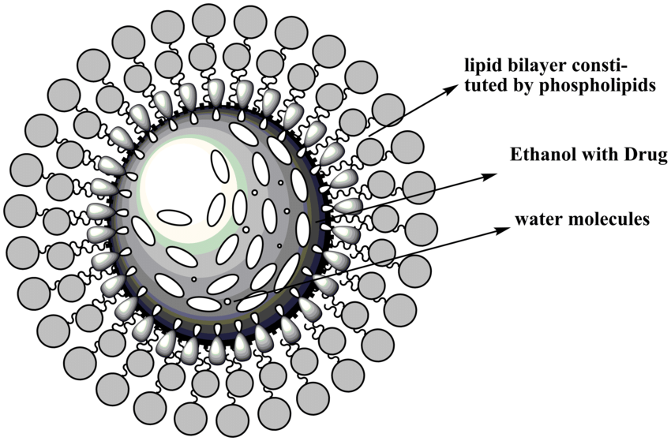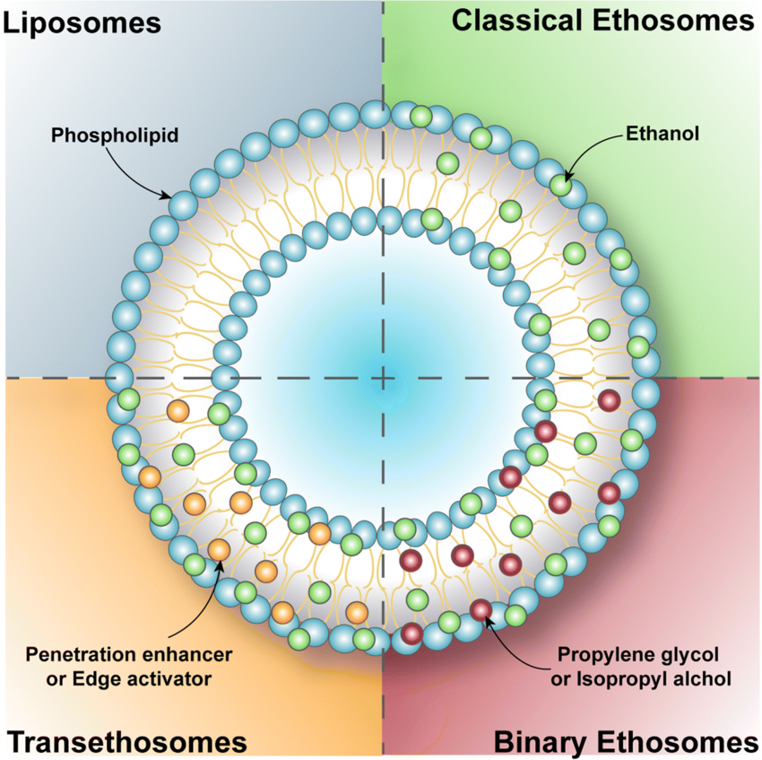
Fig No. 4 Structure of Ethosome[13] Fig No. 5 Types of Ethosome [6]

Mechanism of action
The improved drug penetration of Ethosomes over liposomes is their principal benefit. There is no known mechanism for how drugs are absorbed from Ethosomes. Drug absorption probably occurs in the following two phases:

1.Ethanol effect
Through the skin, ethanol enhances permeation. Its penetration-enhancing effect has a well-known mechanism. In addition to increasing the fluidity of cell membrane lipids and lowering the density of the lipid multilayer of the cell membrane, ethanol also penetrates into intercellular lipids.[3]

2. Ethosomes effect
The ethanol of ethosomes increases the fluidity of cell membrane lipids, which in turn increases skin permeability. Thus, the ethosomes easily penetrate the deep skin layers, where they fuse with the lipids of the skin and release the medicine.[3]
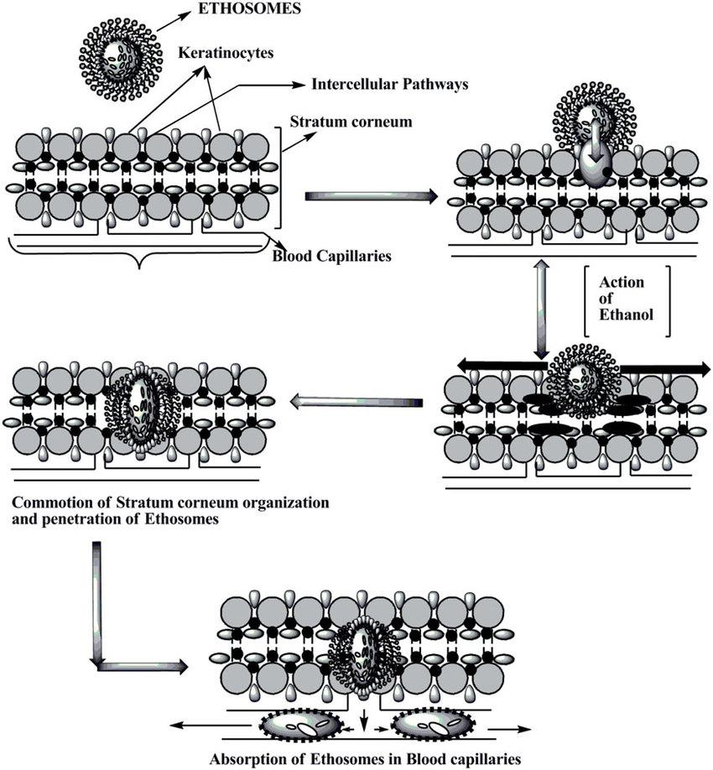
Fig No. 6 Mechanism of Action [11]

Types of Ethosomes
1. Classical ethosomes
They are essentially modified versions of traditional liposomes that include a lot of Alcohol (45%w/w). Compared to traditional ethosomes, they exhibit improved entrapment efficiency and a greater negative zeta potential. The molecular weights range from 130.007 Da to 24k Da², so they have increased permeability and improved stability.[1]
In addition, traditional ethosomes outperformed traditional liposomes in terms of skin penetration and stability characteristics.

2. Binary ethosomes
Zhou et al. were the first to present them. They are binary because another alcohol is added to the formulation to give them more of the perfect qualities. Isopropyl alcohol (IPA) and propylene glycol (PG) are two alcohols that are frequently added. [1]

3. Transethosomes
These are lipid vesicles composed of transfersomes and ethosomes. They are comparable to traditional preparations but include an extra ingredient in the form of a penetration enhancer or an edge activator (usually a surfactant). In a formulation known as transethosomes, the unique delivery mechanism combines the optimal characteristics of traditional ethosomes with the flexibility and deformability of transfersomes. They were said to possess traits that were better and more advantageous than those of traditional ethosomes. They can capture drugs with molecular weights between 200 and 235 kDa and 130.077Da. Transethosomes contain up to 30% of ethanol, which is a good penetration enhancer. They are irregular in shape. They contain advantages of both ethosomes and transfersomes. Rearrangement of lipid bilayers occurs in combination with ethanol and edge activator, resulting in higher values in vesicle elasticity and skin penetration studies. They have a tendency to cross the intact skin by transcutaneous hydration gradient.[1]

Sr. No | Parameter | Classical ethosomes | Binary ethosomes | Transethosomes
1 | Composition | 1. Phospholipids  2. Ethanol  3. Stabilizer  4. Charge inducer  5. Water  6. Drug/agent | 1. Phospholipids  2. Ethanol  3. Propylene glycol  4. Charge inducer  5. Water  6. Drug/agent | 1. Phospholipids  2. Ethanol  3. Surfactant  4. Charge inducer  5. Water  6. Drug/agent
2 | Morphology | Spherical | Spherical | Regular or irregular spherical shapes
3 | Size | Smaller than the classical liposomes | Equal to or smaller than classical ethosomes | Size based on type and concentration of penetration enhancer or edge activator used
4 | Entrapment efficiency | Superior to traditional liposomes | Often higher than traditional ethosomes | Higher than the majority of typical ethosomes
5 | Skin permeation | Usually greater than traditional liposomes | Usually on par with or superior to traditional ethosomes | Often higher than traditional ethosomes
Table 2: Difference between various ethosomes for transdermal drug delivery [1]

Methods of Preparation of Ethosomes
Ethosomes can be prepared by two very simple and convenient methods: the cold method and the hot method.

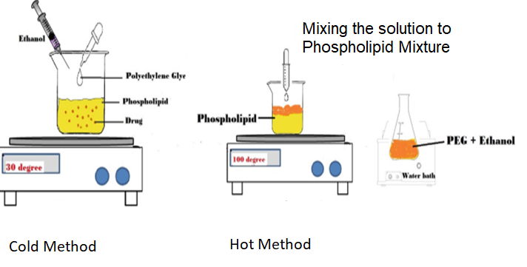
Fig No. 7 Methods of Preparation of Ethosomes [8]

1. Cold Method
This procedure involves vigorously swirling with the aid of a mixer to dissolve phospholipid, medication, and other lipid components in ethanol in a covered vessel at room temperature. While stirring, propylene glycol or another polyol is added. In a water bath, this combination is heated to 30⁰C. The mixture is then agitated for 5 minutes in a covered vessel while the water heated to 30⁰C in another pot is added to it. Sonication or extrusion techniques can be used to reduce the ethosomal formulation's vesicle size to the required level. The formulation is then kept in a refrigerator.[1]

2. Hot method
By heating the phospholipid in a water bath at 40⁰ C until a colloidal solution is formed, the phospholipid is dispersed in water using this approach. Ethanol and propylene glycol are combined and heated to 40⁰ C in a different tank. The organic phase is introduced to the aqueous phase once both solutions have reached 40⁰ C. Depending on whether the medication is hydrophilic or hydrophobic, it dissolves in either water or ethanol. Using the probe sonication or extrusion approach, the vesicle size of the ethosomal formulation can be reduced to the required degree.[1]

Advantages
1. Proteins and peptides can be conveniently supplied with the help of technology. [1]
2. The delivery method can be applied in a variety of ways, including veterinary and aesthetic care, in addition to the pharmaceutical
industry. [1]
3. It contains an ethosomal system, which is passive, non-invasive and available for immediate commercialization. [2]
4. High patient compliance: The ethosomal drug is administered in semisolid form (gel or cream), hence producing high patient
compliance. [3]
5. It is the simplest among other methods of drug delivery like iontophoresis, sonophoresis and other complicated methods. [4]
6. No preservatives need to be added since twosomes contain Alcohol, which acts as a natural preservative. [4]
7. Manufacturing ethosomes is very cheap.[4]
8. The transport of drugs across the skin is concentration-independent. [4]
9. High market attractiveness for products with proprietary technology. Relatively simple to manufacture with no complicate
technical investment required for the production of ethosomes.[5]
10. Low-risk profile -The technology has no large-scale development risk as the toxicological profiles of the ethosome components
are well documented in the scientific literature. [5]
11. Ethosomes enhance the permeation of the drug through skin transdermal and dermal delivery. [5]

Disadvantages
1. The drug's molecular size needs to be appropriate for percutaneous absorption. [1]
2. Excipients in ethosomes can cause skin irritation or disadvantages. [1]
3. They require high blood levels. It is limited only to potent molecules, those requiring a daily dose of 10mg or less. [2]
4. It is not meant to achieve rapid bolus-type drug input; rather, it is usually designed to offer slow, sustained drug delivery. [2]
5. It requires adequate solubility of the drug in both lipophilic and aqueous environments to reach dermal microcirculation and gain
access to the systemic circulation. [3]
6. They show poor adhesive properties and hence, do not adhere properly to all skin types. [3]
7. Allergic reactions can be identified if the patients are allergic to ethanol or any of the ethosomal components. [4]
8. Unlike other carriers (solid lipid nanoparticles, polymeric nanoparticles, etc.), which can be used for multiple routes, ethosomal
carriers are important only for transdermal use. [4]
9. Ethosomes are not very economical as they give poor yields. [4]

Therapeutic Applications of Ethosomes
1. Treatment of microbial and viral skin infections
Antibiotic-containing ethosomal systems have been studied for the treatment of various skin infections. Animal models of deep skin infections were used to construct and test the efficacy of the bacitracin and erythromycin ethosomal systems. [2]

2. Anti-inflammatory ethosomal systems
Paolino and colleagues investigated the effects of ammonium glycyrrhizinate (AG) ethosome on human volunteers who had chemically induced erythema from methyl-nicotinate. A spectrum visible spectrophotometer utilized for the calculation of the erythema indices was used to contrast the anti-inflammatory effects of the ethosomal AG system to those of aqueous or hydroethanolic medication solutions after either pre-treating or treating skin erythema. Results demonstrated that compared to other formulations, AG ethosomes greatly lowered the level of severity and duration of erythema.[2]

3. Ethosomal Systems for Menopausal Syndromes
Ethosomal compositions have undergone tests to see how well they can treat menopausal syndrome in women and androgen deficit linked to menopause in males. The Testosome testosterone ethosomal patch technology was created to treat masculine androgen insufficiency. A study comparing the testosterone serum levels in rabbits following single or several applications of either the Testosome or Testoderm patch (Alza) was done in vivo. Single patch test results exhibited no discernible differences between the tested groups.[2]

4. Management of Erectile Dysfunction
In an "in-office" pilot clinical trial, 16 males with 17 episodes of erectile dysfunction were treated with ethosomal prostaglandin E1 (PGE1_ systems administered to the glans penis. In addition to the doctor's assessment of the patients' erections, the patients were asked to rate their capacity to engage in sexual activity. After 15 minutes of application, the effect was further investigated by performing a duplex examination of the cavernous arteries to measure the peak systolic velocity (PSV) and pulsatile index (PI) of the left and right cavernous arteries. It was noted how long the erection lasted. The study's findings revealed that 12 men had better peak systolic velocity and increased penile stiffness after receiving a single topical injection of the PGE1 ethosomal system.[2]

5. Analgesic and Antipyretic Ethosomal Systems
A recent study used the tail flick nociception mouse and Brewer's yeast-induced fever rat as animal models for examining the in vivo analgesic and antipyretic therapeutic benefits of transdermal ethosomal ibuprofen. Rats with fevers had their body temperatures gradually lowered after administering ibuprofen gel to their skin. In mice, the tail-flick test was used to compare the analgesic effects of ibuprofen gel applied topically to oral therapy. The ethosomal ibuprofen method exhibited a statistically significant greater effect 120 and 360 minutes after treatment. The effect lasted at least six hours.[2]

6. Topical Delivery of DNA
Many infections from the environment try to enter the body through the skin. As a result, skin has developed into a superb protective barrier that can express the gene and is immunologically active. Based on the previously mentioned information, topical transfer of DNA molecules to activate genes in skin cells is another significant usage of ethosomes.

Table No. 3 Marketed Products Based On Ethosomal Drug Delivery System [3]
Sr. No. | Name of Product | Uses | Manufacturer
1. | Cellutight EF | Topical cellulite cream contains an effective combination of ingredients that boost metabolism and break down fats. | Hampden Health, USA
2. | Decorin cream | An anti-ageing cream treats, repairs and slows down the visible signs of skin ageing, such as wrinkles, sagging, ageing, loss of elasticity and hyperpigmentation. | Genome Cosmetics, Pennsylvania, US
3. | Nanominox | The first minoxidil product to use ethosomes. It contains 4% minoxidil, a known hair growth agent, which must be metabolized to the active compound by sulfation. | Sincere, Germany
4. | Supravir cream | For the treatment of herpes virus | K Trima, Israel

Conclusion
It is clear that ethosomes can penetrate the skin more effectively than liposomes. Ethosomes are preferable to transdermal and dermal administration methods. They are the non-invasive drug delivery mechanisms that allow medications to pass through the deep layers of the skin and eventually reach systemic circulation. It transports big molecules like protein and peptide molecules. Ethosomes can be customized for improved skin penetration of active medicines and are distinguished by ease of manufacture, safety, and efficacy. Ethosomes can significantly reduce the epidermal barrier, which serves as the primary barrier to transdermal medication delivery systems. Ethosomal carriers create new difficulties and possibilities for the creation of innovative, improved treatments. Additionally, this research will enable more precise drug release control.

References:
[1] Chauhan N, Vasava P, Khan S, Siddiqui F, Islam S, Chopra H, Emran T, Ethosomes: A novel drug carrier, AMS 2022;82;1-3.

[2] Mohanty D, Sahoo C, Haque M, Ethosomes: A Novel Approach for Transdermal Drug Delivery, IJCTR, 2018;11(8);220-224

[3] Aggarwal D, Nautiyal U, Ethosomes: A review, Int. J. Pharm. Med. Res, 2016;4(4);354-363.

[4] Jadhav P, Kapadnis K, Shinkar D, Pathan V, Jadhav A, Ethosomes as Novel Drug Delivery System: A review, Int. J. Pharm. Sci. Rev. Res, 2020;62(1);173-182. (5)

[5] Verma P, Pathak K, Therapeutic and Cosmeceutical Potential of Ethosomes: An Overview, J Adv Pharm technol Res, 2010;1(3);274-282. (7)

[6] Saieswari K, Gopinath E, Ganesh N.S, Chandy V, Transethosomes: A Novel Drug Delivery Through Skin, IJARIIE 2022;8(2);1736-1739. (8)

[7] Devaki J, Pavuluri S, Suma N, Ethosomes: A Vesicular Carrier as a Novel Tool for Transdermal Drug Delivery System, Journal of Drug Delivery and Therapeutics. 2023; 13(4):159-164.

[8] Nayal D, Mohanda Y, Rauta P, Chakrabartty R, Saravanan M, Pharmaceutical Nanobiotechnology for Targeted Therapy, Ethosomes for Dermal and Transdermal Drug Delivery Systems, 19 october 2022, [cited 2023 Aug 23].

[9] Maxwell A, Priya S, Nanosized Ethosomes-A Promising Vesicular Drug Carrier for Transdermal Drug Delivery, Research, Journal of Pharmacy and Technology:2019:12(2)876.

[10] Skin Diagram, Available on https://byjus.com/biology/skin-diagram (Cited 14 August 2023)

[11] Pandey V, Golhani D, & Shukla R, (2015) Ethosomes: versatile vesicular carriers for efficient transdermal delivery of therapeutic agents, Drug Delivery, 22:8, 988-100.

[12] Rahman H, Othman H, Hammadi N, Yeap S, Novel Drug Delivery Systems for Loading of Natural Plant Extracts and Their Biomedical Applications, Int. Journal of Nano medicine, 2020; 15:2439-2483

[13] Pandey V, Golhani D, Shukla R, Ethosomes: Versatile vesicular carriers for efficient transdermal delivery of therapeutic agents, 2014:22(8):2

