MALLA REDDY UNIVERSITY SCHOOL OF AGRICULTURALA SCIENCES
DEPARTMENT OF AGRONOMY
M SC.AGRONOMY
D Swathi, SHANTHI B, THAMMINANA JYOTSNA, Y Durga Venkat Hemu
ARTIFICIAL INTELLIGENCE IN AGRICULTURE
Abstract
A major issue on every continent is artificial intelligence. One of the most practical ways to manage food shortages and adjust to the needs of a growing population is the use of AI in agriculture. Despite his best efforts, the farmer was unable to live up to the demands using the standard approach. The synthetic intelligence approach will then be included. Many people now have the opportunity to work and obtain the daily food they require thanks to this. A parallel agricultural revolution is being driven by artificial intelligence in agriculture. Many people now have the opportunity to work and obtain the daily food they require thanks to this. In this period, a number of concerns, including population growth, climate change, labor market challenges, and concerns regarding. The main problem of the document is to verify the numerous artificial intelligence applications in agriculture, including irrigation, weeding, and spraying, which are combined with sensors and other tools used in robots and drones. By using less water, using fewer pesticides, and maintaining soil fertility, these advances can help save money. They can also help increase productivity, better utilize human resources, and deliver higher-quality services. To automate weeding in agricultural structures, robotics and drones are used. According to the information now available, it is widely acknowledged that the application of artificial intelligence in agriculture in the United States has led to significant breakthroughs. Crop productivity, price, and disease detection are three areas where AI has proven to be quite useful. It has also helped farmers make informed decisions on all three areas of agriculture by supplying information about the best growing conditions and utilizing price prediction models to analyze data collected using a variety of approaches.
INTRODUCTION
Because of its rapid technological development and broad variety of applications, artificial intelligence is one of the primary fields of research in computer science. Artificial intelligence is founded on the hypothesis that human intelligence can be defined in a way that a computer can simply duplicate it and perform tasks, from the most basic to the most complex.The main issue and new condition around the world is agriculture automation. Agriculture is one of the key industries where AI is absolutely essential. AI is having a significant impact on all business sectors. One of the oldest and most important vocations in the world is agriculture and farming. Farmers must accept agriculture as their primary source of income because it requires a lot of time and effort to grow suitable crops. However, due to low income and occasionally no gain from land due to weather conditions or resource scarcity, farmers must deal with loss and decline in financial conditions, which ultimately leads to suicide due to depression. A revolution in agriculture has been sparked by artificial intelligence. The crop output has been impacted by a number of variables this generation, including population growth, employment issues, and issues with food safety and climate change. using artificial intelligence in agricultural for irrigation, weeding, and spraying of robots and drones have sensors and other technology built in. These Technology reduces the need for further applications of water, pesticides, and herbicides while preserving soil fertility, allowing for more effective use of human labor, increasing output, and raising the standard of living. It is essential to the economic sector. Numerous programs exist. Using AI to increase crop quality and accuracy can really help farmers develop their agricultural intelligence. Plant illnesses, insect pests, and weeds can all be found using AI sensor targets. The solution is cooperative agricultural robots with farmers. Large and swift plants are gathered by the robot. The spraying method allows farmers to employ drones to work five times faster than traditional equipment. In the Blue River era, there existed an agricultural robot that could be used to control weeds. The agricultural calculator, which enables farmers to choose appropriate crops and determine their pricing at a lesser cost, is one of the intelligent programs included in agriculture can increase the productivity of farmers all over the world.
1) WHY ARTIFICIAL INTELLIGENCE IS IMPORTANT IN AGRICULTURE ?
- Artificial intelligence (AI) has the potential to be used across disciplines and to fundamentally alter the way we now view farming.
- AI-powered solutions will not only help farmers work more efficiently with less money, but they will also enable them to increase their harvest as a result of the growing use of excessive technology in areas such as government, healthcare, and education.
- Agriculture is the industry that has been most affected by artificial intelligence because of its emphasis on efficiency and ease of use. The use of AI in agriculture should be improved for low cost and simple processing.
- Of all industries, agriculture is the most heavily impacted because artificial intelligence is geared toward efficiency and smart working.
- AI should be used to improve agricultural areas at minimal cost and with simple processing.
- There are several ways in artificial intelligence to increase crop production rates and harvest quality, such as the introduction of indoor farming.
- There are numerous AI packages available to genuinely assist farmers, including those that analyze farm statistics with the goal of increasing the quality and accuracy of the flora, detect weeds using sensors, and discover pests and other ailments in the flora.
- AI addresses issues related to labor, As a result of the fact that fewer people are entering this field, farmers are experiencing a labor shortage and a lack of personnel. Agriculture robots, who will work alongside farmers, are a solution to these issues.
- Aerial spraying with drones is five times faster than traditional machinery, which is another benefit of crop spraying technology for farmers.
- AI also performs diagnostic analysis similar to satellites for weather forecasting and crop sustainability, which would be very beneficial for farmers if they already had a general understanding of the weather. changes. Agri-ECalculator, which enables farmers to select appropriate and less expensive flora by calculating its price, is one of the smart farming packages offered by AI. There are many better products on the market, but the drawback is that they come with expensive prices and challenging instructions. In plain English, we may state that the application of AI to agriculture is enhancing the productivity of farmers worldwide.
2) AGRICULTURAL LIFECYCLE :
We can categorize the agricultural process into various components.
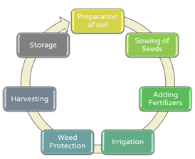
1.soil preparation: Farmers prepare the soil for planting seeds during the first stage of farming. Large soil clumps must be broken up during this procedure, and debris like sticks, pebbles, and roots must be removed. To establish the optimum environment for crops, you may also add organic matter and fertilizers based on the type of crop.
2.seed planting: In this stage, it's important to consider the space between seeds and the depth at which to plant them. Climate factors at this point, including temperature, humidity, and rainfall, are significant.
3.Boost fertilizers: Maintaining soil fertility is crucial for the farmer to be able to create nourishing and robust crops. Fertilizers are used by farmers because they provide plant nutrients including nitrogen, phosphorus, and potassium. Fertilizers are merely nutrients that are planted and added to agricultural areas to augment the necessary minerals already present in the soil. The crop's quality is also determined at this stage.
4.Water management:This phase aids in maintaining humidity and soil moisture. Crop growth can be hampered by underwatering or overwatering, and if done improperly, can result in damaged crops.
5.Protection against weeds: Unwanted plants known as weeds typically appear at the edge of farms or next to crops. Weeds reduce yields, drive up production costs, impede harvest, and degrade crop quality, hence they must be considered when planning for crop production.
6.Harvesting: It is the procedure for gathering ripe harvests out of the fields. This activity is labor-intensive because it calls for numerous workers. Additionally, postharvest handling activities like cleaning, sorting, packing, and refrigeration are included in this stage.
7.Storage: This stage of the post-harvest system is when the goods are stored so as to provide food security outside of agricultural seasons. Crop packing and transportation are also included.
3) IMPACT OF AI IN AGRICULTURE
Agriculture is a $5 trillion global industry, and AI technology can help with a wide range of agricultural-related tasks throughout the entire food supply chain, including managing pests, monitoring soil and growing conditions, preparing information for farmers, helping with workload, and yielding more healthy crops. However, under this setting, the $204 million Indian Agri-tech market has only reached 1% of its estimated capacity of $ 24 billion. Large Agricultural Data Resource India offers a fantastic opportunity for information scientists and AI professionals to develop state-of-the-art AI tools and solutions for agriculture because of the variety of its soil types, climate, and geography. For the time being, ndian farms and farmers provide excellent and plentiful information to help develop AI solutions. the entire world, not just the United States. And that is one of the factors that sets Indian agriculture's use of AI apart from other nations.

4) ARTIFICAL INTELLIGENCE APPLICATIONS IN AGRICULTURE
Artificial intelligence technology are expected to assist the sector. produce healthier crops, control pests, monitor soil and growing conditions, organize data for farmers, ease workloads, and improve a variety of agriculture-related jobs along the entire food supply chain.agri-related activities throughout the entire food supply chain.
1.USE OF WHEATHER FORCASTING: Farmers find it challenging to decide when to plant seeds due to climate change and rising pollution. With the aid of artificial intelligence, farmers can analyze weather conditions using weather forecasting to help them plan the type of crop that can be grown and when should seeds be sown.

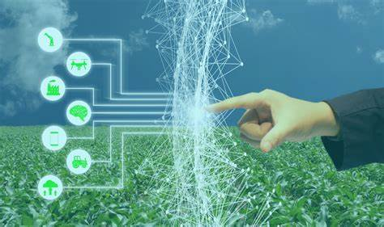
2. Farming Robotics:
- Robots that can readily do a variety of duties in farming fields are being developed by AI businesses. This kind of robot is taught to control weeds and harvest crops more quickly and in greater quantities than humans.
- These particular robots have been taught to simultaneously harvest and pack crops while assessing crop quality and weed presence.
- These robots can also handle difficulties experienced by agricultural laborers.
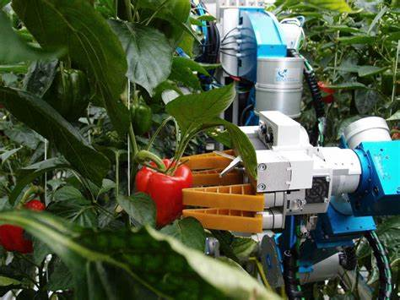
3.Monitoring system for soil and plant health:
- The quality of the soil is declining as a result of increased deforestation, making it difficult to assess.
- A technology startup with a German base PEAT has created an AI-based tool called Plantix that can detect nutrient deficits in soil as well as pests and illnesses that affect plants, giving farmers the knowledge they need to utilize fertilizer to increase the quality of their harvest. Image recognition-based technology is employed by this app.
- Using smartphones, the farmer can take pictures of the plants. Through brief films on this program, we may view soil restoration methods along with suggestions and other fixes. Similar to others, Trace Genomics is a machine learning-based business that assists farmers with soil analyses.
- With the aid of these kinds of apps, farmers can monitor the quality of their soil and crops, resulting in more productive and healthy harvests.

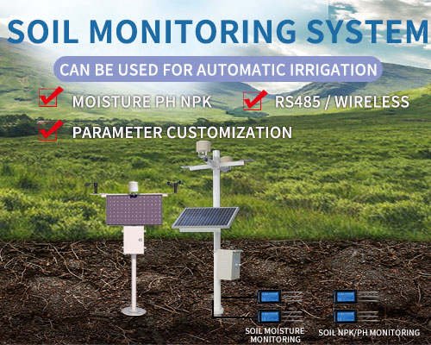
4. Using drones to assess crop health
- Ariel imaging systems for drones have been introduced by SkySqurrel Technologies to track the health of crops. This technology uses a drone to collect data from fields, which is subsequently sent by USB drive to a computer for expert analysis.
- This business analyzes the photographs it has collected using algorithms and then provides a thorough report on the state of the farm. By identifying pests and germs, farmers can utilize pest control technologies and other timely measures to take the necessary action.

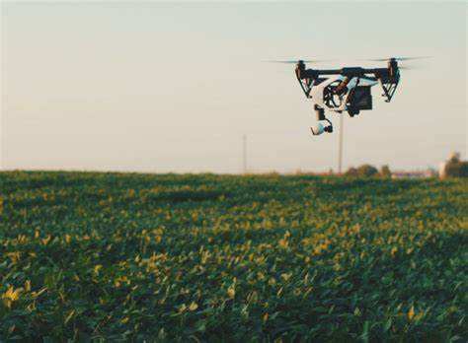

5. Accurate Agriculture:
- The use of artificial intelligence (AI) in agriculture has led to the development of tools and applications that assist farmers in conducting accurate and controlled farming by giving them the right advice regarding water management, crop rotation, timely harvesting, the type of crop to be grown, optimal planting, pest attacks, and nutrition management.
- AI-enabled technologies forecast weather conditions, analyze crop sustainability, and evaluate farms for the presence of diseases or pests and inadequate plant nutrition using data like temperature, precipitation, wind speed, and solar radiation in conjunction with images taken by satellites and drones.
- Farmers who don't have access to the internet can already benefit from AI thanks to equipment as basic as an SMS-capable phone and the Sowing App. Farmers with Wi-Fi connectivity can utilize AI apps to get a constantly AI-tailored plan for their farms, in the meantime.
6.Monitoring plant maturity
- The kind of labor-intensive task that manual observation of wheat head growth phases falls under is precisely the one that AI can assist with in precision agriculture.
- Researchers were able to construct a "two-step coarse-to-fine wheat ear detection mechanism" by gathering photos of wheat over the course of three years and in various lighting conditions at various "heading" phases.
- The farmers no longer needed to make daily trips out into the fields to inspect their crop because this computer vision model could then more precisely identify wheat growth stages than human observation.
7. Determining insect and plant diseases
- We can now automatically detect plant illnesses and pests using deep learning-based picture recognition technology.
- This functions by way of picture classification, detection, and an The ability to manually eliminate weeds not only saves the farmer a lot of labor but also lessens the need for chemicals, making the entire farming process much more sustainable and environmentally benign.Using picture segmentation techniques, models that "keep an eye" on plant health are created.
8.Identifying bugs with code
Additionally, computer vision systems for insect detection can tell you not only whether your crops are infested with pests but also how many there are.
9.Automatic weeding
- Not all artificial intelligence (AI) is involved in weeding, well, weeding. Other computer vision robots are removing undesirable plants in even more direct ways. Now, weed detection doesn't truly free up much effort for the farmer compared to computer vision's ability to detect a bug.
- The ability to manually eliminate weeds not only saves the farmer a lot of labor but also lessens the need for chemicals, making the entire farming process much more sustainable and environmentally benign.
10.Robots in the weeds
- All of this serves to present BoniRob, an agricultural robot that searches for weeds using camera and image recognition technologies before removing them by hammering a bolt into the ground.
- Through picture training on leaf size, shape, and color, it learns to distinguish between weeds and crops.

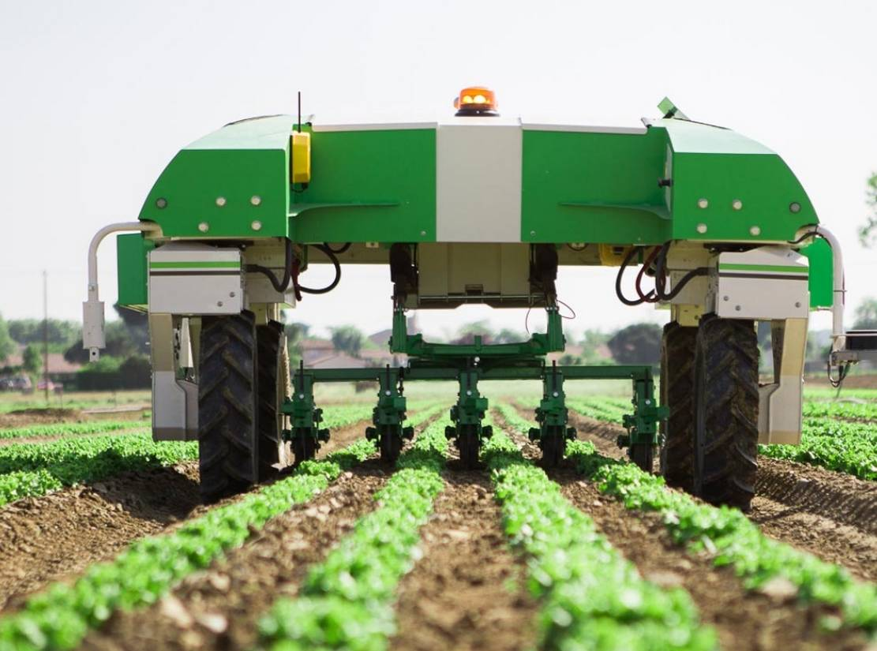
11.Produce grading and sorting
- Last but not least, AI computer vision can assist farmers even after the crops have been harvested. Imaging algorithms can be used to separate "good" produce from defective or unsightly produce, much as they can identify flaws, illness, and pests while the plants grow.
- Computer vision can automate the grading and sorting procedure with accuracy rates and speed that are far higher than even those of a qualified professional by examining the size, shape, color, and volume of fruit and vegetables.
5) AI Challenges in Agriculture
Implementing this technology may seem like an obvious move for every farmer after realizing the benefits of AI for sustainable farming. However, as we all know, there are still some significant obstacles to overcome.
1.Insufficient knowledge of emerging technologies
- For underdeveloped nations, implementing AI and cutting-edge technologies in agriculture can be difficult.
- Selling such technologies in regions where they are not currently being used in agriculture will be exceedingly challenging.
- Farmers in such places require assistance in order to use these technology.
2.Privacy and security issues
- As there are still unclear rules and guidelines for using AI, it may lead to a number of legal problems. Additionally, there can be certain privacy and security risks like cyberattacks and data leaks as a result of the use of software and the internet.
- For farm owners or farmers, all of these problems could be very problematic.

6) ADVANTAGES OF AI IN AGRICULTURE:
1.AI decreases the labor shortage:
- The agricultural sector has long struggled with a labor deficit. This problem of farming automation can be resolved by AI.
- Farmers may complete tasks without adding more staff members thanks to AI and automation. Some examples are driverless tractors, intelligent irrigation and fertilization systems, smart spraying, vertical farming software, and AI-based harvesting robots.
2.AI improves decision-making:
- The agriculture sector greatly benefits from predictive analytics. It aids farmers in overcoming the major difficulties they face in farming, including analyzing market demands, predicting prices, and determining the best window of time to plant and harvest a crop.
- Additionally, AI-powered equipment can assess the health of the soil and the crops, suggest fertilizer applications, track the weather, and assess crop quality. The farmers can make better decisions and practice effective farming thanks to all these advantages of AI in agriculture.
3. AI results in cost savings:
- Precision farming with AI-enabled machinery enables farmers to produce more crops with fewer inputs and expenses. Farmers can make informed decisions at every stage of farming thanks to the real-time insights that AI offers them.
- With this wise choice, there will be less product and chemical loss and more effective use of both time and money. Additionally, it enables the farmers to pinpoint the precise regions that require pesticide application, fertilization, and irrigation, reducing the amount of chemicals that are applied to the crop.
- All of these factors add up to less herbicide use, greater crop quality, and higher profits with fewer resources.
7) FUTURE SCOPE
Future developments in artificial intelligence are difficult to forecast. Enhancing research and development was the main purpose of artificial intelligence in the 1990s, but would that still be the case in the future? Research focuses on comparing robots or machines that resemble humans. Humans' roles will undoubtedly alter if machines start undertaking human labor. Researchers' perseverance may one day pay off, and we may find that machines do our work and that a robot walks alongside us. In the future, we will observe robots laboring in agricultural fields, producing more yields of higher quality.
CONCULSION
In order to achieve larger yields and higher quality with fewer resources, agricultural AI can not only assist farmers in automating their operations but also help them move to precise harvesting techniques. The development of unmanned aircraft and self-driving vehicles will lead to scientific advancements, more practical uses, and will assist in resolving the issues with food supply brought on by population expansion. Due to crop peak and extreme weather conditions, the agricultural sector faces a number of challenging problems, including the loss of efficient irrigation systems, weeds, and issues with plant monitoring. However, with the help of the generation resource, the performance may be increased and these issues may be resolved. Farmers had the issue that precision weeding techniques eliminated the significant number of crops lost during the weeding process. Aside from this, farmers may utilize drones to efficiently spray pesticides and herbicides on their farms, and tracking plants is no longer a hassle. For starters, the resource of man-made brain electricity in agribusiness difficulties can be used to understand shortages of assets and jobs. In traditional methods, a lot of labor was needed to purchase crop attributes including plant height, soil texture, and content. As a result, manual testing occurred, which became tiresome. With the help of the many systems explored, quick and non-destructive high-throughput phenotyping may take place with the benefit of flexible and beneficial interest and on-request gain access. to spatial objectives and data.
REFERNCES
1. Kataoka T, Murakami A, Bulanon D M, et al. Estimating Apple Fruit Locations for Manipulationby Apple Harvesting Robot[J]. Ifac Proceedings Volumes, 2000, 33(29):67-7
2.Bak T, Jakobsen H. Agricultural Robotic Platformwith Four Wheel Steering for Weed Detection[J]. biosystems engineering, 2004, 87(2):125-136.
3. Aitkenhead M J, Dalgetty I A, Mullins C E, et al. Weed and crop discrimination using imageanalysis and artificial intelligence methods[J]. Computers & Electronics in Agriculture, 2003,39(3):157-171.
4. Albattah, Waleed, Ali Javed, Marriam Nawaz, Momina Masood, and Saleh Albahli. 2022. “Artificial Intelligence-Based Drone System for Multiclass Plant Disease Detection Using an Improved Efficient Convolutional Neural Network.” Frontiers in Plant Science 13 (June). https://doi.org/10.3389/fpls.2022.808380.
5. Kumar, Parasuraman, Srinivasan Raghavendran, Karunagaran Silambarasan, Kaliaperumal Senthamarai Kannan, and Nallaperumal Krishnan. 2022. “Mobile Application Using DCDM and Cloud-Based Automatic Plant Disease Detection.” Environmental Monitoring and Assessment 195 (1). https://doi.org/10.1007/s10661-022-10561-3.
6. [1] Figueredo, A. J. and Wolf, P. S. A. (2009). Assortative pairing and life history strategy -a cross-cultural study. Human Nature, 20:317–330.
7.Tanha Talaviya, Dhara Shah, Nivedita Patel, Hiteshri Yagnik, Manan Shah, Implementation of artificial intelligence in agriculture for optimisation of irrigation and application of pesticides and herbicides,Artificial Intelligence in Agriculture,Volume 4,2020
8. Muangprathub, Jirapond & Boonnam, Nathaphon & Kajornkasirat, Siriwan & Lekbangpong, Narongsak & Wanichsombat, Apirat & Nillaor, Pichetwut. (2019). IoT and agriculture data analysis for smart farm. Computers and Electronics in Agriculture. 156. 467-474. 10.1016/j.compag.2018.12.011.
9. Gray, Leslie & Morant, Philippe. (2003). Reconciling indigenous knowledge with scientific assessment of soil fertility changes in southwestern Burkina Faso. Geoderma. 111. 425-437. 10.1016/S0016-7061(02)00275-6.
10.Vijai Singh, Namita Sharma, Shikha Singh,A review of imaging techniques for plant disease detection,Artificial Intelligence in Agriculture,Volume 4,2020.
11.Vijayanand, Chinnusamy. (2018). Artificial Intelligence (AI) in Agriculture. International Journal of Current Microbiology and Applied Sciences. 7. 2122-2128. 10.20546/ijcmas.2018.712.241
12.Das, Swarup & Ghosh, Indrajit & Banerjee, Gouravmoy & Sarkar, Uditendu. (2018). Artificial Intelligence in Agriculture: A Literature Survey.
13.“Intelligent data mining and agriculture [2]
Artificial Intelligence for Agriculture book.
14. Sharma S.K., K. R. Singh "An Expert System for diagnosis of diseases in Rice Plant." International Journal of Artificial Intelligence
15. The fourth age By Byron Reese.
16.McCarthy J, Minsky ML, Rochester N and Shannon CE 1955 A Proposal for the Dartmouth Summer Research Project on Artificial Intelligence 27 12-12
Google Scholar.

16.Banerjee G., Sarkar U., Das S. and Ghosh I. 2018 Artificial Intelligence in Agriculture: A Literature Survey[J] International Journal of Scientific Research in Computer Science Applications and Management Studies 7 1-6
Google Scholar.

17.Michael C and Fuetc 2016 Google DeepMind's AlphaGo[J] Or/ms Today
Google Scholar.

18."Hunger and Food Insecurity." Food and Agriculture Organization of the United Nations, Food and Agriculture Organization of the United Nations, 2020, www.fao.org/hunger/en/ Google Scholar

dcdc

