DESIGN AND DEVELOPMENT OF INTELLIGENT IGNITION SYSTEM FOR EVS AND IC ENGINE CARS
Abstract
The current situation demonstrates that drunk driving causes the majority of traffic accidents. Every human attempt made to curb drinking and driving on the edge is undermined by enforcement officials' limited capabilities. Therefore, a system that can detect alcohol without being constrained by time or area is needed. In this project, the MQ3 Sensor and Arduino UNO are used to create and construct an alcohol detection system with engine locking for automobiles. The technology will continuously check the alcohol detection sensor's concentration level and shut off the vehicle's engine if it rises above a certain level. The concept offers a practical way to reduce accidents caused by intoxicated driving.

1. Introduction
1.1 Background
Driving under the influence of alcohol continues to be one of the nation’s most serious problem faced by the general public. It is a known fact that under the influence of alcohol the driving skills is impaired and the risk of involvement in accidents increases exponentially.
One study estimate that eliminating alcohol would reduce traffic fatalities by 47 percent (± 4%), equivalent to a reduction of between 20,000 and 24,000 fatalities annually. There is no doubt that a reduction in alcohol-impaired driving would result in a substantial savings of human lives and resources, worldwide.
India had earned the questionable qualification of having a greater number of fatalities because of street mishaps on the society. Street wellbeing is rising as a noteworthy social worry far and wide, particularly in India. Drinking and driving is as of now a genuine general medical issue, which is probably going to rise as a standout amongst the most critical issues sooner rather than later. The primary reason behind this task is "Drunk driving detection". Since numerous mishaps are increasing due to the liquor utilization of the driver or the individual who is driving the vehicle. Subsequently Drunk driving is a noteworthy reason of mischances in all nations everywhere throughout the world. Thus, the framework diminishes the quantum of street mischances and fatalities because of drunk driving in future.
Drunk driving is the purpose for the vast majority of the deaths, Since the Drunk Driving Detection and Car Ignition Locking Using Arduino intends to change that with mechanized, straightforward, non-invasive liquor wellbeing check in vehicles. Alcohol sensor is implanted on the seat belt of the car, to such an extent that when the level of liquor crosses an admissible breaking point, where the start of vehicle will stop ignition and the motor will stop. The Arduino processor always uses the liquor sensor information to check drunk driving and works a bolt on the vehicle. In 2009 alone, more than 10,000 activity fatalities were connected directly to drivers who had more blood alcohol level as permitted. Numerous accidents occur because of the carelessness with respect to driver. Numerous drivers drink and drive which is a criminal offense. Such drivers are a danger to society and ought to be captured rapidly. Despite the fact that the nation has laws to check drunken driving yet its viable usage is still to be worked upon and at times even questionable. For such reason we are outlining a framework to decide if he/she is fit to drive or not.
This framework is fundamentally an Embedded System which is mix of both programming and equipment which can play out some particular capacities. There are developing worry about the quantity of mischance caused by a man who driving vehicles particularly during drunken. Statistic demonstrates the accident caused by drunken drivers expanded every year. As indicated by the Insurance Information Institute, 16,068 individuals were killed in 2000 in liquor related engine vehicle crashes, a 1.8 percent expansion more than 1999, and alcohol keeps on being a factor in 38 percent of all traffic fatalities. Everything has been identified with level of alcohol in the blood after they drunk. Blood Alcohol Content (BAC) is typically communicated as a level of alcohol in the blood.
High BAC of the drunken driver will influence their practices likes obviousness, passionate swings, and outrage or bitterness. There is the exploration about Blood Alcohol Concentration and with 0.2mg/l or more, (estimated in mg of 1 liquor for each 100ml of blood, or mg/l) the judgment, coordination and tangible discernment are impeded, response time moderates, execution in scholarly tests falls, and vision is debilitated. So, there is a requirement for an effective framework to check drunken drivers and this drunk driving detection using car ignition locking task can be one of the strategies to decrease this issue or more particular to keep away the drunken driver itself to driving the vehicles.
Consistently, 40 individuals which underneath the age of 25 die due to highway accidents. What's more, as per the world fitness association, car crashes caused an around 1.24 million deaths within the year 2010, somewhat down from 1.26 million in 2000. That is one individual is passed on for at regular intervals. Just 28 global areas, speaking to 449 million individuals (7% of the total population), have all around legitimate rules that adapt to each of the five threat components. The five perils components for street mischances are pace, drink–utilizing, protective caps, safety belts and type restraints. Over a third piece of road site visitors dying are in low and centre income nations are among walkers and cyclists.
However, under 35% of low and focus profit countries have directions in zone to monitor those street clients. The vital point of this gadget is to avoid the charge mischances which can be generally happened because of drunkenness of driving power.
This gadget discovers the drunkenness of driving power and spare the passengers from riding, so this attempt to give one type of security or insurance to driving power and spare remain. The principle expectation of this framework is to maintain a strategic distance from the rate of accidents which are ordinarily occurred due to drunkenness of driver. This framework identifies the drunkenness of driver and keep them from driving, so this framework will try to give one kind of security or wellbeing system to driver and spare lives.
Alcohol influences the focal sensory system of a man. Indeed, even 0.05% BAC understands judgment disabled and the capacity to control directing is influenced. In this paper we have composed a programmed alcohol detector which is coordinated with the seat belt of the cart. This work identifies with mechanical assembly to prevent a motorcar from being driven by a drunk driver. At the point when the sensor distinguishes nearness of alcohol in the breath of the driver, car is bolted automatically. "Drinking is not just damaging to drunken driver it likewise influences the encompassing zone and individuals."
Nowadays street accidents are real issue everywhere throughout the world. As report by WHO (World Health Organization) in its first Global status report (2014) 80,000 of Indian individuals are died on streets due to finished speeding, drunk driving and different reasons. Drunk driving is a central point for ascent of deaths on streets. Drink and drive not just convey street dangers to others, yet in addition influences the wellbeing of his own life. The greater part of the mischances is happening outside the urban areas because of the drunk driving. In India consistently auto collision is caused by drunk driving. Around 3 thousand deaths and more than 6 thousand are wounded in a year and it’s expanding quickly.
Other Wide zones of drunk fatalities are suicides, unmanned railroad crossing, fundamental city activity. The greater part of nowadays, we hear lot of accidents because of drunken driving. Drunken drivers won't be in stable condition thus the rash driving is the burden for other road users and furthermore question of life and death for the drunken driver and for others. The principle reason behind this project is "Drunk driving detection". Presently, numerous accidents are occurring a direct result of the liquor utilization of the driver or the individual who is driving the vehicle. In this way Drunk driving is a noteworthy reason of mishaps in all nations everywhere throughout the world.
Detector in Car is intended for the safety of the general population seating inside the car. This project ought to be fitted/introduced inside the vehicle. Alcohol sensor will be appended with Arduino. While liquor is noticed by the sensor, sensor sends the input voltage to Arduino. On the off chance that there are any hints of Alcohol over as far as possible, at that point the framework will lock the Engine in the meantime will automatically give a buzzer, we can reduce the accidents by checking the driving individuals on the roads. Drunk driving is one of the intense national and worldwide street security issue.
Even though driving under the drunken condition is illegal and punishable in relatively every nation, and still, at the end of the day numerous people/youths, break the guidelines and feel eager to drink and drive. The fundamental thought spins around the idea Why not make the vehicle sufficiently keen to check the drunk condition of the driver and take alarming and preventive activities previously any incident on street? This paper examines the plan, improvement and in-vehicle testing of the proposed drunk driver detection and modifying system. The work is finished with the intend to expand the wellbeing component of smart vehicles by installing a dependable drink and drive circumstance detection gadget in the steering wheel of the vehicle that consequently recognize alcohol content in the exhaled breath of the driver and shows the alarming drunk condition of the driver.
1.2 Literature Review
The author has proposed a method to detect alcohol but uses GPS and GSM module which increases the overall cost which could be avoided. In our project, we are using a siren which will be more cost efficient. Use of siren will alert the people nearby and hence any kind of necessary action can be taken [1].
The authors discuss about complex health monitoring systems and infrared sensor to detect the presence of alcohol. A major drawback of this system is the possibility of a false alarm. The system is designed in a manner that even a slight change in some condition can result in ringing false alarms even though everything was normal. In our project, we are using only the required technology thereby making the system more reliable and cost effective when implemented [2].
Wearing smart helmet to prevent any mishap is suggested by writer which have certain deficiencies. Firstly, restrictions on the use of helmets to only 2 wheelers. Secondly, microcontrollers are software based mega system in comparison to the economical siren that are open-source hardware [3].
Worrying about the drunken driving the Project suggests the system to overcome the issue but using mQ2 alcohol sensor has come flames .MQ2 alcohol sensor is not authentic and raises the chance of false alarm while we have used MQ3 which is highly authentic [4].
The authors discuss the problem of drunken driving and propose to solve it by suggesting a system. However, the major drawback of their system is that they are using MQ2 alcohol sensor which is not accurate and is not specifically sensitive to alcohol. In our project, we are using a MQ3 sensor which is designed to be accurate towards alcohol detection which gives more accurate results and saves from raising false alarms. Also, they have used a PIC microcontroller which is expensive when compared to Arduino Uno which is open sourced [5].
The authors have proposed a system to prevent the accidents due to drunken driving. Major drawback of this system is that they have used PIC16F877A microcontroller which is not as useful as Arduino Uno microcontroller that we are using. Also, they have used an old design system which is not useful and increases the overall cost of the system which makes it expensive and somewhat unaffordable to certain segments of society thereby limiting its scope to be used. Hence, our system is more cost effective and can be easily afforded [6].
The author has proposed a system to prevent accidents due to drunken and driving. Major drawback of this system is that it is only applicable only for Electric vehicles. Hence, our system is applicable for IC Engine vehicles [7].
Composite health monitoring and sensors based on infrared are utilized to ascertain alcohol as talked about by writer, but the chance of false alarm can't be avoided in this system, because minute change in some situations can result in false alarm but in our project use of required technology makes it more authentic. [9]
To prevent the mishap of drunken driving writer have used PIC16F877A microcontroller which is an outdated system and expensive one also which restrains its use to only certain class of society whereas we are using Arduino and Uno microcontroller which is advanced as well as economical. [10]
To cope with helmet negligence and alcohol detection simultaneous the writer proposed a system which is very complicated and use of P89V57RD2 microcontroller makes it highly expensive also this system can only be equipped with 2 wheelers whereas, Arduino uno microcontroller is economical as well as can be equipped with any class of vehicle making it more authentic and successful. [11]

1.3 Motivation
The problem of road accidents caused by drunk driving is worth investigating because the lives of people are at risk. Also, road accidents, in the long run, cause a stir in the Gross Domestic Product (GDP) of a country. Essentially, road accidents that result in the loss of lives or severe injury reduce the scarce labor force in the country hence, reducing human resources needed to carry out various activities that will lead to economic growth in the country. Therefore, developing an engineered solution to accidents caused by drunk driving will not be saving only the lives of individuals directly affected by such accidents but also looking out for the welfare of the country.
1.4 Objective
The target of this project is to give an idea and inventive method for avoiding drunken driving of a Motorcar by locking the car. Likewise, to permit man who is not alcoholic to drive a same Motorcar. To broaden this thought with more innovative headways and make it accessible in a financially effective way. We need to plan a sort of framework which can recognize the alcohol content in the cars to prevent the conduct of alcoholic driving. The sensor will be fixed close to the driver's seat. The driver should breathe to the system before the individual begins the car. On the off chance that the alcohol level identified is underneath the permissible standard, the car can be started regularly. The framework ought to be protected, delicate, exact, advantageous, and cheap. This sort of framework can be fixed on each car to guarantee the driver's driving security.
To develop an intelligent ignition system with following features
    - Stops the ignition if driver is found to be impaired by alcohol.
    - Stops the ignition if driver seat belt is not latched (in case of cars)

2. Proposed System
The Alcohol Detection with Engine Locking system helps to reduce accidents which are occurring due to drunk driving. MQ-3 sensor detects the presence of alcohol in the surroundings. The sensor provides output based on the concentration of the alcohol, if the alcohol concentration is higher the conductivity of MQ-3 sensor increases which in turn gives the reading to ARDUINO.
Using Arduino UNO microcontroller, we have designed a system that consists of an alcohol sensor i.e., MQ3 sensor will detect the alcohol by analyzing a person's breath and Heartbeat sensor which is placed in seatbelt which detects weather the driver has latched seatbelt or not, then stop the ignition of the vehicle to prevent any kind of accident that may happen due to a drunken driver taking control.
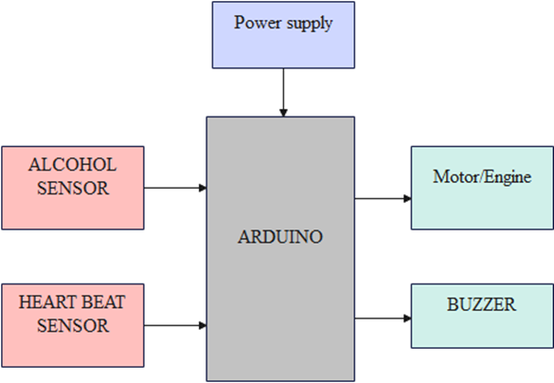

Fig. 2.1: Block diagram of proposed system
Above fig-1 represents the Block diagram of the proposed system. Where alcohol sensor detects the presence of alcohol in the driver breath. And whereas Heartbeat sensor check for the pulse of the driver. Then these sensors send signal to ARDUINO. From there ARDDUINO sends signal weather to block the engine or not.
The main aim of using heartbeat sensor is that we will be placing alcohol sensor in seatbelt. But we should get confirmation that driver has latched seatbelt or not. In market there are many methods to block engine if driver has not latched the seatbelt, but our methodology is completely different from which are already exist.
The detected analogue voltage values are read by the microcontroller; the Arduino Uno board contains 8 channels, 10-bit device that changes an analogue voltage on a pin to a digital number. The system will link input voltages from 0-5V with values from 0-1023V to generate 5Vs for every 1024 units. The system will process the analogue signal and convert it to digital value of 0 or 1. Also, the analogue values from the alcohol sensor will be scaled to percentage, and this percentage is equivalent to the analogue voltage values in ppm (part per million).
The first condition is the intoxication stage; the second condition is the slightly drunk stage, and the last stage is drunkenness stage. Each stage will be a condition to perform a task based on the level of alcohol. In the intoxication stage, the LED indicator will be activated only, the alarm will be OFF, and the car engine will be ON. In stage two, the alarm and the green LED indicator will be ON, as well as the car engine. Finally, the driver is mentally and physically inactive in stage three, so the engine will be OFF while the alarm and red LED will be ON. Therefore, once the system detects alcohol in stage three the car will be stopped, and the driver can park by the roadside.
3. Hardware Implementation
3. 1 Major Components
The hardware components of proposed system consist of following components:
- MQ3 Sensor
- Pulse sensor
- ARDUINO UNO
- Buzzer
- Diode 1N5408
- Power Supply Module
- Engine
- Solenoidal switch
- Single channel relay
3.2 MQ3 Sensor
MQ3 is one of the most commonly used sensors in the MQ sensor series. It is a Metal Oxide Semiconductor (MOS) type of sensor. Metal oxide sensors are also known as Chemiresistors, because sensing is based on the change of resistance of the sensing material when exposed to alcohol. So, by placing it in a simple voltage divider network, alcohol concentrations can be detected. MQ3 alcohol sensor works on 5V DC and draws around 800mW. It can detect Alcohol concentrations anywhere from 25 to 500 ppm.
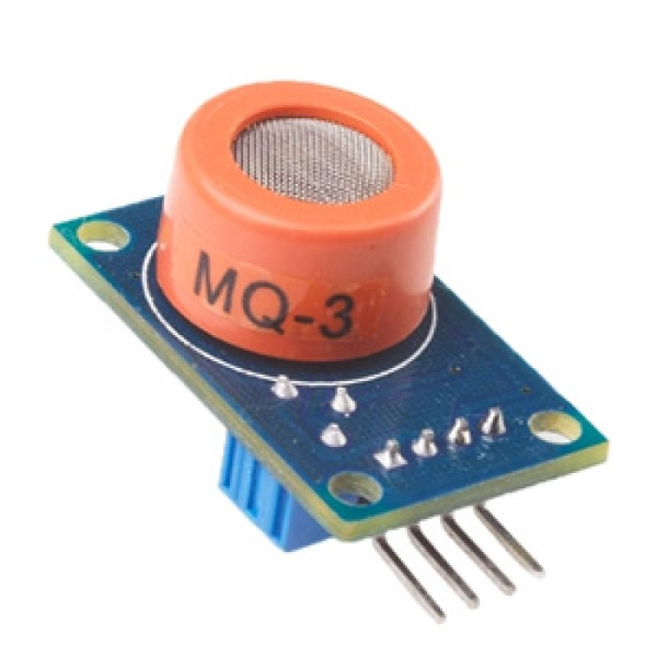

Fig. 3.1(a): MQ3 sensor
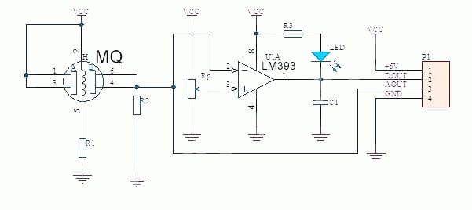

Fig.3.1(b): Circuit diagram of MQ3 Sensor
3.3 Pulse sensor
The Pulse Sensor is a type of sensor designed to measure heart rate or pulse rate from the fingertip. It is commonly used in applications such as fitness trackers, heart rate monitors, and biofeedback devices. The sensor detects the changes in blood volume in the fingertip caused by the pulsating blood flow with each heartbeat.
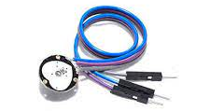
Fig. 3.2: Pulse sensor
3.4 Arduino UNO
The Arduino Uno is a type of Arduino board that is provided as an open-source board that uses an ATmega328p microcontroller in the board. The Arduino Uno contains a set of analog and digital pins that are input and output pins which are used to connect the board to other components. There are a total of fourteen I/O pins placed inboard in which six are analog input pins. The board has a USB connection that can be used to a power supply to the board. The board is used for electronics projects and used to design the circuit.
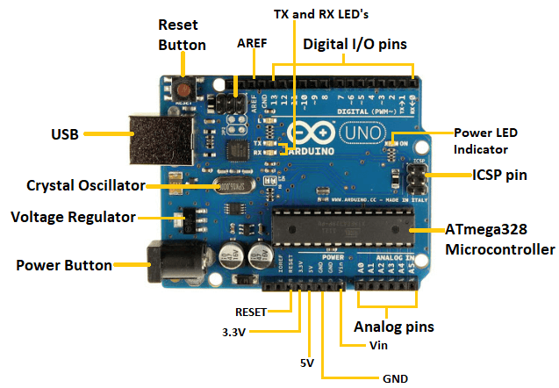
Fig. 3.3: Arduino UNO
3.5 Buzzer
An audio signalling device like a beeper or buzzer may be electromechanical or piezoelectric or mechanical type. The main function of this is to convert the signal from audio to sound. Generally, it is powered through DC voltage and used in timers, alarm devices, printers, alarms, computers, etc. Based on the various designs, it can generate different sounds like alarm, music, bell & siren. It includes two pins namely positive and negative. The positive terminal of this is represented with the ‘+’ symbol or a longer terminal. This terminal is powered through 6Volts whereas the negative terminal is represented with the ‘-‘symbol or short terminal and it is connected to the GND terminal.
3.7 Power supply module
A hardware setup requires power supply modules to provide the necessary power to the different components of the system. Different components may require different voltage levels to operate correctly. A power supply module can be used to convert the input voltage to the required output voltage levels for each component.
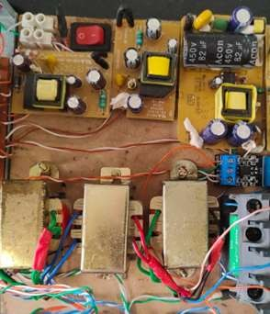
Fig. 3.6: Power supply module
3.8 Engine
An engine is some machine that converts energy from a fuel to some mechanical energy, creating motion in the process. Engines - such as the ones used to run vehicles - can run on a variety of different fuels, most notably gasoline and diesel in the case of cars.

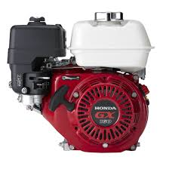
Fig. 3.7: Engine

3.9 Solenoidal Switch
A solenoidal switch, also known as a solenoid switch or solenoid relay, is an electrical component that uses a solenoid to control the operation of a switch or relay mechanism. It combines the functionality of a solenoid and a switch into a single device.
A solenoid is an electromagnetic coil that produces a magnetic field when an electric current passes through it. When the solenoid is energized, it generates a magnetic force that can actuate a mechanical mechanism, such as moving a plunger or actuating a switch.
In the case of a solenoidal switch, the solenoid is used to control the position or state of a switch or relay. When the solenoid is energized, it activates the switch or relay, allowing the flow of current or control signal through the switch contacts. When the solenoid is de-energized, it returns the switch or relay to its default position, interrupting the flow of current or control signal.
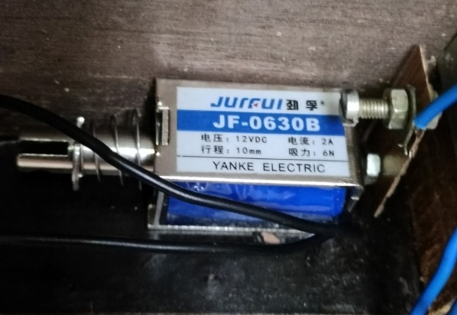
Fig. 3.8: Solenoid Switch

4. Software Description
4.1 Arduino Software (IDE)
The main software used in the Arduino software (IDE). This software is open-source and makes it easy to code and upload this code onto the microcontroller unit. Thus, this was used to program the ATMEGA 328P (MCU). Basically, the MQ-3 gas sensor which detects the presence of alcohol through the breath of the driver. The data obtained from the MQ-3 gas sensor sent to the MCU where it is processed to obtain BAC values. If the BAC value is above the set threshold, the relay connected to the car ignition remains open and thus, ignition is disabled. Here we use C programming for operation of Arduino. A summary of this operation is shown in the figure below.
The Arduino IDE (Integrated Development Environment) is a software application used for programming Arduino microcontroller boards. It provides a user-friendly interface and a set of tools for writing, compiling, and uploading code to Arduino boards.
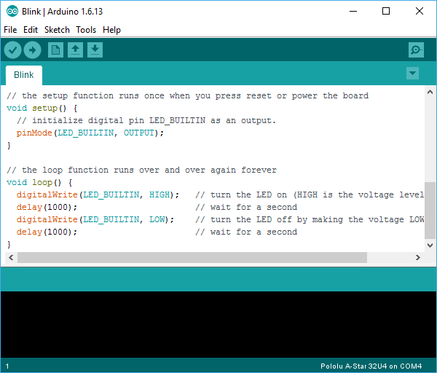
Fig. 4.1: Dumping of code into Arduino.
4.3 Flow Chart
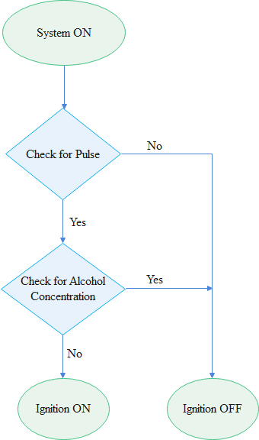
Fig. 4.2: Flow Chart

Step 1: System ON
Step 2: Check weather Driver has latched seat belt or not.
Step 3: If seat belt is worn Check for Alcohol concentration or else switch off the engine.
Step 4: If alcohol is not detected switch on the ignition.
Step 5: If alcohol is detected block the engine and give the siren.
4.4 Program
#define USE_ARDUINO_INTERRUPTS true
#include <PulseSensorPlayground.h>
const int PulseWire = 1;
const int LED13 = 13;
int Threshold = 550;
PulseSensorPlayground pulseSensor;
#define sensorDigital A0
#define buzzer 8
#define Motor 9
void setup()
{
Serial.begin(9600);
pinMode(sensorDigital, INPUT);
inMode(buzzer, OUTPUT);
pinMode(Motor, OUTPUT);
pulseSensor.analogInput(PulseWire);
pulseSensor.blinkOnPulse(LED13);
pulseSensor.setThreshold(Threshold);
if (pulseSensor.begin())
{
Serial.println("PulseSensor object created!");
}
}
void loop() {
int myBPM = pulseSensor.getBeatsPerMinute();
bool digital = digitalRead(sensorDigital);
if (pulseSensor.sawStartOfBeat())
{
Serial.print("BPM: ");
Serial.print(myBPM);
Serial.print("A: ");
Serial.println(digital);
//delay (0);
}
if ((digital==1) &&(myBPM>100))
{
digitalWrite (Motor, HIGH);
digitalWrite (buzzer, LOW);
}
else
{
digitalWrite (Motor, LOW);

digitalWrite (buzzer, HIGH);

//delay (20);
}
}
5. Results

Whenever a drunk person tries to take control of vehicle, the alcohol sensor will detect the presence of alcohol and if presence of alcohol is detected by the sensor, it will shut down the vehicle’s engine and sound an alarm thereby alerting the nearby people. So that people are aware of the situation and hence can take the necessary action that may be required. And also, with presence of smart seat belt driver will not be able turn ON the ignition if seat belt is not latched. Therefore, by using this system on a vehicle, any kind of loss of life or damage to property can be avoided.

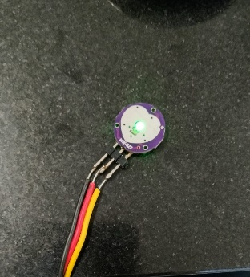
Fig.5.1. Heartbeat Sensor
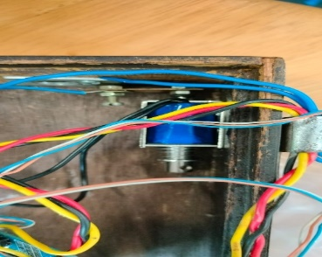
Fig.5.2. Switch condition-1
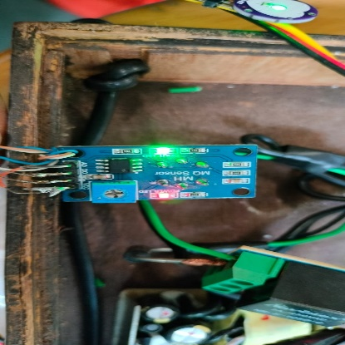
Fig. 5.3. Alcohol detection
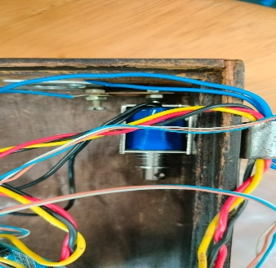
Fig. 5.4. Switch Condition-2
6. Conclusion
Alcohol detection and engine locking systems are valuable technologies aimed at preventing drunk driving and enhancing road safety. These systems typically utilize Breathalyzer to measure the alcohol content in a driver's breath or body, and if the content exceeds a predetermined threshold, the engine of the vehicle is automatically immobilized or locked, preventing the driver from operating the vehicle.
The implementation of alcohol detection and engine locking systems has shown promising results in reducing the incidence of drunk driving and related accidents. By preventing intoxicated individuals from starting their vehicles, these systems act as a deterrent and serve as an effective means of enforcing sobriety while operating a vehicle.
One of the key advantages of such systems is their ability to detect alcohol impairment in real-time, making them a proactive safety measure. This technology is particularly crucial given the serious consequences and risks associated with drunk driving, including injuries, fatalities, and property damage.
Alcohol detection and engine locking systems are powerful tools in the fight against drunk driving. They provide an added layer of protection by immobilizing vehicles when alcohol impairment is detected, thus promoting responsible and sober driving habits. However, these systems should be seen as complementary to other measures aimed at preventing impaired driving, and continuous efforts in education, enforcement, and public awareness are crucial to achieving long-term road safety goals.
REFERENCES
[1] Lea Angelica Navarro, Mark Anthony Dino, Exechiel Joson, Rommel Anacan, Roberto Dela Cruz Electronics Engineering Department, Technological Institute of the PhilippinesManila [2016, 7th International Conference on Intelligent Systems, Modelling and Simulation] - “Design of Alcohol Detection System for Car Users thru Iris Recognition Pattern”
[2] Mugila J., Muthulakshmi.M, Santhiya K, Prof.Dhivya. P [International Journal of Innovative Research in Science Engineering and Technology (IJIRTSE) ISSN: 2395-5619, Volume – 2, Issue – 7. July 2016] - “Smart helmet system using alcohol detection for vehicle protection”.
[3] Dhivya M and Kathiravan S, Dept. of ECE, Kalaignar Karunanidhi Institute of Technology [Smart Computing Review, vol. 5, no. 1, February 2015] - “Driver Authentication and Accident-Avoidance System for Vehicles”
[4] Nimmy James, Aparna C, Tenna P John, International Journal of Research in Computer and Communication Technology, Vol 3, Issue 1, January- 2014 – “Alcohol Detection System”
[5] Prashanth K P1, Kishen Padiyar2, Naveen Kumar P H3, K Santhosh Kumar, Dept. of Mechanical Engineering, East West Institute of Technology, Bangalore, India [International Journal of Engineering Research & Technology (IJERT) ISSN: 2278-0181, IJERTV3IS100754, Vol. 3 Issue 10, October- 2014] - “Road Accident Avoiding System using Drunken Sensing Technique”
[6] Ms. Subia Sayeed, Department of Electronics and communication, VVIET, Mysore, India [International Journal of Scientific & Engineering Research Volume 2, Issue 12, December-2011 1, ISSN 2229-5518] - “Drunken drive protection system”
[7] Vignesh M, Kavin T P, A. F. G. G. C. R. K. S. (2020). Accident Detection and Alerting System Using GPS & GSM. International Journal of Advanced Science and Technology, 29(3), 3598 - 3601. Retrieved from http://sersc.org/journals /index.php /IJAST/article/view/5037.
[8] Dhivya M and Kathiravan S, Dept. of ECE, Kalaignar Karunanidhi Institute of Technology- Driver Authentication and Accident-Avoidance System for Vehicles [Smart Computing Review, vol. 5, no. 1, February 2015].
[9] Mugila. G, Muthulakshmi.M, Santhiya.K, prof.Dhivya.p- smart helmet system using alcohol detection for vehicle protection[International Journal of Innovative Research in Science Engineering and Technology (IJIRTSE) ISSN: 2395-5619, Volume 2, Issue 7. July 2016].
[10] A. ISuge, H. Takigawa, H. Osuga, H. Soma, K. Morisaki, Accident Vehicle Automatic Detection System By Image Processing Technology, Â©IEEE 1994 Vehicle Navigation & ISC.
[11] Paul Baskett, Yi Shang, Michael V. Patterson, Timothy Trull , Towards A System for Body-Area Sensing and Detection of Alcohol Craving and Mood Dvsregulation , Â© 2013 IEEE.
[12] Nookala Venu, Karthik Kumar Vaigandla, Dr.A. ArunKumar, “Investigations of Internet of Things (IoT): Technologies, Challenges and Applications in healthcare”, International Journal of Research (IJR), ISSN: 2236-6124, Volume XI, Issue II, Feb 2022, PP: 143-153
[13] Babor, AUDIT: The alcohol use disorders identification Test: Guidelines for use in primary health care. 1992, Geneva, Switzerland: World Health Organization.
[14] L. A. Navarro, M. A. Dino, E. Jason, R. Anacan and R. D. Cruz, "Design of Alcohol Detection System for Car Users thru Iris Recognition Pattern Using Wavelet Transform," 2016 7th International Conference on Intelligent Systems, Modelling and Simulation (ISMS), Bangkok, 2016, pp. 15-19.
[15] Cahalan, D, I. Cisin, and Crossley, American Drinking Practices: A National Study of Driving Behaviour and Attitudes. 1969, Rutgers University Press: New Brunswick, NJ
[16] Dhivya M and Kathiravan S, Dept. of ECE, Kalaignar Karunanidhi Institute of Technology- Driver Authentication and Accident-Avoidance System for Vehicles [Smart Computing Review, vol. 5, no. 1, February 2015].
[17] Paul Baskett, Yi Shang, Michael V. Patterson, Timothy Trull, Towards A System for Body-Area Sensing and Detection of Alcohol Craving and Mood Dysregulation, © 2013 IEEE.

