CHRONIC KIDNEY DISEASE

Ms. Udhayamalini. C,
Lecturer, Department of Renal Dialysis Technology,
School of Allied Health Sciences, Vinayaka Missions Research Foundation-Du,
AV Campus, Paiyanoor.
bindhumalini7@gmail.com

ABSTRACT

Chronic kidney disease (CKD) is a condition characterized by gradual loss of kidney function over time. The major role of the kidney is excretion of water-soluble waste products. Meanwhile, the kidneys respond continually to changes in blood volume as well as osmolality, and adjust the level of water, electrolyte, and acid-base balance by selectively excreting or reabsorbing them. In addition, the kidneys are main site of production for several hormones, mainly renin and erythropoietin there are millions of adults who have CKD and others who have diabetes,hypertension,and family history of renal failure are at high risk. The best estimate of kidney function is glomerular filtration rate with protein urea is staging of CKD.Patient with ESRD (End stage of renal failure) may develop complications like cardiovascular disease, anemia and mineral bone disorder and nervous system disease. People with kidney failure require dialysis or renal transplantation. There are 1.4 million patients receiving renal replacement therapy worldwide. In this chapter, we will overview the definition,epidemiology,outcomes of CKD.The detailed diagnosis and treatment will be discussed in the following topics.
Key points: chronic kidney disease, ESRD, Diabetes, Hypertension.

1.INTRODUCTION

Chronic kidney disease (CKD) is kidney impairment that lasts for > months, implying that it is irreversible. The most common causes are Hypertension and diabetes; however, they are multitude of other etiologies. In the early to moderate stages, CKD is usually asymptomatic, and it can be primarily diagnosed by laboratory abnormalities. Regardless of the etiology, Progression of renal impairment is common and can ultimately lead to end-stage renal disease and need for renal replacement therapy (e.g., Dialysis or Renal transplantation).

1.1 DEFINITION
Chronic kidney disease (CKD) is irreversible loss of renal function it is characterized by progressive and irreversible detonation of renal function due to slow distraction of renal parenchyma eventually terminating to death. When enough nephrons have been damaged with consequent development of azotemia in clinical uremia.

1.2 EPIDEMIOLOGY
The prevalence of CKD is around 10% to 14% in the general population. The true incidence and prevalence of CKD are difficult to determine because of the asymptomatic nature of early to moderate CKD. kidney disease is the 10th leading causes of death in the United States.
The largest increase occurred in people with stage 3 CKD
Mortality: Approximately 66% after five years on dialysis
Sex: Increase risk of disease progression in male
Highest rate in people of African descent
Hispanics have increase rates as compared with non-Hispanics

2.CLASSIFICATIONS

Based on the classifications the kidney function is measured by estimating the glomerular filtration rate (GFR), The presence of albuminuria as a marker of kidney damage.

2.1 CLASSIFICATION OF CKD BY GFR

STAGE | DESCRIPTION | GFR (ml /min /1.73m2)
1 | Kidney damage with normal or GFR | >90 (ml /min)
2 | Kidney damage with mild GFR | 60-89(ml /min)
3A | Mild to moderate GFR | 45-59(ml /min)
3B | Moderate GFR | 30-44(ml /min)
4 | Severe GFR | 15-29(ml /min)
5 | Kidney failure | <15 or dialysis

2.2 CLASSIFICATION OF CKD BY ALBUMINURIA
Category | Albumin excretion(mg/24h) | Albumin: Creatinine ratio (A:CR) (mg/mmol)
A1 | <30 | <3
A2 | 30-300 | 3-30
A3 | >300 | >30

2.3 ETIOLOGY
The causes of CKD vary globally, and the most common primary disease-causing CKD and ultimately end-stage renal disease (ESRD) are as follow:
Diabetes and high blood pressure, that is hypertension, are responsible for chronic kidney disease cases.
(A)Diabetes: Diabetes occurs when your blood sugar remains too high. Over time, unmanaged blood sugar can cause damage to many organs in your body, including the kidneys and heart and blood vessels, nerves and eyes.
There are two main types of diabetes, and both can harm the kidney:
- In type 1, the immune system kills the ells in the pancreas that make insulin
- In type 2, the pancreas does not make enough insulin, or the body can't use what it does make
Most of the people are affected by type 2 diabetes.

(B)High blood pressure: High blood pressure occurs when your blood pressure against the walls of your blood vessels increases. If it is uncontrolled, it can be a leading cause of heart attacks,stroke,and chronic kidney disease.also,chronic kidney disease can cause high blood pressure. From 2005 to 2009 ,27.8% of those on dialysis had kidney failure due to high blood pressure. High blood pressure can harm the blood vessels that leads to the kidney and the tiny glomeruli.
When the causes of blood pressure are unknown whether it is primary or essential hypertension. This can be treated with diet, salt limit, exercise and medications.
Secondary hypertension is high blood pressure that is caused by another health problem or a response to a drug. During surgery or after surgery can fix some problem, like a birth defect in the aorta (large artery leaving the heart) or narrowing of renal artery that brings blood to the kidneys.

(C)Glomerular Disease:
Glomerulonephritis is a group of disaese,that cause inflammation and damage the kidneys filtering units. These are the third most common type of kidney disease.
Glomerulosclerosis is scarring of the kidney filtering part of the kidneys (glomerulus)it allows protein to leak in the urine.
(D)Inherited disease: polycystic kidney disease pr PKD, is a common inherited disease that causes large cysts to form in the kidneys and damage the surrounding tissue. If PHD affects the brain, It can causes aneurysms (bulging blood vessels that can burst). from 2005 to 2009,3.2% of those whose kidneys failed had cystic disorder.
(E)Autoimmune disease: When the body’s defense system, the immune system, turns against the body, it’s called an autoimmune disease. Lupus nephritis is an autoimmune disease that results in inflammation (swelling or scarring) of the small blood vessels that filter waste in the kidney.
3. SIGNS & SYMPTOMS:
- Nausea
- Vomiting
- Loss of appetite
- Fatigue and weakness
- Sleep problem
- Urinating more or less
- Decreased mental sharpness
- Muscle cramps
- Swelling of feet and ankle
- Dry, itchy skin
- High blood pressure (Hypertension)that’s difficult to control
- Shortness of breath, if fluid builds up in the lungs
- Chest pain, if fluid buildup around the lining of the heart
People with kidney disease may also develop anemia, bone disease and malnutrition

4. RISK FACTOR
- Oldre age
- Abnormal kidney structure
- Family history of kidney disease
- Obesity
- Smoking
- Heart and blood vessel (cardiovascular)disease
- High blood pressure
- Diabetes
- Acute kidney injury
- Nephrotoxins like NSAIDs
- Kidney stones
- Infectious like Hep C and HIV

5.DIAGNOSIS
The initial diagnosis of CKD is by finding a decreased GFR, Hematuria, Proteinuria
or abnormal imaging.

5.1 General workup
- History and physical examination
- Serum labs:
- Creatinine to obtain the estimated GFR
- Screen for diabetes
5.2 Other findings common in CKD:
- Anemia (present in 90% of patients with a GFR <30ml/min
- Metabolic Acidosis
- Hyperkalemia
- Secondary Hyperparathyroidism

5.3 Urine analysis
Urine analysis with microscope, finding of CKD include:

- Hematuria
- Proteinuria
- Spot urine protein to creatinine ratio

- Renal ultrasonography
- Renal biopsy

6. COMPLICATION OF CHRONIC KIDNEY DISEASE

- Hyperkalemia
- Cardiovascular disease
- Osteoporosis
- Anemia
- Damage cardiovascular system
- Decrease immune system
- Pregnancy complication that carries risk for the mother and the developing fetus
- Irreversible damage to your kidney (End stage kidney disease)

7. PHARMOCOLOGICAL TREATMENT

- Anti-Hypertensive and cardiovascular agents.
- Anti-seizure agents
- Erythropoietin
- Anti-diuretics
- Antacids (Hyperphosphatemia and hypercalcemia are treated with aluminum-based antacids that binds dietary phosphorus in the GI tract.

8. MANAGEMENT OF CKD

Renal replacement therapy (RRT): Dialysis
Dialysis is a process that purifies blood and excretes nitrogenous waste products like urea,creatinine,uric acid through artificial kidney.
There are two types of dialysis,
- Hemodialysis
- Peritoneal dialysis
- Renal transplantation
8.1 HEMODIALYSIS is a treatment to filter waste and water from your blood, through a man-made membrane called a dialyzer, or artificial kidney, hemodialysis help to control blood pressure and balance important minerals, such as potassium, sodium, and calcium, in your blood.

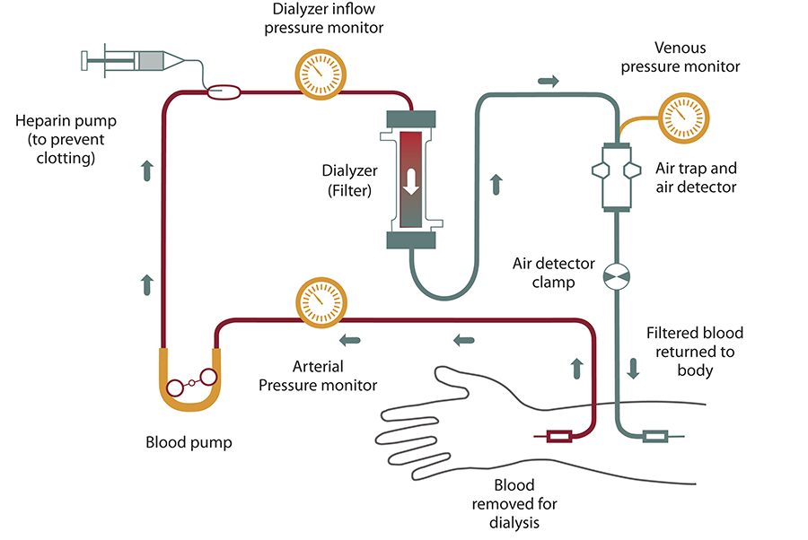

8.2 PERITONEAL DIALYSIS
- Peritoneal dialysis (PD) is a type of dialysis that uses the Peritoneum in a person's abdomen as the membrane through which fluid and dissolved substance are exchanged with the blood.
- It is used to remove excess fluid, correct electrolyte problems, and remove toxins in those with kidney failure.
- Other benefits include greater flexibility and better tolerability in those with significant heart disease
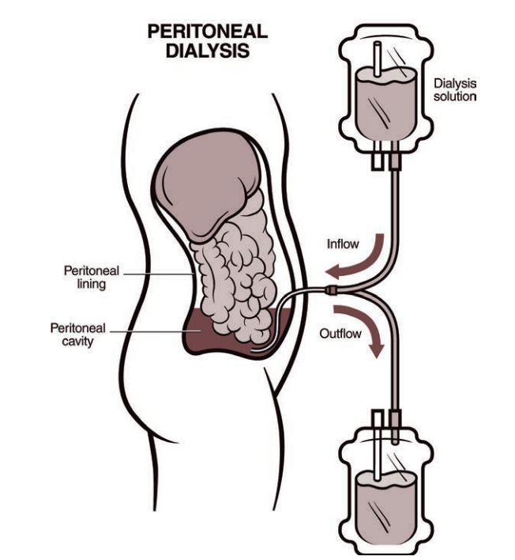

8.3 RENAL REPLACEMENT THERAPHY
Kidney transplant or renal transplantation is the organ transplantation of a kidney into a patient who has end-Stage renal disease.

9. CONCLUTION

CKD is extremely common and has emerged as one of the leading noncommunicable causes of death worldwide. It is projected to affect an increasing number of individuals over time and to further rise in importance among the various globally causes of death. CKD affects populations in different regions of the world unequally, likely as a result of differences in population demographic characteristics, their comorbidities, and access to health care resources common nature and devastating effects of CKD should prompt major effects to develop and implement effective preventative and therapeutic efforts aimed at lowering the development of CKD and slowing its progression.

REFERENCE

- Core curriculum-for dialysis technician (a comprehensive review of Hemodialysis)
- Handbook of dialysis fifth edition Edited by John T Daugiridas, MD, FACP, FASN
- Handbook of dialysis therapy fifth edition
- Handbook of dialysis technology by R. Kasi Visweswaran
- Basics of kidney, renal disease, fluid, Electrolyte and Acid-Base Balance
- https://www.slideshare.net/AbhayRajpoot3/chronicdney-disease-ckd-230799668
- http://www.nhs.uk/Conditions/kidney-disease/
- Oxford handbook of clinical medicine-10th edition
- http://www.ncbi.nlm.nih.gov/pmc/article/PMC4089662
- https://www.ncbi.nlm.nic.gov/pmc/articles/PMc9073222
- https://www.slideshare.nett/JyotiGavers/ckd-ppt
- https://www.ncbi.nlm.nih/gov/books/NBK535404
- Lectoria app

