ANTIBACTERIAL EFFECT OF TANNASE PRODUCING BACTERIA - ISOLATED FROM GOAT FAECAL SAMPLE

B. Aruna, Assistant Professor,
Department of Microbiology, St. Francis College for Women,
Begumpet, Hyderabad-500016, Telangana State, India
kaviliaruna@sfc.ac.in

Aarthi Kunwar Rathore, Post Graduate Student
Department of Microbiology, St. Francis College for Women,
Begumpet, Hyderabad-500016, Telangana State, India

aarthi.rathore855@gmail.com

ABSTRACT
The faecal samples of goat were used for isolation of tannase producing bacteria. The tannase producing isolates (T1 and T2) were identified as Corynebacterium xerosis and Corynebacterium kutser. The tannase activity of the isolates, were found to be 15.2 U/mL and 16.5 U/mL at 37ᴼC; 16.2 U/mL and 16.1 U/mL at pH 8 by using tannin as a carbon source. The tannase activity was maximum at 37 ̊ C and pH 8. Tannase activity of the isolates was further confirmed by detection of gallic acid using chromatographic method and showed antimicrobial activity. Tannins are found in industrial effluents that are toxic to the plant. Tannase producing bacteria that degrade tannins, reduce the toxic effect of tannins towards plants in contaminated environments and help in plant growth.

Keywords: Tannase; Tannase activity; Corynebacterium; Gallic acid; Antimicrobial activity

I. INTRODUCTION
Tannase, also known as tannin acyl hydrolase, is a microbial enzyme that can be induced under specific conditions. Its primary function is to catalyze the hydrolysis of ester and depside bonds found in various substrates such as gallo-tannin, epigallocatechin-3-gallate, as well as gallic acid esters and other hydrolysable compounds, tannins to release gallic acid and glucose. Tannase is produced by variety of microorganisms such as fungi, bacteria, and yeast. Tannins are known for their antimicrobial property and are resistant against microbes to protect plant bodies. They are toxic and release bacteriostatic compounds making non-reversible action with proteins (1). Despite their antimicrobial activity, tannins can also act as a source of nutrients or substrate for certain microbes. These microorganisms utilize tannins by employing a hydrolytic enzyme called Tannase. With a composition of glucose and gallic acid in a 1:9 ratio, tannic acid forms a heteropolymer known for its diverse commercial uses. When evaluating the production capacity of the tannase enzyme, environmental conditions play a significant role in influencing its performance. Tannin, on the other hand, serves as a crucial factor impacting tannase activity and efficiencyIndustrial bioconversion of tannic acid is achieved with Tannase (2). Gallic acid has significance in food and pharmaceutical industry (3). It can be used as a precursor in production of antioxidant such as, propyl gallate. It is an important intermediary compound in the synthesis of the anti-bacterial drug, trimethoprim, used in pharmaceutical industry. In recent years, researchers have discovered a connection between tannase-producing bacteria and colon cancer, suggesting the potential of bacterial tannase as a biomarker for this disease (4, 5). Additionally, tannase enzymes have proven to be valuable hydrolyzing agents, aiding in the removal of highly polluting tannins from the effluent generated by the leather industry. The widespread industrial applications of tannase in fields such as food, beverage, pharmaceuticals, and bioremediation have elevated its status as one of the most significant enzymes in current research. Tannase enzyme also used in the prevention of phenol-induced turbidity in wine (6).
Tannase can be extracted from different sources like; microbes, plants, and animals. In plants, tannase is extracted from leaves, branch, and bark and in animals tannase is extracted from bovine stine and ruminal mucous. But, the most important source to obtain this enzyme is by microbial way, because the produced enzymes are more stable than similar ones obtain from other sources (4.). The sources of tannins are very varied. Numerous trees and shrubs are known to contain tannins. Notable for either their present or past economic and industrial importance are black wattle or black mimosa bark (Acacia mearnsii), quebracho wood (Schinopsis balansae or lorentzii), oak bark (Quercus spp.), chestnut wood (Castanea sativa) etc., and the bark of several species of pines and firs. Tannase producers primarily come from two main groups: fungi and bacteria.
Bacteria: Over the past 25 years, researchers have successfully isolated numerous bacterial strains exhibiting tannase activity. Several of these strains have shown promising potential for various applications in industries such as food, pharmaceuticals, and biotechnology. Several species were identified among which organisms from the genus Bacillus, Lactobacillus, Staphylococcus, Serratia, Pseudomonas and some of the genera falling in the Enterobacteriaceae family are predominant (7, 8).
Fungi: the first tannase protein was extracted and identified from the fungi strain now known as Aspergillus niger. Apart from this several fungal tannase have also been indentified from the genus Aspergillus, Penicillium, Trichoderma, Fusarium, Paecilomyces and Rhizopus (7).

II. MECHANISM OF TANNASE ACTION

Tannase can hydrolyze gallotannins, complex tannins, and gallic acid esters, but it does not have an impact on carbon-carbon bonds. As a result, tannase is unable to hydrolyze condensed tannins (9, 10, 7, 11). The Figure below illustrates the bonds that are hydrolyzed by tannase.
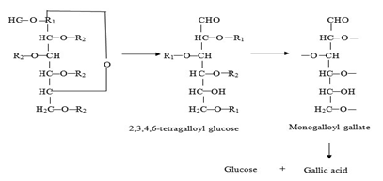

Figure 1: Hydrolysis pathway of tannic acid by tannase
(Source: https://www.biotech-asia.org/vol5no1/tannase-enzyme-the-most-promising-biocatalyst-for-food-processing-industries/)

Tannase derived from various sources exhibits distinct molecular masses. For instance, in the case of fungi and yeasts, they are glycoproteins and frequently assemble into hetero- or homo-oligomers comprising two to eight subunits. Bacterial tannases exist in the form of monomers, rather than forming complex structures. (11). The dual activities of tannase cause this enzyme to have a wider range of substrate specificity. This specificity depends on the source and the methods utilized for its production and isolation (10, 11). Apart from its bi-functional nature, tannase also exhibits existence as isoenzymes. Tannase displays hydrolytic activity towards various substrates, including methyl gallate, propyl gallate, digallic acid, epicatechin gallate, and epigallocatechin gallate, releasing gallic acid (12). Additionally, tannase acts on ellagitannins like rosacyanin or phyllanemblinin, selectively hydrolyzing the galloyl moieties and yielding gallic acid and degalloylated ellagitannins (13).
Tannases belong to the family of serine esterases, characterized by a catalytic triad with a serine residue present in the conserved pentapeptide motif (-Gly-X-Ser-X-Gly-), which is essential for their catalytic activity (10, 11). The enzyme's mechanism of action was extensively described by Ren et al. (2013) for the Lactobacillus plantarum tannase.
After the substrate binds to the enzyme, the hydroxyl group of Ser163 starts a nucleophilic attack on the carbonyl unit of the galloyl unit. Assistance in this attack is provided by His451, serving as a general base. His451-H serves as a general acid, facilitating the collapse of the tetrahedral intermediate, leading to the formation of both the alcohol product and the acyl-enzyme intermediate. Subsequently, His451 activates a water molecule, which then attacks the acyl-enzyme, resulting in the formation of the second tetrahedral intermediate. This intermediate then collapses, releasing gallic acid and restoring the enzyme to its original state.

III. APPLICATION OF TANNINS IN VARIOUS INDUSTRY

Tannins, naturally occurring polyphenolic compounds, find applications in various industries due to their diverse properties:

A. In the food and beverage industry, tannins play a significant role in winemaking, contributing to the color, flavor, and mouthfeel of wines. They are also utilized in brewing, imparting astringency and stabilizing proteins. Moreover, tannins serve as natural food additives due to their antioxidant properties and act as preservatives in food products.

B. Tannins have a long history of application in the leather industry, where they have been used for centuries in the tanning process to convert animal hides into leather. By binding to collagen fibers, tannins enhance the leather's durability, flexibility, and resistance to decay.

C. In the pharmaceutical industry, tannins are highly valued for their antimicrobial, anti-inflammatory, and antioxidant properties. These properties make them valuable components in the development of pharmaceutical products. Tannins have been used in traditional medicine for various purposes, including wound healing, diarrhea treatment, and managing different ailments.

D. In the textile industry, tannins find application as natural dyes or mordants to enhance the colorfastness of textiles. They offer a wide range of rich and vibrant colors, making them suitable for use with both natural and synthetic fibers.

E. Tannins prove highly effective in water treatment processes, particularly for the removal of organic contaminants and heavy metals. As natural coagulants and flocculants, they play a crucial role in purifying water, serving industries such as municipal water treatment and wastewater management.

F. Within the wood and paper industry, tannins serve various purposes. They are essential components in wood adhesives, contributing to improved bonding properties. Additionally, tannins find application in the paper manufacturing process as natural dispersants and fillers, enhancing the quality and strength of paper products.

G. The cosmetics and personal care industry utilizes tannins for their astringent properties. In skincare products, they effectively tighten pores, regulate excess oil, and provide a toning effect on the skin, making them valuable additions to cosmetic formulations.

H. Tannins and their derivatives demonstrate remarkable antibacterial properties, effectively targeting a wide range of bacterial species, including Aeromanas, Bacillus, Clostridium, Enterobacter, Helicobacter, Klebsiella, Proteus, Pseudomonas, Shigella, Escherichia, Staphylococcus, Streptococcus, as well as fungal species like Aspergillus, Coniophora, and Penicillium. Particularly, the antibacterial activity of polymeric proanthocyanidins has proven highly effective against Escherichia coli and Staphylococcus aureus. The ability of tannins to bind with urinary tract epithelium and intestinal epithelium prevents the attachment of disease-causing organisms, contributing to their antibacterial action.
Based on these findings, tannic acid is employed as an inhibitor and immunomodulatory agent against multidrug-resistant bacteria (MDR). Notably, the antibacterial properties of tannins have been explored not only in animals but also in plants. A recent study involved the use of a crude methanol extract from Sapium baccatum to combat Ralstonia solanacearum, the causal agent of bacterial wilt in tomatoes. This extract mainly contains gallic acid, methyl gallate, corilagin, tercatain, chebulagic acid, chebulinic acid, and quercetin 3-O-α-L-arabinopyranoside, all of which exhibit robust antibacterial activity, with the exception of one tannin-based product, quercetin 3-O-α-L-arabinopyranoside. In in vivo studies, concentrations of 2000 and 1000 μg/mL of the crude extract reduced the development of tomato bacterial wilt by 83% and 63%, respectively. These findings highlight the significant potential of tannins and their derivatives as potent antibacterial agents, applicable in both animal and plant systems.

IV. MATERIAL AND METHODS

Faecal samples were collected from goat farm. Faecal sample was serially diluted, plated on Tannic acid agar medium (TAA) and incubated at 37º C for 96 hours. The tannic acid in the medium forms tannin-protein complex. Bacteria that produce tannase have the ability to break down this complex, resulting in the formation of a distinctive zone around their colonies. After incubation TAA plates were flooded with Gram’s iodine instead of FeCl₃ (14). Upon applying Gram's iodine, a dark brown complex is formed with tannic acid, but not with hydrolyzed tannic acid, which leads to the appearance of a clear, well-defined zone around the colonies of tannase-producing microbes. Colonies that displayed a distinct zone of tannic acid hydrolysis were identified and selected as tannase producers. The colony showing highest zone was selected for further studies.
Carbohydrates with free aldehyde or ketone groups have the ability to reduce solutions of various metallic ions. Under alkaline conditions, reducing sugars undergo tautomerization, transforming into enediols. Enediols are powerful reducing agents. In the presence of cupric ions, they act as reducing agents, converting cupric ions into the cuprous form while undergoing their own transformation into sugar acids. Upon interaction with OH- ions, cuprous ions form yellow cuprous hydroxide, which, when subjected to heating, undergoes conversion into red cuprous oxide.

A. Identification of tannase producing bacteria
To identify tannase-producing bacteria, the isolated microorganism was cultured again on nutrient agar medium.. Observations were made regarding colony characteristics, including size, shape, texture, consistency, and transparency. Further, a Gram staining procedure was conducted on the isolate. Various biochemical tests, such as the Indole test, Methyl red test, Voges-Proskauer test, Triple sugar iron (TSI) agar test, and Carbohydrate utilization test, were performed to analyze the characteristics of the isolate.

B. Tannase production
The isolate that exhibited the largest zone in Tannic Acid agar plates was selected for further analysis. It was inoculated into a 50 ml tannic acid broth within a 250 ml Erlenmeyer flask and then incubated at 37oC for 24 hours. After incubation, the culture was filtered, and the resulting filtrate was utilized as the crude enzyme for the tannase assay.

C. Estimation of Tannase by Folin lowry method
The concentration of Tannase was estimated by Folin lowry method (1951), using Bovine serum albumin (BSA) as Standard (15) with a concentration of 0.1 mg/ ml.

D. Thin Layer Chromatography - Analysis of Gallic Acid
Tannase is an enzyme that facilitates the hydrolysis of tannic acid, leading to the release of glucose and gallic acid. For this study, the active culture of isolates was inoculated into Nutrient broth containing Tannic acid and incubated for 24 –
48 hours. Following incubation, the culture was subjected to centrifugation, and the resulting supernatant was employed for the detection of gallic acid using thin layer chromatography (TLC).
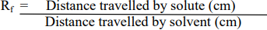
To analyze the degradation product, gallic acid, liberated by the action of tannase from the bacterial isolate, a solvent system consisting of ethyl acetate: chloroform: acetic acid in a ratio of 50:50:1 was utilized. The results were visualized by employing iodine crystal vapor. From the chromatogram, the retention factor (Rf) value was calculated using the following equation.

E. Detection of Glucose by DNS Method
The concentration of glucose was estimated by DNS (3, 5-Dinitrosalicylic acid), using glucose as Standard with a concentration of 1 mg/ ml.

F. Effect of Temperature and pH on Tannase activity and determination of glucose production by DNS method
Tannase activity was determined by estimating glucose liberated using 3,5-dinitrosalicylic method. To 1 ml of supernatant (crude enzyme), 1 ml (0.1M) acetate buffer (pH 7.0), 1ml (0.5%) tannic acid as substrate was added and incubated for 15 min at 5°C, 27°C, 37°C, 48°C respectively. DNS of 0.5 ml was added to all the test tubes, the contents were incubated for 10 min in a boiling water bath and cooled to room temperature, 0.5 ml of distilled water was added to all the tubes, contents were mixed and absorbance was recorded at 540 nm.
Tannase activity was determined by estimating the reduced glucose liberated using 3,5- dinitrosalicylic method. To 1 ml of supernatant (crude enzyme), 1ml (0.5%) tannic acid as substrate and 1 ml (0.1M) acetate buffer adjusted pH to 4.0, 5.0, 6.0 and 8.0 added respectively, 1 ml of 0.5% tannic acid was introduced as the substrate and incubated at 37°C for 15 min. To all the test tubes, DNS of 0.5 ml was added, the contents were mixed, incubated for 10 min in a boiling water bath and cooled to room temperature, 0.5 ml distilled water was added to all the tubes, contents were mixed and absorbance was recorded at 540 nm.
The activity was calculated using following formula:
Enzyme Activity = (Amount of Product formed) / (Time) / (Volume of enzyme solution)

G. Antibacterial activity of tannase
The agar well diffusion method was used to observe the antimicrobial activity. The microbial inoculum (indicator organism) was spread evenly over the entire surface of the agar plate. Then, a hole with a diameter of 6 to 8 mm was punched aseptically with a sterile cork borer and a volume (20 µl) of the supernatant (antimicrobial agent) was added into the well. The agar plates were incubated at 37°C for 24 hr. The antimicrobial agent diffuses in the agar medium and inhibits the growth of the bacteria.
V. RESULTS AND DISCUSSION

A. Isolation and Screening of Tannase Producing Bacteria
Six morphologically different bacterial colonies were obtained from the faecal samples which showed tannic acid hydrolysis on TAA (Tannic acid agar medium) plates. Out of six isolates T1 and T2 exhibited maximum zone (25 mm) of tannic acid hydrolysis, were selected for further studies. Bacillus subtilis showed clear zone of clearance around the isolates after 72 hr (8). The tannase producing bacteria were isolated from tannin rich sources (16), their study was in correspondence with the present data.
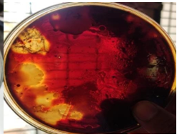

Figure 2: Tannic acid hydrolysis by T1 & T2 bacterial isolate detected by addition of iodine

B. Cultural, Morphological and Biochemical Characteristics of Isolate
Cultural, morphological and biochemical characteristics of Bacterial isolate T1 & T2 were studied and the results are represented in Figure 3, Figure 4 and Table 1. The colony of T1 was large in size, irregular, wavy, opaque and cream in colour with moist consistency. The T1 and T2 isolates were gram positive and non-motile. T1 isolate showed M-R test positive, fermentation test for glucose, maltose and lactose was positive (Table 3); positive for triple sugar iron test; positive for citrate test. The T2 isolate colony was medium in size, round, smooth, opaque and cream in colour with moist consistency. T2 showed M-R test positive, fermentation test for glucose, lactose was positive and maltose negative. The T2 isolate was negative for citrate test. Both the isolates (T1 and T2) were positive for indole test and negative for Voges Prauskauer test (Table 2, Figure 5). The cultural characteristics, biochemical reactions and Carbohydrate utilization tests of the isolates were compared with Bergey’s Manual of Systematic Bacteriology and was found to be Corynebacterium xerosis (T1 isolate) and Corynebacterium kutseri (T2 isolate). The tannase enzyme producing bacteria isolated from tea waste dump soil site and maximum tannase activity produced by Corynebacterium striatum III B 8914, and was positive for MR test, fermentation of sugars like glucose, maltose and lactose were analysed and triple sugar iron test was found to be positive (17) and the results were in accordance with the present data.

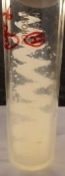
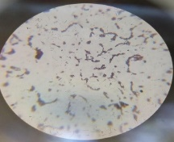

Figure 3: T1 Isolate - Growth on nutrient agar slant and
Microscopic view – Gram positive short rods
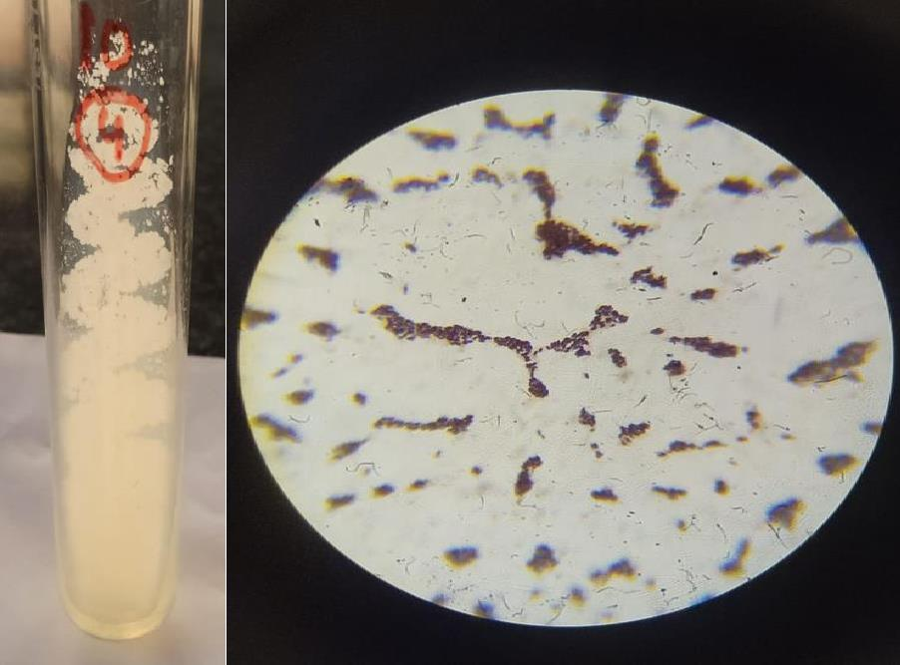

Figure 4: T2 Isolate - Growth on nutrient agar slant and

Microscopic view – Gram positive short rods

Table 1: Colony morphology and Gram nature studies of isolates

Isolate | Colony  characters | Morphological characters
 |  | Gram nature, Shape of the cell | Endospore | Acid fast | Motility | Identification
T1 | Large, Irregular, Opaque, Moist Cream colour | Positive, short rods | - | - | - | Corynebacterium xerosis
T2 | Medium in size, Round, Smooth, Opaque, Cream colour, Moist consistency | Positive, short rods | - | - | - | Corynebacterium kutseri

Table 2: Biochemical tests
Biochemical Test | T1 Isolate | T2 Isolate
Indole | - | +
Methyl red | + | +
Voges Proskauer | - | -
Citrate | + | -
Catalase | + | +
Oxidase | - | -
Starch | - | +
H₂S | - | -
Urease | - | +

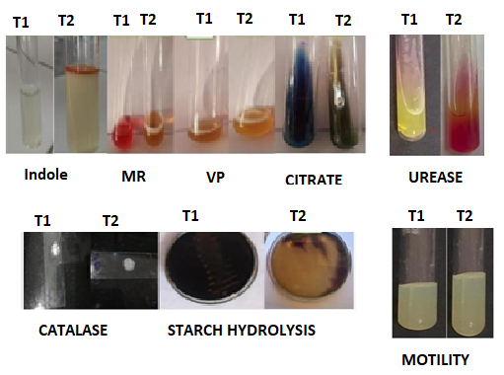

Figure 5: Biochemical tests

Table 3: Carbohydrate fermentation tests

Isolate | Glucose |  | Lactose |  | Mannitol
 | Acid | Gas | Acid | Gas | Acid | Gas
T1 | Positive | Positive | Negative | Negative | Positive | Positive
T2 | Positive | Negative | Positive | Positive | Positive | Positive

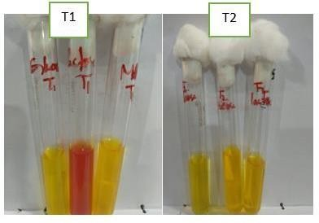

Figure 4.5: Carbohydrate fermentation tests

C. Estimation of tannase by Folin Lowry method
The maximum tannase production was observed in T2 isolate, 0.61mg/ml compared to T1 isolate, 0.49 mg/ml (Figure 6). The study result was in accordance with purification method of tannin acyl hydrolase and maximum tannase production (0.61mg/ml) was by Bacillus subtilus (18).

Figure 6: Estimation of tannase by Folin Lowry method

D. Thin Layer Chromatography – For the detection of Gallic Acid
Thin layer chromatography (TLC) was used to detect, the presence of gallic acid as a product of tannin hydrolysis. Pure gallic acid was used as standard, and was compared with the test (T1 and T2 isolates) to detect the presence of gallic acid. The Rf value of pure Gallic acid was 2.5, T1 isolate was 2.2 and T2 isolate was 2.4 (Figure 7). The Rf value of isolates was nearer to the pure Gallic acid. The study showed that the isolates were producing Tannase, hydrolyzed tannic acid to Gallic acid. The Rf value of standard gallic acid was 1.0 and the Rf value of test sample was 0.90, which is nearer to the Rf value of standard gallic acid, the tannic acid was hydrolysed by the tannase enzyme produced by Bacillus megaterium (19), this investigation was in correspondence with the present data.

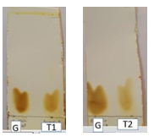

Figure 7: Thin layer chromatography of gallic acid by isolate T1 and T2
G: Gallic acid

E. Detection of glucose by DNS method
The concentration of glucose produced by hydrolysis of tannic acid was estimated by DNS method and it was observed as 0.32 mg/ml by T1 isolate and 0.31mg/ml by T2 isolate (Figure 8). The tannase assay was studied by spectrophometrically and concentration of glucose produced by hydrolysis of tannase was estimated as 0.35mg/ml (20), which was correspondence to the present data.

Figure 8: Detection of glucose by DNS method

F. Effect of Temperature and pH on Tannase activity and determination of glucose production by DNS method
The T2 isolate showed maximum tannase activity, 16.5 U/mL at 37ᴼC (Figure 9). The maximum tannase activity by Pseudomonas aeruginosaIII B 8914 was observed at an incubation temperature of 37 °C (21). The maximum tannase activity was observed at 30°C by Citrobacter freundii (22). The maximum tannase activity was observed at pH 8 (Figure 10) with both the isolates T1 (16.2 U/mL) and T2 (16.1 U/mL). An optimum pH of 7 for Pseudomonas aeruginosa III B 8914 (21), while an optimum pH of 6 for Bacillus cereus KBR9 reported maximum tannase activity (21, 23). For Bacillus lichiniformis KBR6, the tannnase activity was maximum at optimum pH 7.5 (23).

Figure 9: Effect of Temperature on Tannase

Figure 9: Effect of Temperature on Tannase activity

Figure 10: Effect of pH on Tannase activity

G. Antibacterial activity of Tannase
The Staphylococcus aureus showed maximum sensitivity, E. coli showed least sensitivity, Pseudomonas sp and Proteus sp were resistant to tannase of T2 isolate. Theindicator organisms were resistant to tannase of T1 isolate The Staphylococcus aureus and Bacillus sp showed maximum sensitivity to tannase produced by Citrobacter sp isolated from water and soil samples (24).

Zone of inhibition (mm)
Indicator organism | T1 | T2
E.coli | - | 0.2
Pseudomonas sp | - | -
Staphylococcus aureus | - | 0.6
Bacillus sp | - | 0.5
Klebsiella sp | - | 0.4
Proteus sp | - | -

Figure 10: Antibacterial activity of Tannase

VI. CONCLUSION

Faecal sample was used to isolate the bacteria having natural ability to degrade hydrolysable tannins by producing tannase. Six bacterial strains were isolated from goat faecal sample. Among them isolate T1 and isolate T2 was selected which could hydrolysis tannin. The isolate was identified by morphological and biochemical characteristics and was found to be Corynebacterium xerosis and Corynebacterium kutseri. Temperature played a major role in tannase production. The T2 isolate showed maximum tannase activity (16.5 U/mL) at 37ºC for 15 mins of incubation period. The T2 and T1, both showed maximum tannase activity (16.2 U/mL and 16.1 U/mL) at pH 8 for 15 min of incubation period.

REFERENCES
[1] Bhat, T. K., Singh, B. and Sharma, O. P. (1998). Microbial degradation of tannins-A current perspective. Biodegradation. 25: 343-357.
[2] Mondal, K. C., Banerjee, D., Jana, M. and Pati, B. R. (2001). Colorimetric assay method for determination of tannin acyl hydrolase (E.C. 3.1.1.20)
activity. Anal Biochem 295: 168-171.
[3] Pourrat H, Regerat F, Morvan P, Pourrat A. (1987). Microbiological production of gallic acid from Rhus coriaria L. Biotechnol. Lett. 9: 731-734.
[4] Lekha, P.K., Lonsane, B. K. (1997). Production and application of tannin acyl hydrolase: state of the art. Adv. Appl. Microbiol. 44: 215-260.
[5] Das Mohapatra, P.K., Mondal, K. C. Pati, B. R., Halder, S. K., Maity, C. and Jana, A. 2012). Rapid screening of tannase producing microbes by
using natural tannin. Braz. J. Microbiol. 43(3):1080-1083
[6] Koichi, Y. and Tokuji, T. (1972). Wine making using Tannase in fermentation process, Japanese patent 2224100.
[7] Belur, P. D., Gopal, M., Nirmala, K. R and Basavaraj, N. (2010). Production of novel cell-associated tannase from newly isolated Serratia ficaria
DTC. Journal of Microbiology and Biotechnology. 20(4): 732-736.
[8] Jana, A., Maity, C., Halder, S.K., Mondal, K.C., Pati, B.R.and Mohapatra, P.K.D. (2013). “Enhanced tannase production by Bacillus subtilis PAB2
with concomitant antioxidant production”. Biocatalysis Agricultural Biotechnology, 2: 363-371.
[9] Haslam, E. and Stangroom, J. E. (1966). The esterase and depsidase activities of tannase. Journal of Biochem. 99: 28-31.
[10] Rodriguez-Dur´an, L. V., Valdivia-Urdiales, B., Contreras-Esquivel, J. C., Rodriguez- Herrera, R. and Aguilar, C.N. (2011). Novel
Strategies for Upstream and Downstream Processing of Tannin Acyl Hydrolase. Enzyme Research. 823619.
[11] Ren, B., Wu, M., Wang, Q., Peng, X., Wen, H., McKinstry, W.J. and Chen, Q. (2013). Crystal structure of Tannase from Lactobacillus
plantarum. Journal of Molecular Biology. 425: 2737-2751.
[12] Curiel, J. A., Rodriguez, H., Acebrion, I., Mancheno, J. M., de Blanca Rivas, L. and Munoz, R. (2009). Production and physicochemical
properties of recombinant Lactobacillus plantarum tannase. Journal of Agricultural and Food Chemistry. 57 (14): 6224-6230
[13] Lu, M. J. and Chen, C. (2007). Enzymatic tannase treatment of green tea increases in vitro inhibitory activity against N-nitrosation of
dimethylamine. Process Biochemistry. 42: 91285–1290.
[14] Rakesh Kumar., Ashwani Kumar., Ravinder Nagpal., Jitender Sharma and Anju Kumari. (2010). A novel and sensitive plate assay for screening
of tannase-producing bacteria. Annals of Microbiology. 60: 177-179.
[15] Lowry, O. H., Rosebrough, N. J., Farr, A. L., Randall, R. J. (1951). Protein measurement with the Folin phenol reagent. J Biol Chem.193(1): 265-
75.
[16] Hamada A. Abou-Bakr., Malak A. El-Sahn and Amr A. El-BannaInt. (2013). International Journal of Agricultural and Food Research. 2 (3): 1-
12.
[17] Dave, A., Modi., H.A., Chavada, N. (2011). Study and isolation of tannase enzyme production bacteria from tea waste dump soil site. Int. J. Pharm.
Appl. Sci. 2(1): 20-22.
[18] Iibuchi, S., Monida, Y. and Yamada, K. (1967). Studies on tannin acylhydrolase of micro-organisms Part III. Purification of enzyme and some
properties of it. Agr. Biol. Chem. 32: 803-809.
[19] Archana D. Tripathi, Kajal Sharma and Lakshmi B. (2016). Study on Tannase Producing Bacillus megaterium Isolated fromTannery Effluent. Int.
J. Adv. Res. Biol. Sci. 3(7): 28-35.
[20] Sharma, S., Bhat, T.K. and Dawra, R.K. (2000). A Spectrophotometric Method for Assay of Tannase using Rhodonine. Analytical Biochemistry.
278: 8589.
[21] Selwal, M.K., Yadav, A., Selwal, K.K., Aggarwal, N.K., Gupta, R. and Gautam, S.K. 2010. Optimization of culture conditions for tannase
production by Pseudomonas aeruginosa III B 8914 under submerged fermentation. Wolrld J. Micrbiol. Biotechnol. 26: 599-605.
[22] Kumar, R. A., Gunasekaran, O. and Lakshmanan, M. (1999). Biodegradation of tannic acid by Citrobacter freundii isolated from tannery
effluent. Journal of Basic Microbiology. 39:161-168
[23] Mondal, K.C., Banerjee, D., Banerjee, R and Pati, B.R. (2001). Production and characterization of tannase from Bacillus cereus KBR9. The
Journal of general and applied microbiology.47: 263-267.
[24] Wilson, P.A., Rojan, P.J., Kumar, P. and Sabu, T. (2009). Tannin Acyl Hydrolase Production by Citrobacter species isolatedfrom Tannin rich
Environment, using Tamarindus indica seed, powder. Journal of Applied Sciences and Environmental Management.13: 95-97.

