Braking Framework Investigate Utilizing All-Electric Braking Framework

Dr. Hredeya Mishra¹ Dr. Pradnya Prakash More²

Lecturer in MED Lecturer in MED

MVPS’s RSM Polytechnic Nashik MVPS’s RSM Polytechnic Nashik

1002mishrahk@gmail.com pradnya.more@rsmpoly.org

Abstract— The brake system is a combination of pneumatic and electric brake. This system is the main cause of train noise and friction of disc brake shoes during braking. causes environmental pollution. Therefore, this article presents a method of using the all-electric brake system as a standstill brake system to remove dust and other impurities.
Keywords— - braking system; all-electric braking system
- INTRODUCTION
Electric trains have become an important means of public transportation in recent years. With the improvement of passenger comfort and the development of electronic equipment, the performance, behavior and operation of the vehicle should also be improved. The braking system controls a combination of pneumatic and electric brakes. This system is the main cause of train noise and friction of disc brake shoes during braking. It causes environmental pollution.
Therefore, this article presents a method to use the all-electric braking system as a standstill brake braking system to remove dust and other contaminants.

- ELECTRIC BRAKE Framework
The starting and stopping of the electric train is controlled by the drive controller of the inverter. The electric brake operates at a speed of about 5 km/h. The air brake operates at a speed of about 5 km/h. The system uses an encoder to sense the motor, which acts as a vector controller. Precise vector control is not possible due to the characteristic power of about 60 to 100 pulses per revolution of the encoder system.
For this reason, a hybrid electric and pneumatic braking system is used. This system is the main cause of train noise and friction of the disk brake shoes during braking. It causes environmental pollution. When the train speed drops below 5 km/h, the compressor makes noise, it is not easy to maintain, and the pneumatic brake runs the risk of aging.
The all-electric brake is mainly used for electric braking to reduce the risk of air brake. The effects of using the completely electric brake frames are as follows:
1. Reduce brake shoe wear by minimizing the use of the air brake
2. Reduce brake noise caused by mechanical wear and cleanliness
3. Save money on brake maintenance
4. Maximize the use of energy for the development of regenerative braking.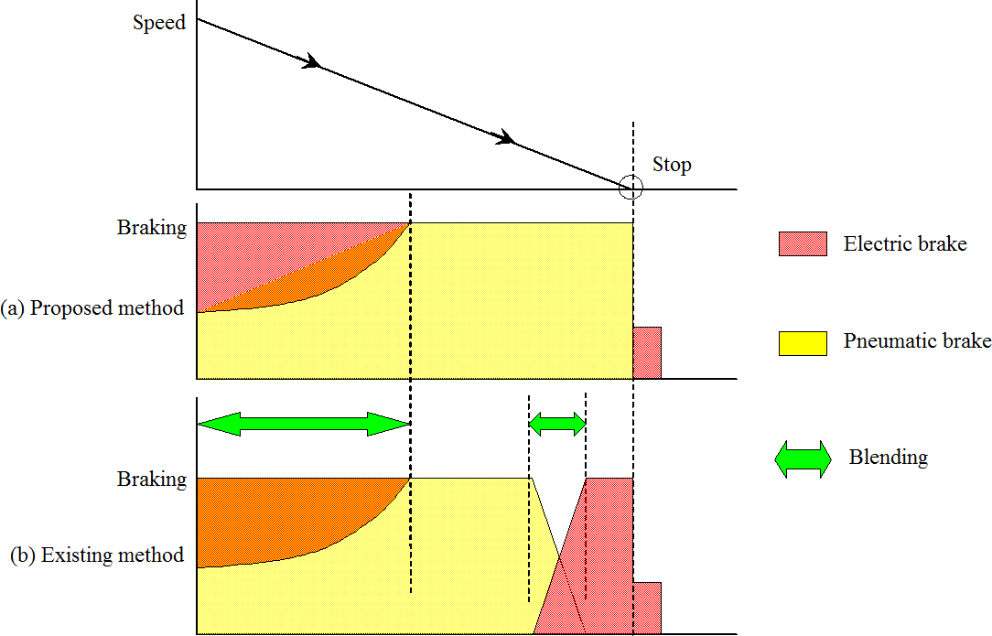
Figure 1. Electric brake framework
- COMPOSITION OF FULLY ELECTRIC BRAKE SYSTEM

The braking system consists of the inverter, PWM control unit, vector control unit, drive control unit and speed control unit. The inverter controls the speed of the motor by switching the voltage from DC to the voltage of AC via a current collector.
The PWM control unit controls the inverter's door swing. The PWM controller changes the input circuits of the foot motor in voltage and frequency. The vector control unit receives the speed and current signals from the motor.
The vector control unit decides the inverter voltage and frequency. The drive control unit executes the drive command for acceleration, recuperation and braking..
The brake controller controls the holding brake. The speed detection unit detects the rotor speed for motor control. The inverter for motor control does the work from starting to stopping and the holding brake when the preparation stops.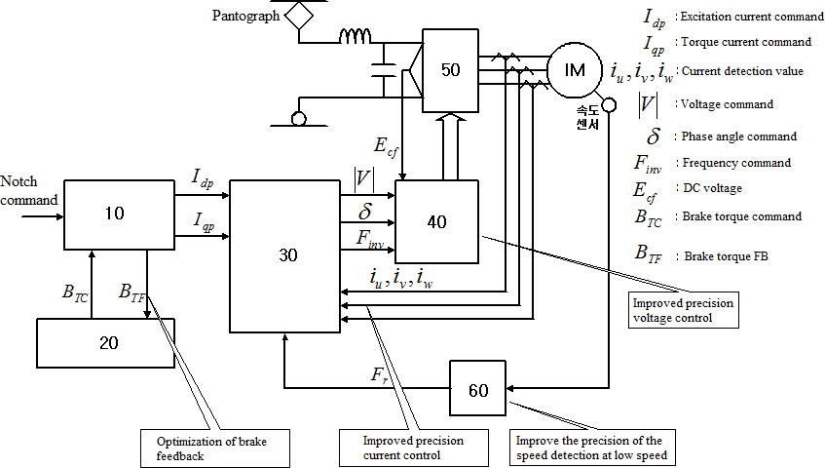
Figure 2. Vector control configuration
The vector control unit gets the motor current detection value and speed to criticize the foot control and speed from the foot motor. And it changes the yield of stroke width balance control unit.
The vector control unit performs critical control of current and repetition as vector control to answer the reference value of drive control unit.
In this consideration, the resolver is used to drive the speed determination and accurate control in the low speed range.
Figure 3 shows the brake control at low speed during deceleration. When the stop flag is detected, the torque current command (Iqp) is executed to apply the braking power.
When the speed of the preparation enters the low-speed range (5 km /h or less), the electric braking force is reduced and the torque current set point is steadily lowered. When the vehicle comes to a stop, the pneumatic brake is applied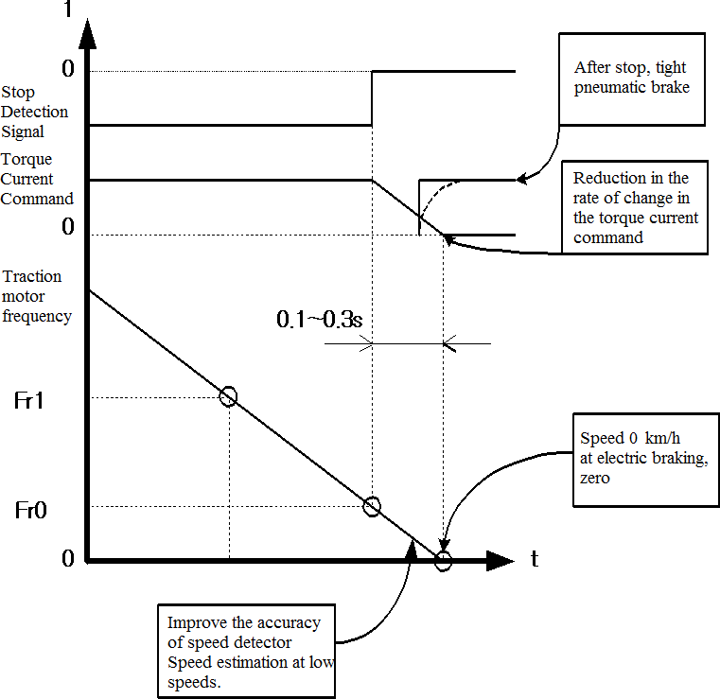
Figure 3. Brake control at moo speed amid deceleration
- TEST

There are the following conditions to stop the motor.
4.1 Avoid revolution after stopping.
1. Operation of the pneumatic brake when the braking torque is 0
2. The braking torque is generated within the gradient. Braking with pneumatic brake forces to prepare the work of stopping.
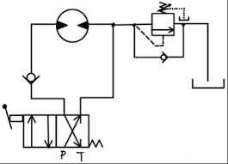
Figure4: Braking Sequence
The electric motor is the drive for propulsion and regenerative braking. Figure 5 shows that the starting speed of the characteristic drive is 360 [rpm] and the torque is 0 at 800 [rpm]. The braking torque is proportional to the stopping speed.
In Figures 5 and 6, the torque setting is a step change. Slow driving was observed during stopping
The braking system is a combination of pneumatic and electric brakes.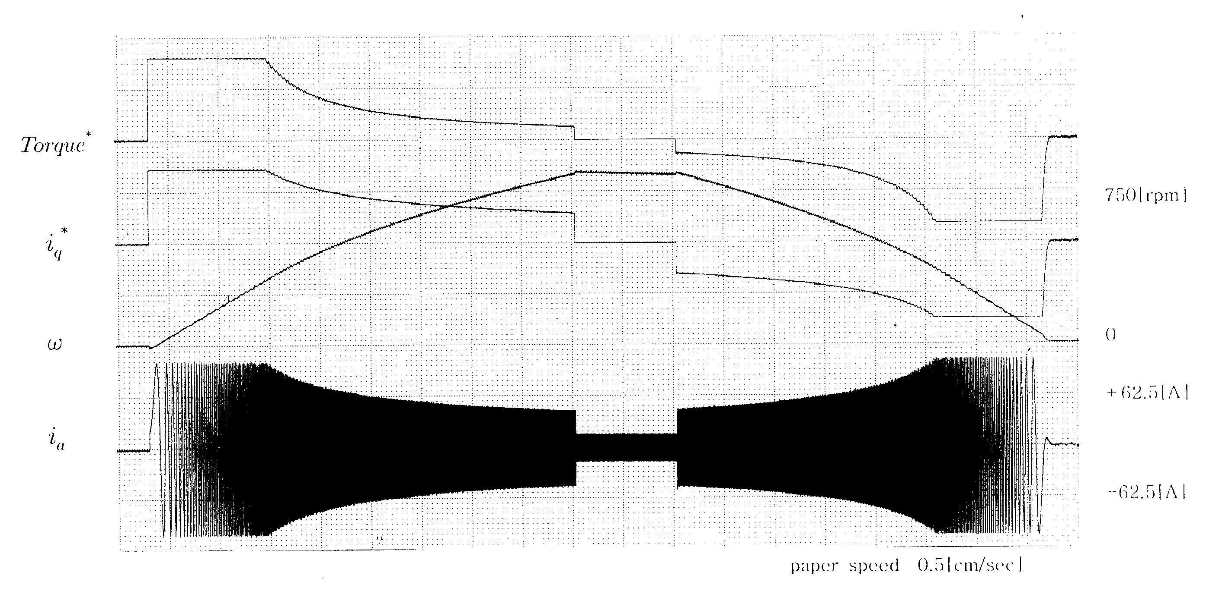
Figure 5. Drive tests on Inertial load
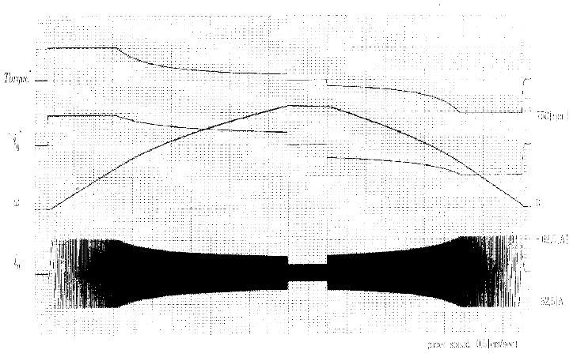
Figure 6. Drive tests on Inertial load (Torque Variable)

- CONCLUSION

The braking framework oversees a combination of pneumatic braking and electric braking. Section The fundamental cause of prepare commotion and plate brake shoe contact when braking is the framework. causes natural contamination. In this manner, this article presents a strategy for utilizing the all-electric braking framework as a zero-speed braking framework to evacuate tidy and other contaminants. The benefits of utilizing an all-electric machine are:
1.Reduce the utilize of pneumatic brakes and diminish shoes.
2. Can diminish commotion and clean from machine use
3. Spare on brake cost
4. Utilize the most noteworthy quality to connect extra adaptability

REFERENCES

- Hanmin lee, Gildong Kim, Changmu Lee, Euijin Joung, “A study on Braking Control for Pure electric Brake of Electric Train”, The Korean Institute of Electrical Engineers conference, 2012
- Hanmin lee, Gildong Kim, “A Study on Electric Braking System to 0km/h”, The Korean Society for Railway conference,pp.178, 2007
- Sone, Ashiya, "Pure electrical brake of the railway electric vehicles",Railway cybernetics, vol.34,No.513, pp.194~197, 1997
- Ogasa, Nagai, Watanabe, "Plant-test Result of All Electrical Braking (Report 1)", National convention Record I.E.E.Japan, 1260,pp.5- 389~390, 1998
- Ogasa, Nagai, Watanabe, Toda, "Plant-test of Electrical Breaking to Zero Speed for Railway Vehicle", National Convention Record I.E.E.Japan-Industry Application Society-, No.77,pp.257~262, 1998
- Sato, Iida, Hisatomi, "Pure electric braking system test using stsrt", National Convention Record I.E.E.Japan-Industry Application Society-, No.78,pp.253~2666, 1998

