Design and Validation of Noise Modelling for Underwater Acoustic in Broadband Communication using Software Reference Models

Manjunatha K N
Asscociate Professor
Department of Mechatronics Engineering
Acharya Institute of Technology,
Bengaluru, India.
Chandrashekhar L
Assistant Professor
Department of Mechatronics Engineering
Acharya Institute of Technology,
Bengaluru, India.

ABSTRACT
The paper focuses on development and validation of communication system for underwater acoustic with comparison to the existing designs. The prime objective is to select the suitable methods to analyze the performance of the channel targeted for the application. Using simulation platform, evaluate the various noise model and deploy the suitable one after the experimentation. The research has focused on Simulation of noise and loss models, Modulation detection techniques, channel estimation algorithms and Signal to noise Ratio (SNR). The practical part of the work consists of the implementation of the selected techniques, and the following set of experiments: software simulations and comparison. The underwater system has been developed in MATLAB, due to the advantages of this application, in order to debug the program, tune the chosen parameters, and analyze results.

Keywords: Transceivers, MATLAB, Signal to Noise Ratio, wireless channel, Digital communication

- INTRODUCTION
Advances in wireless communication has made an impact on our today’s life, but the underwater communication still might have many challenges and gives space for many researchers on various domains like noise identification and modelling. From past many years research on underwater information communication is very active and consistently improving on its new innovation. Collecting an information of underwater from remote locations and its analysis is still has many challenges.
It is extremely difficult to attain high data rate communication link underwater due to various constraints [1] such as poor propagation of electromagnetic signals underwater, high attenuation of acoustic signals, lack of accurate mathematical models of the channel in underwater acoustic etc. Also, some of the wired underwater communication links would be prone to attacks by aquatic animals. Also, these wired links have problems related to dispersion and low data rate due to extreme pressure underwater. A typical under water communication system is represented in Fig. 1.
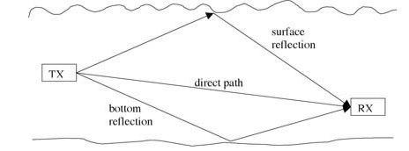

Fig.1. Basic underwater communication system
The above said factors will influence the research on underwater acoustic wireless communication [2]. With an advances in sensor and vehicular technology, wireless communication will empower the new range of applications in monitor and control of various domains like ocean search and rescue, marine archaeology and oceanography, emergency Communications from a ship - Wired Media, mobile communication from a submarine, AUV with other stations that include ships, land based stations and other submarines – wireless acoustic media and many more.
The primary research goal of this project is to investigate various algorithms for underwater communication systems and hence enhance the performance. Since, low data rate is the major bottleneck in successfully implementing an underwater communication system. The project aims to address the data rate issue by investigating numerous novel algorithms customized for underwater systems. This would be done by studying and optimizing the modulation schemes and the communication parameters for an underwater channel. The underwater channel model would be adopted from published literature and used for simulations. Then for this channel various studies would be performed to explore for better performance.
- BACKGROUND METHODS
The Under-water Acoustic (UWA) communication has gained an importance in the recent days as their area of operation is spread over from military to the commercial operations. UWA channels will significantly differ from conventional wireless channels compared to other media like radio channels, here signal degradation will happen due to high temporal and spatial visibility and multipath propagation of channel circumstances [3]. The Underwater communication is depending on the methods of non-coherent modulation. To improve the high data speed of UWA band limited channels, modulation techniques like bandwidth efficient are considered. Higher data throughput is consistently increased with the use of phase coherent modulation in current and next generation of underwater communication systems.
In the recent underwater acoustic system will function on the network with mobile and stationary nodes. The present research focuses on development of efficient coding and modulation techniques, optimized algorithms for signal process, interference based multiuser communications [4] [5].
Propagation of acoustic signal is characterized on three parameters, which are low speed of sound, multipath propagation and the frequency of the signal being attenuated. When the channel has impulse response, each path behaves as low pass filter with time variation and adds additional shifting and Doppler spreading. Signal propagation is highly supported at minimum frequencies so, acoustic communications are broadly used inherently in wide band. The parameters affect the method of signal processing [6], the way in which single and multi-carrier systems are used. In the acoustic signals transmission power and bandwidth mainly depends on high channel latency, distance, protocols and implications of network architectures.
Underwater communication is complex system rather compared to terrestrial wireless communication system. During under water communication, researcher main focus is on underwater interferences, modulation techniques, instrumentation, error coding inter symbol interferences, SNR, BER, attenuation, transmission distance, power consumption and channel model. Because of the water dynamic nature, research in underwater interference has become very challenge task.
- CARRIER SIGNAL CHARACTERISATION
Most commonly used carrier wave in underwater acoustic wireless communication[4] [7] are categorized in three types
- Electromagnetic wave: Higher bandwidth and frequency can be used to establish through the electromagnetic wave-based communication. But this mode of communication finds limitation due to absorption that has direct impact on the signal transmission. For electromagnetic wave-based communication requires large antenna this in turn makes design complex and expensive.
ii. Optical wave: High speed communication can be established through optical wave, but the signal badly effected for scattering due to stronger absorption in water medium. The overall communication efficiency will suffer by poor data transmission accuracy.
iii. Acoustic wave: Acoustic wave-based communication is widely preferred for underwater communication application as carrier due to its low absorption capabilities. The minimum absorption offers the acoustic wave to travel for the longer distance though the data transmission speed is slower compared to other carrier signals [8].
Acoustic wave faces the more challenges and are comparatively different. Here, water is the medium and it is the main source of interference of signal. The sound transmission is impacted by various factors of water like type of water, depth pressure, impurities, temperature and water composition. Underwater communication also experiences some common terrestrial distraction [9] like reflection, scattering and refraction.
For effective communication, the communication system design plays a vital role. Factors such as transducer [10] parameters (sensitivity, power consumption, noise immunity, transduction mechanism, directivity, resolution and properly matched impedance) must be taken into account during the design process. One of the important areas that worth focusing on is the receiver (sensor) design. Nowadays, with the advancement in electronic technology, the transducer design (especially receiver) can adopt MEMS technology to overcome several sensor issues that proves to have several advantages compared to the conventional approach. It is found to have many advantages compared to the conventional design.
- METHODOLOGY
Characterization of underwater channel with a well-known mathematical model, to be borrowed from published literature. To survey the various novel communication schemes in Digital Communication such as wireless, to study MSE and BER performance: MIMO, OFDM, hybrid solutions would be explored and various modulation techniques like BPSK, QPSK are studied from various journals dedicated to digital communication, the motive behind this is that the underwater acoustic communication channel would be fundamentally a digital communication system, novel ideas in a conventional digital system might be helpful for performance enhancement of underwater communication.
Mathematical models for the same would be built using academic software. Also, the results published in the literature and simulated results would be compared. The primary difference between a conventional wireless channel and a underwater channel is the impulse response of the channel is quite different in both the cases.
Attempt to implement the same schemes and variations of it for an underwater communication channel in the theoretical domain. First, the mathematical model for underwater channel would be adopted from published literature, assuming realistic parameters. Later, the novel schemes simulated and tested (ideas from typical wireless systems) would be tested for a underwater channel. Optimize the schemes for better performance. Once, the various schemes for an underwater channel is performed. Tweaking of the scheme or optimization process would be performed to extract suitable results. In other words, the communication system’s scheme would be customized for a underwater scenario. Compare and contrast the new model with previously established schemes.
- UNDERWATER ACOUSTIC COMMUNICATION
The study of propagation of sound and the mechanical wave interaction in water that constitute the sound with in its boundaries is called underwater acoustics. Here the water can be in lake, tank or a ocean. The range of under water acoustic frequencies varies between 10Hz to 1MHz. A sound wave with less than 10Hz frequency in ocean is difficult without penetrating deep into seabed. But the frequencies more than 1MHz are rapidly absorbed by the water during wave propagation. Hydro acoustics is an alternate nomenclature for the underwater acoustics. This underwater acoustics has much correlation with other fields of acoustic study, including acoustic oceanography, bioacoustics, acoustic signal processing, sonar, transduction and physical acoustics.
Messages are transmitted and received below the water is refers to underwater acoustic communication. Hydrophones are commonly used to though many methods are available for under water communications. Underwater acoustics is still challenging due to some factors such as channel time variation, multipath propagation, strong attenuation and small bandwidth over long ranges. Electromagnetic waves provide high data rates compared to underwater acoustic waves due to high absorption and various noises. During the commencement of 20th century, some ships communicated by underwater bells, the system being competitive with the primitive Maritime radio navigation service of the time. The later Fessenden oscillator allowed communication with submarines.
In wireless communication, underwater acoustic channels are identified as difficult media for communication in today’s usage. At lower frequencies and limited communication bandwidth, acoustic propagation is highly supported. An acoustic system functions between frequency range of 10 to 15kHz is an example for such communication. A system with ultra-wideband of total bandwidth 5 kHz is considered to be very negligible compared to center frequency. Sound wave travels at the speed of 1500 m/s and travels over multiple paths is taken very low speed compared to terrestrial wireless communication. Doppler effect dominates when the frequency selective signal is distorted during delay spreading over hundreds of milliseconds. Some of the worst characteristics of multiple channels are combined to underwater acoustic channel such as poor physical link of terrestrial radio channel and high latency of satellite channel.
Broadly defined, modeling is a method for organizing knowledge accumulated through observation or deduced from underlying principles while simulation refers to a method for implementing a model over time. The field of underwater acoustic modeling and simulation translates our physical understanding of sound in the sea into mathematical models that can simulate the performance of complex acoustic systems operating in the undersea environment.
Sound Waves in Under water
Rarefaction and alternating compression are the two major phenomena shown by the sound wave while propagating through underwater. Due to change in pressure Rare faction and compression are detected by human ear or hydrophone which acts as receiver. These sound waves are treated as either natural or man made.
The significance of underwater acoustics is to quantify the oceanic properties via the ocean waveguide for information transformation to analyze the underwater characteristics. The work is focused to model the various noise simulations to accumulate and organize the knowledge through testing and simulation. Simulation is used to implement the tested noise models.
SONAR is the acronym for Sound Navigation And Ranging. Sonar technology is similar to other technologies such as: RADAR = Radio Detection And Ranging; ultrasound, which typically is used with higher frequencies in medical applications; seismic, which typically use slower frequencies in the sediments. The knowledge and understanding of underwater sound are not new.
The acoustics propagate well in the ocean Sound is pressure perturbations that travels as a wave. Sound is also referred to as compressional waves, longitudinal waves, and mechanical waves the acoustic vibrations can be characterized by the following Sonar technologists initiated the development of underwater acoustic modeling to improve sonar system design and evaluation efforts principally in support of naval operations. These models were used to train sonar operators, assess fleet requirements, predict sonar performance and develop new tactics. Despite the restrictiveness of military security, an extensive body of relevant research accumulated in the open literature, and much of this literature addressed the development and refinement of numerical codes that modeled the ocean as an acoustic medium. This situation stimulated the formation of a new sub-discipline known as computational ocean acoustics
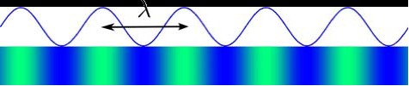
Fig. 2. Basic acoustic wave.
- UNDER WATER NOISE MODELS
(i) Attenuation: This is the loss in sound signal as it propagates. Practically, whatever we transmit, it will undergo some or other kind of attenuation in nature. It may attenuate because of its own limitations because nothing has 100% efficiency or limitations provided by nature. It is given by,
$A\left(l,f\right)=dk*a(f)d$ ………………………………. (1)
(ii) Shipping: It can exhibit spatial and temporal variabilities, because of the speed of ship and also the if the ship movement is in more dense areas when compared to ship movements in arctic regions where the traffic is less. Shipping noise is extremely less due to less surface traffic. But in extremely busy areas like the English Channel, shipping noise starts to dominate. There is no theoretical formula, because it depends on various factors like traffic on a particular route, it is time variant, with how much thrust a ship moves and causes ripples in water due to which sound signals may vary. But it is given by,
$Ns=10\left(40+20\left(s-0.5\right)\right)+(26log10(f)(60log10\left(f+0.03\right))/10{)N}_{soff}$…… (2)
(iii) Wave: It is because of the movements of waves; it also depends on various factors. On a given day, if the waves are calm, the effect caused by them on sound signal is significantly less. But on a full moon day, the waves are at their full threshold, so this may start to induce noise in the sound signal. Only from few Hz to 50kHz, wave generated noise starts to dominate. It is given by,
$Nw=10\left(50+\left(\frac{7.5\left(w\right)1}{2}\right)\right)+20log10(f+0.4))NN_{woff}$…………………………….…. (3)
(iv) Thermal: In underwater acoustics, thermal noise provides a lower limit on the detection of underwater acoustic signals. It means that weaker noise sources cannot be measured, so thermal noise is of no use. But for frequencies above 50kHz,
molecular bombardment of the medium with the receiver generates thermal noise. It is given by,
$N_{th}=10\left(\frac{-15+20log10\left(f\right)}{10}\right)N_{thoff}$ …………………………………………………… (4)
(v) Sea Surface Reverberation: In this reverberation, the roughness of sea surface and the presence of trapped air bubbles make the sea surface an effective scatter of sound. It can take occur due to out-of-plane as well as Vertical plane. Here, the scattering of the sea surface varies with grazing angle, frequency and roughness of the surface. If the roughness is more, then the scattering effect is high and vice versa. Sea surface roughness is because of the wind speed or the height of the wave. Here, there is a large variation for low frequencies and low grazing angles, and less variation for high frequency and high grazing angles. It is given by,
$S_{a}=3.3\left(β\right)log10\left(\frac{angle}{30}\right)-42.2l\log_{10}\left(β\right)+2.6$ …………………………………. (5)
where β = 158[vf^{1/3}]^{-0.58}
(vi) Turbulence: It is caused by various factors. As ships propagate faster, they cause turbulence in water. This may lead to ripples which in turn affect the propagation of sound. Turbulence is also caused by instability. It is caused by tidal energy, when waves gush in and out causing more force on water which in turn affects our sound wave. It is given by,
$N_{th}=10\left(50+\left(7.5\left(w\right)*\frac{1}{2}\right)\right)+20log10\left(f\right)40 log10(f+0.4))N_{woff}$ …………. (6)
- SOFTWARE MODELLING
Sound absorption Sim model: Simulation model for absorption of sound is as shown in Fig.3. the simulation model consists of various edit boxes like sound speed, depth, temperature, salinity and pressure. After reading the edited data, the program calls for the data calculation for the sound absorption coefficient. Spreading loss and absorption loss occurs due to the signal propagates through the sea water caused by the change of energy into heat due to water molecule viscous friction.
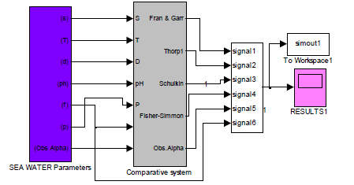
Fig. 3. Main sim model of coefficient of absorption.

The main simulation model in Fig 4. has been designed using simulink toolbox of MATLAB to determine the coefficient of absorption in the sea water. The input data like depth, salinity, temperature, frequency, pressure and observed coefficient of absorption have been read from workspace through the sim block in the simulink library. The empirical formulae proposed by different investigators have been used to calculate the coefficient of absorption.
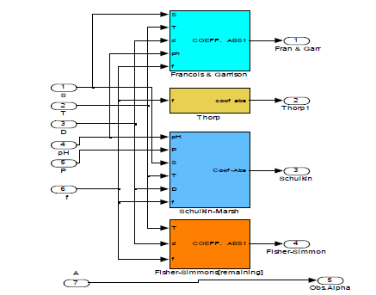
Fig. 4. Detailed sim model of coefficient of absorption.

Laboratory and sea based experimentation researchers have been proposed the absorption coefficient expression.
- DESIGN FLOW AND DISCUSSION
Give the inputs like power, range, margin. Define transmitter properties which include transmitter symbol rate (depends on frequency), receiver symbol rate, number of tones, frame duration.
Assign frequency values to each tone. Generate QPSK bit pattern by randomly generated 16 tones (32-bits). Convert the bits into frequency domain using IFFT definition. Display the transmitted signal. Estimate noise and calculate attenuation. Calculate the effect of channel on signal at the receiver end.
Plot the received signal. Calculate the SNR, C/B ratio.
Floor the C/B ratio value using round off algorithm.
Plot SNR and C/B ratio values before and after round off algorithm. The signal and the noise modelling flow diagram is as shown in Fig. 5.
Allocation of frequency for each tone
Modulation
Define Transmitter properties
Start
Channel and noise estimation
Calculation of attenuation
Displaying Transmitted Signal
IFFT
SNR and Probability calculation
Effect of channel on signal

Fig. 5.: Flow diagram for the modelling.
Wind Factor-15, Shipping Factor-2
The following results in Fig.6 and Fig.7 shows transmitted signal, received signal, SNR profile, probability profile, probability profile after round off for a wind factor of 15 and a shipping factor of 2 for different ranges and for different models.
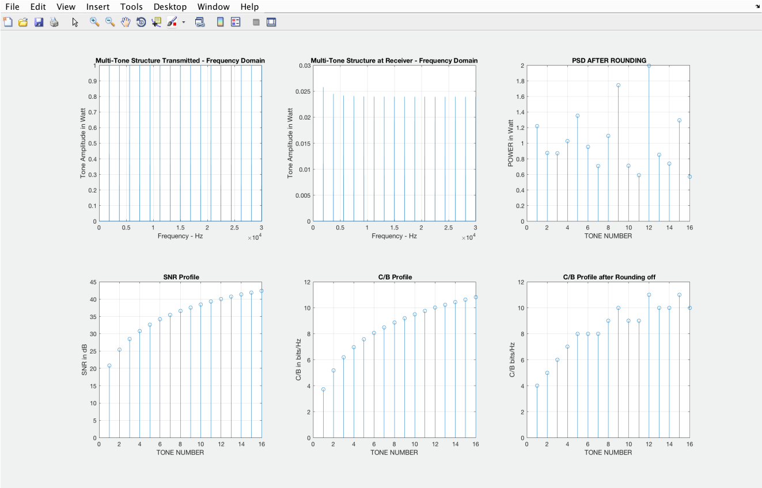
Fig. 6. Ainslie Model for Range-10Km
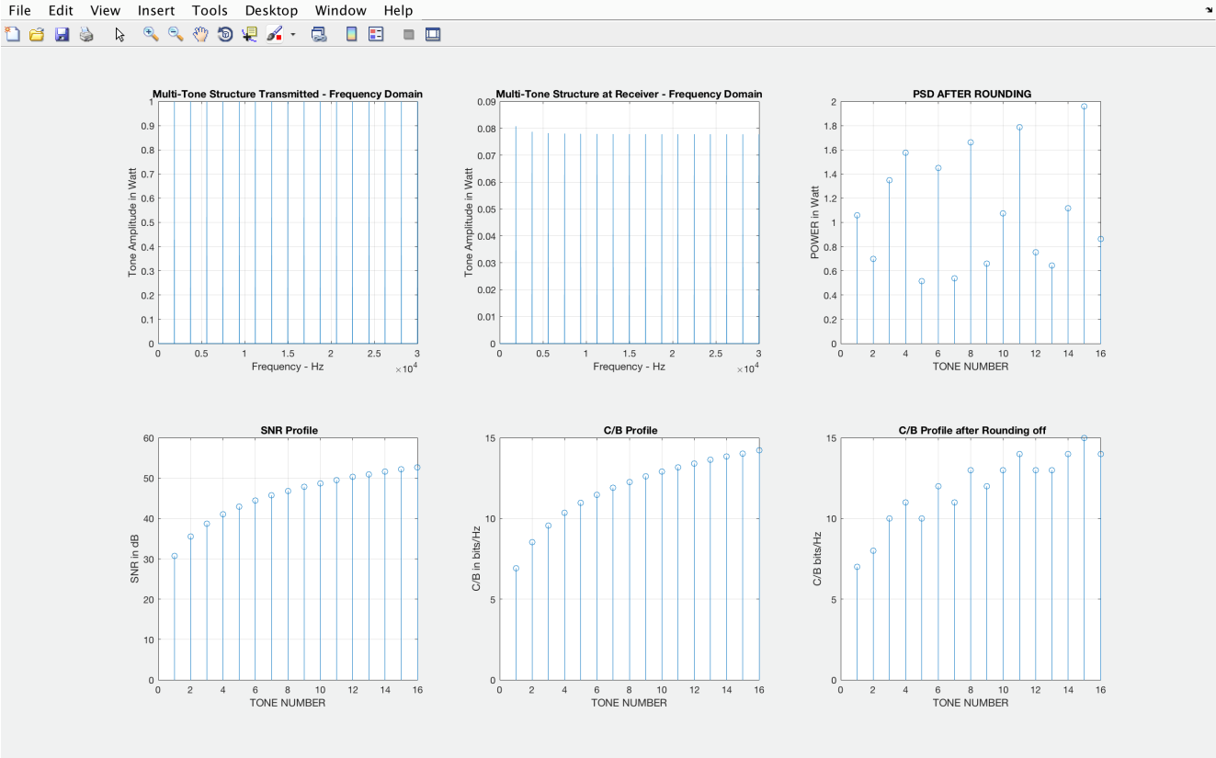
Fig. 7. Ainslie Model for Range-5Km.

WIND FACTOR-25, SHIPPING FACTOR -2
The following results in Fig. 7 (a) and Fig. 7 (b) shows transmitted signal, received signal, SNR profile, probability profile, probability profile after round off for a wind factor of 25 and a shipping factor of 2 for different ranges and for different models.
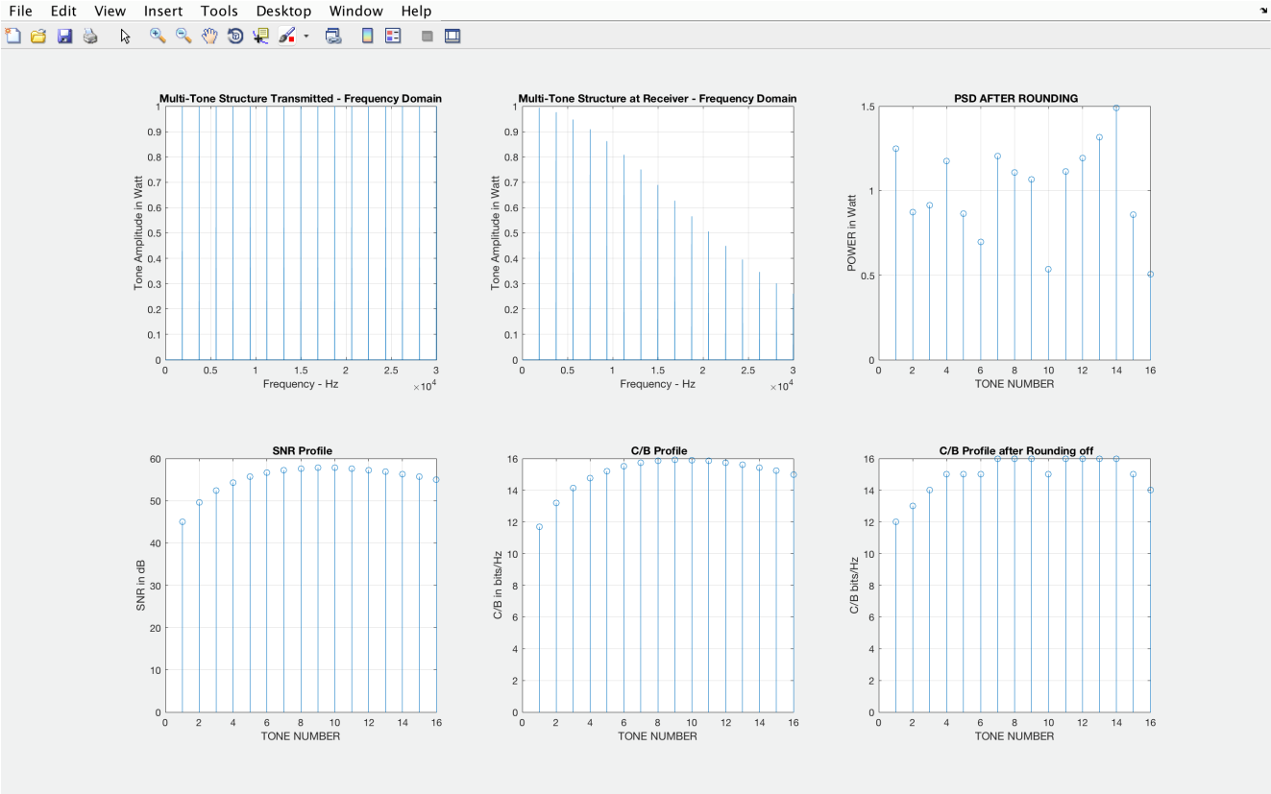
Fig. 7 (a). Fisher Simmons Model for Range-1Km
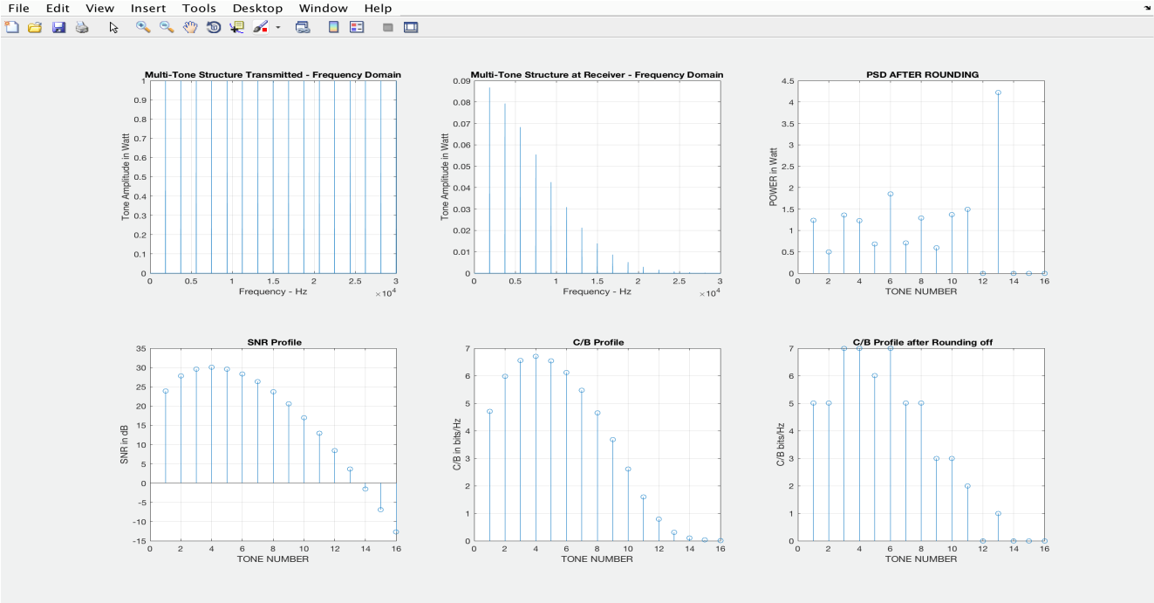
Fig. 7 (b) Fisher Simmons Model for Range-5Km

Comparison Table of All Models
Table 1: Comparison of different noise models with signal strength
Model  Type | Range, Wind factor, shipping factor | Transmitted  Signal  Strength | Received  Signal  Strength | SNR
AINSLIE | 1KM, SF-1, WF- 25 | Good | Good | Good
FISHER-SIMMONS | 1km, SF-1, WF-25 | Good | Average | Good
THORP | 1KM, SF-1, wf-25 | Good | Average | Good
AINSLIE | 5KM, SF-1, wf-25 | Good | Good | Good
FISHER-SIMMONS | 5km, SF-1, wf-25 | Good | Bad | Average
THORP | 5km, SF-1, wf-25 | Good | Bad | Bad

The above Table 1 shows the comparison of transmitted signal, received signal, and SNR. considering different models like Ainslie model, Fisher Simmons, Thorp and different ranges by varying shipping factor and wind factor. So, it is been observed that Ainslie model gives the best results when compared to Fisher Simmons and Thorp model even after considering different ranges, shipping factor and wind factor.

Conclusions And Future Scope
The acoustic underwater channel poses great challenges on the design of a communication system, especially in the present case of high-speed communication in a shallow-water channel. Thus, during this work the focus of the work lay on one hand on the careful design of the receiver and transmit circuitry and on the other hand on the development of a highly specialized simulation tool for stable shallow water channels with rather small dimensions. Here various noises in under water are modeled using Simulink and are evaluated for different ranges. It is also concluded that, Ainslie model will prove the good results on transmitted, received and SNR signal strengths. With the present results, the future of this work will include the following tasks: Application of the Covariance Matrix Adaptation evolution strategy onto the simulation, Implementation of the electronic design, refinement of the simulation using tests with the implemented electronics, development of powerful signal processing algorithms using the real-world environment and simulation results.
All the mathematical models of acoustic underwater channel are compared based on the listed parameters such as transmitted and received signal strength and SNR values. The optimal noise model is selected for the electronic implementation.

REFERENCES
- M. Zhou et al. “A Novel DNN based channel estimator for under water acoustic communication with IM-OFDM”, IEEE international conference on signal processing, communications and computing (ICSPCC)-2020.
- J. Xiaolin et al. “A novel cooperative spectrum signal detection algorithm for underwater communication system”, Journal of Wireless Communication Network (2019).
- Dr. T.B Mohite patil, T.T mohite Patil, Patil smita: Simulation Model for Comparative Study of Acoustic wave propagation in International Journal of Advanced Research in Computer and Communication Engineering Vol. 4, Issue 1, January 2015
- K. Saraswathi, Netravathi K A., Dr. S Ravishankar, “A Study on channel modeling of underwater acoustic communication”, International Journal of Research in Computer and Communication Technology, Vol 3, Issue 1, January- 2014.
- Tri Budi Santoso, Wirawan, Gamantyo Hendrantoro “Development of Underwater Acoustic Communication Model: Opportunities and Challenges”, International Conference of Information and Communication Technology (ICoICT), 2013.
- J. Poncela · M. C. Aguayo · P. Otero “Wireless Underwater Communications”, Springer Science+Business Media, LLC. 2012.
- T.B Mohite patil, A.K. Saran, S.R. Sawant, R.H. Chile, T.T. Mohite patil, "Modeling of acoustic wave absorption in ocean”, In International journal of computer applications (0975-8887) Volume 9- No. 12, Novermber 2010.
- Sermsak Jaruwatanadilok, Member, IEEE “Underwater Wireless Optical Communication Channel Modeling and Performance Evaluation using Vector Radiative Transfer Theory” IEEE Journal on selected areas in Communications, Vol. 26, No.9, December 2008.
- Milaca Stojanovic, “Recent Advances in High-speed Underwater Acoustic Communications”, In IEEE Journal of Oceanic Engineering, Vol. 21, No. 2, April 1996.
- Milaca Stojanovic, “Underwater acoustic communication: design considerations on the physical layer”, In MIT, Cambridge, MA 02139.
- Paul C Etter Underwater acoustic modelling and simulink, 5th Edition, CRC Press, 2019
- M. C. Domingo, “Overview of channel models for underwater wireless communication networks,” Physical Communication, vol. 1, no. 3, pp. 163–182, 2008.
- V. K. Ingle and J. G. Proakis, Digital Signal Processing Using MATLAB: A Problem-Solving Companion. Cengage Learning, 2016.
- M. Patzold and V.-D. Nguyen, “A spatial simulation model for shadow fading processes in mobile radio channels,” in Personal, Indoor and Mobile Radio Communications, 2004. PIMRC 2004. 15th IEEE International Symposium on, vol. 3. IEEE, 2004, pp. 1832–1838.
- X. T. Nguyen, X. B. Tran, and V. D. Nguyen, “An improvement of the lp-norm method to model acoustic shallow water channels,” 2014.
- Liu, L.; Li, J.; Zhou, L.; Zhai, P.; Zhao, H.; Jin, J.; Lv, Z. An underwater acoustic direct sequence spread spectrum communication system using dual spread spectrum code. Front. Inform. Tech. El. Eng. 2018, 19, 30–41.
- Ebihara, T.; Leus, G. Doppler-Resilient Orthogonal Signal-Division Multiplexing for Underwater Acoustic Communication. IEEE J. Ocean. Eng. 2016, 41, 408–427.
- Han, J.; Leus, G. Space-Time and Space-Frequency Block Coded Vector OFDM Modulation. IEEE Commun. Lett. 2016, 21, 204–207.
- Han, J.; Shi, W.; Leus, G. Space-frequency coded orthogonal signal-division multiplexing over underwater acoustic channels. J. Acoust. Soc. Am. 2017, 141, 513–518.
- Han, J.; Zhang, L.; Zhang, Q.; Leus, G. Low-Complexity Equalization of Orthogonal Signal-Division Multiplexing in Doubly-Selective Channels. IEEE Trans. Signal Process. 2018, 915–929.
- Ebihara, T.; Mizutani, K. Underwater Acoustic Communication with an Orthogonal Signal Division Multiplexing Scheme in Doubly Spread Channels. IEEE J. Ocean. Eng. 2014, 39, 47–58.

