IoT Enabled Health Monitoring System

Jayashree C Nidagundi
Dept. of Electronics & Communication Engineering
SDM College of Engineering & Technology, Dharwad, India
jayaparjwal@rediffmail.com

ABSTRACT
Monitoring patient health condition using IoT system deals with collection, interoperation of patient data which is taken from the sensors connected with the system deployed at the hospitals environment through IoT technology. The collected sensor information will help the doctor in the situations like emergency for the quick treatment and keeping the patient in better health condition. To implement proposed system the hardware required are set of sensors and Raspberry Pi 3 Model B+ with well equipped communication module to communicate with a doctor through IoT technology. The Python software is embedded into the Raspberry Pi model. The proposed health monitoring system will help doctors for quick diagnosis after knowing the patient health conditions anywhere in the world. In the proposed system, sensors will collect the medical information about the patient the parameters like heart rate, movement information in special cases of bed ridden situation, pulse rate, present temperature, humidity condition and air quality conditions of the patient room. The sensor's captured information is uploaded to the cloud storage through an IoT technology and stored as health data server. Both doctor and patient have access to this server. They can monitor the patient data by sitting anywhere in world with IoT enabled gadgets. Hence, the health parameters of patients are regularly monitored by doctor and patients. The proposed system is sure of suggesting quick and correct medical care for patients at the affordable cost.
Keywords—Internet of Things(IoT), Health Monitoring System, Sensors, Cloud, ThingSpeak etc.

INTRODUCTION

The IoT is gaining lot of importance in technical, economical and social domains. IoT use sensors, and competent processors with relevant accessories providing very effective means of communication between end users. The communication within the world between two parties is possible using IoT technology which enhances faster way of communication. With the assistance of IoT technology any application can be invoked anywhere around the world. So, an IoT based technology reduces the difficulty level by providing lots of information on the internet. The IoT based technology also enables the health conditions monitoring of patient remotely for patient and doctors. This technology provides support for enhancing the cost and quality of patient life and also increases the life span of patients with early medication. In the conventional health care system unsolved and unidentified health related issues can be solved by this technology hence increasing healthcare services with digital identity for anybody(authenticated) in the world. The following motivational objectives need to be implanted in the proposed work are :
- IoT assisted proposed system helps to monitors in real-time, health care parameter's status of the patient. The system aids doctors to make the instant decision about seriousness of the patient condition. Depending upon emergency situation of patient condition immediate treatment can be given. Which in turn save the life of critical patients.
- The proposed work is aimed with development of low cost and efficient system which helps the patients make use of the resources available at the hospitals while being at their places and lot of money and time can be saved by the patients.
- The proposed system may be considered as easy working environment for medical professionals and patients.
- The proposed system is found to be more suitable for doctors in case patient is suffering from chronic diseases. Normally in most of incurable chronic diseases, it is required to continuously monitor the status of the patient while they are at their home and helps the doctors take necessary quick action if health condition of patient become worsen.
- The Human Machine Interface is found more useful and portable. So, becomes very convenient for doctors to manage patients from the web server, and it is also very easy for patient’s guardians to monitor their family members health remotely.
Health monitoring using IoT is a technology to enable monitoring of patients outside of conventional clinical settings (e.g., in the home), which may increase access care right to the home. In addition, patients and their family members feel comfort knowing that they are being monitored to care and decrease healthcare delivery costs. This can significantly improve an individual's quality of life. It allows patients to maintain independence, prevent complications, and minimize personal costs. This system facilitates these goals by delivering and will be supported if a problem arises.

BACKGROUND

The system which monitors the health conditions of patient consists of several sensors connected to a patient and they communicate the data through the processing unit. In [1], the patient monitoring system consist of Raspberry Pi as a data collecting as well as a processing device, patient and doctor smart phone/computer are used as a monitoring system. The prototype developed in [2], detects the human walking motion , running or position change within a closed room. It can classify activities like standing, sleeping, sitting, position. This system also tracks heart rate with the body temperature and humidity to determine the physical condition and abnormality. Md. Milon Islam et al.[3], proposed smart healthcare system to monitor the heart rate, body temperature, and some measures of hospital room’s condition such as room humidity, the level of CO and CO2 gases. This healthcare monitoring system uses Web User Interface for Data Processing. The paper[4], developed a prototype to monitor the health parameters of the patient i.e.; heartbeat and temperature using Raspberry Pi 3. They proposed continuous monitoring of the patient conditions and store the patient's data in the server using the IoT concept. Rameswari.R, Divya.N[5] describes the system which contains various existing and blooming technologies in the healthcare such as ECG, EMG monitoring through android apps, usage different protocols for transferring data such as MQTT, TCP/UDP, OCN authenticated mode, WLAN technologies etc. The paper[6] presents a health care monitoring system. for COVID-19 patients, high blood pressure patients, diabetic patients, etc., To support the health monitoring parameters specially in rural areas, the system will measure a patient’s body temperature, heartbeat, and oxygen saturation (SpO2) levels in the blood and send the data to a mobile application using Bluetooth. The main objective considered here is to increase affordability for regular people. Besides sustainability in the context of finance, patients will have easy access to personal healthcare. The authors presents an IoT-based system that will simplify the utilization of an otherwise complicated medical device at a minimum cost while sitting at home. A 95 percent confidence interval with a 5 percent maximum relative error is applied to all measurements related to determining the patient’s health parameters. The Module[7] implemented using ESP32 processor and two sensors effectively monitors the essential health parameters and information is sent to doctors/ nurses on mobile or computer system. Doctors can see the ECG, EEG waveforms & monitor other parameters of the patient on their computer screen sitting in their room and suggest medicines immediately in emergency. Information also received to cloud through Wi-Fi from the processor. The review paper[8] systematically list out the effectiveness, efficiency, privacy, data protection aspects of various health monitoring schemes. The authors brings out the challenges in the existing systems and provide some suggestions and recommendations for parameters of health monitoring. A smart health monitoring system[9] is developed using IoT technology specially to reach out for rural areas or village people especially in covid-19 situations. This system would help in identifying and early treatment of COVID-19 individual patients. The patient monitoring system[10] is designed using IoT platform, Arduino Mega 2560 and ESP8266 Wi-Fi Module and sensors. The system is able to detect the vital signs of patient using sensors and analyze it as per the patient age and privide alert message through android apps. Doctors will compare the vital information of particular patient with information stored in the cloud for necessary medication. The system[11] is developed to monitor the BP, HB, ECG information on LCD based on finger clip sensor information of the patient. Continuous monitoring is carried using IoT platform if any health parameter variations alert message sent to caretakers. The system[12] is highly used in emergency cases for suggesting medicines for patients using IoT platform. The review in [13] investigated many aspects for healthcare monitoring system including wheelchair monitoring, asthma monitoring, mood monitoring etc using latest technologies. An IoT based wearable health monitoring system[14], which remotely monitors the exact locations and health parameters of individuals of quarantined in real time. The system is built using optoelectronic and electronic components. The study of all the literature leads to formation desired requirements of health monitoring system using latest technologies aiming at:
- Implementation of wired communication is difficult. It is most expensive and takes more time . With help sensor wireless network like IoT makes the system cost effective and have fast installation procedural times with more reliability
- In conventional mechanism, doctor has to visit to patient room and check his medicine details and the patient condition and then suggest further treatment. In the proposed model NO such mechanism exist looking at the patient dashboard screen through IoT doctor immediately suggest suitable medicine
- This system can be deployed in patient and doctor's mobile phones for ease and fast accessing.
- Efficiency of healthcare is enhanced with this proposed system.
- All the sensors can monitor simultaneously and sends the results to the authenticated person. Provide medical assistance according to the data received i.e., heart rate, pulse rate etc.

METHODOLGY
The online continuously monitoring patient health and his room condition is the main theme of the proposed system. The block diagram of health care monitoring system is shown in Fig.1, consist of different hardware and software blocks. The explanation of all the required hardware blocks and embedded software is described in subsequent sub sections. The input sensors sense the change and then information is sent to Raspberry board for evaluation. Then results are continuously updated onto the cloud account. Doctor can see the information available with him on his screen and immediately and suggest the treatment to patient. Both doctor and patient are connected to internet.

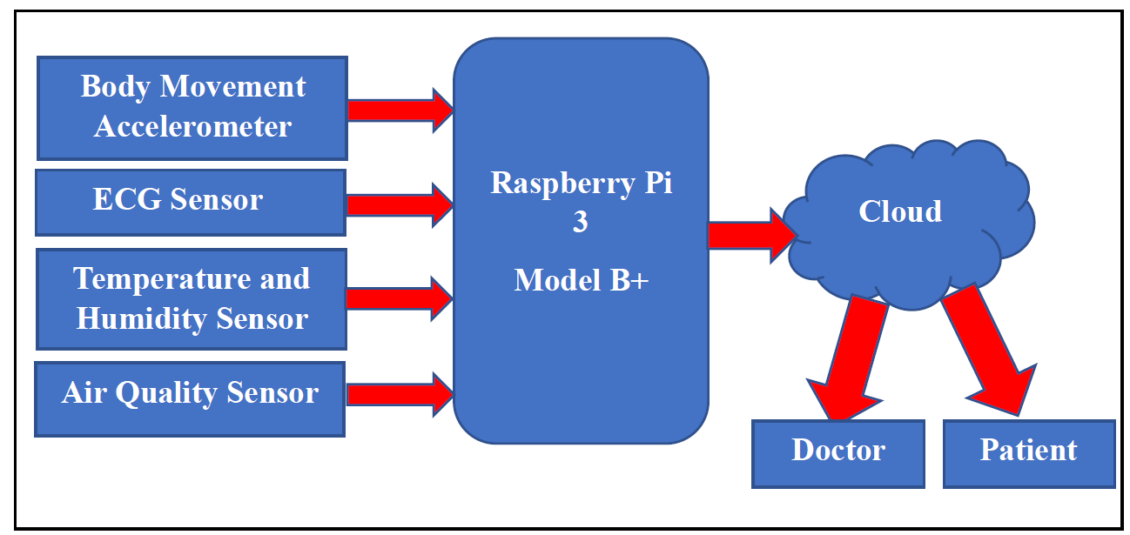

Fig. 1 Block Diagram of IoT Enabled Health Monitoring System

Hardware Reqiurement of Proposed Syatem.
- Raspberry pi 3 Model B+
The Raspberry Pi is a like efficient computing device consisting of deck of cards. It uses what's called a system on a chip, which integrates the CPU and GPU in a single integrated circuit, with the RAM, USB ports, and other components soldered onto the board for an all-in-one package. It doesn't have onboard storage, but it has an SD card slot you can use to house your operating system and files. The Raspberry module used is shown in Fig.2.
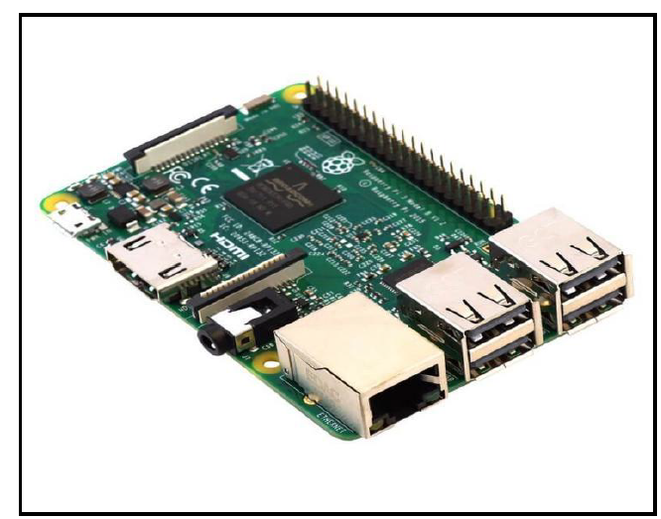

Fig. 2 Raspberry Pi-3B Model

- ECG Sensor:
The ECG sensor as shown in Fig.3, records the electrical activity of the human heart over a period of time with help of set electrodes placed above the skin. These electrodes detect the changes in the electrical signal on the skin that arise from the heart muscle's electrophysiological pattern of depolarizing and repolarizing during each heartbeat.

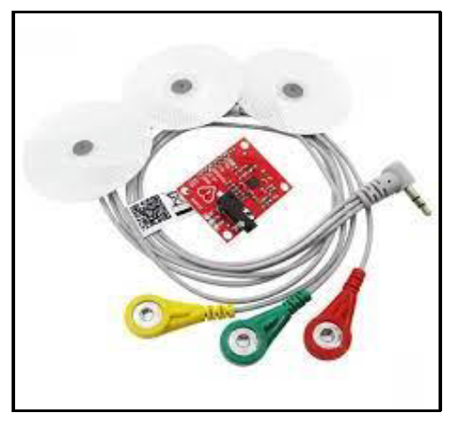
Fig.3 ECG Sensor

- Temperature and humidity-based sensor:
DHT11 sensor module which shown in Fig.4 detects the Temperature and humidity of the respective room. It is a cost effective digitized sensor. This DHT11 can be easily interfaced with any of the micro-controller such as Raspberry Pi module to measure humidity or moisture and temperature continuously. This DHT11 sensor is available with integrated one any of microcontroller devices. This sensor uses thermistor and capacitive concepts to measure relative humidity.
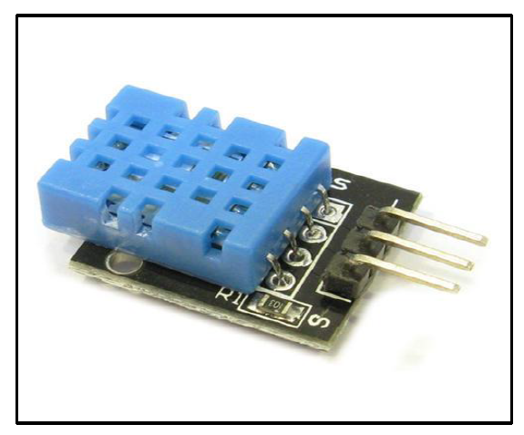
Fig.4 Temperature and Humidity Sensor
- Air Quality Sensor:
The electronic gas sensor MQ2 is used in the proposed system senses the concentration level of of gases present in the air. Gases such as LPG, Propane, Methane, Hydrogen, Alcohol, Smoke and Carbon monoxide are used to detect from MQ2 sensor. This MQ2 sensor is also called as chemi-resistor. This sensor consist of sensing material whose resistance changes when sensor lead comes in contact with the any of the above sensible gases. This type of sensors are the devices used to detect contaminants in the air. The air quality sensor is shown in Fig.5.

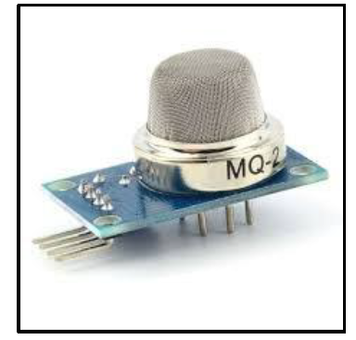
Fig.5 Air Quality Sensor
- Body Movement Accelerometer:
The ADXL 345 module shown in Fig.6 is used for detecting the moving direction. By using this sensor module, human movement can be observed in which direction it moves like Left or Right.
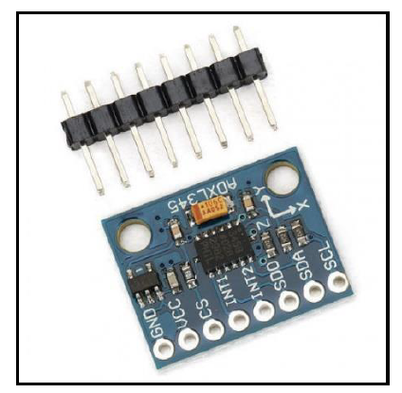
Fig.6 Body Movement Detection Sensor

Software Requirement

ThingSpeak is an freely downloadable cloud storage pictorially shown in Fig.7, allows users to communicate with an Internet enabled devices. It facilitates data access, retrieval and logging of data by providing an API to both the devices and social network websites. In, IoT Cloud platform, where we can send sensor collected data and store it as part of cloud. We can analyze and visualize data storge of clouda with MATLAB or other software applications and build certain analysis.
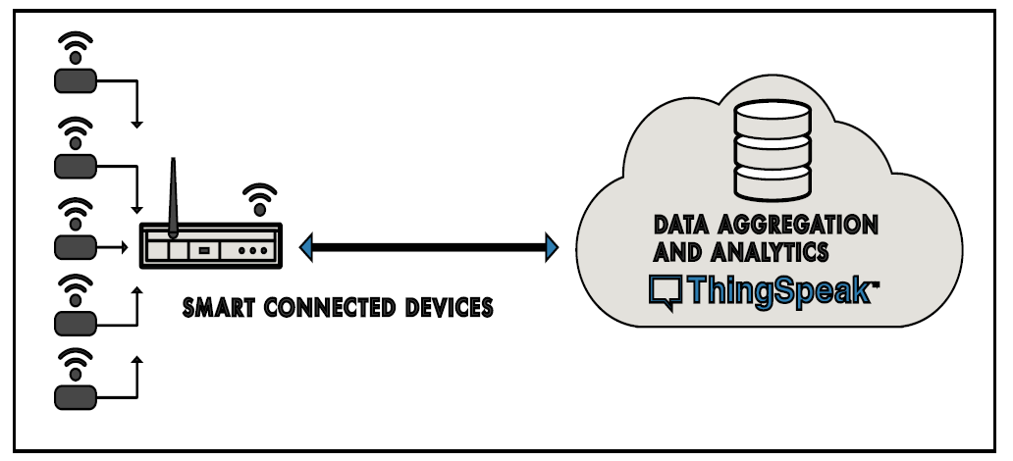
Fig.7 Thing Speak Cloud Connectivity with Smart Devices
The monitoring proposed system contains the three-stage architectural features, such as input sensing Sensor Module , Computation of Data Processing and user Web Interface module .The wired sensors which are basically collect data from the patient’s body and the environment by gathering physiological signs. The collected data is sent to the cloud storage and it processed using computation device like raspberry pi 3 B+ module. The collected information is also then stored to the cloud through ThingSpeak web application. ThingSpeak can be used for the graphical interpretation, and also display the collected information. Both patient and doctors can have access the details of collected data by logging on to the concerned application. The prototype of the proposed model is described in Fig.8
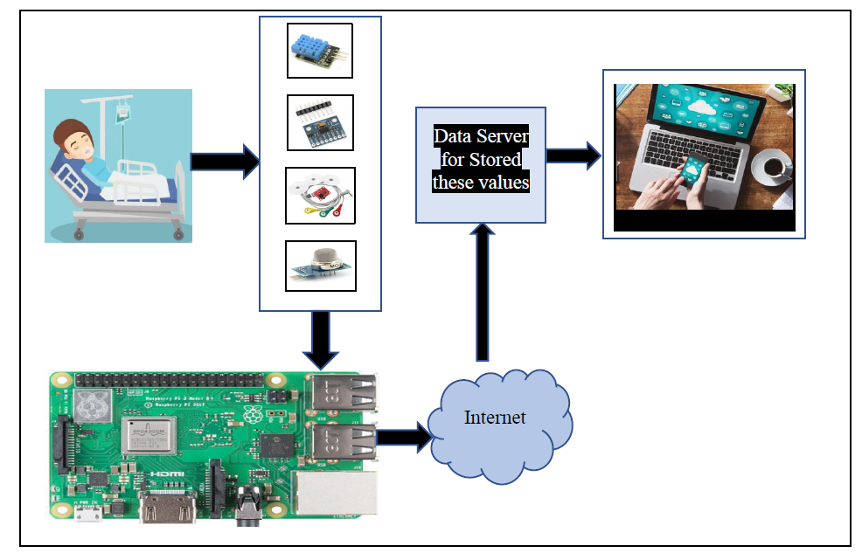
Fig.8 Prototype Model of Proposed work

RESULTS

This system is enhanced to automatically collect the Temperature and Humidity, Body Movement, Air Quality and ECG Sensors. The output of a critical patient and the collected data is then processed in Raspberry pi 3 model B+. The processed data will be sent to cloud via Internet and both the Doctors and Patients relatives are able to access the data by logging on to the web application. The results of Temperature and Humidity monitoring are shown in Fig.9.

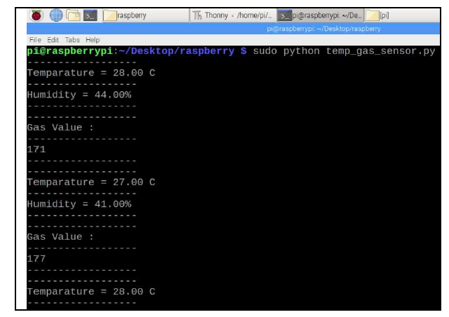
Fig.9 Readings obtained with interfacing Temperature and Gas Sensors

Similarly the monitoring of body movements of bed ridden patients positions are also recorded on the screen as shown in Fig.10.
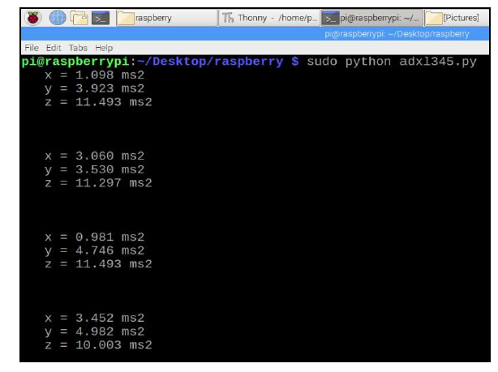
Fig.10 Readings obtained with interfacing Position Sensor

The proposed prototype helps the doctors to arrive at quick decisions if the condition of patient is very critical. The results are also continuously sent to the cloud storage via internet. Monitoring system on the ThingSpeak storage are shown in Fig.11.
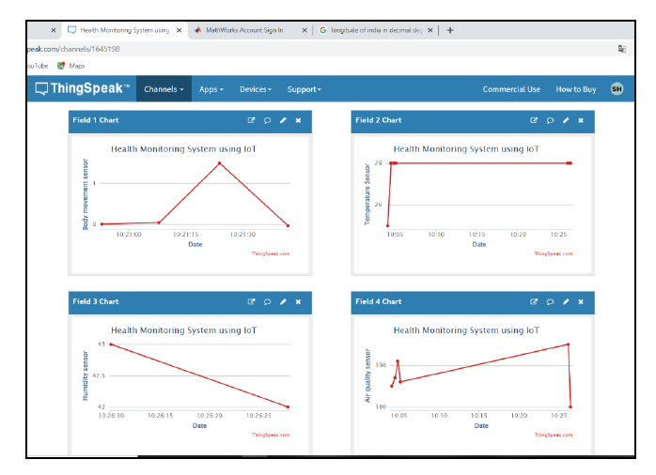
Fig.11 Sample Data Storage on Cloud

Monitoring health condition of patients using IoT platform will assist the doctors to take decisions about patients very quickly and prioritize treatment to critical conditioned patients which helps to provide urgent immediate treatment which leads to saving of patient's lives. The proposed system is most effective and competent patient's health monitoring and management system. This system makes use of the available resources existing in the hospital more efficiently by saving time and money of the patients. The proposed system is user friendly system to be used by patients and medical professionals. In case of patient is suffering from any of chronic diseases this remote health monitoring system is especially useful to monitor patient's status continuously. It seems to more attentive with patients having chronic diseases which are most of the time are incurable, so monitoring the health condition of the patient is necessary while being at home and give immediate treatment if health indicators showing worst health conditions. This prototype Human Machine System is more ease to use and it is portable. So, it is very easy for doctors with proposed system for manage patients from one app remotely. It is also be easy for patients to monitor their own health parameters by having a lightweight device like a bracelet, watch, ear rings etc.

CONCLUSION & FUTURE WORK
This proposed system introduces smart healthcare device to monitor the basic important signs of patients like heart rate, body movements, and some measures of hospital room’s condition such as room temperature, room humidity and the air quality of room. Only registered and authentic medical professionals can view and track the data in real-time even though the patients are outside of the hospital. This system found to be very useful in cases like infectious disease like a novel coronavirus (COVID-19) treatment. The developed system will improve the current healthcare system that may protect lots of lives from death. In near future, such IoT based health monitoring systems will provide assistance to patients and doctors in turn dependence and mobility of patients specially elderly, sick, and physically or mentally disabled patients will be reduced. In turn reduced stress looks very comfortable for family members of the patients and doctors who can be alerted always to address the issues immediately in case of emergency. The proposed system can be enhanced to detect and collect several anomalies for monitoring purpose such as brain signal monitoring, tumour detection etc. The system can be designed further to send alert messages in emergency situation. The situation becomes worst when a patient is suffering from dementia. The wearable devices detect the patient’s condition along with sending information to the caretaker too. The information can either be given through text or email while alerting the doctors too. In medical emergencies, people of any age require immediate help from any source of help. Seeing how beneficial these IoT monitoring devices are- in future, the number of homes will have a sensor network. These networks will monitor each and every activity of a patient with the sensor of sending in alerts in an emergency. IoT monitoring device that keeps track of a patient’s prescribed medicine routine. The technology can be proven best for patients with dementia or Alzheimer’s.

REFERENCES

- Dr. E.N. Ganesh, “Health Monitoring System using Raspberry Pi and IOT, ” Oriental Journal of Computer Science and Technology An International research journal of Computer Science and Technology published on 07 Mar 2019
- Prabu K, Ravikumar T, “Arduino and Raspberry Pi Based Efficient Patient Monitoring System, ” International Journal of Engineering Research & Technology (IJERT) ISSN: 2278-0181 Published By, www.Ijert.Org ICETET - 2016 Conference Proceedings
- Md. Milon Islam, Ashikur Rahaman, Md. Rashedul Islam, “Development of Smart Healthcare Monitoring System in IoT Environment,” Springer Nature Singapore Pte Ltd 2020
- Mohd Abdul Muqeet, Mohammed Umair Quadri, “IOT Based Patient Monitoring System Using Raspberry Pi,” IJRECE VOL. 7 Issue 2 (April- June 2019)
- Rameswari.R, Divya.N, “Smart Health Care Monitoring System Using Android Application: A Review,” International Journal of Recent Technology and Engineering (IJRTE) ISSN: 2277-3878, Volume-7 Issue-4S, November 2018
- Mohammad Monirujjaman Khan,¹Turki M. Alanazi,²Amani Abdulrahman Albraikan,³and Faris A. Almalki, " IoT-Based Health Monitoring System Development and Analysis, "International Journal on Security and Communication Networks, Special Issue . 2022
- Sangeethalakshmi K., Preethi Angel S., Preethi U., Pavithra S., Shanmuga Priya V.,"Patient health monitoring system using IoT, " Vol.28, PP. 2228-2231, https://www.sciencedirect.com/science/article 2023
- Suliman Abdulmalek,^{1,2} Abdul Nasir,^{1,*} Waheb A. Jabbar,³ Mukarram A. M. Almuhaya,¹ Anupam Kumar Bairagi, Md. Al-Masrur Khan, and Seong-Hoon Kee, "IoT-Based Healthcare-Monitoring System towards Improving Quality of Life: A Review, " article National Library of Medicine National centre for Biotechnology Information PubMed central , October,2022
- Vaneeta Bhardwaj ¹, Rajat Joshi , Anshu Mli Gaur, " IoT-Based Smart Health Monitoring System for COVID-19 ," National Library of Medicine National centre for Biotechnology Information PubMed central , Jan,2020
- Nor Shahanim Mohamad Hadis, Muhammad Nazri Amirnazarullah, Muhammad Mahdi Jafri and Samihah Abdullah, " IoT Based Patient Monitoring System using Sensors to Detect, Analyse and Monitor Two Primary Vital Signs, " Journal of Physics,2020
- Yedukondalu Udara, Srinivasarao Udara, Harish H M,Hadimani H C, " HEALTH MONITORING SYSTEM USING IOT, " International Journal of Engineering and Manufacturing Science, 2018 , ISSN 2249-3115 Volume 8, Number 1, pp. 177-182,
- C.Senthamilarasi, J.Jansi Rani, B.Vidhya , H.Aritha, " A SMART PATIENT HEALTH MONITORING SYSTEM USING IOT," International Journal of Pure and Applied Mathematics, Vol. 119 No. 16, pp 59-70,2018
- Bikash Pradhan,¹Saugat Bhattacharyya,²and Kunal Pal," IoT-Based Applications in Healthcare Devices," Journal of Healthcare Engineering,2021
- ] Ju-Yu Wu, Yuhling Wang , Congo Tak Shing Ching, ,Hui-Min David Wang , Lun-De Liao,"IoT-based wearable health monitoring device and its validation for potential critical and emergency applications," Front. Public Health, 16 June 2023

