Fermentation Technology: Empowering Biotechnology for a Sustainable Future

Aswathy M R, S.Ajay Samuel
BIRAC E-YUVA Centre
PSGR Krishnammal College for Women
Coimbatore, Tamil Nadu
Email: aswathymr@psgrkcw.ac.in
ajaysamuel@psgrkcw.ac.in

Silpa P S ( Pandikkadan Sundaran )
Dept. Of Environment science
Central university of Kerala
Kasargod, Kerala, India
Email: silpa1997@gmail.com

T. L. Sai Sangari
Department of Biotechnology,
RVS COLLEGE OF ARTS AND SCIENCE, SULUR
Coimbatore, Tamil Nadu
saisangari99@gmail.com

ABSTRACT
Fermentation technology is a powerful biotechnological tool that drives transformative changes across sectors and promotes sustainable development. This chapter extensively examines fermentation's crucial role in producing functional foods enriched with bioactive compounds, going beyond basic nutrition to offer enhanced health benefits. Examples include fermented soy products, vegetables, and beverages, aligned with trends such as plant-based options and personalized diets, all underpinned by a strong commitment to sustainability. In the field of biopharmaceuticals, fermentation emerges as a vital facilitator for complex drug manufacturing. It skillfully manipulates the metabolic processes of microorganisms to yield targeted therapies with fewer side effects. The chapter highlights the creation of diverse biopharmaceutical products, like monoclonal antibodies, vaccines, hormones, and enzymes, achieved through meticulous coordination of fermentation processes. Fundamental factors such as facility design, microorganism selection, optimization of growth mediums, and environmental control are explored, alongside downstream processing, regulatory compliance, continuous manufacturing, and advanced analytics.
The chapter addresses challenges including process scalability, quality assurance, and potential avenues in personalized medicine, biosimilar development, and sustainable manufacturing methods, collectively advancing drug production practices. Moreover, it delves into the implications of microbial consortia in bioprocessing, showcasing their efficiency compared to individual species. Applications span lignocellulosic degradation, biofuel production, water treatment, bioremediation, and specialty chemical synthesis. Fermentation-based bioremediation is explored as an environmentally sound approach for cleaning up, harnessing microorganisms to convert pollutants into less harmful forms. Various techniques, covering aerobic and anaerobic processes, bio augmentation, and bio stimulation, are examined. The chapter emphasizes the transition to a circular economy in fermentation for sustainable resource management, highlighting micro algal-based bio refineries as promising solutions. In summary, this chapter comprehensively explores the applications of fermentation technology, steering biotechnological advancements, and promoting an ecologically conscious world. Through innovation, careful development, and strategic resource management, fermentation technology lays the foundation for a sustainable future.

- INTRODUCTION

Over the past few years, biotechnology has emerged as a significant driving force in paving the way towards a sustainable future. One of the key pillars driving this progress is fermentation technology, a field that has witnessed remarkable advancements and contributed to numerous applications across various industries. This book chapter aims to explore the role of fermentation technology in empowering biotechnology for sustainable development.Microorganisms convert organic compounds through the natural process of fermentation, which has been practiced by humans for thousands of years. It has evolved from its early roots in food and beverage production to become a cornerstone of modern biotechnology. By understanding and manipulating the metabolic capabilities of microorganisms, scientists and engineers can harness fermentation's potential to produce a wide range of valuable compounds [1].
The potential of fermentation technology for sustainable development is vast, with applications in healthcare, agriculture, food production, and environmental sustainability. In the field of healthcare, fermentation plays a critical role in the production of pharmaceuticals, including vaccines, antibiotics, and therapeutic proteins. These biopharmaceuticals offer new treatment options, improved efficacy, and reduced production costs [2]. In agriculture, fermentation technology has revolutionized crop improvement and animal husbandry. Scientists have created genetically modified crops with improved traits, such as increased resistance to various illnesses and pests or improved nutritional value, through genetic modification and fermentation processes. Fermentation also enables the production of animal feed additives that promote livestock health and growth while minimizing environmental impacts [3,4].
Moreover, fermentation technology has transformed the food and beverage industry by enabling the production of probiotics, enzymes, and other food additives that enhance food safety, preservation, and nutritional value. It has also played a crucial role in the production of biofuels, contributing to renewable energy sources and reducing greenhouse gas emissions [5]. The convergence of fermentation technology with other scientific disciplines, such as molecular biology, biochemistry, and chemical engineering, has further expanded its potential applications. Researchers and industry professionals continue to push the boundaries of fermentation technology by leveraging the latest scientific advancements and innovative approaches [2]. However, the ethical and sustainable use of fermentation technology is of paramount importance. As biotechnology progresses, it is crucial to address safety concerns, environmental impacts, and equitable access to its benefits. Robust regulatory frameworks and public policies need to be in place to ensure responsible and sustainable utilization of fermentation technology [6].
This book chapter aims to provide an in-depth exploration of fermentation technology's contributions to biotechnology for a sustainable future. By examining historical milestones, current applications, and future prospects, we seek to shed light on the potential of fermentation technology to address global challenges and promote sustainable development. Through comprehensive analysis and case studies, we will delve into the advancements and breakthroughs in fermentation technology, highlighting its impact on various industries and its potential for future innovations. We will also discuss the difficulties and factors to be taken into account when implementing fermentation technology responsibly, such as security measures, moral issues, and environmental sustainability.By the end of this chapter, readers will gain a comprehensive understanding of fermentation technology's pivotal role in empowering biotechnology for a sustainable future. It is our hope that this exploration will inspire further research, collaboration, and responsible utilization of fermentation technology to address the pressing challenges faced by our society and contribute to a more sustainable and prosperous future.

- FERMENTATION FOR NUTRACEUTICALS: EXPLORING FUNCTIONAL FOODS AND HEALTH BENEFITS

The term "nutraceuticals" refers to naturally occurring dietary components that are frequently found in food and are believed to have positive effects on one's health or wellbeing when taken orally. In 1989, Dr. Stephen Defelice created the phrase by fusing the words "nutrition" and "pharmaceutical." Due to the potential nutritional and therapeutic impacts of nutraceuticals, the sector has seen a significant increase in attention. Supplementing with nutraceuticals or eating foods that have been developed or fortified with these beneficial ingredients can help people enhance their health. Due to their perceived safety and possible health advantages, nutraceuticals have become more and more popular as an alternative to or supplement to conventional medications [7]. They can be classified as either traditional or non-traditional nutraceuticals, depending on the type of food that is available. Traditional nutraceuticals: These are whole foods or dietary components that are naturally nutritious but also offer additional health advantages. Contrarily, non-traditional nutraceuticals are biotechnologically produced synthetic foods [8].

- Fermentation as a valuable technique for producing nutraceuticals
Using microorganisms like bacteria, yeast, or fungus, fermentation is a natural process that transforms organic chemicals into more palatable ones. When used to create nutraceuticals, fermentation has several advantages. The figure 1 illustrates the step-by-step process of creating nutraceuticals from raw ingredients, including fruits, grains, and vegetables. Nutraceuticals with improved nutritional properties can be produced through the use of fermentation. The bioavailability and digestibility of dietary components are improved by fermentation through the use of microbes [9]. Complex proteins, lipids, and carbohydrates are broken down into simpler forms for easy absorption by the body. For instance, the fermentation of soybeans results in the production of short-chain fatty acids, vitamins, and amino acids, which increases the nutritional value of the final product [10].
In addition, fermentation encourages the production of bioactive substances with positive health effects. These chemicals include immune boosters, anti-inflammatory drugs, antimicrobials, and antioxidants. Fermented foods have larger levels of these advantageous compounds than their non-fermented equivalents. Consuming fermented nutraceuticals allows people to access a greater variety of bioactive compounds, improving their health and wellbeing in general [11]. Probiotics that boost immune system performance and gastrointestinal health are created during fermentation, but it also has advantages for preservation. Probiotics, living microorganisms found in fermented foods like yoghurt, kefir, and sauerkraut, support a healthy balance of gut flora and offer extra health advantages.
At the same time, bacteria that cause spoiling are prevented from growing due to the acidic and antibacterial environment created by the metabolic byproducts of fermentation, such as organic acids and alcohol. The shelf life of items that have undergone fermentation is extended due to this preservation effect, extending their availability. As a result, consumers may take advantage of nutraceuticals' improved nutritional attributes and longer storage times [12]. Additionally, fermentation provides an opportunity for waste utilization, as agricultural and food processing waste can be transformed into valuable nutraceuticals through the use of appropriate microbial cultures. This not only reduces waste but also promotes sustainability in the food industry [13].

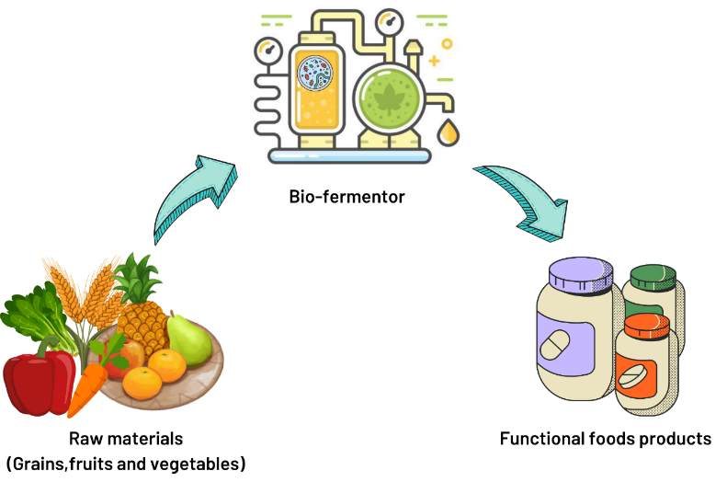
Figure 1: Schematic representation of the fermentation process for nutraceuticals production

Fermentation's ability to enhance nutritional properties, increase bioactive compound production, promote probiotic formation, remove anti-nutritional factors, extend shelf life and digestive tolerance, enrich nutrients and utilize waste makes it a valuable technique for producing nutraceuticals with enhanced nutritional benefits [14].

- Functional foods and their contribution to fostering well-being and preventing illnesses
Functional foods are dietary items that offer additional health advantages beyond basic nutrition. They include bioactive substances with distinct physiological benefits that can promote health and fight illness. The figure 2 outlines and highlights several health advantages associated with consuming functional foods. These bioactive ingredients, such as vitamins, minerals, dietary fiber, probiotics, prebiotics, antioxidants, phytochemicals, and omega-3 fatty acids, play a critical role in enhancing overall wellbeing, preventing illness, and promoting good health [15]. By incorporating functional foods into a healthy diet, individuals can optimize their nutritional intake and support their long-term health.
The gut, which plays a vital role in immune function, can be positively influenced by fermented foods. Probiotics present in these foods help regulate the immune response by stimulating antibody production, enhancing immune cell activity, and modulating inflammatory pathways. The release of bioactive peptides from proteins during the fermentation phase of microorganisms is thought to have immune-stimulating effects that prevent infectious diseases by increasing the activity of macrophages and immunoglobulin A-producing cells [16]. A study conducted with 200 healthy participants, using a randomized, placebo-controlled design, demonstrated that the consumption of dairy yoghurt enriched with probiotics led to increased levels of immunoglobulin G1 (IgG1), interleukin-12 (IL-12), interferon (IFN), and natural killer (NK) cells when compared to the placebo group [17].
In terms of cancer prevention, certain fermented functional foods like miso, tempeh, and certain fermented vegetables contain bioactive compounds. These compounds possess antioxidant and anti-carcinogenic properties, which protect against certain types of cancer. Consumption of fermented soy products and miso was found to be negatively correlated with interleukin-6 (IL-6) levels in blood serum in a study involving 1053 men and 373 [18].

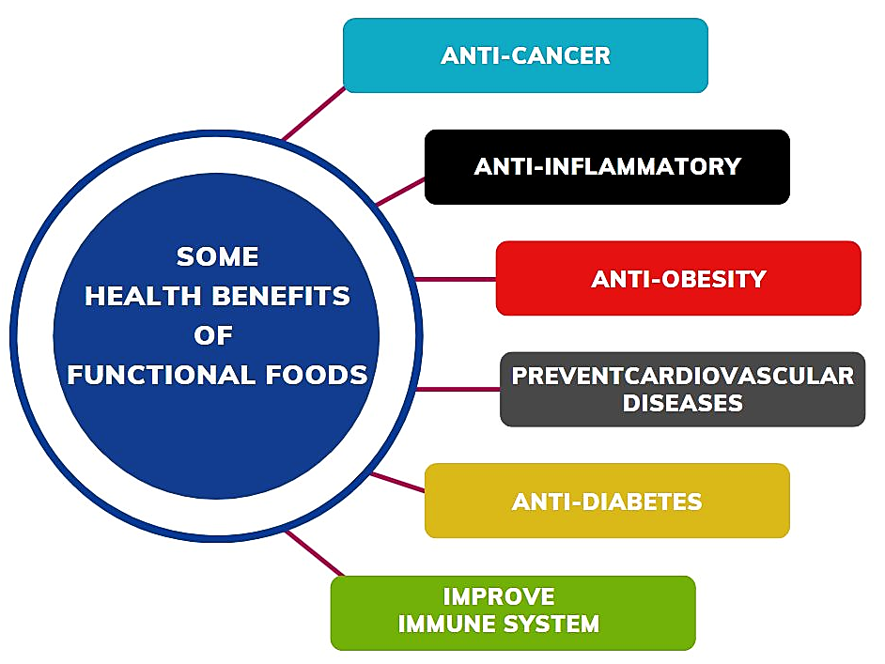
Figure 2: Various Health Benefits of Functional Foods

Pediococcus pentosaceus CRAG3, a strain that was isolated from fermented cucumbers, showed anti-cancer activity when tested on cervical cancer (HeLa) and colon cancer (HT29) cell lines in in vitro cytotoxicity studies [19].
Fermented functional foods also have anti-inflammatory effects, which are important for various health conditions. The probiotics and bioactive compounds in fermented foods help mitigate inflammation by reducing markers of inflammation and modulating the immune response. Guo et al. showed that curcumin inhibited inflammatory mediators (TNF-a) and monocyte chemoattractant protein-1 (MCP-1) and reduced ROS (reactive oxygen species) production in HIV-1-gp120-stimulated murine microglial N9 cells to prevent neuronal damage [20]. In a study conducted by Han et al. it was shown that EGCG (epigallocatechin gallate) had a suppressive effect on endothelial inflammation and cellular oxidative stress induced by polychlorinated biphenyl 126 [21]. Astaxanthin, administered at a concentration of 0.05% in the diet of diabetic rats, demonstrated anti-inflammatory effects in a study by Chan et al. The treatment increased glutathione (GSH) levels and decreased both serum and renal levels of reactive oxygen species (ROS). Furthermore, pro-inflammatory markers IL-6, TNF-a, and MCP-1 levels were decreased as a result of astaxanthin supplementation. These results show astaxanthin's potential to reduce the oxidative stress and inflammation linked to diabetes [22].
Furthermore, fermented functional foods contribute to cardiovascular health. According to a meta-analysis study, patients with type 2 diabetes who consume soy products see significant reductions in some but not all cardiovascular risk factors [23]. During a randomized controlled trial with 72 participants, consisting of both individuals with cardiovascular disease and healthy volunteers, the administration of 7 mg of lycopene an active (carotenoid compound found in tomatoes) for a duration of 2 months resulted in substantial advantages. The study demonstrated significant enhancements in both LDL cholesterol levels, commonly known as "bad" cholesterol and associated with higher cardiovascular disease risk, as well as improvements in endothelial function. These findings suggest that lycopene supplementation has the potential to be effective in preventing cardiovascular disease [24]. Researchers found that a diet high in legumes (equivalent to 1.5 servings per 1000 kcal) led to a significant reduction in low-density lipoprotein cholesterol (LDL), total cholesterol (TC), total cholesterol to HDL cholesterol, and LDL cholesterol to HDL cholesterol ratios in a controlled crossover trial involving 64 middle-aged men who had undergone colonoscopies [25].
The prevention of diabetes can be greatly helped by functional foods. These foods typically contain high concentrations of beneficial nutrients, including dietary fiber, antioxidants, and particular bioactive compounds, which can help control blood sugar levels, enhance insulin sensitivity, and support good metabolic health. Rats with STZ-induced diabetes showed improved blood sugar control after consuming fermented tea beverage, as demonstrated by a reduction in HbA1c levels. Furthermore, the beverage increased insulin levels and supported the storage of hemoglobin and tissue glycogen. The fermented tea beverage also restored the normal functioning of key enzymes involved in glucose metabolism, including glucose-6-phosphatase, fructose-1, 6-bisphosphatase, and hexokinase [26]. The regular consumption of both fresh and fermented kimchi significantly reduced both blood pressure and insulin resistance in a study with volunteers who had been diagnosed with prediabetes (n = 21). Additionally, consumption of kimchi was linked to improved insulin sensitivity, as shown by higher QUICKI (Quantitative Insulin Sensitivity Check Index) and disposition index values [27].
Moreover, fermented foods have beneficial effects on weight management and satiety. Certain fermented soy products, for instance, are high in protein, promoting a feeling of fullness and aiding appetite control. Fermented foods also contain short-chain fatty acids, which increase satiety and reduce calorie intake. By supporting healthy weight management, fermented foods can help reduce the risk of obesity and associated complications. In a mouse experiment, drinking fermented blueberry juice (FBG) daily for 17 weeks prevented mice from gaining weight, storing fat, developing insulin resistance, and accumulating serum lipids. The gut microbiota was also impacted by FBG, which led to an increase in the number of good bacteria and enhanced production of short-chain fatty acids. FBG also reduced the expression of genes linked to fatty acid synthesis and increased the expression of genes linked to cholesterol regulation and glucose metabolism. Inflammatory markers and antioxidant enzymes also underwent positive changes as a result [28]. In an 8-week study conducted with C57BL/6 mice on a high-fat diet (HFD), the administration of 30% fermented soybean paste derived from Bacillus licheniformis-67 yielded beneficial outcomes. These included reduced body weight, epididymal fat pad weight, total cholesterol (TC), fasting blood sugar (FBS), leptin, and insulin levels. Moreover, the expression of liver X receptor A was increased, while the expression of CPT-1 (carnitine palmitoyltransferase-1), an enzyme involved in fatty acid oxidation, was enhanced [29].

- Examples of fermented functional foods and their health effects
The phrase "fermented functional foods" describes a broad class of food products that have been purposefully fermented by helpful microorganisms like bacteria, yeast, or fungi. As a result of the fermentation process, the raw ingredients acquire new flavors, textures, and nutritional qualities. Table 1 provides examples of fermented functional foods, their nutritional components, and the corresponding health benefits they offer.

Table 1: Fermented Functional Foods - Nutritional Composition and Health Benefits
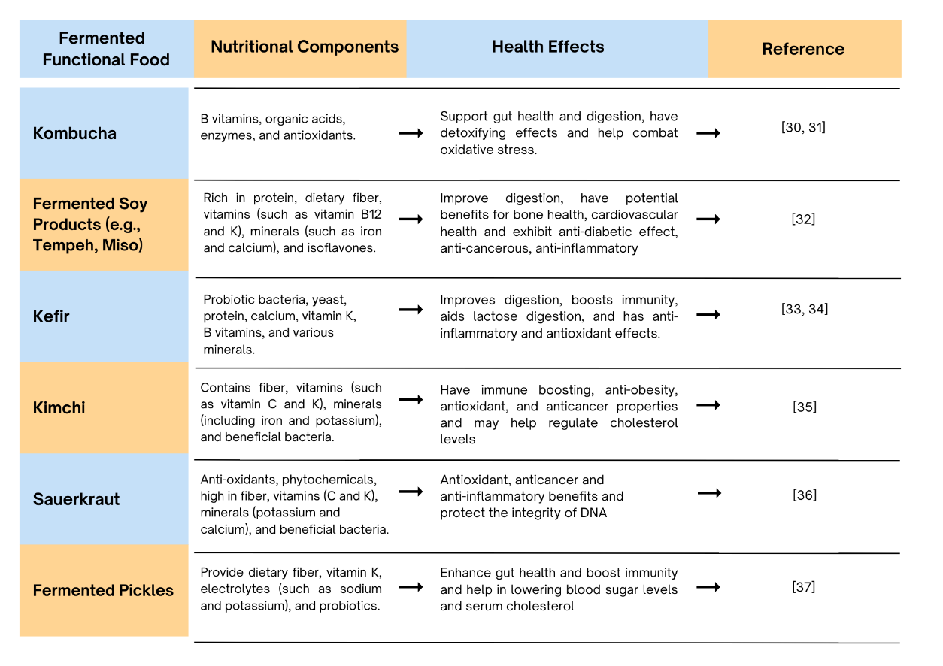

- Fermentation techniques and microorganisms used in creating functional foods.
The use of fermentation techniques to improve the flavors, textures, and nutritional profiles of foods is essential for their development as functional foods. The particular functional food being produced and the desired results determine the fermentation process to be used. Every approach has its own advantages, such as longer shelf life, higher nutritional content, better flavors, and the addition of beneficial microbes [38]. Foods that are useful are turned into delectable, health-improving goods by using the power of fermentation.
Creating functional foods through fermentation involves the application of specific fermentation techniques and the use of various microorganisms. One commonly employed fermentation technique is lactic acid fermentation. Lactic acid bacteria (LAB) are used in this method to turn sugars into lactic acid. For this, lactic acid bacteria like species of Bifidobacterium, Streptococcus, and Lactobacillus are frequently used. Lactic acid is the main byproduct of the fermentation of carbohydrates. Fermented dairy products like yoghurt, kefir, and some kinds of cheese are made using lactic acid fermentation. It is also used in the creation of fermented vegetables like kimchi and sauerkraut [39].
Another fermentation technique is acetic acid fermentation, which involves the conversion of ethanol into acetic acid by acetic acid bacteria. Acetic acid bacteria, primarily from the Acetobacter and Gluconacetobacter genera, are used for acetic acid fermentation. These bacteria convert ethanol, typically derived from fermented beverages like wine or cider, into acetic acid through oxidative fermentation. This technique is used to produce vinegar, which is a functional food with potential health benefits [40].
Yeast fermentation is a process in which yeast converts sugars into alcohol and carbon dioxide through anaerobic respiration. Various yeast strains, such as Saccharomyces cerevisiae, are used for yeast fermentation. They metabolize sugars present in the starting material, producing alcohol and carbon dioxide. Alcoholic beverages like wine, beer, and sake are made using this method. Bioactive substances like polyphenols and antioxidants may be present in fermented beverages, which may have health benefits [41].
Tempeh fermentation is another technique used to create functional foods. It involves the solid-state fermentation of soybeans using specific molds. The fermentation of tempeh is typically carried out by the fungus Rhizopus oligosporus or Rhizopus oryzae. The mold spores are inoculated onto cooked soybeans, allowing them to grow and produce mycelium that binds the soybeans together. Tempeh fermentation increases the availability of nutrients, such as vitamins and minerals, and enhances the digestibility of soy proteins [42].
Koji fermentation is a traditional fermentation technique used in East Asian countries, particularly in the production of soy sauce, miso, and sake. It involves the solid-state fermentation of grains or legumes using a specific mold called koji. The most commonly used koji mold is Aspergillus oryzae. This mold produces enzymes that break down complex carbohydrates, proteins, and lipids into simpler forms, enhancing the nutritional value and bioavailability of the fermented product. Koji fermentation is responsible for the characteristic flavors and aromas of soy sauce, miso, and other fermented condiments [43].

- Promising Trends and Opportunities in the Development of Novel Functional Foods
Emerging trends and opportunities for the development of novel functional foods are continuously evolving as consumer demand for healthier and more nutritious food options increases. One key trend is the rise of plant-based functional foods. With the growing popularity of plant-based diets and environmental concerns, companies are exploring new plant protein sources such as peas, lentils and hemp. These ingredients offer various health benefits, including high protein content, essential amino acids, and lower environmental impact compared to traditional animal-based proteins [44].
Another trend is the focus on gut health and microbiome-targeted foods. There is increasing recognition of the importance of a healthy gut microbiome for overall well-being. In order to support gut health, probiotics, prebiotics, and synbiotics a combination of prebiotics and probiotics are being added to functional foods. Due to their probiotic content and advantages for immune system and digestion, fermented foods like yoghurt, kefir, sauerkraut, and kombucha are becoming more and more popular [45, 46]. The functional beverage market is also expanding rapidly. Manufacturers are developing beverages enriched with vitamins, minerals, antioxidants, and herbal extracts to provide health benefits. Functional beverages can target specific needs such as energy enhancement, stress reduction, cognitive function, or hydration. Examples include enhanced waters, herbal teas, and beverages with added vitamins, adaptogens, or natural stimulants [47].
Advances in technology and data analytics are enabling personalized nutrition solutions. Companies are exploring the development of functional foods tailored to individual genetic profiles, dietary needs, and health goals. DNA testing and wearable devices can provide insights into an individual's nutritional requirements, enabling the creation of personalized functional food products, supplements, and meal plans [48]. The COVID-19 pandemic has increased consumer interest in immune-boosting foods and ingredients. Functional foods fortified with immune-supportive nutrients such as vitamins C, D, E, zinc and selenium are in high demand [49].
Brain health and cognition are also key areas of focus. As the aging population grows, there is an increasing demand for foods that support brain health and cognitive function. Functional foods enriched with omega-3 fatty acids, antioxidants, vitamins, and minerals are being developed to promote memory, focus, and mental clarity [50]. Sustainability and eco-friendliness are important considerations for consumers. Novel functional foods that are produced sustainably, minimize waste, and utilize eco-friendly packaging materials are gaining popularity [51]. Overall, these emerging trends and opportunities in the development of novel functional foods reflect the evolving consumer preferences towards healthier, sustainable, and personalized food options. Ongoing research, technological advancements, and collaborations between food scientists, nutritionists, and health professionals will further drive innovation in functional food development.

- FERMENTATION IN BIOPHARMACEUTICALS: REVOLUTIONIZING DRUG DEVELOPMENT AND PRODUCTION

Pharmaceutical drugs made from biological sources and produced using biotechnology techniques are referred to as biopharmaceuticals, also known as biologics. These medications are made up of complex, big molecules, mostly proteins or antibodies. The importance of biopharmaceuticals stems from their crucial function in the creation and administration of medications. In comparison to conventional pharmaceuticals, they offer highly targeted treatments by interacting with particular molecules or cells in the body, leading to increased effectiveness and fewer side effects. Biopharmaceuticals have revolutionized the way that previously challenging-to-treat diseases are now treated. They offer improved biocompatibility, lowering the possibility of negative reactions. Additionally, they have intricate modes of action that involve targeting therapeutic payloads or blocking receptors. Biopharmaceuticals have significantly improved the treatment of chronic illnesses and are now essential to targeted therapy [52].

- Harnessing Fermentation for Biopharmaceutical Manufacturing: An Essential Role
By utilizing the metabolic capabilities of microorganisms, fermentation has revolutionized the development and production of biopharmaceuticals. In order to effectively produce particular therapeutic molecules like proteins, enzymes, antibodies, and hormones, scientists can manipulate the growth conditions of microorganisms using this technique, which has become a cornerstone in drug discovery. Biopharmaceuticals can be produced on a large scale by optimizing the fermentation process, ensuring their accessibility for patients in need. Introducing the genes that code for the desired protein into the host cell is a crucial step in the fermentation process when it comes to producing therapeutic proteins. After that, this altered cell is grown in a controlled fermentation procedure, giving it a nutrient-rich medium for growth and protein synthesis. Once the cells have multiplied and the desired protein has been produced, it is harvested and put through purification and formulation processes to become the finished pharmaceutical. This streamlined process makes it possible to produce therapeutic proteins, antibodies, vaccines, and other drugs with biological origins quickly and effectively, satisfying the growing demand for new and potent treatments [53].
Host cells that have been genetically modified to produce the desired antibody are used to make monoclonal antibodies. These cells are developed in bioreactors where they undergo controlled fermentation to generate significant amounts of the antibody. Purified and prepared for therapeutic use, the harvested antibodies are next processed [53, 54]. Fermentation is used to create bacterial or viral antigens that trigger an immune response in the production of vaccines. To make the vaccine formulation, these antigens are first processed after being expressed in host cells and growing in bioreactors. Fermentation methods are used to produce a variety of vaccines, including those for hepatitis B, HPV, and influenza [53]. Enzymes, hormones, growth factors, and cytokines are just a few biologically derived drugs that are produced in large quantities using fermentation. Genes encoding these therapeutic molecules are introduced into host cells during this process, and the host cells are then grown and fermented to help produce the desired drugs. It is impossible to overstate the importance of fermentation to the production of biopharmaceuticals because it has completely changed the industry by making it possible to create novel, efficient treatments for diseases with rising demand [55].

- Essential Factors for Ensuring Successful Fermentation in Biopharmaceutical Production
The production of biopharmaceuticals depends on a number of variables for successful fermentation. Facilities, environmental factors, and important process components are all included. By offering a controlled environment for microbial growth and product formation, large-scale fermenters or bioreactors play a crucial part. The preservation of sterility in media, apparatus, and vessels is guaranteed by sterilization equipment like autoclaves. To purify and isolate the desired biopharmaceutical product, facilities should also have downstream processing equipment [55].
Another crucial factor is the choice of microorganisms, with cell lines like the Chinese Hamster Ovary mammalian cell, yeast, and bacteria like Escherichia coli frequently used [56]. To increase productivity or introduce particular metabolic pathways required for the production of biopharmaceuticals, genetic modification may be used. Commonly found in the growth medium, which supplies vital nutrients for microbial growth, are carbon and nitrogen sources, vitamins, minerals, and other essential elements. To increase productivity, the growth medium may need to be optimized by changing nutrient concentrations, pH levels, or adding particular supplements or inducers [57].
To ensure successful fermentation, it is essential to maintain certain environmental conditions. As microorganisms have specific temperature requirements for ideal growth and product formation, temperature control is crucial. While oxygen supply is necessary for aerobic fermentations and oxygen-free conditions are needed for anaerobic fermentations, pH control regulates enzyme activity and product stability. Several optimization techniques can be used to increase product yield while preserving cell viability. Adjusting process variables like temperature, pH, agitation, and aeration rate falls under this category. At various stages of fermentation, additional nutrients or inducers can be added to implement feed strategies. To ensure successful biopharmaceutical production, factors like mixing, mass transfer, and equipment design must be taken into account when scaling up the fermentation process from lab-scale to large-scale production [58]. It is important to remember that depending on the target product and the intended scale of production, the precise conditions for a successful fermentation in the production of biopharmaceuticals can change. The fermentation process is typically fine-tuned for each unique application through process development and optimization.

- Examples of successful biopharmaceutical products developed through fermentation processes
The development of biopharmaceutical products through fermentation processes, which have had a significant impact on both drug development and patient care, has transformed the field of medicine. These products, which are derived from living things or their parts, are fermented using contemporary methods. Numerous biopharmaceutical products, including insulin for the treatment of diabetes and monoclonal antibodies for the targeted treatment of cancer, have been successfully produced through fermentation. These examples show how fermentation can be used to make potent, life-saving medications. Table 2 showcases notable instances of biopharmaceutical products that were successfully manufactured utilizing fermentation techniques and the microorganisms employed in the fermentation process [56, 59].

Table 2: Biopharmaceutical products produced through fermentation, their health benefits, and microorganisms used for fermentation

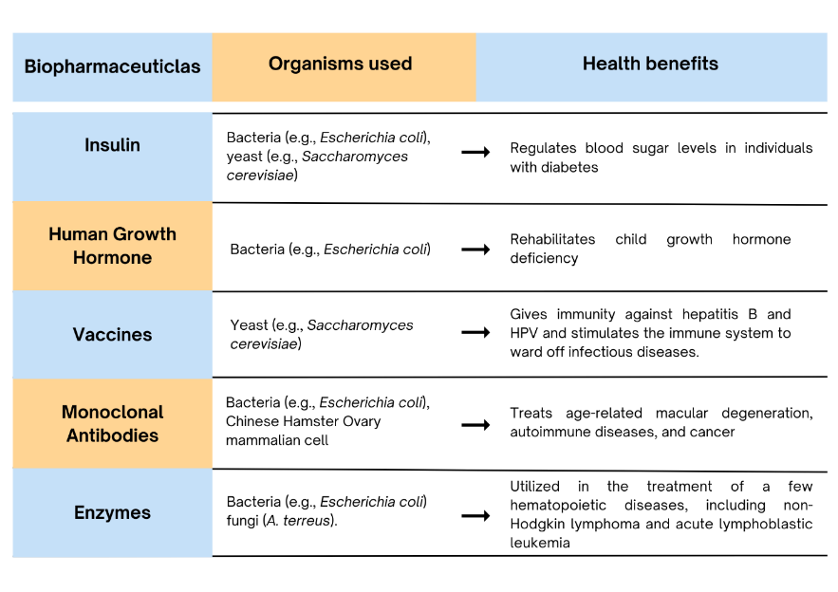

- Overview of the subsequent steps involved in downstream processing
It takes several steps to separate and purify the desired product from a biological source during downstream processing, an important stage in the production of biopharmaceuticals. Harvesting is the first step in the process, during which the product is taken from tissue samples, fermentation broth, or cell cultures. To separate the cells from the culture medium, the harvested material is subjected to cell removal. The removal of impurities like aggregates or cell debris is then accomplished through the use of a clarification step. Following clarification, the product goes through purification, during which the desired biopharmaceutical is isolated using a variety of separation techniques like chromatography, precipitation, or filtration. Following formulation to prepare the concentrated product for stability, the right dosage form, and administration, concentration methods may be used to increase potency or reduce volume [60, 61].
To guarantee product safety, sterilization procedures are used, and the filled and finished product goes through rigorous quality control testing. The product is then distributed in accordance with legal requirements and good distribution practices (GDP) after being stored in an appropriate environment. Before biopharmaceutical products are delivered to hospitals, pharmacies, or patients, these steps guarantee their efficacy, safety, and purity [62].

- Overview of Regulatory Guidelines and Requirements for Fermentation in Biopharmaceutical Production
The production of proteins, antibodies, vaccines, and other biological products is made possible by fermentation, which is essential to the production of biopharmaceuticals. While there are regional variations in the regulations and requirements relating to fermentation, some general guidelines are followed. The fundamental rules, including facility design, equipment validation, process controls, documentation, employee training, and quality control, are provided by good manufacturing practices (GMP). By providing proof that the fermentation process consistently results in products with the desired quality attributes, process validation ensures consistency and dependability. To guarantee the safety, purity, and potency of biopharmaceutical products, stringent quality control procedures are used, such as microbial testing and product identity assays [62].
To obtain approval for their products, biopharmaceutical companies must file regulatory documents such as IND applications, BLAs, or MAAs. Comprehensive details on the host organism, fermentation conditions, downstream processing, and product characterization are all included in these filings. To keep a clean and controlled manufacturing environment, environmental monitoring programmes are put in place. The parameters, raw materials, equipment, and facility design are all covered in risk assessments to find and reduce any potential risks related to fermentation. Data integrity should be preserved throughout the fermentation process, and any modifications to the procedure, machinery, or facility must go through a formal change control procedure [63]. Regulatory agencies examine batch records to determine whether standards are being followed. Companies must comprehend specific rules issued by organizations like the FDA or EMA and seek their advice to ensure compliance. Biopharmaceutical companies can uphold high standards of quality, safety, and efficacy in their fermentation-based production processes by adhering to these rules and specifications [64].

- Emerging Trends, Challenges, and Opportunities in Fermentation-Based Biopharmaceutical Production
Production of fermentation-based biopharmaceuticals is significantly evolving and changing as a result of new technologies and creative strategies. Traditional batch processes are losing favor in favor of continuous manufacturing, which offers many advantages like improved process control, increased productivity, and reduced manufacturing footprint. Continuous fermentation systems in particular allow for steady-state operations, which boosts product yields and ensures constant product quality [65]. Production of fermentation-based biopharmaceuticals is also utilizing more single-use technology, such as bioreactors and disposable tools. These innovations improve process flexibility, do away with the need for thorough cleaning and sterilization, and lower the risk of cross-contamination. Additionally, they enable quicker process setup and require less capital investment [66]. Additionally, bioprocessing is being transformed by the incorporation of advanced analytics, machine learning, and process control techniques. With data analytics and real-time monitoring of key process parameters, processes can be better understood, deviations can be caught early, and processes can be optimized. This development opens the door for fermentation processes that are more reliable and effective [67].
The emergence of cell-free systems is another fascinating development in the manufacture of biopharmaceuticals. Since cell wall restrictions are removed in cell-free systems, precise control over protein production is possible. They are perfect for difficult proteins like membrane proteins and toxins and optimize protein production by modifying reaction conditions. By cutting out cell culture, extensive purification steps, and gene transfection, they speed up the production process. PCR-generated templates are used to simplify gene expression. Despite issues like lower protein yields and higher costs, ongoing advancements aim to increase scalability and efficiency [68].
Several difficulties with the production of fermentation-based biopharmaceuticals still exist, despite these developments. Process scaling up and optimization remain challenging tasks that necessitate a thorough understanding of biology, process dynamics, and engineering principals [55]. Another major challenge is managing product heterogeneity, as biopharmaceutical products may differ as a result of things like post-translational modifications and protein aggregation [69]. It is essential to ensure consistent product quality, which motivates efforts to enhance process control and create cutting-edge analytical tools for characterization.
However, the production of biopharmaceuticals based on fermentation offers promising prospects. One such opportunity is personalized medicine, which enables the development of customized treatments aimed at particular patient populations or even individual patients [70]. The development of biosimilar, which provide affordable substitutes for current biopharmaceutical products, is also gaining traction [68, 71]. By utilizing renewable feedstocks, improving process effectiveness, and implementing green technologies to lower the carbon footprint of biopharmaceutical manufacturing, fermentation-based production processes can also contribute to sustainable manufacturing [72, 73].
Overall, the advancements and challenges in fermentation-based biopharmaceutical production are shaping the future of this field, opening doors to innovative therapies, improved manufacturing processes, and a more sustainable approach to drug production.

- MICROBIAL CONSORTIA IN FERMENTATION: HARNESSING SYNERGISTIC INTERACTION FOR ENHANCED BIOPROCESSING

Bioprocessing is ultimately depending on the microbial metabolism. Both single microbial species and consortia of microbes are making the fermentation active. Unlike the single species, combinations of microbial species are much contributing to an effective fermentation which provides high yields. Different kinds of interactions among the microbial species are the foremost reason for the enhanced and efficient production [74]. Each microorganism belongs to a consortium might have different metabolic characteristics. So each can contribute their own abilities to the bioprocessing and that will aid the effective usage of the wide range of available resources.
Microbial consortia are the complex of diverse microorganisms that coexist and interact in a community. Various microorganisms belongs to bacterial, algal, fungal and other communities take part in diverse interactions like mutualistic, commensal and competitive relationships. The fundamental characteristics of microbial consortia include cooperative interactions (byproducts of one used by others will lead to increased efficiency and productivity), niche differentiation (avoid direct competition among species and effective utilization of diverse resources) and spatial organization (different species exhibit specific pattern or structure of colonization to facilitate operative communication, resource utilization and productive interactions) [75]. Different microorganisms play distinct role in a consortium as degraders, cross feeders, synergistic metabolizers, quorum sensing regulators, biofilm formers, niche occupiers, etc. In this chapter, we are discussing about the synergistic interactions among the microbial consortium and their benefits in bioprocessing.

- Role of synergistic interaction within microbes and the benefits in bioprocessing
With respect to pure cultures, in a microbial consortium each microorganism has specific roles depending on their metabolic functions, adaptations, and the nature of interactions with others collectively promote the bioprocessing capability, stability and efficiency. Xander, a gene-targeted metagenomic assembly technique, was employed to study the cooperative relationships between different microbial communities during the fermentation of lignocellulolytic biomass. The findings demonstrated that these synergistic interactions play a pivotal role in improving biomass degradation and biofuel production. These interactions facilitate the division of labor among microorganisms, promote the exchange of metabolites, and enable the coordination of their metabolic activities, ultimately leading to higher yields, optimized substrate utilization, and increased resilience of the entire system [76]. The figure 3 presents an overview of the characteristics and effects resulting from the synergistic interactions of microbial consortia. The role of synergy in microbial consortia will ultimately leads to a concept of ‘whole being is always greater the sum of its parts’ [77, 78, 79].

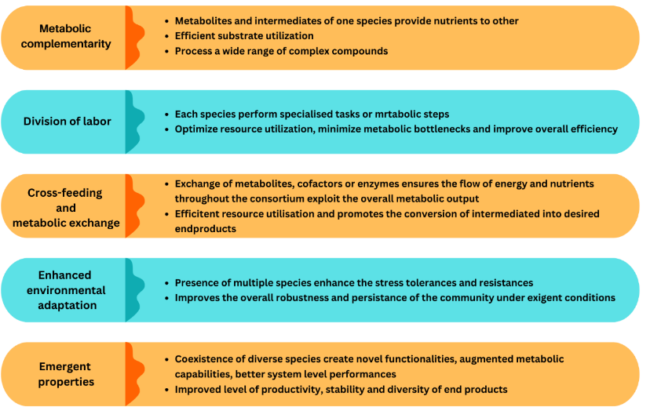
Figure 3: Characteristics and Effects of Synergistic Interactions of Microbial Consortia

In the biofuel production, the lignocellulosic degradation is making possible by the synergistic cooperation between the microorganisms. In a study focused on corn stover degradation, it was revealed that cellulolytic bacteria exhibited proficient cellulose hydrolysis, while fungi played a crucial role in facilitating xylan degradation. The combined action of these microorganisms resulted in significantly enhanced biomass production [80]. Like, acetate producing bacteria, methanogens and syntrophic acetate oxidizing bacteria undergo synergistic relationship in the bioprocess yields methane [81]. In the wine production, the interactions among complex microbes are the cause of various flavors and aromas and also, improve the sensory profile, stability and quality [82]. Yeasts convert sugar into alcohol and Lactic acid bacteria perform malolactic fermentation.

- Engineering Microbial consortia for enhanced bioprocessing
Several techniques are used in the planning and construction of microbial consortia in order to achieve specific functions and improve the effectiveness of bioprocessing. One of the important among them is strain selection based on their metabolic capabilities. For the intent of developing a functional consortium, microorganisms with complementary metabolic abilities must be carefully chosen. By using this tactic, the consortium's various species are ensured to carry out certain functions and add to the overall metabolic network. For example, researchers conducted a study aiming to develop a synthetic consortium dedicated to butanol synthesis. The successful conversion of multiple carbon sources into butanol relied on the strategic selection of bacteria possessing diverse metabolic pathways [83].
Another strategy is genetic engineering and synthetic biology tools. Techniques for genetic engineering can be used to alter and improve the metabolic processes of different species within a consortium. With this strategy, it is possible to create particular enzymes, pathways, or regulatory components to increase compatibility and improve desired functionality. In a study, researchers developed bioplastics by employing a two-bacterium consortium. To enhance the metabolic pathways and increase the yields of the desired bioplastic polymers, genetic modification techniques were utilized. Spatial organization played a crucial role in facilitating cooperative interactions and distinguishing between niches within the microbial consortia. This organization can be achieved by engineering physical structures or creating appropriate microenvironments. The design of a synthetic consortium is essential for producing complex bioactive molecules [84]. In a research study, a synthetic consortium was established to generate a sophisticated bioactive chemical. The consortium consisted of various cell types enclosed within hydrogels, enabling spatial organization that improved substrate transfer efficiency and resulted in higher production yields [85].

- Applications
Synergistic interactions among the microbes are the key aspect of the bioprocessing to get better yield. So it has been studied and exploited in the diverse areas of bioprocessing includes waste water treatment, bioremediation, lignocellulosic degradation, production of alcohol, biogas, pharmaceuticals, food products, value added compounds, etc. The enhanced performance and expanded capabilities of microbial consortia helped the degradation of complex lignocellulosic biomass into valuable products like biofuels and platform chemicals. A study explored the possibility of enhancing biofuel production through the combined action of cellulolytic and hemicellulolytic bacteria during the degradation of lignocellulosic biomass [86]. A group of researchers investigated the unique metabolic abilities of consortium members, which enable the efficient decomposition of organic matter and the elimination of contaminants from wastewater. Their findings demonstrated that the applications and benefits of using a consortium surpass those of single strain systems [87]. Hydrocarbons, heavy metals, and pesticides can all be effectively degraded through the metabolic interactions between the various consortium members. So as bioremediation, microbial consortiums are used to clean up contaminated environments, such as soil and water [88]. In the bio production of various value-added compounds, including pharmaceuticals, enzymes, and specialty chemicals, the efficient transformation of substrates into desired products is made possible by the cooperative interactions within the consortia [89].

- Analytical approaches to study microbial consortia in bioprocessing
It is necessary to study microbial consortia using analytical techniques that can provide information on the composition, dynamics, and function of the microbial community. Using the profiling of microbial communities at high resolution is made possible by high-throughput sequencing technologies such as 16S rRNA sequencing and shotgun metagenomics. These methods reveal details regarding the consortium's taxonomic diversity and functional potential [90]. The complete profiling of small compounds made by microbial consortia is made possible by metabolomics. This method offers insights into the consortium's metabolic processes, metabolic relationships, and functional outcomes. Metabolomics techniques, such as liquid chromatography-mass spectrometry and gas chromatography-mass spectrometry, are frequently used to analyze the consortium's metabolites [91].
Using a microscopic technique called FISH, distinct microbial groups within a consortium can be seen and identified. It makes use of fluorescently labelled oligonucleotide probes that are directed at certain microbial species and provide details on their spatial distribution and relative abundance within the consortium [92]. Stable Isotope Probing (SIP) is an additional technique. This method identifies the metabolically active members of a microbial consortium. When certain substrates are mixed with stable isotopes (like 13C or 15N), labelled microbial populations can then be discovered using techniques like DNA or RNA sequencing. SIP provides perceptions into the roles and patterns of various consortium members' substrate usage. It can also be used to research how microbial consortiums contribute to biogeochemical cycling [93].

- FERMENTATION-BASED BIOREMEDIATION: GREEN SOLUTIONS FOR ENVIRONMENTAL CLEANUP

Utilizing microorganisms to break down and transform pollutants into less harmful forms, bioremediation is an environmentally friendly method for cleaning up contaminated areas. This environmentally friendly technique can be used on-site, causing little disruption to the ecosystem, and it works to remove a variety of contaminants [94]. Bioremediation offers a reasonably priced and environmentally safe alternative to conventional cleanup techniques like chemical treatment and excavation for polluted sites. It doesn't create dangerous byproducts, and the employed microorganisms are adaptable and support ongoing remediation [95]. Bioremediation fits into more comprehensive strategies for sustainable land and water management because it is consistent with environmental conservation principles [96].
In bioremediation, fermentation is essential and serves two main functions. First off, it helps to produce fermentation products that degrade pollutants into simpler compounds, increasing the effectiveness of biodegradation as a whole. Second, fermentation creates anaerobic conditions that are perfect for breaking down some contaminants that are difficult to treat, like heavy metals and chlorinated compounds [97]. Utilizing fermentation has benefits like in-situ application and controlled optimization, which reduce environmental disturbance. Understanding the nature of the contaminant and having the right microbial communities are essential for fermentation-based bioremediation to be successful. Effective site characterization is necessary for putting strategies into practice [95].

- Various fermentation-based bioremediation techniques
Environmental cleanup methods that rely on microbial fermentation processes are collectively referred to as fermentation-based bioremediation. These techniques fall broadly into the categories of aerobic and anaerobic processes, as well as bio augmentation and bio stimulation techniques. Utilizing oxygen-dependent microorganisms, aerobic bioremediation breaks down organic pollutants. It is effective for petroleum hydrocarbons because the amount of oxygen in the contaminated areas is increased, supporting the development and activity of aerobic bacteria and fungi that break down pollutants into simpler, less harmful substances [95]. Anaerobic bioremediation, on the other hand, uses microorganisms that can survive in environments with little to no oxygen. It is appropriate for contaminants that are challenging to break down, such as some heavy metals and chlorinated solvents. Specific bacteria use pollutants as electron acceptors or donors during fermentation in anaerobic environments, resulting in the transformation of the pollutants into less toxic forms [95].
In order to improve the efficiency of the already present microbial community, bio augmentation entails introducing specialized microbial strains or consortia with improved pollutant-degrading capabilities to the contaminated site. When the necessary metabolic diversity is not present in the natural microbial population, this method is hel.pful [98]. Last but not least, bio stimulation aims to increase the activity of native microorganisms by supplying extra nutrients or growth-promoting substances. Bio stimulation enhances the degradation of organic pollutants in a practical and long-lasting way by enhancing microbial growth and metabolic activity [98].
Overall, fermentation-based bioremediation provides adaptable and environmentally responsible solutions for cleaning up a variety of contaminated sites, offering promising ways to restore the environment while reducing ecological impact.

- Microbial Communities & Enzymes: Key to Fermentation-Based Bioremediation.
The success of fermentation-based bioremediation depends on the involvement of numerous microbial communities that are each equipped with specialized enzymes for the efficient degradation of different contaminants. These microorganisms are vital to the bioremediation process because they are essential in the transformation of pollutants into less harmful ones. For instance, a variety of microorganisms that break down hydrocarbons, such as bacteria like Pseudomonas, Alcaligenes, and Mycobacterium species, can be found in hydrocarbon-contaminated sites. These bacteria produce particular enzymes that function as catalysts to transform alkanes into fatty alcohols and aldehydes, which are then further metabolized by the microorganisms, gradually removing the pollutants [95].
Dehalorespiring microbial communities are essential to bioremediation in anaerobic environments contaminated with chlorinated solvents. Bacteria like Dehalococcoides and Dehalobacter species, which have specialized enzymes like reductive dehalogenases, make up these communities. These enzymes help the reductive dechlorinating procedure, which gradually removes chlorine atoms from chlorinated solvents. This enzymatic process is essential for converting dangerous and persistent chlorinated compounds into safe compounds, accelerating the cleanup of contaminated sites [96].
Heavy metals and some organic compounds can be bio remediated with the help of sulfate-reducing bacteria (SRB). In a bioreactor experiment, sulfate-reducing bacteria (SRB) were utilized to assess the effectiveness of different organic carbon sources (dairy, chicken, and sawdust manure) in removing sulfates and heavy metals. The results demonstrated that after 35 days of treatment, chicken manure exhibited the highest sulfate removal rate at 79%, followed by dairy manure at 64%, and sawdust at 50%. Sawdust showed relatively lower performance due to its lower biodegradable fraction and higher acidity compared to the manure sources. The experiment successfully removed metals such as Cd, Cu, Fe, Mn, Ni, and Zn. Furthermore, the study revealed that a consistent supply of organic carbon not only enhances sulfate and heavy metal removal efficiency but also stimulates the growth of SRB [99]. Additionally, SRBs take part in the anaerobic sludge blanket reactor-based sulphate and heavy metal removal from acid mine drainage. They accomplished a remarkable 99% sulphate removal over a 500-day period, as well as 98–100% removal of As, Cu, Fe, Ni, and Zn. Desulfomicrobium baculatum and Desulfovibrio desulfuricans were the two species of sulfate-reducing bacteria that were discovered. Their metabolic capacities significantly aid in the cleanup of contaminated areas, especially in anaerobic conditions with scarce oxygen availability. [100].
Fungi are important players in processes involving the oxidation of complex organic compounds like lignin and cellulose. In the aerated bioreactor containing wood chips, Phanerochaete chrysosporium was used to treat synthetic wastewater containing Naproxen and carbamazepine at concentrations of 20 mg/l. The study found that the bioreactor system effectively eliminated 59.7-91.3% of carbamazepine and 87.7-90.3% of naproxen from the wastewater [101]. The spent wash effluent from a distillery using Aspergillus oryzae MTCC7691 was treated in an immobilised fungal bioreactor. The bioreactor achieved notable removal efficiencies, including removal of 49% of phenolic pigments, 75% of colour, 51% of BOD, and 86% of COD [102]. The breakdown of recalcitrant organic matter by these fungi's enzymatic activities is essential for facilitating the remediation of sites contaminated with complex and difficult substances.
Overall, the success of fermentation-based bioremediation strategies is driven by the diverse microbial communities and their unique enzymes. The ability to comprehend and control these microorganisms and their enzymatic properties is crucial for optimizing bioremediation strategies for various contaminants and environmental circumstances, delivering efficient and eco-friendly solutions for environmental cleanup.

- Integrating Fermentation-Based Bioremediation with Other Technologies.
Environmental cleanup efforts can be improved by combining fermentation-based bioremediation with other cutting-edge technologies, which opens up exciting new possibilities. To improve microbial interactions and accelerate the degradation of contaminants, bioremediation can be combined with nanotechnology, which deals with materials and structures at the nanoscale. Nanoparticles, when applied directly to polluted areas, have the capacity to serve as carriers for nutrients or electron acceptors. This facilitates the stimulation of particular microorganisms engaged in the process of bioremediation. Nanomaterials can also act as powerful sorbents, trapping pollutants and accelerating their biodegradation. By enabling targeted and effective pollutant removal, this integration improves the overall efficiency of the bioremediation process [103].
In the area of bioremediation, genetic engineering has enormous potential. Researchers can improve the capacity of microorganisms for biodegradation by introducing particular genes or gene clusters into microbial communities [104]. In order to increase the efficiency of degrading pollutants, genetically modified bacteria can produce novel enzymes with increased substrate affinity or broader substrate specificity. Additionally, genetic modification can make microorganisms more resilient to adverse environmental conditions, enabling them to survive and function in difficult bioremediation sites [105]. However, careful consideration of potential ecological risks associated with the release of genetically modified organisms is crucial to ensure the safety and sustainability of these approaches.
Environmental cleanup procedures have a great deal to gain from the fusion of genetic engineering, nanotechnology, and fermentation-based bioremediation. These integrations provide innovative and focused ways to clean up contaminated sites, reduce their negative effects on the environment, and rebuild ecosystems. To ensure the ethical and long-term use of these technologies in bioremediation efforts, it is essential to approach these advancements cautiously, carefully weigh any potential risks, and put in place the necessary safety measures.

- FERMENTATION AND CIRCULAR ECONOMY CLOSING THE LOOP IN SUSTAINABLE RESOURCE MANAGEMENT

Two interconnected strategies fermentation and the circular economy have emerged as key players in the pursuit of sustainable resource management in closing the waste loop and fostering environmental stewardship. Industrial fermentation uses microorganisms to turn raw materials into useful products, but it also produces waste as a side effect of the process. The circular economy idea has been incorporated to address this issue, with a focus on resource recovery and the production of value-added materials from waste. It is possible to move towards a more sustainable future where waste is reduced, resources are effectively used, and the material cycle is closed, benefiting both the present and the next generation, by combining the principles of fermentation and the circular economy.

- Industrial Fermentation: Sustainable Applications and Waste Management
In industrial fermentation, different valuable products are produced by selectively transforming raw materials using microorganisms like bacteria, yeasts, and fungi. These products include ethanol, amino acids (lysine, glutamic acid, threonine), natural acids (such as citric, lactic, succinic, itaconic, etc.), and antibiotics (such as penicillin, tetracycline, cephalosporin, polyketides, etc.). Antibiotics are derived from secondary metabolites, obtained via aerobic fermentation in submerged culture under sterile conditions. Similar processes exist where other types of cells, like mammalian cells, are used to produce bio-pharmaceuticals such as immunoglobulins, monoclonal antibodies, and more. Industrial fermentation yields different types of biochemical compounds that find application in various industries, have a significant impact on economic growth, and benefiting people through the products produced. Many countries host diverse industries that manufacture fermented end products consumed by people in various forms. However, these industrial processes generate a considerable amount of waste. At the end of each day, these wastes are collected and either reused or reformed for use in various industries [73].

- Harnessing bio-char from waste for sustainable bio-fuels and energy: Advancing resource recovery.
Resource recovery is the process of using different types of waste treatment to produce new materials with added value. This idea can be used to recover valuable resources for the creation of new products from a wide range of materials found in municipal solid waste (MSW), bio waste, construction waste, industrial waste, and more. Utilizing bio-char that is created by synthesizing bio-waste, innovative technology has been developed to produce biofuels and bioenergy. At two different temperatures, 250 °C and (the second temperature is absent from the text provided), the bio-char is produced through pyrolysis [106].

- Micro algal-based bio-refinery
A bio-refinery is a facility that transforms waste and biomass into energy, fuels, and numerous products with value additions. There are various types of bio-refineries that can be used, depending on the feedstock that is available and the desired end products. Innovative bio-refining technologies and bio-energy processes require the development of pilot-scale pre-treatment and fermentation facilities. Focus must be placed on integrated systems, which include sensor-based technologies for bio refining and bioenergy processes, wireless technologies, software, hardware, statistical approaches for process optimization, and more [107]. The field of bio-refineries has undergone significant recent research and development. To develop more energy-efficient, environmentally friendly, and economically advantageous processes, additional in-depth study is required, including thorough life cycle assessment studies [106].

- Modelling and simulation of energy systems
Energy system modelling is essential for the creation of modern, environmentally friendly, and economically advantageous energy systems. To understand, create, and maintain systems that aim for technical advancements, higher economic returns, and environmental benefits, various computer models are used. The goal of a study that was published in NAXOS 2018 VSI was to simulate advanced gasification systems. The authors used a brand-new model called MAGSY that is based on the process-based model and vis-à-vis [106].

- Circular Economy in fermentation
The origins of the circular economic system can be traced back to its severe critique of theories and empirical studies from various educational disciplines, including environmental economics, ecological economics, commercial ecology, and others [108]. The circular economic system also includes a critique that evaluates the potential tensions and obstacles inherent in the adoption and implementation of circular economic structures.
In the examination of the economy's relationship with previous research, the researcher clarifies how the proposition of the circular economic system, with its closed-loop structures, is being planned, implemented, and measured by sustainable groups and policymakers in specific contexts. This contribution sheds light on the concept of the circular financial system and offers a critique of its inherent boundaries. Furthermore, it identifies future research avenues that could be undertaken [108]. A typical Circular Economy in fermentation, involving the conversion of waste materials into organic fertilizers and the reduction of economic burden through the reuse of some organic byproducts of fermentation, has emerged as a key factor in achieving a sustainable future. The figure 4 illustrates the process of waste utilization from different sources within fermentation to produce organic fertilizers and various other organic byproducts. It visually demonstrates how this system efficiently manages waste and contributes to the production of valuable organic resources.

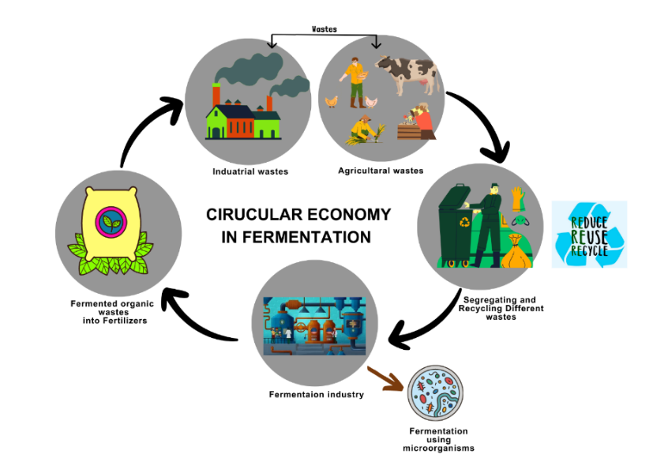
Figure 4: System of waste utilization in fermentation for organic fertilizer production and other organic byproducts

The Brundtland report urged societies, including businesses, to adopt an all-encompassing strategy for development that addresses current needs without jeopardizing the capacity of future generations to address their own. The underlying premise is that physical resources should be managed because they are finite and should be preserved for future generations. This justification fits the circular economy's definition. In order to reduce resource input, waste, emissions, and energy leakage, a circular economy aims to slow down, close, and restrict material and energy loops. To do this, strategies including long-lasting design, maintenance, repair, reuse, re-manufacturing, refurbishing, and recycling are used. The term "circular economy" gained popularity as its proponents framed it as the opposite of the linear economy. In contrast, the linear economy relies on the extraction of natural resources (through mining or unsustainable harvesting) in the production of goods, often leading to negative externalities such as waste pollution and environmental degradation. The linear economic model assumes an infinite supply of natural resources and an unlimited capacity of the environment to absorb waste and pollution [109]. On the other hand, the circular economy aims to reduce the throughput of energy and raw materials, designed to restore and regenerate resources [108]. Due to its toxic effects on the ecosystem and human health, environmental pollution brought on by anthropogenic activities and advanced industrialization is a serious issue in the modern era.
In order to meet consumer demand, the market for these products is growing in tandem with the rising demand for functional food on a global scale. But as a result, there is now a lot of organic waste being produced on a large scale from different places, such as the food industry, agriculture, cities, towns, and starch manufacturing. Globally, this has grown to be a serious problem. The transformation of this organic waste into value-added products through bioconversion presents an opportunity to address this problem by reducing waste generation and decreasing dependency on fossil fuels. Biomass currently contributes to around 10-14% of global energy production. Even urban pollutants like agricultural trash and industrial leftovers include valuable organic ingredients that may be turned into high-value goods. Given the sheer amount of organic waste, which is estimated to be more than 13 109 tons annually, using it in the upcoming years could be very advantageous [110].
Bioconversion is being used to create bio products that have definite advantages over traditional therapeutic approaches. With this strategy, the value of organic wastes has increased while the problem of ecological degradation has been resolved. Bio-refineries have become a top priority in the history of biomass conversion as a means of efficiently utilizing organic wastes with environmentally friendly methods. Early research on biomass transformation concentrated primarily on bioenergy, such as bioethanol and biodiesel, due to the dearth of fossil fuels. However, important advances in genetic manipulation that started in the early 20th century led to breakthroughs in waste bioconversion. These advancements paved the way for significant improvements in waste bioconversion, leading to the derivation of numerous intended bio-based products through various bio-transformation processes, depending on the type of organic wastes involved [110].
There are three stages to the entire bio-transformation methodology. After choosing the organic waste biomass, there is a phase in which microorganisms are genetically altered. Based on a precise analysis of the composition of the organic waste, the right pre-treatments are used to increase the efficiency of biomass conversion. Metabolic engineering plays a crucial role in this process, enabling scientists to gain a better understanding. The second stage, known as midstream regulation, aims to boost overall bioprocess productivity. During the conversion of organic waste to biomass, fermentation optimisation is frequently used to boost product concentration. In order to increase the rate of organic waste conversion, both the fermenter's configuration and the transformation parameters are crucial. The final step involves separating the products from the conversion system using an effective downstream technique. These organic streams' resource recovery is consistent with the circular economy strategy, which can help ease resource constraints and promote sustainability [110].
The integration of the circular economic model, which eliminates the use of hazardous synthetic substances preventing reuse and replaces the idea of "end of life" with "reclamation," involves transitioning to the use of renewable energy sources and focusing on effective material use planning. As a result, in order to adhere to the circular economy concept, novel bio-refinery approaches must be created while taking into consideration the fundamental elements of the financial system, society, and ecosystem. This would ideally enable the re-entry of produced bio-based food products into the food chain. The current study provides details on biomass classification and the advancement of bioconversion of organic wastes using industrial bio products as a paradigm [110].

- CONCLUSIONS

The book chapter "Fermentation Technology: Empowering Biotechnology for a Sustainable Future" delves into the vast potential of fermentation in revolutionizing biotechnology and driving us towards a more sustainable world. By harnessing the power of microorganisms, fermentation offers a plethora of benefits, from producing enhanced nutraceuticals and functional foods with added health advantages to developing targeted and effective medications with fewer side effects in the biopharmaceutical industry. The chapter emphasizes the critical factors for successful fermentation, including optimized growth conditions, careful microorganism selection, and precise environmental controls, ensuring product safety and quality. Collaboration and ongoing research continue to fuel innovation in this field, catering to consumer preferences for healthier, sustainable, and personalized food choices. The significance of microbial consortia is highlighted, showcasing their ability to enhance bioprocessing capabilities through synergistic interactions among diverse microorganisms. This cooperative nature leads to increased efficiency, improved substrate utilization, and system resilience in various bioprocessing applications.
Furthermore, fermentation-based bioremediation emerges as an eco-friendly approach to environmental cleanup, offering targeted and efficient solutions for managing pollutants in a sustainable manner. The integration of nanotechnology, genetic engineering, and circular economy principles further amplifies the potential of fermentation-based bioremediation, promoting resource recovery from waste and contributing to a greener future. Throughout the chapter, we observe how fermentation technology empowers biotechnology to tackle pressing challenges in public health, environmental pollution, and resource scarcity. By exploring opportunities in personalized medicine, biosimilar, and sustainable manufacturing, we pave the way for advancements in nutraceuticals and biopharmaceuticals, contributing to the improvement of public health and environmental protection.
In conclusion, fermentation technology serves as a linchpin in the journey towards a sustainable future. Its multifaceted applications inspire further research and innovation, offering a promising path to shape a brighter and more sustainable world for present and future generations. By leveraging the potential of fermentation across diverse sectors, we can foster improved public health, environmental stewardship, and responsible resource management, ultimately creating a world that thrives in harmony with nature.

REFERENCES

- Sun, W., Shahrajabian, M. H., & Lin, M. (2022). Research Progress of Fermented Functional Foods and Protein Factory-Microbial Fermentation Technology. Fermentation, 8(12), 688.
- Kuila, A., & Sharma, V. (Eds.). (2018). Principles and applications of fermentation technology. John Wiley & Sons.
- Parmar, A. B., Patel, V. R., Usadadia, S. V., Rathwa, S. D., & Prajapati, D. R. (2019). A solid state fermentation, its role in animal nutrition: A review. International Journal of Chemical Studies, 7(3), 4626-4633.
- Wikandari, R., Manikharda, Baldermann, S., Ningrum, A., & Taherzadeh, M. J. (2021). Application of cell culture technology and genetic engineering for production of future foods and crop improvement to strengthen food security. Bioengineered, 12(2), 11305-11330.
- Taveira, I. C., Nogueira, K. M. V., Oliveira, D. L. G. D., & Silva, R. D. N. (2021). Fermentation: humanity's oldest biotechnological tool. Frontiers for Young Minds, 9, 1-7.
- Mehta, M. D., & Gair, J. J. (2001). Social, political, legal and ethical areas of inquiry in biotechnology and genetic engineering. Technology in Society, 23(2), 241-264.
- Singh, J., & Sinha, S. (2012). Classification, regulatory acts and applications of nutraceuticals for health. International Journal of Pharma and Bio Sciences, 2(1), 177-187.
- Nwosu, O. K., & Ubaoji, K. I. (2020). Nutraceuticals: history, classification and market demand. Functional Foods and Nutraceuticals: Bioactive Components, Formulations and Innovations, 13-22.
- Samtiya, M., Aluko, R. E., Puniya, A. K., & Dhewa, T. (2021). Enhancing micronutrients bioavailability through fermentation of plant-based foods: A concise review. Fermentation, 7(2), 63.
- Elhalis, H., Chin, X. H., & Chow, Y. (2023). Soybean fermentation: Microbial ecology and starter culture technology. Critical Reviews in Food Science and Nutrition, 1-23.
- de Marco Castro, E., Shannon, E., & Abu-Ghannam, N. (2019). Effect of fermentation on enhancing the nutraceutical properties of Arthrospira platensis (Spirulina). Fermentation, 5(1), 28.
- Sharma, R., Garg, P., Kumar, P., Bhatia, S. K., & Kulshrestha, S. (2020). Microbial fermentation and its role in quality improvement of fermented foods. Fermentation, 6(4), 106.
- Patel, S., & Shukla, S. (2017). Fermentation of food wastes for generation of nutraceuticals and supplements. In Fermented foods in health and disease prevention (pp. 707-734). Academic Press
- Marco, M. L., Heeney, D., Binda, S., Cifelli, C. J., Cotter, P. D., Foligné, B., & Hutkins, R. (2017). Health benefits of fermented foods: microbiota and beyond. Current opinion in biotechnology, 44, 94-102.
- López-Varela, S., Gonzalez-Gross, M., & Marcos, A. (2002). Functional foods and the immune system: a review. European Journal of Clinical Nutrition, 56(3), S29-S33.
- Park, S., & Bae, J. H. (2016). Fermented food intake is associated with a reduced likelihood of atopic dermatitis in an adult population (Korean National Health and Nutrition Examination Survey 2012-2013). Nutrition Research, 36(2), 125-133.
- Lee, A., Lee, Y. J., Yoo, H. J., Kim, M., Chang, Y., Lee, D. S., & Lee, J. H. (2017). Consumption of dairy yogurt containing Lactobacillus paracasei ssp. paracasei, Bifidobacterium animalis ssp. lactis and heat-treated Lactobacillus plantarum improves immune function including natural killer cell activity. Nutrients, 9(6), 558.
- Yang, X., Nakamoto, M., Shuto, E., Hata, A., Aki, N., Shikama, Y., & Sakai, T. (2018). Associations between intake of dietary fermented soy food and concentrations of inflammatory markers: a cross‐sectional study in Japanese workers. The Journal of Medical Investigation, 65(1.2), 74-80.
- Shukla, R., & Goyal, A. (2013). Novel dextran from Pediococcus pentosaceus CRAG3 isolated from fermented cucumber with anti-cancer properties. International journal of biological macromolecules, 62, 352-357.
- Lu, C. C., & Yen, G. C. (2015). Antioxidative and anti-inflammatory activity of functional foods. Current Opinion in Food Science, 2, 1-8.
- Han, S. G., Han, S. S., Toborek, M., & Hennig, B. (2012). EGCG protects endothelial cells against PCB 126-induced inflammation through inhibition of AhR and induction of Nrf2-regulated genes. Toxicology and applied pharmacology, 261(2), 181-188.
- Chan, K. C., Pen, P. J., & Yin, M. C. (2012). Anticoagulatory and antiinflammatory effects of astaxanthin in diabetic rats. Journal of food science, 77(2), H76-H80.
- Asbaghi, O., Ashtary-Larky, D., Mousa, A., Rezaei Kelishadi, M., & Moosavian, S. P. (2022). The effects of soy products on cardiovascular risk factors in patients with type 2 diabetes: a systematic review and meta-analysis of clinical trials. Advances in Nutrition, 13(2), 455-473.
- Asgary, S., Rastqar, A., & Keshvari, M. (2018). Functional food and cardiovascular disease prevention and treatment: a review. Journal of the American College of Nutrition, 37(5), 429-455.
- Zhang, Z., Lanza, E., Kris-Etherton, P. M., Colburn, N. H., Bagshaw, D., Rovine, M. J., & Hartman, T. J. (2010). A high legume low glycemic index diet improves
- Srihari, T., Karthikesan, K., Ashokkumar, N., & Satyanarayana, U. (2013). Antihyperglycaemic efficacy of kombucha in streptozotocin-induced rats. Journal of Functional Foods, 5(4), 1794-1802.
- An, S. Y., Lee, M. S., Jeon, J. Y., Ha, E. S., Kim, T. H., Yoon, J. Y., & Lee, K. W. (2013). Beneficial effects of fresh and fermented kimchi in prediabetic individuals. Annals of Nutrition and Metabolism, 63(1-2), 111-119.
- Zhong, H., Deng, L., Zhao, M., Tang, J., Liu, T., Zhang, H., & Feng, F. (2020). Probiotic-fermented blueberry juice prevents obesity and hyperglycemia in high fat diet-fed mice in association with modulating the gut microbiota. Food & function, 11(10), 9192-9207.
- Choi, J. H., PB, T. P., Kim, M. J., & Cha, Y. S. (2016). Cheonggukjang, a soybean paste fermented with B. licheniformis-67 prevents weight gain and improves glycemic control in high fat diet induced obese mice. Journal of Clinical Biochemistry and Nutrition, 59(1), 31-38.
- Chong, A. Q., Lau, S. W., Chin, N. L., Talib, R. A., & Basha, R. K. (2023). Fermented Beverage Benefits: A Comprehensive Review and Comparison of Kombucha and Kefir Microbiome. Microorganisms, 11(5), 1344.
- Martínez Leal, J., Valenzuela Suárez, L., Jayabalan, R., Huerta Oros, J., & Escalante-Aburto, A. (2018). A review on health benefits of kombucha nutritional compounds and metabolites. CyTA-Journal of Food, 16(1), 390-399.
- Jayachandran, M., & Xu, B. (2019). An insight into the health benefits of fermented soy products. Food chemistry, 271, 362-371.
- Ahmed, Z., Wang, Y., Ahmad, A., Khan, S. T., Nisa, M., Ahmad, H., & Afreen, A. (2013). Kefir and health: a contemporary perspective. Critical reviews in food science and nutrition, 53(5), 422-434.
- Farag, M. A., Jomaa, S. A., Abd El-Wahed, A., & R. El-Seedi, H. (2020). The many faces of kefir fermented dairy products: Quality characteristics, flavour chemistry, nutritional value, health benefits, and safety. Nutrients, 12(2), 346.
- Park, K. Y., Kim, H. Y., & Jeong, J. K. (2017). Kimchi and its health benefits. In Fermented foods in health and disease prevention (pp. 477-502). Academic Press.
- Penas, E., Martinez-Villaluenga, C., & Frias, J. (2017). Chapter 24–Sauerkraut: Production, Composition, and Health benefits fermented foods in health and disease prevention (pp. 557–76).
- Behera, S. S., El Sheikha, A. F., Hammami, R., & Kumar, A. (2020). Traditionally fermented pickles: How the microbial diversity associated with their nutritional and health benefits?. Journal of Functional Foods, 70, 103971.
- Ray, M., Ghosh, K., Singh, S., & Mondal, K. C. (2016). Folk to functional: an explorative overview of rice-based fermented foods and beverages in India. Journal of Ethnic Foods, 3(1), 5-18.
- Leroy, F., & De Vuyst, L. (2004). Lactic acid bacteria as functional starter cultures for the food fermentation industry. Trends in Food Science & Technology, 15(2), 67-78.
- Gomes, R. J., de Fatima Borges, M., de Freitas Rosa, M., Castro-Gómez, R. J. H., & Spinosa, W. A. (2018). Acetic acid bacteria in the food industry: systematics, characteristics and applications. Food technology and biotechnology, 56(2), 139
- Rai, A. K., & Jeyaram, K. (2017). Role of yeasts in food fermentation. Yeast diversity in human welfare, 83-113.
- Ahnan‐Winarno, A. D., Cordeiro, L., Winarno, F. G., Gibbons, J., & Xiao, H. (2021). Tempeh: A semicentennial review on its health benefits, fermentation, safety, processing, sustainability, and affordability. Comprehensive Reviews in Food Science and Food Safety, 20(2), 1717-1767.
- Allwood, J. G., Wakeling, L. T., & Bean, D. C. (2021). Fermentation and the microbial community of Japanese koji and miso: A review. Journal of Food Science, 86(6), 2194-2207.
- Arshad, M. S., Khalid, W., Ahmad, R. S., Khan, M. K., Ahmad, M. H., Safdar, S., & Suleria, H. A. R. (2021). Functional foods and human health: An overview. Functional Foods Phytochem Health Promoting Potential, 3.
- Ajayi, Ayodeji, Ogunleye, Bimpe, Akinola, Oluwasola, Ohore, Hannah, & Akinnola, Olayemi. (2020). Functional Foods and the Gut Microbiome. Tropical Journal of Natural Product Research, 4, 861-865. doi:10.26538/tjnpr/v4i11.3
- Damián, M. R., Cortes-Perez, N. G., Quintana, E. T., Ortiz-Moreno, A., Garfias Noguez, C., Cruceño-Casarrubias, C. E., ... & Bermúdez-Humarán, L. G. (2022). Functional foods, nutraceuticals and probiotics: a focus on human health. Microorganisms, 10(5), 1065.
- Istrati, D. I., Pricop, E. M., Profir, A. G., & Vizireanu, C. (2018). Fermented functional beverages. Functional foods, (403).
- Alongi, M., & Anese, M. (2021). Re-thinking functional food development through a holistic approach. Journal of Functional Foods, 81, 104466.
- Alkhatib A. (2020). Antiviral Functional Foods and Exercise Lifestyle Prevention of Coronavirus. Nutrients, 12(9), 2633. https://doi.org/10.3390/nu12092633
- Makkar, R., Behl, T., Bungau, S., Zengin, G., Mehta, V., Kumar, A., & Oancea, R. (2020). Nutraceuticals in neurological disorders. International journal of molecular sciences, 21(12), 4424.
- Betoret, E., Barrera, C., Seguí, L., & Betoret, N. (2022). Sustainable strategies in the development of functional foods. In Innovation Strategies in the Food Industry (pp. 145-156). Academic Press.
- Chen, Y. C., & Yeh, M. K. (2018). Introductory chapter: biopharmaceuticals. In Biopharmaceuticals. IntechOpen.
- Rahman, M. (2013). Medical applications of fermentation technology. Advanced Materials Research, 810, 127-157.
- Spadiut, O., Capone, S., Krainer, F., Glieder, A., & Herwig, C. (2014). Microbials for the production of monoclonal antibodies and antibody fragments. Trends in biotechnology, 32(1), 54–60. https://doi.org/10.1016/j.tibtech.2013.10.002
- Singh, R. S. (2014). Industrial biotechnology: an overview. Advances in industrial biotechnology. IK International Publishing House Pvt. Ltd., India, 1-35.
- Jozala, A. F., Geraldes, D. C., Tundisi, L. L., Feitosa, V. D. A., Breyer, C. A., Cardoso, S. L., ... & Pessoa Jr, A. (2016). Biopharmaceuticals from microorganisms: from production to purification. brazilian journal of microbiology, 47, 51-63.
- Pham, J. V., Yilma, M. A., Feliz, A., Majid, M. T., Maffetone, N., Walker, J. R., & Yoon, Y. J. (2019). A review of the microbial production of bioactive natural products and biologics. Frontiers in microbiology, 10, 1404.
- Carsanba, E., Pintado, M., & Oliveira, C. (2021). Fermentation strategies for production of pharmaceutical terpenoids in engineered yeast. Pharmaceuticals, 14(4), 295.
- Nielsen, J. (2013). Production of biopharmaceutical proteins by yeast: advances through metabolic engineering. Bioengineered, 4(4), 207-211.
- Benyahia, B., Brumano, L. P., Pessoa, A., & da Silva, F. V. S. (2020). Biopharmaceutical development, production, and quality. In New and Future Developments in Microbial Biotechnology and Bioengineering (pp. 69-89). Elsevier.
- Jungbauer, A. (2013). Continuous downstream processing of biopharmaceuticals. Trends in biotechnology, 31(8), 479-492.
- Geigert, J. (2002). Quality assurance and quality control for biopharmaceutical products. Development and Manufacture of Protein Pharmaceuticals, 361-404.
- Castillo, F. C., Cooney, B., & Levine, H. L. (2016). Biopharmaceutical manufacturing process validation and quality risk management. Pharm Eng, 36(3), 82-92.
- Thomas, F. (2019). Going Global in Biopharma Regulatory Affairs. BIOPHARM INTERNATIONAL, 32(4), 42-45.
- Terefe, N. S. (2022). Recent developments in fermentation technology: toward the next revolution in food production. Food engineering innovations across the food supply chain, 89-106.
- Galliher, P. M. (2018). Single use technology and equipment. Biopharmaceutical Processing, 557-577.
- Rathore, A. S., Bhambure, R., & Ghare, V. (2010). Process analytical technology (PAT) for biopharmaceutical products. Analytical and bioanalytical chemistry, 398, 137-154.
- Kesik‐Brodacka, M. (2018). Progress in biopharmaceutical development. Biotechnology and applied biochemistry, 65(3), 306-322.
- Chung, S., Tian, J., Tan, Z., Chen, J., Lee, J., Borys, M., & Li, Z. J. (2018). Industrial bioprocessing perspectives on managing therapeutic protein charge variant profiles. Biotechnology and Bioengineering, 115(7), 1646-1665.
- Mathur, S., & Sutton, J. (2017). Personalized medicine could transform healthcare. Biomedical reports, 7(1), 3-5.
- Makurvet, F. D. (2021). Biologics vs. small molecules: Drug costs and patient access. Medicine in Drug Discovery, 9, 100075.
- Marcellin, E., Angenent, L. T., Nielsen, L. K., & Molitor, B. (2022). Recycling carbon for sustainable protein production using gas fermentation. Current Opinion in Biotechnology, 76, 102723.
- Ewing, T. A., Nouse, N., van Lint, M., van Haveren, J., Hugenholtz, J., & van Es, D. S. (2022). Fermentation for the production of biobased chemicals in a circular economy: a perspective for the period 2022–2050. Green Chemistry, 24(17), 6373-6405.
- Stolyar, S., Van Dien, S., Hillesland, K. L., Pinel, N., Lie, T. J., Leigh, J. A., & Stahl, D. A. (2007). Metabolic modeling of a mutualistic microbial community. Molecular Systems Biology, 3(1), 92.
- Madsen, J. S., Røder, H. L., Russel, J., Sørensen, S. J., & Burmølle, M. (2016). "A review of cooperative interactions in microbial biofilms." Microbial Ecology, 72(2), 317-328.
- Wang, Q., Fish, J. A., Gilman, M., Sun, Y., Brown, C. T., Tiedje, J. M., & Cole, J. R. (2017). "Xander: employing a novel method for efficient gene-targeted metagenomic assembly." Microbiome, 5(1), 1-13.
- Harcombe, W. R., Riehl, W. J., Dukovski, I., Granger, B. R., Betts, A., Lang, A. H., ... & Marx, C. J. (2014). Metabolic resource allocation in individual microbes determines ecosystem interactions and spatial dynamics. Cell Reports, 7(4), 1104-1115.
- Ren, X., Yan, X., & Zhu, L. (2014). Synergistic degradation of phenol by bacterial consortium. Environmental Science and Pollution Research, 21(6), 4381-4390.
- Song, Y., Dai, L., Zhu, G., Hu, X., Yang, Y., Li, S., & Li, H. (2019). Microbial syntrophy in anaerobic digestion: A review. Journal of Environmental Management, 238, 210-220.
- Zheng, Y., Li, A., Zhang, T., Liu, D., & Ge, X. (2017). Microbial community modulates growth of Pseudomonas putida and degradation of phenol under interactions between soil and phenol-degrading bacteria. Journal of Hazardous Materials, 324(Part B), 395-403.
- Jing, Y., Wang, Q., Xie, X., Zhang, Y., & Zhang, Y. (2019). Microbial interactions in anaerobic digestion process: A review. Bioresource Technology, 289, 121649.
- Belda, I., Navascués, E., Marquina, D., & Santos, A. (2016). Microbial contribution to wine aroma and its intended use for wine quality improvement. Molecules, 21(2), 189.
- Kato, S., Maruyama, F., Ozawa, T., Ogasawara, W., & Ohkuma, M. (2015). Synthetic biology approach to the construction of microbial consortia for the production of high-value compounds. Journal of Bioscience and Bioengineering, 120(5), 511-519.
- Zhou, L., Xu, J., Wang, J., & Zhang, X. (2015). Biomanufacturing by anaerobic bacteria for polyhydroxyalkanoates. Biotechnology Advances, 33(8), 1533-1542.
- Minty, J. J., Singer, M. E., Scholz, S. A., Bae, C. H., Ahn, J. H., & Foster, C. E. (2013). Design and characterization of synthetic fungal-bacterial consortia for direct production of isobutanol from cellulosic biomass. Proceedings of the National Academy of Sciences, 110(36), 14592-14597.
- Zhou, J., Wang, Y., Chu, J., Luo, L., & Zhuang, Y. (2014). Engineering bacterial consortia for enhanced lignocellulosic biomass utilization. Applied Microbiology and Biotechnology, 98(13), 6079-6094.
- Deng, Y., Zou, Y., Wang, J., Wei, X., & Xu, X. (2019). Microbial consortia-based biological nitrogen removal from wastewater. Environmental Science and Pollution Research, 26(18), 18082-18092.
- Mishra, S., Singh, S., Sharma, M., & Kumar, S. (2020). Microbial consortia: promising probiotics in bioremediation of diverse pollutants. 3 Biotech, 10(8), 1-16.
- Bernstein, H. C., Kesaano, M., Moll, K., Smith, T., Gerlach, R., Carlson, R. P., & Peyton, B. M. (2019). Direct measurement and application of microbial consortia engineering principles to overcome complex biodegradation challenges. Current Opinion in Biotechnology, 57, 44-50.
- Hugerth, L. W., & Andersson, A. F. (2017). Analysing microbial community composition through amplicon sequencing: from sampling to hypothesis testing. Frontiers in Microbiology, 8, 1561.
- Abate-Pella, D., Mooshammer, M., Buee, M., de Vries, F. T., & Herbold, C. W. (2019). Harnessing the ecology and metabolism of candidate phyla to advance the integration of microorganisms into soil science. Soil Biology and Biochemistry, 133, 148-157.
- Amann, R., Fuchs, B. M., & Behrens, S. (2001). The identification of microorganisms by fluorescence in situ hybridisation. Current Opinion in Biotechnology, 12(3), 231-236.
- Dumont, M. G., & Murrell, J. C. (2005). Stable isotope probing: a powerful tool for microbial ecology. Journal of Microbiological Methods, 66(1), 1-16.
- Sharma, I. (2020). Bioremediation techniques for polluted environment: concept, advantages, limitations, and prospects. In Trace metals in the environment-new approaches and recent advances. IntechOpen.
- Shukla, S. K., Tripathi, V. K., & Mishra, P. K. (2020). Bioremediation of distillery effluent: present status and future prospects. Bioremediation of Industrial Waste for Environmental Safety: Volume I: Industrial Waste and Its Management, 77-97
- Azubuike, C. C., Chikere, C. B., & Okpokwasili, G. C. (2020). Bioremediation: An eco-friendly sustainable technology for environmental management. Bioremediation of Industrial Waste for Environmental Safety: Volume I: Industrial Waste and Its Management, 19-39
- Tomer, A., Singh, R., Singh, S. K., Dwivedi, S. A., Reddy, C. U., Keloth, M. R. A., & Rachel, R. (2021). Role of fungi in bioremediation and environmental sustainability. Mycoremediation and Environmental Sustainability: Volume 3, 187-200.
- Dhanya, M. S., & Kalia, A. (2020). Bioremediation: an eco-friendly cleanup strategy for polyaromatic hydrocarbons from petroleum industry waste. Bioremediation of Industrial Waste for Environmental Safety: Volume I: Industrial Waste and Its Management, 399-436.
- Zhang, M., & Wang, H. (2014). Organic wastes as carbon sources to promote sulfate reducing bacterial activity for biological remediation of acid mine drainage. Minerals Engineering, 69, 81-90.
- Sahinkaya, E., Yurtsever, A., Toker, Y., Elcik, H., Cakmaci, M., & Kaksonen, A. H. (2015). Biotreatment of As-containing simulated acid mine drainage using laboratory scale sulfate reducing upflow anaerobic sludge blanket reactor. Minerals Engineering, 75, 133-139.
- Li, X., de Toledo, R. A., Wang, S., & Shim, H. (2015). Removal of carbamazepine and naproxen by immobilized Phanerochaete chrysosporium under non-sterile condition. New Biotechnology, 32(2), 282-289.
- Chavan, M. N., Dandi, N. D., Kulkarni, M. V., & Chaudhari, A. B. (2013). Biotreatment of melanoidin-containing distillery spent wash effluent by free and immobilized Aspergillus oryzae MTCC 7691. Water, Air, & Soil Pollution, 224, 1-10.
- Patel, H. K., Kalaria, R. K., & Khimani, M. R. (2020). Nanotechnology: a promising tool for bioremediation. Removal of toxic pollutants through microbiological and tertiary treatment, 515-547.
- Perera, I. C., & Hemamali, E. H. (2022). Genetically modified organisms for bioremediation: current research and advancements. Bioremediation of Environmental Pollutants: Emerging Trends and Strategies, 163-186
- Kumar, S., Dagar, V. K., Khasa, Y. P., & Kuhad, R. C. (2013). Genetically modified microorganisms (GMOs) for bioremediation. Biotechnology for environmental management and resource recovery, 191-218.
- Moustakas, K., Rehan, M., Loizidou, M., Nizami, A. S., & Naqvi, M. (2020). Energy and resource recovery through integrated sustainable waste management. Applied Energy, 261, 114372.
- Ravella, S. R., Bryant, D. N., Hobbs, P. J., Winters, A., Warren‐Walker, D. J., & Gallagher, J. (2022). Going Green: Achieving the Circular Economy with Sustainable Biorefineries, Process Scale‐Up, and Fermentation Optimization. Lignocellulose Bioconversion through White Biotechnology, 367-397.
- Camilleri, M. A. (2018). Closing the loop for resource efficiency, sustainable consumption and production: A critical review of the circular economy. International Journal of Sustainable Development, 21(1-4), 1-17.
- WCED, S. W. S. (1987). World commission on environment and development. Our common future, 17(1), 1-91.
- Chavan, S., Yadav, B., Atmakuri, A., Tyagi, R. D., Wong, J. W., & Drogui, P. (2022). Bioconversion of organic wastes into value-added products: A review. Bioresource Technology, 344, 126398.

