A review on the study of physicochemical properties and Application of surfactants
Benvikram Barmanª and Manoj Kumar Banjare^{b}
MATS School of Sciences, MATS University, Pagaria Complex, Pandri, Raipur (C.G.), 492004, India
------------------------------------------------------------------------------------------------
Abstract
This review article discusses the physical characteristics of surfactants and how crucial they are to contemporary science and technology. Surfactants are surface active agents, commonly referred to as "active at the surface." Surfactants are materials with an adsorption capacity at surfaces and interfaces. A distinct class of chemical substances is comprised of surfactants. Chemical surfactants come in a variety of forms and are typically categorised according to the charge of the surface-active molecules, which can be anionic, non-ionic, cationic, or amphoteric. Due to their superior physicochemical features and capacities for effective adsorption, solubilization, dispersion, suspension, and transportation, among other things, surfactants have been the subject of a lot of interest. By mixing the correct additives, such as “salts, polymers, co-solvents, ionic liquids, and other additives,” the characteristics of the surfactant self-assembled nanostructures can be successfully modified for desired applications. They have a “polar head group and a non-polar hydrophobic tail” as part of their structure. These nanostructures have shown a wide range of potential applications, nanoscience, pharmaceutics, including synthesis, catalysis, separation and extraction, etc. The primary capability of surfactant molecules is the formation of self-aggregating micelles, which give rise to the ability to use the surfactants. The study of surfactants opens up a variety of fields for employment, including “food, health and personal care goods, biological systems, nanotechnology, mineral and petroleum processing” etc.
Keywords: Surfactants, micelle, CMC, self-aggregate, surfactants in biological system.
1.Introduction
Surfactants are “surface active agents”, commonly referred to as "active at the surface." Surfactants are materials with an adsorption capacity at surfaces and interfaces, when any two immiscible phases are connected by an interface and any one phase, such as air, is a gas, the interface is referred to as the surface [1-2]. The following are some illustrations of surfaces and interfaces: Liquid - Liquid, Solid - Solid, and Solid - Solid interfaces Liquid - Vapour (surface), are all possible. Surfactant molecules can lessen the surface tension between two liquids or between a liquid and a solid. These might serve as emulsifiers, dispersants, and wetting agents. A polar head group plus a non-polar hydrophobic tail group make up surfactants.
The following are some illustrations of surfaces and interfaces: Liquid - Liquid, Solid - Solid, and Solid - Solid interfaces Liquid - Vapour (surface), Surfactant monomers can join together to produce micelles, which are colloidal-sized clusters (CSCs) with sizes ranging from 1 to 100 nm, in liquids. Micelle formation occurs within the range of surfactant concentrations referred to as the critical micelle concentration (CMC) [3–4]. The surfactant monomers in the solution scatter below this concentration. Surfactant self-assembled nanostructures, such as conventional micelles, reverse micelles, and micro-emulsions, have major significance because of the broad variety of potential applications in several scientific and technical fields.
Water's surface tension can be decreased by surfactants and other amphiphilic compounds acting as surface active agents. As antiseptics, foaming agents, emulsifiers, dispersants, and corrosion inhibitors, surface-active compounds are often used [5]. Salts, co-solvents, polymers, ionic liquids, and other additives can be used with the right additives to successfully modify the properties of these surfactant self-assembled nanostructures for specific purposes.
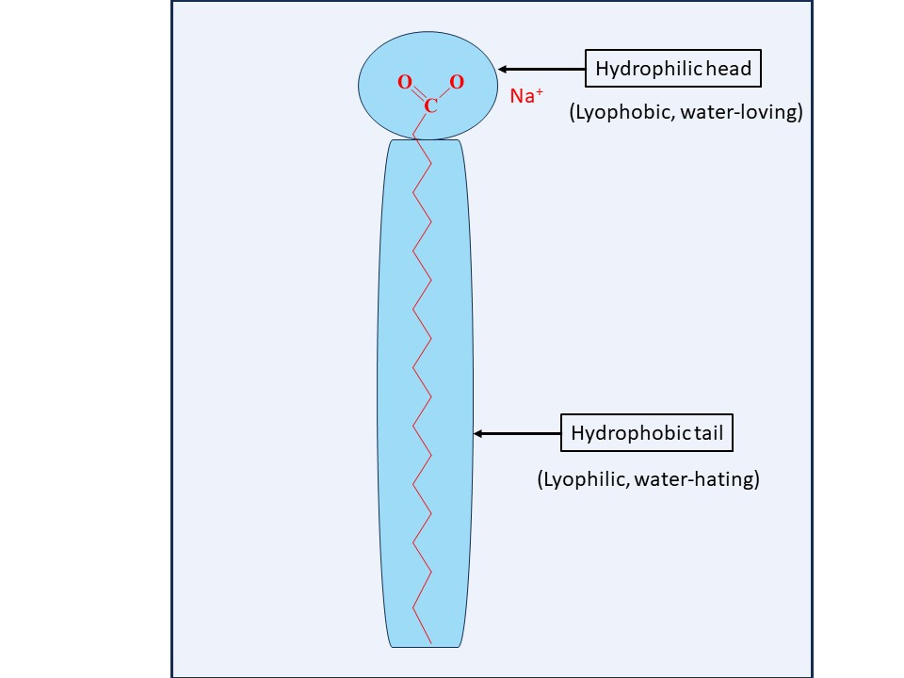

Fig-1 structure of surfactant molecule

2.Classified of surfactants
Surfactants are available in many forms, and are generally classified based on charge of the surface-active molecules such as anionic, non-ionic, cationic and amphoteric.
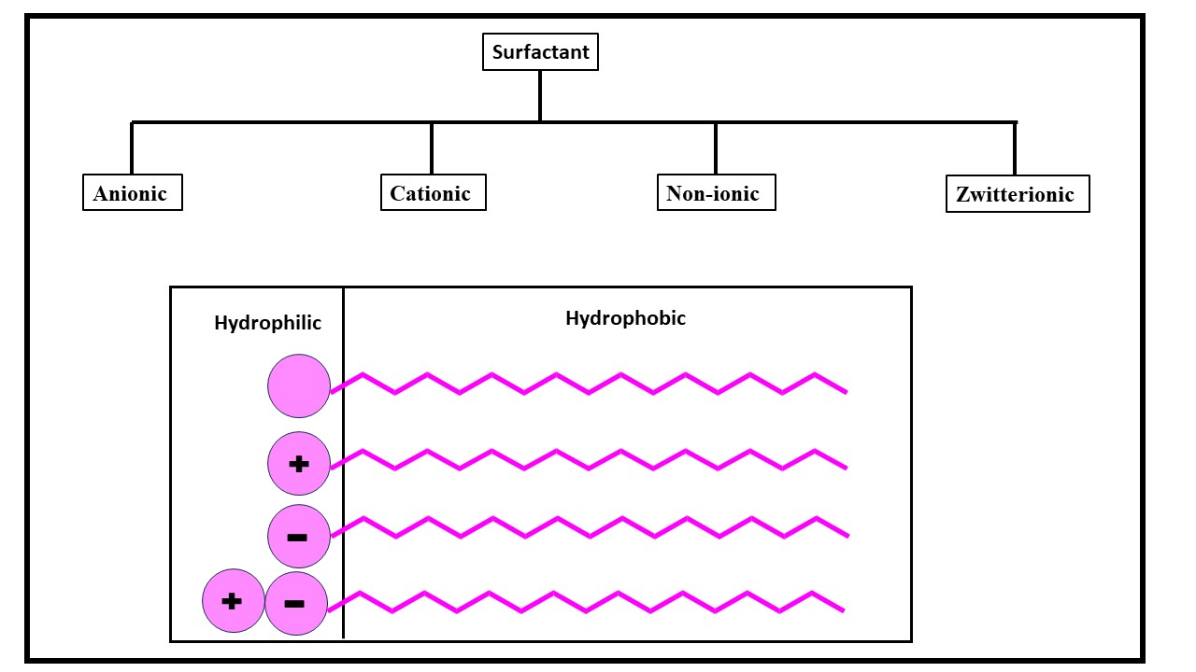
Fig:2 types of surfactants and their structure
2.1 Anionic surfactants
Anionic surfactants are made up of anionic functional groups like sulphate, sulfonate, phosphate, and carboxylate. The majority of detergent formulations contain anionic surfactants, which we use more frequently than any other kind of surfactant. The best detergency is provided by alkyl and alkyl-aryl chains with a length of C12–C18 [6-7]. Soaps are anionic surfactants produced by saponifying natural oils and fats, making them the most prevalent type of surfactant. The metal salt of an alkali carboxylic acid that was originally generated from plant- or animal-based fats is referred to as "soap" in this context. The bulk of the time, the base of soap bars is a mixture of tallow and coconut fatty acids.
2.2 Cationic surfactants
In this category, the hydrophilic element is positively charged. It sticks to surfaces and may have softening, antistatic, soil-repelling, antibacterial, or corrosion-inhibiting properties despite the fact that this group doesn't have any wash activity. In many typical uses, they serve as softeners (fabric softeners) and antistatic. The counter ion of cationic surfactants is often a halide or methyl sulphate [8]. The pH affects the primary, secondary, or tertiary amines.
2.3 Non-ionic surfactants
Hydrophilic components that are not charged are present in non-ionic surfactants. These substances work well for cleaning and are unaffected by the water's hardness. They are frequently found in cleaning detergents and belong to classes like fatty alcohol polyglycosides and alcohol ethoxylates. Some surfactant properties are present in long chain alcohols [9]. The most common varieties of these are fatty alcohols, cetyl alcohol, stearyl alcohol, cetostearyl alcohol (mostly composed of cetyl and stearyl alcohols), and oleyl alcohol.
2.4 Zwitterionic surfactants
Two groups (anionic and cationic) with opposing charges make up a zwitterionic surfactant. Although zwitterions are usually described as "amphoteric," these ideas are separate. A surfactant that undergoes a pH change from low to high and transforms from a net cation to a net anion via Zwitterion is called an amphoteric surfactant. Because neither the acid nor the base sites are always charged, the molecule is only Zwitterionic across a limited pH range. At the isoelectric point, the physicochemical behaviour usually resembles that of non-ionic surfactants [10]. Below and above the isoelectric point, there is a continuous transition towards the cation and anion character, respectively. A subgroup called Zwitterion is renowned for having outstanding dermatological skills. The following are some illustrations of surfaces and interfaces: Liquid - Liquid, Solid - Solid, and Solid - Solid interfaces Liquid - Vapour (surface), They cause minor skin and eye irritation. The use of them in shampoo and other personal care (cosmetic) products is so appropriate. Surfactants that are zwitterionic (amphoteric) include both cation and anion centres connected to the same molecule. Primary, secondary, or tertiary amines or quaternary ammonium cations are required for the cation component.
Types of surfactants | Example | Uses
Anionic | Alkyl sulfates, soap, calsoft, texapon | 50% of overall industrial production, laundry detergent, dishwashing liquid, shampoos.
Cationic | Quaternary ammonium salts | Used together with nonionic surfactant but not with anionic, softness in textiles, anti-static additives.
Nonionic | Ethoxylated aliphatic alcohol, polyoxyethylene surfactants, triton x-100, span, tergitol. | 45% of overall industrial production, a wetting agent in coatings, food ingredients.
Zwitterionic | Betaines, amphoacetates. | Expensive, special use e.g. cosmetic.

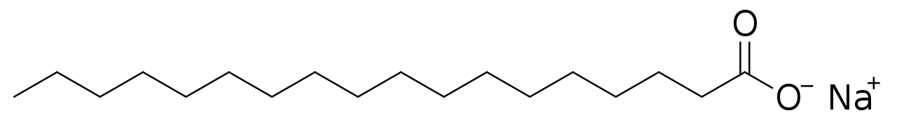

Sodium stearate
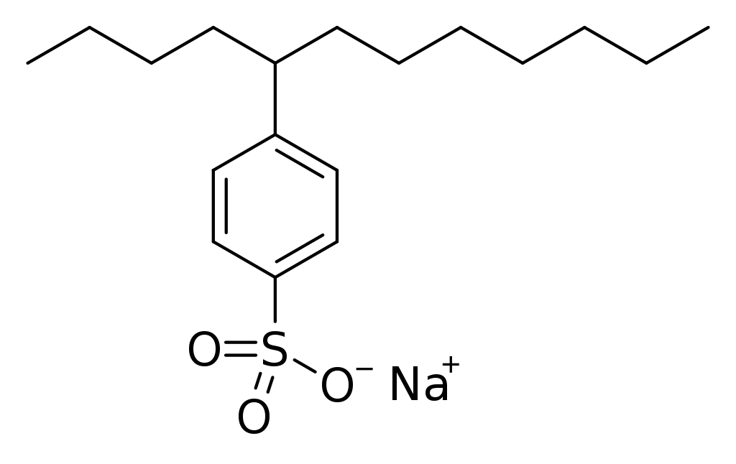
4-(5-Dodecyl) benzenesulfonate

Fig:3 Molecular structure of surfactants
3. Physicochemical properties of surfactants
Surfactant have their excellent physicochemical qualities and capacities for effective adsorption, solubilization, dispersion, suspension, and transportation, among other things, surfactants have drawn a lot of interest.
3.1 Hydrophilicity and Hydrophobicity of Surfactant Molecules
The hydrophilic functional group of surfactant molecules has a strong affinity for interacting with polar materials such as water, metals, and other ions. Surfactants frequently stick to metal surfaces, obstruct active areas such those near corrosive fluid exposure, and so limit the attack of corrosion [11]. Current theories suggest that the surfactant adsorption mechanism is dominated by the structure of heterocyclic surfactant molecules. The surfactant concentration at which a monolayer of molecules sticks to and covers a metal surface is known as the surface aggregation concentration. A rise in surfactant concentration favours the formation of surface bilayers or multilayers. Surfactant molecules can also form clusters in the aqueous phase at the solubility saturation point, where they typically point their hydrophilic head groups towards water or hydrophilic surfaces and their hydrophobic tails towards other surfactant molecules.
3.2 Surface Tension
“Surface tension” is the product of cohesive energy in molecules. Water molecules communicate with one another in aqueous media through hydrogen bonding and van der Waals forces. However, the hydrogen bonding is insufficient above the air-water barrier. Van der Waals interactions at the interface are further weakened by the absence of interacting molecules in the air phase [12]. As a result, molecules at the air-water interface have more energy available and fewer opportunities to form bonds than those present in the bulk phase. This added energy is what creates surface tension. The name "surfactant" derives from the term "surface-active agent," which lowers surface tension, in accordance with this. Surface tension is predicted to be higher in substances having higher cohesive energies between water molecules at the air-water interface.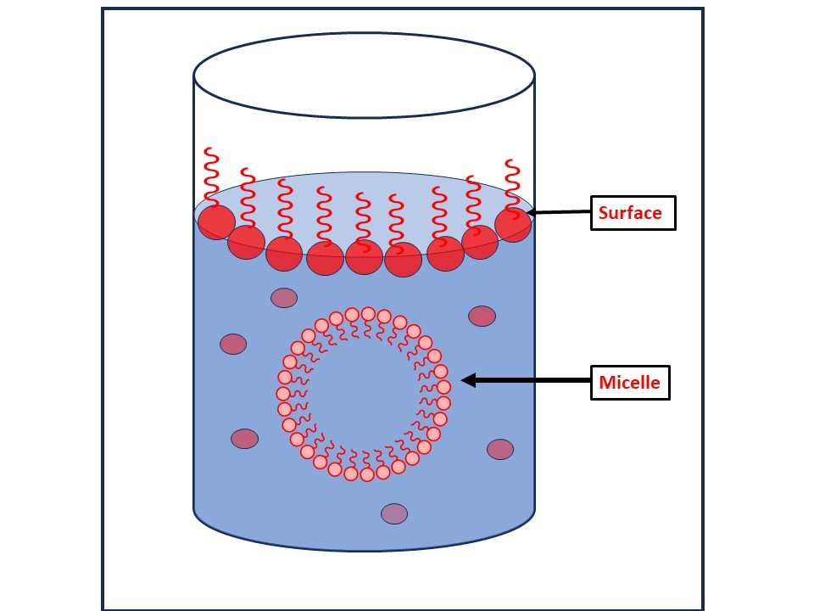
Fig-4 Solution of surfactant

3.3 Krafft point
The following are some illustrations of surfaces and interfaces: Liquid - Liquid, Solid - Solid, and Solid - Solid interfaces Liquid - Vapour (surface), Surfactant molecules do not considerably dissolve in aqueous solutions below the Krafft point. Above the Krafft point or temperature, surfactants can form micelles, greatly increasing their total solubility [13].
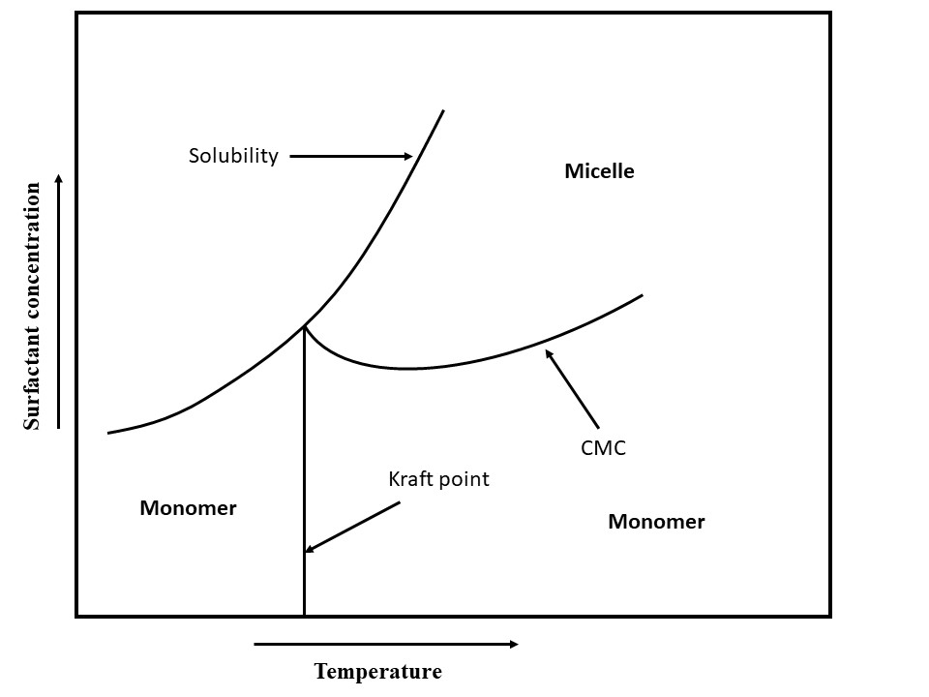
Fig-5 Temperature, total surfactant concentration, and their interactions with surfactant states are all compared. adjacent to the axes, arrows Point at the direction of the increase.
3.4 The Surfactant States
Liquid - Liquid, Solid - Solid, and Solid - Solid interfaces Liquid - Vapour (surface), Surfactants are capable of arranging themselves into several phases or states. Concentration and surfactant phase or condition are frequently closely related. The quantitative connections between micelle concentration, related cmc, monomer concentration, and total surfactant concentration [14] show that monomeric surfactants assemble into micelle-like structures when surfactant concentration climbs over the cmc. Surfactants can also form gels and micelles at the gel temperature. Surfactants can also result in the formation of liquid crystals. The gel state exists between the liquid crystal phase and the solid state. At high temperatures, the solubility of some surfactants is restricted. Because of greater energy levels and conformational changes in the surfactant's structure, there is less hydrogen bonding with water as a result of this decrease [15].
3.5 Microemulsions
Fluids that include micelles are similar to microemulsions. They are simply micelles that have been inflated and contain liquid droplets that range in size from 5 to 100 nm. They can exist in an oil continuous phase with nanoscale water droplets inside of a surfactant shell or in an oil continuous phase with oil droplets inside of a water continuous phase with surfactant shell. Microemulsions, which combine water, oil, and alcohol with an ionic surfactant, have many uses [16]. A microemulsion is a type of thermodynamically stable emulsion.
3.6 Adsorption at Surface
3.6.1 “Adsorption”
Adsorption of the surfactant is necessary for the surface to be covered with surfactants. a typical explanation for the ionic surfactant's adsorption on negatively and positively charged substrates.
3.6.2 Adsorption Isotherms
The most used adsorption models are the Stern Adsorption model, van der WaalsStern model, Temkin model, Freundlich model, Frumkin model, Flory-Huggins model, Dhar-Flory-Huggins model, Bockris-Swinkels model, and Bockris-Devanathan Muller model [17]. The Langmuir adsorption isotherm assumes that all surface adsorption sites are comparable, regardless of whether surrounding sites are occupied.
3.6.3 Adsorption Kinetics
Due to desorption, the surfactant concentration in aqueous solution diminishes with time. In order to optimise the frequency of surfactant injections and ensure efficient surfactant adsorption and surface coverage, it is essential to understand the adsorption and desorption kinetics of surfactants [18]. Both the concentration of the surfactant and the concentration of competing ions have an impact on the extent and rate of adsorption of many surfactants. 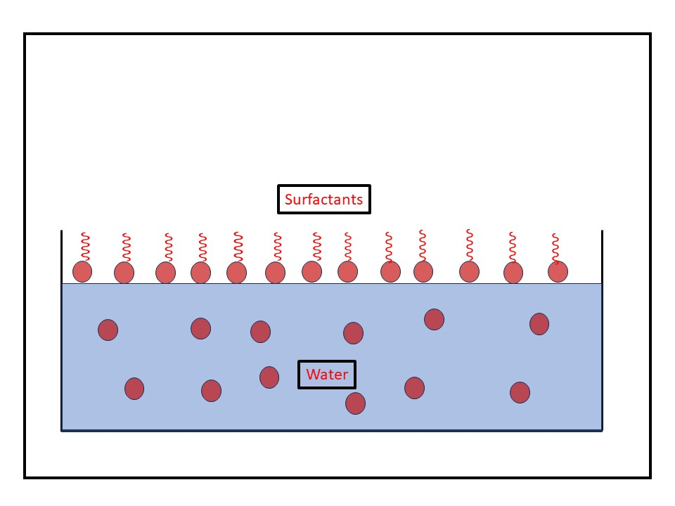
Fig-6 Adsorption of surfactant at the surface of water.

3.7 The Surfactant Partitioning Between Water and Oil
Different types of surfactant molecules form in water, oil, and their mixtures. In an oil and water solution, surfactant molecules have been found to be in equilibrium in a number of different forms. A surfactant can interact with hydrogen ions or metal ions to make hydrogenated compounds and metal salts, as well as adsorb on solid surfaces to form dimers and micelles. It can also divide into the aqueous and oil phases [19]. When an aqueous surfactant solution comes into contact with an immiscible organic liquid, such as oil, the surfactant monomers may prefer partitioning into the organic liquid until equilibrium between the two liquids is reached.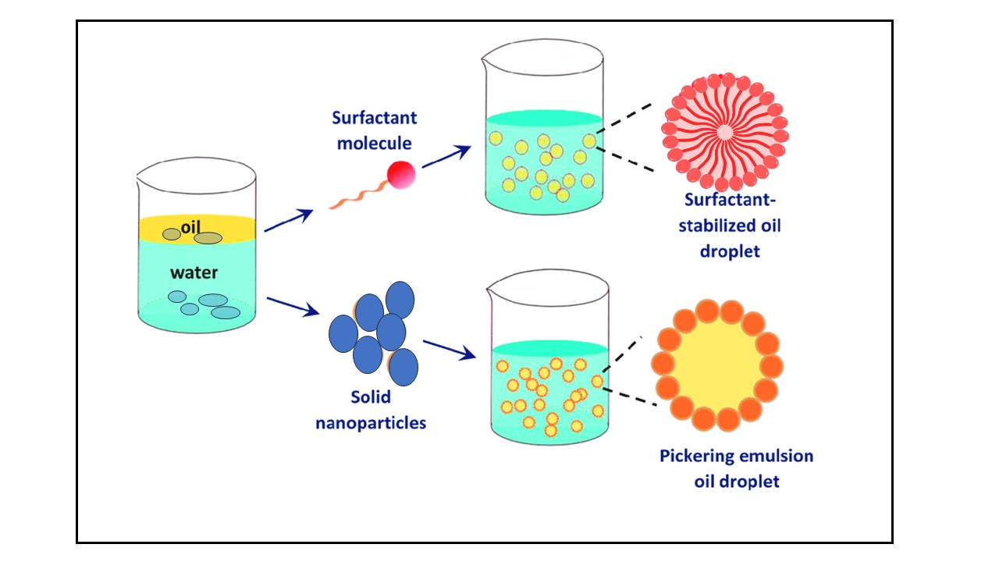
Fig-7 Surfactant as stabilizer oil/water.
3.8 The Surfactant Precipitate and Colloid Formation
In solutions, ionic surfactants typically interact with other ions. Surfactants can react to produce precipitates when they come into contact with reactive counter ions. It is common for oil droplets to develop when certain surfactants, including carboxylates, combine with hydrogen ions to generate carboxylic acid. Additionally, carboxylates can interact with other species that are positively charged, such as calcium or magnesium ions, to produce colloidal, solid particles that are hydrophobic and behave like miniature wax particles. Water solubility is significantly decreased during the precipitation process that produces neutral molecules. However, nonpolar solvents like oils frequently make the hydrophobic colloidal precipitate particles liquid. Precipitation thus substantially favours the lipophilic or oil phase and has a very noticeable effect on phase partition [20]. Ionic surfactants interact with hydrogen ion, hydroxide ion, and other ions.
3.9 The Salt/Ion Effects on Surfactant Behaviour
The aqueous phase in oil fields typically contains mixtures of different inorganic salts, which affect surfactant-related processes like aggregation, adsorption, partitioning, surfactant ion pair, hydration, and thus affect corrosion inhibition. These processes not only promote the corrosion of metal in certain ways [21]. This should be considered in any modelling and experimental evaluation work.
3.10 Micelle
Surfactant molecules are forced to band together above the cmc to create micelle-like structures. A micelle typically consists of tens to hundreds of surfactant molecules. The quantity of surfactant monomers contained within a micelle is indicated by the aggregation number. The molecular weight of a micelle can be calculated by merely multiplying the aggregation number by the molecular weight of the surfactant monomer. The number of surfactants that aggregate depends on several factors, including temperature, hydrophobic chain lengths, head group properties, and ionic strength. Increasing ionic strength increases the tendency for aggregation by reducing the interaction between ionic head groups and enhancing the attraction of the hydrophobic tail to the aqueous medium. On the other hand, micelles form and split apart in milliseconds [22]. But as the surfactant concentration and the surfactant's size and properties change, these time scales drastically alter. Micelle aggregates can take the forms of vesicles, rod-like or cylindrical micelles, spherical micelles, hemimicelles, plate-like micelles, and more. The arrangement of the surfactant's hydrocarbon chain in a micelle is what determines its shape.
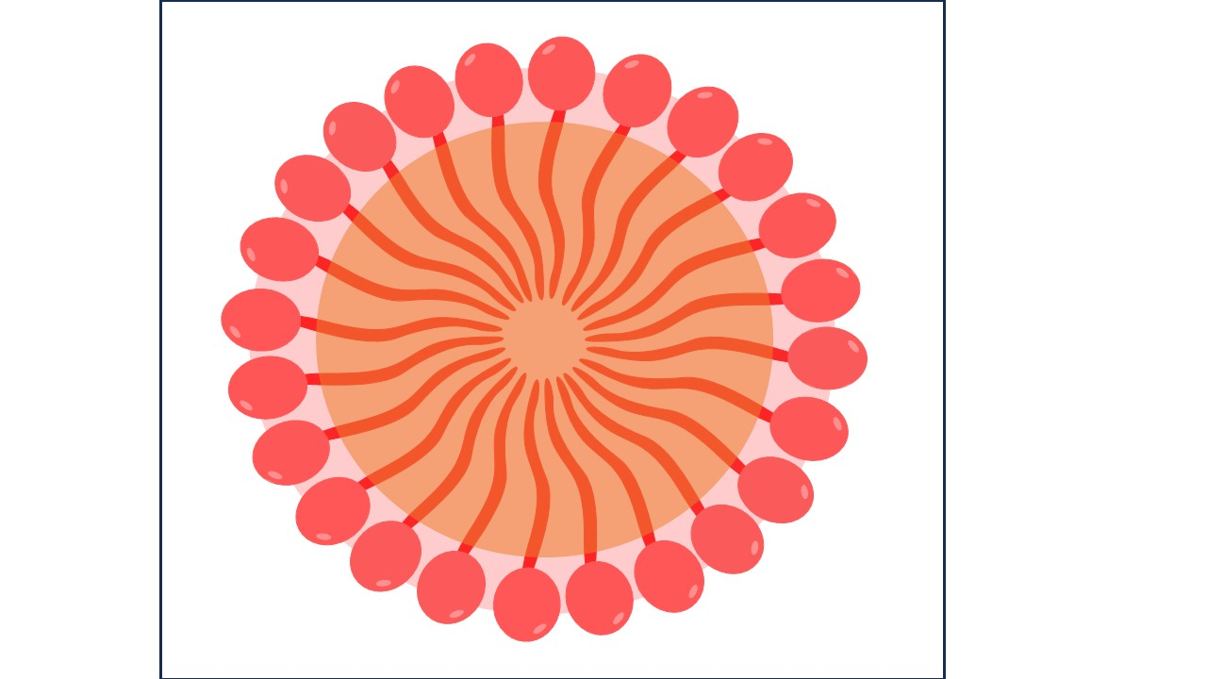
Fig-8 Micelle
3.11 Critical Micelle Concentration (CMC):
The concentration of surfactants (amphiphilic molecules) over which micelles form is known as the critical micelle concentration (CMC). Micelle nanoparticles are 5 to 100 nm in size. An essential quality of a surfactant is its CMC. These molecules begin to form the micellar structure at this concentration thanks to the reduction in free energy driving assembly. Temperature, pressure, and (in some cases strongly) the presence and concentration of additional surface-active compounds and electrolytes all affect the CMC value for a specific dispersant in a given medium [23]. Only at temperatures over the crucial micelle or Kraft temperature do micelles develop. Micelles cannot form below the Kraft temperature.

4. Applications of the “Surfactants”
The surfactant is a crucial component of cleaning, wetting, dispersing, emulsifying, foaming, and anti-foaming agents and is used in a wide range of goods, some of which are listed below:
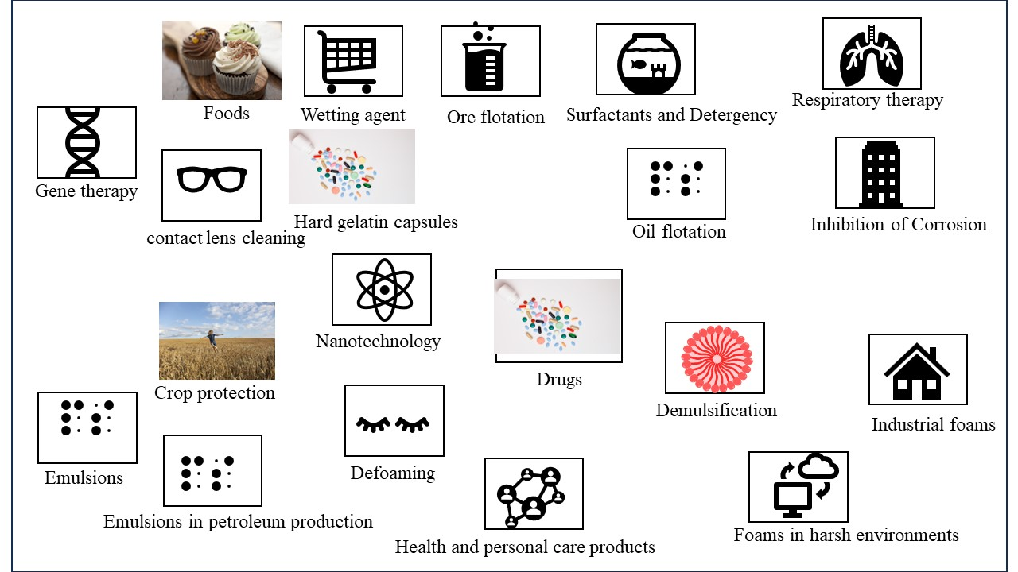
Fig: Application of surfactants
4.1 Surfactants in crop protection
4.2 Surfactants in foods
4.3 Surfactant and wetting
4.4 Ore flotation
4.5 Surfactants and detergency
4.6 Surfactants in respiratory distress therapy
4.7 Surfactants for contact lens cleaning
4.8 Surfactants in hard gelatin capsules
4.9 Solubilization of Drugs
4.10 Inhibition of Corrosion
4.11 Gene therapy
4.12 Surfactant in Nanotechnology
4.13 Surfactants in health and personal care products
4.14 demulsification.
4.15 Industrial foams.
4.16 Oil flotation.
4.17 Foams in harsh environments
4.18 Defoaming.
4.19 Emulsions
4.20 emulsions in petroleum production

4.1 Surfactants in crop protection
Pesticides, herbicides, fungicides, and insecticides are categorised as crop protection products. The stability and effectiveness of pesticides are significantly influenced by their formulation. Crop protection products are now being developed to be stronger, safer for users, less harmful to the environment, easier to use, and more effective when applied. Colloid and interface science has an impact on every area of application for sprayed items. Spray droplets first hit the surface of the leaf, forming a foliar deposit from which the pesticide enters the leaf or comes into touch with the insect [24]. The applicator nozzle, the physical characteristics of the spray fluid, and the motion of the sprayer vehicle all have an impact on the spray pattern. The formulation affects the droplets' effect and retention, the duration of the deposit, and the readiness of the active ingredient to enter the plant. Effectiveness is also influenced by environmental variables as temperature, humidity, wind, sunlight, and rainfall.
4.2 Surfactants in foods
The extraction of cholesterol, the solubilization of oils, the liquor emulsification, the prevention of component separation, and the solubilization of key nutrients are all processes that are aided by surfactants, which are also used in the preparation of many common food items. Ice cream, a partially frozen foam that contains 40–50% air (by volume), is one well-known example. Making an emulsion is the first stage in the ice cream formulation process. Under moderate pressure (about 15 to 19 MPa), the homogenization process pushes hot substances (milk fats, milk solids-no fat, sweeteners, corn-syrup solids, stabilizers/emulsifiers, and other dry solids) through tiny orifices. The consistency of droplet sizes leads to smoother, more consistent final products, improved whipping ability, and more stable fat droplets throughout time [25]. In order to allow for a broad surface area for protein adsorption (which in turn stabilises the emulsion to coalescence), the fat droplet diameters decrease to 0.4 to 2.0 micrometres.
4.3 The surfactant & wetting
If a liquid drop has just a weak affinity for the surface, that is, if its surface tension is higher than the surface's critical surface tension (c), a bead will form on the surface. On the other hand, if it has a significant affinity for the surface, that is, if its surface tension is lower than c, it will spread and create a film. Teflon's essential surface tension is 18 mN m-1, while nylon's is around 46 mN m-1. In commercial settings, surfactants are frequently utilised as wetting agents, especially when applying the wetting liquid to a waxy or "wax-like" surface. In this context, anionic surfactants are most frequently utilised [26].
4.4 Ore flotation
The ability of solid particles to float on a liquid medium depends on the contact angle, which can be changed by the application of surfactants. A popular experiment in fundamental chemistry involves coating a needle in wax to make it float on the surface of water. When later household detergent is added, the needle sinks. The ideas are the same as those employed in the flotation process, which adds a little amount of collector oil during the grinding and slurring step, to treat raw mineral ores. The ability of the ore particles to remain wet is influenced by the collector oil, an anionic, cationic, or nonionic surfactant [27]. For oxide and carbonate ores, long-chain fatty acids are typically used, but for sulphide ores, organic xanthates and thiophosphates are frequently used. A foaming agent is frequently added to the suspension in practise in order to help the ore particles stick to the air bubbles when air is shot through it. When skimming is employed to extract the ore bits, they float to the surface. Sludge and effluents are purified using this type of flotation as well.
4.5 Surfactants & Detergency
The action of the surfactants that causes aids in the removal of foreign material from solid surfaces by adsorbing at interfaces and reducing the energy needed to affect the removal is the definition of detergent action. The most efficient wetting agents often rapidly diffuse and adsorb at the right interfaces. Long used as a detergent, soap is a surface-active fatty acid salt with at least eight carbon atoms. Glycerol is produced as a by-product when glyceride oils and fats are saponified with NaOH or KOH in the past to make soap. Although soaps are great deodorizers, they are sensitive to acidic pHs and the hardness of the water (Ca2⁺ and Mg²⁺ ions), which results in soap scum. Although the usage of detergent producers will make up for this shortcoming, synthetic detergents have mostly taken the place of soaps [28]. The majority of the production of surfactants is used to create the components that go into commercial detergent formulations.
4.6 Surfactants in respiratory distress therapy
Neonatal respiratory distress syndrome, commonly known as hyaline membrane disease, affects premature newborns, and is treated with surfactant formulations as a replacement therapy. This lung condition, which causes 5000 fatalities annually, affects 20% of the 250,000 preterm infants born in the US each year. A severe lack of endogenous lung surfactant is the primary contributor to the pathophysiology of respiratory distress syndrome [29]. Lung surfactant preparations are used along with more oxygen and mechanical ventilation to improve gas exchange for the prevention or rescue treatment of newborn respiratory distress syndrome. Exogenous surfactants can be produced artificially or derived from animal products.
4.7 Surfactants for contact lens cleaning
Surfactants serve as cleaners by emulsifying lipid, oil, and inorganic deposits that have accumulated on contact lenses. By dabbing a few drops of solution onto the surface of the lens and gently rubbing it back and forth with the thumb and fingers, or by holding the lens in the palm of the hand and gently rubbing with a fingertip (20 to 30 seconds), surfactant agents are used in mechanical cleaning systems. Among the ingredients of these cleaners are frequently a non-ionic detergent, a wetting agent, buffers, and preservatives.
4.8 Surfactants in hard gelatine capsules
Pennings et al.24 gave poorly soluble benzoic acid as a loose powder, and the same powder was added to size 00 and size 1 capsules. The size 1 capsule that had the tightest powder packing disintegrated at the slowest pace. This problem is resolved by adding 0.5% polyol surfactant to the mix. They showed that this led to an increase in the material's rate of disaggregation, which they utilised to demonstrate that the dissolving rate significantly improved as a result [30]. If hydrophobic compounds must be included in formulations due to filling machine requirements, wetting agents, or surfactants, can be added at levels of 0.1-0.5% to prevent their adverse effects on drug release.
4.9 Solubilization of Drugs
Surfactants play a significant part in modern pharmaceutical biotechnology since they are widely used in many therapeutic dosage forms to regulate qualities including wetting, stability, and bioavailability, among others. Regarding their capacity to solubilize hydrophobic medicines and their use in medication delivery, surfactants are crucial. Solubilization is the reversible interaction of a substance with the micelles of a surfactant in water to produce a thermodynamically stable isotropic solution with a decreased thermodynamic activity of the solubilized substance. The ability of surfactants to dissolve pharmaceuticals is influenced by a variety of variables, including temperature, pH, ionic strength, surfactant and drug chemical structures, and many others [31]. Cremophor EL, a non-ionic surfactant that has been utilised to solubilize a wide range of hydrophobic medications including anaesthetics, photo sensitizers, sedatives, immunosuppressive medicines, and anticancer treatments, merits special attention.
4.10 Inhibition of Corrosion
Surfactants' promising prospective use as corrosion inhibitors has been thoroughly researched during the past few years. It is common knowledge that surfactants have a propensity to collect together at interfaces and in solutions. The basic role of the surfactant functional group is to be adsorbed on the metal surface, which is essential for the suppression of corrosion. The capacity of the surfactant to aggregate to form micelles is generally directly tied to the adsorption of the surfactant molecules onto the metal surface, which was discovered to be responsible for the metal's corrosion inhibition [32]. According to the polarisation technique examination, SDS is an effective anodic inhibitor at low anodic overvoltages, and the inhibitor's adsorption followed the Langmuir isotherm.
4.11 Gene therapy
The idea behind gene therapy is to transfect cells with healthy DNA to replace damaged or missing genes. This process is known as transfection. To allow negatively-charged DNA to travel across hydrophobic membranes, many vectors contain a positive charge. It has proven challenging to foresee a vector's efficiency, nevertheless. To allow negatively-charged DNA to travel across hydrophobic membranes, many vectors contain a positive charge [33].
4.12 Surfactant in Nanotechnology
Surfactant molecules can self-assemble into a variety of nanostructures, including spherical/rod-shaped micelles and lamellar sheets, thanks to their amphiphilic nature. It is conceivable to design a surfactant package using surfactant nanotechnology that can solubilize significant amounts of oil while vigorously wetting the casing. Surfactant mixes can be used to create in-situ oil-in-water microemulsions, enabling the wetting of surfaces [34]. This might make it possible to get rid of dangerous chemicals.
4.13 The Surfactants in health & personal care products
Quaternary ammonium surfactants (quats), cationic surfactants with significant germicidal activity, are also used as fabric softeners in detergents. The most popular fabric softener and antistatic is ditallow dimethyl ammonium chloride (DTDMAC). In contrast to emulsifiers, which frequently have a N-alkyltrimethylammonium chloride or N-alkylimidazoline chloride configuration, germicides, such as benzalkonium chloride, frequently have a N-alkyldimethylbenzylammonium chloride structure. The idea that "natural" cosmetics are more pure, safe, and effective is what has made them so popular. Even while many products are marketed as "natural" or "herbal," they actually just include herbal extracts that have been added for marketing purposes [35–36].
When creating a shampoo, the following criteria are often met: light detergency, good foaming, passable conditioning, suitably maintained, and aesthetically pleasant. There are no prerequisites for "natural" shampoo, although it may have the following ingredients: no harmful chemicals, usage of plant or plant-based surfactants, and only natural additives (such xanthan gum as a viscosity builder) and preservatives (like alkylpolyglucosides as an antibacterial). The phrase "natural surfactant" can be used to refer to both a surfactant that was taken directly from a natural source as well as one that was synthesised chemically from one [37, 38]. For cosmetic formulations, new emulsion formulation techniques are crucial, particularly for their preservation abilities. The phase inversion temperature (PIT) emulsion and microemulsion are distinguished by their extremely small droplet sizes and high stability. Microemulsions are useful for creating an O/W formulation that is clear and also appears to be less unpleasant.
4.14 Demulsification.
Some emulsions, when they do, are undesirable. Process industries typically utilise chemical demulsification to separate water from oil and produce a fluid suitable for additional processing. The specific type of emulsion treatment required can vary widely, even within the same industry. The first step in systematic emulsion breaking is to characterise the emulsion in terms of its nature (O/W, W/O, or multiple emulsion), the number and kind of immiscible phases, the presence of a protective interfacial layer around the droplets, and the sensitivity of the emulsifiers. Based on their chemical composition, surfactants are often classed as demulsifiers [39]. Demulsifier surfactants include soaps, glyceryl esters, fatty acid esters, fatty alcohols, alkylphenol ethoxylates, alkyl sulfonates, alkyl aryl sulfonates, and other detergents.
4.15 Firefighting foam
The numerous industrial operations that involve the transportation, processing, or handling of flammable petroleum liquids include refineries and offshore production platforms, to name just two. Since their initial introduction in the early 1900s, firefighting foams have evolved into specialised and frequently used systems. Firefighting foams function to put out a fire by smothering it, preventing air from coming into contact with flammable vapours, separating flames from the fuel surface, and chilling the fuel and its surface. The foams used to put out fires are referred to as "low expansion" foams and typically contain 75–97% air [40]. Foam is chosen based on traditional qualities such as static half-lives, salt tolerance, toxicity, and stability to decomposition, as well as qualities like as expansion and fire extinguishing capability.
4.16 Oil flotation.
Mineral ore flotation, which depends on wettability alteration and bubble attachment, is less dependent on attachment and filmmaking than oil and bitumen flotation, which generates an oleic foam [41]. In the hot water flotation method used commercially in Canada to recover bitumen from oil sands, surfactants play crucial roles in the separation of bitumen from mineral particles and the subsequent floating of the former.
4.17 The Foams in harsh “environments”.
To control the mobility of injected fluids or to block particular zones or channels, foams can be injected into a petroleum reservoir. As a result, injected fluids are diverted into different sections of the reservoir. A number of gases, including air/nitrogen, hydrocarbons, carbon dioxide, or steam, can be used to form acceptable foams for injection [42].
4.18 Defoaming.
Foam breakers or defoamers are substances that function to lessen a system's foam stability, whereas foam preventatives or foam inhibitors work to stop foam from forming in the first place. Such compounds are many; Kerner 331 lists over a hundred different foam inhibitor and foam breaker compositions. Even if these substances aren't often surfactants in and of themselves, they are nonetheless relevant since in each and every instance the reason for the decreased foam stability can be linked to numerous modifications made to the characteristics of the surfactant-stabilized interface [43].
4.19 Emulsions
A mixture of “oil and water” is called an emulsion when one of the phases, the dispersed phase, is present as a dispersion of droplets inside the continuous phase. The droplet diameters can range from a few nanometers to hundreds of micrometres, but they are commonly in the range of 0.1 to 100 m. The two most popular emulsion types, O/W (oil/water) and W/O (water/oil), are easily distinguishable.
4.20 “Emulsions” in petroleum production.
As part of an improved oil recovery process, chemicals may be injected into oilfields after the primary and secondary cycles of oil recovery. To drive out surplus oil, this procedure may entail creating in-place emulsions in the reservoir [44]. The relative oil and water saturations in a petroleum reservoir are determined by the distribution of pore sizes in the rock.

5. Conclusion
Surfactants hold certain beneficial properties; their use in everyday life becomes nearly indispensable. The wide applications of surfactants such as Surfactants are among the most essential ingredients encountered in laundry detergents, dishwashing detergents, liquid soaps, cleaning products, cosmetic hair care and personal care products etc. these are the main applications of the surfactants.
Acknowledgments
The authors gratefully acknowledge the department of chemistry mats university Raipur (C.G.).
AUTHORS CONTRIBUTION
The manuscript was written through the contributions of all authors. All authors have approved the final version of the manuscript.
NOTES
All authors declare no competing financial interest.
CONFLICTS OF INTEREST
There are no conflicts to declare.
References
1. Attwood D, Florence AT. (1983). Surfactant systems; Their Chemistry, Pharmacy and Biology. London: Chapman & Hall, 1140-1141.
2. R. Azarmi and A. Ashjaran,( 2015). Type and application of some common surfactants, Journal of Chemical and Pharmaceutical Research,7 (2): 632-640.
3. Rosen M. j., kunjappu J. T., (2012), Surfactants and Interfacial Phenomena. 4th ed. John wiley and sun. inc.

4. I. Cattaneo, M.C. Astuto, (2023). Surfactants, anionic and non-ionic, J. Reference Module in Biomedical Sciences.
5. Colby L. Presley, Michelle Militello, Cara Barber, Ryan Ladd, Melissa Laughter, Heather Ferguson, Jesse Dewey, Kayd J. Pulsipher, Chandler W. Rundle, Cory A. Dunnick, The History of Surfactants and Review of Their Allergic and Irritant Properties, Dermatitis, , 32, 5, (289-297), (2021).
6. Juan Wu, Ping Mei, Wu Chen, Zhong‐Bao Li, Qing Tian, Qi‐Xiang Mei, (2019)., Surface Properties and Solubility Enhancement of Anionic/Nonionic Surfactant Mixtures Based on Sulfonate Gemini Surfactants, Journal of Surfactants and Detergents, 22, 6, (1331-1342),
7. Shenyuan. Yang. And khaledi m.g., (1995), Chemical Selectivity in Micellar Electrokinetic Chromatography: Characterization of Solute-Micelle Interactions for Classification of Surfactants,J. analytical chemistry, 67, 3, 499–510
8. Rui A. Gonçalves, Krister Holmberg, Björn Lindman, (2023), Cationic surfactants: A review, j. molliq. 375, (121335).
9. Gary E. Petrowski, John R. Vanatta, (1973), Gas chromatographic determination of hydrophile‐lipophile balance of nonionic emulsifiers, Journal of the American Oil Chemists' Society, , 50, 8, (284-289),.
10. Zhou, M., Li, S., Zhang, Z. et al. Progress in the Synthesis of Zwitterionic Gemini Surfactants. J Surfact Deterg 20, 1243–1254 (2017).
11. Chandrabhan Verma ª, M.A. Quraishi ª, K.Y. Rhee , (2022), Hydrophilicity and hydrophobicity consideration of organic surfactant compounds: Effect of alkyl chain length on corrosion protection, j. advance and colloidal sci. interface, 306,102723
12. Hanae Kawamura, Naoto Yoshino, Kazuyuki Murakami, Hideki Kawamura, Ikumi Sugiyama, Yutaka Sasaki, Takashi Odagiri, Yasuyuki Sadzuka, Yasushi Muraki, (2023), The relationship between the chemical structure, physicochemical properties, and mucosal adjuvanticity of sugar-based surfactants, European Journal of Pharmaceutics and Biopharmaceutics, j.ejpb, 182, (1-11),
13. Tiren Gu, Johan Sjöblom, (1992), Surfactant structure and its relation to the Krafft point, cloud point and micellization: Some empirical relationships, J. Colloids and Surfaces, Volume 64, Issue 1, , Pages 39-46,
14. Daniel Otzen, (2011), Protein–surfactant interactions: A tale of many states, J. Biochimica et Biophysica Acta (BBA) - Proteins and Proteomics,Volume 1814, Issue 5, Pages 562-591,
15. Kurepa, D., Perveen, S., Lipener, Y. et al. The use of less invasive surfactant administration (LISA) in the United States with review of the literature. J Perinatol 39, 426–432 (2019).
16. Wanguo Hou, Jie Xu, (2016,) Surfactant-free microemulsions, J. Current Opinion in Colloid & Interface Science, Volume 25, Pages 67-74,
17. Rosen, M. J. (2004). Surfactants and Interfacial Phenomena. Germany: Wiley, 500.

18. R. Miller, G. Kretzschmar, (1991), Adsorption kinetics of surfactants at fluid interfaces, J. Advances in Colloid and Interface Science, Volume 37, Issues 1–2, Pages 97-121,
19. K. Shinoda, T. Nakagawa, B-I. Tamamushi and T. Isemura,( 1963). Colloidal Surfactants, Some Physicochemical Properties, Academic Press, New York.
20. S. Ross and I. D. Morrison,( 1988). Colloidal Systems and Interfaces, Wiley, New York, NY.
21. Håkan Wennerström, Björn Lindman, (1979), Micelles. Physical chemistry of surfactant association, J. Physics Reports, Volume 52, Issue 1, Pages 1-86,
22. [22] K. Shinoda, T. Nakagawa, B-I. Tamamushi and T. Isemura,( 1963). Colloidal Surfactants, Some Physicochemical Properties, Academic Press, New York.
23. R. J. Williams, J. N. Phillips and K. J. Mysels (1955), The critical micelle concentration of sodium lauryl sulphate at 25° C, J. Trans. Faraday Soc., ,51, 728-737
24. Tatiana Cardoso Damato ª, Letícia D.M. Carrasco ^{b}, Ana Maria Carmona-Ribeiro ^{b}, Ricardo Vagner Luiz ^{c}, Roberta Godoy ^{c}, Denise F.S. Petri ª (2017), The interactions between surfactants and the epicuticular wax on soybean or weed leaves: Maximal crop protection with minimal wax solubilization, J. Crop protection., 91, 57-65.
25. Taiki Miyazawa, Mayuko Itaya, Gregor C Burdeos, Kiyotaka Nakagawa, Teruo Miyazawa, A Critical Review of the Use of Surfactant-Coated Nanoparticles in Nanomedicine and Food Nanotechnology, J. International Journal of Nanomedicine, Volume 16, (3937-3999), (2021).
26. Lilla Landeck, Lynn A. Baden, Swen Malte John, (2019)., Detergents, Kanerva’s Occupational Dermatology, (1131-1143),
27. Somasundaran, P., Wang, D. (2006). Solution Chemistry: Minerals and Reagents. Netherlands: Elsevier Science.
28. Haruhiko Arai, Study of detergency. I. Effect of the concentration and the kind of detergent in hard water, Journal of the American Oil Chemists' Society, 43, 5, (312-314), (1966).
29. M Griese (1999), Pulmonary surfactant in health and human lung diseases: state of the art., J. European Respiratory Journal Jun, 13 (6) 1455-1476;
30. F. H. Pennings, B. L. S. Kwee & H. Vromans (2006) Influence of Enzymes and Surfactants on the Disintegration Behavior of Cross-Linked Hard Gelatin Capsules During Dissolution, J. Drug Development and Industrial Pharmacy, 32:1, 33-37,
31. Amélia M. Silva, Carlos Martins-Gomes, Tiago E. Coutinho, Joana F. Fangueiro, Elena Sanchez-Lopez, Tatiana N. Pashirova, Tatiana Andreani, Eliana B. Souto, Soft Cationic Nanoparticles for Drug Delivery: Production and Cytotoxicity of Solid Lipid Nanoparticles (SLNs), J. Applied Sciences, 9, 20, (4438), (2019)
32. Industrial Applications of Surfactants IV. (2014). United Kingdom: Elsevier Science.
33. Taksim Ahmed, Amany O Kamel & Shawn D Wettig (2016), REVIEW, Interactions between DNA and Gemini surfactant: impact on gene therapy: part I, J. Future medicine, NANOMEDICINE VOL. 11,
34. Marcia Nitschke & Crisiane Aparecida Marangon (2022) Microbial surfactants in nanotechnology: recent trends and applications, J. Critical Reviews in Biotechnology, 42:2, 294-310,
35. [35] JW Mc Bain, ECV Cornish, Bowden RC (1912) Studies of the constitution of soap in solution: sodium myristate and sodium laurate. J. Chem. Soc., Trans., 101: 2042–2056.
36. Xuejiao Wang, Yuting Liu, Tongyue Wu, Biaofeng Gu, Hao Sun, Huanling He, Haiqin Gong, Hu Zhu, (2023)., A win-win scenario for antibacterial activity and skin mildness of cationic surfactants based on the modulation of host-guest supramolecular conformation, Bioorganic Chemistry,134, (106448),
37. L. L. Schramm, E. N. Stasiuk, D. Gerrard Marangoni, (2003). Surfactants: and their applications. Annu. Rep. Prog. Chem., Sect. C, 99, 3.
38. Kenia Barrantes, Mary Fuentes, Luz Chacón, Rosario Achí, Jorge Granados-Zuñiga, María José Alvarado, Luis Somarribas, José Vázquez-Tato, M. Pilar Vázquez-Tato, Julio A. Seijas, Víctor Soto Tellini, (2019), Synthesis and Evaluation of Aromatic Surfactants as Potential Antibacterial and Cytotoxic Agents, J. Letters in Organic Chemistry, 16, 6, (478-484),
39. Surfactants in Personal Care Products and Decorative Cosmetics. (2006). United Kingdom: CRC Press.
40. Sheng, Y., Jiang, N., Lu, S. et al. (2020) , Study of Environmental-Friendly Firefighting Foam Based on the Mixture of Hydrocarbon and Silicone Surfactants. Fire Technol 56, 1059–1075
41. [41] J. P. Tatum, (1988). in Chemicals in the Oil Industry, ed. P. H. Ogden, Royal Society of Chemistry, London, p. 31.
42. Sun L. , Bai B. , Wei B. , Pu w. , Wei P. , Li D. , Zhang C. (2019), Recent advances of surfactant-stabilized N₂/CO₂ foams in enhanced oil recovery, j.fuel, 241, 83-93.
43. Pugh R.J., (1996), Foaming, foam films, antifoaming and defoaming, advances in colloid and interface science, 64,67-142.
44. Bobby Haney, Dong Chen, Li-Heng Cai, David Weitz, Subramanian Ramakrishnan, (2019). Millimeter-Size Pickering Emulsions Stabilized with Janus Microparticles, Langmuir, 35, 13, (4693-4701),

