X RAY PRODUCTION IN DIAGNOSTIC RADIOLOGY
AUTHORS
1* VIGNESH. K, DEPARTMENT OF RADIOLOGY AND IMAGING TECHNOLOGY
SCHOOL OF ALLIED HEALTH SCIENCES, VINAYAKA MISSIONS RESEARCH FOUNDATION -DU, CHENNAI, TAMILNADU, INDIA
Vigneshmphy9@gmail.com

2*PREETHI.B, DEPARTMENT OF RADIO DIAGNOSIS
SRM MEDICAL COLLEGE HOSPITAL AND RESEARCH CENTRE
MAHATMA GANDHI RD, POTHERI, SRM NAGAR, KATTANKULATHUR, TAMIL NADU 603211, INDIA.
preethibaskar2406@gmail.com
Abstract
X-rays are electromagnetic waves with wavelengths of 0.01 to 10 nanometers. In the field of diagnostic radiology, X-rays have been used for a long time to image bodily tissues and aid in the identification of disease. To put it simply, X-rays are produced when electromagnetic radiation is produced when electrons are accelerated by a potential difference. A generator and an X-ray tube, each of whose components is encased in a vacuum, are the basic components of X-ray production.
I. INTRODUCTION
A source of energy is necessary for medical imaging of the human body. The energy used to create the image in radiology's medical imaging procedures must be able to pass through tissues. Most medical imaging outside of the radiology department is done using visible light, which has a limited capacity to penetrate tissues at depth. Skin photography, endoscopy, and light microscopy are all applications of visible light pictures in pathology, gastrointestinal, and obstetrics. Direct visual observation, which also makes use of visible light, is a standard practice across all medical specialties. Mammography, computed tomography, magnetic resonance imaging, and nuclear medicine are examples of diagnostic radiology procedures that utilize electromagnetic spectrum wavelengths outside of the visible light region in addition to X-rays.
II. PRODUCTION OF X RAY
The glass envelope of a conventional X-ray tube is filled with high vacuum. A cathode (negative electrode) and a positive electrode, both hermetically sealed in the tube, are located at either end. Thermionic emission occurs when heat emits an electron from the tungsten plate that serves as the cathode. When extremely energetic electrons contact with materials, they turn their kinetic energy into electromagnetic radiation, producing X-rays.
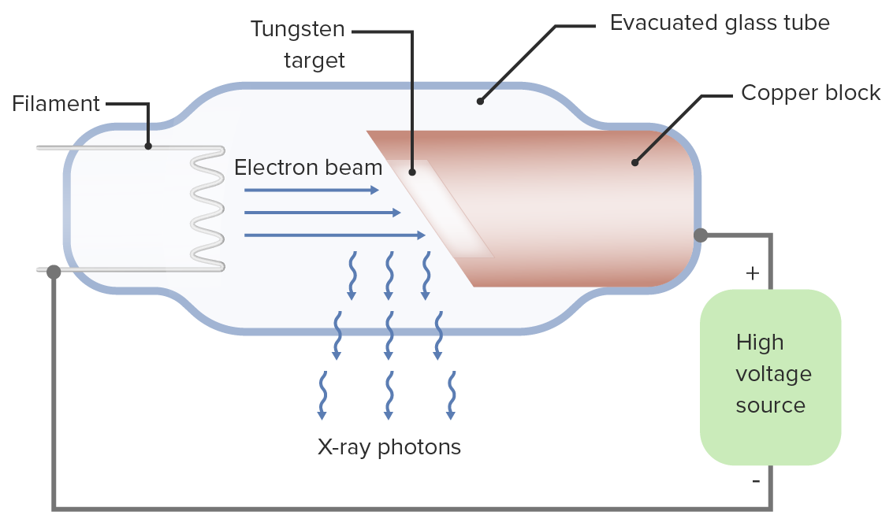

Figure:1 X Ray Production

A device that accomplishes this task consists of
1. Electron Source
2. An evacuated path Vacuum for electron acceleration
3. An External energy source to accelerate that electron
X-Ray Tube
X-Ray Tube
1. Cathode
2. Anode
3. Rotor/Stator
4. Glass or Metal envelope
5. Tube Housing

Cathode:
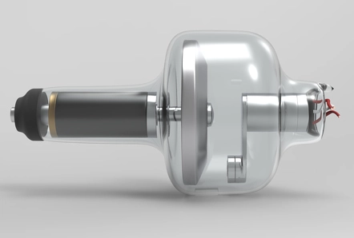
1. A focusing cup surrounds a helical coil of tungsten wire that serves as the cathode.
2. The filament circuits supply a voltage of up to 10 V and up to 7 A of current to the filament.
3. The filaments are heated by electron resistance, which releases electrons.
4.When a positive voltage is given to the anode relative to the cathode, an electron released from the filament flows through the tube's vacuum to the anode.
Focusing cup Figure:2 Cathode
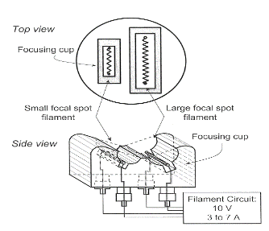
Shapes the electron beam's width and surrounds the filaments.
It is possible to bias an insulated focusing cup with a greater negative voltage (about 100V less) than the filament. intensify the electric field surrounding the filament.
1. Limits the beam's spread
2. Produces a narrow focal spot width
Filament Current
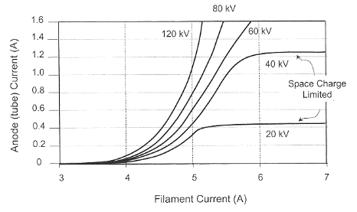
The rate of thermionic electron emission is dependent on filament temperature, which is determined by filament current. A space charge cloud forms around the filament when no voltage is provided between the cathode and the anode.
the use of highly positive The electron is accelerated toward the anode by the cathode-to-anode voltage, which results in tube current. Relatively substantial changes in tube current can result from small changes in the filament current.
Anode Figure: 3 Filament Current
A metal target electrode known as the anode is kept at a positive potential differential with respect to the cathode.
Due to its high atomic number (Z=74) and high melting point (3,370°C), tungsten is the most commonly utilized anode material.
The surface of a tungsten anode can withstand significant heat deposition without cracking or pitting.

Anode configurations:
1. The simplest X-ray tube type features a stationary (fixed) anode.
2. consists of a copper block with a tungsten inlay placed in it.
3. Copper holds the tungsten target in place and effectively drains heat from the target.
4. A small target area reduces the rate of heat dissipation, which lowers the maximum tube current and, consequently, the x-ray flux.
5. Used in portable fluoroscopy systems, portable X-ray equipment, and dental X-ray units
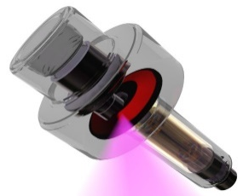
Rotating anode:
1.The most common diagnostic x-ray applications employ rotating anodes.
2. Higher x-ray production capabilities due to increased heat loading
3. Electrons give a rotating target energy, distributing thermal energy across a vast surface and mass.
Rotor:
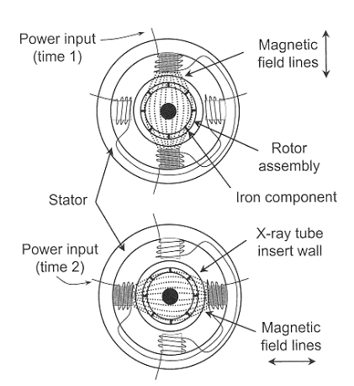
Copper bars are placed around a cylindrical iron core in the rotor. The stator is composed of electromagnets that encircle the rotor outside the x-ray tube. Rotor rotation is caused by alternating current flowing through the stator windings. Rotational speeds range from 3,000 to 3,600 rpm for low speed rotation to 9,000 to 10,000 rpm for high speed rotation.
Focal spot size
Effective focal spot width is equal to the actual focal spot width
Effective focal length = actual focal length sin
Foreshortening of the focal spot length, as viewed down the central ray, is called the line focus principle
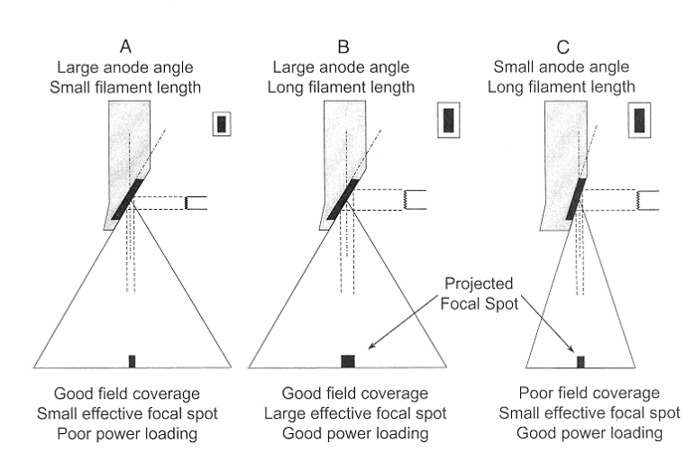
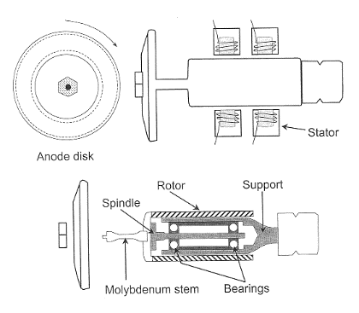

Figure:4 Focal Spot Size
Anode angle
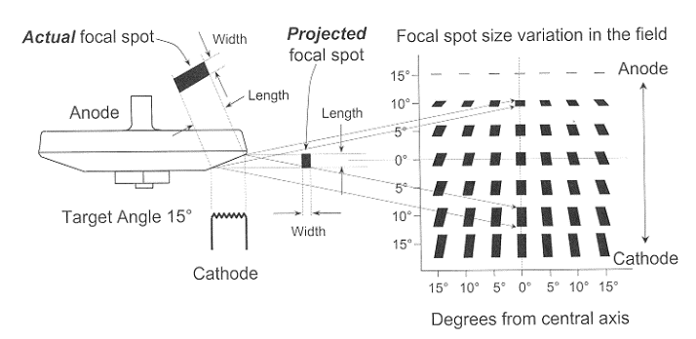
Optimal anode angle depends on the clinical imaging application small anode angle desirable for small field-of-view image receptors (cineangiographic and neuroangiographic equipment, where field coverage is limited by the image intensifier diameter)
Large anode angles necessary for general radiographic work to achieve large field area coverage at short focal spot-to-image distances
- Effective focal spot length varies with the position in the image plane, in the anode-cathode direction
- In the width dimension, the focal spot size does not change appreciably with position in the image plane
- Nominal size specified at the central ray of the beam
III. Transformers
Perform task of “transforming” alternating input voltage into alternating output voltage using principles of electromagnetic induction
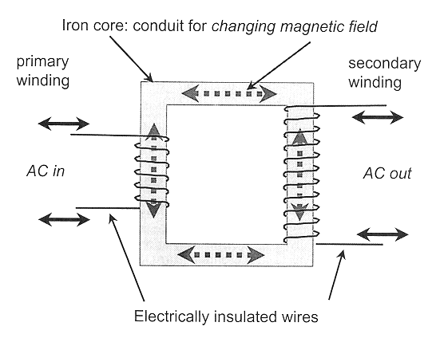
Generic transformer has two distinct, electrically insulated wires wrapped about a common iron core

Figure:5 Transformer
Law of Transformers

The ratio of the primary voltage to the secondary voltage is equal to the ratio of the number of coil turns in the primary winding to the number of coil turns in the secondary winding.
VP/VS equals NP/NS
1. A transformer may change the voltage or isolate it is dependent on the ratio of the turns in the two coils.
2.NS > NP: A "step-up" transformer that raises the secondary voltage
3.NS NP: a "step-down" transformer that lowers the secondary voltage
4.NS = NP: "isolation" transformer, primary voltage and secondary voltage are equal.

Autotransformer
consists of an iron core and a single coil of wire. The Transformers Law still holds true. operates on the self-induction, as opposed to mutual induction, premise. secondary voltage changes or climbs more gradually compared with conventional transformers electrically separates the primary circuit from the secondary circuit.

Diodes
Electrical devices that only permit current to flow in one direction and have two terminals The x-ray tube itself is an example of a diode. A semiconductor material crystal that is part of a solid-state diode is "doped" with traces of impurity elements. When voltage was applied in one direction, conductivity increased, but when voltage was applied in the opposite direction, it decreased to very low levels.

DIODES
ONE-WAY FLOW OF ELECTRON

ANODE CATHODE

Vacuum tube diode
(e.g.-Ray Tube)

Solid-State Diode

Figure:6 One Way Flow of Electron
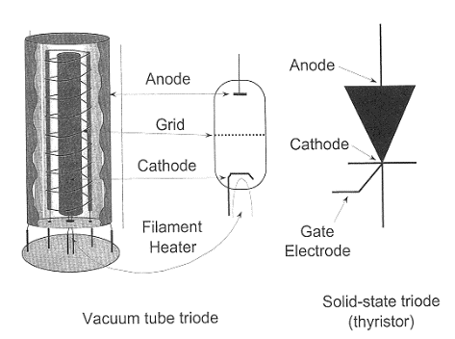
Triodes
A vacuum tube diode with a grid-like third electrode near the cathode
The grid is required for electrons traveling from the cathode to the anode. By applying a tiny negative voltage to the grid, the cathode's electrons are subjected to a strong force that allows on/off switching or current regulation.
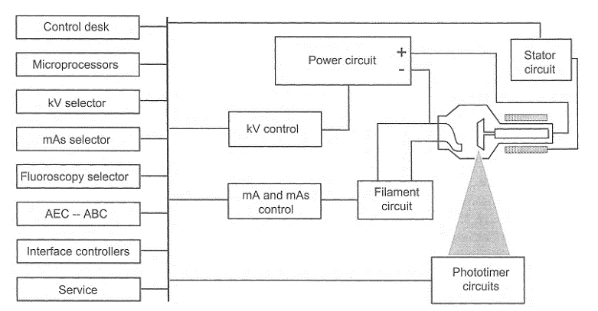

Operator Console
The operator chooses the focused spot size, exposure time, kVp, and mA (corresponding to how many x-rays are present in the beam at a particular kVp). The quality of the x-ray beam (penetrability), which influences subject contrast, is controlled by peak kilovoltage (kVp). Tube current (mA) determines the x-ray flux. The focus spot size is frequently chosen based on the mA setting. The use of preprogrammed procedures is permitted by some generators. Figure:7 X Ray Control Console Circuits
Timing the x-ray exposure
Electronic timers have mostly been superseded by digital timers because of their great repeatability and microsecond accuracy. Only single-phase, low-power generators use mechanical switches. switches with a high voltage that are utilized in 3-phase and constant potential circuits The primary side of the high-voltage transformer is switched electronically by the high-frequency inverter.

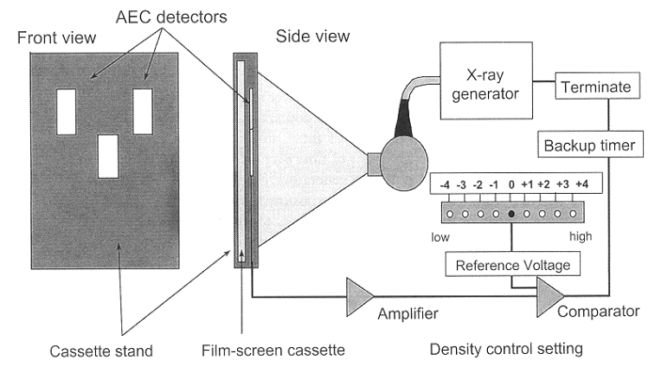
Photo timers
Measure the radiation that actually hit the image receptor. When an accurate amount is produced, stop the x-ray process. compensates for thickness and other patient-specific variations in attenuation to offer a constant exposure to the image receptor.
Figure:8 Photo Trimers
Falling-Load Generator
When used in conjunction with the photo timing (AEC) subsystem, it delivers the most mA for the chosen kVp while taking the x-ray tube's instantaneous heat load characteristics into account. continues to lower the wattage as exposure time passes gives the image receptor (IR) the desired amount of radiation in the shortest amount of time possible.
Factors affecting x-ray emission
An x-ray tube's output is described by its quality, quantity, and exposure.
An x-ray beam's penetrability is characterized by quality
The quantity of the beam's photons is referred to as its size.
Since exposure is nearly proportional to the x-ray beam's energy fluence, it possesses features related to both quality and quantity.

Efficiency, exposure, quality, and amount of X-ray production are influenced by the following factors:
1. X-ray tube target material
2.Voltage
3. Current
4. Exposure
5. Beam Filter
6. Waveform of the generator

Target (anode) material
Have an impact on the creation of bremsstrahlung radiation. Atomic number and output exposure are roughly inversely related. The target material affects the energies of the characteristic x-rays. Target material impacts both the quantity and quality of characteristic radiation and bremsstrahlung radiation.

Tube voltage (kVp)
Determines the bremsstrahlung spectrum's maximum energy and has an impact on the output spectrum's quality
Tube voltage has a direct impact on how efficiently x-rays are produced. Exposure in the diagnostic range roughly equal to the square of the kVp
$$\text{Exposure}∝\text{kV}{\text{p}}^{2}$$

Changes in kVp must be compensated by corresponding changes in mAs to maintain the same exposure
Additional consideration of technique adjustment concerns the x-ray attenuation characteristics of the patient
To achieve equal transmitted exposure through a typical patient, the mAs varies with the fifth power of the kVp ratio:

Tube current is equal to the number of electrons flowing from the cathode to the anode per unit time Exposure of the beam for a given kVp and filtration is proportional to the tube current

Exposure
Exposure time is the length of time that x-rays are produced. The relationship between the number of x-rays produced and exposure time (mAs) is straightforward.

The beam filter
Beam filtering alters the x-ray beam's amount and quality by eliminating only high-energy photons from the spectrum. As a result, the average energy increases and the photon number (quantity) decreases, improving the quality.

Power source waveform
For the same kVp, a single-phase generator offers a smaller average potential difference than a three-phase or high-frequency generator. This has an impact on the quality of the produced x-ray spectrum. The fifth power of the kVp ratio affects both the number of x-rays generated and the quality of the x-ray spectrum

References
[1] Diagnostic Radiology Physics: A Handbook for Teachers and Students
[2] J.T. Bushberg, J.A. Seibert, E.M. Leidtholdt, J.M. Boone, 3rd edn. (Lippincott Williams &
Wilkins, 2011)
[3] W.R. Hendee, E.R. Ritenour, Medical Imaging Physics, 4 edn. (Wiley, New York, NY, USA,
2002)
[4] IAEA. (2010). Clinical Training of Medical Physicists Specializing in Diagnostic Radiology.
Training Course Series, 47, International Atomic Energy Agency
[5] Core Curriculum for medical physicists in Radiology, Recommendations from am EFOMP/ESR working group, 2011
[6] International Commission on Radiological Protection,
the 2007 Recommendations of the international commission on Radiological
Protection, ICRP Publication 103, Elsevier (2008)
[7] United nations, sources and effects of ionizing Radiation, Report 2000, Vol.
1: Sources, Scientific Committee on the Effects of Atomic Radiation (UNSCEAR),un, new York (2000)
[8] H. Jones, J. Cunningham, The Physics of Radiology, Fourth Edition (C. Thomas, 1983)

