doSAGE FORM DESIGN
V. Swetha, S.B. Yashika, Hemalatha K*
Saveetha College of Pharmacy, Saveetha Institute of Medical and Technical Sciences, Saveetha University, Thandalam, Chennai, Tamil Nadu-602105, India
*Corresponding author: hemalatha6585@gmail.com, hemalathak.scop@saveetha.com

ABSTRACT:
Dosage form comprises of active and inactive ingredients. Dosage formulation are alternate modalities developed for highest therapeutic response. The medicine must be compatible with proper quality control measures. Drug formulation rationally designed by inventive computer aided drug design. Desired products are maintained with specialization at different fundamentals. Preformulating studies dealing with physical description providing specific modification, heat of vaporization involving vapor pressure, membrane as barrier for active and inactive diffusion and stability testing to check specification of drug.
Keywords: Preformulating, Solubility, Stability, Efficacy, Partition coefficient, Toxicology

INTRODUCTION:
Drug substances are a component of pharmaceutical formulations that also include one or more recipients or other pharmacological ingredients. drugs that are manufactured with various dose forms and feature specialized activities. Basic characteristics including physical nature, physiological nature, stability, efficacy, and safety are considered for proper drug design.
Drug stability
The capacity of a specific formulation in a particular container system to maintain its chemical, physical, therapeutic, microbiological, and toxicological specifications is known as stability of pharmaceutical product.
DRUG FORMULATION:
To create a given final product, active drug substance is combined with other ingredients while considering factors like pH, solubility, and particle size.
DRUG DESIGN:
New drugs are rationally designed using an inventive approach based on an understanding of their biological targets. Computer-aided drug design is the term for drug development using computer modelling.
EFFICACY OF DRUG DOSAGE FORM:
According to pharmacology, the drug's greatest response is referred to as its efficacy.

GENERIC ANALYSIS:
The development of several initial product formulations, investigation of these formulations for the desired features and scaleup are then required. The product's primary formulation is chosen because it best satisfies the goals of the product. Every new batch of the product must conform to the requirements outlined in the fundamental recipe.
- How it is handled:
Although taking medications orally is the most patient and practical way to do so, tablets and capsules are usually made for oral use. Additional examples of conditions affecting treatment dosage. The condition includes nausea, vomiting, and motion sickness.
- The patient's age and projected condition:
There may be some debate over how much of a child’s medication is truly ingested vs how much of it has been expectorated when the kid has a productive cough, is throwing up, or is simply being disobedient. In such a case injection can be necessary. Some medications are designed as chewable tablets because a person may have trouble swallowing solid dosage form during childhood or similar maturity, especially uncoated pills. Modern tablets break down in the mouth in 10 to 15 seconds, allowing patients to take a pill while really swallowing a beverage.

Need for dosage form DESIGN and convertion of drug to

dosage form
- formation of dosage with drug such as tablets, capsules, and syrups, must be able to provide exact amounts safely and easily.
- After oral administration, protection against stomach acid
Example: Tablets with an enteric coating
- Protection against atmospheric gases like oxygen and moisture
Example: A sealed or covered capsule vehicle which would like to possess,
for instance, like suspension
need for conversions:
1-Precise dose.
2-Shield e.g., coated tablets, sealed ampoules.
3-Shelter from intestinal fluid.
4-Cover taste and odor (to make palatable).
5-Disbursement of an unmetabolized drug

FIGURE 1: TYPES OF DOSAGE FORM:

Types of dosage form  1.Solid dosage form:  Tablets, capsules, chewing gum, pellets.  2.Liquid dosage form:  Solutions, elixirs, syrups.  3.Semi- solid dosage form:  Cream, gel, liniment, lotion.  4.Gaseous dosage form: | Merits  1.Dose accuracy  2.Stability of drug  3.Uniformity of dose  4.Reproductivity  1.Easy to swallow  2.Easy to manufacture  3.Fast absorption  4.Improves bioavailability  1.Easy to use  2.More stable that liquid  3.Avoidance of first pass metabolism  4.Patient convenience  1.Easy to handle and convenient  2. Withdrawal of dose without contamination  3. Provides medication to local area | Demerits  1.Non suitable for unconscious  2.Formulations complications  3.Not preferable for acid labile and stomach irritant drug.  1.Non uniformity of dose  2.Bulky  3.Less stability  4. Unsuitable for unpleasant taste.  1.Difficult to handle  2.Chances of contamination  3. May cause irritation and staining.  1.Expensive  2.May create environmental hazards.  3. Non reliable performance.
FIGURE 2: MERITS AND DEMERITS OF DOSAGE FORMS

PREFORMULATION STUDIES:
It involves the physiochemical property related to drug molecule providing the sense of modification to show better performance.
- Physical description:
Dealing with studies of physical, chemical, and pharmaceutical properties which relate molecule by providing specific modification to show better performance.
- Heat of vaporization:
The amount of heat that is required to convert of the liquid substance into a vapor form, without involving the temperature increase. Carmustine drug exhibits large (or) greater vapor pressure while the temperature tends to be increased, while cisplatin, cyclophosphamide is lesser than that.
- Particle size:
Particle size distribution is the measurement which defines the total number of particles to present according to their size. They can be spherical, non- spherical with various length and width measurement. Particle size distribution play vital role in affixing the physiochemical properties like bioavailability, color, texture, stability. Spiranolactone, nitrofurantoin, procaine penicillin are certain drugs which influenced as oral absorption.
- Solubility:
Solubility is the important property influencing physical, chemical nature of drug substance, specifically in the aqueous solution/aqueous system. When drug entering the systemic circulation in body the drug must be soluble. While insoluble drug substances show the incomplete absorption in body.
- Membrane permeability:
Membrane permeability is the drug substance crossing the biological membranous layer to produce the biological response at a site.
Membrane acts as barriers against lipid which permit soluble drug molecules through passive diffusion. This property permits both active and passive diffusion.
- Stability testing:
Quality of drug products are shifted by environmental factors lie temperature, humidity, light, pressure that are tested by stability testing. Stability testing Is a “re-testing” process done for check in the specification of given drug substances.

DESIGN FOR CONTROLLED RELEASE IN DRUG DELIVERY SYSTEM
Aim:
It enables the therapeutic effect in body by improving its efficacy and safety over controlled time and specific place of release/site of action in body.
- It is maintaining the state of equilibrium at levels of drug substance in blood fluid and in all tissues for exceeded time.
- It gives the précised in reproducibility in the drug release of pharmacokinetics reaching at a desired concentrated level.
- Sustained release provides the constant rate of drug in the human body known to be zero order dissolution.
- This design over the dosage form implies the release of specific dose having therapeutic effect over desired zone and optimal serum –drug concentration.
Mechanism of controlled release that:
Includes the degradation, swelling, diffusion active efflux.
Advantages of controlled system:
- Maintains the levels with desired range.
- Avoids overdosing.
- Prevention /reduction of side effects
- Reduces dose frequency.

formulation additives:

of solid, liquid, semisolic dosage form:

solid dosage form
Solid dosage form make significant role in medical care and sizable population depends on them for good health. Tablet and capsule are some of example for solid dosage form in general. The professional can benefit greatly from solid dose forms like pills, granules and powders. Solid dosage form in lubricants, binder and diluents.
Solid dosage form classification on usage:
Diluent;
When active ingredient formulation is reduced, these additions increase the dosage form's bulk content. Example: Mannitol, sorbitol, sucrose, dilute calcium phosphate dihydride, immediately compressible starch, hydrolysed starch, MCC and lactose among the other cellulose derivative.
Surfactant (wetting agent):
Surface active agent plays role (tablet, capsule) in solid forms by increasing De- aggregative and wetting property which promotes disintegration process.
Sequestering agents:
Sequestering agent among Tablets (oleptiss 350 mg tablet, kelfer 250 mg tablet, ferasiro 360 mg) has greater importance on promotion

LIQUID DOSAGE FORMS
Dosage forms are the essentially pharmaceuticals product in the form involves is a mixture of active drug components. Liquid formulation has been widely used in pharmaceuticals use to their high dosing flexibility, and quick onset of action. Solutions are dosage form prepared by dissolving the active ingredients in a aqueous and non-aqueous solvent.

- Solvents:
Solvents are vehicles used as base in which drugs and other excipients are dissolved or dispersed.
E.g.: water, hydro-alcoholic liquid and buffers.
- Cosolvents: It is defined as water miscible organic solvents that are used to increase the solubility of poorly water-soluble substance.
Complexation:
When complexing agents is added to solution complexes are formed it increase solubility of drug
E.g.: Citric acid, disodium EDTA.
Wetting agents and surfactants:
Wetting agents increase wetting property of hydrophobic drug particles by absorption at solid particles and increase their solubility.
E.g.: sodium lauryl sulphate
Preservatives:
The major problem with liquid dosage form is microbial contamination and use of preservatives prevent growth of microorganism.
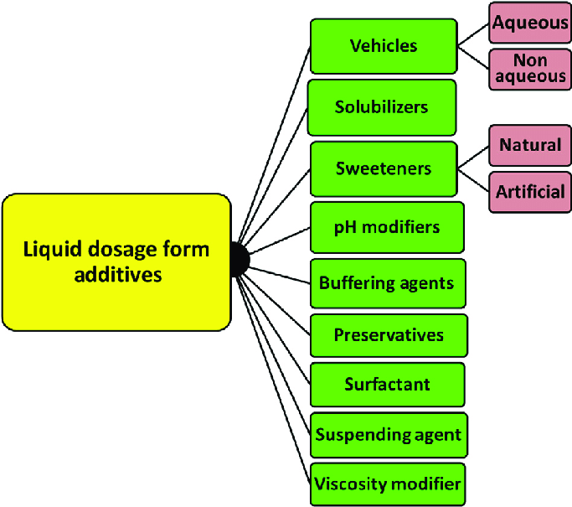
Figure 4: liquid dosage forms

semisolid dosage from
Semisolid are the topical dosage form used for the therapeutic, protective or cosmetic function. They may be applied to the skin or used vaginally or rectally. These semisolids are prepared by base containing or by the excipients these are designed to adhere to the applied surface for the sometime period before they are washed or they get worn off. The adherence property is due to the plastic rheological behaviour. Because they maintain the shape and stick to the applied area as the film till the time they are deformed or removed by the external force.
Water-soluble base and water miscible bases:
i) Glycerol gelatin base:
It is a mixture of glycerine and water made stiff by addition of gelatin particularly used for making pessaries. It is suitable for suppositories containing boric acid, bromides, iodides, iodoform, opium etc…
ii) soap- glycerin suppositories:
In this gelatin is replaced by curd soap or sodium stearate make it sufficiently hard. The main disadvantages of this they are very hygroscopic must be protected from atmosphere

STABILITY STUDIES
DRUG AND DRUG PRODUCT STABILITY:
STABILITIES ARE:
            - Chemical:
Active ingredients retain chemical integrity and label. Potency within the specified limits.
            - Physical:
Original physical properties, appearance, palatability, uniformity dissolution and suspend ability are retained.
            - Microbiologic:
Sterility/resistance to microbial growth.
            - Therapeutic:
Therapeutic effect remains unchanged.
Results:
The proper design and formulation of a dosage form requires consideration of the physical, chemical, and biological characteristics of all the drug substances and pharmaceutical ingredients (excipients) to be used in fabricating the product. The drug and pharmaceutical materials utilized must be compatible and produce a drug product that is stable, efficacious, palatable, easy to administer, and well tolerated. Preformulating factors include physical properties such as particle size, crystalline structure, melting point, solubility, partition coefficient.

References:
- https://www.sciencedirect.com/science/article/abs/pii/S0149291808004098https://uomustansiriyah.edu.iq/media/lectures/4/4_2021_09_03!07_43_57_PM.pdf
- https://www.academia.edu/41075112/DOSAGE_FORM_DESIGN_CONSIDERATIONS
- https://www.researchgate.net/topic/Dosage-Form-Design/publications
- https://shop.elsevier.com/books/dosage-form-design-considerations/tekade/978-0-12-814423-7
- https://www.bspublications.net/downloads/05805bfacb3933_Ch-1_Pharmaceutical%20Dosage%20form_Kamlesh.pdf
- https://pubmed.ncbi.nlm.nih.gov/19108798/

