Title: Plastination: An amazing educational technique for understanding medical anatomy.

Author: Dr. Amit Kumar Shreevastava
Assistant Professor
Department of Anatomy
All India Institute of Medical Sciences, Raebareli.
Uttar Pradesh, India.
PIN: 229405
Mobile No: 7706006006
Email: dr.amitaiims12@gmail.com
Introduction:
The word "Plastination" is derived from the Greek word plassein (to shape, to form).
It is an ideal process for the long-term preservation of cadavers and biological specimens for educational, research, public exhibitions, and instructional purposes. Dr. Gunther von Hagens developed the method in Heidelberg, Germany in 1977. It revolutionizes the concept of body preservation [1,2,3].
Principle of plastination-
Plastination involves removing water and lipids from the biological tissues and replacing them with curable polymers. Plastination has been performed with several different polymers, the most common being: silicone (S10), epoxy (E12), and polyester (P40). The prepared specimens are dry, odorless, inert, durable, natural-looking, easy to carry, and non-toxic [1,2,3].
What are human plastinates and their importance?
The specimens obtained after the plastination of cadavers and their body parts are called human plastinates. It may play a vital role in generating resources for the study of 3D gross anatomy, cross-sectional anatomy, pathology, forensic medicine, biology, and radiology. It is an important tool for studying both macroscopic and microscopic structures [1,2,3,4].
Disadvantages of the traditional formaldehyde fixation method:
- Volatile in nature leading to a short life span
- The storage tank area should be spacious & and equipped with exhaust fans.
- Difficulties in handling specimens.
- Long-term exposure to formalin fumes may cause cancer [5].
- Lack of student participation due to offensive odor, watering of eyes, and skin irritation [6].
Plastination consists of the following steps:
- Specimen Preparation (dissection and fixation): The cadaveric tissue is fixed and prevented from bacterial decomposition by formalin (10%) based chemical solutions pumped through major easily accessible arteries. This process takes about 3-4 hours. After that, dissection takes several days to get the desired anatomical structures [1,6-8].
- Dehydration & Defatting: Water and soluble fat are dissolved from the body by being placed by immersion in a cold acetone bath. Under freezing conditions (-25°C), the acetone draws out all the water and replaces it inside the cells. During this procedure, at least three changes of the acetone are necessary. It will take 4-5 weeks [1,6-8].
- Impregnation: Here specimen is placed in a bath of liquid polymers, such as silicone rubber, polyester, or epoxy resin. Due to the creation of a vacuum inside the chambers, acetone comes outside the cells and the liquid polymer goes inside. This process lasts 2-5 weeks [1,6-8].
- Curing: The specimens are hardened with gas, light, or heat. Curing protects the plastinate against decomposition and decay. It takes several weeks [1,6-8].
Types of plastination:
- Whole body plastination: The entire body or an organ is plastinated with silicon S10 polymer. The anatomical structure and topography of an organ/body are preserved.
- Luminal plastination: It is done for hollow viscera like intestines, lungs, stomach, heart & and kidneys.
- Sheet plastination: This procedure is followed for making thin transparent or thick opaque sections of the cadaver or an organ. The plastinated sheets display cross-sectional anatomy. The epoxy polymer (E12) is used for transparent body slices (2-3 mm), polyester (P40) for semi-transparent brain slices (3-6 mm), and silicone (S10) for 1 cm slices. It is very useful for cross-sectional anatomy and radiology [1-4,6].
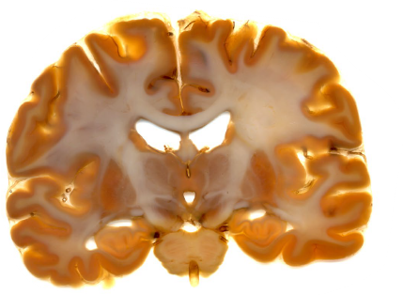
Figure 1: Coronal section of the human brain (sheet plastination). Polyester (P40) technique [3].
Advantages of plastinates:
- Lack of odor.
- Clean, inert, and non-toxic.
- Dry and hand-able items.
- More student participation.
- Provides excellent additional resource materials for medical teaching and research purposes.
- Long-lasting and minimal aftercare.
- Using real specimens is motivational.
- Excellent 3D and cross-sectional anatomical view.
- Public museum.
- Plastinates can be photographed and digitalized [1,2,3,4].
Disadvantages of plastinates:
- Expensive time-consuming
- Trained technician needed
- The emotional and tactile experience provided by a wet cadaver is not provided by the plastinates.
- Lack of hands-on skill development.
Silicon cast preparation:
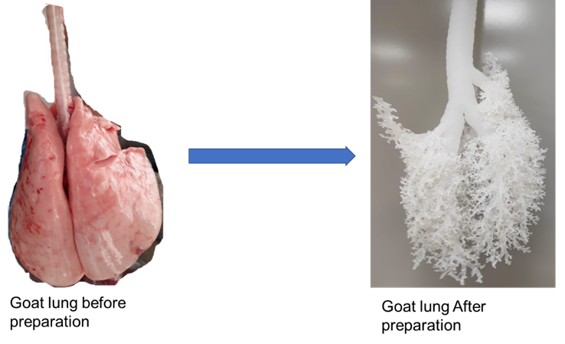
Figure 2: Preparation of silicon cast of tracheobronchial trees.
Conclusion:
- Plastinated specimens are the ‘Anatomical Art’.
- Plastinated specimens are excellent alternatives to formalin-fixed specimens.
- They make excellent teaching aids both in the classrooms and the clinical settings.
- Plastination is not a replacement for traditional guided dissection but provides an additional learning tool to understand complex human anatomy.
- Considering the ethical issues plastinated cadavers must not be commercialized.

References:
- Von Hagens G, Tiedemann K, Kriz W. The current potential of plastination. Anat Embryol 1987;175(4):411-421. doi: 10.1007/BF00309677.
- Pashaei S. A brief review on the history, methods, and application of plastination. Int J Morphol 2010; 28(4):1075-1079.
- Sora MC, Latorre R, Baptista C, López-Albors O. Plastination-A scientific method for teaching and research. Anat Histol Embryol 2019;48(6):526-531. doi: 10.1111/ahe.12493.
- Riederer BM. Plastination and its importance in teaching anatomy. Critical points for long-term preservation of human tissue. J. Anat 2014; 224, 309-315. doi: 10.1111/joa.12056.
- NTP (National Toxicology Program). 2021. Report on Carcinogens, Fifteenth Edition. Research Triangle Park, NC: U.S. Department of Health and Human Services, Public Health Service. https://ntp.niehs.nih.gov/go/roc15 (EndNote XML). doi: https://doi.org/10.22427/NTP-OTHER-1003
- Raed Ogaili, Sameem S.M. Baker, and Hong-Jin Sui. International Journal of ChemTech Research 2018,11(09): 393-398. DOI= http://dx.doi.org/10.20902/IJCTR.2018.110945.
- https://bodyworlds.com/about-us/organisations/.
- DeJong K, Henry RW. Silicone Plastination of Biological Tissue: Cold-temperatureTechnique Biodur S10/Sl5 Technique and Products. J Int Soc Plastination 2007; 22:2–14.

