A drug is “a chemical or synthetic substance used in the,
cure, prevention or diagnosis of disease or used to
otherwise enhance physical or mental well being.
BANNED DRUGS- banned drugs are drugs that not
allowed to intake because they could artificially
improve their performance and shows various adverse
effects more than therapeutic effects. Whose production
or use is prohibited or strictly controlled via
prescription.
“Drug Controller general of India” is the highest
authority in India to expand the approval of any drug or
to ban a drug. Some of the dangerous drugs have been
globally discarded but are available in India.
A drug is “a chemical or synthetic substance used in the,
cure, prevention or diagnosis of disease or used to
otherwise enhance physical or mental well being.
BANNED DRUGS- banned drugs are drugs that not
allowed to intake because they could artificially
improve their performance and shows various adverse
effects more than therapeutic effects. Whose production
or use is prohibited or strictly controlled via
prescription.
“Drug Controller general of India” is the highest
authority in India to expand the approval of any drug or
to ban a drug. Some of the dangerous drugs have been
globally discarded but are available in India.
A drug is “a chemical or synthetic substance used in the,
cure, prevention or diagnosis of disease or used to
otherwise enhance physical or mental well being.
BANNED DRUGS- banned drugs are drugs that not
allowed to intake because they could artificially
improve their performance and shows various adverse
effects more than therapeutic effects. Whose production
or use is prohibited or strictly controlled via
prescription.
“Drug Controller general of India” is the highest
authority in India to expand the approval of any drug or
to ban a drug. Some of the dangerous drugs have been
globally discarded but are available in India.
drug is “a chemical or synthetic substance used in the,
cure, prevention or diagnosis of disease or used to
otherwise enhance physical or mental well being.
BANNED DRUGS- banned drugs are drugs that not
allowed to intake because they could artificially
improve their performance and shows various adverse
effects more than therapeutic effects. Whose production
or use is prohibited or strictly controlled via
prescription.
“Drug Controller general of India” is the highest
authority in India to expand the approval of any drug or
to ban a drug. Some of the dangerous drugs have been
globally discarded but are available in India. The most
common are like
drug is “a chemical or synthetic substance used in the,
cure, prevention or diagnosis of disease or used to
otherwise enhance physical or mental well being.
BANNED DRUGS- banned drugs are drugs that not
allowed to intake because they could artificially
improve their performance and shows various adverse
effects more than therapeutic effects. Whose production
or use is prohibited or strictly controlled via
prescription.
“Drug Controller general of India” is the highest
authority in India to expand the approval of any drug or
to ban a drug. Some of the dangerous drugs have been
globally discarded but are available in India. The most
common are like
drug is “a chemical or synthetic substance used in the,
cure, prevention or diagnosis of disease or used to
otherwise enhance physical or mental well being.
BANNED DRUGS- banned drugs are drugs that not
allowed to intake because they could artificially
improve their performance and shows various adverse
effects more than therapeutic effects. Whose production
or use is prohibited or strictly controlled via
prescription.
“Drug Controller general of India” is the highest
authority in India to expand the approval of any drug or
to ban a drug. Some of the dangerous drugs have been
globally discarded but are available in India. The most
common are like
Public Awareness Regarding Prohibited Household Drugs
Garima Verma¹, Vinay Kumar¹, Hem Chandra Pant³ and Rajiv Dutta* ^{1, 2}
¹ School of Biological Engineering and Sciences, Shobhit University, Gangoh,
_{Saharanpur, UP-247341, India}
² Department of Biotechnology, School of Biological Engineering and Life Sciences,
Shobhit Institute of Engineering and Technology (Deemed-to-be-University),
_{Meerut, UP-250110, India.}
*Corresponding Author Email ID: director.sbt@gmail.com (ORCID: 0000-0003-3411-6530)
³Department of Clinical Research,
Himgiri ZEE University, Dehradun Uttarakhand, India

INTRODUCTION
A drug is defined as "a chemical or synthetic substance used in the treatment, prevention, or diagnosis of disease or used to improve physical or mental well-being." Drugs are rigorously examined before they are released onto the market, firstly on animal beings and then in humans. Drug's efficacy and safety characteristics are evaluated during clinical trials for IND (Investigational New Drugs) approval ⁽¹⁾. Despite this, certain harmful pharmacological effects do not manifest until the drug is used in a wider populations. It has been seen that various fake pharmaceuticals that have been banned, withdrawn, or promoted with restrictions in India, are still available in various pharmacies and medical stores.
News Related To Banned Drugs
The risk benefit ratio, however, depends on the dosage and the environment, according to Dhananjay Bhakhle, executive vice president of medical research at Lupin. According to independent data analyses, some nations would continue to use it while others would restrict it outside of India, according to DG Shah, director general of the Indian Pharmaceutical Association⁴.
Thousands of people's lives are being jeopardised by pharmaceutical firms and defaulters, peoples are not aware about the dangers of the medications they offer. In India, there are around 60,000 branded formulations available. These formulations comprise either a single medication or a fixed-dose combination of medicines (FDC). All formulations are utilised for illness treatment or prevention. Only a few of them are lifesaving and vital drugs; the others are available as alternatives or substitutes for one another. This article is based on the prohibited household drugs that were used in regular basis by consumers in a routine manner and peoples as well as pharmacist are not aware about that which cause serious issue and death threatens.
Keywords: Toxicity, Enviormental Health, Drugs

Fixed dose combinations (FDCs)
A fixed dosage combination combines two or more active ingredients in a known dosage ratio. It can be used as a completed pharmaceutical product or as a single-entity product. The creation of fixed-dose combinations (FDCs) is becoming more and more important from the perspective of public health (2). These medication combinations are effective in treating a variety of diseases, but they are particularly helpful in the treatment of HIV/AIDS, malaria, and TB, which are now considered to be the three most dangerous infectious diseases in the world. When there is a well-defined patient group for whom therapy with a particular active combination in a set ratio of doses has been demonstrated to be safe and effective, FDCs offer benefits.
Banned drug
Banned medicines are those that are not permitted to be consumed because they can artificially boost performance and have more negative consequences than therapeutic effects. Whose manufacture or use is forbidden or highly regulated by prescription. The "Drug Controller General of India" is India's highest authority for expanding drug approval or banning drugs. Some of the harmful pharmaceuticals have been eliminated globally, but they are still available in pharmacies. The most popular are as follows Crocin Cold and Flu, D-Cold Total, Sumo, Oflox, Chericof, Nimulid, Dolo, Decoff, O2, paediatric syr T-98 and TedyKoff etc.
Reason for banning a drug
Prior to being released onto the market, drugs are put through extensive testing. The drug's safety and efficacy profiles are examined. Despite this, a condition known as pharmacovigilance causes some pharmacological side effects to emerge only after the drug is made available².
The field of pharmacology known as pharmacovigilance investigates and works to avoid unfavourable consequences, particularly the long- and short-term adverse effects of medications1. The medicine Controller General of India is the highest authority in India with the power to enhance a medicine's clearance or to impose a drug ban. Pharmacies will immediately stop selling hazardous pharmaceuticals if physicians stop prescribing them since no one will be asking for them and no one will be making them. The government issues a ban order if any medication is shown to have negative side effects, and all manufacturers and wholesalers are requested not to carry the specific medication ².
Why pharmacies still selling banned household drugs
India has developed into a distribution hub for illegal narcotics.
Ironically, very few people are aware of the prohibited substances and use them unknowingly, which results in serious death threatens. They do themselves harm. We must warn both perpetrators and innocent people immediately since this is a serious problem.
- Crocin Cold and Flu
This medication should not be used by those who have kidney, liver, alcoholism, heart illness, or recurrent headaches. As part of its decision to halt the production and distribution of FDCs for safety reasons.
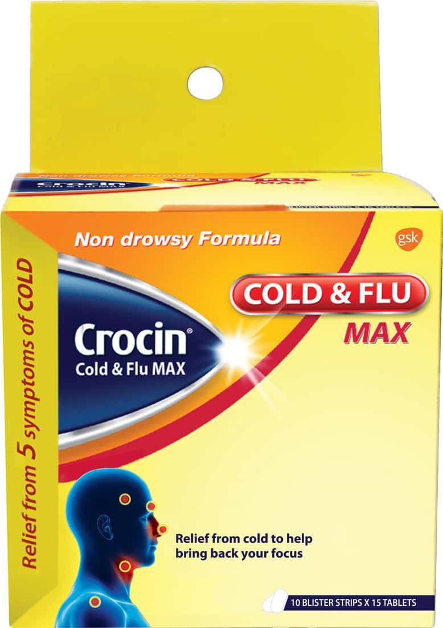
Fig 1: Banned crocin cold and flu (Source: google.com)

- D-Cold Total

D cold was once used to treat mild to moderate discomfort, headaches, allergies, nasal congestion, fever, and colds, but it has since been outlawed due to its fatally lethal combination.
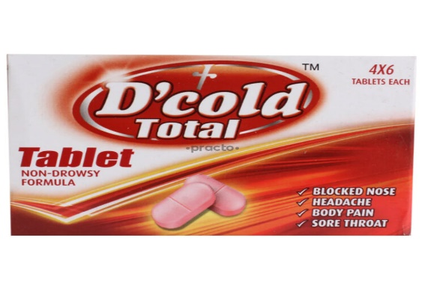
Fig 2: Banned D’ cold (Source google.com)

- Sumo
Nonsteroidal anti-inflammatory drugs (NSAIDs) are a class of medications, and Sumo Tablet is a mixture of two NSAIDs. It is used to relieve pain, edoema, and inflammation that affects joints and muscles temporarily. It works by stopping the chemical messengers in the brain from alerting us to pain. It can help with the pain treatment of conditions including osteoarthritis and rheumatoid arthritis, but use is prohibited in India owing to potentially dangerous liver effects.

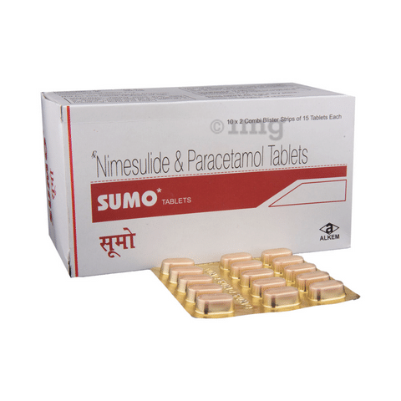
Fig 3: Banned Sumo (Source google.com)

- Oflox

Oflox 200 Tablet is an antibiotic drug that can be used to treat a variety of bacterial illnesses. It eliminates the infection and halts the growth of the bacterium that is the cause of it. Avoid missing doses and take it for the entire time that the doctor has suggested. This will guarantee that all germs are killed and do not develop resistance, but due to the combination of predetermined dosages, it will be outlawed in India.
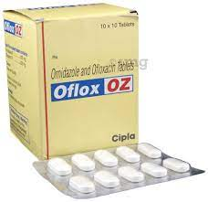
Fig 4: Banned Oflox (Source google.com)

- Nimulid
A medication called Nimulid is used to alleviate pain and discomfort. It suppresses the brain's chemical messengers, which alert us to pain. Although it works well to treat headaches, migraines, nerve pain, toothaches, sore throats, period (menstrual) pain, arthritis, and muscle aches, it is now illegal due to its hyptotoxicity and potential drug interactions, which can have catastrophic liver effects.
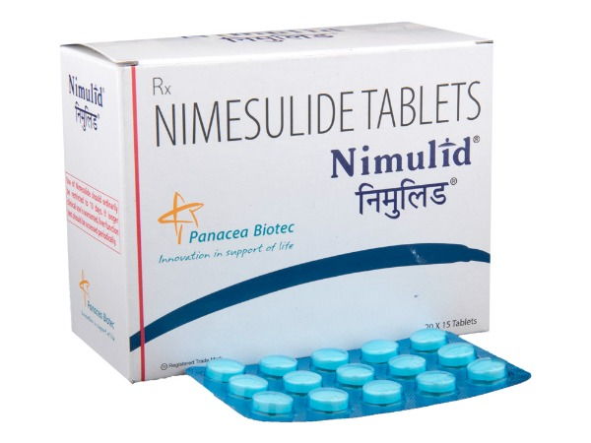
Fig 5: Banned Nimulid (Source google.com)
- Dolo
Dolo 650 Tablet helps relieve pain and fever by blocking the release of certain chemical messengers responsible for fever and pain. It is used to treat headaches, migraine, toothaches, sore throats, period (menstrual) pains, arthritis, muscle aches, and the common cold but now banned because of fix dose combination.

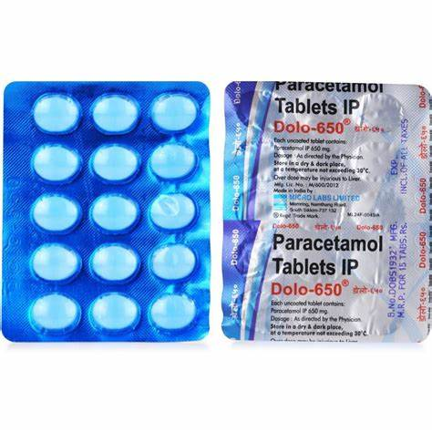
Fig 6: Banned Dolo (Source google.com)

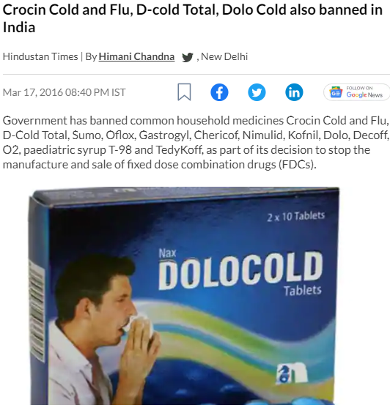

Fig 7: Recent article in Hindustan times (Source google.com)
Conclusion
The government outlawed FDC medications, which included around 6,000 brands, citing health dangers in a report by a six-member committee.
The panel deemed 963 FDCs to be unreasonable and dangerous to one's health in its report. Industry forecasts predict that the present restriction will have an annual impact of around Rs. 3,800 crore on India's $98,000 billion pharmaceutical industry. Pharms corporation quickly petitioned the Supreme Court. The first company to receive a stay of the Corex cough syrup ban was Pfizer but now these household drugs are probhited. According to the top court, the government's conduct seemed hurried and arbitrary. The chemist should actively engage patients in educating them about such legal and illegal substances on a regular basis and stop the selling of prohibited drugs that are dangerous to health.

References
- The importance of pharmacovigilance safety monitoring of medicinal products. World Health Organisation 2002;44
- Gulhati CM. government commission identifies useless, hazardous, irrational drugs. Monthly Index of Medical Specialities, India Nov 2005.
- Fixed dose combinations [Internet]. Apps.who.int. 2016 [cited 28 September 2016]. Available from: http://apps.who.int/prequal/info_applic ants/Guidelines/info for applicant's guidelines fdcs.htm
- Kiran Kabtta Somyanshi. Drugs banned abroad may still be use in some cases. The Economic Times. www.articles.economictimes.indiatimes.com/2013-01-07/news/36192943_1_cdsco_drugs_standard_control_organization_side_effects.
- Google sources

