Internet of Things (IoT) and Smart World

Nirmala Nitin Kamble Deepak Avinash Kulkarni
School of Science, School of Science,
ISBM University, Nawapara, ISBM University, Nawapara
(Kosmi), Teh.- Chhura, (Kosmi), Teh.- Chhura,
Gariyaband, Chhattisgarh Gariyaband, Chhattisgarh
nirmala.ej@tpoly.in profdeepakkulkarni@gmail.com

.

ABSTRACT

The Internet of Things (IoT) has emerged as a transformative technology that connects the physical and digital worlds, revolutionizing how devices, objects, and systems interact. As the world becomes increasingly interconnected, IoT paves the way for the development of smart cities, homes, industries, and healthcare systems. This paper presents a comprehensive analysis of the Internet of Things and its role in shaping the smart world. The first section of this paper delves into the foundational concepts of IoT, outlining its history, principles, and key components. The discussion highlights the rapid growth of IoT devices, sensors, and communication protocols, which have enabled seamless data exchange and connectivity on a global scale. The potential benefits and challenges of IoT adoption are addressed, emphasizing the need for robust security and privacy measures to protect against potential threats.

The second section explores the pivotal role of IoT in shaping smart cities. With urbanization on the rise, the need for efficient resource management, sustainable infrastructure, and enhanced citizen services becomes more pressing. IoT-driven solutions empower cities to optimize traffic flow, manage energy consumption, improve waste management, and enhance public safety through real-time data analytics and predictive modeling. In the context of smart homes, the third section investigates how IoT applications have revolutionized the way people interact with their living spaces. Smart home devices, such as smart thermostats, lighting systems, and voice-activated assistants, provide users with increased convenience and energy efficiency. However, concerns surrounding data privacy and potential vulnerabilities necessitate a discussion on the best practices for securing smart home ecosystems.

The fourth section examines the impact of IoT on industries, from manufacturing to agriculture. IoT-enabled industrial processes streamline production, enhance supply chain management, and facilitate predictive maintenance, leading to increased productivity and reduced operational costs. Additionally, precision agriculture applications of IoT offer farmers real-time data on soil conditions, weather patterns, and crop health, leading to improved crop yield and resource utilization. The fifth section addresses the transformation of healthcare systems through IoT integration. From remote patient monitoring to wearable health devices, IoT has opened new avenues for personalized and proactive healthcare. This section emphasizes the potential of IoT to revolutionize healthcare delivery by facilitating timely interventions, reducing hospital readmissions, and empowering patients to take an active role in their health management. The sixth section discusses the challenges and barriers hindering the widespread adoption of IoT and the smart world. Interoperability issues, standardization, and the complexity of integrating diverse systems pose significant challenges for stakeholders. Moreover, concerns regarding data ownership, privacy, and cyber-security remain key obstacles that need to be addressed to build public trust in IoT technologies.

The final section explores future trends and possibilities for IoT and the smart world. With the proliferation of 5G networks, edge computing, and artificial intelligence, the potential for IoT applications is boundless. The paper concludes by emphasizing the importance of collaboration among governments, industries, and researchers to shape a sustainable and inclusive smart world powered by IoT technologies. In summary, this paper provides a comprehensive analysis of the Internet of Things and its role in shaping the smart world. From its foundational principles to its diverse applications across various sectors, IoT has the potential to transform societies and redefine how we interact with technology. However, addressing challenges related to security, privacy, and standardization is crucial to unlock the full potential of IoT and pave the way for a truly interconnected and intelligent future.

Keywords — Internet, Technology, Smart, Device, Sensor, Protocols, Cyber-Security, Sustainable, Artificial, Revolution, Integration etc.

- INTRODUCTION TO INTERNET OF THINGS (IoT)

The Internet of Things (IoT) is a system of interrelated computing devices, mechanical and digital machines, objects, animals or people that are provided with unique identifiers (UIDs) and the ability to transfer data over a network without requiring human-to-human or human-to-computer interaction.
IoT evolved from machine-to-machine (M2M) communication, i.e., machines connecting to each other via a network without human interaction. M2M refers to connecting a device to the cloud, managing it and collecting data. Taking M2M to the next level, IoT is a sensor network of billions of smart devices that connect people, systems and other applications to collect and share data.
The IoT is extension of SCADA (supervisory control and data acquisition), a category of software application program for process control, the gathering of data in real time from remote locations to control equipment and conditions. SCADA systems include hardware and software components. The hardware gathers and feeds data into a computer that has SCADA software installed, where it is then processed and presented it in a timely manner. The evolution of SCADA is such that late-generation SCADA systems developed into first-generation IoT systems.

Examples of IoT: The first most smart and interactive IoT device is the ATM, Others are smart watches, fitness trackers, sleep monitors, heart monitors.

- Importance of IoT

1. The IoT helps people live and work smarter as well as gain complete control over their lives and also offers smart devices to automate homes.
2. IoT provides businesses with a real-time look into how their companies’ systems really work, delivering insights into everything from the performance of machines to supply chain and logistics operations.
3. IoT enables companies to automate processes and reduce labor costs.
4. It also cuts down on waste and improves service delivery, making it less expensive to manufacture and deliver goods as well as offering transparency into customer transactions.
5. IoT touches every industry, including healthcare, finance, retail and manufacturing.
6. Smart cities help citizens reduce waste and energy consumption and connected sensors are even used in farming to help monitor crop and cattle yields and predict growth patterns.
As such, IoT is one of the most important technologies of everyday life and it will continue to pick up steam as more businesses realize the potential of connected devices to keep them competitive.

- Advantages of IoT

1. Ability to access information from anywhere at any time on any device.
2. Improved communication between connected electronic devices.
3. Monitor their overall business processes.
4. Improve the customer experience.
5. Save time and money.
6. Enhance employee productivity.
7. Integrate and adapt business models.
8. Make better business decisions.
9. Generate more revenue
10. IoT encourages companies to rethink the ways they approach their businesses, industries and markets and gives them the tools to improve their business strategies
11. Transferring data packets over a connected network saves time and money.
12. Automating tasks helps improve the quality of a business’ services and reduces the need for human intervention.

- Disadvantages of IoT

1. As the number of connected devices increases and more information is shared between devices, the potential that a hacker could steal confidential information also increases.
2. Enterprises may eventually have to deal with massive numbers of IoT devices and collecting and managing the data from all those devices will be challenging.
3. If there’s a bug in the system, it’s likely that every connected device will become corrupted/ effected.
4. Since there’s no international standard of compatibility for IoT, it’s difficult for devices from different manufacturers to communicate with each other.

D. Major components of IoT system

1. Physical object: with embedded software into hardware
2. Hardware: Consisting of microcontroller, firmware, sensors, control unit, actuators, and communication modules.
3. Communication Module: Software consisting of device APIs and device interface for communication over the network and communication circuits, ports and middleware for creating communication stacks using 6lowPAN, CoAP, LWM2M, IPv4, IPv6, ZigBee and other protocols
4. Software: for actions on messages, information and commands which devices receives and drives actuators which enables actions such as glowing light, on off domestic or industrial equipment’s.

An IoT ecosystem: consists of web-enabled smart devices that use embedded processors, sensors and communication hardware to collect, send and act on data they acquire from their environments as shown in fig 1.

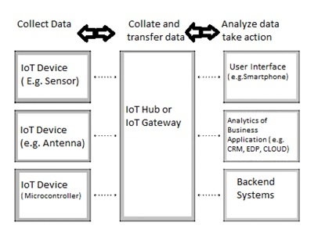

Figure 1: IoT System

IoT devices share the sensor data they collect by connecting to an IoT gateway or other edge device where data is either sent to the cloud to be analyzed or analyzed locally. Sometimes, these devices communicate with other related devices and act on the information they get from one another. The devices do most of the work without human intervention, although people can interact with the devices -- for instance, to set them up, give them instructions or access the data.
The connectivity, networking and communication protocols used with these web-enabled devices largely depend on the specific IoT applications deployed.

- LITERATURE REVIEW

The Internet of Things (IoT) has emerged as a revolutionary concept, transforming the way we interact with the digital world and the physical environment around us. It is a paradigm that connects various devices, sensors, and objects to the internet, enabling them to communicate, share data, and perform tasks autonomously. The growing interest in IoT has prompted extensive research, resulting in a plethora of literature exploring its enabling technologies, applications, challenges, and future prospects. In this 1500-word paragraph, we will delve into the insights provided by some of the key references related to IoT and its impact on the smart world.

One of the foundational works in the field of IoT is the comprehensive survey conducted by Al-Fuqaha et al. (2015). The authors shed light on the fundamental elements of IoT, covering enabling technologies, communication protocols, and a wide range of applications. They highlight the significance of various communication protocols, such as Zigbee, Bluetooth, and RFID, which play a crucial role in facilitating seamless device-to-device communication in IoT systems. The survey emphasizes the diverse applications of IoT, spanning industries like healthcare, transportation, agriculture, and smart cities. Additionally, the authors discuss the challenges faced in the implementation of IoT, including security, privacy, and interoperability concerns. This seminal work provides a solid foundation for researchers and practitioners interested in exploring the vast landscape of IoT.

In line with Al-Fuqaha et al.'s survey, Gubbi et al. (2013) present a visionary article that outlines the key architectural elements and future directions of the IoT. They propose a hierarchical architecture for IoT, comprising edge devices, middleware, cloud computing, and services layers. This architectural framework enables seamless integration and scalability of IoT applications. The authors envision a future where IoT will revolutionize various sectors, such as healthcare, energy, and environmental monitoring, leading to the realization of a smart world. They also discuss the challenges that need to be addressed, such as standardization, data management, and energy efficiency, to fully realize the potential of IoT.

Atzori et al. (2010) provide an earlier but crucial survey that contributes to the understanding of IoT. This survey explores the evolution of IoT, beginning with RFID and wireless sensor networks, to the emergence of the IoT as we know it today. The authors emphasize the role of IoT in shaping smart cities, environmental monitoring, and industrial automation. They discuss the need for interoperability and integration among various IoT components to ensure seamless data sharing and efficient resource utilization. This survey serves as a valuable resource for understanding the historical context and the evolution of IoT technologies and applications.

Another relevant literature review by Madakam et al. (2015) focuses on the IoT's vast and growing body of research. The authors present a comprehensive analysis of research articles, categorizing them into various IoT application domains and technologies. The study reveals that smart cities, healthcare, and transportation are some of the prominent application areas of IoT. Moreover, the review underscores the importance of data analytics and machine learning in harnessing the vast amounts of data generated by IoT devices. This review helps researchers identify the gaps and challenges in IoT research and offers valuable insights into potential areas of further investigation.

Li et al. (2015) present an insightful survey on the Internet of Things, highlighting its impact on information systems. They discuss the transformation of traditional information systems into smart systems through IoT integration. The authors explore the integration of IoT with cloud computing, data analytics, and mobile computing, creating intelligent environments that enhance user experiences and decision-making processes. The survey also addresses the challenges related to data privacy and security, as the seamless flow of data in IoT systems raises concerns about potential vulnerabilities and data breaches.

Borgia's work (2014) focuses on the vision of the Internet of Things, emphasizing its key features, applications, and open issues. The author highlights the ability of IoT to create smart environments through ubiquitous sensing, communication, and actuation. The review provides a detailed examination of the applications of IoT in areas like healthcare, agriculture, and industrial automation. Borgia also explores open challenges, including standardization, power efficiency, and data management, which need to be addressed to fully unlock the potential of IoT.

Security and privacy are critical concerns in the IoT ecosystem, and Zhou et al. (2015) address these issues comprehensively in the context of cloud computing. Their survey delves into the challenges faced in cloud-based IoT systems and proposes various security mechanisms and protocols to ensure data protection and integrity. The authors also discuss privacy-preserving techniques to safeguard sensitive information while enabling seamless data sharing in IoT environments.

Verma and Tripathi (2017) provide an updated review of IoT, focusing on its role in building a smart world. They discuss how IoT is driving advancements in various sectors, such as smart homes, transportation, and energy management. The authors analyze the potential economic impact of IoT and the challenges faced in its deployment, such as regulatory compliance, standardization, and data governance.

The integration of IoT technologies into smart cities is a significant area of research, and Zanella et al. (2014) examine this topic in detail. Their study highlights the role of IoT in enhancing urban infrastructure, transportation, and environmental monitoring. The authors discuss the challenges faced in building IoT-driven smart cities, including scalability, security, and resource constraints.

In the context of industrial applications, Perera et al. (2017) conduct a survey on the Internet of Things from an industrial market perspective. They explore the adoption of IoT in industrial processes, such as manufacturing, logistics, and supply chain management. The authors discuss the potential benefits of IoT in improving productivity, reducing costs, and enabling predictive maintenance in the industrial sector.

Gluhak et al. (2011) investigate the facilities available for experimental research in the Internet of Things domain. The authors analyze various testbeds and experimental platforms designed to simulate real-world IoT scenarios. Their work facilitates the testing and validation of IoT solutions before their deployment, ensuring reliability and efficiency in real-world applications.

Lee and Lee (2015) focus on the practical applications of the Internet of Things and the associated investments and challenges for enterprises. The authors explore how businesses can leverage IoT to enhance their operations, improve customer experiences, and gain a competitive edge. They also discuss the challenges that organizations face, such as data security, interoperability, and scalability when adopting IoT solutions.

Alaba et al. (2016) present a review of various applications and technologies in the Internet of Things. The authors analyze how IoT is transforming diverse sectors, including healthcare, agriculture, and smart homes. They discuss the enabling technologies, such as sensor networks, data analytics, and cloud computing, which are instrumental in realizing the full potential of IoT applications.

Stankovic (2014) offers a forward-looking perspective on research directions for the Internet of Things. The author identifies key areas for future exploration, such as seamless integration of IoT with cyber-physical systems, data analytics, and energy-efficient communication protocols. The article serves as a guide for researchers, highlighting potential research avenues to address emerging challenges and opportunities in the IoT domain.

Lastly, Dey et al. (2019) present a comprehensive compilation of works on the Internet of Things and its association with big data analytics. The edited volume explores the synergy between IoT and big data, emphasizing the need for intelligent data processing and analytics to derive meaningful insights from the massive amounts of IoT-generated data. The book provides a holistic view of IoT's integration with big data, demonstrating its potential in shaping the next generation of intelligent systems.

- CYBER PHYSICAL SYSTEM COMPONENTS

- Cyber-Physical Systems (CPSs)

Cyber-Physical Systems represent systems, where computations are tightly coupled with the physical world, meaning that physical data is the core component that drives computation. Industrial automation systems, wireless sensor networks, mobile robots and vehicular networks are just a sample of cyber-physical systems. CPS’s have limited computation and storage capabilities due to their tiny size and being embedded into larger systems. CPSs extend their capabilities by taking advantage of the emergence of cloud computing and the IoT.

- IoT Sensors

IoT connectivity is enabling all types of physical sensors to send their data directly to virtual dashboards with close to no human interaction. A sensor is a device capable of detecting changes in an environment. A sensor is able to measure a physical phenomenon and transform it into an electric signal that can represents the magnitude of the conditions being monitored. Those conditions may be light, heat, sound, distance, pressure, or some other more specific situation, such as the presence or absence of a gas or liquid.

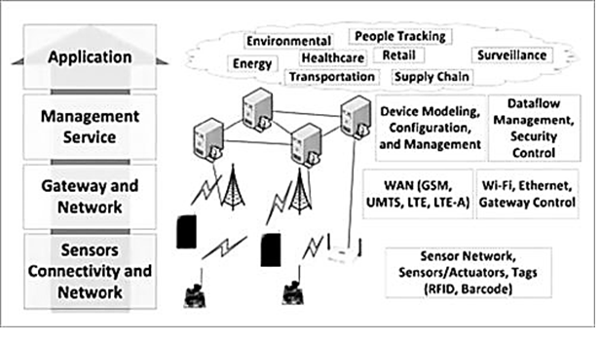

Figure 2: IoT architecture layers

As shown in Fig 4.2, the bottom layer of the IoT system consists of sensor connectivity and network to collect information. This layer is an essential part of the IoT system and has network connectivity to the next layer, which is the gateway and network layer.
The main purpose of sensors is to collect data from the surrounding environment. Sensors, or ‘things’ of the IoT system, form the front end. These are connected directly or indirectly to IoT networks after signal conversion and processing. But all sensors are not the same and different IoT applications require different types of sensors. For instance, digital sensors are straightforward and easy to interface with a microcontroller using Serial Peripheral Interface (SPI) bus. But for analogue sensors, either analogue-to-digital converter (ADC) or Sigma-Delta modulator is used to convert the data into SPI output.

- Edge Gateway

The main function of the Edge (IoT) Gateway:
1. Forwarding packets between LAN and WAN on the IP layer
2. Performs application layer functions between IoT nodes and other entities
3. Enables local, short-range communication between IoT devices

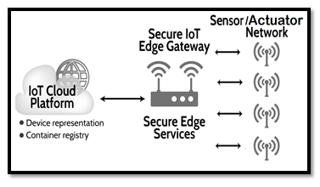

Figure 3: Edge gateway

An IoT gateway is a physical device or software program that serves as the connection point between the cloud and controllers, sensors and intelligent devices as shown in fig 3.
All data moving to the cloud, or vice versa, goes through the gateway, which can be either a dedicated hardware appliance or software program. An IoT gateway may also be referred to as an intelligent gateway or a control tier.
A gateway provides a place to preprocess that data locally at the edge before sending it on to the cloud. When data is aggregated, summarized and tactically analyzed at the edge, it minimizes the volume of data that needs to be forwarded on to the cloud, that have a big impact on response times and network transmission costs.
Another benefit of an IoT gateway is that it can provide additional security for the IoT network and the data it transports. Because the gateway manages information moving in both directions, it can protect data moving to the cloud from leaks and IoT devices from being compromised by malicious outside attacks with features such as tamper detection, encryption, hardware random number generators and crypto engines.

- Cloud

Cloud has the responsibility of accepting large amount of information from the IoT gateway, store and process them into actionable resources and send them to the user interface (web app/mobile app/dashboard).
There is an inextricable link between IoT and Cloud. The data collected by the sensors is quite huge in the case of an industrial application of IoT and a gateway is not capable of processing and storing it. This data is stored in cloud (a secure database) and processed in an affordable and scalable way.
The cloud is connected to the IoT gateway through the internet and receives all the data fed to the gateway by the sensors. Message Queuing Telemetry Transport [MQTT] is the most common used protocol that connect gateways to the IoT cloud applications.
Sensors collect and feed data at all times and this huge chunk of data after the aggregation and some pre-processing is transferred to the cloud for storage and processing.

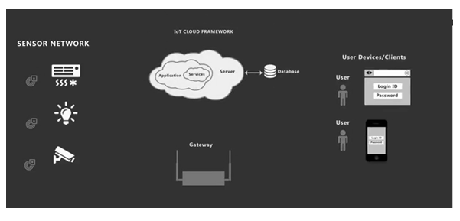

Figure 4: Cloud Application

- Benefits of Cloud in an IoT ecosystem

Caters the data storage and processing demands of IoT:
IoT has huge potential and in near future, all kinds of physical entities connected to each other. This would require raw computing power and only cloud can provide that.
1. Advanced analytics and monitoring:
With ‘things’ now being connected, there would be a need for constant analysis and monitoring in order to ensure seamless IoT experience to the users. Advanced cloud application development will ensure that the cloud is equipped with such capabilities.
2. Smoother inter-device connectivity:
In an IoT, the sensors not only talk to the users, they also interact with each other. IoT Cloud applications along with the IoT gateway ensure that different sensors and actuators are able to talk to each other without any incompatibility.

- IoT Architecture Layers

Basically, there are three IoT architecture layers:
1. The client side (IoT Device Layer)
2. Operators on the server side (IoT Getaway Layer)
3. A pathway for connecting clients and operators (IoT Platform Layer)
In fact, addressing the needs of all these layers is crucial on all the stages of IoT architecture. Being the basis of feasibility criterion, this consistency makes the result designed really work. In addition, the fundamental features of sustainable IoT architecture include functionality, scalability, availability, and maintainability. Without addressing these conditions, the result of IoT architecture is a failure. Therefore, all the above-mentioned requirements are addressed in 4 stages of IoT architecture described here — on each separate stage and after completing the overall building process.

- Main Stages in the IoT Architecture Diagram

In simple terms, the 4 Stage IoT architecture consists of
1. Sensors and actuators
2. Internet getaways and Data Acquisition Systems
3. Edge IT
4. Data center and cloud.

Stage 1. Networked things (wireless sensors and actuators):
The outstanding feature about sensors is their ability to convert the information obtained in the outer world into data for analysis. It’s important to start with the inclusion of sensors in the 4 stages of an IoT architecture framework to get information in an appearance that can be actually processed.
For actuators, the process goes even further — these devices are able to intervene the physical reality. For example, they can switch off the light and adjust the temperature in a room.
Because of this, sensing and actuating stage covers and adjusts everything needed in the physical world to gain the necessary insights for further analysis.

Stage 2. Sensor data aggregation systems and analog-to-digital data conversion:
Even though this stage of IoT architecture still means working in a close proximity with sensors and actuators, Internet getaways and data acquisition systems (DAS) appear here too. Specifically, the later connect to the sensor network and aggregate output, while Internet getaways work through Wi-Fi, wired LANs and perform further processing.
The vital importance of this stage is to process the enormous amount of information collected on
the previous stage and squeeze it to the optimal size for further analysis. Besides, the necessary conversion in terms of timing and structure happens here. Stage 2 makes data both digitalized and aggregated.

Stage 3. The appearance of edge IT systems:
During this moment among the stages of IoT architecture, the prepared data is transferred to the IT world. In particular, edge IT systems perform enhanced analytics and pre-processing here. For example, it refers to machine learning and visualization technologies. At the same time, some additional processing may happen here, prior to the stage of entering the data center.
Likewise, Stage 3 is closely linked to the previous phases in the building of an architecture of IoT. Because of this, the location of edge IT systems is close to the one where sensors and actuators are situated, creating a wiring closet. At the same time, the residing in remote offices is also possible.

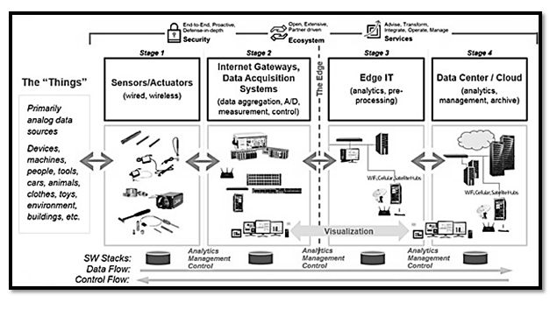

Figure 5: 4 Stage IoT Solutions Architecture

Stage 4. Analysis, management, and storage of data:
The main processes on the last stage of IoT architecture happen in data center or cloud. Precisely, it enables in-depth processing, along with a follow-up revision for feedback. Here, the skills of both IT and OT (operational technology) professionals are needed. In other words, the phase already includes the analytical skills of the highest rank, both in digital and human worlds. Therefore, the data from other sources may be included here to ensure an in-depth analysis.
After meeting all the quality standards and requirements, the information is brought back to the physical world — but in a processed and precisely analyzed appearance already.

Stage 5 of IoT Architecture:
In fact, there is an option to extend the process of building a sustainable IoT architecture by introducing an extra stage in it. It refers to initiating a user’s control over the structure — if only user result doesn’t include full automation, of course. The main tasks here are visualization and management. After including Stage 5, the system turns into a circle where a user sends commands to sensors/actuators (Stage 1) to perform some actions.
And the process starts all over again.

- IoT Applications

Use of IoT in Agriculture
Improving farm productivity is essential for increasing farm profitability and meeting the rapidly growing demand for food that is fueled by rapid population growth across the world. Farm productivity can be increased by understanding and forecasting crop performance in a variety of environmental conditions.

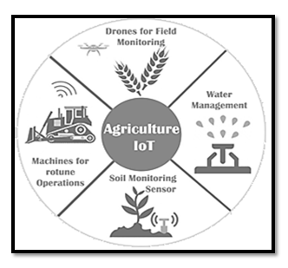

Figure 6: IoT use in Agriculture

Emerging IoT technologies, such as IoT devices (e.g., wireless sensor networks, network-connected weather stations, cameras, and smart phones) can be used to collate vast amount of environmental and crop performance data, ranging from time series data from sensors, to spatial data from cameras, to human observations collected and recorded via mobile smart phone applications. Such data can then be analyzed to filter out invalid data and compute personalized crop recommendations for any specific farm. IoT based farming can automate the collection of environmental, soil, fertilization, and irrigation data, automatically correlate such data and filter-out invalid data from the perspective of assessing crop performance. Then compute crop forecasts and personalized crop recommendations for any particular farm.
Major activities of farming can be smartly monitored, controlled and managed using IoT as follows:
Crop Water Management: In order to perform agriculture activities in efficient manner, adequate water is essential. Agriculture IoT is integrated with Web Map Service (WMS) and Sensor Observation Service (SOS) to ensure proper water management for irrigation and in turn reduces water wastage.

Precision Agriculture: High accuracy is required in terms of weather information which reduces the chances of crop damage. Agriculture IoT ensures timely delivery of real time data in terms of weather forecasting, quality of soil, cost of labor and much more to farmers.

Integrated Pest Management or Control (IPM/C): Agriculture IoT systems assures farmers with accurate environmental data via proper live data monitoring of temperature, moisture, plant growth and level of pests so that proper care can be taken during production.

Food Production & Safety: Agriculture IoT system accurately monitors various parameters like warehouse temperature, shipping transportation management system and also integrates cloud based recording systems.

Benefits of IoT in Agriculture:
The following are the benefits of IoT in Agriculture:
1. IoT enables easy collection and management of tons of data collected from sensors and With integration of cloud computing services like Agriculture fields maps, cloud storage etc., data can be accessed live from anywhere and everywhere enabling live monitoring and end to end connectivity among all the parties concerned.
2. IoT is regarded as key component for Smart Farming as with accurate sensors and smart equipment’s, farmers can increase the food production
3. With IoT productions costs can be reduced to a remarkable level which will in turn increase profitability and sustainability.
4. With IoT, efficiency level would be increased in terms of usage of Soil, Water, Fertilizers, and Pesticides etc.
5. With IoT, various factors would also lead to the protection of environment.

- SMART WORLD

- Introduction

A smart home is one that incorporates all the advanced automation systems so as to offer those who live in with the ability to monitor and control various devices such as the refrigerator, washing machine, TV, ovens, the opening and closing of doors and windows, without the need to physically operate the devices and interacting with them remotely through a wireless connection.(Wi-Fi, Bluetooth, or ZigBee) that allows multiple devices connected to each other through an appropriate app (developed and made available by the manufacturers of smart devices) that work as an administrative console. This supports, from anywhere in one’s home or office.

- Need
Smart home technology provides homeowners with security, comfort, energy efficiency and convenience. The term “smart home” is used to describe a residence that has lighting, appliances, heating, TVs, air conditioning, entertainment audio and video systems, computers, cameras and security systems that can communicate with one another and be remotely controlled from any room in the home, as well as remotely from any location via a smartphone or the internet. Thus smart home provides:
- Comfort, security and convenience.
- Remote automation.
- Conserve the earth’s limited resources.
- Increase the independency and given greater control of home environment.
- Make it easier to communicate with family.
- Save time and effort.
- Improve personal safety.
- Reduce heating and cooling costs.
- Increase home’s energy efficiency.
- Alert audibly and visually to emergency situations.
- Allow to monitor home while away.
- Detect intruders.

Today in the 21st century, that the vision of the fully automated, smart home is actually being realized. This possible because of Internet, due to which it's easy to set up virtually any electric appliance in the home, can be controlled from a Web browser anywhere in the world, known as the Internet of Things.

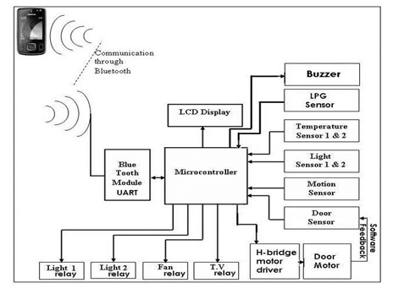

Fig.7:-Block diagram of Smart Home

A smart home has various electric and electronic appliances are wired up to a central computer control system so they can either be switched on and off at certain times (for example, heating can be set to come on automatically at 6:00 am on winter mornings) or if certain events happen (lights can be set to come on only when a photoelectric sensor detects that it's dark).
For a natural-gas-powered central heating system, likely has a thermostat on the wall is switched on and off according to the room temperature, or an electronic programmer that activates it at certain times of day whether or not in the house. Thus the system is hi-tech, with having a robotic vacuum cleaner that constantly crawls around floors sweeping the dust.

- Operation-
The central controller sends regular switching signals through the ordinary household wiring, effectively treating it as a kind of computer network. Because these signals work at roughly twice the switching frequency of ordinary AC power (which works at 50–60Hz), they don't interfere with it in any way. Each signal contains a code identifying the unit it relates to (a table lamp in living room, perhaps, or a radio in the bedroom) and an instruction such as turn on, turn off, or (for lamps) brighten, or dim. Although all the control units listen out for and receive all the signals, a particular signal affects only the appliance (or appliances) with the correct code. Apart from appliances that receive signals, can also plug in sensors such as motion detectors, thermostats, and so on, so the system will respond automatically to changes in daylight, temperature or intruders. With most systems, can also switch appliances on and off with a handheld remote control (similar to a TV remote) The remotes either send signals directly to each module using radio wave (RF) signals or communicate with the central controller, which relays the signals accordingly.X-10 has become one of the international standard for remotely controlling appliances

- X10 Protocol for Home Automation: Plug-in X-10 modules

Developed in 1975, the oldest and best-known smart home automation system is called X-10 (sometimes written "X10") and uses ordinary household electricity wiring to switch up to 256 appliances on and off with no need for any extra cables to be fitted. X-10 has become one of the international standard for remotely controlling appliances
Each appliance is plugged in order to automate into a small control unit (usually called a module) and plug that into an ordinary electrical power outlet. Using a small screwdriver, then adjust two dials on each module. One dial is what's called the house code and set this to be a letter from A through P, so use the house code to link appliances together (for example, so all the lamps on the first floor of home can be controlled as a group). The other dial is set so each individual appliance has a unique identifier known as its unit code, which is a number 1–16. Further, the plug of central controller unit into another electrical socket and program it to switch the various appliances on and off (identifying them through their codes) whichever is required. Wireless router can be used to control an X-10 system

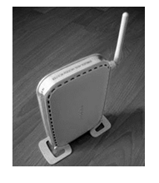

Fig. 8: Wireless router

Wireless Internet system

Security is one of the biggest reasons why many people are interested in smart homes. When away at work or on holiday, making the home seem lived in is a good way to deter intruders, a basic X-10 system can turn the lights and the TV on and off at unpredictable times, but if required to push the boat out on security, a wireless, Net-connected system is much better. Effectively, it's a computer-controlled X-10 system with an interface one can access over the Web. With a system like this, one can hook up webcams to watch home/ pets, switch appliances on and off in real time, or even reprogram the whole system.
Example -Harmony Home Automation provides this system.

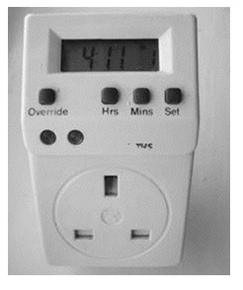

Fig 9: Remote for setting and control

Features

Control up to minimum four home appliances wirelessly (expandable based on free IO pins).
Monitor status of home like temperature inside and outside the home, light intensity inside and outside the home, motion (presence) on the main entrance, LPG leak in the home and status of main door.
Open/close main door electrically and wirelessly.
As the android application is password protected it automatically adds security to home as it can be controlled by the user only.
Automate indoor lightening, outdoor lightening and fan/AC to switch ON/OFF automatically when the light intensity and temperature conditions exceed the programmed threshold values.(This feature, we named it “SENSOMATE”).
It automatically monitor home against LPG leaks and cases of fire. If it detects something wrong, it automatically switches off all home appliances instantly and immediately opens the door to let the LPG/fire exhaust off home.
Has a “SLEEP MODE”, once activated will switch light off and program the motion sensor and door sensor to raise alarm if anything goes wrong.
At last, as it uses Bluetooth the user can use the android phone within a range from 10-100m.

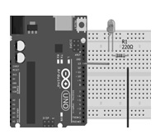

Fig 10. Home automation

There are many elderly and disabled people, and those with special needs, struggle with simple household tasks. Home automation could make all the difference between them being able to live happily and independently in their own home or having to move into expensive sheltered accommodation.
This application gives them a helping hand, feel secure with the help of motion sensor, give alarm to the guardian at times of emergency, check indoor and outdoor temperatures, Enable/Disable Automatic AC control, Enable/Disable Automatic Room light control and monitor windows/doors.
While the nascent smart home market still has plenty of room for growth, examples of smart home technology currently on the market include internet-enabled and controlled refrigerators, smart thermostats like the Nest thermostat, smart lights with light occupancy sensors, and smart door locks and security systems. Most of these smart home devices now include a mobile app for managing them via a smartphone or tablet.

Basic requirements and components for smart home.

Components -The few of the smart home devices available on today’s market:

- Monitored Security System
- Security Cameras and Video Surveillance
- Smart Door Locks
- Thermostat Control
- Lighting Control System
- Intercoms
- Video Doorbells
- Home Entertainment
- Smart TVs
- Energy Management
- Garage Door Opener
- HVAC Units with Climate Control
- Window Blinds Control
- Bed Mattress Control
- Wireless pendants for senior citizens
- Fire and Gas detection systems

Requirements and Components for Smart Home

Various sensors are placed at different places .It gathers physical conditions such as motion, temperature illumination etc. The parameters are processed using controllers such as Raspberry Pi or Arduino. Processor generates various control signal depending upon sensor information. These control signals are used to control the operation of home appliances through switches and relays.

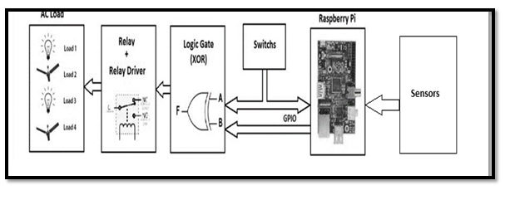
Fig 11 Block diagram of Appliances control

Video monitoring

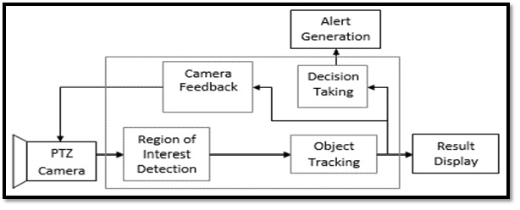

Fig 12:- Video recording system

Video monitoring system for home consists of camera (outdoor unit) and displays (indoor unit). Camera can be wired or wireless. Cameras transmitting the capture video through a radio (RF) transmitter. The video is sent to a receiver that is connected to a built-in storage device .Display unit have an easy link to access all of image or video clips.
Video monitoring system can be outfitted with motion sensor technology that is both energy-efficient and more secure. Video monitoring system that include motion detectors will start recording automatically any time they sense movement in range. In the case of pan-and-tilt cameras, the camera lens will automatically point itself in the direction of the motion and record.

Security and Alarm

ALARM SYSTEMS- Alarm systems are made up of a combination of different sensors which will trigger an alarm when it detects an action it was specifically built for. Here are some of the basic alarm systems which can install in the home to safeguard family from any outside danger:
Wired / Wireless home alarm systems-Wired alarm systems use a low-voltage current that flows between two points throughout the home’s entry points, and breaking the circuit will

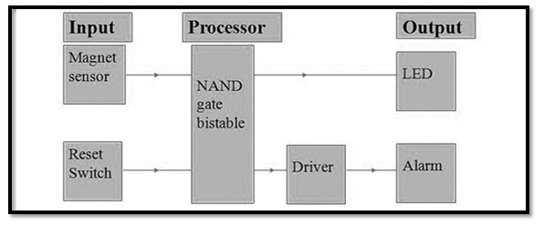

Fig 13:- Security and alarm system

result in the alarm being triggered; wireless alarm systems use built-in radio frequency transmitters where the signal is transmitted to the control panel and the alarm is activated.
Monitored / Unmonitored alarm systems- Alarm systems may be monitored by a call center who will get notified if the alarm gets triggered who will dispatch emergency services, or they may be unmonitored i.e. it’ll just set off a loud siren inside and outside the house when the alarm is tripped and will have to take necessary action .
Outdoor / Indoor Siren-The alarm system sirens may be installed indoor, outdoor or both places so that when the alarm is triggered the loud siren will be heard by neighbors as well who can alert the police.
Burglar Alarm System
A combination of different sensors and security cameras make up the burglar alarm system detects an unauthorized entry inhome. When the alarm is triggered, an alert is sent to and the police so that immediate action can be taken.

Door control

SMART DOOR-Smart doors are nowadays by installing video door phones and smart doorbells. These instruments will help know who is standing outside door before opening it, can even communicate with them about the reason for their visit without the need for physical interaction with them. By making doors smart, can rest assured that family will be safe even from unforeseen dangers.

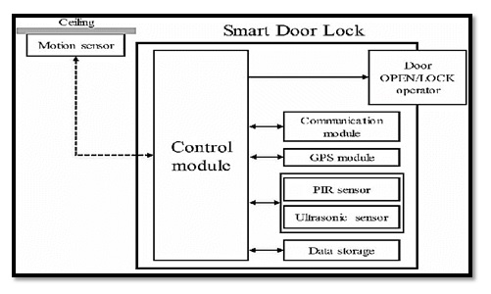

Fig 14 -Door control system

Smart lighting

Smart switches are the most cost-effective way to make the lights in home work with a mobile app or smart home system, because it doesn’t need to replace every light bulb in the home with a smart one, which is more expensive than replacing a few switches. Controlling lights with voice, have smart lighting systems to make a feel all-powerful. Smart lighting generally uses mesh networking, where each smart bulb wirelessly connects to its nearest neighbor. That network is controlled by a hub that plugs into router, enabling other networked devices - such as phone or tablet - to communicate with bulbs. Some systems also have an away from home mode that enables to control the lights when far away, which is handy if just remembered that the lights were left on. Smart light systems can also be accessorized with additional items such as dimmer switches or motion detectors, and in some cases they can be linked to the IFTTT (If This Then That) service to create complex rules that trigger particular recipes for particular things.
Example-Smart lighting systems are controllable with smartphone or tablet apps. Philips’ Hue system works with Apple’s HomeKit, Amazon’s Echo and Google Home, can use those platforms voice assistants to relay the voice commands. Example-saying “Hey Siri, set scene to cinema” or “Alexa, turn the lights off” and seeing it happen. With HomeKit can also control the lights with an Apple Watch. Most smart lighting systems use the same ZigBee wireless networking technology. It’s called ZigBee Light Link and it’s used by Philips, IKEA and Osram, which should ensure ongoing compatibility and interoperability between competing systems. Smart light bulbs aren't currently suitable for enclosed light fixtures, as heat can build up in the fixture, which shortens the bulb's life.
Smart Lighting includes-
1. Smart Light Bulbs
2. Smart Dimmers
3. Smart Ceiling fans
4. Smart flash mount lighting
5. Smart lighting kits
6. Smart light switches
7. Smart outdoor lighting
8. Smart outlets
9. Smart plugs

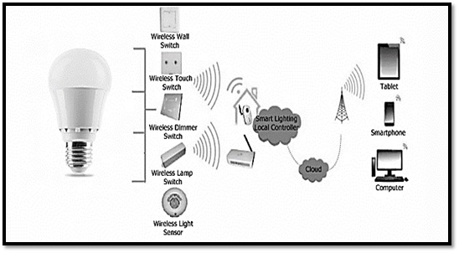

Fig 15:-Smart lighting for home and its control

Smart Metering

Introduction: A smart meter is an electronic device that records consumption of electric energy and communicates the information to the electricity supplier for monitoring and billing. Smart meters typically record energy hourly or more frequently, and report at least daily.
Smart meters enable two-way communication between the meter and the central system. Such an advanced metering infrastructure (AMI) differs from automatic meter reading (AMR) in that it enables two-way communication between the meter and the supplier.
Communications from the meter to the network may be wireless, or via fixed wired connections such as power line carrier (PLC).
Wireless communication options in common use include cellular communications (which can be expensive), Wi-Fi (readily available), wireless ad hoc networks over Wi-Fi, wireless mesh networks, low power long range wireless (LoRa), ZigBee (low power, low data rate wireless), and Wi-SUN (Smart Utility Networks).
Smart metering offers potential benefits to householders. These include,
a) An end to estimated bills, which are a major source of complaints for many customers
b) A tool to help consumers better manage their energy purchases-stating that smart meters with a display outside their homes could provide up-to-date information on gas and electricity consumption and in doing so help people to manage their energy use and reduce their energy bills.
An academic study based on existing trials showed that homeowners' electricity consumption on average is reduced by approximately 3-5%.

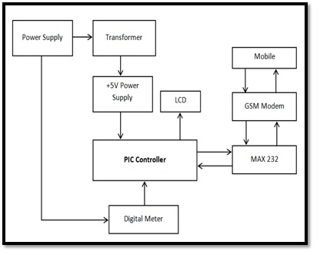
Fig 16:- Smart meter system

Advance metering system: -Advanced Metering Infrastructure (AMI) refers to systems that measure, collect, and analyze energy usage, and communicate with metering devices such as electricity meters, gas meters, heat meters, and water meters, either on request or on a schedule. These systems include hardware, software, communications, consumer energy displays and controllers, customer associated systems, meter data management software, and supplier business systems. The network between the measurement devices and business systems allows collection and distribution of information to customers, suppliers, utility companies, and service providers. This enables these businesses to participate in demand response services. Consumers can use information provided by the system to change their normal consumption patterns to take advantage of lower prices. Pricing can be used to curb growth of peak demand consumption. AMI differs from traditional automatic meter reading (AMR) in that it enables two-way communications with the meter. Systems only capable of meter readings do not qualify as AMI systems.

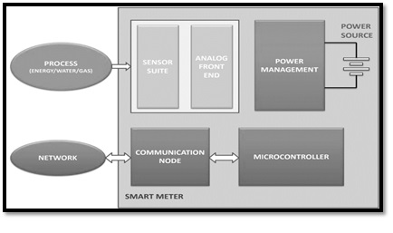

Fig 17:- Block diagram Smart Meter

- Smart City

- Basic requirements for Smart City

A Smart city is an urban area that uses different types of electronic Internet of things (IoT) sensors to collect data and then use these data to manage assets and resources efficiently. This includes data collected from citizens, devices, and assets that is processed and analyzed to monitor and manage traffic and transportation systems, power plants, water supply networks, waste management, crime detection, information systems, schools, libraries, hospitals, and other community services

Requirements that makes smart city are:
1. Health and education
2. Sustainable environment
3. Affordable housing, especially for the poor
4. Adequate water supply
5. Assured continuous Electric power supply and backup
6. Sanitation, solid waste management
7. Efficient urban mobility along with public transport and broad highways
8. E-governance and participation of citizens
9. Safety and security, especially senior citizens, women and children
10. Security for banks, ATMs
11. Complete digitization and online trading, IT Connectivity.

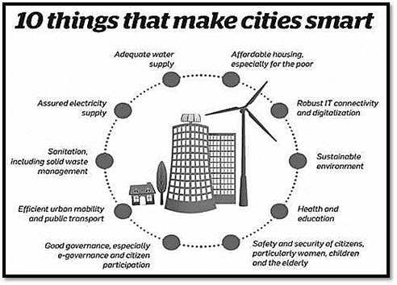

Fig 18:- Requirements of smart city

- Concept of Smart City

New Internet technologies is platform for promoting cloud-based services, the Internet of Things (IoT) real-world user interfaces, use of smart phones and smart meters, networks of sensors and RFIDs, and more accurate communication based on the semantic web, open new ways to collective action and collaborative problem solving.
Online collaborative sensor data management platforms are on-line database services that allow sensor owners to register and connect their devices to feed data into an on-line database for storage and allow developers to connect to the database and build their own applications based on that data.
Large IT, telecommunication and energy management companies launched the Global Intelligent Urbanization initiative to help cities using the network as the fourth utility for integrated city management, better quality of life for citizens, and economic development. Smarter Cities stimulates economic growth and quality of life in cities and metropolitan areas with the activation of new approaches of thinking and acting in the urban ecosystem. Sensor developers and startup companies are continually developing new Smart city applications.

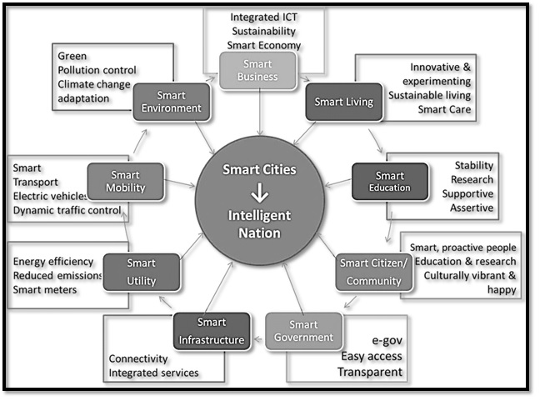
Fig 19: -Features of smart city

- Smart city model

Thus a Smart city, also called as community, business cluster, urban agglomeration or region, uses information technologies to:
1. Make more efficient use of physical infrastructure (roads, built environment and other physical assets) through artificial intelligence and data analytics to support a strong and healthy economic, social, cultural development.
2. Engage effectively with local people in local governance and decision by use of open innovation processes and e-participation, improving the collective intelligence of the cities
institutions through e-governance, with emphasis placed on citizen participation and co-design.
Learn, adapt and innovate and thereby respond more effectively and promptly to changing circumstances by improving the intelligence of the city.

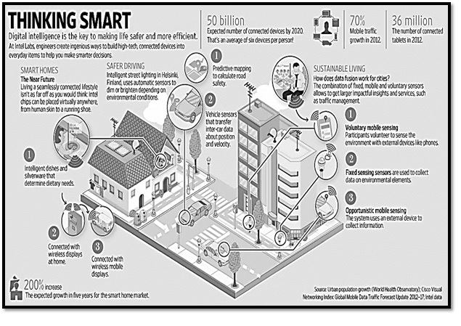
Fig 20: Smart city model

Government of India (GoI) planning and budget for upcoming Smart Cities:

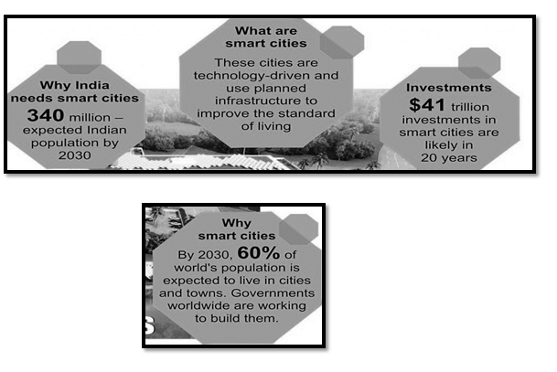

Fig21:- Smart city plan and budget for the future

Current Indian working projects/cities towards smart cities

Smart Transportation

In 1950, thirty percent of the world’s population was urban, expected to grow to 66 percent by 2050. Cities across the world are expanding, so pressures on cities to augment their infrastructure and facilities to accommodate all existing/potential residents and enable them to lead a good quality of life. Smart cities use technology to augment their urban services-transportation, utilities and energy-to improve efficiency, reduce wastage and operate more sustainably. The government of India, too, launched the Smart Cities Mission to develop 100 Indian cities to be sustainable and citizen-friendly.

Delivering seamless mobility- Smart transportation is developed on the base of smart infrastructure that includes not only multi-modal connected conveyance but also automated traffic signals, tolls and fare collection. Data integration drives the system, incorporating weather and traffic data, linking emergency services data as well as information from government agencies. Smart services offer different benefits, from smart parking and vehicle locating systems, to route diversion alerts. A central command center can tie together the smart transportation ecosystem, with real-time and updated data, handling passenger information, Optimized on-demand services can ensure that citizens can use all modes of transport according to their needs. Shared mobility solutions can help provide first and last mile connectivity in conjunction with public transportation, they can act as feeder services and improve access to metro/rail or bus services. If public transportation is made robust and accessible through multi-modal shared mobility, citizens can choose it for all their commuting needs be it office travel, travel for daily needs or leisure travel. The number of private vehicles can be reduced, which can contribute to lowering congestion and pollution. Traffic signals, incident management and vehicle health monitoring.

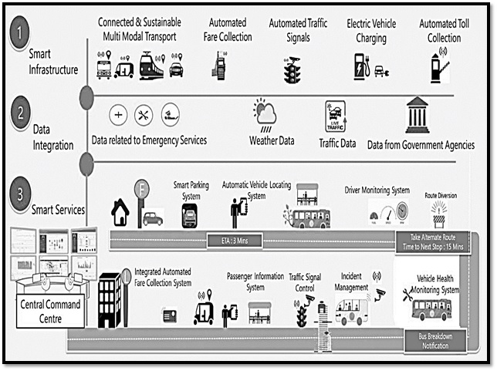

Fig 22. Smart city model

Multi-modal mobility options-through Mobility-as-a-Service (MaaS):- MaaS aims to solve the problems associated with urban density and make mobility more efficient and convenient. It offers users access to different modes of transport via a single platform such as a mobile application

Intelligent traffic management-Traffic Demand Modeling: City planners can track data
records and area-wise people movement and use this information to build models whereby public transportation gets deployed in areas of maximum people movement to ensure better connectivity.
Implementing smart transportation would need the government, transport operators and service providers to collaborate in planning and execution, saving staff-hours through better traffic management, reducing polluting emissions, or increasing Gross Domestic Product (GDP) by reducing the consumption of vehicular fuel and oil imports, smart transportation is here to stay. State DOTs must closely collaborate with local jurisdictions to understand what the communities’ critical needs are to help them achieve their goals to provide-

- Connecting underserved communities to jobs
- Moving goods in and out of the city
- Integrating data collection throughout various systems
- Establishing better parking systems
- Controlling carbon emissions
- Improving traffic flow

Example-Transportation in the Smartest City: Singapore plans to improve commuters’ overall experience with a wait time for public transport shortened by three to seven minutes and a 92% reduction of overcrowded transportation. By leveraging real-time location intelligence. In their Open Data and Analytics for Urban Transportation project, Singapore’s Land Transport Authority (LTA) plans to use data from sensors installed in over 5,000 vehicles to make sure arrival time and bus availability are sufficient for commuter demand. LTA has also worked to provide travelers with access to real-time data such as bus arrival time, taxi availability, traffic conditions, and carpark availability so they can make informed decisions on how to navigate their surroundings.

- Smart Healthcare

Among all the facilities to citizens in a smart city, smart healthcare counts as foremost important facility as a city which has healthy citizens is balanced in every sphere. Smart Health Technology’ combines Smart Technology and latest mobile device with health, such as fitness tracker or fitness bands and even health assessment apps in smartphones have gained grand attention amongst fitness enthusiasts. They not only just monitor health but also provide solutions if needed at the right time. Smart Health technology interacts and engages with data produced by those devices which can be analyzed by doctors, researchers and health care professionals for better-personalized diagnosis and solutions. These digital records save cost and time of both patients and hospitals as they not only offer personalized treatments and medications but also give preventive measures through real-time data collection
Role of technologies in Smart Healthcare - Here IoT plays an important role, allows connecting data collected from smart devices and sensors to extract valuable insights, then convey that information to the doctors and staff in real-time, thus improving the effectiveness in the overall healthcare system. When the health data is collected it needs to be analyzed and managed for accurate treatment and here Artificial intelligence and automation are applied.

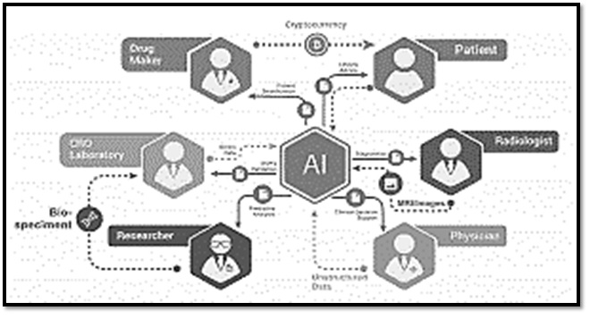

Fig 23:- Smart healthcare

E-health delivers health information and services to enable data transmission, storage and retrieval for clinical, educational and administrative purposes. Mobile health (or m-health) is the practice of medicine and public health supported by mobile devices. Speech and hearing systems for natural language processing, speech recognition techniques, and medical devices can aid in speech and hearing (e.g. cochlear implants). Tele-health, tele-medicine, tele-care, tele-coaching and tele-rehabilitation provide various forms of patient care remotely at a distance

Example- Smart Dust-Millimeter-scale self-contained micro-electromechanical devices that include sensors, computational ability, bi-directional wireless communications technology and a power supply. As tiny as dust particles, smart dust motes can be spread throughout buildings or into the atmosphere to collect and monitor data. Smart dust devices have applications in everything from military to meteorological to medical fields.

- Smart Waste

In the field of IoT, the objects communicate and exchange information to provide advanced intelligent services for users, the technology is used to solve the problem of Waste management in smart cities, where the garbage collection system is not optimized.
Waste management is all the activities and actions required to manage waste from its inception to its final disposal. This includes collection, transportation, treatment and disposal of waste together with monitoring and regulation. Domestic waste collection services are often provided by local government authorities such as municipal corporations. The waste is collected at regular intervals by specialized trucks. Waste collected is then transported to an appropriate disposal area. Today cities with developing economies experience exhausted waste collection services, inadequately managed and uncontrolled dumpsites and the problems are worsening. Waste collection method in such countries is an on-going challenge and many struggle due to weak institutions and rapid urbanization.

Need: - Improvement and involvement of technology is required to manage the disposal of waste as:
- By 2030, almost two-third of the world’s population will be living in cities, demanding for development of sustainable solutions for urban life, managing waste is a key issue for the health.
- Efficient and energy-saving waste management, reducing CO2,air pollution and vehicle exhaust emissions
- Waste management may swallow upto 50% of a city’s budget, but only serve a small part of the population. Sometimes, upto 60%of waste is not being collected, it is often simply burned by the roadside. It can pollute drinking water, it can spread disease to people living nearby.
- Even with great route optimization, the worker must still physically go to the dustbin to check waste levels. Because of this, trucks often visit containers that do not need emptying, which wastes both time and fuel.
- Waste management prevents harm to human health and the environment by reducing the volume and hazardous character of residential and industrial waste.
- Improving proper waste management will reduce pollution, recycle useful materials and create more green energy.

Features

- The smart, sensor based dustbin will judge the level of waste in it and send the message directly to the municipal corporation.
- It can sense all the type of waste material either it is in the form of solid or liquid.
- According to the filled level of the dustbin, the vehicles from the municipal corporation will choose the shortest path with the help of the “TRANSPORTATION SOFTWARE”, which will save their time.  It emphasizes on “DIGITAL INDIA”.
- The system is simple. If there is any problem with any equipment in the future, that part is easily replaceable with new one without any difficulty and delay.

Advantages

- Less time and fuel consumption as the trucks go only to the filled containers.
- Decreased noise, traffic flow and air pollution as a result of less trucks on the roads.
- Our smart operating system enable two way communication between the dustbin deployed in the city and service operator. Therefore the focus is only on collection of route based fill level of the containers.
- The sensors installed in the containers provide real time information on the fill level. This information helps determine when and where to prioritize collection.
- In this way both service providers and citizens benefit from an optimized system which results in major cost savings and less urban pollution.
- Reduces the infrastructure (trucks, containers), operating (fuel) and maintenance costs of the service by upto 30%.
- Applying this technology to the city optimizes management, resources and costs, and makes it a “SMART CITY”.
- Historical information on collections helps adapt the deployment of containers to the actual needs of the city, therefore reducing the number of containers that clutter up the road and increasing public parking spaces.
- It keeps the surroundings clean and green, free from bad odour of wastes, emphasizes on healthy environment and keep cities more beautiful.
- Reducing manpower required to handle the garbage collection

Main Equipments used in Smart Waste Management System:

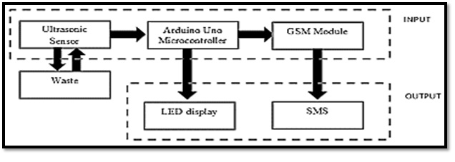

Fig.24: –Smart waste System

Garbage Container: A waste container is a container for temporarily storing waste, and is usually made out of metal or plastic. The curbside dustbins usually consist of three types: trash cans (receptacles made of metal or plastic), dumpsters (large receptacles similar to skips) and wheelie bins (light, usually plastic bins that are mobile). All of these are emptied by collectors, who will load the contents into a garbage truck and drive it to a landfill, consuming crush facility to be disposed of.

Ultrasonic Sensor- A special sonic transducer is used for the ultrasonic proximity sensors, which allows for alternate transmission and reception of sound waves. The sonic waves emitted by the transducer are reflected by an object and received back in the transducer. After having emitted the sound waves, the ultrasonic sensor will switch to receive mode. The time elapsed between emitting and receiving is proportional to the distance of the object from the sensor.

Arduino Board-: Arduino is a software company, project, and user community that designs and manufactures computer open-source hardware, open-source software, and microcontroller-based kits for building digital devices and interactive objects that can sense and control physical devices.

Software of Arduino: The Arduino project provides the Arduino integrated development environment (IDE), which is a cross-platform application written in the programming language Java.

GSM Module: GSM (Global System for Mobile Communications, originally Group Special Mobile), is a standard developed by the European Telecommunications Standards Institute (ETSI) to describe the protocols for second-generation (2G) digital cellular networks used by mobile phones.

Smart Physical safety/security

Life safety products Monitoring typically includes

- Monitored smoke detectors and heat detectors for fire monitoring
- Carbon monoxide poisoning detectors
- Flood sensors to detect unwanted water damage in areas like indoor laundry room and basements
- Medical emergencies.
- Every home should have at least one of monitored smoke detector which would be placed in the hallway next to the bedrooms. For a multiple story house, it should have at least one monitored smoke detector on each level. Heat detectors should be added to the kitchen, garage and laundry room. Some homeowners would like to replace the smoke detectors in all bedrooms with a monitored photoelectric smoke and heat detector.

Benefits of fire monitoring:

- ADT Central Station will call the fire department in the case of a fire emergency
- Photoelectric smoke detectors detect smoldering smoke before a fire starts.
Monitoring for carbon monoxide poisoning is also important as it will notify the ADT Central Station in case home is being filled with this poisonous gas. The monitoring center operator will call and notify the detected carbon monoxide poisoning and dispatch local fire department. This will ensure not to enter into home when it is not safe.
- Flood sensors are designed to notify water in unwanted areas. Most often these are installed in the laundry room or in the basement that may have issues. This can protect from the massive damage water can cause.

Smart Education

For the past few years, the transformation has taken place in higher education system into smart-education and traditional universities into smart-universities, requirements of the smart-economy and smart-society with the aim of achieving quality training of specialists.
It provides the flexibility of learning in an interactive educational environment, free access to worldwide content, personalization and adaptation of learning are presented and analyzed. The education based on smart-technology helps to realize inner potential through matching the content of the study course with their own results, and building an individual learning program
with an emphasis on their personal qualities of a student.

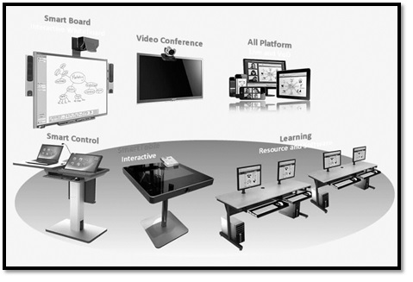

Fig 25. Smart Education Interactive displays

The upcoming revolution in education system is replacing traditional classroom and learning methods. The implementation of information technology is driving the smart education and learning markets. Educational institutes are adopting advanced teaching methods and tool which includes white boards, projectors and smart notebooks. Implementation of such technology in classroom improves understanding of students and provides clear view about what to learn. Coordination between hardware provider, software innovator and education material provider is making learning easy for students.
The key driver of smart education and learning is the interactive displays hardware, active learning .Increase number of mobile learning applications and professional expertise with technology and towards digital learning are anticipated to drive the smart education and learning market.

Advantages-

- Today AR/VR is adopted for more enhanced and detailed learning.
- Smart classes use all interactive modules like videos and presentations and these visually attractive methods of teaching becomes appealing to students.
- Smart classes are almost like watching movies as sometimes, animated visuals are used to teach a point
- Visual is eye-catching and young students can easily relate with them because the audio-visual senses of students are targeted and it helps the students store the information fast and more effectively.
- Enhanced and Interactive learning experience
- Easy Access to Online Resources
- Follows Go Green Concept
- Time Saving Technology
- Increased Productivity
- Smart Boards are Fun.

VI. CONCLUSION

The Internet of Things (IoT) has emerged as a groundbreaking technology that has revolutionized the way we interact with the world around us. In this discussion, we have explored the significant impact of IoT on transforming our lives and shaping the concept of a "smart world." With the rapid advancement of IoT applications, the potential for connectivity, automation, and data-driven decision-making has expanded exponentially. As we conclude this discussion, it becomes evident that the integration of IoT into various sectors has paved the way for a more efficient, convenient, and sustainable future.

One of the most remarkable aspects of IoT lies in its ability to bridge the gap between the physical and digital realms. Through the deployment of sensors, actuators, and data analytics, IoT enables real-time monitoring and control of devices and processes. This interconnectedness has led to the creation of smart cities, smart homes, and smart industries, ushering in an era of increased efficiency and optimization. Smart cities, for instance, have leveraged IoT to optimize traffic flow, reduce energy consumption, and enhance public safety. The integration of IoT into homes has provided residents with greater control over their environments, enabling energy conservation and the management of household appliances remotely. Similarly, industries have seen improvements in productivity, safety, and predictive maintenance through IoT-enabled industrial automation.

Beyond individual applications, the true potential of IoT lies in its ability to facilitate a holistic and integrated approach to problem-solving. The vast amount of data generated by IoT devices offers unparalleled insights into human behavior, environmental patterns, and system performance. Leveraging this data intelligently can lead to informed decision-making and targeted solutions. However, this abundance of data also poses challenges, such as data security, privacy concerns, and the need for robust data management strategies. As we progress towards a smart world, it becomes crucial to address these issues diligently and responsibly.

Furthermore, the proliferation of IoT devices raises concerns about interoperability and standardization. For the seamless functioning of a smart world, different IoT devices and platforms must communicate effectively with one another. Industry-wide standards and protocols are essential to ensure compatibility, interoperability, and scalability. Collaborative efforts between technology providers, policymakers, and stakeholders are needed to establish comprehensive guidelines and frameworks that foster the growth of IoT in a secure and reliable manner.

In the context of a smart world, the role of artificial intelligence (AI) cannot be overlooked. AI and machine learning algorithms analyze the vast datasets generated by IoT devices, uncover patterns, and predict future events. This convergence of AI and IoT opens up new opportunities across various domains, including healthcare, agriculture, transportation, and more. Nevertheless, as we embrace AI-driven IoT solutions, ethical considerations surrounding AI's decision-making capabilities and potential biases must be taken into account.

The realization of a smart world also depends on ensuring equitable access to IoT technologies and digital infrastructure. Bridging the digital divide is essential to avoid exacerbating existing socio-economic disparities. Governments, in collaboration with the private sector, must prioritize initiatives that enable digital literacy, provide affordable access to IoT-enabled services, and address accessibility challenges faced by marginalized communities.

Furthermore, sustainability should remain at the forefront of IoT development. While IoT holds the potential to enhance resource management and reduce waste, its widespread adoption must align with environmentally responsible practices. Implementing energy-efficient designs, recycling electronic waste, and promoting circular economy principles are crucial in ensuring the long-term viability of IoT technologies.

In conclusion, the Internet of Things (IoT) has emerged as a transformative force, propelling us towards a smart world characterized by unprecedented connectivity and intelligence. The integration of IoT into various sectors has brought forth a plethora of benefits, ranging from improved efficiency and convenience to enhanced safety and sustainability. However, realizing the full potential of IoT and its smart world applications requires concerted efforts in addressing challenges related to data security, interoperability, ethics, and equitable access. By embracing IoT responsibly and collaboratively, we can harness its power to create a more connected, intelligent, and prosperous future for humanity.

REFERENCES

[1] Al-Fuqaha, A., Guizani, M., Mohammadi, M., Aledhari, M., & Ayyash, M. (2015). Internet of Things: A Survey on Enabling Technologies, Protocols, and Applications. IEEE Communications Surveys & Tutorials, 17(4), 2347-2376.

[2] Gubbi, J., Buyya, R., Marusic, S., & Palaniswami, M. (2013). Internet of Things (IoT): A Vision, Architectural Elements, and Future Directions. Future Generation Computer Systems, 29(7), 1645-1660.

[3] Atzori, L., Iera, A., & Morabito, G. (2010). The Internet of Things: A Survey. Computer Networks, 54(15), 2787-2805.

[4] Madakam, S., Ramaswamy, R., & Tripathi, S. (2015). Internet of Things (IoT): A Literature Review. Journal of Computer and Communications, 3(5), 164-173.

[5] Li, S., Da Xu, L., & Zhao, S. (2015). The Internet of Things: A Survey. Information Systems Frontiers, 17(2), 243-259.

[6] Borgia, E. (2014). The Internet of Things Vision: Key Features, Applications, and Open Issues. Computer Communications, 54, 1-31.

[7] Zhou, J., Leung, V.C.M., Shu, L., & Li, S. (2015). Security and Privacy in Cloud Computing: A Comprehensive Survey. Journal of Computing Science and Engineering, 9(2), 89-122.

[8] Verma, P., & Tripathi, A. (2017). A Review of Internet of Things (IoT) towards Smart World. International Journal of Computer Applications, 160(5), 1-7.

[9] Zanella, A., Bui, N., Castellani, A., Vangelista, L., & Zorzi, M. (2014). Internet of Things for Smart Cities. IEEE Internet of Things Journal, 1(1), 22-32.

[10] Perera, C., Liu, C.H., Jayawardena, S., Chen, M., & Ngu, A.H.H. (2017). A Survey on Internet of Things From Industrial Market Perspective. IEEE Access, 5, 6702-6719.

[11] Gluhak, A., Krco, S., Nati, M., Pfisterer, D., Mitton, N., & Razafindralambo, T. (2011). A Survey on Facilities for Experimental Internet of Things Research. IEEE Communications Magazine, 49(11), 58-67.

[12] Lee, I., & Lee, K. (2015). The Internet of Things (IoT): Applications, Investments, and Challenges for Enterprises. Business Horizons, 58(4), 431-440.

[13] Alaba, F.A., Aderonmu, P.A., & Akinwale, A.T. (2016). Internet of Things: A Review of Applications and Technologies. International Journal of Computer Applications, 142(12), 1-7.

[14] Stankovic, J. A. (2014). Research Directions for the Internet of Things. IEEE Internet of Things Journal, 1(1), 3-9.

[15] Dey, N., Ashour, A. S., Hassanien, A. E., & Bhatt, C. (Eds.). (2019). Internet of Things and Big Data Analytics Toward Next-Generation Intelligence (Vol. 1). Springer.

