Integrated Multi Trophic Aquaculture (IMTA) System: Way Forward towards Sustainable Aquaculture
Dr. Naresh Raj Keer^{1*}, Dr. Showkat Ahmed Dar¹, Dr. Abhiman¹ Md. Idrish Raja Khan², Chetan Kumar Garg³
¹College of Fisheries, BASU, Kishanganj, Bihar-855107, India
²College of Fisheries, CAU (I), Lembucherra, Tripura-799210, India
³Narayan Institute of Agricultural Sciences, Gopal Narayan Singh University, Rohtas, Bihar-821305, India
Abstract
The development of sustainable culture practices needs to minimize environmental degradation with intent towards horizontal and vertical expansion of aquaculture system. Integrated multi trophic aquaculture (IMTA) system is a novel integrated slant similar as polyculture system that involves the culture of two or more species together. IMTA is the exercise that integrates the suitable proportions of fed species (finfishes /shrimps) with organic extractive (shellfishes/herbivorous fishes) and inorganic extractive species (seaweed cultivation) in a particular culture system. IMTA stands as a fully sustainable technology with environmental benefits. Mainly, this chapter highlighted the introduction, history, present status, concept behind the integration, advantages and disadvantages, design and nutrients flow and future prospective of IMTA. The technology ensures the eco-biological balance by controlling the organic and inorganic pollution in the cultural environment. In conclusion, the IMTA can be an eco-friendly and sustainable technology that can be done in open water (marine and freshwater) to benefit the farmers as additional revenue.
Keywords: IMTA, Seaweed, Cobia, Eco-friendly, Eco-biological Balance, Polyculture System

Introduction
Globally, aquaculture growth involves a sharp increase in cultivation area, and high density-based aquaculture systems require greater use of formulated feed resources. These aquaculture systems need to be managed regularly, but it will negatively affect the aquatic environment and production system when the farmers fail to manage.So aquaculture needs to involve novel technologies that must be socially acceptable and environmentally, economically sustainable andshould have an option to culture multiple species. Integration of fish together with plants and vegetables has been practiced for centuries. From the decade, many researchers have studied how to improve productivity and environmental sustainability in cultural practices. The study includes inspecting the economic and ecological benefits by growing various species together, including finfish, shellfish, and plants or algae in the water. This idea has come up as an integrated multi-trophic aquaculture. IMT Aquaculture is based on ecosystem slants for aquaculture (EAA), promoting higher efficiency to use nutrients from the ecosystem and creating an opportunity to diversify the tropical aquaculture system towards sustainability (FAO, 2009).The main aim of this review chapter was to describe IMTA in an easy way.
Background and present scenario
John Ryther reignited the interest in IMTA systems in the 1970s, wherein advantages of synergistic interfaces between species and environment were notified. This man was considered as the grandfather of modern IMTA for his influential effort on combined waste-recycling marine polyculture systems. He integrated polyculture, ecologically engineered aquaculture, ecological aquaculture and integrated fish and plant culture. Moreover, Jack Taylor combined integrated aquaculture and multi-trophic aquaculture into the term IMTA during the year 2004 (Johnson et al., 2019).
In the last few decades, only some countries have been practicing the IMTA system near to the commercial level viz. Canada, Ireland, South Africa, China, Chile, United States of America, United Kingdom of Great Britain and Northern Ireland (primarily Scotland). Portugal, France and Spain are doing many research projects related to the expansion of IMTA. The Scandinavia country, especially Norway had worked some individual effort toward evolving the IMT Aquaculture technology, in spite of owning an extensive fish aquaculture linkage (Barrington et al., 2009). In India, ICAR-CMFRI has magnificently established IMTA under hands-on mode fishermen’s groups at Munaikadu in Palk Bay (Ramanathapuram district) of Tamil Nadu state India by the integration of seaweed species and fish viz. Kappaphycus alvarezii with Cobia (Rachycentron canadum) cultivation in cage. However, seaweed culture is being widely practiced and adopted in many places of Tamilnadu coast, hence, addition of seaweed with cobia farming in a cage was initially endeavoured (Johnson et al., 2019). Nearly hundred fishers in Ramanathapuram district of Tamilnadu are practicing IMTA in various locations.
What is IMTA and its basic concept?
IMTA system is similar to a polyculture system where two or more organisms farmed together (Johnson et al., 2019). In IMTA, multiple aquatic species are farmed together in an integrated manner with efficient waste utilization and ecosystem niches. IMTA is the practice that assimilates the suitable proportions of fed cultivable aquatic species (example: finfishes/shrimps) with organic extractive cultivable aquatic species (example: shellfishes/herbivorous fishes) and inorganic extractive cultivable aquatic species (example: seaweeds). The IMT aquaculture system is a balanced aquaculture system for the environment (bio-mitigation), social (better managing practices) and economic (product divergence and risk drop) sustainability (Shah et al., 2017). Design and concepts of IMTA is presented in Figure 1 and Figure 2.
Criteria for selection of species combinations in IMTA
The selection of co-culture species in the IMTA is based on a number of following conditions.-
- Based on their corresponding roles with other species in the IMTA.
- Based on the adaptableness of species correspondence to the habitat.
- Based on the culture technics and site ecological conditions.
- Based on the aptitude of species to offer both effectual and unceasing bio-mitigation.
- Based on the market ultimatum for the cultivable species and valuing as raw product or their derived products.
- Based on their commercialization prospective.
- Based on their contribution to improved environmental performance.

Nutrient flow in IMTA
There are numerous prospects intended for nutrient lessening from IMT Aquaculture systems between nutrient load and its sequestration in the biomass of cultivated species along with (Figure A and Figure B).
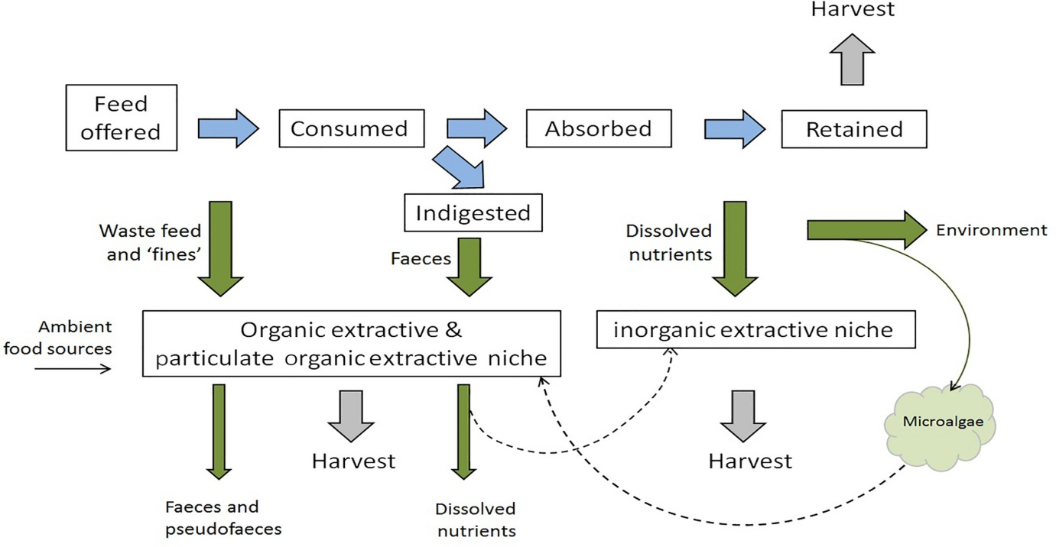
Figure A: Flowchart of the nutrients from fed tropic species to extractive species. Blue arrows are on behalf of the nutrient and energy flow in tropic level of fed species. Green colure arrows are demonstrating the losses potentially accessible to culture extractive niches/ contribution for non-culture species. Surrounding food sources also are offered to organic extractive niches. The arrows in black coloured dash are on behalf of potential two-step transfer, for instance growth enhancement of microalgae and uptake by organic extractive niches. Arrows in grey colour are for nutrient sequestered in culture biomasses that are removed system upon harvest (Reid et al., 2020).
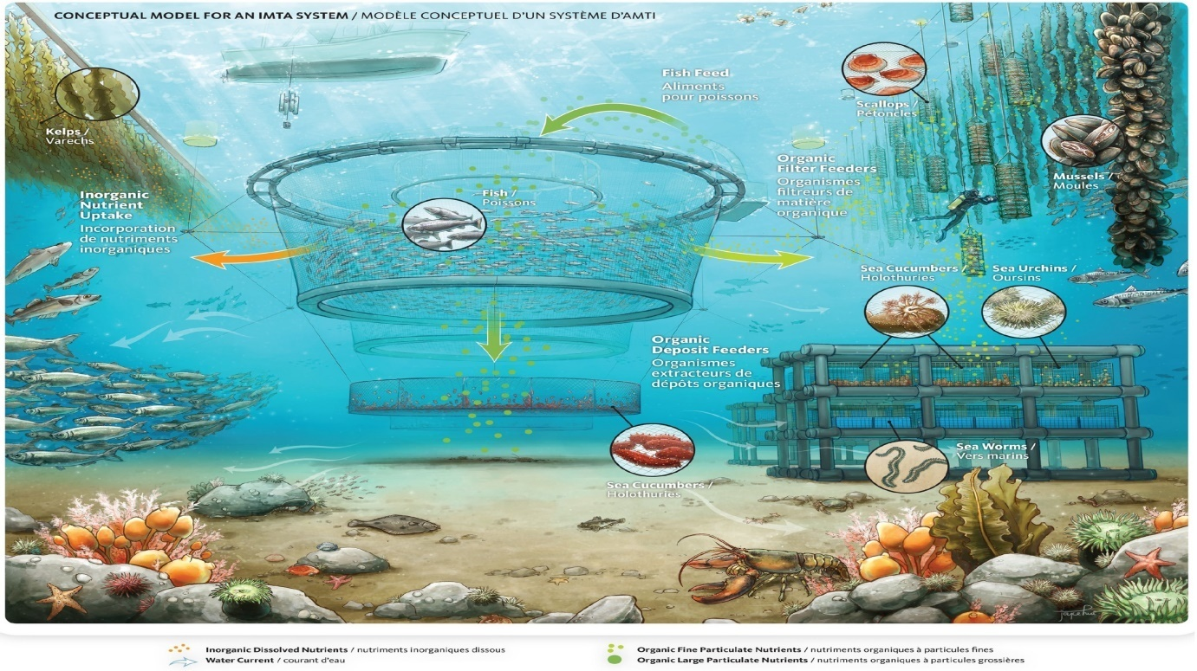
Figure B: Intangible illustration of an IMTA in open-water area (Image courtesy: Fisheries and Oceans Canada). Nutrient portions flows to cultured niches or for natural micro- or macro-species into the environment (Reid et al., 2020).
Advantages of IMTA
- It is based on nutrient recycling in the ecosystem (particularly in closed systems).
- Ultimatum of feed from pelagic maritime fisheries and terrestrial crops will be reduced.
- Ecologically sustainable and improves environmental condition through Effluent bio-mitigation.
- IMTA increases farm productivity.
- This technology can be applied to various environmental conditions (example: land-based or marine-based).
- It increases profit through species diversification in aquaculture.
- It increases profit through obtaining premium prices with the help of eco-labeling or organic certification of products).
- It produces healthful food (protein, Omega-3 etc.)
Disadvantages/challenges of IMTA
- It lacks thorough understanding of environmental influences.
- Presently emphasizes only high value species foodstuffs and therefore, it is less likely to make a good contribution in world’s food demand (except some seaweeds).
- Chances of shifting nutrient flows in the environment into diminish natural production of the system.
- It is complex when operated, high in risks structural, operations, disease and seed supply.
- It has site-specific criteria (because of numerous species): current, temperature, salinity, etc.
- It needs more significant capital costs for a start-up.
- It has complexity in regulatory.
- It has some conflict of use (e.g., water, space etc.).
Species cultured along with the main species in such system are characterised into three diverse niches based on the nutrient flows through the consumption of waste. Group one which can extract their diet from organic particles which are settled/suspended in the system, Group second which can extract their diet from inorganic particles which are settled/suspended in the system and last one is seaweeds/plants that can captivate soluble nutrients (Table 1).
Table 1: Species groups in cultured extractive niches and nutritional inputs in IMTA based ecosystem (Reid et al., 2020).
Extractive Niches | Extractives species group | Targeted nutrients | Property of Nutrients
Inorganic | Seaweeds and aquatic plants | Soluble inorganics | Soluble inorganic and the end-products of metabolism, such as ammonium (NH₄⁺), nitrate (NO₃⁻), phosphate (PO₄³⁻) and carbon dioxide(CO₂)
Organic | Detritus feeding species and grazers (eg. polychaetes, sea cucumbers and sea urchins | Organic solids | Large settled matter, which has high in organic content and it comes from the fed trophic level (eg. waste feeds and faeces and lower organic content solids from non-fed species viz. bio-deposits comes from suspension feeders).
Particulate organic | Suspension and filter feeders for instance shellfish | Suspended organic matter | It is very fine and comes from waste feed and small faecal matter, in addition to natural or IMT aquaculture- promoted microalgae
Several following steps should be taken for the expansion of IMTA
- Foundation of the financial and ecological worth of frameworks and their co-items.
- Determination of the right species, suitable to the natural surroundings, accessible advancements, and the ecological and oceanographic conditions, reciprocal in their environment capabilities, developing to huge biomass for proficient bio-relief.
- Advancement of compelling government regulation/guidelines and impetuses to work with the improvement of IMTA rehearses and the commercialization of IMTA items.
- Rearrangement of the advantages of IMTA and instructing partners about this practice.
A case study: IMTA by CMFRI (Johnson et al., 2019)
Demonstration of IMTA (integration of Seaweed cobia cages)
Sixteen bamboo rafts (12× 12 feet), each contains 75 killograms of seaweed were integrated with one cobia cage encloser (seaweed farming= 4 cycles; cobia farming= 180 days, 180 days need to produce four cycle of sea weed farming). The seaweed raft were kept in a semi-circular manner 15 feet away from the cobia cage therefor seaweed is enable to utilise the inorganic nutrient wastes emerging from the cobia cage, which moves together with the water current from the cage. A 6 m dia GI cage and 3.5 m depth with 750 fingerlings of cobia integrated with the seaweed raft (Figure 3a). The cobia fingerlings fed twice a day @ 5% of total biomass with chopped low-valued fishes like lesser sardine, sardine, rainbow sardine, et cetera. Based on the assessment of fouling on the net of cage, nets changed periodically to ensure sufficient water circulation through the cage. The cropping period for cobia was 180days. A separate set of seaweed rafts of the same number and size were cultivated as a control on different locations without cobia cage or any cage (Johnson et al., 2019).
Economic benefits of Seaweed production cultivated under IMTA (Johnson et al., 2019)
A seaweed production cycle of 40-45 days performed. At the end of the cycle, the rafts are pushednear the shore to harvest the seaweed. A 75 kilograms of yield retained as seed for the next set up and the remaining kept to dry in the sun light for three days and sold out in as dried. The obtained seaweed’s average weight was only 10 percentage of the entire wet weight. After harvesting, rafts again seeded again (after 2-3 days) and incorporated with the cobia cage. In 180 days, four cycle of seaweed were cultivated. The average yield from per raft (12 x 12 feet) without the incorporation was 150 kilograms while it was 260 kilograms in the raft incorporated with cobia cage. After four cycles, 576 kg of seaweeds was produced without integration, while 1280 kg was produced with the integration of rafts with cobia cage. Thus 704 kg of seaweed was an additional production with the integration of cobia cage farming.
b
a
Figure 3: Seaweed raft incorporated/integrated with cobia cage (a) and seaweed raft without integration (b) (Johnson et al., 2019)
The rafts incorporated with cobia cage culture had significant advantage as an amplified number (90-100) of newly emerge apical portion/tips in harvested seaweed (bunch) is due to effective utilization of organic solid waste in IMT Aquaculture. The less numbers (30- 40) of apical tips for the rafts that were not incorporated with the system. When used for replanting, bunches having more and less numbers of recently emerge apical tips/portion were ready for harvest early (within 40 days) and late (around 54 days), respectively. The additional revenue / additional net profit of Rs. 26,400 with an increased profit of 41% through integration of seaweed rafts to cobia cages with thesame operational cost for the rafts was notable (Johnson et al., 2019). The extra income generation/extra net benefit of Rs. 26,400 with an expanded benefit of 41% through incorporation of ocean growth pontoons to cobia confines with the same functional expense for the pontoons was remarkable.
Table 2: Comparison of cost and returns of seaweed cultivation in IMTA (16 rafts / one cage / 4 cycle) and without IMTA (Johnson et al., 2019)
Particulars | In IMTA | Without IMTA | Difference
Production of dried seaweed (4 cycles, 16 rafts) | 1280 kg | 576 kg | 704 kg
Price of dried seaweed (Rupees / kg) | 37.50 | 37.50 | -
Revenue (Rupees) | 48,000 | 21,600 | 26,400
Costs (Rupees) | 16,000 | 16,000 | -
Net Profit (Rupees) | 32,000 | 5,600 | 26,400
Profit Margin (%) | 67 | 26 | 41
Monetary benefit of cobia crop under IMTA
The incorporation of seaweed rafts with cobia cage producedgood returns. In one crop (180 days) of cobia the yield was produced 1220 kg and 960 kg with integration and without integration of seaweeds (four-cycle), respectively. The gross income from the cobia was 353800 and 278400 rupees for the integrated and non-integrated cages (average weight of cobia was 2.2 kilogram at the cost of Rs. 290/ kg). Integrated cobia cages had an additional income of 75400 rupees.
Table 3: A comparative economics cobia farming with and without IMTA in sea cage (single crop/cage; 180 days duration)(Johnson et al., 2019)
S.No | Particulars | In IMTA (Rs) | Without IMTA (Rs.) | Difference
Cobia seeds stocked: 750 numbers in a 6m dia GI cage with 3.5m depth
1. | Fixed cost of a cage | 61600 | 61600 | Nill
2. | Total operating cost of a cage | 130000 | 130000 | Nill
3. | Total cost of production (180 days) | 191600 | 191600 | Nill
4. | Cobia production in kilogram (in 180 days; average weight- 2.2 kg) | 1220 | 960 | 260
5. | Gross income in Rs. (@ Rs. 290 per kg) | 353800 | 278400 | 75400
6. | Net income | 162200 | 86,800 | 75400
7. | Net operating income (Income over operating cost) | 223800 | 1,48,400 | 75400
8. | Farm entry gate Price (Rs.) | 290 | 290 | Nill
9. | Capital Productivity (Operating ratio) | 0.37 | 0.47 | Nill
10. | Cost of production (Rs. per kg) | 157 | 199 | 42
 | Profit Margin (%) | 85 | 45 | 40
Future prospective
India has a vast opportunity to establish the IMTA set up at various reservoirs and as well as marine water. IMTA could be a beneficial technology in open water body or land-based aquaculture system as well as in marine or freshwater aquaculture systems. IMTA can also be set up in intensive land-based tank culture. The design of the IMT aquaculture can vary and depend on the choices based on different climatic, environmental, biological, physical, chemical, societal, economic, historical, political, governance and many more conditions, prevailing in the many parts at global level where they operate. Organism in IMTA are must be chosen on their complementary functions basis in the ecosystem and economic potential from different tropic levels. Normally, fed species are finfish or shrimp and are cultured with extractive species like seaweeds and aquatic plants, which can better utilise dissolved inorganic nutrients in the water, and shellfish and invertebrates that utilise organic particulate nutrients.
Globally, it is a great opportunity to use micro-algae as bio-filters in IMTA and process them as a product with higher business esteem. In any case, a couple of nations are rehearsing IMTA at the business level. Most of the seaweed farming is monocultured in open water in Asia, South America, South Africa, and East Africa (Johnson et al., 2019).
Conclusion
This review briefly provides a better understanding about the integrated multi-trophic aquaculture (IMTA) system. IMTA is an eco-friendly and sustainable integrated system that can mitigates organic and inorganic pollution in the open water and provides additional income through the surplus production of multi species. This technique can also generate a heightened business hobby as soon as high-cost seaweeds species may be cultured as biofilters producing novel human meal products. Still, aquaculture needs to implement the IMTA in the available open water resources as the units of IMTA are significantly less in numbers. This chapter recommends incorporating the IMTA to make the open water productive, sustainableand pollution free by utilising the ecosystem’s niche.
References
Johnson, B., Nazar, A.K.A., Jayakumar, R., Tamilmani, G., Sakthivel, M., Ramesh Kumar, P., Anikuttan, K.K., Samal, A.K. and Sankar, M. (2019). Integrated multitrophic aquaculture (IMTA): A technology for uplifting rural economy and bio-mitigation for environmental sustainability. Aquaculture Spectrum. 2(5): 9-18.
Shah, T.K., Nazir, I., Arya, P. and Pandey, T. (2017). Integrated multi-trophic aquaculture (IMTA): An innovation technology for fish farming in India. International Journal of Fauna and Biological Studies. 4(1): 12-14.
Reid, G.K., Lefebvre, S., Filgueira, R., Robinson, S.M., Broch, O.J., Dumas, A. and Chopin, T.B. (2020). Performance measures and models for open‐water integrated multi‐trophic aquaculture. Reviews in Aquaculture. 12(1): 47-75.
Barrington, K., Chopin, T. and Robinson, S. (2009). Integrated multi-trophic aquaculture (IMTA) in marine temperate waters. Integrated Mariculture: a Global Review. FAO Fisheries and Aquaculture Technical Paper. 529: 7-46.
Johnson, B., Nazar, A.K.A., Jayakumar, R., Tamilmani, G., Sakthivel, M., Ramesh Kumar, P., Anikuttan, K.K., Samal, A.K. and Sankar, M. (2019). Integrated Multitrophic Aquaculture (IMTA): A technology for uplifting rural economy and bio-mitigation for environmental sustainability. Aquaculture Spectrum. 2(5): 9-18.
F.A.O. (2009). The State of World Fisheries and Aquaculture 2008. FAO of the United Nations, Rome, xvi + 176 p.

