Structural Analysis of The Tethered Aerostat Envelope

Sivasankar G A¹, Anudharshini K², Abirami D³, Robert K⁴, Hemapriya S⁵
¹Department of Aeronautical Engineering, KIT-Kalaignarkarunanidhi Institute of Technology, Coimbatore, Tamil Nadu, 641402, India
²Department of Aeronautical Engineering, KIT-Kalaignarkarunanidhi Institute of Technology, Coimbatore, Tamil Nadu, 641402, India
³Department of Aeronautical Engineering, KIT-Kalaignarkarunanidhi Institute of Technology, Coimbatore, Tamil Nadu, 641402, India
⁴Department of Aeronautical Engineering, KIT-Kalaignarkarunanidhi Institute of Technology, Coimbatore, Tamil Nadu, 641402, India
⁵Department of Aeronautical Engineering, KIT-Kalaignarkarunanidhi Institute of Technology, Coimbatore, Tamil Nadu, 641402, India
Email address: gassaero@gmail.com (G.A. Sivasankar)

  - ABSTRACT
LTA (Lighter than air) systems called Aerostats are used to transport significant payloads at predetermined altitudes. There are different types of aerostats available now. Aerostats that are tethered to the ground use a tether to keep their position and supply power. Depending on their use, aerostats must function in a variety of atmospheric circumstances. This essay provides a review of the literature on “The tethered aerostats with varied materials”. LTA gas, which provides the lift force to carry the payload in the air, is contained in the aerostat envelope. This research study provides a thorough assessment of the literature on the various materials. The review has been put forth to highlight the analysis of different materials in the development of aerostat.

  - Keywords: Tethered Aerostat, LTA gases, Kevlar, Decan, Vectran, Tedlar, Polyester, Polycarbonate, Polyurethane.

1.INTRODUCTION
An aerostat, derived from the Greek words aer (air) and statos (standing), is a lighter-than-air aircraft that uses a buoyant gas to generate lift. Both powered and unpowered airships are examples of aerostats. A balloon can be tethered or free-flying. Because its primary component is a lightweight skin containing a lifting gas (including heated air and gases with a lower density than air) to provide buoyancy, the craft's average density is lower than that of atmospheric air. Other components, such as a gondola containing equipment or people, are attached to the gasbags. The gasbags are frequently protected by an outer envelope, particularly on airships.
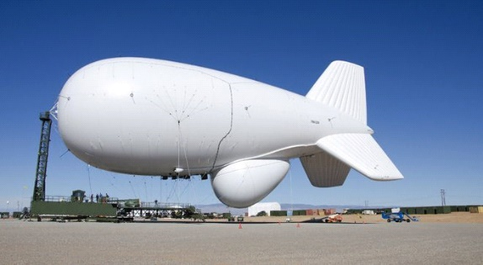
Figure 1: Tethered Aerostat System
Aerostats have the ability to VTOL due to their use of aerostatic lift, a buoyant force that does not require movement through the surrounding air mass. This is in contrast to heavy aerodynes, which rely primarily on aerodynamic lift and require a wing surface to move through the surrounding air mass. In contrast to the free-flying airship, the term has also been used in a more narrow sense to describe the statically tethered balloon.
A. TYPES OF AEROSTAT
Vehicles called "airborne platforms" are able to fly through the air by overcoming the pull of gravity through either static or dynamic lift. The LTA category includes things like balloons and blimps, while the Heavier-Than-Air (HTA) category includes things like airplanes and unmanned aerial vehicles (UAVs). There is also a category of platforms called "hybrids," which make use of both static lift and dynamic lift. In these Tethered Aerostat comes under LTA category hence, let’s see about them as follows.
B. LIGHTER-THAN-AIR (LTA)
Aerostats are the LTA platforms that use static lift or aerostatic lift. They are filled with helium or another low-density LTA gas. According to Archimedes' principle, buoyancy is produced when the density of the LTA gas and the density of the air outside the aerostat's envelope differ. Blimps and balloons are the most frequently used LTA. The tethered aerostat falls under the category of blimps.
2.COMPONENTS OF AEROSTAT
In this section, we describe in detail the various Aerostat components, which are also summarized in Fig.
A. ENVELOPE / SHELL
The Aerostat's envelope is filled with gas, which enables the platforms to soar and remain in the air. A few envelopes have round structures (inflatables), others have a fish-formed or on the other hand smoothed out structure (zeppelins). These envelopes' lifts are entirely dependent on buoyant gas. Kites attached to other envelopes, such as Helikites, provide an aerodynamic lift that boosts their performance in strong winds. Most of the time, envelopes are made of a synthetic material like polyester, polyurethane, or polyvinyl. Materials to protect the envelope from abrasions or laminates to prevent degradation from ultraviolet light exposure are common in envelopes.
B. LIFTING GAS
Lifting gas, also known as an LTA gas or atmospheric gas, has a lower density than air and fills the aerostat's envelope. Consequently, it buoys according to Bernoulli's law. The most common and lightest gases used in aerostats are hydrogen and helium. The fact that hydrogen is the lightest gas currently in existence and is simple to produce are its primary advantages. However, its high flammability is its primary drawback. In contrast, helium is the second lightest gas and, unlike hydrogen, does not ignite. Nonetheless, helium is pricey.
C. PAYLOAD
The aerostat's capacity to carry weight in the air is known as the payload. The payload on each aerostat is different. To be more specific, we define the total capacity payload as the total weight that the platform can lift at the desired altitude, excluding its own weight and that of its tether.
The operational payload, which includes equipment related to the mission, includes high-definition (HD) cameras, telescopes, electronics, panchromatic imaging cameras, electro-optical/infra-red sensors, and acoustic detectors.
The supporting system payload, on the other hand, includes all the equipment required to operate the platform, such as the power system, communication repeaters, backup batteries, lights, and so on. The kind of equipment used varies from mission to mission.
D. TETHER
At one end, the tether is wrapped around a winch and connected to the envelope or shell at the other. Typically made of synthetic fibers, tethers vary in length, diameter, resistance, and weight depending on the aerostat's type and size. It is possible to use multiple tethers on a large platform. The following are the purposes of a tether:
- Maintain the platform's stability from the air to the ground;
- Use a power line to supply the platform with power; and
- optical fibers to transmit data to the platform.
In addition, the tether needs to be weatherproof in order to withstand a variety of weather conditions, including lightning, rain, snow, and high humidity.
E. MOORING STATION AND ANCHOR UNITS
a. Mooring Facilities: The system that holds the aerostat's envelope while it is inflated prior to launch, deflated after flight, and during maintenance is called the mooring station. Size, design, and complexity of the mooring stations vary. For instance, while smaller platforms like Helikites require mooring stations that are lighter and simpler, large blimps require mooring stations that are both substantial and heavy. Additionally, the environment in which the aerostats will be utilized determines the mooring stations. Aerostat, for instance, can be used over water or the ocean; consequently, they should have securing stations intended for sea applications.
b. Anchoring Factors: The platform is anchored into the unit known as the anchor point or anchor unit, which also keeps the platform in place while it is in the air. Anchor units come in a variety of sizes and varieties.
F. WINCHES
A winch is a gadget used to let out the tie during the sending off process, change its pressure while the stage is overhead, or pull it back in during the recuperation cycle. The winch drum is the drum around which the tether is wound. The type and size of the winch vary. More modest aerostats can be winched physically utilizing a wrench, though bigger aerostats require power or on the other hand motored winch. The winch can be mounted on a flatbed or truck bed trailer or attached to a mooring station.
G. GROUND CONTROL UNIT
Aerostats operate from a base at ground control stations. They can be used to regulate the platforms' altitude. Control and monitor the equipment and platforms they carry and store and, in some cases, process mission-related data like videos and images. A ground control station can be a building, a tent, a vehicle, a container, or any other sheltering location, depending on the type of mission.
H. TRANSPORTATION
Aerostats' components, such as their envelope, mooring stations, and winch must be transported to the location of the deployment. Trucks can be used to transport aerostats on the ground, but ships are used for maritime applications
3. MATERIALS
Today's tethered aerostat systems are intricate, flexible structures that must function in winds of at least 70 knots and harsh environmental conditions. Under continuous around-the-clock operation in global weather conditions, aerostat life times of ten years are anticipated, while twenty years are desired. To increase payload capacity, vehicles need to be lighter. The materials engineer must now develop materials and materials technology to meet today's requirements in light of these requirements. Now we are going to investigate about the properties of some materials that can be used in aerostats.
A. PROPERTY REQUIREMENT FOR MATERIAL
For high altitude deployments, the envelope material has to possess the following properties:
- The material should exhibit low gas permeability.
- The envelope material should be light weighted.
- Sufficient strength is necessary for the material.
- High tear strength is important to maximize the damage tolerance.
- At high altitudes the material should withstand the Temperature and Pressure variation without any change in their physical strength properties and it should retain it flexibility over wide range of temperature variations.
- It should also resistant to environmental degradation factors such as, UVs, ozone, Humidity, heavy winds and extreme weather conditions.
- The material also show excellent creep resistance to maintain its shape throughout its life time.
- The material should be resistant to flex-fatigue.
- The material of the aerostat should satisfy the abovementioned properties for extended life time.

B. DACRON (PET)
DuPont manufactures the polyester brand Dacron. It is a material of excellent quality with excellent technical performance. It is sturdy, long-lasting, provides thermal comfort, and it wicks away moisture. Polyethylene terephthalate (PET) is more commonly referred to as polyester. Dacron polyester textures are known for their solidarity, sturdiness, and protection from scraped spot.

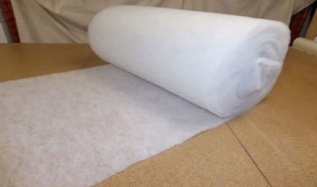
Figure 3: DACRON Material
The typical properties of DARCON fabric are that it resists tearing and abrasion, has a long working life, is stable in the sun, has good bias stability, is extremely durable, does not absorb water, has low stretch, and can't withstand high temperatures.
C. KEVLAR (poly-para-phenylene terephthalamide)
Kevlar is a strong, heat-resistant synthetic fiber made of poly-para-phenylene terephthalamide. It is related to other aramids like Technora and Nomex. The high-strength material, which Stephanie Kwolek developed at DuPont, was first used commercially as a replacement for steel in racing tires. Typically, it is spun into fabric sheets or ropes that can be used as such or as a component in composite materials. The strength-to-weight ratios of potential hull materials made with KEVLAR cloth show significant improvements.
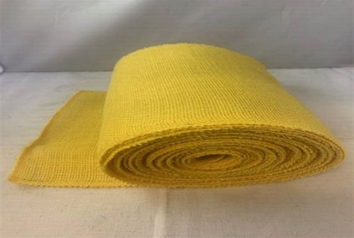
Figure 5: KEVLAR Material
The KEVLAR material has the following attributes:
- High tensile strength.
- Five times stronger than steel wire.
- Cut-resistant.
- Abrasion-resistant.
- High tenacity and modulus.
- Excellent impact resistance (bulletproof).
- Dimensional stability.
- Vulnerable to UV.
- Superb thermal stability.
- Melting point of 450 °C.
The KEVLAR yarn has a strength-to-weight ratio of 2 to 3.5 times that of DACRON and ten times that of steel. This means that it can save a lot of weight or have a better strength than the ones that are currently made of DACRON. Despite the fact that the gas barrier accounts for a sizeable portion of the material's total weight.
D. VECTRAN
VECTRAN is a superior exhibition multifilament yarn turned from fluid precious stone polymer (LCP). This fiber has remarkable rigidity and strength. The substance is ten times stronger than aluminum and five times stronger than steel. It has a low moisture absorption, excellent creep and abrasion resistance, and high strength and modulus.
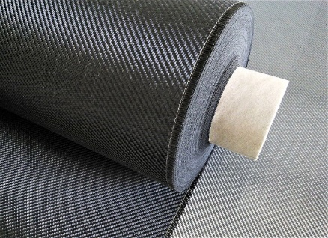
Figure 7: VECTRAN material
VECTRAN is ten times as strong as aluminum and five times as strong as steel. VECTRAN has a high strength modulus and excellent fiber tensile properties thanks to its use of liquid crystal polymer (LCP) technology. In 2005, Kuraray bought VECTRANTM from Celanese. This unique fiber is still made in Fort Mill, South Carolina, by Kuraray. The following are additional features of VECTRAN:
- Chemical resistance.
- Low coefficient of thermal expansion (CTE).
- High dielectric strength.
- Outstanding cut resistance.
- Vibration damping characteristics.
- High impact strength.
- Excellent creep resistance.
- Abrasion resistance.
- Excellent flex/fold characteristics.
- Minimal moisture absorption.
The chemical structure of the VECTRAN is given below
E. POLYESTER
Polyester, in most cases, refers to the trade name for polyethylene terephthalate or PET. It is the thermoplastic polymer that is used the most worldwide. In fact, it accounts for about 18% of all polymer production worldwide. Polyester is frequently used in the textile industry. It is used to make clothing fibers and textile product packaging. Polyester is also frequently used to make plastic PET bottles. Polyester is a semi-crystalline, transparent material that also has a high moisture barrier. Additionally, it has a good strength-to-weight ratio.
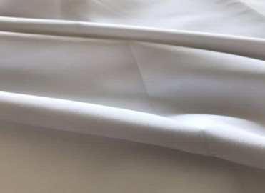
Figure 9: Polyester Material
Polyester or PET is resistant to a variety of chemicals and does not react with liquids or foods. It can also be used to make containers because it is resistant to shattering. It can be heated to 260oC, cooled, and then reheated again without significantly deteriorating because it is a thermoplastic material. Now we see about the properties of the polyester:
- Polyester is transparent and has good transmissivity.
- Polyester is resistant to moisture and has low water absorption.
- Polyester has great electrical properties.
- Polyester has good chemical resistance to water as well as organic material.
- Polyester has good heat and aging resistance.
- Polyester provides high UV protection.
We are unable to use polyesters as a material for the aerostats because they lack the ability to heat seal.
F. TEDLAR (Polyvinyl Fluoride)
The biaxially oriented DuPont TM TEDLAR polyvinyl fluoride (PVF) film's unique characteristics include excellent weathering resistance, exceptional mechanical properties, and inertness to a wide range of chemicals, solvents, and staining agents. There are no plasticizers in TEDLAR; As a result, it has good properties for aging and stays tough and flexible across a wide temperature range.
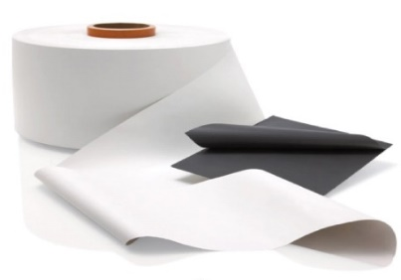
Figure 11: TEDLAR Material
Polyvinyl fluoride (PVF) is a homopolymer of vinyl fluoride. The molecular structure of PVF is show in Fig 3.9. PVF has excellent resistance to weathering, staining, and chemical attack (except ketones and esters). It exhibits very slow burning and low permeability to vapor. Its most visible use is on the interiors of the passenger compartments of commercial aircraft.
a. Properties of TEDLAR
- DuPont TM TEDLAR PVF film resists fatigue, and is flexible and strong. It is remarkable in its resistance to flexing failure. TEDLAR performs well at temperatures between -72 and 107 degrees Celsius (-98 and 225 degrees Fahrenheit), with short-term peaking up to 204 degrees Celsius (400 degrees Fahrenheit).
- It is extremely resistant to photolytic degradation and does not significantly absorb visible or ultraviolet light. As a result of superior UV absorption, TEDLAR keeps the integrity, color, and brilliance of exterior surface graphics intact.
- Due to its inert and non-stick properties, TEDLAR is an excellent release film when processing parts under high temperature and pressure.
- TEDLAR offers long-lived gloss retention creating easy-to-clean surfaces.
- It is an excellent choice for scientific endeavors that require gas sample bags due to its chemical inertness and resistance to gas permeation.
- Among different properties, its lightweight and adaptable attributes make it extraordinary fit for the avionic business.
G. Polyurethane (PUR)
Organic polyurethanes can be found in a variety of forms, including thermoplastics, thermosets, elastomers, foams, adhesives, and so on and can be used in a wide range of fields, including energy, transportation, apparel, biomedical, aviation, and shipping. The polyurethanes have a block copolymer structure with the monomers combined by a urethane bunch. A soft segment, which is typical of the Polyol segment, and a hard segment, which is typical of the Isocyanate and chain extender segment, make up the structure of polyurethane.
Figure 12: Polyurethane Material
Polyurethane has been at the forefront and one of the prominent reasons for this redeeming of the interest. PUR holds an edge in possessing the requisite properties over some of its competitors like PET (Polyester), Nylon, PVF (Polyvinylidene Fluoride), PVDF (Polyvinylidene difluoride), PTFE (Poly-tetrafluoroethylene), LDPE (Low Density Polyethylene), PVF (Polyvinyl Fluoride), PVC (Polyvinyl Chloride) and Silicone Rubber.
As it is one of the polymers with the lowest gas permeability, polyurethane is used in the Ballonet and Gas Barrier Layer in the Hull section of the envelope. Polyurethane's permeability is determined by the structure of its soft and hard segments. The LTA system is expected to face harsh conditions, including intense UV radiation, rain, humidity, and environmental pollutants, on the envelope. Additionally, the envelope is anticipated to have a long, dependable deployment life for which it was designed. The PUR has excellent weatherability in this instance. The good flex-fatigue properties of polyurethanes tend to deteriorate with increasing polymer cross-linking.

H. Polycarbonate (PC)
Polycarbonates (PC) are a class of thermoplastic polymers whose chemical structures contain carbonate groups. Polycarbonates are tough, strong, and some grades are optically transparent, making them useful in engineering. They can be worked, molded, and thermoformed with ease. It has organic functional groups that are linked by carbonate groups (–O–(C=O)–O–) and has a unique combination of properties. PC is a popular engineering plastic because of its unique properties, which include:
- Good electrical properties amongst others.
- High impact strength.
- High dimensional stability.
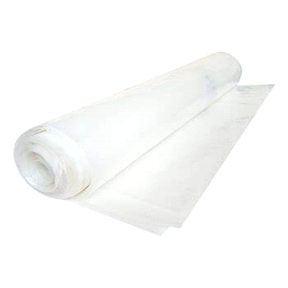
Figure 14: Polycarbonate Material
Although polycarbonate's properties are comparable to those of polymethyl methacrylate (PMMA, also known as acrylic), polycarbonate is stronger and can be used in a wider temperature range (Melting point:155°C), but more costly.
Polycarbonate has a unique combination of properties, including good electrical properties, high dimensional stability, and high impact strength. Polycarbonate with a glass filling is also resistant to chemicals and moisture well. Polycarbonates can be made to completely shield against UV rays and block ultraviolet light. Because of its high strength, polycarbonate is resistant to impact and fracture, providing safety and comfort in applications requiring high performance and reliability. Additionally, the lightweight property enables increased productivity, simplified installation, and overall cost savings for transportation.
4. MATERIAL ANALYSIS USING ANSYS
A. STATIC STRUCTURAL ANALYSIS:
CONTENT | POLYESTER | POLYCARBONATE | TETRAPTHALATE
Density (Kg/m³) | 1200 | 950 | 1111.4
Young’s modulus (Pa) | 3.e+009 | 1.1e+009 | 2.2e+009
Poisson’s ratio | 0.316 | 0.42 | 0.573
Bulk modulus (Pa) | 2.7174e+009 | 2.2917e+009 | 3.2341e+009
Shear modulus (Pa) | 1.1398e+009 | 3.8732e+008 | 3.4678e+009
Minimum stress (Pa) | -34787 | -15267 | -25649
Maximum stress (Pa) | 14.805 | 15269 | 24654
Average stress (Pa) | -9381.4 | 2.1559e-002 | 2.0674
Tensile Yield Strength (Pa) | 2.5e+007 | 2.5e+007 | 2.5e+007
Tensile Ultimate Strength (Pa) | 3.3e+007 | 3.3e+007 | 3.3e+007

B. GRAPH
a. Polyester
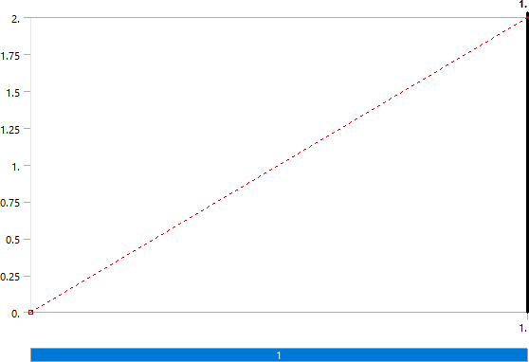
Figure 15: Model Static Structural > Force
b. Polycarbonate

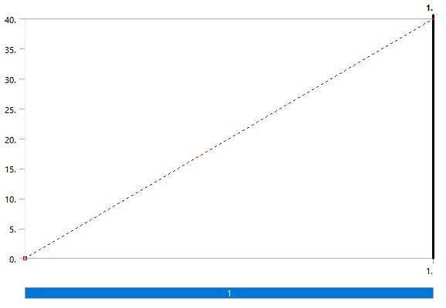
Figure 16: Model Static Structural > Force
C. Tetrapthalate

Residuals
Residuals
4.00e+0

3.00e+0
continuity x-velocity y-velocity
energy
2.00e+0
1.00e+0
9.00e−1
8.00e−1
7.00e−1
6.00e−1
5.00e−1
0
50
100
150
200
iterations

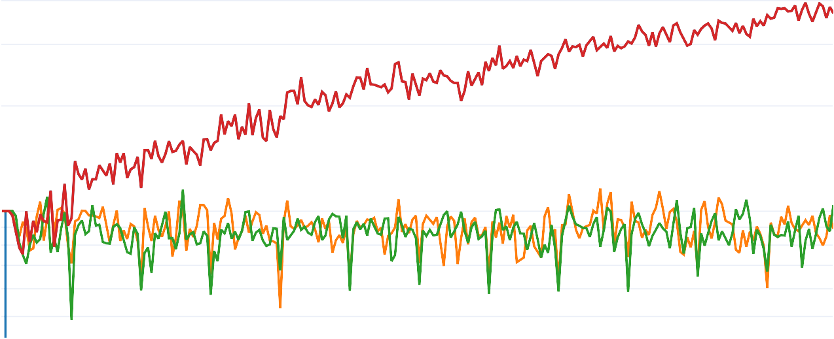

Figure 17: Tetrapthalate test results

5. Result
As we are interested in employing a new material for our aerostat, we have done research on previous materials used in aerostats and have chosen polycarbonate as our new material because it meets the requirements for the material. The material doesn't have the expected flexibility, according to our study of it using the Ansys software. We have chosen three materials after doing some research that meet the requirements. The materials are polyester, PCDT (poly 1, 4-cyclohexylene dimethylene tetraphthalate), and polyethylene (by increasing its microns). The microns enhanced polyethylene is chosen as the material from the list above because, in comparison to the other two materials, it meets the requirements for the aerostat.
6. Reference
- Mahmood, K., et al (2020, April). Tethered aerostat envelope design and applications: A review. In AIP Conference Proceedings (Vol. 2226, No. 1, p. 050003). AIP Publishing LLC.
- Mahto, N. K. (2018). Feasibility study of a hot-air tethered aerostat system.
- Westergard, C. J. (2018, December). Hybrid use of tethered aerostat balloons with UAV's for long duration collection of aerial data. In AGU Fall Meeting Abstracts (Vol. 2018, pp. A31R-3191).
- Pant, R. S. (2016). Tethered aerostat systems for agricultural applications in india. The Institution of Engineers (India), 82.
- Dasaradhan, B., et al(2018). A Brief Review of Technology and Materials for Aerostat Application. Asian Journal of Textile, 8, 1-12.
- Greenhalgh, D. (2017). Aerostat for electric power generation (Doctoral dissertation, University of Southampton).
- . Dusane, C. R.,et al. (2017). An elevated balloon-kite hybrid platform for surveillance. In 23rd AIAA Lighter-Than-Air Systems Technology Conference (p. 3995).
- Chiba, K., et al(2017). Aerodynamic influences on a tethered high-altitude lighter-than-air platform system to its behavior. Aerospace Science and Technology, 70, 405-411.
- Mahmood, K., & Ismail, N. A. (2021). The effect of hull fineness ratio and fin parameters on the optimization of tethered aerostat. Aircraft Engineering and Aerospace Technology.
- Miller, J. M., & Decrossas, E. (2018, September). Using small unmanned aerial systems and helium aerostats for far-field radiation pattern measurements of high-frequency antennas. In 2018 IEEE Conference on Antenna Measurements & Applications (CAMA) (pp. 1-4). IEEE.
- Yilmaz, N., et al (2018). Where to Locate Tethered Aerostats for an Effective Surveillance System: A Case Study on Southern Turkey. Gazi University Journal of Science, 31(1), 189-200.
- Gupta, S., et al. (2020). Harvesting solar energy onboard LTA systems: Modeling and design. Energy Reports, 6, 3399-3411.
- Gupta, S., et al. (2020). Harvesting solar energy onboard LTA systems: Modeling and design. Energy Reports, 6, 3399-3411.
- Tarchi, D., et al (2017, June). Mini-radar system for flying platforms. In 2017 IEEE International Workshop on Metrology for AeroSpace (MetroAeroSpace) (pp. 40-44). IEEE.
- Yadav, V. K. (2016). Development of Wireless Sensor Network as an Application in Aerostats. Development, 5(4).
- Santos, J. S., et al(2016). Stability augmentation system for a tethered airship. In 16th AIAA Aviation Technology, Integration, and Operations Conference (p. 4224).
- Dhawan, A., & Jindal, P. (2021). A review on use of polyurethane in Lighter than Air systems. Materials Today: Proceedings, 43, 746-752.
- Krishna, K. R. (2021). Aerial Robotics in Agriculture: Parafoils, Blimps, Aerostats, and Kites. Apple Academic Press.
- Moulinier, T., et al(2019, December). Connected Tethered Aerial Detection System for Supporting Safe Marine Seismic Operations. In First EAGE Workshop on Unmanned Aerial Vehicles (Vol. 2019, No. 1, pp. 1-5). European Association of Geoscientists & Engineers.
- Dobrzyński, P., et al(2019). Expanding the current possibilities of data recognition and retransmission using modern aerostats. Journal of Machine Construction and Maintenance-Problemy Eksploatacji.
- Ganesh, M. (2018). Design of airship for aerial surveillance and communication using knowledge based engineering. International Journal of Mechanical and Production Engineering Research and Development (IJMPERD), 8(1), 17-26.
- Santos, J. S., de Azevedo, B. A., Góes, L. C., & Pant, R. S. DEVELOPMENT OF A NOVEL AERIAL PLATFORM WHICH MERGES THE CONCEPT OF AIRSHIPS AND TETHERED AEROSTATS.
- Fadlelmoula, A. Y. E. M. (2016). CERTIFICATION OF APPROVAL.
- Ilcev, D. S. (2016). Development of Airships Stratospheric Platform Systems (SPS).
- Lambert, C., & Nahon, M. (2008). An aerostat positioning system with cable control. IFAC Proceedings Volumes, 41(2), 779-784

