The Role of Internet of Things (IoT) in Healthcare
Ms. Poonam Abraham Lakraª
ªAssistant Professor, Department of Computer Applications (MCA), Patna Women’s College (Autonomous), Patna University, Patna
Abstract
Internet of Things (IoT) in healthcare refers to the integration of internet-connected devices and technologies to enable efficient data collection, analysis, and communication within the healthcare ecosystem. This empowers healthcare providers to deliver personalized care, monitor patients remotely, and enhance operational efficiency. In essence, IoT in healthcare involves leveraging interconnected devices such as wearables, sensors, and medical equipment to gather real-time patient data, automate workflows, and enable seamless communication and collaboration among healthcare professionals. These connected devices generate a wealth of data that can be analyzed to improve patient care. IoT devices enable continuous monitoring of vital signs, ensuring early detection of health issues and timely interventions, leading to improved patient outcomes. With IoT, healthcare professionals can automate routine tasks, streamline data entry, and access critical patient information instantly, freeing up time for more direct patient care.
Keywords: IoT, healthcare, wearables, sensors
- Introduction
The term "Internet of Things" (IoT) describes the process of creating Internet-connected Things via computer networks. IoT suggests that having a wide number of less powerful devices, such as a wrist band, air conditioner, umbrella, and fridge, is preferable to having a small number of powerful computer devices, such as a laptop, tablet, and phone. Air fresheners and cars, for example, are frequently used items that are intelligently programmed by computer processors, supported by sensors, and provide results in the actual world. All of these components are integrated into commonly used items. As a result, connected objects have processing and communication capabilities that go beyond those of basic objects, such as a typical lamp and umbrella, and they can even connect buildings through network connectivity. These magical Internet of Things (IoT) things have the technical aptitude to complete the prescribed mission without the requirement for a name and personality [1]. IoT and "ubiquitous computing" vary in that IoT operates over a wide range of Internet connections, but ubiquitous computing does not. The "Thing" or object in the real world can take input from a live thing or a person and change it into data before sending it to the Internet for data gathering and analysis. For instance, a sewing machine can keep track of the thread used, the number of stitches made, and the approximate number of stitches it can produce. This is made feasible by the use of sensors to record the performance the object displays over the allotted time. The sensors can use "actuators" to display the outputs to the human world by connecting the objects in world
Even when dealing with extremely huge amounts of data, machine learning algorithms play a significant part in the decision-making process. Determining data kinds like velocity, variety, and volume is a step in the process of implementing data analysis techniques in the targeted fields. Standard data analysis modeling incorporates the use of efficient algorithms together with the neural network model, classification model, and clustering technique. Data might be produced from a variety of sources with certain data kinds, so it's critical to build procedures that can manage the data properties. In the Internet of Things, there are a lot of resources that produce the required data in real time without any issues, including scalability, velocity, and the optimal data model [2].
In this article, the transformative power of the Internet of Things (IoT) in the field of healthcare and its specific impact on disease diagnosis is explored. Discover how IoT enables remote patient monitoring, early detection, improved accuracy, and efficiency. Also discuss the challenges and risks associated with implementing IoT in disease diagnosis, as well as exciting future prospects and advancements in this rapidly evolving field.
- Internet of Things Changing Healthcare

Fig.1: Various aspect in healthcare is changing

  - Tools for Safety & Adherence
In addition, IoT in Life Sciences and healthcare science offers cost-effective, innovative technologies to monitor day-to-day activities. For example, when a patient requires emergency support, like medication dispatching, doctors may monitor and contact the patient if the patient's device is linked to the medication dispatching machine (and vice versa). With billions of IoT sensors and devices set to be added to the life science sector, healthcare will now be more personalized than ever before.
  - Quality, Compliance, and Oversight
The IoT can be leveraged more broadly to reduce costs, enhance patient safety, enhance data capture, provide robust monitoring, and enable more direct and immediate doctor-patient communications. Utilizing real data and regular healthcare data releases will lead to tremendous benefits for quality patient care Internet of Things (IoT) devices will help hospitals provide better hygiene monitoring outcomes, which will complement the benefits of planned real-time environment monitoring [3].
  - Digital Biomarker to Track Disease Prediction
Notifications are an essential and important part of existing situations, giving doctors essential information so they can track current symptoms and perform the most accurate diagnostics ever for recurrent medical issues. Providing a comprehensive report can also help with chronic disease monitoring and understanding important determinants of wellness [3].
  - Effortless Asset Tracking
IoT devices will track, collect, and communicate glucose levels, ECG’s, and blood clotting factor’s. This means that patients, doctors, and insurance companies can access the data at any time, any place, and on any device they choose. The benefits of real-time monitoring for medical conditions include: Asthma, Hypoglycemia, Heart problems and others [4]. IoMT is a network of connected devices that continuously monitor and analyze data. More personalized care Better comprehensive medical treatments Technology helps in the diagnosis and treatment of modern diseases. Internet of things classifies every medical issue to find the best solution in the life science industry
  - Real World Environment
Healthcare IoT devices talk to each other directly and share data by communicating with a remote server via SSL (secured service layer) The large amount of data transmitted by sensors is hard to store and process. IoT devices analyze the raw data along with collecting and reporting, with the possibility of final reports that include visualizations such as charts. This means that important information and conclusions are up-to-date, speeding decision-making and reducing the risk of mistakes. Wearables and technologies provide ongoing, valuable vital surveillance [5].
  - Treatment & Diagnostics in closed Loop
Because the patient register includes real-time data, a patient can get in touch with their doctor immediately from anywhere. This means more accurate diagnosis of diseases using the most up-to-date data, and the delivery of medications based on the patient’s prescription. A cost-efficient system like this means health monitoring combined with effective management and an improved quality of life for patients [5].
- Benefits of Using IoT in Disease Diagnosis
  - Remote Patient Monitoring

By integrating IoT devices and wearables, healthcare providers can remotely monitor patients' vital signs, activity levels, and overall health in real-time. This facilitates proactive intervention, reduces hospital stays, and enables more effective and personalized treatment plans.
  - Early Detection and Prevention

IoT-enabled devices and connected platforms facilitate early detection and prevention of diseases. Continuous monitoring and data analysis allow for the identification of subtle changes in patient health, enabling timely interventions and better management of chronic conditions [6].
  - Improved Accuracy and Efficiency

IoT enables seamless data integration, AI-driven analytics, and decision support systems that enhance diagnostic accuracy [7]. Automation of manual tasks, such as data collection and analysis, reduces human error, lowers healthcare costs, and improves overall efficiency.

Challenges and Risks of Implementing IoT in Disease Diagnosis

Data Privacy and Security Issues

The widespread use of IoT devices raises concerns regarding the privacy and security of sensitive patient data. Robust security measures and strict data governance policies are essential to protect patient privacy and ensure the integrity of healthcare systems.

Integration and Compatibility Challenges

The integration of diverse IoT devices and platforms with existing healthcare systems presents technical challenges. Standardization of communication protocols and interoperability are critical for seamless data exchange and efficient collaboration.

Ethical Considerations

As IoT becomes more prevalent in disease diagnosis, ethical issues arise. Questions regarding the informed consent of patients, equity of access to IoT-enabled care, and potential biases in AI algorithms need to be addressed to ensure ethical and fair deployment of IoT technologies [8].

- Future Prospects and Advancements in IoT for Disease Diagnosis

  - Artificial Intelligence and Machine Learning
The integration of AI and machine learning algorithms with IoT devices offers exciting possibilities for disease diagnosis. These technologies enable predictive analytics, personalized medicine, and the identification of complex health patterns that may go unnoticed by traditional diagnostic approaches.
  - Blockchain for Data Security
Blockchain technology shows promise in enhancing the security and privacy of IoT-generated healthcare data.[9] Implementing blockchain solutions can ensure transparent and tamper-proof records while giving patients greater control over their health information.

Edge Computing for Real-time Insights
Edge computing, which brings data processing closer to the source, can enable real-time analysis of IoT-generated health data. This facilitates timely decision-making, reduces latency, and addresses potential bandwidth and connectivity challenges.

- Market Analysis of IoT
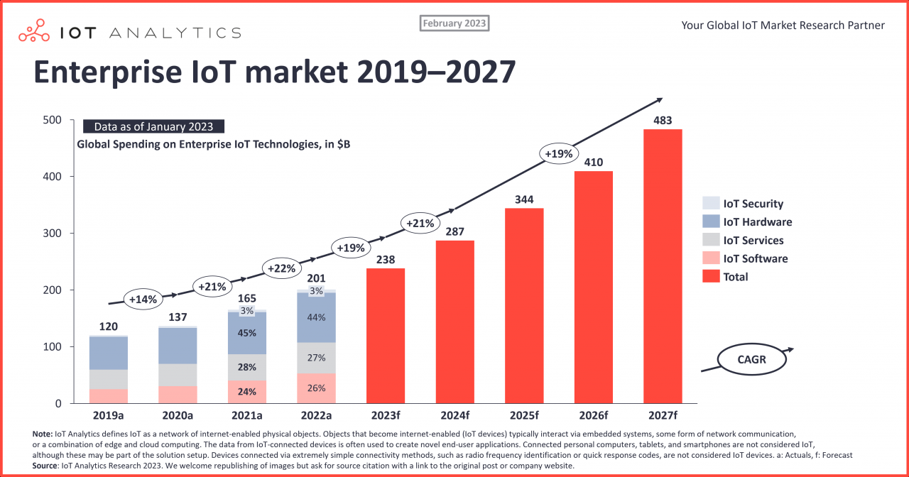

Fig.2- src: https://iot-analytics.com/iot-market-size
According to market study conducted by IOT Analytics, Growth of the enterprise IoT market Growth in the enterprise IoT market in 2022 was $201 billion, according to IoT Analytics' Global IoT Enterprise spending Dashboard in January 2023. Growth in 2022 was slightly slower than last year's 23% forecast, and is projected to be even lower in 2023 at a compound annual growth rate (CAGR) of $19.4% from 2022 to 2027 [10]. In our latest forecast, we anticipated a faster recovery in the global economy, improved supply chain resilience, and continued investment in new technologies to address labor shortages. We estimated spending growth in 2023 at 24%. Nine months later, we need to lower our forecast to only 19% for the year 2023. APAC is projected to outpace the rest of the world, growing at a rate of 22% (CAGR 2022-2027), while North America will grow at a slower pace (CAGR of 20% from 2022-2027.
Conclusion
As IoT continues to evolve, its potential to transform healthcare is immense. By leveraging IoT technologies, healthcare organizations can enhance patient care, improve operational efficiency, and drive better health outcomes. Embracing IoT in healthcare is not just a technological shift; it is a paradigm shift towards patient-centric, data-driven, and connected healthcare.
Reference:
1. Priyan Malarvizhi Kumar, S. Lokesh, R. Varatharajan, Gokulnath Chandra Babu, P. Parthasarathy,Cloud and IoT based disease prediction and diagnosis system for healthcare using Fuzzy neural classifier,Future Generation Computer Systems,Volume 86,2018,Pages 527-534,ISSN 0167-739X,https://doi.org/10.1016/j.future.2018.04.036.
2. Y. Shaikh, V. K. Parvati and S. R. Biradar, "Role of IoT and Bigdata Analytics in Healthcare for Disease Prediction," 2020 International Conference on Convergence to Digital World - Quo Vadis (ICCDW), Mumbai, India, 2020, pp. 1-6, doi: 10.1109/ICCDW45521.2020.9318662.
3. B. Charyyev, M. Mansouri and M. H. Gunes, "Modeling the Adoption of Internet of Things in Healthcare: A Systems Approach," 2021 IEEE International Symposium on Systems Engineering (ISSE), Vienna, Austria, 2021, pp. 1-8, doi: 10.1109/ISSE51541.2021.9582493.
4. G.G. Jose, B. Andrzej and N. Sylwia, "Analysis of Healthcare Systems by Using Systemic Approach", Complexity Hindawi.
5. Karthick T, Manikandan M. Fog assisted IoT based medical cyber system for cardiovascular diseases affected patients. Concurr Comput Pract Exp. 2019; 31(12):e4861.
6. Maksimović M, Vujović V, Periśić B. A custom internet of things healthcare system. 2015 10th Iberian conference on information systems and technologies (CISTI). IEEE. 2015; 1-6.
7. Usak M, Kubiatko M, Shabbir MS, et al. Health care service delivery based on the internet of things: a systematic and comprehensive study. Int J Commun Syst. 2020; 33(2):e4179.
8. Kumar JS, Patel DR. A survey on internet of things: security and privacy issues. Int J Comput Appl. 2014; 90(11): 20-26.
9. Jahantigh MN, Rahmani AM, Navimirour NJ, et al. Integration of internet of things and cloud computing: a systematic survey. IET Commun. 2019; 14(2): 165-176.
10. https://onlinelibrary.wiley.com/doi/10.1002/dac.4683

