Biomass: Sustainable resource to Empower Bio-based Future
Ajay Kumar
Assistant Professor
Department of Zoology
Gargi College, University of Delhi, Delhi-110 049, India.
Email: scienceaware01@gmail.com
Phone: +919319603208

Abstract
For human civilization, fossil fuels have been essential, impacting technology, society, the economy, and global advancement. Coal, natural gas, and other fossil fuels make up the lion's share of today's energy supply. The environment and human life are seriously threatened by these non-renewable energy sources, which also contribute to air and water pollution and global warming. A fundamental component of energy, biomass can be used to generate renewable energy and create biofuels for use in transportation and electricity. Biofuels can be created utilizing a variety of methods and procedures and are obtained from biological carbon fixation. It is possible to transform biomass into useful products and energy in a renewable way using a range of techniques and procedures, a variety of methods and processes can be used to convert biomass into useful products and energy in a renewable way, both thermochemical and biochemical processes can convert biomass into fuels, chemicals, or electric energy. Heat and catalysts are used in thermochemical processes, whereas enzymes and microorganisms are used in biochemical processes. The use of nanotechnology and nanomaterials as instruments for biomass conversion has shown promise. Due to their small size, distinctive characteristics, and durability, nanoparticles (NPs) have many benefits over other sources for the synthesis of biofuels. The accurate chemical characterization of feedstocks employing tools like FT-ICR MS, GPC, and NMR can improve performance in biomass conversion reactions. Biomass conversion approaches for renewable energy production encounter hurdles. In order to increase reaction rates, selectivity, stability, and raw material solubility, it is important to develop more active, selective, and stable catalysts. Impurities in biomass-derived feedstocks can also impair catalyst activity, so it becomes necessary to design more active, stable, and selective catalysts.
- Introduction
Energy regimes played a crucial part in the urbanization and industrial growth of human civilization. A major factor contributing to the growth of technological advances, economic activity, and society at a broad have been the use of fossil fuels. The world's energy systems continue to be dominated by fossil fuels. Coal, natural gas, and other fossil fuels make up the majority of the energy utilized today[1]. Utilizing these high-carbon fuels in combustion engines, boilers, and power plants in the forms of coal, petroleum, and liquid petroleum gases are non-renewable energy sources, and have a finite supply in nature. There are, however, a number of drawbacks to the use of fossil fuels. For instance, harmful CO2 and GHGs emissions are raising the planet's temperature and endangering previously unimaginable alterations to the planet's chemistry as well as climate, which would have a catastrophic impact on ecosystems and human civilization[2].When evaluating various alternative energy sources, biomass has been a crucial component of the energy economy. With the exception of polymers created from petrochemical and fossil materials, biomass is any organic matter that is produced either directly or indirectly from the photosynthesis process[3].Massive potential exists for biomass as a source of renewable energy, and it can be used to produce biofuels for transportation, electricity generation, and other uses [4]. A form of fuel known as biofuel is one whose energy is obtained by biological carbon fixation. It includes fuels produced from the conversion of biomass, as well as solid biomass, liquid fuels, and other biogases. One of the sources utilized for meeting the world's energy needs could be biofuels, which are created by converting biomass utilizing a wide range of methods and procedures. It has been considered to be a possible substitute source for the production of sustainable energy in the future. There are various conversion mechanisms and processes that are capable of converting biomass into energy. These include physical conversion (mechanical pressing, distillation of crops with high oil content, briquetting) thermochemical conversion through combustion, pyrolysis while chemical conversion through carbonation, and thermal decomposition, and biochemical conversion through biological pre-treatments and the using various microorganisms. The process provides a platform to obtain fuels and chemical products such as biogas, hydrogen, ethanol, butanol, acetone, and a wide range of organic acids. The main types of biomass include wood and agricultural products, such as bagasse, solid waste, crop waste, alcohol fuels etc. The application of nanomaterials in processes like transesterification, lipid extraction, and biomass pre-treatment has led to the development of an effective tool that provides strategies of improving output quality. Nanoparticles (NPs) provide a lot of advantages for the production of useful chemical products and biofuels since they are unique owing to their compact size, high surface area to volume ratio, strong adsorption, high catalytic activity and stability[5].
2. Biomass
Any organic material derived from plants or animals is considered to be biomass, which is defined as "a non-fossilized and biodegradable organic material originating from plants, animals, and micro-organisms as well as products, by-product residues, and wastage from forestry and agriculture-related industries". The definition of biomass can be affected by the broad range of constituents, the intended use, and the source. Biomass is a set of materials that are organically derived and comprises anything made of organic matrix and materials obtained from plants, and microorganisms, with the exception of polymers made from petrochemical and fossil components.[6]
2.1. Biomass-resources
The most significant biomass sources include sewage, algae, agricultural and forestry wastes, animal livestock waste, and aquatic crops (Fig. 1). Municipal solid waste (MSW) and waste products from anthropogenic activities are also included in the biomass category if further processing does not allow for their recycling [7]. "Feedstocks" are usually employed to refer to renewable biomass resources that are either used directly as fuel or transformed into another sort of energy product.
Fig. 1. Different sources of biomass.
2.2. Biomass-classification
Depending on its quality, origin, composition, and other characteristics as well as how it functions, biomass can be classified into a number of categories.
2.2.1. Classification-Based on biomass feedstock
Specialized energy crops, crop residues, leftovers from the harvesting of trees, algae, industrial wastes, sorted municipal solid waste, urban wood waste, and food waste are a few examples of biomass feedstocks (Fig. 2). They also include wet waste, algae, municipal refuse, and waste left behind after treating wood.
1st -Generation biomass
First-generation(1st-Gen.) biomass is made from crops that are harvested straight from the fields, including grains, maize, sugar beet, and cane. These biomasses, including sugars and triglycerides, are edible.
2nd -Generation biomass
Second-generation (2nd-Gen.) biomass is comprised of non-edible oils, non-edible lignocellulose biomass, such as cereal straw, sugar cane bagasse, forestry crops, and residual kitchen vegetable waste, as well as municipal organic waste.
3rd -Generation biomass
Third-generation (3rd -Gen.) biomass, mainly obtained from algae, produces massive yields faster and with fewer resources than lignocellulose biomass. Because algae species are grown in photobioreactors, open ponds, and seawater. Several nutrients, including hemicellulose, lignin, minerals, proteins, pigments, vitamins, amino acids, lipids, and carbohydrates, can be found in various types of algae. The vast majority of microalgal species may be utilized to produce biodiesel since microalgae have a high lipid content.
4th -Generation biomass
The fourth generation (4th Gen.) biomass is related to the genetically modified feedstocks from the first and second, as well as third generations of biomass. [8]. Currently, genetically modified microalgal biomass is the main focus of research in this field. The current research aims to modify microbes and plants to produce a substantial amount of fats and carbs. Biotechnology promises to boost photosynthetic productivity for faster growth, which will increase CO₂ usage and decrease atmospheric carbon dioxide emissions.[9].
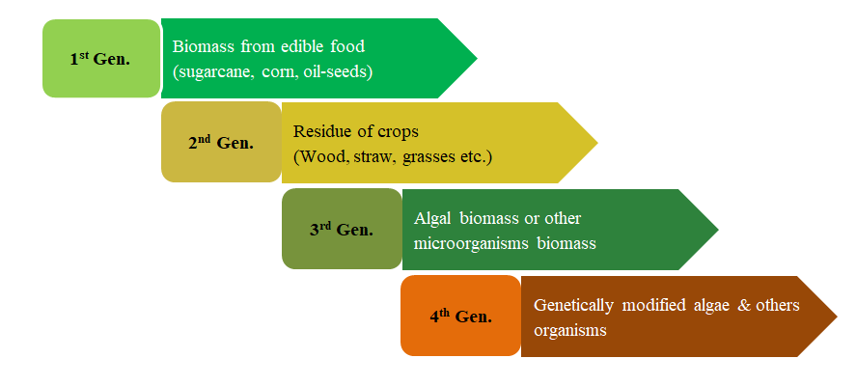
Fig. 2. Classification of Biomass.
2.2.2. Classification-Based on chemical composition
Biomass can be classified into many categories based on its chemical composition, comprising carbohydrates, lignin, essential oils, vegetable and animal fats, and natural resins (gums). The biomass of carbohydrates is composed of cellulose, hemicellulose, and starch. Depending on the type of linkage and/or the sugars used, these biopolymers exhibit different structural variations.
Starch
It is composed of a large number of glucose units connected by α-O-4 glycosidic bonds. Two polyglycans amylose (10%–20%) and amylopectin (80%–90%) combine to form the polymeric, non-reducing biopolymer. The appearance of a helix is created by the straight chain structure of amylose, which consists of 250–300 units of -D-glucose connected by a single sugar unit. Amylopectin is coupled to glucose monomers that have α -(1→4) bonds in addition to those that have α-(1→6) linkage. Starch is present in large quantities in plants, tubers, and cereals[9].
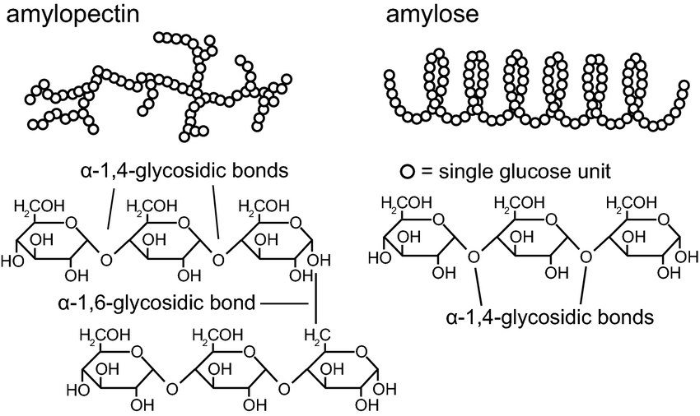
Fig. 3. Structure of Starch Biopolymer [10]
Cellulose
As a linear polymer, cellulose is composed of unbranched anhydrous -glucose rings with oxygen covalently bound to the C1 of one glucose ring and the C4 of adjacent glucose; it is the most prevalent organic substance in nature and plays a structural role in plant cell walls; it contributes 90% and 50%, respectively, of the structure of cotton and wood..

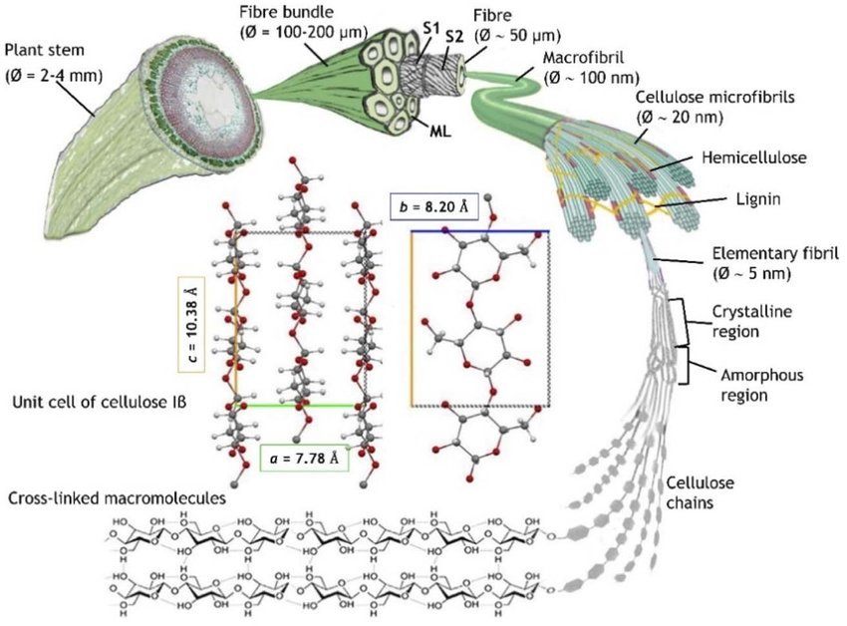
Fig.4. Cellulose Biopolymer [11]
Hemicellulose
Hemicellulose one of the main constituents of plant cell walls, is a heterogeneous branching polysaccharide. It has an intricate connection with the cellulose microfibrils' surface. The primary sugars in hemicellulose include pentose (D-xylose, L-arabinose), hexose (D-mannose, D-glucose, and -D-galactose), hexuronic acids (4-O-methyl-D-glucuronic acid, galacturonic acid). Hemicellulose monomers vary in size from 500 to 3000 units. Hemicellulose is primarily made up of 4-O-methylglucuronoxylan with acetyl substituents in plants with hardwood roots. The majority of the hemicellulose in softwood-based plants is made of mannose and glucose-containing O-acetyl-galacto glucomannan units[9].

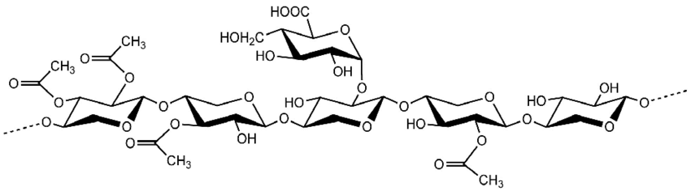
Fig. 5. Structure of hemicellulose biopolymer[12]
Xylans
The core of xylans is composed of D-xylose units and the branches that accompany them, connected by β -1.4 linkage. Although xylan show a primary chain identical with cellulose, but consists of the monomeric units D-xylose and small amount of L-arabinose. The ramification of the main chain, which can assume several shapes, is composed of branches made of L-arabinofuranose joined to the O-3 positions of D-xylose residues and D-glucuronic acid, acetyl esters, or 4-O-methyl-D-glucuronic acid linked to the O-2 positions. It is possible to connect additional groups, like ferulate groups, to other substituents.[3].
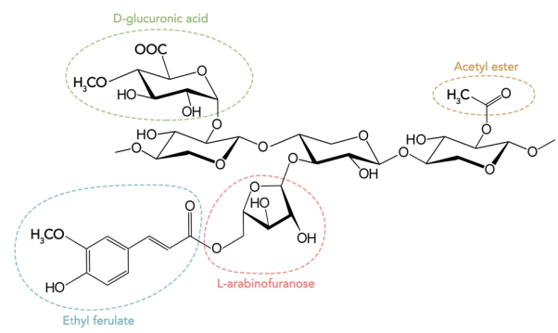
Fig.6. Structure of xylan.

Mannans
Mannan substances such as mannan, galactomannan, glucomannan, glucuronic acid mannan, etc.primarily makes the composition of hemicellulose. Mannans are made up of mannose residues connected by β-(1-O-4) linkages, whereas galactomannans are made up of galactose units linked by β- (1-O-6) bonds [3].
Lignin
Lignin is the second-largest heterogeneous natural organic biopolymer, constituting 10%–35% by weight and 40% by energy of the biomass composed up of lignocellulose. Lignin is considered a waste product or by-product in the paper, sugar, ethanol, and other bio-based production industries. Its three-dimensional complex cross-linking is made up of the three primary mono-olignols, coumaryl alcohol, coniferyl alcohol, and sinapyl alcohol, which are connected by strong C-O and C-C bonds.[12]

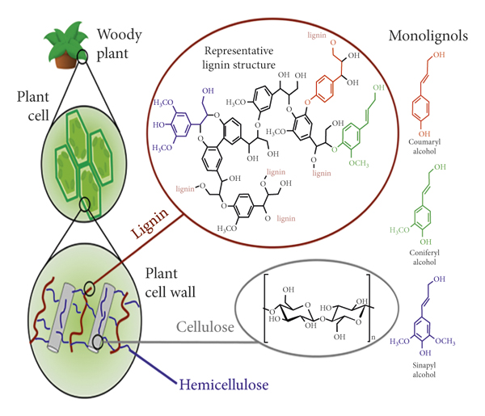
Fig.7. Structure of lignin biopolymer complex[13].
Essential oil
Essential oils are composed of terpenes (monoterpenes, sesquiterpenes, as shown in Fig. 8a & 8b), which are secondary metabolites of the plants and naturally occurring volatile complex liquids (usually colourless at room temperature). Essential oils have been grouped into chemical classes that include alcohols, ethers, carbonyl compounds, amines, phenols, acids, heterocyclics and their derivatives[14].

( a.) 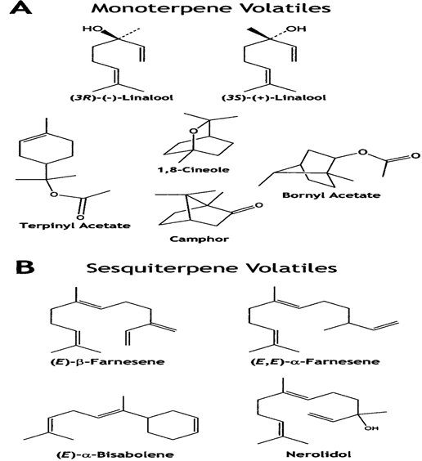 (b.)
Fig. (8a & 8b) Monoterpenes and Sesquiterpenes.

Vegetable oils and animal fats
Triacylglycerols, also referred to as triglycerides, are the term for animal and vegetable fats that originate from both plant and animal sources. Lipids are the broad term for oils and fats. Unlike other biomass sources, oils and fats have been extensively explored to produce valuable compounds that have proven beneficial for a number of industrial processes. Through transesterification, biodiesel is produced on a big scale using oils obtained from oil-producing plants, plant seeds, and animal fats.
Lignocellulosic biomass
Lignocellulosic biomass is a complex mixture of chemical and biological substances, including cellulose, hemicelluloses, lignin, fat, starch, water-soluble sugar, amino acids, and other substances. Lignocellulosic biomass is made up of three primary substances: lignin (C₈₁H₉₂O₂₈), which is found on the outside, hemicelluloses [(C₆H₁₀O₅) _{n}], which are found below lignin, and cellulose [(C₅H₈O₄) _{n}] which is found in the middle. Lignin, which has a composition of roughly 40%, is a crucial ingredient in the production of biofuel.
Chitin and Peptidoglycan
Chitin is a nitrogen containing polysaccharide synthesized from units of N-acetyl-d-glucosamine through the covalent β-(1→4)-linkages (like the linkages between glucose units forming cellulose).The C₂ position of chitin has an acetyl amine group as opposed to a hydroxyl group) therefore, chitin may be described as cellulose with one hydroxyl group on each monomer replaced with an acetyl amine group. Peptidoglycan is the main structural polymer composed of repeating glycan chains of N-acetyl glucosamine and N-acetylmuramic acid residues that are cross-linked by peptide side chains.

2.3. Biomass processing and conversion technologies
As biomass production increases steadily, it is essential to create more efficient and effective waste management systems to ensure environmental sustainability. One beneficial use of biomass is in the production of electricity, biofertilizers, water purification systems, cement, thermal insulators, etc. Biomass is used as the processing input (feedstock) in the biorefinery system, which yields a variety of bio-based products. The production of biofuel and other chemical products from biomass is the core concept behind the biorefinery technology.
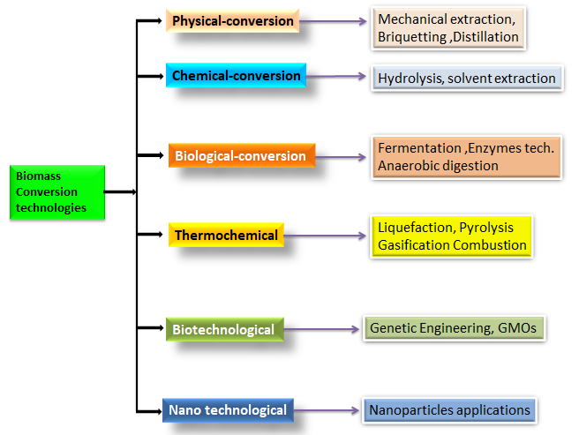
Fig.9. Biomass Conversion Technologies.
Innovations in technologies (Fig. 9) for the processing of biofuels broadly refer to recent developments in the production of chemical compounds and alternative fuels, including biomass-to-liquid technologies (liquefaction, pyrolysis, and transesterification), gas-to-liquid technologies (syngas fermentation and Fischer-Tropsch synthesis), co-processing technologies, fuel upgrading technologies (Hydrotreating and reforming), and novel catalyst development for Bioenergy can be created from biomass processing as heat, electricity, or biofuels (gaseous, liquid, or solid) by thermochemical or biochemical processes. Biomass or biomass waste can be transformed into a variety of useful chemical products and energy-producing products (Fig. 10). The selection of a specific biomass conversion method is determined by several factors, including the type and quantity of biomass utilized as a feedstock, availability, the choice of ultimate products, process economics, and environmental considerations.
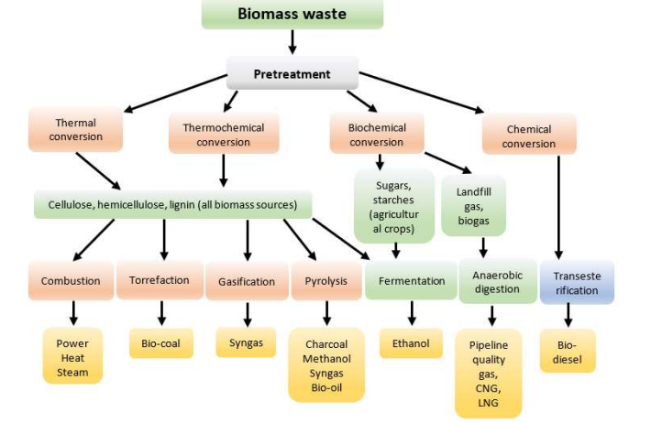
Fig.10. Products from Biomass Conversion Technologies [15]
The most common technique for transforming biomass into useable energy is direct combustion. Biomass is converted thermo-chemically by procedures like pyrolysis and gasification. The biomass feedstock materials used in both processes are heated to high temperatures in gasifiers, which are pressurized, sealed tanks, and then thermally decomposed. The main difference between both processes is the conversion temperatures and the amount of oxygen present. When organic molecules are heated to 800–900°F with almost no free oxygen present, the process is known as pyrolysis. while the process of gasification involves heating organic materials to temperatures between 800°F and 1,700°F while injecting controlled amounts of free oxygen or steam into the reactor to produce synthesis gas, also known as syngas, which is rich in hydrogen and carbon monoxide[6]. The pyrolysis of biomass results in the production of fuels such as methane, hydrogen, sustainable diesel, charcoal, and Bio-oil. Bio-oil, which is produced through fast pyrolysis, is treated with hydrogen at high temperatures and pressures in the presence of a catalyst to produce clean diesel, green gasoline, and jet fuel. Synthesis gas or Syngas can be used as fuel in gas turbines, diesel engines, and other devices that use gas to produce heat and electricity. Following its separation from the gas through processing, the hydrogen can either be burnt directly or utilised in fuel cells. It is possible to further process the syngas to produce liquid fuels using the Fischer-Tropsch method. The chemical process of transesterification transforms vegetable oils, animal fats, and greases into fatty acid methyl esters, which are then utilized to make biodiesel. The biological conversion of biomass involves two processes: fermentation, which produces ethanol, and anaerobic digestion, which produces biogas.
2.4. Challenges associated with biomass conversion technologies
The conversion of biomass into a renewable energy source involves a number of techniques; however, some of these techniques face challenges that must be resolved to improve their efficacy. Because some biomasses are chemically complex, Realistic biomass feedstocks should be thoroughly chemically characterized using methods like Fourier-transform ion cyclotron resonance mass spectrometry (FT-ICR MS), GPC, and NMR, etc. It has been observed that mixed solvent environments, or mixtures of water and organic co-solvents, not only enable but significantly improve the efficacy of some major biomass conversion reactions when compared to conversion using water as a solvent alone. As a result, the parameters used to choose a solvent have an effect on a variety of factors, including the rates and selectivity of chemical reactions, the stability of products generated during the liquid phase, and the solubility of raw materials. Biomass-derived feedstocks often contain impurities that can reduce the activity or lifetime of catalysts. So there are some challenging factors related to the catalytic conversion of biomass that can be overcome with designing the more active and selective as well as stable catalysts [16].
3. Conclusions
Fossil fuels, such as coal and natural gas, have significantly impacted human civilizations, posing significant environmental challenges such as toxic emissions and climate change. Biomass, derived from organic substances from photosynthesis, is a crucial alternative energy source that can be used to produce biofuels for electricity and transportation. Biofuels, including solid biomass, liquid fuels, and biogases, contribute to a low-carbon environment and a sustainable future. The four different types of biomass are first-generation edible, second-generation non-edible oils, third-generation algal biomass, and fourth-generation genetically modified biomass. Algal species are suitable for the production of biodiesel because they yield high quantities with fewer inputs and faster processing times than lignocellulose biomass. Renewable fuels are produced through bioconversion processes including gasification and Hydrotreating. However, more active, selective, and stable catalysts are required since pollutants are typically present in biomass feedstocks. The processing of biofuels includes advancements in the production of alternative fuels and chemicals, such as biomass-to-liquid, biomass-to-gas, gas-to-liquid, co-processing, fuel upgrading, and the development of novel catalysts. Biomass waste can be transformed into various kinds of energy and chemical compounds. The type of feedstock, availability, final product choice, process economics, and environmental issues all affect the conversion technology that is used. The correct chemical characterization of feedstocks using techniques like FT-ICR MS, GPC, and NMR is one of the challenges faced by biomass conversion techniques for the production of renewable energy. Conditions with a mix of solvents improve the efficiency of biomass conversion reactions. The appropriate solvent choice affects the solubility of raw materials, reaction rates, selectivity, and stability. More active, selective, and stable catalysts are needed for biomass feedstocks since they often include contaminants, which lower efficiency.
References
[1] F. Wang et al., “Technologies and perspectives for achieving carbon neutrality,” Innovation, vol. 2, no. 4. 2021. doi: 10.1016/j.xinn.2021.100180.
[2] F. Perera, “Pollution from fossil-fuel combustion is the leading environmental threat to global pediatric health and equity: Solutions exist,” International Journal of Environmental Research and Public Health, vol. 15, no. 1. 2018. doi: 10.3390/ijerph15010016.
[3] A. Tursi, “A review on biomass: Importance, chemistry, classification, and conversion,” Biofuel Research Journal, vol. 6, no. 2. 2019. doi: 10.18331/BRJ2019.6.2.3.
[4] M. Saleem, “Possibility of utilizing agriculture biomass as a renewable and sustainable future energy source,” Heliyon, vol. 8, no. 2. 2022. doi: 10.1016/j.heliyon.2022.e08905.
[5] I. Arya et al., “Current trends and future prospects of nanotechnology in biofuel production,” Catalysts, vol. 11, no. 11. 2021. doi: 10.3390/catal11111308.
[6] A. Garba, “Biomass Conversion Technologies for Bioenergy Generation: An Introduction,” in Biotechnological Applications of Biomass, 2021. doi: 10.5772/intechopen.93669.
[7] J. Ben-Iwo, V. Manovic, and P. Longhurst, “Biomass resources and biofuels potential for the production of transportation fuels in Nigeria,” Renewable and Sustainable Energy Reviews, vol. 63. 2016. doi: 10.1016/j.rser.2016.05.050.
[8] V. Singh, R. Tiwari, V. K. Chaturvedi, N. Singh, and V. Mishra, “Microbiological Aspects of Bioenergy Production: Recent Update and Future Directions,” 2021. doi: 10.1007/978-981-33-4615-4_2.
[9] S. K. Parakh, Z. Tian, J. Z. E. Wong, and Y. W. Tong, “From Microalgae to Bioenergy: Recent Advances in Biochemical Conversion Processes,” Fermentation, vol. 9, no. 6. 2023. doi: 10.3390/fermentation9060529.
[10] A. Willfahrt, E. Steiner, J. Hötzel, and X. Crispin, “Printable acid-modified corn starch as non-toxic, disposable hydrogel-polymer electrolyte in supercapacitors,” Appl. Phys. A Mater. Sci. Process., vol. 125, no. 7, 2019, doi: 10.1007/s00339-019-2767-6.
[11] A. Dal Fovo et al., “Nonlinear imaging and vibrational spectroscopic analysis of cellulosic fibres treated with COEX® flame-retardant for tapestry preservation,” RSC Adv., vol. 12, no. 41, 2022, doi: 10.1039/d2ra02384a.
[12] L. Hu, X. Fang, M. Du, F. Luo, and S. Guo, “Hemicellulose-Based Polymers Processing and Application,” Am. J. Plant Sci., vol. 11, no. 12, 2020, doi: 10.4236/ajps.2020.1112146.
[13] M. R. Ridho et al., “Lignin as Green Filler in Polymer Composites: Development Methods, Characteristics, and Potential Applications,” Advances in Materials Science and Engineering, vol. 2022. 2022. doi: 10.1155/2022/1363481.
[14] P. Noriega, “Terpenes in Essential Oils: Bioactivity and Applications,” 2021. doi: 10.5772/intechopen.93792.
[15] T. Kalak, “Potential Use of Industrial Biomass Waste as a Sustainable Energy Source in the Future,” Energies, vol. 16, no. 4. 2023. doi: 10.3390/en16041783.
[16] T. W. Walker, A. H. Motagamwala, J. A. Dumesic, and G. W. Huber, “Fundamental catalytic challenges to design improved biomass conversion technologies,” Journal of Catalysis, vol. 369. 2019. doi: 10.1016/j.jcat.2018.11.028.

