Utility Scale Floating Solar PV (FSPV) Projects and their Perspective in Context of India

Saurabh Motiwalaª, Ashish Kumar Sharma^{b}, Ishan Purohit^{b}

ªIndian Institute of Technology Bombay
^{b}International Finance Corporation, World Bank, India

- Introduction

India’s aims to reach net zero emissions by 2070. The Government of India has set an ambitious target of having 500 GW of installed non-fossil fuels based clean energy by 2030, which mainly includes of the installation of 280 GW of solar power and 140 GW of wind power. The installed renewable power generation capacity has grown at a CAGR of 15.92% between FY16-22. India is the market with the fastest growth in renewable electricity, and by 2026, new capacity additions are expected to double. According to a report by the Institute for Energy Economics and Financial Analysis (IEEFA), the cost of solar power in India has fallen by 84% since year 2010. India's renewable energy success can also be attributed to the rapid technological advancements in the sector. Fig 1 shows the growth of solar projects in India since the launch of National Solar Mission (NSM).

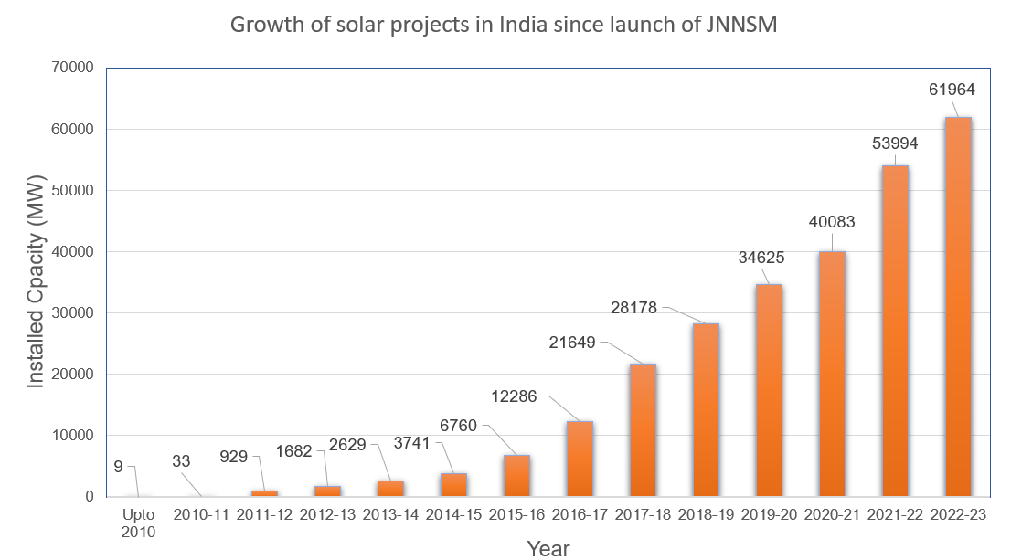
India has achieved fourth rank in the world in solar power deployment. As on May 2023, solar projects of capacity of 67.8 GW has been commissioned in the country. This capacity includes 52 GW from ground-mounted solar projects, 7.82 GW from rooftop solar projects, and 2.09 GW from off-grid solar projects.
Figure-1. Growth of solar power in India
Source: Ministry of New and Renewable Energy, Govt. of India
Drawbacks to solar energy expansion are that traditional ground-based PV systems require large land areas for installation. They also require substantial volumes of water for cleaning and are prone to heat-related losses in hot climates. Lack of availability of land for large scale solar projects and competition of land use for other economic activities like agriculture limits its application. Key advantages of floating photovoltaic projects (FSPV) installed on existing reservoirs are that they preserve land for other uses, and most reservoirs tend to be in proximity to existing grid systems. Furthermore, the cooling effect of water in some installations enhances energy conversion efficiencies and FPV panels/floats reduce reservoir water losses from evaporation by blocking radiative energy and lowering water temperatures.

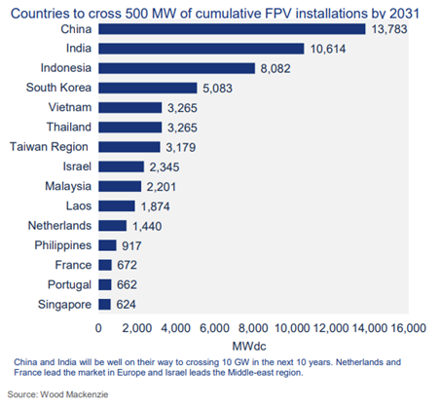
Floating solar is expected to have a steady market share compared to overall global solar demand, with the compounded annual growth rate (CAGR) for floating solar PV (FSPV) expected to rise 15% in the next ten years. About 15 countries are forecasted to exceed 500 megawatts (MW) of cumulative FPV installations by 2031 (see Fig 2), with Indonesia, India and China making up almost 70% of the total FPV demand in 2022.
Figure-2. Country wise FSPV installation projected till FY 2031
Source: Wood Mackenzie

By the next decade, China’s cumulative floating solar capacity is expected to cross 13 GW growing at a CAGR of 12%. The country has been able to utilise flooded coal mines that have been decommissioned to develop floating solar. An international group of researchers has calculated the potential for floating solar across the world. The results show a generation potential of 9,434 TWh per year across 114,555 global reservoirs, with 30% of their area covered. The United States leads with 1,911 TWh per year of potential, followed by China at 1,107 TWh per year and Brazil at 865 TWh per year (see Fig 3).
Figure-3. Potential (TWh) of utility scale FSPV (country wise)
Source: nature sustainability

The study only considers global reservoirs larger than 0.01 km², with 30% of their area covered but not exceeding 30 km². The academics used three global databases to filter the eligible reservoirs, Global Reservoir and Dam (GRanD), the Georeferenced Global Dam and Reservoir (GeoDAR), and OpenStreetMap (OSM). There are a total of 114,555 reservoirs worldwide meeting the criteria with a total area of 554,111 km². Of those, 2,561 reservoirs already have hydraulic power generation and grid infrastructure in place.

The Energy and Resources Institute (TERI) had undertaken a study to estimate the potential of FSPV in the country. It analysed 30% of medium and large water bodies, amounting to an area of 18,000 km². An overall potential of 280 GW was identified through this study.
India has already taken a lead in this direction by setting up world's largest FSPV of 100 MW capacity at Ramagundam, Telangana. India currently has less than 300 MW of installed FSPV capacity, accounting for less than 0.5% of the country’s total solar capacity. Rewa Ultra Mega Solar Limited (RUMSL) has auctioned 600 MW FSPV projects at the Omkareshwar dam reservior in Madhya Pradesh. Once commissioned, it would be the world’s largest FSPV project. The auction by RUMSL was held in two phases of 300 MW each. RUMSL is a joint venture of Solar Energy Corportation of India and Madhya Pradesh Urja Vikas Nigam Limited. The lowest bid quoted for a 100 MW project was INR 3.21/kWh. The government is planning to provide viablity gap funding (VGF) to bring the cost down to the range of INR 2.3 - 2.9 /kWh which will make it competitive to ground mounted solar PV projects.

For the optimal development of an FSPV plant, it is necessary to identify a location that meets several conditions that facilitates its development. Some of the essentials for a potential site are a good availability of solar irradiation, favourable bathymetric, topographic and environmental conditions, as well as adequate socio-economic integration. Most of the potential sites lack bathymetry data. Hence, it is important to carry out a study to characterize the physical properties of water body and assess site limitations which will allow to define the optimal location for FSPV development. Over the last few years, efforts have been made to prepare Standards and Best Practices for FSPV projects but there is still a lot of scope for improvement. These standards and practices play an essential role in development of more mature commercially viable FSPV projects.

- Floating Solar PV Technology

Solar PV modules form an essential integral of an FSPV project. All PV module technologies used for conventional solar projects like poly-crystalline, mono-crystalline or thin-film solar panels are used for the projects. The selection of PV module technology depends on space availability, cost and relative humidity. Operating temperature, high moisture, type of water body and relative humidity conditions are important criteria to be considered in comparison to solar PV modules used for land-based installations.

  - Solar PV Modules
The biggest challenge on water for PV modules is constant high humidity and constant movement. This creates significant stress that increases risks of module degradation and failure. In general, the current ‘standard’ photovoltaic module design of a 60 or 72 multi or mono cell glass front, aluminium framed module with IP67 rated junction box, fluoropolymer coated backsheet and EVA encapsulant has performed well under a variety of conditions and represents much of the current world-wide installed base. Given the robustness of existing modules designs, modules suitable for tropical environments on a pontoon-based installation may be suitable for floating solar applications with minimal or no modification.

2.2 Solar Inverters

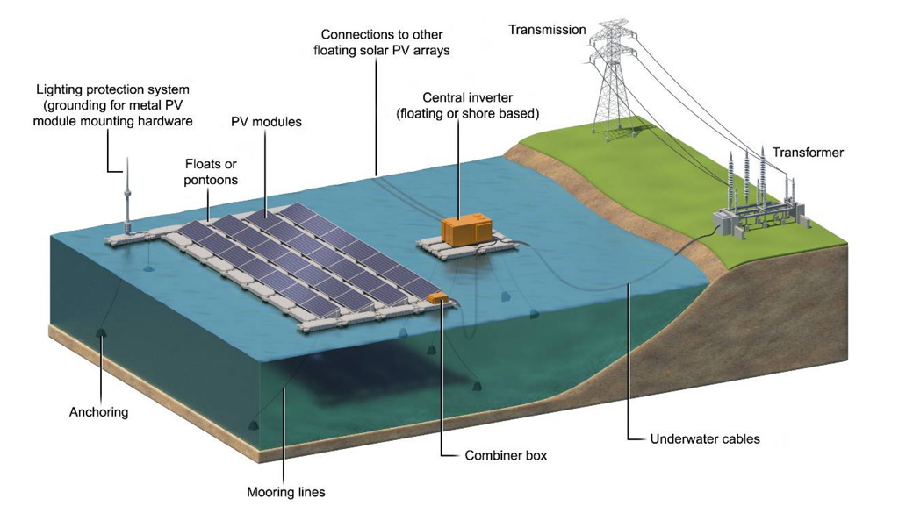
Inverters play an important role in solar projects by converting direct current (DC) to alternating current). Both central and string inverters can be used for FSPV projects as used in conventional solar projects. String inverters connect a string (chain) of multiple PV modules (panels) in series to one single inverter. The power conversion from DC to AC happens at a string level at the output of the inverter. In case of FSPV projects, string inverters are preferred because of their ease of installation at the end of each floating island. The output of each floating island is then pooled to the main power evacuation substation.
Figure – 4. Schematic of a utility scale FSPV project
Source: Lee et al. 2020

A central inverter pools the output of solar PV modules to DC combiner boxes and then terminates in a central inverter. In the case of floating solar PV power plants, a few projects are constructed where the central inverters are installed on floats along with transformer and switchgears. A typical configuration of a FSPV project consists of solar PV modules, inverters, the balance of system, and related evacuation infrastructure similar to ground mounted project. The vital difference is that the PV modules and sometimes inverters also float on water with the help of an anchoring and mooring system. Figure -4 depicts a FSPV project with PV modules and central inverters floating on pontoons. DC power from PV module strings is collected at the combiner boxes and converted to AC power by inverters. The essential elements of the project are the floating structure, anchoring, and mooring system. The design of these elements requires critical attention as they are to be designed specific to the site requirements.

2.3 Floats

The floats for the floating structures are designed based on the buoyancy principle and form
a crucial component of the floating structure. Materials like fibre-reinforced plastic (FRP), medium density polyethylene (MDPE), ferro-cement, and high-density polyethylene (HDPE most used) are used for the design of the float. Equipment like PV modules, inverters, cables, combiner boxes, mounting structures, and transformers are kept afloat with the help of this structure. A brief overview of float designs are described below.

2.3.1 Pure floats

It is one of the most matured float designs and offered by many large players in the market. Ciel & Terre (C&T), a French company, pioneered this design and is being utilized for large FSPV projects globally. Figure 5 illustrates the example of such a float time offered by C&T in the market. The float system is modular with main and secondary floats. The main floats support the PV modules while the secondary floats connect to the main floats, ensure proper spacing between modules, and allow space for walkways while providing additional buoyancy. These floats are connected with the help of pins, bolts, or bands. The material used for manufacturing is HDPE with UV and corrosion resistance.

2.3.2 Modular raft floats

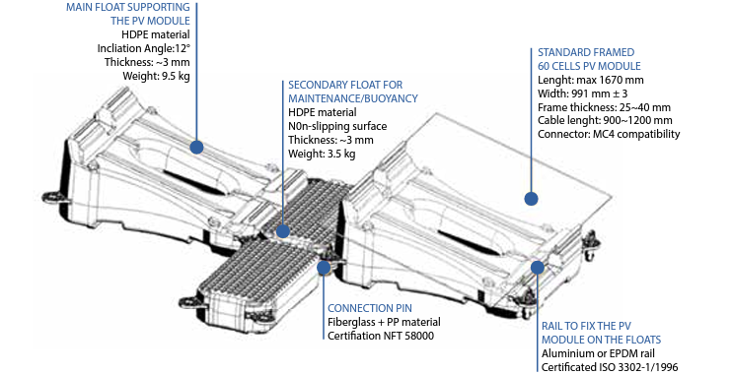
In this design, PV modules are placed on metal structures similar to ground mounted solar projects. These metal structures are fixed to floats/pontoons. These floats provide only buoyancy, eliminate the requirement for a specially designed float, and can be sourced locally. The metal structures can be fixed on the floats, as designed by NRG Energia (see Figure 6).
Figure-5. Schematic diagram of pure floats of FSPV system
Source: Ciel & Terre
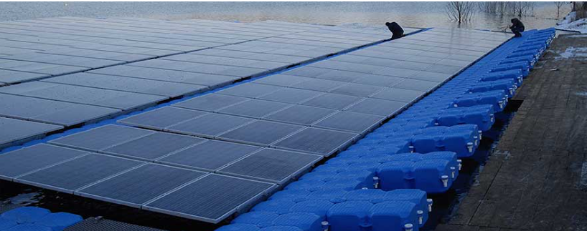

Figure-6. Schematic diagram of modular raft floats of FSPV system
Source: NRG ENERGIA

2.3.3 Membrane floats

The PV modules are attached to some non-permeable membrane/sheet supported by tubular plastic rings providing buoyancy. The giant pool-shaped membrane, along with the rings, make up this float system. Typically these floats are used for offshore installations, as depicted in Figure 7.

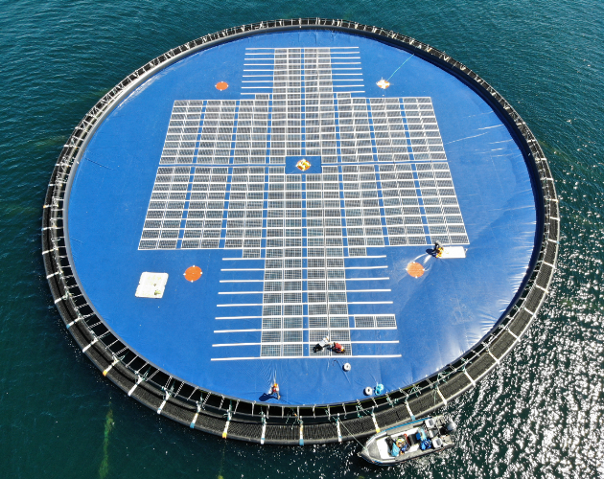
Figure-7. Schematic diagram of Membrane pure floats of FSPV system
Source: OCEAN SUN

2.4 Anchoring and mooring system

The anchoring and mooring system are essential to the FSPV project, ensuring that the floating platforms are kept in place. The floating structures could be anchored at the bottom (bottom anchoring) or at the bank/shore (bank anchoring). These two banking options are depicted in Fig 8. One to three anchors per MWp could be required in large scale projects.
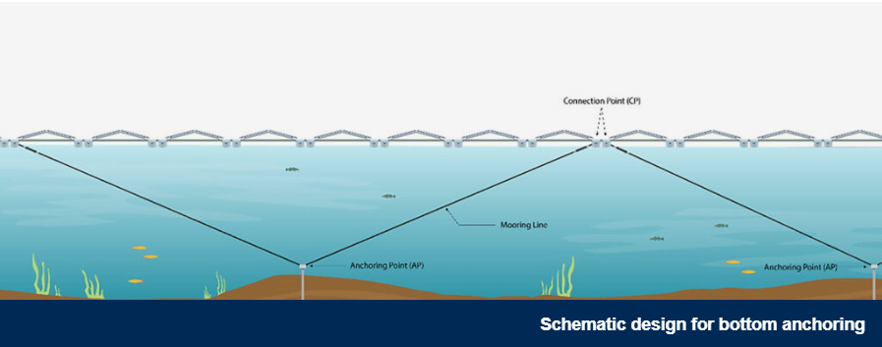
Figure-8. Schematic design diagram for bottom anchoring of FSPV system
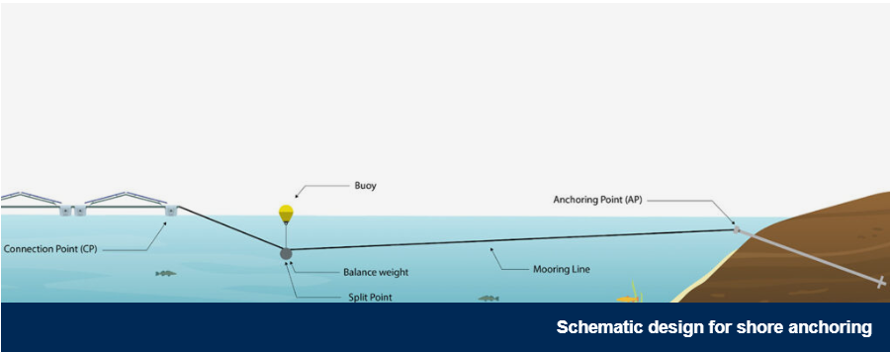
Bank anchoring is cheaper than bottom anchoring. It is suitable for small, shallow ponds or water bodies where the FSPV project is close to the shore. Bank anchoring allows easier access to perform periodic O&M.
Figure-9. Schematic design diagram for shore anchoring of FSPV system
Source: ZIMMERMANN

The mooring system should be customized to fit the local geographic and climatic conditions and secured. This system minimizes the movement of floating structures caused due to winds, waves, and currents. It helps the structures survive under varying water levels and maintains a minimum distance between the solar arrays. Various software tools like Orcaflex or NEMOH are used by developers to perform simulations for appropriate mooring system.
Commonly used material for mooring lines include chain, wire ropes and a range of synthetic materials such as Nylon, Polyester, and Ultra High Molecular Weight Poly Ethylene (UHMWPE). For conventional solar projects, cable size depends on voltage and current of the cable and losses from the cable. For FSPV projects, cable size optimization, routing and management needs detailed planning. Extra length in the form of slack is to be provided for accommodating the movement of the floating platform. If the cable length is insufficient, it may result in cables to snap and rupture due to the tension.

- Potential site assessment

A typical FSPV project starts with concept development and site identification, followed by pre-feasibility and feasibility studies, permitting, financing, engineering, construction, and commissioning. The initial phase of designing an FSPV project starts with site selection. Various parameters such as the technical, environmental, and social (E&S) and interconnection should be studied for the proposed site. The ideal site should have adequate solar irradiance, less prevalence of weather events such as storms, hurricanes and typhoons, shallow reservoir depth, water bodies that are not used for competing purposes such as recreation and aquaculture, accessibility for transportation power evacuation, and stable legal and regulatory framework for FSPV development.

A thorough solar resource assessment of the site should be conducted. A suitable area of the reservoir or the water body should be identified based on the reservoir depth and proximity to power evacuation infrastructure. Reservoir bed characteristics should be studied including depth and bathymetry, geology, and reservoir bed conditions (rugosity, morphology) and physicochemical properties of reservoir bed soil and water. Land requirement for power evacuation infrastructure and assembling of structures during should be analysed in terms of its ownership and proximity. The site condition and climatic factors that affect the structural behaviour must be taken into account while assessing the site's suitability. These parameters are bathymetry study results, bottom slope, soil conditions, wind conditions, wave conditions and current conditions

3.1 Bathymetry survey

The bathymetry survey provides information on the reservoir bed in the form of a contour map comprising details related to the depth of the waterbed with reference to the datum level. Depth of reservoir and reservoir bed characteristics are essential parameters for assessing and designing the anchoring and mooring of the FSPV plant.

3.2 Geotechnical survey

The purpose of the geotechnical investigation is to examine the physical and chemical properties of soil and rock data to assess and select suitable anchoring system. The geotechnical investigation includes the collection and analysis of soil and water samples. It is recommended to collect the soil samples from the reservoir bed and nearby shore and analyse them for physical and chemical parameters such as natural moisture content, bulk density, grain size and distribution, specific gravity and atterberg limit. These soil characteristics are important to select a suitable anchoring system.

3.3 Water current study

Understanding the current speed at the different water column levels and the flow turbulence induced by the topography of the water reservoir would be essential for the mooring system design of FSPV. Various parameters related to water current such as speed, direction and velocity at different depths are measured by deploying ADCP (Acoustic Doppler Current Profiler). Water current and velocity profile for six months is ideal for designing the FSPV system.

3.4 Geophysical Study

Understanding the subsoil strata is essential to design the anchoring and mooring. Sub-bottom profilers are most commonly used to view the layers of sediment and rocks under the water body floor. The slope at the bottom has a direct impact on the behaviour of the floating solar plant. This is because an excessive slope causes an asymmetric mooring, which can cause greater movements in the system and, therefore, greater damage to floats and a reduction in the possible useful life of the solar plant.

A thorough investigation to be done collating all information and in consultation with stakeholders while selecting the location, avoid waterbodies with protected natural habitats or species. Natural lakes or water bodies with recreational priorities should be avoided due to higher socio-environmental impacts. Water body should have a regular shape, no obstacles and wide in order to reduce currents and drags. The ideal site should be 20m away from land and less than 30 m depth; minimal variation in water level. Depths of less than 1.5 m in the water column (minimum draw down level) make the location not suitable for installation of floating technology, as the plant could rest on the bottom in dry season, causing significant damage to the components. Social aspects are crucial and need to be studied as part of the initial assessment. The project should not negatively impact the livelihood.

- Project Cost estimates and techno-economics

An FSPV project and a GMPV project are identical regarding their electric systems. A PV project consists of PV modules that produce DC electricity. This DC electricity fed to inverters gets converted into AC electricity and then connected to the grid network for consumption. So, a typical PV project consists of PV modules, inverters, mounting structures, and balance of system (BOS) - cables, connectors, etc.

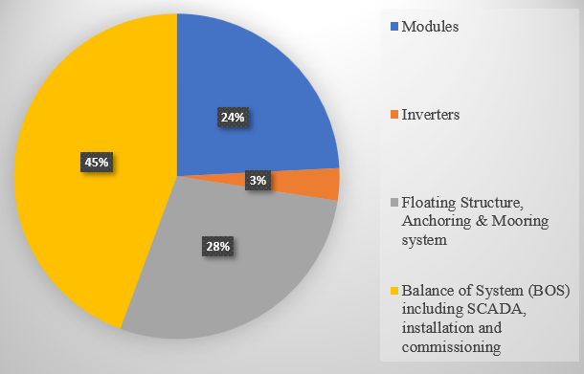
The most significant difference between an FSPV project and a GMPV project is how the PV modules are mounted. In a GMPV project, PV modules are mounted on a rigid structure with a firm foundation, whereas in an FSPV project, these modules are placed on a floating system on the water's surface. Another striking difference between these projects is the choice of equipment with seawater environment considerations. The inverters, cable, fittings, and floats should be of marine grade with higher Ingress Protection (IP) ratings and corrosion-resistant materials. A typical cost break up of a 50 MW FSPV project is indicated in Fig 10. CAPEX for a MWp FSPV project can be considered in the range of USD 1.2 to 1.4 per Wp.
Figure-10. Project cost break-up of a utility scale FSPV solar project

There is no significant difference in the OPEX cost of an FPSV project compared to a GMPV project. OPEX of a typical GMPV project includes proper cleaning of modules along with other preventive maintenance checklists. Checking the floating structure (yearly) and verifying the integrity of the anchoring and mooring system (every three years) would be additional for an FSPV project in contrast to a GMPV project. OPEX of FPSV projects may be assumed to vary from USD 0.011 to 0.013 per Wp per annum.

Levelized Cost of Electricity (LCOE) calculations are based on the abovementioned CAPEX and OPEX estimates. A sample location of Dahod Dam reservoir (23.021°N, 77.474°E) in India is considered for energy generation estimates. The estimates are referred from Global Solar Atlas. The list of assumptions for calculating LCOE are presented in Table- -1 below.
Table -1. Techno-commercial parameters of FSPV project

Project capacity | 1 MWp
CAPEX | 1300 USD/kWp
OPEX | 11 USD/kWp/year
Discount rate | 10%
Lifetime | 30 years
Specific power output | 1607.5 kWh/kWp/year

The LCOE, with the above assumptions, was obtained to be 0.093 USD/kWh. A sensitivity analysis was performed considering variation in CAPEX and specific power output. The results of the analysis are presented in Table-2.
Table -2. Sensitivity assessment of LCOE of FSPV project

 |  | CAPEX (USD/kWp)
 |  | 1203 | 1300 | 1398
Specific power output (kWh/kWp/year) | 1446.8 | 0.096 | 0.103 | 0.110
 | 1607.5 | 0.086 | 0.093 | 0.099
 | 1768.3 | 0.078 | 0.084 | 0.090

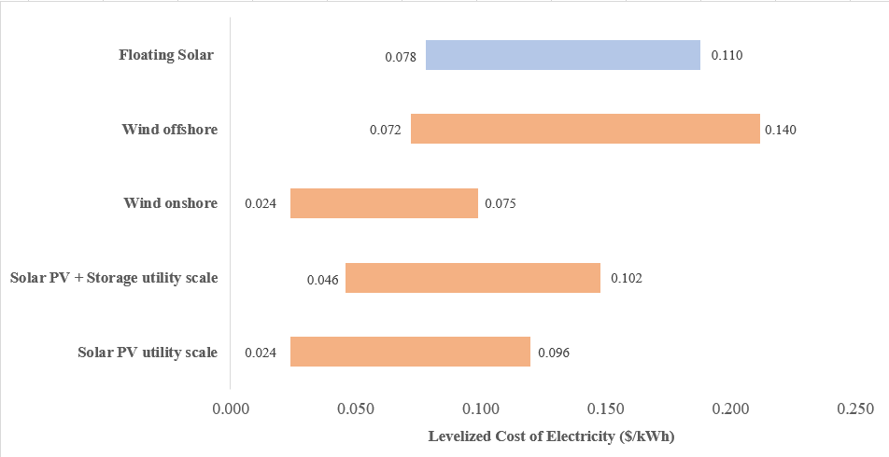
It has been observed that LCOE of the FSPV project varies from 0.078 USD/kWh to 0.110 USD/kWh. Figure 11indicates LCOE ranges of different renewable energy technologies for 2023. The obtained LCOE range for FSPV is observed to be competitive with other commercial scale renewable energy technologies.
Figure 11. Comparison of LCOE of various commercialized RE technologies

Factors like water conservation and land conservation will enhance the attractiveness of an FSPV project.

- FSPV in India (case Study)

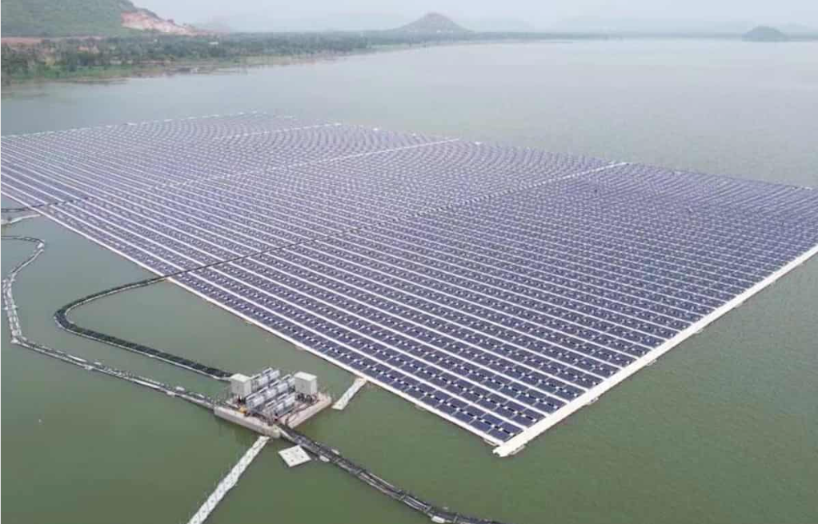
India’s largest FSPV project of 145 MWp/100 MW is commissioned by NTPC in Ramagundam, Telangana in July 2022. The project was awarded to BHEL at a contract price of INR 423 crore and is developed on 450 acres of the Balancing reservoir of NTPC Ramagundam Station. The project is divided into 40 blocks of 2.5 MW capacity each. The floating system is anchored through special HMPE (High Modulus Polyethylene) rope to the dead weights placed in the balancing reservoir bed. The power is being evacuated up to the existing switch yard through 33kV underground cables. This project is unique in the sense that all the electrical equipment including inverter, transformer, HT panel and SCADA (supervisory control and data acquisition) are also on floating ferro cement platforms. The anchoring of this system is bottom anchoring through dead weight concrete blocks.
Figure 12. Utility scale FSPV at Ramagundam, India
Source: Siasat
From an environment point of view, the most obvious advantage is minimum land requirement mostly for associated evacuation arrangements. Further, with the presence of floating solar panels, the evaporation rate from water bodies is reduced, thus helping in water conservation. Approximately 32.5 lakh cubic meters per year water evaporation can be avoided. The water body underneath the solar modules helps in maintaining their ambient temperature, thereby improving their efficiency and generation. Similarly, while coal consumption of 1,65,000 Tons can be avoided per year; CO2 emission of 2,10,000 tons per year can be avoided. NTPC has commissioned 237 MW of FSPV capacity in the country so far. List of projects commissioned by NTPC.

Table -3. Sensitivity assessment of LCOE of FSPV project

Project name | Project capacity | Annual energy yield (MU) | Annual CO₂ savings (MT) | Location | EPC/OEM
Simhadri Floating Solar PV Project | 25 MW | 55.11 | 47.5 | NTPC Simhadri (District Vishakhapatnam), Andhra Pradesh
Ramagundam Floating Solar PV Project | 100 MW | 223 | 192 | Ramagundam Village, District Karimnagar, Telangana | EPC - M/s BHEL, Floaters - M/s Prabhdayal,  Anchoring system - M/s Adtech
Kayamkulam - I Floating Solar PV Project | 22 MW | 215.5 | 185.5 | Choolatheruvu in Alappuzha district of Kerala | EPC - M/s BHEL, Floaters - M/s Purushottam Profiles,  Anchoring system - M/s Adtech
Kayamkulam - II Floating Solar PV Project | 70 MW |  |  |  | EPC - M/s Tata Power, Floaters - M/s Ciel & Terre,  Anchoring system - M/s Adtech
Auraiya Floating Solar PV Project | 20 MW | 39 | 33.6 | Dibiyapur in Auraiya district of Uttar Pradesh | EPC - L&T, Floaters & Mooring system - M/s Purushottam Profiles

- Barriers to FSPV projects

Although FSPV projects have started gaining commercial traction, many challenges must be addressed.
  - Site selection and acquisition

For a country like India, no consolidated database provides details of water bodies with information on water surface area, water level variations, local weather profiles, historical changes in the water surface, data on local biodiversity, etc. This information is critical while designing an FSPV project and is part of risk assessment, ensuring the project's bankability. There is a lack of clarity on the ownership of water bodies and their usage for power generation vis a vis for fishing or other commercial activities. The lead time to acquire or lease these water bodies could delay the initiation/construction of proposed projects.

6.2 CAPEX

The CAPEX of FSPV projects is higher than that of ground mounted PV projects. The desings of floats, mooring and anchoring system needs to be site specific. The electrical components should also withstand harsh marine conditions for 25 years lifetime. CAPEX dominates the LCOE of floating solar with the operating costs being approximately 20% of the levelized costs. The CAPEX of FSPV will depend on the development of PV module costs, which has a cost-learning rate of 27% and will decline to 17% in 2050. The cost of floats is also expected to drop over time. Local manufacturing and availability of floats could potentially lead to this price drop.

6.3 Operation & Maintenance (O&M)

O&M activities on water are a bit tedious to perform as compared to land. The access ways, spare parts, workman, tools and tackles would add to the O&M cost for FSPV projects. The anchoring and mooring system needs regular inspection. Special interventions are required to minimize bird droppings and clean solar PV modules for energy generation. With more and more projects commissioned on a large scale, the O&M cost is expected to have a downward trend.

6.4 Environmental barriers

Different environmental barriers may impact FPV system deployment depending on the project size, site characteristics such as the ecosystem and reservoir use, and other potential local environmental concerns. The water bodies are used for multiple activities, such as fishing, livelihood generation, recreation, social activities, drinking, farming, aquatic life research, etc. When planning an FPV system deployment, the entire area of influence of the project must be assessed, which includes the immediate environmental footprint of the system and associated facilities (such as substations, transmission lines and towers, and hydropower dams, among others), the deployment water body, and upstream and/or downstream waters and their associated users. International Financial Institutions (IFIs) are very particular about the projects' E&S assessment; the FSPV projects are thoroughly assessed before financing. The uncertainty about FSPV ecological impacts may increase public opposition to projects and lengthen the environmental review process.

6.5 Technical challenges

An FSPV project’s electrical and electronic components are constantly exposed to harsh environmental conditions such as high humidity, salinity of water, high wind speed, etc. Frequent fluctuations in temperature may cause stresses in float material and its joints.

Unlike ground-based solar PV, long-run operation risks could be relatively high in case of FSPV plants. The structures are in constant motion and are exposed to enhanced Degradation and corrosion when compared to ground mounted projects. The components also face bio-fouling, which may impact its long-term relialblity and safety. DNVGL has released recommended practice document for design, development, and operation of FSPV projects. The stakeholders could evaluate these practices once large capacities of such projects are commissioned. The minimum and maximum wind resistance requirements for a floating platform is determined by a number of factors including inclination, final size of platform and whether a rigid or flexible platform is chosen. In 2019, a 13.7 MW capacity FSPV project on Yamakura Dam in Japan was destroyed due to anchor failure caused by the heavy storm. It is necessary to perform bathymetry and geotechnical surveys to establish the shape of the lake’s bed and soil structure across the site. There is no standard or guideline to perform these studies as of now.

6.6 Regulatory considerations

There is no separate regulation to push the FSPV sector in most countries. Most of these projects are deployed for captive consumption only. There needs to be an integrated policy/regulation which ensures the smooth clearance of these projects across departments. The lack of clarity on environmental approvals in most countries with good potential is also making the projects less financially appealing.

- Way Forward

FSPV projects are becoming an increasingly competitive option for power generation. There are still questions technology, its benefits, its potential impacts given its small opertional history. Countries like India, Netherlands and Taiwan are considering to take up FSPV projects with their abundant solar and hydropower resources, land-use benefits, option to hybridize with hydropower generation.

The FSPV market in China, Japan and South Korea are comparatively mature. China supported FSPV projects on artificial water bodies as opposed to natural water bodies that may have a more complex environmental review process. Japan and South Korea invetsed in FSPV development to land energy conflicts caused by ground mounted solar PV projects.

The countries with higher technical potential need consistent and targeted government support to FSPV projects systems in the form of rebates, tax incentives, and competitive RE auctions could help de-risk FPV systems and attract private sector financing. There needs to be a clear regulatory process on the ownership and market participation models and valuation methods for FSPV hydropower hybrid systems. More research is required in the potential environmental and ecological impacts of FSPV projects. The countries with mature markets should collaborate and develop operational and engineering best practices and training of hydropower power plant operators to help ensure smooth operation of FSPV hydropower hybrid systems.

Author for Correspondence (ipurohit@ifc.org)
https://mnre.gov.in/solar/solar-ongrid
https://www.woodmac.com/press-releases/global-floating-solar-to-top-6gw-threshold-by-2031/
https://www.nature.com/articles/s41893-023-01089-6
Mohit Acharya and Sarvesh Devraj (2019),»Floating Solar Photovoltaic (FSPV): A Third Pillar to Solar PV Sector ?, TERI Discussion Paper: Output of the ETC India Project (New Delhi: The Energy and Resources Institute).
https://www.livemint.com/economy/centre-weighs-financial-aid-for-nascent-floating-solar-projects-11685729001350.html
https://www.nrel.gov/docs/fy21osti/76867.pdf
https://www.nrg-energia.it/floating-pv-systems.html
https://oceansun.no/project/kyrholmen/
https://pv-floating.com/our-system/anchoring-mooring/
https://globalsolaratlas.info/detail?s=23.114093,77.518162&m=hydro&c=43.149094,-3.054199,7
https://www.lazard.com/research-insights/2023-levelized-cost-of-energyplus/
https://www.siasat.com/indias-largest-floating-solar-power-plant-in-ramagundam-excels-ntpc-to-set-up-more-such-units-2570659/
https://ntpcrel.co.in/verticals/floating-solar-2/100mw-ramagundam-floating-solar-pv-project/
DNV (2021) Energy Transition Outlook 2021 – A global and regional forecast to 2050
https://www.dnv.com/energy/standards-guidelines/dnv-rp-0584-design-development-and-operation-of-floating-solar-photovoltaic-systems.html
https://www.pv-magazine.com/2020/02/22/the-weekend-read-dont-throw-caution-to-the-wind/
https://www.nrel.gov/docs/fy22osti/83228.pdf

