Synthesis, Characterization and Application of CdS:Pr³⁺ nanomaterial

Jitendra Pal Singh^{1*}, Sudha Pal
Department of Physics, School of Sciences Department of Physics
IFTM University Moradabad-244102, India M.B. Govt. P.G. College, Haldwani, Uttrakhand- India paljitendra124@gmail.com palsudh2011@gmail.com

Y. K. Sharma³ Atanu Nag⁴

Department of Physics, Department of Physics, School of Sciences
Pt. L. M. S. S.D.S.University Campus Rishikesh, India IFTM University, Moradabad-244102, India. dryksharma@gmail.com Atanu.nag@iftmuniversity.a

Richa Sexena⁵, Narender Singh⁶

Department of Physics, School of Sciences, Department of Physics, School of Sciences
IFTM University, Moradabad-244102, India IFTM University, Moradabad-244102, India.
saxena.rich23@gmail.com nspal_physics@rediffmail.com

Abstract
Pr³⁺ doped CdS nanomaterial are successfully synthesized and characterized through an easy, inexpensive and single-step simple chemical precipitation method. The synthesized particles are nearly spherical shaped and their size is found to decrease with the increase in Pr³⁺ concentration. The chemical identity of the synthesized nanoparticle was confirmed by the representative EDAX spectra. The absorption spectra of the prepared nanomaterial have been recorded in the UV-visible region at room temperature. The structure, shape, band gap and optical behavior are also investigated. The obtained CdS:Pr³⁺ nanomaterial exhibit approximately sphere-like shapes of about 1μ-200nm diameter. The synthesized CdS:Pr³⁺ nanoparticles can be potential for different optoelectronic applications.

Keyword: CdS:Pr³⁺, SEM, EDAX, FTIR, UV-visible spectra

1. Introduction
Generally, nanomaterials have structured components with at least one dimension less than 100 nm and distinctly different physical and optical properties in different science of field [1]. As per the Royal society and Royal academy of engineering, UK; nanoscience and nanotechnology can be defined as follows: “Nanoscience is the study of phenomena and manipulation of materials at atomic, molecular and macromolecular scales, where properties different significantly from those at a larger scale and nanotechnologies characterization production and application of structures devices and systems by controlling shape and size at nanometer scale” [2]. In nanoparticles the various material properties such as electrical, mechanical, optical, magnetic etc., can be selectively controlled by engineering the size, morpholopy of the materials by using a variety of synthesis methods, in the various forms like thin films, powder, quantum wires, quantum wells, quantum dots etc. Nanocrystals are characterized as atomic clusters and are called quantum confined systems [3]. The requirement for quantum confinement is that the size of the nanocrystals should be smaller than the excitation Bohr radius of the material [4]. This intense interest in the science of the nanomaterials, which confined within the atomic scales, stems from the fact that this nonmaterial exhibit fundamentally interesting unique properties with great potentials of next generation technologies in electronics, computing, optics, biotechnology, medical imaging, medicine drug delivery, structural materials, aerospace etc. Group II-VI semiconductor nanoparticles are a type of compound semiconductors composed of group II and VI elements which have wide and direct band gap structures and are very important in many field, due to their tunable electrical and optical properties [5-7].

2. Experimental Details
Cadmium sulfide (CdS) nanoparticles doped with praseodymium (Pr³⁺) ion commonly referred as CdS:Pr³⁺ were synthesized by simple chemical precipitation synthesis method [8]. A paper on the synthesis of CdS nanoparticles using the chemical precipitation method has been published recently by Jitendra Pal Singh et al [9]. This is an easy, inexpensive, and single-step method. The chemicals, used in this work, were of analytical grade without purification. Cadmium nitrate tetrahydrate [Cd (NO₃)₂.4H₂O], sodium sulphide [Na₂S], diethylene glycol [DEG], ethanol [C₂H₅OH], praseodymium chloride [PrCl₃] and distilled water were used as a source material. At first 0.1M of Cd(NO₃)₂.4H₂O solution (50ml) was taken in conical flask and around 20 ml of diethylene glycol (DEG) was added to this Cd(NO₃)₂.4H₂O solution under constant stirring. Then 50 ml Na₂S solution and different concentration (0.1, 0.2 and 0.3mol %) of PrCl₃ were added drop wise under constant stirring and it was kept for reaction for 4hrs at 60⁰Cwith constant stirring. Finally, a yellow precipitate of CdS is formed. It was washed with ethanol and distilled water and dried at room temperature [10].

3. Result and Discussion
The CdS nanoparticles doped with Pr³⁺ have been synthesized by simple chemical precipitation method and this is then characterized in terms of SEM, EDAX, FTIR and absorption spectra to compute the shape, size and band gap.
3.1 SEM
Representative scanning electron microscopy (SEM) images of Pr³⁺ doped CdS nanoparticles, prepared by simple chemical precipitation method at room temperature, is shown in Fig. 2. The images show approximate spherical shape of CdS nanoparticle and the size of the particles are around 1μ-200nm. It demonstrates clearly the formation of spherical CdS nanoparticles. The morphology of the nanoparticles was found to be changed with the Pr³⁺ ion concentrations.
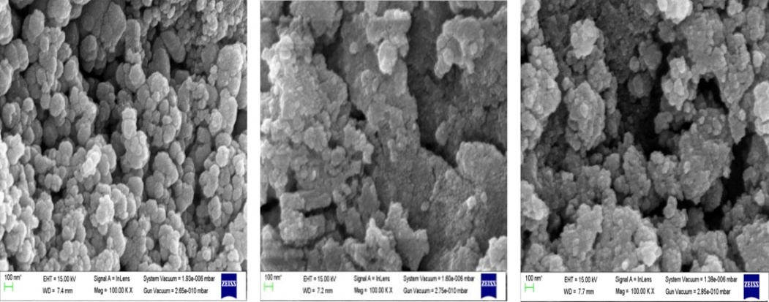
Fig. 2: SEM images of Pr³⁺ doped CdS nanoparticles
3.2. EDAX
Repersentative energy dispersive X-ray (EDAX) spectrum of CdS nanomaterial doped with Pr³⁺ specimens is shown in Fig. 3. This reveals that all the elements are present in the final composition which is take initially [11].
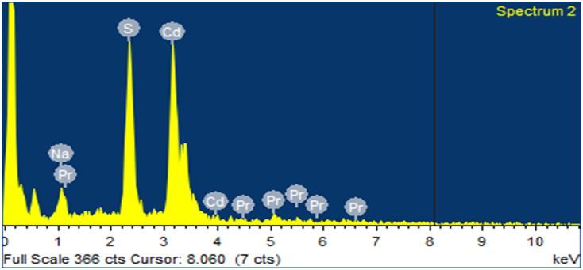

Fig. 3: Representative EDAX spectrum of CdS: Pr³⁺ nanomaterial.
3.3. FTIR Spectroscopy

Fourier Transform Infrared (FTIR) spectra are formed as a consequence of the absorption of the electromagnetic radiation at frequency that vibration of specific sets of chemical bonds within a molecules [12]. The expermentally observed FTIR spectra in the range of 400-4000cm⁻¹ is given in Fig. 4. FTIR spectrum of the Pr⁺³ doped CdS nanomaterials was recorded in the wavelength region 400-4000cm⁻¹. The FTIR spectra of Pr³⁺ doped CdS nanomaterial consists of several peaks which are broad and moderate in bandwidth. The peaks in the range 607-636 cm⁻¹ are due to metal–oxygen bonds (Pr³⁺/CdS). The peak around 1613-1623cm⁻¹ is assigned due to the asymmetric stretching vibrations of CdS bonds from metal-oxygen group. The broad band in all the CdS nanomaterial matrices around 3427-3456 cm⁻¹ is due to the fundamental stretching vibrations of O-H indicating the presence of hydrogen groups.

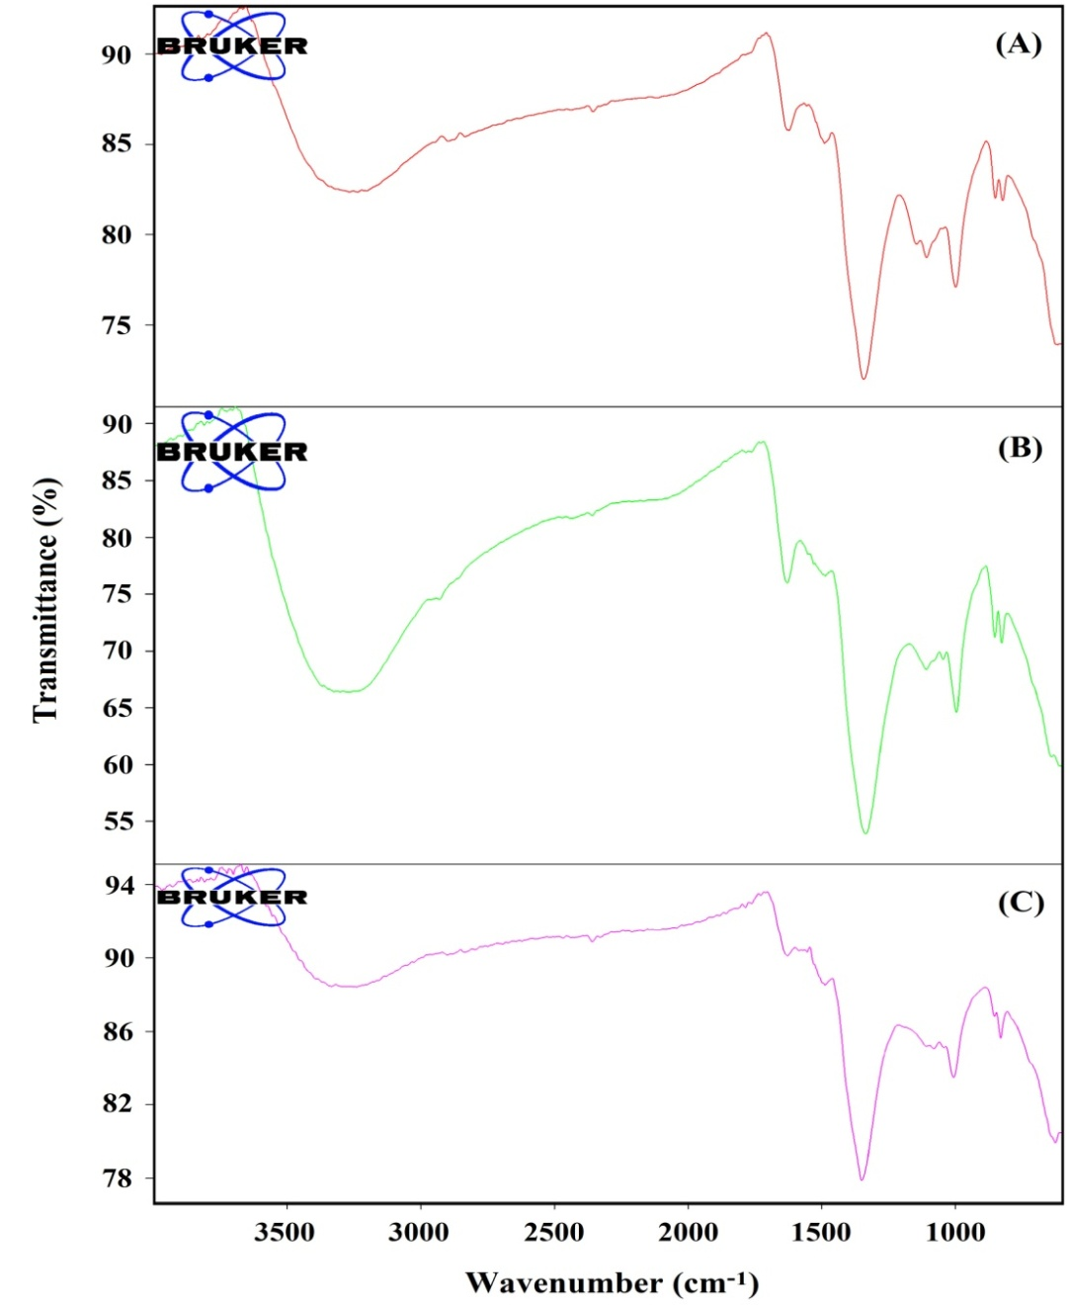
Fig. 4: FTIR spectrum of CdS nanomaterial doped 0.1 mol%Pr³⁺ion.
3.4 Absorption spectra

The absorption spectra of Pr³⁺ doped CdS nanoparticles were recorded for different concentration of Pr³⁺ ions at room temperature. The absorption spectra of CdS:Pr³⁺ was recorded for a wavelength range of 300-1000 nm and it corresponds to transitions from the ground level to different excited levels as indicated by the representative absorption spectrum in Fig. 5.
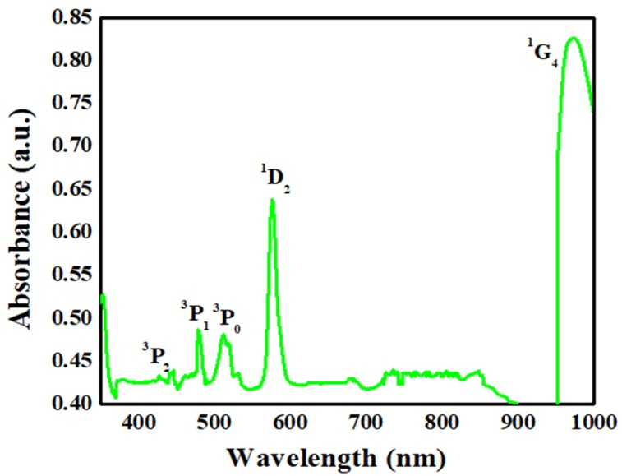
Fig.5: Representative absorption spectrum of CdS nanomaterial doped with Pr³⁺ ion.

3.5 Energy band gap
Table 1 shows the optical energy band gap (E_{g}) of CdS nanoparticles doped with different concentration of Pr³⁺ ion as revealed from the absorption spectrum. This shift in the band gap is due to the quantization effect according to which the band gap value increases with the size of crystallites formation of nanometer sized CdS doped Pr³⁺ nanoparticles. It is clear from Table-1 and Fig. 5 that there with an increase in the concentration of Pr³⁺ ions the band gap decreases.
Table.1: Optical energy band gap (E_{g}) of CdS nanoparticles doped with different concentration of Pr³⁺ ion as obtained from the absorption spectrum

0.1 mol% |  | 0.2mol% |  | 0.3mol%
Wavelength  λ (nm) | Optical Energy  Band gap (eV) | Wavelength  λ (nm) | Optical Energy  Band gap (eV) | Wavelength  λ (nm) | Optical Energy  Band gap (eV)
446 | 2.78 | 445 | 2.78 | 448 | 2.76
480 | 2.58 | 482 | 2.57 | 481 | 2.57
513 | 2.41 | 512 | 2.42 | 513 | 2.41
576 | 2.15 | 576 | 2.15 | 577 | 2.14
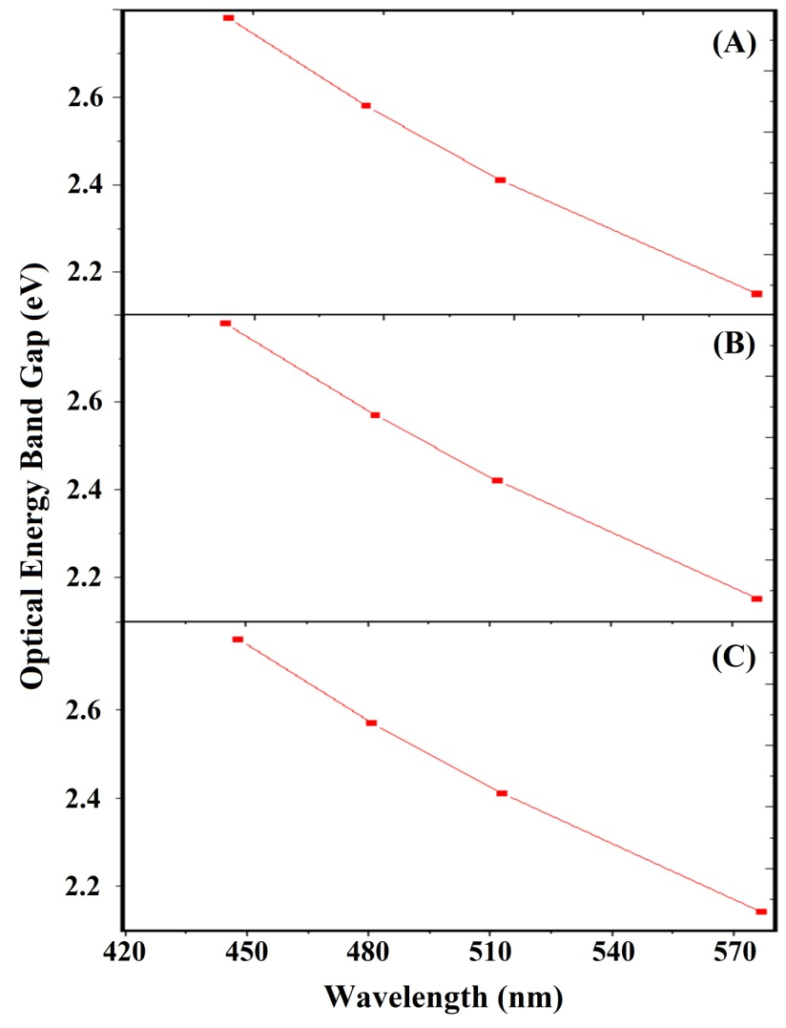
Fig.5(A) : Band gap concentration CdS nanoparticles doped 0.1% mol Pr³⁺
4. Conclusion
CdS is considered to be the most common semiconductor due to its high band gap (2.42eV) and potential applications in area of spectroscopy and electronics [13]. CdS structures are classified in three type namely hexagonal wurtzite, high pressure rock-salt phase and cubic zinc blend. Hexagonal wurtzite is the most important among these because of its stability and easy to be synthesized [14, 15]. Rare earth elements possess interesting optical properties due to their good interaction with light [16, 17]. Pr³⁺ doped CdS have particles have been gained much more interest in the recent year due to their describable properties and applications in different areas [18-20].
We have successfully prepared Pr³⁺ doped (0.1 mol%, 0.2 mol% and 0.3mol%) CdS nanoparticles by simple chemical precipitation method with an objective to use this for different optoelectronic applications. The chemical identity of the nanoparticles was confirmed by EDAX spectrum and the absorption peaks was confirmed by the FTIR spectrum. The SEM images clearly signifying the change of morphology of the spherical CdS nanoparticles with the different concentrations of Pr³⁺ ion doping. The band gap decreases with increasing concentration of Pr³⁺ ion. The band gap values show that it is suitable to use in solar cell fabrication as well as optoelectronic and high frequency applications. The developed Pr³⁺ doped CdS nanoparticles could also be useful for display devices, LED, design of UV Sensors for temperature measurement [21]. The physical properties depend on their crystallite sizes and they show size dependent electrical or optical properties in the quantum size region. Due to the fundament as well as technological importance, the modification in the energy band gap of semiconductors is the most attractive property. Semiconductor which posses such property of tunable energy band gap are considered to be the materials for next generation flat panel displays, photovoltaic, optoelectronic devices, laser, photonic band gap devices etc.
REFERENCE
- P Holister,J W Weener,C R Vas and T Harper; “Nanoparticles Technology” White paper nn 3.clientifca(2003).
- Nanoscience and Nanotechnologies : Opportunities and uncertainties, report by The Royal Society and The Royal Academy of Engineering(2004).
- Nida Qutub, Ph.D Thesis; “Cadmium Sulphide Nanoparticles” A .M .U.India (2013) .
- R Bhattacharya, S Saha., “Growth of CdS Nanoparticles by chemical method and its characterization”, Pramana J. Phys., 71 , 187-192 (2008).
- Sanyasinaidu Boddu, Ph.D Thesis “Synthesis and characterization of lanthanide ions doped Nanomaterials” Bhabha Atomic Research, Centre ,(2011).
- Banerjee R, R Jaya Krishnan, Ayyub P, “Effect of the size Induced structural Transformation on the Band Gap in CdS Nanoparticles”. Journal of Physics Condensed Matter, 12 (2000) 10647-10654.
- Rajvee R, Prabhu M, Abdul Khadar; “Characterization of chemically Synthesized CdS Nanoparticles” Pramana Journal of Physics, 65 (2005) 801-807.
- P. Sahare , “Synthesis and Characterization of CdS Nanoparticle” International Engineering Research & Technology, 6 (2018) 2278-2281.
- J. P. Singh, P. Goyal, Y.K .Sharma, D.R Prakash “Synthesis and Characterization of Pr³⁺ doped CdS Nanomaterial”. J. Emerging Technologies and Innovative Research 6(2019) 3093-3101.
- L .Saravanan, R.Jayavel A Pandurangan, J.H Liu, M.H Yuan, , “Synthesis Structural and optical properties of Sm⁺³ and Nd³⁺ doped Cadmium Sulfide nanocystals” . Materials Research Bulletin 52 (2014)128- 133.
- Jitendra Pal Singh ,Yogesh Kumar Sharma,Sudha Pal ,Atanu Nag, “Fluorescence study of Pr³⁺doped CdS Nanoparticles and its application in Sensors and detectors”, Journal of fluorescence, Published(online) July 2023. https://doi.org/10.1007/s10895-023-03325-w.
- Yogesh Kumar Sharma,Priyanka Goyal,Sudha Pal and Umesh Chandra Bind, “Laser action in Praseodymium doped Borosilicate Glasses in visible region”3(2016)1031-1035.
- EL.BiallyA.B., Seoudi R., Eisa W., Shabaka A.A., Soliman S.I., Abd El- Hmaid R.K and Ramdan R.A . “Preperation characterization and Physical properties of CdS Nanoparticles with different sizes” ,Journal of Applied Science Research, 8 (2011) 676-685.
- V.P. Singh, J. Chauhan. “Synthesis and structural properties of wurtzite type CdS Nanoparticles” Chalcogenide .lett., 6 (2009) 421-426.
- Jitendra Pal Singh.,Priyanka Goyal.,Yogesh Kumar Sharma,Vinod Kumar and Hari Om Yadav., “Optical Energy band and Absorption spectra of CdS:Pr³⁺Nanomaterials”, International Journal of Current Advanced Research,10(2021)2319-6505.
- Peijing Tian,Zhe Zhang,Jian Yuan,Weihong Zheng,Hong Li and Shimei Zhu., “Crystallization and luminescence of Pr³⁺-doped CdS QDs silicate glass”., Functional Materials letters(Accepted Manusscript)”,(2018)1-4.
- A.Ali.Safi and M.Isam.Ibrahim., “The effect or rare earth doping CdS nanostructure on structural, optical and photoconductivity properties” 17(2019)108-118.
- L.Bokatial,S.Rai., “Optical properties and up-conversion of Pr³⁺doped CdS nanoparticles in sol-gel glasses” Journal of luminescence 130(2010)1857-1862.
- M.Naziruddin Khan, Abdullah Almoharmmedi, MA Majeed Khan and Muhammad Ali Shar, “Metal doped CdS quqntum dots:Structural,Optical and Photocatalytic Properties under Visible light Irratiation”, 5(2020)2-17.
- J.Zhang,H.Chen, K. Xu,D.Deng,Q.Zhang, ,Luo.L, “Current progress of radiometric fluorescence sensors based on carbon dots in Foodbornne Contaminant Detection &Biosensors”, 13(2023) 233.
- Zhou S, Jiang G, Wei X, Duan CK Pr³⁺-Doped beta-NaYF4 for Temperature Sensing withFluorescence Intensity Ratio Technique. Journal of Nanoscience and Nanotechnology 14(2014)3739-3742.

