Ethnobotany and Biotechnology: From tradition to Modern aspects

Introduction:
For centuries, the history of pharmacy and drug discovery has been identical with the history of pharmacognosy and ethnobotany. Based on the story of curare, quinine, and later morphine or artemisinin, plenty of natural products and plant extracts have been used in ethnopharmacology. India bears a long history of people-plant interaction that has been significantly enhanced by biotechnology. Ethnomedicinal plants have been targeted in the search for new natural products, but their exploitation has led to concern for their conservation. Biotechnology has applications that extend beyond conservation to optimizing natural product research and adding value to useful products. Several plant species have been considered as a source for developing therapeutic agents for nearly 1000 years and even today most of the drugs in practice are plant derived natural products. Reports on the existence of written drafts dated 2600 BC about medicinal values of the herbals and the medicinal plant records of ancient Mesopotamia period have paved the way for potential drug development based on plants and natural products. “Ebers Papyrus”, Egyptian traditional medicine based record of 2900 BC is a most conserved record comprising of 700 plant derived drugs. Both traditional Chinese medicine and Indian Ayurveda system was recorded over a millennium period of around 1st millennium BC. As per the universal statistics 80% of world's population, primarily rely on ethnobotanical remedies and herbal medicine, e.g. analgesic:morphine; codeine; antineoplastic: camptothecin, taxol, antidiabetic: allicin, antimalarial, artemisinin, quinine; cardiac depressant: quinidine; antigout: colchicines; antidiabetic: allicin, and for brain functions: nicotine and caffeine. The vast and versatile pharmacological effects of medicinal plants are basically dependent on their phytochemical constituents.
Ethnobotany and Biotechnology:
Ethnobotany is a multidisciplinary science involving the traditional use of plants by human beings. Billions of people in the world rely chiefly on herbal medicines. The great majority of medicinal and aromatic plants (MAPs) used locally or entering into trade and herbal industries comes from wild sources and constitutes the source of livelihoods of millions of people. Ethnobotanical information and knowledge are believed to have contributed to the development of close to 30% of modern medicines. In recent years, the increasing demand for herbal medicines in industrialized countries is being fueled by a growing consumer interest in natural products. The study of the association, interaction, and interrelationships of ethnic human societies (especially tribal communities) with the surrounding flora is termed ‘ethnobotany’ or aboriginal botany. The term ethnobotany was coined in 1896 by Harshberger, one of the fathers of economic botany of America. Ethnobotany has more recently been defined as the study of the interrelationship of plant environment and primitive societies. There are many subdisciplines of ethnobotany dealing with various aspects of tribal plants such as ethnoagriculture, ethnotaxonomy, ethnomedicobotany, ethnoecology, ethnomycology, ethnogynaecology, ethnotoxicology, ethnopharmacology, ethnopharmacognosy, ethnophytotaxonomy, ethnoveterinary medicine, etc.
Biotechnology or biotech is the use of living systems and organisms to develop or make useful products or any technological application that uses biological systems, living organisms, or derivatives thereof, to make or modify products or processes for specific use, and plant biotechnology may be defined as generation of useful products or services from plant cells, tissues, and, often, organs (very small organ explants). Such cells, tissues, and organs are either continuously maintained in vitro or they pass through a variable phase to enable regeneration from them of complete plants which are ultimately transferred to the field. There is an emerging trend in biotechnology and therapeutic applications of medicinal plants in the last century. Many studies have been focused on the various advanced biotechnological methods used to identify and synthesise active compounds of medicinal significance. In addition, there have been some recent novel studies on the therapeutic applications of various medicinal plants from different geographical regions of the world. These studies reported the presence of antiviral activity of medicinal plants against some pathogenic microbial strains. Such pharmacological properties play an important role in discovering novel bioactive compounds which will lead to the development of drugs treating human diseases including diabetes, cardiovascular disease, and hypertension. In addition, amid the COVID-19 pandemic, the screening and identification of natural compounds from medicinal plants against coronavirus diseases are also particularly important for drug discovery.
In recent years, plant breeders have tried to compensate for these shortages by developing different breeding strategies, especially faster biotechnology-based breeding methods (BBBMs). Next-generation sequencing (NGS)-based forward genetic techniques have enabled the identification of key genetic elements involved in biosynthetic pathways of valuable bioactive compounds. In vitro-based BBBMs, including in vitro micropropagation, gene transformation, and polyploidy induction have been widely applied to enhance the valuable secondary metabolites of medicinal plants. CRISPR/Cas9 has great potential to target different key genes at the same time and produce plants with desired secondary metabolite profiles. Agrobacterium rhizogenes-mediated hairy root transformation is a perfect strategy for large-scale in vitro accumulation of valuable bioactive compounds of medicinal plants. Agrobacterium rhizogenes-mediated hairy root transformation coupled with bioreactors is a perfect strategy for large-scale in vitro accumulation of valuable bioactive compounds of medicinal plants.
The biotechnological tools are important to select, multiply and conserve the critical genotypes of medicinal plants. In-vitro regeneration holds tremendous potential for the production of high-quality plant-based medicine. Cryopreservation is long-term conservation method in liquid nitrogen and provides an opportunity for conservation of endangered medicinal plants. In-vitro production of secondary metabolites in plant cell suspension cultures has been reported from various medicinal plants. Bioreactors are the key step towards commercial production of secondary metabolites by plant biotechnology. Genetic transformation may be a powerful tool for enhancing the productivity of novel secondary metabolites; especially by Agrobacterium rhizogenes induced hairy roots.
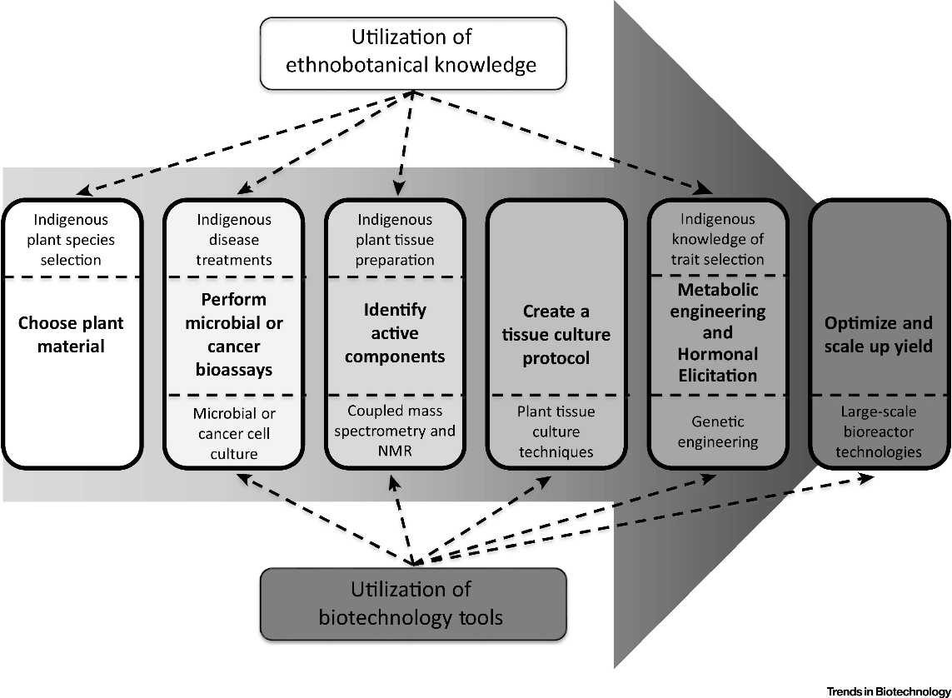
In-vitro propagation of plants holds tremendous potential for the production of high-quality plant-based medicines. This can be achieved through different methods including micropropagation. Micropropagation has many advantages over conventional methods of vegetative propagation, which suffer from several limitations. With micropropagation, the multiplication rate is greatly increased. It also permits the production of pathogen-free material. Micropropagation of various plant species, including many medicinal plants, has been reported. Propagation from existing meristems yields plants that are genetically. identical with the donor plants. Plant regeneration from shoot and stem meristems has yielded encouraging results in medicinal plants like Catharanthus roseus, Cinchona ledgeriana and Digitalis spp, Rehmannia glutinosa, Rauvolfia serpentina, Isoplexis canariensis. Numerous factors are reported to influence the success of in-vitro propagation of different medicinal plants. The effects of auxins and cytokinins on shoot multiplication of various medicinal plants have been reported. Benjamin et al. has shown that 6-Benzylaminopurine (BA), at high concentration (1–5ppm), stimulates the development of the axillary meristems and shoot tips of Atropa belladonna.
The cryopreservation of in-vitro cultures of medicinal plants is a useful technique. Cryopreservation is long-term conservation method in liquid nitrogen (–196 °C) in which cell division and metabolic and biochemical processes are arrested. A large number of cultured materials can be stored in liquid nitrogen. Since whole plants can regenerate from frozen culture, cryopreservation provides an opportunity for conservation of endangered medicinal plants. For example, low temperature storage has been reported to be effective for cell cultures of medicinal and alkaloid producing plants such as Rauvollfia serpentine, D. lanalta, A. belladonna, Hyoscyamus spp.
Different bioactive compounds from different plant sources are found to be effective against a vast array of diseases, e.g., taxol from and vinblastine and vincristine from , topotecan and irinotecan from Camptotheca acuminate, etoposide and teniposide from Podophyllum peltatum show antitumor and anticancer activity; curcumin from Curcuma longa show anticancer, anti-inflammatory, hepatoprotective; flavonoid silymarin (silibinin) from Silybum marianum show anticancer, anti-inflammatory, liver tonic for hepatic disorders property; ricinine), lectin (ricin) from Ricinus communis show hepatoprotective, antioxidant, hypoglycemic, antitumor activity; tannins, shikimic acid compounds, triterpenoids, ellagic acid from Terminalia chebula show antioxidant, antidiabetic, renoprotective, hepatoprotective activity; steroidal lactones, withanolides, notably withaferin A from Withania somnifera show chemopreventive, anticancerous, memory enhancer, and immunomodulatory properties and used in parkinson’s and alzheimer’s disorders; mono and sesquiterpenoids, zingerone and gingerols from Zinziber officinalis are anticancer, antioxidant, hepatoprotective, hypercholesterolaemic, anti-atherosclerotic; limonoids (nimbidinin), di- and tri- terpenoids from function as inhibitor of carcinoma, chemopreventive, inhibit colon cancer, antiallergic, blood purifier; piperidine, dehydropipernonaline of Piper nigrum are anticarcinogenic, anti-hyperlipidaemic, useful in epilepsy; diterpenoid furanolactones (tinosporin), isoquinoline alkaloids from Tinospora cordifolia function as immunomodulator, chemopreventive, cardioprotective, antidiabetic agents; aloin and emodin, campesterol, β-sisosterol from vera show healing properties, antiviral and antitumor activity antidiabetic, hepatoprotective, antiseptic effect; apigenin, taxol and ursolic acid, citral from Ocimum sanctum show antidiabetic, hepatoprotective antibacterial, antifungal, antipyretic, and anticancer properties; berberine from Berberis vulgaris works as antidiabetic, hepatoprotective, antimicrobial; digoxin, from lanata is used in heart diseases; thymoquinone from Nigella sativa show antidiabetic, anticancer, antimicrobial, hepatorenal protective, and gastro-protective; quinq quinine from Cinchona robusta show antimalarial, antiparasitic effect; artemisinin from Artemisia absinthium is an antimalerial drug; ophelic acid, sawertiamarine, mangeferin and amarogenitine from Swertia show antidiabetic antiviral, hepatorenal protective activities; allicin from Allium sativum is cardioprotective, anti-inflammatory; arjunic acid, tannic acid, tannins, saponins, gallic acid and phytosterols from Terminalia arjuna are cardioprotective, anticancer agents, hepatoprotective; emblicanin A, emblicanin B, punigluconin, and pedunculagin from phyllanthus emblica are antiviral, antimicrobial, anticancer, hepatoprotective and antidiabetic; ajmalicine and reserpine from Rauvolfia serpentine show hypotensive properties, phenol compounds from Gynura procumbens are antidiabetic, etc.
Secondary Metabolites:
Plant chemistry is the basis of the therapeutic uses of herbs. A good knowledge of the chemical composition of plants leads to a better understanding of its possible medicinal value. Modern chemistry has described the role of primary plant metabolites in basic life functions such as cell division and growth, respiration, storage and reproduction. They include the components of processes such as glycolysis, the Krebs or citric acid cycle, photosynthesis and associated pathways. Primary metabolites include small molecules such as sugars, amino acids, tricarboxylic acids, or Krebs cycle intermediates, proteins, nucleic acids and polysaccharides. Eventually, the primary metabolites are similar in all living cells.
Plant metabolite can be of two types: primary and secondary. Primary metabolites such as amino acids, proteins, sugar, nucleic acids and polysaccharides are alike in every living cells and are involved in growth and development. From the primary metabolic pathways, secondary metabolites are derived and are not involved in growth. Since secondary metabolites have shown to have various biological effects, it is widely used as traditional medicine. The concept of secondary metabolite was first defined by Albrecht Kossel, Nobel Prize winner for physiology or medicine in 1910. Thirty years later, Czapek described them as end-products. According to him, these products are derived from nitrogen metabolism by what he called ‘secondary modifications’ such as deamination. In the middle of the twentieth century, advances of analytical techniques such as chromatography allowed the recovery of more and more of these molecules, and this was the basis for the establishment of the discipline of phytochemistry. The classes of secondary plant metabolites include:
- Phenolics
- Simple
- Tannins
- Coumarins
- Flavonoids
- Chromones & Xanthones
- Stilbens
- Lignans
- Alkaloids
- Nicotine
- Caffeine
- Vinblastin
- Saponins
- Terpenes
- Hemiterpenes
- Monoterpenes
- Sesquiterpenes
- Diterpenes
- Sesterterpenes
- Triterpenes
- Lipids
- Fixed oils
- Waxes
- Essential oils
- Carbohydrates

Advantages of Tissue Cultures in Production of Useful Bioactive Compounds:
With the increasing demand of the market for novel products derived from plants, in vitro culture has become a reliable technique for the mass production of plant material. These and a number of other advantages in using plant cell culture provide impetus for its use for large-scale production of important bioactive compounds at industrial level. These advantages are summarized as follows:
- Plant cell cultures are independent from environmental factors.
- Production levels may be geared more accurately according to the market demand.
- By using characterized cell lines, a more consistent product quality and yield can be maintained.
- New routes of synthesis can be recovered from mutant cell lines which may lead to the development of novel products.
- Culture of cells will reduce the pressure on already overexploited medicinal and other economically important plants.
- The advantage of this method is that it can ultimately provide a continuous, reliable source of natural products.
- The advantage of the cell cultures includes synthesis of bioactive secondary metabolites, running in controlled environment, independently from climate and soil conditions.
- The use of in vitro plant cell culture for the production of chemicals and pharmaceuticals has made great strides building on advances in plant science.
- The increased use of genetic tools and an emerging picture of the structure and regulation of pathways for secondary metabolism will provide the basis for the production of commercially acceptable levels of product;
- The increased level of natural products for medicinal purposes coupled with the low product yields and supply concerns of plant harvest has renewed interest in large-scale plant cell culture technology;
- Knowledge of biosynthetic pathways of desired phytochemicals in plants as well as in cultures is often still in its infancy, and consequently strategies needed to develop an information based on a cellular and molecular level. These results show that in vitro plant cell cultures have potential for commercial production of secondary metabolites; and
- The introduction of newer techniques of molecular biology, so as to produce transgenic cultures and to effect the expression and regulation of biosynthetic pathways, is also likely to be a significant step toward making cell cultures more generally applicable to the commercial production of secondary metabolites.

Novel Bioactive Agents and Herbal Formulation:

Projects have been supported for developing products and processes from medicinal and aromatic plants following multi-disciplinary approach. Some illustrative examples are as follows:

- Tirbulus terrestris and Achyranthes aspera were studied in detailed for their potential effects in kidney stone mediated renal injury. They were found to inhibit calcium phosphate (CaP) nucleation and the demineralization of the preformed mineral phase effectively.
- Syzygium cumini, Costus speciosus, Momordica charantia, Gymnema sylvestre and Azadirachta indica were studied to identify a potent molecule with anti-diabetic and anti-adipogenic activity. Oleanolic acid 3-glucoside (OAG) from S.cumini has been identified using bioactive guided fractionation and structural characterisation. OAG was found to be a bifunctional molecule showing antidiabetic and antiadipogenic effects through inhibition of PTP1B and partial agonism to PPARã.
- A dipstick-based diagnostic kit for early detection of Begomovirus infection in mint (Mentha arvensis) has been developed at CSIR-CIMAP, Lucknow from the viral coat protein.
- An anti-dermetophytic topical formulation using essential oil of Trachyspermum ammi (Ajwain) as main ingredient has been developed jointly at Dolphin Institute of Biomedical and Natural Sciences, Dehradun and Centre for Aromatic Plants (CAP), Dehradun. The tested formulation showed better efficacy as compared to some popular antimycotic ointments and antifungal drugs already available in the market.
- A topical formulation for antibacterial and anti-inflammatory has been developed using combination of four plant extracts (Terminalia bellerica, Piper betle, Boswellia serrata and Bergenia ciliata).

