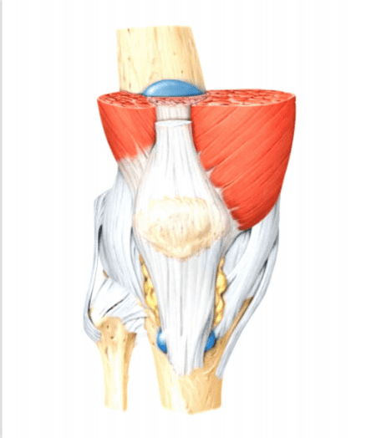
JOINTS

  - PREFACE-
- Introduction to joints
- Classification of joints
- Types of movement
- Structure of joints
- Disorders of joints

1.2 INTRODUCTION
A part of the body that allow the movement by connecting two or more bones. hyoid bone in the throat does not connect another bone, other bones connects at joint. The function of a bone determines its structure. It is either called as an articulation.
Greater movement of the joints leads to the damagesrisk and cause weak bone.
CLASSIFICATION(JOINTS) -
Number of joints depends on sesamoids ( bone embedded within the tendon or a muscle).
Clinical and numerical classification:
- Monoarticular (Involving 1 joint)
- Oligoarticular or pauciarticular- (Involving 2 to 4 joints)
- Polyarticular- More than 5 joints

STRUCTURAL CLASSIFICATION (BINDING TISSUES)
Four structural classification of joints,viz
- Fibrous joints- here the connective tissues are rich with collagen fibers, they are dense and irregular.
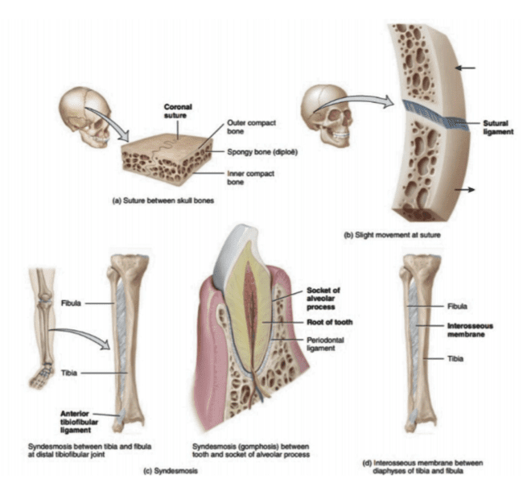
Fig 1. The presence of fibrous joints

- Cartilaginous joint- joined by cartilage. There are two types:
- Primary cartilaginous consists of hyaline cartilage.
- Secondary cartilaginous consists of hyaline cartilage and firocartillage coverings respectively.
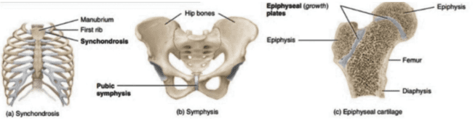
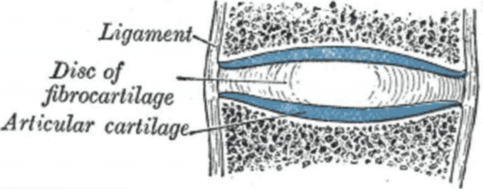
Fig 2. Structure and presence of cartilaginous joints and the structure of vertebral disc.
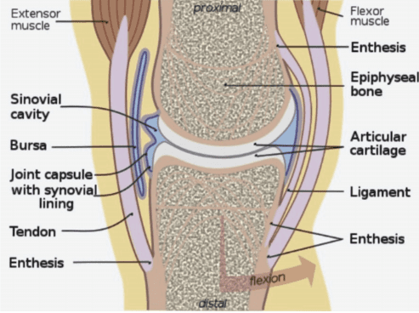
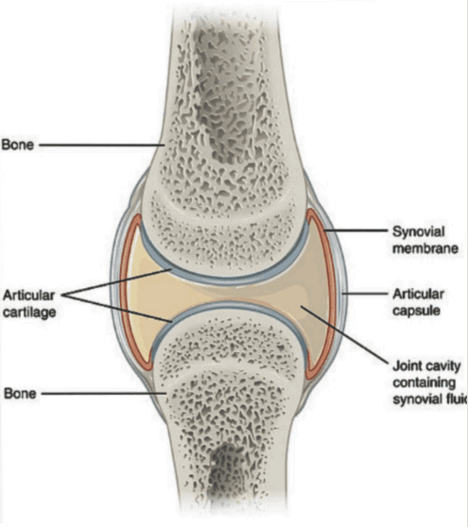
- Synovial joint- having synovial cavity and are joined together by the dense irregular connective tissue and forms articular capsule.

Fig 3. Structure of synovial joints

Classification based on movements(Functional classification)
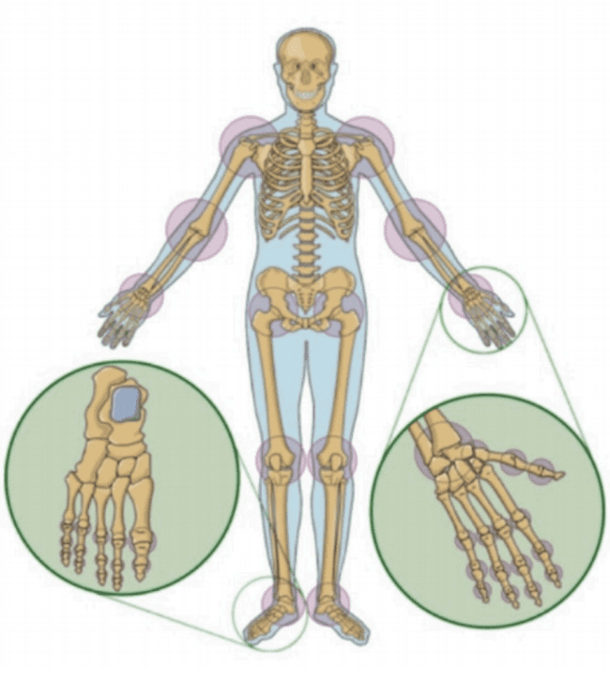
Fig 4. Presence of joints according to anatomical classification.

Based on the allowance of the movement joints are broadly classified into three classes this include as follows:
- Immovable- no movement occur in such joints because they are in close contact with each other. This are fibrous joints
- Slightly movable- this type of joints permit very little or restricted movement in which they are held together tightly. e.g. intervertebral disc.
- Freely movable or synovial joint- most of the joints are free movable.
TYPES OF FREELY MOVABLE JOINTS:
The following are the six different categories
- Ball and socket joint- head of the bone fits within the socket of the another bone,eample hip joint and shoulder joint. All direction movement is allowed.
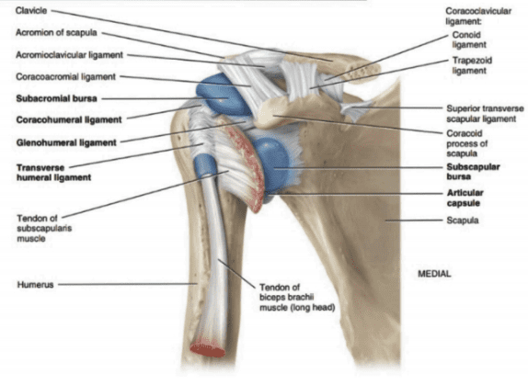
Fig 5. Ball and socket joint in shoulder

- Saddle joint- this permits the movement back and forth and from side to side, but doesn’t allow rotation, such the joint at the base of the thumb.
- Condyloid joint- It allows movement without rotation, example vertebrae in the neck.
- Hinge joint- This involves unidirectional opening and closing of the two bones in one plane e.g. elbow, knee joints.
- Pivot joint- one bone revolve around ring formed by another bone,example 1 and 2 cervical vertebrae
- Gliding joint- surfaces slides each other,permitting a certain amount of movement, like the wrist joints.
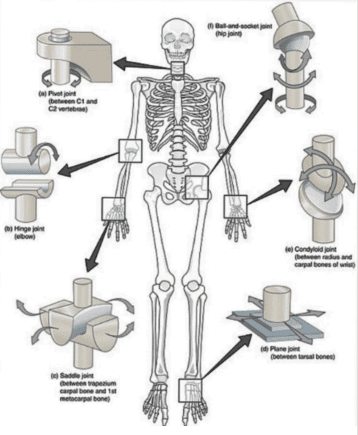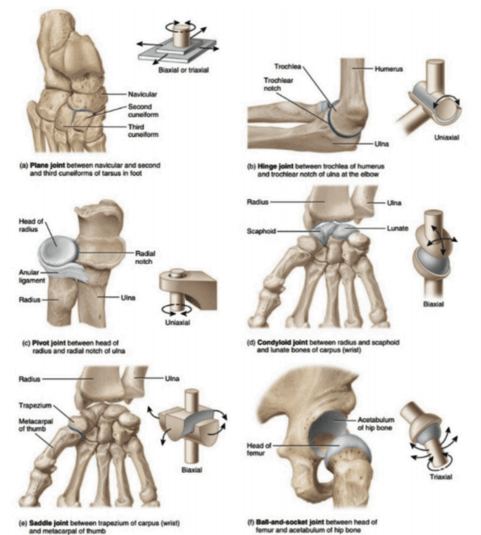
Fig 5a. The structure of different types of synovial joints.

CLASSIFICATION BASED ON NUMBER OF AXES
- Monoaxial (uniaxial)
- Biaxial
- Multiaxial
CLASSIFICATION BASED ON shape:
- Flat surface
- Convex surface
- Concave surface
BIOMECHANICAL CLASSIFICATION-
Classified as follows-
- Simple joint: Involving 2 articulation surfaces (e.g. shoulder joint, hip joint)
- Complex joint: an articular disc or meniscus, 2 or more surfaces e.g. knee joint
- Compound joint: 3 or more surfaces of articulation (e.g. radiocarpal joint)
JOINTS may be anatomically classified into following groups:
- Joints of the hand
- Elbow joint
- Axillary joint
- Wrist joint
- Vertebral articulations
- Sternoclavicular joints
- Temporomandibular joints
- Hip joints
- Sacroiliac joints
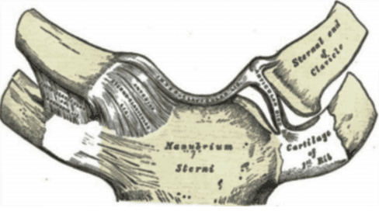
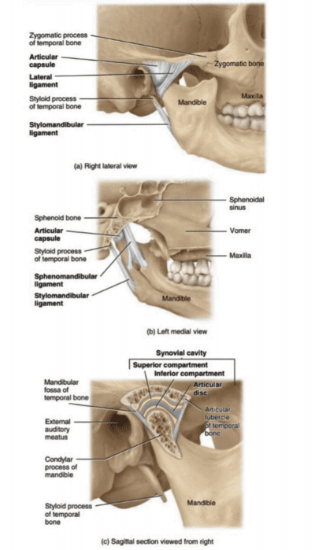
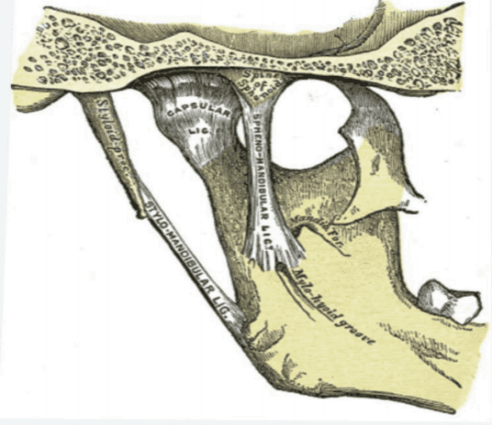
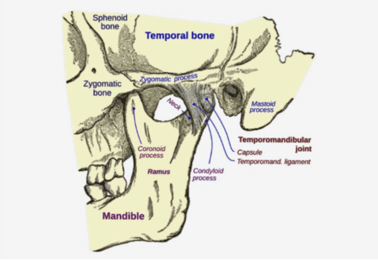
- Knee joints or tibiofemoral joint
d.
a.

b.

c.
Fig 6: a. Temporomandibular joints, b.Temporomandibular inner view, c. Strenoclavicular joints, d. Joints present in the jaw.

Movements
- Change the angle between the bones
- Sliding of the two different surfaces on each other
- No displacement of the bone from location only has rotatory motion.
TYPES OF MOVEMENT IN SYNOVIAL JOINT
- Gliding- flat bone surfaces move from side to side ,back and froth and with one another.
- Flexion, Extension, Lateral Flexion, and Hyper- extension- These are opposite movements, decrease in the angle between articulating bones observed in flexion and increase in the angle between articulating bones is found in extension (stretch out).

- Angular movements- In articulating bones ,either increase or decrease in angle.
- Abduction, Adduction, and Circumduction-
Abduction- radial deviation is the movement of the bone away from the midline.
Adduction- bone moves near to the midline of body.
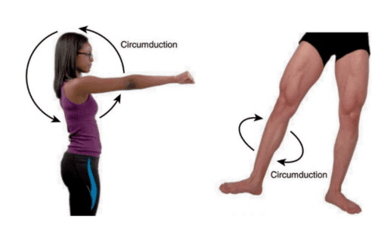
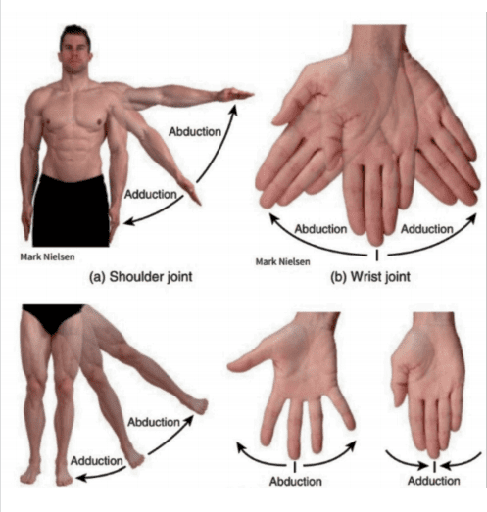
Circumduction- movement of distal part of body in circle e.g. humerus at the shoulder point in circular motion.

Fig 7. The abduction and adduction and circumduction.
- Depression- inferior movement of body part example mouth opening brings mandible down.
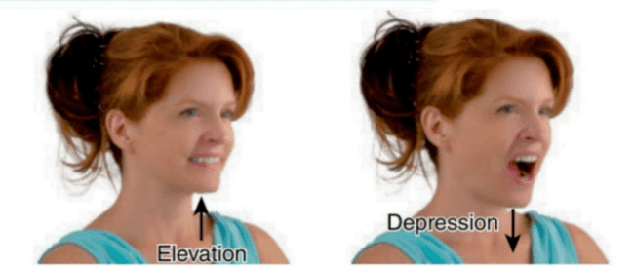
Fig 8. Elevation and Depression
- Protraction- anterior movement of the body in the transverse plane and retraction is opposite to it.
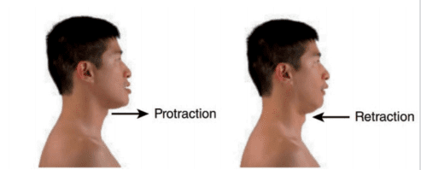
Fig 9. Protraction and Retraction
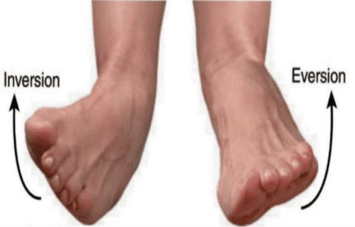
- Inversion and Eversion- sole movement medially and eversion is opposite to it.
Fig 10. Inversion and Eversion.
- Dorsiflexion- Bending near or at foot near the ankle

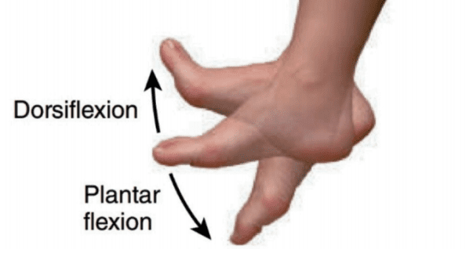
Fig 11. The movement of Dorsiflexion and plantar flexion.
- Plantar flexion- bending of the foot at the ankle joint or at inferior surface.
- Supination- movement of forearm anteriorly .
- Pronation- movement of forearm posteriorly.
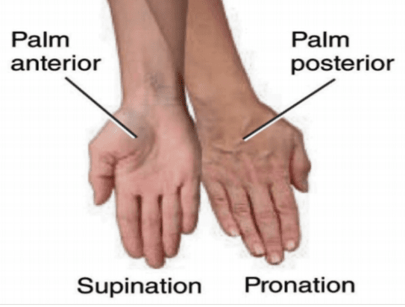
Fig 12. The movements of Supination and Pronation
- Opposition-which thumb moves across the palm on the same hand to touch the tips of the fingers .
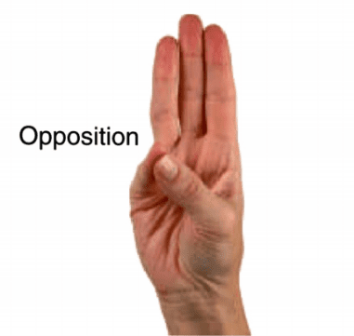
Fig 13. The movement in opposition.

STRUCTURE OF A JOINT

Ligaments are the tough connective bands that hold the joints. Soft cartilage prevent friction.
Tendons are the structure which are thick and tough that connect the the muscle to bone.
DISORDERS OF JOINTS

- Arthritis- inflammation,pain and stiffness in the joints

- Osteoporosis- a condition in which bones become weak and brittle, this is usually caused due to low intake of calcium.

- Osteoarthritis- degenerative disorder of joints, usually having by stiffness and pain

- Bursitis-Bursae inflammation

- Tendonitis- swelling inflammation and irritation of a tendon associated with the joint.

- Ankylosing Spondylitis- spine disease in which there is gradual loss of mobility in the joints between the vertebrae.
- Gonococcal arthritis- It is an infection of joints in person suffereing suffering from gonorrhea.

- Gout- Uric acid deposition in the skin,kidneys and joints

- Juvenile Rheumatoid Arthritis (JRA)- inflammatory arthritis in children under the age of sixteen.

QUESTIONS
5 marks-
- Define joints and classify them with examples?
- Write the different types of movements occurring in the synovial joint?

2 marks-
- Define osteoporosis and arthritis?
- What is gout?
- Write in general about the structure of joint?
- Classify joints based on movement?
- Define the following:
- Hinge joint,Pivot joint and Ball and socket joint.

