Perfect Edge Roman Domination in Fuzzy simple graphs
S.VIJAYALAKSHMI,S.SANGEETHA,P.MALLIGA,R.RAMANI
DEPARTMENT OF MATHEMATICS
DHANALAKSHMI SRINIVASAN COLLEGE
OF ARTS AND SCIENCE FOR WOMEN (AUTONOMOUS)
(AFFILIATED TO BHARATHIDASAN UNIVERSITY)
PERAMBALUR
EMAIL:sangeethasankar2016@gmail.com

Abstract: A perfect edge Roman dominating function (PERDF) of a graph is a function which satisfies the rule that every edge with is adjacent to exactly one edge with so that . The weight of a PERDF is . The minimum is the perfect edge Roman domination number (PERDN). The symbol is used to denote PERDN. In this paper, we introduce and investigate perfect edge Roman domination in graphs. We obtain strict bounds for PERDN and determine PERDN for some standard graphs.
Keywords: Perfect edge Roman dominating function, Perfect edge Roman domination number.

- Introduction:
Let be a simple connected graph. Let be a subset of ). If each vertex that is not in is adjacent to a vertex of , then is said to be a dominating set. The minimum cardinality of a dominating set of is the domination number . Mitchell and Hedetniemi [8] introduced edge domination in graphs. A collection of edges of form an edge dominating set if every edge of is either in or is adjacent to an edge in . The edge domination number (EDN) is the minimum number of elements in an edge dominating set of . The symbol is used to denote the EDN. The collection is called a perfect edge dominating set if each edge that is not in is adjacent to one and only one edge in .
Motivated by Stewart’s article “Defend the Roman Empire” [3], Cockayne et al. [1] introduced Roman dominating function (RDF). The edge version of Roman domination was introduced by Roushini Leely Pushpam et al. [7]. A function having the property that each edge with is adjacent to an edge with is called an edge Roman dominating function (ERDF). The weight of an ERDF is . The minimum weight of an ERDF of is called the edge Roman domination number . The perfect Roman domination was introduced by Henning et al. [5]. A function is called a perfect Roman dominating function (PRDF) if it satisfies the rule that each vertex with is adjacent to exactly one vertex with. The weight of a PRDF is . The minimum is called the perfect Roman domination number .
Chellali et al. [6] introduced Roman {2}-domination. Henning and Klostermeyer [4] renamed it as Italian domination. We have introduced the edge version of Italian domination in graphs in [9] and its perfect version in [10]. A function which has the property that every edge with is adjacent to an edge with or is adjacent to at least two edges and with is called an edge Italian domination function (EIDF). The weight of an EIDF is . The minimum is the edge Italian domination number . If the function satisfies the rule that every edge with is adjacent to exactly one edge with or is adjacent exactly two edges and with , then is called perfect edge Italian domination function (PEIDF). The weight of a PEIDF is . The minimum is the perfect edge Italian domination number .
We now review some results which are used in the sequel.
Theorem 1.1.[9] For the path graph , 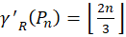 and for the cycle graph ,
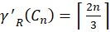.
Theorem 1.2.[7] For every graph G, .

- Perfect Edge Roman domination
In this paper we introduce and investigate the edge variant of the perfect Roman dominating function. A perfect edge Roman dominating function (PERDF) of a graph is a function which satisfies the rule that every edge with is adjacent to exactly one edge with so that . The minimum weight of a PERDF is the perfect edge roman domination number (PERDN) .
Let be the partitions of the edge set , such that for . Then, i) none of the edges of is adjacent to an edge of
ii) every edge of is adjacent to exactly one edge of
Proposition: 2.1. For every graph , .
Proof. It is immediate from the definition that every perfect edge Roman dominating function is a perfect edge Italian dominating function. Hence, .
Proposition: 2.2. For any graph , .
Proof: Every perfect edge Roman dominating function is an edge Roman dominating function and hence . Also, by Theorem 1.4, . Thus, we get .
Proposition: 2.3. For a connected graph on vertices, 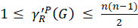.
Proof. If has only edge, in any PERDF on this edge gets the weight . So, A connected graph on vertices can have at most 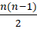 edges. In a PERDF on each edge can get the weight . In that case 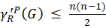.
Theorem 2.4: For a graph on vertices with , if and only if 1.
Proof: Suppose . Then three cases arise.
Case 1: If has exactly two edges, then is isomorphic to and so .
Case 2: If has exactly three edges, then is isomorphic to , or . In all cases, .
Case 3: If has more than three edges, since there exists an edge with . Then all other edges are incident at or and hence get the weight . So is the only edge in the minimum dominating set. Hence, .
Conversely let us assume that . So, the minimum edge dominating set of has exactly one edge say and all other edges are incident at or . If has only edges and then we can get a -function either by assigning the weight to both the edges or by assigning the weights and to the edges and respectively. In any case . If has more than edges we can get a -function by assigning the weight to and the weight to all other edges incident at or . Therefore, .
The following results are immediate from Theorem 2.4
Proposition 2.5: For , .
Proposition 2.6: For the bistar we have .
Theorem 2.7. For a path graph, ,, 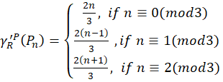
Proof: Let be a path on vertices.
Case (i): If

Define such that
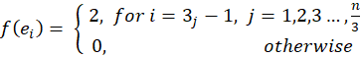
Hence, 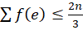.
To obtain the lower bound, consider an edge . Then has at most two neighbours. Let be a -function on and let . Then must be adjacent to exactly one edge of weight . Also, the other edge adjacent to (if it exists) must be given the weight otherwise it contradicts the definition of PERDF. Thus, every three consecutive edges of the path contribute weight to . Since has edges and , edges can get the weight and the remaining two edges together contribute at least to .
So, 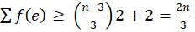. Therefore, 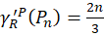.

Case (ii): If
Define such that 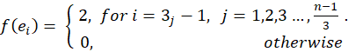
Then, 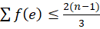.
Now consider a -function on . Then an edge with weight can have at most two adjacent edges with weight . Since, and has edges, at least 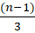 edges must have weight . So, 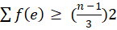. Hence, we get 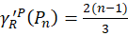.
Case (iii): If
Define such that 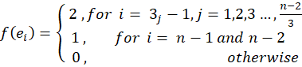
So, 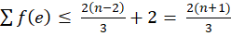.
Let be a -function on . Then an edge with weight can be adjacent to at most two edges with weight . Since has edges and , 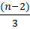 edges must have weight and they contribute 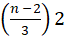 to and the remaining one edge can contribute a maximum weight of . So, 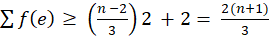. Thus, 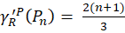.
The next result follows directly from Theorem 1.1 and Theorem 2.7.
Corollary 2.8: and , then .
Corollary 2.9: For , the -function of the path has
Proof: In a path an edge has at most two neighbours. Consider a -function on . It follows from the definition of PERDF that an edge having the weight must be adjacent to exactly one edge of weight and no edge of weight . We claim that the -function of the path has
If possible, assume that there exist an edge in having weight .

Case(i) and has two neighbours and .
Then and . Since is minimum, both and must get the minimum positive weight . That is and . Again, using similar arguments edges adjacent to and must be given the minimum positive weight and so on.
Hence in a -function on , if an edge is given the weight , then all the edges of the path gets the weight . Therefore , which contradicts Theorem 2.7.
Case (ii) and is a pendant edge.
In this case has only one neighbour say and . Since is minimum, must get the minimum positive weight . Now the edge adjacent to must also get the minimum positive weight and so on. In this case also a -function on in which an edge is given the weight , will have all its edges with weight and hence , which is again a contradiction to Theorem 2.7. Therefore, a -function on has
Theorem 2.10. For a cycle, , on vertices, 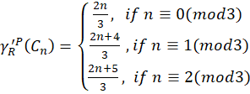

Proof: Let be a cycle on vertices.
Case (i) : If
Define such that,
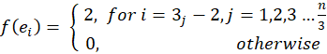
Hence .
In an edge has exactly two neighbours. So, in a -function on an edge having the weight must be adjacent to one edge with weight and another with weight . So, every three consecutive edges contribute to . Now, since and has edges we get 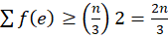. Thus, 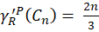 .
Case (ii): If
Define such that
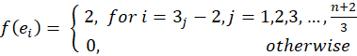
So,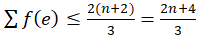.
Let be a -function on . Here, has edges and . Applying a similar argument as in the second part of case(i) 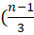) edges contribute 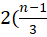) to . The maximum weight that can be given to the remaining one edge is .
So, 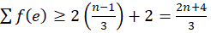. Therefore, 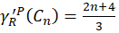.
Case (iii): If
Define such that
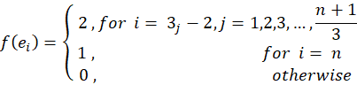
Then 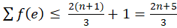 .
Consider a -function on . Since , applying a similar argument as in the second part of the above two cases 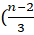) edges contribute 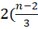) to . Since is minimum, the remaining two edges can get at most the weights and .
So, 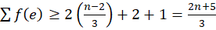. Hence, 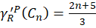 .
From Theorems 2.7 and 1.1, the next result follows.
Corollary 2.11: when .
Proposition 2.12. For a complete bipartite graph with ,
.
Proof: Let be partitioned into two sets and with and . Then, each edge of has its one end in and other end in . There are edges incident at each vertex of and edges incident at each vertex of . A minimum PERDF on can be obtained by assigning the weight to all the edges incident at one vertex of and the weight to all the remaining edges of . Then exactly one edge of weight is adjacent to each edge of weight 0. Hence .
Theorem 2.13. For a complete graph with , 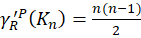.
Proof. Let be a minimum PERDF on .
Claim: No edge of can get the weight .
If possible, let be an edge with . Then must be adjacent to an edge say with . Then no other edge incident at can get a positive weight as in that case will be greater than , which contradicts the definition of PERDF. So, all the remaining edges {incident at must be given the weight . Next consider the edges . Then each is adjacent to at least one edge of . Thus each is adjacent to at least one edge having weight . So, these edges cannot get a positive weight as it again contradicts the definition of PERDF. Thus, no edge of can get the weight .
Hence the minimum positive weight should be given to each edge of to get a minimum PERDF. Therefore, .
Remark 2.14: The bound obtained in Proposition 2.3 is sharp as and
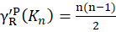, .
- Conclusion
In this paper we initiate a study on PERDF and obtain PERDN of some simple Fuzzy graphs. We create an inequality chain involving PERDN and other edge domination parameters like EDN, EIDN and ERDN. We also establish sharp bounds for this parameter. Study of this parameter can be extended to other classes of fuzzy graphs.
References
- E. J Cockayne, P.M. Dreyer Jr., S.M. Hedetniemi, and S.T. Hedetniemi, On Roman domination in graphs, Discrete Math. 278 (2004), 11–22.
- F. Harary, Graph Theory, Addison Wesley, Reading Mass, 1969.
- I. Stewart, Defend the Roman Empire, Sci. Amer. 281(6) (1999) 136-139
- S.Sangeetha,ERFORMANCE ANALYSIS OF GAME THEORY FOR NETWORK SECURITY IN WSN,Sangeetha S, JOURNAL OF CRITICAL REVIEW
,2637-2642

- S Sangeetha,Fuzzy graph theory and coloring ,material today proceedings
- S.Sangeetha,Turkish Journal of Computer and Mathematics Education Vol.12 No.7 (2021),1171-1176
- S.Sangeetha,Basic concepts of fuzzy matrices,IJERT
- S.Sangeetha Application of RAM in Dual Hesitant Fuzzy Transportation Problem,journal of algebraic statistics
- S.Sangeetha ,Bipolar valued fuzzy B-ideals on B-Algebra, European Journal of Molecular & Clinical Medicine.

