Recent trends in Nursing Research & Education
Introduction: The role of nurses in providing quality healthcare, is essential .They are considered “angel on the earth”. It has been observed that the U.S. experienced to feel the shortage in the number of physicians in the last few years. The shortage of nurses is observed to be a critical factor, the effects of the shortage. In a health care set-up has been demonstrated by increase in patient mortality and morbidity. With the advances in science continues, the work opportunities in the field of nursing have immensely grown. Now-days the nurses can find well-paying and meaningful job offers. Utility of research based knowledge in the field of nursing is shown in Figure1.
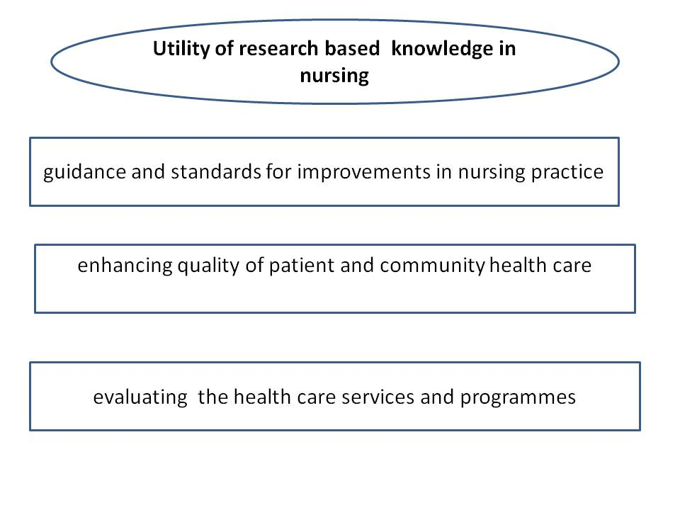
Figure 1: Utility of research based knowledge in nursing

Major areas & intents of many research programmes
Many nursing research programmes are being conducted in nursing field with different intentions such as
- Consequences of diseases or their treatments and the like Endotracheal suctioning.
- Management of symptoms of common problems and understanding the factors that influence these such as pain.
- Self-help programs by National Arthritis Foundation making the families and individuals to adapt to chronic disease like people with arthritis.
- A school-based program now adapted by many schools to focus strongly on promotion of better healthy lifestyles and risk factors reduction. As for young children and adults at risk for cardiovascular disease, advice for regular exercise and balanced diet.
History of Nursing research
Year | Changes happened
Evolution of nursing
mid-1850s | - Florence Nightingale, chief British nurse emphasized the importance of patient care and the environment, not the disease only  - changes in sanitary conditions, hydration and nutrition, resulting in drastic reduction in mortality rates
1850 - 1950 | - guidance in the field of nursing education began  - laws of nursing framed  - epidemiological research  - advancement in nursing research  - supportive environment for nursing research like funding and the availability of advanced research skills in the field of nursing research
1950s- 1960s | - the development of many complex theories explaining nursing concepts with regards to the art and science  - in the teaching field and designing the educational curriculum rather than research.
1952 | - the first journal of Nursing Research  - nursing research textbooks  - The American Nurses Association established the American Nurses Foundation  - first, research conferences at the regional level were instituted, and federal support of
Clinical revolution & Advances in Nursing research
early 1980 | - Patient focused Research  - research methodologies was qualitative research methods like phenomenology and ethnography.
mid 1980s, | - increase in nursing studies experiencing environmental, developmental or illness-generated stress situations
1983 | - Creation of Annual Review of Nursing Research  - development of nursing research and its dissemination.
1986 | - National Center for Nursing Research
1990s | - use of research –based knowledge and its findings for the patients treatment and decision making
- Utilization of research-based knowledge for the improvement in the existing health care system
- Stimulation of nursing research growth
1993 | - National Institute of Nursing Research (NINR.  - strengthening to more equal position of nurses with scientists and other health professions and giving the status of Center institute.

Advances in nursing education & research
Over the years, there have happened many changes in nursing practice, education and research. The current trends are found to be variable and multifactorial and even there is potential for many imminent changes in nursing in the future shown in Figure
- Use of competency-based nursing education
The competency-based nursing education was implemented with the main aim was to make nurses more competent and ready for clinical practice. These competencies are adopted by The American Association of Colleges of Nursing serve as the road map. These competencies provide a standardized structure for development of course content, teaching-learning methods as well as the assessment of learned information in the better and most uniform manner in pre licensure programmes designed for nursing education.
- Learning in COVID-19 era :
- e-learning and electronic communication systems: Video platforms& apps
In the past two-three years, there has been observed the immense use of technology for attending professional meetings & undergoing educational training in the form of visual platforms. The technology has been playing key role in teaching better quality and safety in nursing education & research. The technology has emerged as an essential tool for development of nursing profession in addition to other professions. It also serves as the road map for techniques in the mass education.
It is an alternative approach, important in clinical practice, education and research. Due to the rapid changes in the working environment, traditional educational systems i.e. the classroom setting, have now become ineffective and inefficient. The e-learning system is having more flexibility and responsiveness. Depending upon the learning objectives and resources available, the available systems are: group learning, audience response systems, Video conferencing platform.
Video conferencing platform are quite useful for many participants. During the COVID-19 pandemic, it helped a lot in the training of nurses to work in-patient care units and to educate about new drugs protocols used to combat the virus. The video conferencing platforms were successfully used by the hospitals to deliver virtual didactic lectures, certification courses and even nurse residency program. It enabled the implementation of interactive teaching learning assessment and methods being in the virtual meetings. For individual learning, webinars, videos, and text messaging are useful. The standard learning systems such as Blackboard or Canvas have been used recently in clinical practice to assist the nurses completing prework before attending required face-to-face clinical training. Thus, online learning modules were blended with clinical skill demonstrations and has been found to be successful in maintaining the --continuous education of nurses.
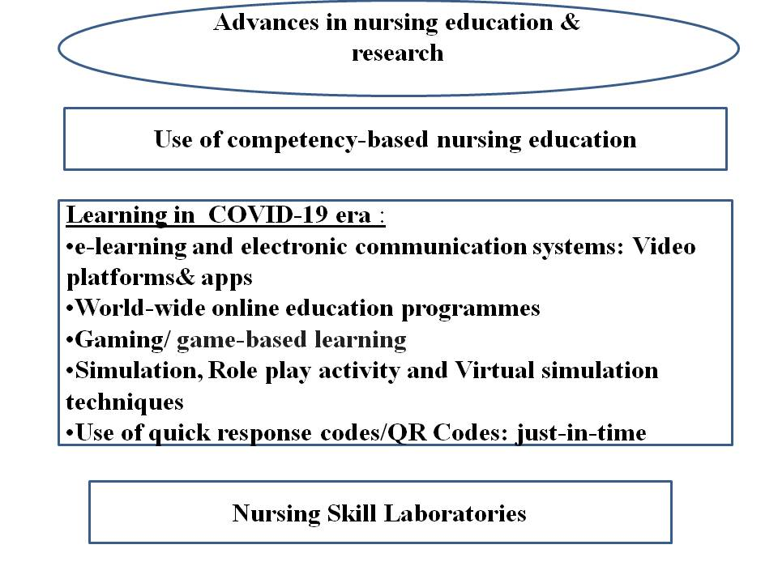
Figure2: Advances in nursing education & research

- World-wide online education programmes
To adjust a changes in nursing practice, more advanced online teaching programmes have been started and being implemented at the level of well reputed universities in India and abroad. Due to recently changed nursing practices, they can now earn Bachelor's or a Master’s of Science degree in the field of Nursing and for those who would like to go in teaching profession or conducting research, even doctorate-level degrees are being offered. As majority of the nurse are working day or night shifts, the numerous accredited schools have been offering the teaching learning programmes across the country.
- Gaming/ game-based learning
Latest growing technologies has created educational opportunities in the form of gaming. As a result, there has been progress in safety and quality in nursing practice.
Gaming / is a safe, innovative and interesting educational approach. Here the game elements are applied to assess learners’ knowledge about any disease, its staging or treatment related topics. It gives the simultaneous feedback to the learners and influence their motivation and retention of knowledge positively.
- Simulation, Role play activity and Virtual simulation techniques
There are also available many more educational techniques like simulation, role play activity and Virtual simulation. These are now a day’s used to enhance the competence of health care professionals in an educational setup and are implemented following the evidence-based guidelines.
Simulation is used widely to impart and evaluate the clinical knowledge and skills. In simulation, there can be used low and high-fidelity manikins. The role-play part of simulated learning provides with the effective domain of the learning outcomes (attitudes and emotional aspects).
Simulation with role play activity: It helps the examiner to evaluate communication skills of the participants along with in timely feedback. With the purpose to develop the spirit of teamwork and cooperation as well as communication skills, Inter professional simulations can be used. The team members work in the scenarios together and develop better management skills as well as critical thinking. This Interprofessional approach results in enhanced quality, better patient outcomes and fewer chances of errors. It can be implemented through the use of electronic communication methods
Virtual Patient Simulation: This is the digital simulation platform. Here features of both technologies; simulation and gaming are combined. It provides learners the experience of clinical scenarios in virtual mode without causing harm to the patient in an interactive way. Learners successfully navigate the virtual patient scenario through diagnosing, stabilizing, and teaching patients thus enabling nurse staff/practitioners to evaluate the clinical reasoning skills of the learners, acquiring required nursing knowledge and clinical skills.
Immersive virtual reality simulation is more an advance technology form, computer generated environment with use of an experiential simulation platform to replicate real-life patients. On reviewing systematically, it is found effective in improving cognitive and psychomotor skills.
- Use of quick response codes/QR Codes: just-in-time
Just-in-time training has proved to be quite effective during the COVID-19 pandemic, to t rain the nursing staff about new or unfamiliar procedures or equipment. It is a micro learning type of process. It is an effective as well as innovative way of delivering on-the-spot” training, directing the learner on scanning the code by the Smartphone to a specific educational portal and providing the access to needed information immediately. Thus, its use during the COVID-19 pandemic showed adaptability of nurses to ensure implementation of competencies in evidence based practice.
- Nursing Skill Laboratories
In the Skill laboratories, latest technology like simulation provides learning opportunities to nurses in a nonthreatening, unhurried environment controlled setting without harming the patient. The educators in the field of nursing should always use a variety of teaching and learning methods to fulfill learning outcomes. Regardless of the gender, age or expertise of the learner, but barriers does exist. This newer technology has been found to be effective in nursing education. To ensure health and health equity, there is requirement to train and employ the nurses with expertise in technology i.e.how to use digital platforms, access artificial intelligence, and other technologies in the health care systems as per the Future of Nursing Report 2020–2030.
The paradigm in professional development is currently shifting from using traditional teaching methods to innovative, technology-focused and more interactive teaching methods in both academic and practice settings. The learner approach has now changed to be relevant, self-directed, experiential and problem-centered, is essential to the development of knowledge and skill.
Conclusion: Now nurses can work with greater efficiency giving more emphasis on better outpatient care. They can enjoy their freely available time in a better way as the post-operative recovery time of patients has also been shortened with best healthcare and technological methods.

