Integration of Renewable Energy and Electric Vehicles

V.V.Sai Santoshi
Department of EEE
Vignan’s Institute of Engineering for Women
Visakhapatnam, India
santo.appi@gmail.com

P.Suresh Kumar
Department of EEE
Vignan’s Institute of Information Technology
Visakhapatnam, India
suresh0260@gmail.com

ABSTRACT
This paper presents the benefits of EV’s with conventional IC vehicles. Along with that we discuss about various Motor drive technologies (MDT),Battery charging technologies(BCT),Energy source technologies, configurations of EV’s and HEV’s. Based on the dynamic modeling of EV’s we reduce the tractive effort on the Electric vehicles.
Keywords— Electric vehicles (EV’s), Hybrid Electric Vehicles (HEV’s), Internal Combustion Engine (IC Engine).

INTRODUCTION

It seems the population has been increasing globally to around 10 billion by 2050. And if all these vehicles are of I C Engine type, then all the cities will be covered by smog and severe air pollution. This leads to damage of health, as per Air Research Board in California almost 9000 people die due to fine air dust particles. So, the only promising solution to reduce this is by using EV’s and HEV’s. So based on the benefits of EV’s we study about the Dynamic modeling of Electric vehicles to develop an efficient Hybrid Electric Vehicle which consumes less energy, more efficient, less emissions.
Electric vehicles can be classified into different types on the terms of energy sources, propulsion devices, energy carriers that are uses as medium to transfer energy to propulsion devices from energy sources.

Classification of EV’s based on different input methods

Table1: Classification of EV’s

The below table shows the classification of various Electric Vehicles based on the input given
 | Propulsion type | Energy carriers | Energy sources
Micro Hybrid EV’S | IC Engine + motor | Liquid fuel+ Electricity | Liquid fuels+ Battery
Mild Hybrid EV’S
Full Hybrid EV’S
Plug in Hybrid EV’s
Range Extended EV’s
Battery EV’s | Electric motor | Electricity | Battery
Ultra fly wheel EV’s |  |  | Ultra fly wheel
Ultra capacitor EV’s |  |  | Ultra  capacitor
Fuel cell and Battery EV’s |  | Hydrogen | Fuel cell

The configuration of a typical battery electric vehicle is explained from the below figure. A BEV consists of a battery bank which is charged directly from a grid using battery charger. The electrical energy stored is transferred to the wheels by an electric drive consists of power converter and electric machine through transmission gear system. The power converter is designed such that it carries bidirectional power flow so that it can regenerate power coming from the wheels during braking. In a BEV clutch mechanism is also not required.

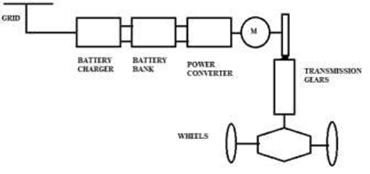
Fig 1: Typical Battery Electric Vehicle
In this configuration of a fuel cell EV’s, a fuel cell is used as a source of energy which is connected to a hydrogen tank. In this a boost converter is required to boost up the voltage output from the fuel cell in order to charge the battery. In this the necessity of battery bank is to allow fuel cell to operate at optimum efficiency and to support transient mechanical energy requirements of the EV’s. During braking it stores the energy due to regenerative braking principle.
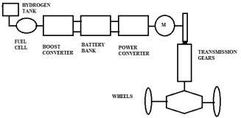

Fig 2: Typical Battery Electric Vehicle with Fuel cell

Fig 2: Typical Battery Electric Vehicle with Fuel cell

In motor drive technology the mechanical energy is transmitted to typical IC based engine vehicle. IC engine cannot operate at their own speed and torques directly so they require a clutch and multiple gear transmission system to achieve variable speeds at variable torques. So, when the clutch is used the energy is transferred from IC engine to wheel with help of gear box. For different speeds and torques the clutch is disengaged and the gears are changed. A typical IC engine-based vehicle is shown below.

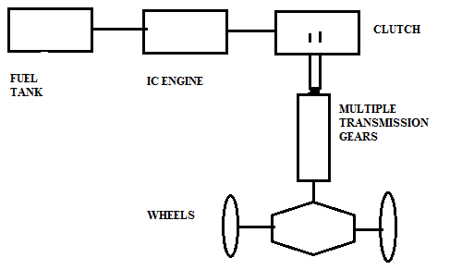
Fig 3: Motor Drive Technology
The force-speed characteristics of a 5 gear IC Engine are shown below which concludes that at low gear the torque is high and the speed is low and at high gear the torque is less and speed is more.

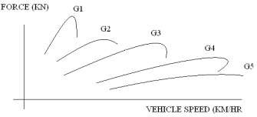

Fig 4: Force-speed characteristics of a 5 gear IC Engine
The force-speed characteristics of a battery electric vehicle with fixed gear system shows that the electric motor readily high torque at the starting and enables high speed at low torque region. This operation can be achieved without any gearing and clutch system.
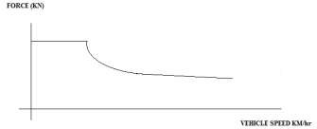
Fig 5: Force-speed characteristics of a BEV

The major requirements of a EV are high torque density, high power density, wide speed range at constant torque and power regions, high efficiency, reliability and robustness.
The various energy sources used by the electric vehicles and hybrid electric vehicles are batteries, Ultra-capacitors, ultra- fly wheels and fuel cells. Where batteries are electro chemical device which stores energy in electrical form, ultra capacitors store high energy in electrostatic form since the value of capacitance is very high. In ultra fly wheel high speed electric machine is used which stores energy in the form of kinetic energy. Fuel cells uses hydrogen as a fuel and stores the energy in electrical form.
In electric vehicle the various types of batteries used are lead acid, nickel cadmium, nickel zinc, zinc air, sodium nickel chloride, lithium ion etc. So, we compare these batteries based on specific energy, specific power, life cycle, cost and safety.
To compare the energy sources technologies Ragone plot is the best way it is plotted between specific energy on X-axis and specific power on Y-axis, where the specific energy determines the driving range per charge and specific power determines the acceleration rate of the vehicle.

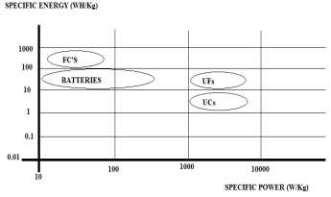
Fig 6: Ragone plot
There are four major methods of charging EV’s which are mainly based on voltage level, current level, power level, time of charging. In normal charging methods we use single phase system with voltage levels 110 to 240V, current rating 13 to 20Amps and a power level of 2 to 4kW. This type of methodology is generally used in homes, garages, residential parking places. It takes around 5 to 8 hours for charging.
Another type of charging is opportunity charging which uses three phase system with voltages 110 to 240V current rating of 32-80 Amps and power range of 8 to 20kW.
Fast charging is also one of the methods for charging EV’s which uses a DC system with voltage levels 200 to 450 volts, current range of 80-200Amps and a power level of 30 to 90 kW. It takes 20 to 30 minutes for charging.
The different methods of charging the batteries are conductive type charging and wireless charging. The wired type charging is simple, low cost, and highly efficient but the major disadvantage is it requires cables to be carried and a scope of electric shocks. So, we opted for wireless charging technologies which is convenient and shock proof but has high installation cost. In wireless power transfer there are two major methods i.e Far field strategies and near field strategies.
If the vehicle is in dynamic motion, then various forces act on which results in the dynamic movement of the vehicle due to Newton’s second law, the major motive force on the vehicle is obtained from traction unit and propulsion unit. The various forces which oppose the movement of the vehicle are air friction, gravitational force, and friction due to vehicle wheels. So, the final acceleration of the vehicle depends on traction component and mass of all components. Vehicle dynamics is a important and integral part of vehicle design so when designing a vehicle we have a two level approach as the system is a complex and a huge system So it’s a iterative process and so when we do the modeling of vehicle dynamics, there are two ways of doing it; one is longitudinal vehicle dynamics, the another is lateral vehicle dynamics.
When the vehicle is moving in one dimension, we need to find the longitudinal dynamics, but when the vehicle moves in more than one dimension then lateral dynamics are to be calculated. For a low-speed vehicle, the first or the longitudinal vehicle dynamics is enough to be understood. But when we are going for very high-speed operation, we have to understand the lateral vehicle dynamics as well, for good control of the vehicle and road handling.
The force propelling the vehicle forward, this is transmitted to the ground through the drive axel and wheels. So let us consider a vehicle having a mass, M which is moving at velocity, v and going at a slope of angle, theta. Then, the typical electric tractive effort that is required to be accomplished is equal to the force required to overcome the rolling resistance; that is the resistance offered due to tire resistance and the road resistance.
The vehicle also has to overcome the aerodynamic drag. So, this is the opposing force due to air pressure. Thirdly, we all know that when we are going on a slope, let’s say on a flyover or on a hill, the vehicle mass itself will act against the driving force. So, this is kind of a gradient force which opposes the motion and it has to be also overcome. Secondly, if the vehicle needs to be accelerated, those forces also need to be delivered by the tractive effort. So this force is absent when vehicle is running at constant speed.

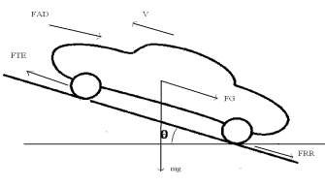
The total tractive effort which we will denote as F_{TE} is equal to the gradient force because of the weight of the vehicle which is F_{G}
F_{G}= mg sinθ
The opposing force due to air which is coming from the front of the vehicle because of the velocity of the vehicle that is moving up is known as force due to air drag or aerodynamic drag.
Also, the vehicle has to provide force due to tire friction or road friction which is generally termed as Frr or F rolling resistance. So, this tractive effort F_{TE} has to support all these forces that is Fg which is forced to gradient, Frr which is force due to rolling resistance, F_{AD} which is force due to aerodynamic drag and also acceleration if there is a change in vehicle speed.
The resistive force acting on the vehicle when it is moving at a velocity through air is called Aerodynamic Drag F_{AD} .
F_{AD} = 0.5 ρC_{D} A(V+V_{Air})²
Where F_{AD} = Aerodynamic drag force
ρ = Density of air
C_{D} = Aero dynamic drag coefficient
V= Forward velocity of air
V_{Air} = opposing air velocity
A= Frontal Area
Aero dynamic drag coefficient depends upon the shape of the vehicle so the design of electric vehicle is important for reducing drag coefficient
The aero dynamic drag power required
P_{AD} = F_{AD} *V
The aero dynamic drag Energy
E_{AD} α V²
Rolling resistance force (F_{RR}) the effect of the tire resistance and the road resistance on electric vehicle this force is due to the deformation of the tire on the road surface when the vehicle is moving
F_{RR} = µ_{RR} mgcosθ
Where µ_{RR} = coefficient of rolling resistance
m = mass of the vehicle
g = gravitational force
The gradient force acting on the vehicle when it is moving up the hill is
F_{G} = mg sinθ

Force due to linear acceleration
F_{LA} = ma
Force due to Angular acceleration
F_{AA} = Ja/r²
The total Tractive effort of the vehicle is given as
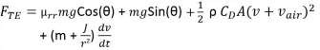
F_{TE} = F_{RR} + F_{R} + F_{AD} + F_{LA} + F_{AA}

III. Integration of Renewable Energy with Electric Vehicles

The effort to reduce the emissions of greenhouse gases that are warming the planet and to save fossil fuels, which are becoming more and more valuable, has prompted a significant increase in the installation of renewable energy installations in recent years. Additionally, the price of photovoltaic systems is getting cheaper every year. As a result, it is predicted that photovoltaic power will become more affordable in the future.
The widespread use of EVs has the potential to have a variety of effects and advantages, including the ability to help integrate renewable energy into the existing electrical grids.

Vehicles and Energy Sources
A massive battery will be utilized to store the electricity from the grid, which will then be used to power the electric vehicle (BEV). The performance of ICEVs using conventional gasoline is 15–18%, whereas the performance of BEVs is 60–70%. Compared to ICEVs, EVs consume substantially more resources. Another sort of electronic vehicle are fuel cell vehicles (FCVs), which produce power in a fuel cell stack using an electric method. FCVs can either be equipped with hybrid batteries like those seen in HEV or PHEV with an onboard fuel source like diesel or hydrogen, or they can be completely reliant on the pump. If hydrogen is produced by electrical electrolysis of water by RE or biomass sources, then the renewable sources are used for FCVs. Future hydrogen economic visions also involve the transportation of FCVs. There are still several obstacles preventing the development of a sustainable hydrogen economy, despite the fact that the vast majority of hydrogen produced worldwide is created from fossil fuels. Additionally, even though hydrogen produced through electrolysis represents a sizable future application of renewable energy, the transition to a hydrogen economy is a complex topic that is beyond the scope of this essay. If sustainable biofuels can replace conventional transportation fuels like ethanol and biodiesel, HEVs can also be produced from RE sources. Both PHEVs and BEVs may utilize all of the renewable energy from the grid, enabling PHEVs to use biofuels in their internal combustion engines.

Grid Connections and Charging system
The numerous grid-based charging options can be used to recharge an electric vehicle's battery. A gadget with a basic or unrestricted charge plan allows the vehicle to begin charging before connecting to the grid right away.
A charging schedule that staggers by, say, three hours will counteract the battery charge. When charging at night, the intention is to suspend the process when power costs are lower and batteries are fully charged in the morning. The utility or device operator controls the intelligent charging of vehicles intelligently. Either direct charging or indirect charging is possible.
When charging is done intelligently, the vehicle begins when it is most advantageous. And this might happen after there is extra capacity, little demand, and low electricity prices. The driver-set parameters may affect the rate, but the main constraint is that the vehicle must be fully charged by morning.
A V2G enabled EV is one that has the ability to store energy or return it to the electrical grid. The intriguing idea of Power V2G was first put up by Kempton or Letendre. The authors suggested that if power is used to provide beneficial services to the grid in such circumstances, V2G can be used to make a profit for owners. When there is a need, a V2G-capable electrical system will re-enter the grid and store the renewable energy from the low demand.

Conclusion
If the right technology is used, the introduction of EVs may expect a specific range of positive consequences, such as cheaper vehicle operating costs, lowered CO2 emissions, as well as supporting and increasing grid power and stability. The ability of EVs to aid in the integration of RE sources into the power grid, however, is perhaps significant. Carbon emissions from either energy production or transportation could be decreased as a result. It should be noted that while though EVs can greatly lessen the negative effects of widespread RE, other techniques & technologies are likely needed to account for the high level of the RE penetration. The grid could gain from EVs' potential benefits as well as the addition of intermittent RE sources. It is important to comprehend the potential, constraints, and effects of combining the transport sector with the production of electricity from renewable sources. This will have an impact on policies and infrastructure development to maximize the environmental and economic benefits of these breakthroughs while lowering global greenhouse gas emissions and fossil fuel dependence. PEV benefits system providers, car owners, and the environment. If given enough on-board power, energy storage connections, and digital charger control circuitry, PEVs can function as tools for storing energy and as a reservoir for the prevention of unplanned outages. It promotes the use of PEVs faster and is better for the environment.

REFERENCES

[1] IEA(2009).Technology Roadmap – Electric Vehicles and plug-in hybrid electric vehicles. Report 2009.
[2] SANDIA REPORT Energy Storage for the Electricity Grid: Benefits and Market Potential Assessment Guide. A
Study for the DOE Energy Storage Systems Program, 2010
[3] Daimler, RWE (2009).Communication Protocol between Electric Vehicles and Charging Units.
[4] N.Rotering, M.Ilic: “Optimal Charge Control of Plug-In Hybrid Electric Vehicles in Deregulated Electricity Markets”, IEEE Transactions on power systems, August 2011
[5] Jones , W.D., "Hybrids to the rescue [hybrid electric vehicles]", IEEE Spectrum, Vol. 40(1) , 2003, pp. 70 - 71.
[6] Jones, W.D., "Take this car and plug it [plug-in hybrid vehicles]", Spectrum, IEEE, Vol. 42, Issue 7, July 2005, pp.10 – 13
[7] Chan, C.C. The Present Status and Future Trends of Electric vehicles, Science and Technology Review , Vol. 23, No.4, Feb 2005
[8] K.W.E.Cheng, "Tapped inductor for switched-mode power converters", 2 Int. Conference on Power Electronics Systems and Applications, 2006, pp. 14-20

