Advancements in Deep Learning Object Detection: A Comprehensive Research Review

Rahul Kumar Dwivedi¹, Bhanu Prakash², Md Sheesh³, Gulrez Akhter⁴, Kartik Meghwal⁵
^{1,2,3,4}GNIOT ENGINEERING COLLEGE, GREATER NOIDA
rahuldwedi.ee@gniot.net.in
bhanupraksah1454@gmail.com
mdsheesh317@gmail.com
akhtersmart441@gmail.com
kartikmeghwal81@gmail.com
Abstract. Computer-aided diagnosis (CAD) in medical imaging is a fast expanding field of study. The development of CAD software is crucial since misdiagnoses in the medical area might result in dangerous therapies. Simple equations would not be adequate to accurately designate objects like organs, hence machine learning is a crucial component of CAD. Therefore, learning from examples is a key component of pattern recognition. The quick development of CAD in the field of medical imaging research emphasises how critical it is to enhance CAD programmes in order to avoid incorrect diagnoses and harmful medical interventions. Machine learning algorithms are essential for improving disease diagnosis precision and encouraging impartiality in judgement. Machine learning algorithms can analyse high-dimensional and multimodal biomedical data by utilising pattern recognition techniques.Pattern recognition and machine learning have the potential to enhance disease awareness and diagnosis precision while fostering unbiased decision-making in the realm of biomedical research. An efficient method for creating automated algorithms to analyse complicated, high-dimensional, and multimodal biological data is machine learning. This review study compares and contrasts several machine learning algorithms that are used to identify various diseases, including hepatitis, diabetes, liver disease, dengue, and kideny disease. In the paper, the variety of machine learning tools and algorithms for illness analysis and decision-making are highlighted.

Keywords: Hyperparameter tuning, Ensemble methods, Model interpretation, Classification algorithms
Introduction
The application of AI can increase the intelligence of computers. A important area of AI is machine learning, which includes drawing information from data. Re,searchers use a variety of machine learning methods to categorise datasets, including supervised, unsupervised, semi-supervised, reinforcement, evolutionary, and deep learning, as shown in Figure 1.
- Supervised learning, alternatively referred to as exemplar-based learning, is a machine learning technique that involves training an algorithm with a set of examples and corresponding targets, allowing it to accurately respond to all possible inputs. This learning can be classified into two categories: classification and regression. Classification entails making predictions regarding binary questions. Regression, on the other hand, involves answering questions pertaining to quantity, such as "How much?" and "How many?"

- Unsupervised learning differs in that it seeks to classify input data by detecting similarities, without the availability of correct responses or targets. This process is also recognized as density estimation. Clustering, which entails organizing data into clusters based on similarities, is among the techniques employed in unsupervised learning.

- Semi-supervised learning is a subset of supervised learning that uses both large amounts of unlabeled data as well as a small quantity of labelled data for training. This method of learning sits somewhere between supervised learning, which uses labelled data in addition to unsupervised learning, which just uses unlabeled data.

- Reinforcement learning, which draws its ideas from behaviourist psychology, involves alerting an algorithm when a response is erroneous but not giving it instructions on how to change it. Up until it finds the right answer, the algorithm must investigate and test many options. This method of learning, commonly referred to as learning with a critic, does not make suggestions for advancement. Because it does not clearly specify suboptimal actions or offer precise input and output sets, reinforcement learning differs from supervised learning. Additionally, it highlights online performance.

- Evolutionary learning draws inspiration from biological evolution, whereby organisms adapt to increase their chances of survival and reproduction. In the field of computer science, this process involves assessing the accuracy of a solution using the fitness concept.

- Deep learning is a machine learning subset that models high-level abstractions in data. This technique employs deep graphs that contain multiple processing layers consisting of both linear and nonlinear transformations.

The ability to recognize patterns and classify data has long been crucial for humans to respond to their surroundings, and with the growth of big data, efficient and effective data extraction and processing have become increasingly vital. In medical science, accurate patient diagnosis through clinical examination and assessment is crucial for effective and cost-efficient management, and computer-based decision support systems can be an invaluable tool. The healthcare industry generates vast amounts of data, such as patient reports, clinical assessments, medication details, and follow-ups, which can be challenging to organize effectively. Machine learning algorithms can create classifiers that divide the data into different classes, and they are particularly useful in medical data analysis and disease detection. With the advent of the digital revolution, data collection and storage have become more accessible and cost-effective, and modern hospitals are equipped with machines for data collection and examination. Machine learning techniques have been developed to analyze medical data more efficiently and effectively, with various tools available to support data analysis. Inputting accurate diagnostic patient records into a computer can generate results from previously solved cases, enabling physicians to diagnose patients quickly and accurately. These classifiers can also be used to train non-specialists or students in diagnosing problems.

Machine learning has been applied in various domains, including self-driving cars, speech detection, efficient web search, and improving the perception of the human generation. It can handle enormous amounts of data, combining information from different sources and integrating background information to aid in analysis. Pattern recognition is an essential component of machine learning, and it provides support for predicting and making decisions for diagnosis and treatment planning.

Optimizing Disease Diagnosis with Machine Learning

It is well known that these machine learning algorithms are successful in diagnosing a wide range of ailments. Several researchers have devoted their efforts to developing diverse machine learning algorithms for diagnosing diseases. In Figure 2, which includes kidney disease, diabetes, liver disease, dengue fever, and hepatitis, this survey article demonstrates a common method for diagnosing diseases using machine learning techniques.

Kidney Disease

Otoom et al. [5] presented a system aimed at analyzing and monitoring coronary artery disease in their publication. To accomplish this, the system employed the Cleveland kideny dataset acquired from UCI, which comprises 303 cases and 76 attributes. However, only 13 features were utilized in the study. In order to detect the disease, the system underwent two tests using three distinct algorithms - Bayes Net, Support Vector Machine, and Functional Trees FT - with WEKA tool utilized for detection purposes.

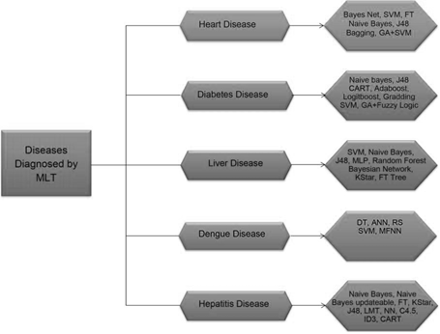

Figure 2. Diseases diagnosed by Machine Learning

Following the studies, the SVM method produced an accuracy of 90.3% in the Holdout test and an accuracy of 86.8% in the Cross Validation test for both SVM and Bayes net. The accuracy achieved by FT was 85.5%. The Cross Validation test was used for validation after the Best First selection algorithm had chosen the top seven features. SVM produced 87.1% accuracy, whereas FT properly identified 86.5% of cases. Bayes Net had an accuracy of 88.5%.

In a different study, Vembandasamy et al. [6] used the Naive Bayes algorithm to identify 500 patients from a Chennai diabetic research facility who had kidney disease. The accuracy of Naive Bayes was 86.419%. On a kidney illness dataset collected from UCI with only 11 variables used for prediction, Chaurasia and Pal [7] suggested the use of data mining methodologies for kidney disease diagnosis using Naive Bayes, J48, and bagging algorithms. J48 had an accuracy of 84.35%, bagging had an accuracy of 85.03%, and Naive Bayes had an accuracy of 82.31%.

500 diabetic patients were included in the dataset that Parthiban and Srivatsa [8] used to apply the Naive Bayes and SVM algorithms. The data was obtained from a research centre in Chennai. SVM had the highest accuracy (94.60%), whereas Naive Bayes had the lowest accuracy (74%). Tan et al. [9] suggested a hybrid method combining Genetic Algorithm and SVM on five datasets, including a dataset for kidney illness, with an accuracy of 84.07% utilizing the WEKA data mining tool.

Analysis

SVM has been observed to offer the highest accuracy of 94.60% in previous studies. In many applications, SVM has shown good performance results, responding correctly to the attributes used in Parthiban and Srivatsa's work. However, in Otoom et al.'s study in 2015, the accuracy of SVM was lower at 85.1%, despite utilizing a variant called SMO and employing FS technique to find the best features. It should be noted that the training and testing sets and data types differ between studies.

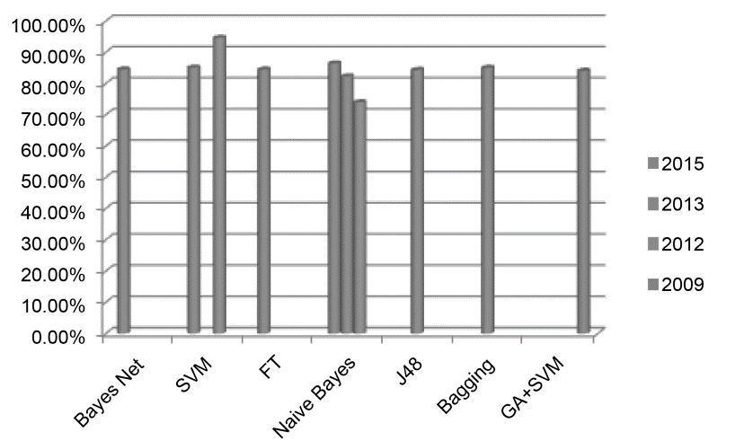

Figure 3. Machine learning algorithm’s accuracy to detect kidney disease.

Table 1. Machine Learning Strategies for Kidney Disease Diagnosis

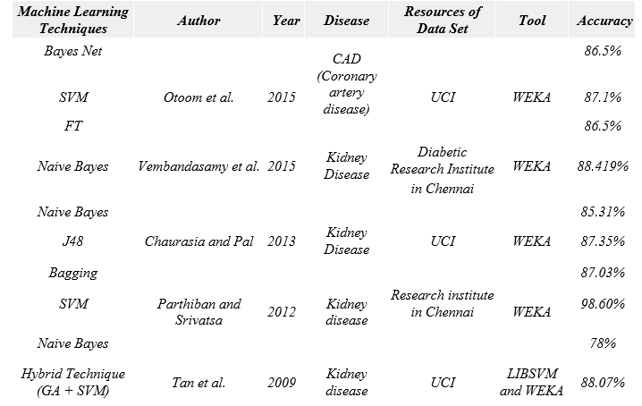

Diabetes Disease

On the basis of the Pima Indian diabetes data set, Iyer et al.'s work [11] used decision tree and Naive Bayes algorithms to predict diabetes illness. Their tests utilising the WEKA data mining programme revealed that cross-validation did not perform as well as the percentage split (60:40), with Naive Bayes exhibiting the maximum accuracy of 89%.
Sen and Dash [12] discussed meta-learning algorithms for diabetes diagnosis, using the Pima Indian diabetes data set and WEKA. They compared the experimental results of different algorithms and found that CART had the highest accuracy of 78.646%.

Kumari and Chitra [13] conducted an experimental study using the support vector machine (SVM) technique with RBF kernel for classification on the Pima Indian diabetes data set. Their experiments using MATLAB 2010a showed an accuracy of 78%.tilising a data set of 515 patients collected from various societal sectors in India, Sarwar and Sharma [14] suggested utilising Naive Bayes for predicting Type-2 diabetes. Their tests using MATLAB and SQL server revealed a 98% accuracy.
Ephzibah [15] proposed a model for diabetes diagnosis that utilized genetic algorithm and fuzzy logic for the selection of the best subset of features and the enhancement of classification accuracy. Their experiments using a data set with 8 attributes and 869 cases from the UCI Machine Learning laboratory and MATLAB showed an accuracy of 87%.

Naive Bayes showed the highest accuracy of 95% in 2012 for diabetes diagnosis, but its accuracy decreased to 79.5652% or 79.57% in 2015. More training data may be required for creating and testing the proposed model for detecting diabetes disease. Figure 4 presents the accuracy graph of algorithms for diabetes diagnosis over time. In conclusion, these studies demonstrate the effectiveness of various machine learning techniques for predicting diabetes disease.

Machine Learning Techniques | Author | Year | Disease | Resource of Data Set | Tool | Accuracy
Naive Bayes | Iyer et al. | 2015 | Diabetes Disease | Pima Indian Diabetes dataset | WEKA | 79.5652%
 |  |  |  |  |  | 76.9565%
CART |  |  |  |  |  | 78.646%
Adaboost | Sen and Dash | 2014 | Diabetes Disease | Pima Indian Diabetes dataset from UCI | WEKA | 77.864%
Logiboost |  |  |  |  |  | 77.479%
Grading |  |  |  |  |  | 66.406%
SVM | Kumari and Chitra | 2013 | Diabetes Disease | UCI | MATLAB 2010a | 78%
Naive Bayes | Sarwar and Sharma | 2012 | Diabetes type-2 | Different Sectors of Society in India | MATLAB with SQL | 95%
 |  |  |  |  | Server
GA + Fuzzy Logic | Ephzibah | 2011 | Diabetes disease | UCI | MATLAB | 87%

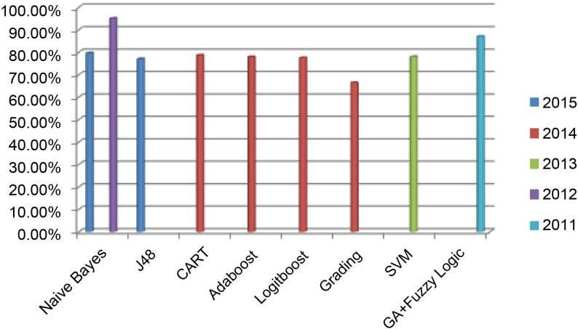

The ILPD dataset from UCI, which contains 560 instances and 10 attributes, was used by Vijayarani and Dhayanand [17] to predict liver disease using the Support Vector Machine and Naive Bayes Classification methods. The accuracy and execution times of the two algorithms were compared in their study, with SVM using MATLAB achieving 79.66% accuracy in 3210.00 ms and Naive Bayes achieving 61.28% accuracy in 1670.00 ms. SVM was better than Naive Bayes in terms of accuracy, however Naive Bayes ran more quickly.

In a study by Gulia et al. [18], intelligent techniques were used to classify liver patients using the UCI dataset and WEKA data mining tool, applying five classifiers: J48, MLP, Random Forest, SVM, and Bayesian Network. Feature selection was employed to obtain a significant subset of liver patients, and outcomes were compared before and after feature selection. After feature selection, SVM provided the highest accuracy at 71.3551%, followed by Random Forest at 71.8696%, MLP at 70.8405%, J48 at 70.669%, and Bayesian Network at 69.1252%.

Rajeswari and Reena [19] used Naive Bayes, K star, and FT Tree algorithms to analyze the UCI liver disease dataset comprising 345 instances and 7 attributes. They conducted 10 cross-validation tests using the WEKA tool, where Naive Bayes achieved 96.52% accuracy in 0 sec, FT Tree achieved 97.10% accuracy in 0.2 sec, and K star achieved 83.47% accuracy in 0 sec. FT Tree had the highest classification accuracy compared to the other data mining algorithms.

There are benefits and drawbacks to the FT Tree algorithm. Fast prediction makes it simple to understand and interpret, but calculations can be difficult, especially when values are ambiguous or when several outcomes are connected. The outcomes show that the FT Tree technique is essential for improving the dataset's classification accuracy.

Machine Learning Techniques | Author | Year | Disease | Resource of Data Set | Tool | Accuracy
SVM | Vijayarani and Dhayanand | 2015 | Liver Disease | ILPD from UCI | MATLAB | 82%
Naive Bayes
J48 |  |  |  |  |  | 86%
MLP |  |  |  |  |  | 78%
Random Forest | Gilia et al. | 2014 | Liver Disease | UCI | WEKA | 77%
SVM |  |  |  |  |  | 77%
Bayesian Network |  |  |  |  |  | 78%
Naive Bayes |  |  |  |  |  | 98%
K Star | Rajeswari and Reena | 2010 | Liver Disease | UCI | WEKA | 88%
FT tree |  |  |  |  |  | 98%

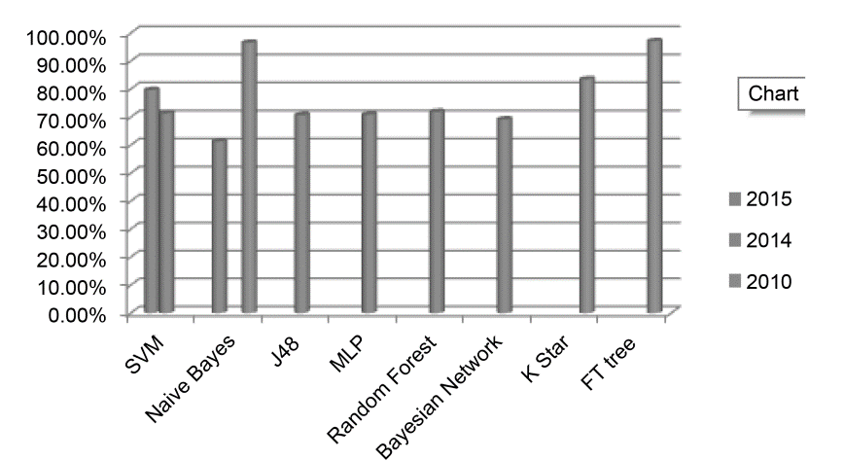

Using three different categorization algorithms—Decision Tree (DT), Artificial Neural Network (ANN), and Rough Set Theory (RS)—this study sought to forecast dengue illness. The WEKA data mining programme was utilised with two tests: Percentage Split and 10 Cross-fold Validation, and the dataset was collected from the Public Health Department of Selangor State. According to the findings, RS theory had the highest accuracy, obtaining 100% accuracy with 10 Cross-fold Validation and 99.72% accuracy with Percentage Split, whereas DT and ANN had marginally lower accuracy rates.

Another study conducted by Fathima and Manimeglai utilized Support Vector Machine to predict Arbovirus-Dengue disease. The dataset used in this study contained 29 attributes and 5000 samples obtained from hospitals and laboratories in India, and their results showed an accuracy rate of 0.9042.

Ibrahim et al. suggested a method using a Multilayer feed-forward neural network (MFNN) algorithm for predicting the defervescence day of fever in dengue disease patients using just clinical signs and symptoms. 252 hospitalised patients made up their dataset, of which 4 had DF and 248 had DHF. Using the neural network toolkit in MATLAB, the MFNN algorithm correctly predicted the day of fever defervescence in DF and DHF with 90% accuracy.

Overall, the Rough Set Theory (RS) algorithm had the highest accuracy rate for diagnosing dengue disease compared to the other algorithms used in this study. RS is a rule-based method that can manage uncertainty, noise, and missing data without requiring any initial or additional information about data. It can also provide a direct understanding of the attained results and discover hidden patterns and relationships that statistical methods may not identify. However, it is not commonly used despite its advantages. On the other hand, DT is complex and expensive, while ANN takes longer to build a model.

Hepatitis Disease

Based on the comparative analysis, a feed-forward neural network with backpropagation showed the highest accuracy of 98% for Hepatitis disease diagnosis. The Naive Bayes algorithm also performed well in terms of accuracy, but it was faster in building the model than the neural network. However, the neural network has advantages such as adaptive learning, self-organization, and real-time operation, but it requires a large sample size and great computational effort, making it time-consuming. Also, the model behaves like a black box, and it does not develop relations between input and output variables based on engineering judgment [26].

Comprehensive Evaluation and Discussion

Various machine learning techniques have been extensively used for the diagnosis of diseases such as kidney, Diabetes, Liver, Dengue, and Hepatitis. Among these techniques, Naive Bayes and Support Vector Machine (SVM) are widely used and perform well in disease diagnosis, as reported in literature. Table 5 presents a comprehensive view of machine learning techniques used for Hepatitis disease diagnosis, including Naive Bayes, Naive Bayes updateable, FT, K Star, J48, LMT, NN, Feed forward NN with Back propagation, C4.5, ID3, and CART. Naive Bayes, in particular, exhibits high accuracy rates, with 96.52% reported in one study and 97% in another. Artificial Neural Network (ANN) also shows excellent prediction capabilities but requires more time compared to other algorithms. Tree algorithms, while offering improved accuracy with correct attribute selection, have not gained widespread acceptance due to their complexity. The RS theory presents the highest output, but it is not widely used. Overall, machine learning techniques have proven to be effective in disease diagnosis, with Naive Bayes and SVM being the most commonly used algorithms.

Machine Learning Techniques | Author | Year | Disease | Resource of Data Set | Tool | Accuracy
Naive Bayes |  |  |  |  |  | 96.52%
Naive Bayes updateable |  |  |  |  |  | 84%
FT |  |  |  |  |  | 87.10%
K Star | Ba-Alwi and Hintaya | 2013 | Hepatitis Disease | UCI | WEKA | 83.47%
J48 |  |  |  |  |  | 83%
LMT |  |  |  |  |  | 83.6%
NN |  |  |  |  |  | 70.41%
Naive Bayes | Karlik | 2011 | Hepatitis Disease | UCI | Rapid Miner | 97%
Feed forward NN with Back propagation |  |  |  |  |  | 98%
C4.5 |  |  |  |  |  | 71.4%
ID3 | Sathyadevi | 2011 | Hepatitis Disease | UCI | WEKA | 64.8%
CART |  |  |  |  |  | 83.2%

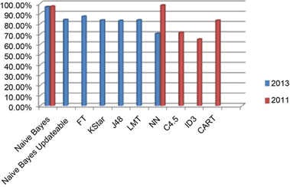
Figure 7. Machine learning algorithm’s accuracy to detect hepatitis disease.

The two most accurate algorithms for disease detection are Naive Bayes and SVM, while Artificial Neural Networks (ANNs) are highly useful for prediction and have maximum output, albeit with longer processing time than other algorithms. Tree algorithms are also utilized for disease detection but their complexity has limited their widespread acceptance, although they have demonstrated improved accuracy with appropriate attribute selection. The RS theory presents the highest output, but it is not commonly used.

Conclusion

The field of statistical models for estimation has grown significantly, but they often struggle with handling categorical data, missing values, and large data sets. As a solution, machine learning techniques (MLT) have emerged as effective tools for various applications, including image detection, data mining, natural language processing, and disease diagnosis. This paper focuses on different MLT utilized in diagnosing diseases such as kidney isease, diabetes, liver disease, dengue, and hepatitis. Several algorithms have achieved outstanding results by accurately identifying the data attributes. For example, SVM has an improved accuracy of 94.60% for kidney disease detection, while Naive Bayes offers the highest classification accuracy of 95% for diabetes. FT has a correctness rate of 97.10% for liver disease diagnosis, and RS theory achieves a perfect 100% accuracy for detecting dengue disease. The feed-forward neural network performs well in correctly classifying hepatitis disease with 98% accuracy. The survey analyzes the strengths and limitations of these algorithms and provides detailed graphs for improving machine learning algorithms used in disease prediction. Additionally, the paper discusses a suite of tools developed by the AI community that are beneficial for analyzing these problems and improving decision-making processes.

References

- Marshland, S. (2009) Machine Learning an Algorithmic Perspective. CRC Press, New Zealand, 6-7.
- Sharma, P. and Kaur, M. (2013) Classification in Pattern Recognition: A Review. International Journal of Advanced Research in Computer Science and Software En-gineering, 3, 298.

- Rambhajani, M., Deepanker, W. and Pathak, N. (2015) A Survey on Implementa-tion of Machine Learning Techniques for Dermatology Diseases Classification. In-ternational Journal of Advances in Engineering & Technology, 8, 194-195.

- Kononenko, I. (2001) Machine Learning for Medical Diagnosis: History, State of the Art and Perspective. Journal of Artificial Intelligence in Medicine, 1, 89-109.

- Tan, K.C., Teoh, E.J., Yu, Q. and Goh, K.C. (2009) A Hybrid Evolutionary Algo-rithm for Attribute Selection in Data Mining. Journal of Expert System with Appli-cations, 36, 8616-8630. https://doi.org/10.1016/j.eswa.2008.10.013

- Karamizadeh, S., Abdullah, S.M., Halimi, M., Shayan, J. and Rajabi, M.J. (2014) Advantage and Drawback of Support Vector Machine Functionality. 2014 IEEE In-ternational Conference on Computer, Communication and Control Technology (I4CT), Langkawi, 2-4 September 2014, 64-65. https://doi.org/10.1109/i4ct.2014.6914146

- Iyer, A., Jeyalatha, S. and Sumbaly, R. (2015) Diagnosis of Diabetes Using Classifi-cation Mining Techniques. International Journal of Data Mining & Knowledge Man-agement Process (IJDKP), 5, 1-14. https://doi.org/10.5121/ijdkp.2015.5101

- Sen, S.K. and Dash, S. (2014) Application of Meta Learning Algorithms for the Pre-diction of Diabetes Disease. International Journal of Advance Research in Comput-er Science and Management Studies, 2, 396-401.

- Kumari, V.A. and Chitra, R. (2013) Classification of Diabetes Disease Using Sup-port Vector Machine. International Journal of Engineering Research and Applica-tions (IJERA), 3, 1797-1801.
- Sarwar, A. and Sharma, V. (2012) Intelligent Naïve Bayes Approach to Diagnose Diabetes Type-2. Special Issue of International Journal of Computer Applications (0975-8887) on Issues and Challenges in Networking, Intelligence and Computing Technologies-ICNICT 2012, 3, 14-16.

- Ephzibah, E.P. (2011) Cost Effective Approach on Feature Selection using Genetic Algorithms and Fuzzy Logic for Diabetes Diagnosis. International Journal on Soft Computing (IJSC), 2, 1-10. https://doi.org/10.5121/ijsc.2011.2101

- Archana, S. and DR Elangovan, K. (2014) Survey of Classification Techniques in Data Mining. International Journal of Computer Science and Mobile Applications, 2, 65-71

- Vijayarani, S. and Dhayanand, S. (2015) Liver Disease Prediction using SVM and Naïve Bayes Algorithms. International Journal of Science, Engineering and Tech-nology Research (IJSETR), 4, 816-820.

- Gulia, A., Vohra, R. and Rani, P. (2014) Liver Patient Classification Using Intelli-gent Techniques. (IJCSIT) International Journal of Computer Science and Informa-tion Technologies, 5, 5110-5115.

- Rajeswari, P. and Reena,G.S. (2010) Analysis of Liver Disorder Using Data Mining Algorithm. Global Journal of Computer Science and Technology, 10, 48-52.

- Tarmizi, N.D.A., Jamaluddin, F., Abu Bakar, A., Othman, Z.A., Zainudin, S. and Hamdan, A.R. (2013) Malaysia Dengue Outbreak Detection Using Data Mining Mod-els. Journal of Next Generation Information Technology (JNIT), 4, 96-107.

- Fathima, A.S. and Manimeglai, D. (2012) Predictive Analysis for the Arbovirus- Dengue using SVM Classification. International Journal of Engineering and Tech-nology, 2, 521-527.

- Ibrahim, F., Taib, M.N., Abas, W.A.B.W., Guan, C.C. and Sulaiman, S. (2005) A Novel Dengue Fever (DF) and Dengue Haemorrhagic Fever (DHF) Analysis Using Artificial Neural Network (ANN). Computer Methods and Programs in Biomedi-cine, 79, 273-281. https://doi.org/10.1016/j.cmpb.2005.04.002

- Ba-Alwi, F.M. and Hintaya, H.M. (2013) Comparative Study for Analysis the Prog-nostic in Hepatitis Data: Data Mining Approach. International Journal of Scientific & Engineering Research, 4, 680-685.

- Karlik, B. (2011) Hepatitis Disease Diagnosis Using Back Propagation and the Naive Bayes Classifiers. Journal of Science and Technology, 1, 49-62.
- Sathyadevi, G. (2011) Application of CART Algorithm in Hepatitis Disease Diagno-sis. IEEE International Conference on Recent Trends in Information Technology (ICRTIT), MIT, Anna University, Chennai, 3-5 June 2011, 1283-1287.

- Singh, Y., Bhatia, P.K., and Sangwan, O. (2007) A Review of Studies on Machine Learning Techniques. International Journal of Computer Science and Security, 1, 70-84.

