CRYSTALLINE CELLULOSE AS BIONANOCOMPOSITE FIBER FOR ANTIMICROBIAL PACKAGING APPLICATION
Dr.R. Manjula^{1,}* and Dr.J. Daisy Rani²
¹Department of Chemistry, Bharath Institute of Higher Education and Research, Chennai 600073, Tamilnadu, India.
²Department of Chemistry, SRM Institute of Science and Technology, Ramapuram Campus, Chennai 600089, Tamilnadu, India.
*Corresponding author: Dr.R. Manjula
E-mail: manjumahesh1906@gmail.com
ABSTRACT
Over the decades in the medicinal field, biopolymers derived from natural resources have found tremendous applications in various fields such as medical, pharmaceutical, food packaging applications owing to their unique characteristics. Significantly, cellulose reinforced polymeric matrix containing smaller size fibers exhibits enhanced physical, mechanical and biological properties in contrast to the pristine polymeric matrix having greater pore size fibers. In this present study, cellulose was extracted from the crop residue of rice husk waste using a feasible chemical treatment. The surface morphological investigation and the particle size of the product cellulose crystals were determined. Fourier transform infrared (FT-IR) spectra of the cellulose revealed that the non-cellulosic constituents from the product have removed effectively. X-ray diffraction (XRD) analysis revealed the three main diffraction peaks at 2θ values of 17.8^{o,} 22.7^{o ,} and 34.4º relative to the cellulose crystalline structure and the crystallinity index of the product cellulose was calculated to be 70 ±3 %. Thermo gravimetric analysis (TGA) showed that the crystalline cellulose decomposed at 333ºC with no additional peaks indicating the purity of the extracted product. These results showed that the extracted cellulose possessed significant thermal stability and higher yield which could be used for advanced biocomposite nanofiber which could be utilised in the packaging applications.
Keywords: Cellulose, biopolymer, biocomposite, crystallinity, nanofibers

INTRODUCTION
In the recent decades, cellulose-based bionanocomposites have a number of benefits, including global availability, low cost, easy manipulability, and good processability [1,2].
Every year, more tonnes of agricultural waste are produced, but only a small portion of that waste is utilised for things like feedstock and energy production. A potential economic use for agricultural wastes is the creation of bionanocomposites, which would exploit their great potential as underutilised renewable resources and give the agricultural industry a non-food market. Agricultural fibres in biocomposites have been the subject of some useful investigations, albeit, the physical, mechanical, and thermal properties of the biocomposite fibres created in these investigations have not yet improved enough for usage in applications [3-7]. Natural cellulose fibres are used in the creation of biodegradable composites and have been the focus of in-depth study. Due to their enormous naturally occurring abundance, high surface area, and good mechanical strength, the reinforcing of nano-cellulose in biocomposites fibres has captured substantial attention [5].
Plant cell walls consist of cellulose fibrillar component. Cellulose has a linear homopolymer chain of β-(1→4)-linked glucopyranose units. Cellulose has ordered arranged chains to form elementary small microfibrils using hydrogen bonds [8]. Cellulose I has two phases, I_{α} and I_{β}. Cellulose I_{α}, occurs only in some green algae plants along with I_{β}. However, cellulose I_{β} exists in an almost pure state over a world wide range of plants. In addition, both the forms of cellulose are reported to frequently coexist in plants with amorphous cellulose [9-10].
Comparing the production of cellulose nanoparticles from microcrystalline cellulose and various renewable fibers, the nanoparticles from agricultural plant residues might be more cost-effective. Rice husk is a low cost and renewable resource suitable for producing bio composites. In addition, Rice husk fibers have a thick layer on its surface composed of non-cellulosic materials such as lignin and hemicelluloses. The presence of hydrophobic wax layer on the surface of husk resists its degradation from moisture. Hence, it is used as a better reinforcing agent in the preparation of bio-composites. Many researchers [11-14] have used different methods of processing from different source of cellulose to obtain nano-cellulose in the recent years. Among the various methods, acid hydrolysis alone or in combination is reported to be well known and a widely used method [14-17].
In this work, an efficient synthesis has been made to extract the cellulose from the crop residue – rice husk to use it as filler in the production of biocomposite nanofibers. We have utilised a chemical treatment and low cost, higher yield which resulted in increased crystallinity and thermal stability of ellulose with an appreciable molecular weight. This synthesis procedure involves the use of, common non-hazardous chemicals at low concentration, simple equipment, easy to work and eco-friendly methods. Moreover, this method provides minimum energy consumption and is more economical and gives significant yield and good quality of the product. The prepared cellulose was systematically characterised.
1 MATERIALS AND EXPERIMENTAL DETAILS
1.1 MATERIALS
Rice husk was obtained from the local agricultural land in Tamil Nadu and used in the present work. Ethyl alcohol, Sodium hydroxide, Sulphuric acid, Hydrogen peroxide, and Nitric acid were bought from Fischer Scientific Company. Analytical grade of all reagents were used.
1.2 EXTRACTION PROCEDURE
The rice husk fibers were subjected to pre-treatment to remove impurities and waxy materials. Next, it was treated by adding 4% H₂O₂ solution at 45°C followed by hydrolysis with 70% HNO₃ at 30°C under continuous agitation. Finally, the product was washed with distilled water and ultra-sonicated under 100W at 60ºC for 30min in order to individualize the fibre bundles. Then the cellulose was vacuum filtered and dried at 60°C for 24 h in oven [18].
1.3 MEASUREMENTS AND CHARACTERISATIONS
FT IR Spectroscopy was employed to characterise the functional groups of the extracted product cellulose. The morphological features of the product obtained was analysed using SEM technique. The particle size of the extracted product was determined using a Particle size analyser (Malvern). The molecular weight and polydispersity index of extracted product was analysed by Gel Permeation Chromatography (GPC). XRD patterns of the extracted cellulose was analysed using a X’pert Pro PANalytical Instrument. In addition, the percentage of crystallinity index of the extracted cellulose (i.e X_{c} %) was calculated from the diffraction intensity data using the following equation [17].
$\% Crystallinity index=\frac{I_{002 } {- I}_{amorph}}{I_{002}} ×100$ (1)
The thermal degradation characteristics of the extracted cellulose was studied by thermogravimetric technique (TGA/DTA Model SDT 2600).
2 RESULTS AND DISCUSSION
2.1 EXTRACTED CELLULOSE
To make the extraction procedure simpler, the raw material, rice husk, was specifically put through a delignification process. To eliminate the waxy components from the cell wall, alkali was added after the raw fibres had been crushed. Sulphuric acid was then used to further remove non-cellulosic materials from the fibres. Additionally, the cellulose fibres were treated with nitric acid (HNO₃) to increase their crystallinity and molecular weight, which led to an improvement in the yield and quality of the extracted cellulose [15].
2.2 FT-IR MEASUREMENTS
The chemical composition of rice husk fibres can alter before and after the chemical treatment process, which can be studied by FT-IR analysis. Figure 1 shows the FT-IR spectra of raw rice husk and extracted cellulose. It can be observed that the hydrophilic nature of both rice husk and cellulose are reflected by the broad absorption peak at the 3700-3200 cm⁻¹ region corresponding to the presence of -OH group [13]. The peak in the 1635–1655 cm⁻¹ region is assigned to O-H stretching due to H₂O absorbed in the product. The absorption peaks at 2900–2920 cm⁻¹ are observed owing to the stretching vibration of C–H group in cellulose. The intensity of the peaks at 1430, 1330, 1264, 1161, 1062 and 896 cm⁻¹ have increased in cellulose indicating the characteristic of cellulose (β-(1→4)-glycosidic linkage) [19-20]. In addition, a slight absorption peak at 896 cm⁻¹ is designated as an amorphous band and a strong absorption band at 1429 cm⁻¹ attributed to the symmetric bending vibration of CH₂ group reveals the high degree of crystallinity of the extracted product cellulose.
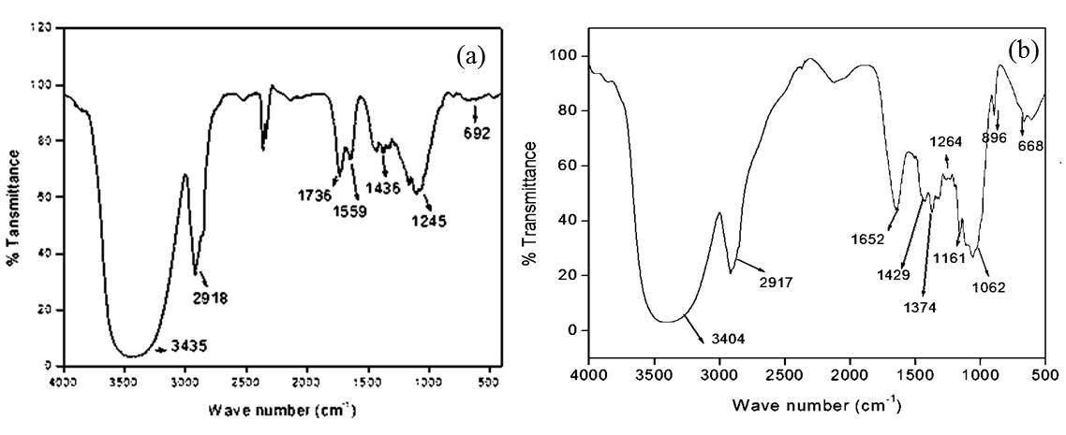
Figure 1. FT-IR spectra of (a) Untreated risk husk fibers (b) Cellulose
2.3 SURFACE MORPHOLOGY ANALYSIS
The Scanning electron micrographs of raw rice husk fibers and cellulose are given in Figure 2. The SEM image of the extracted cellulose product showed the cellulose fibrils as aggregates on the surface. Typically, the diameter of extracted cellulose fibrils were observed in the average range of 800-900 nm, which are lower than the average size (100-250 μm) of the untreated raw fibers. The reduction in the diameter of fibrils are owing to the efficient elimination of the lignin and hemicellulose. These results are also supported by the FT-IR analysis.
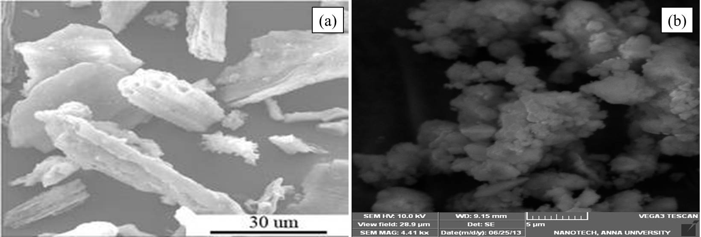
Figure 2. Surface Morphological features of (a) Untreated raw fibers (b) Cellulose
2.4 PARTICLE SIZE DISTRIBUTION
Following chemical treatment, particle size of the cellulose fibrils was determined. The particle size distribution of the extracted cellulose is shown in figure 3. The chemical treatment of rice husk fibers yielded mono-disperse cellulose with a typical dispersion of nanosized fibrils. The majority of the cellulose particles were observed to be between 700 and 955 nm in diameter. These results show that the diameter of the cellulose fibrils reduced to nanoscale range after the chemical treatment and ultra-sonication. The chemical treatment used for synthesising cellulose from rice husk provided a usable and easy process of producing cellulose fibrils in the average diameter range of one micron.
Figure 3. Average Size distribution of cellulose fibrils
2.5 MOLECULAR MASS DISTRIBUTION
The gel permeation chromatogram of the product cellulose is shown in Figure 4. Further, molecular weight averages of the extracted cellulose were determined using the molecular weight distribution curve. Table 1 shows the molecular weight distributions of the extracted cellulose calculated by the chromatogram.
Figure 4. Chromatogram of extracted cellulose
Table 1. Molecular weight distributions of extracted cellulose from rice husk
Molecular weight | g mol⁻¹
Number-average (M_{n}) | 16,586
Weight-average (M_{w}) | 22,272
Z-average (M_{z}) | 30,758
Polydispersity index (M_{w/}M_{n}) | 1.34283

2.6 X-RAY DIFFRACTION ANALYSIS
The XRD pattern of the extracted cellulose is reported in Figure 5. As shown in the Figure 5, the presence of peaks at 2θ values of 17.8°, 22.7°, and 34.4° are characteristic of (10$\overline{1}$), (002), and (040) planes of cellulose respectively indicating the crystalline structure of cellulose-I [21]. The crystallinity index (%) of the product is given in Table 2. These results show that higher crystallinity index of extracted product is attributed to the efficient removal of lignin, hemicelluloses and other non-cellulosic materials and effective reorganization of amorphous and para crystalline cellulose region. These results also further confirmed that the crystalline regions of cellulose were stable while the acid hydrolysis occurred selectively in the amorphous state resulting in the increase of crystallinity of cellulose as reported by many researchers for the case of extraction of cellulose from banana fiber, viscose staple, bagasse, ramie, and cotton respectively [22].
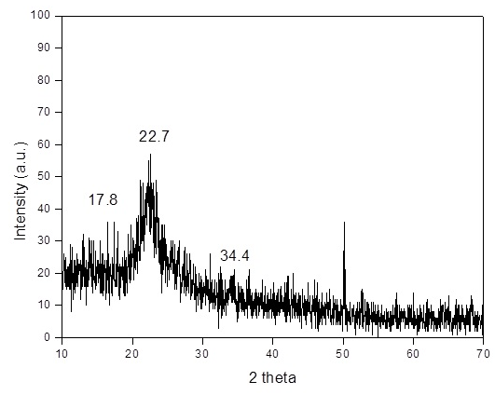
Figure 5. XRD pattern of extracted cellulose
Table 2. The crystallinity index of cellulose
Sample | I(amorphous) | I(002) | % Crystallinity index
Cellulose | 46 | 155 | 70.3

2.7 THERMOGRAVIMETRIC ANALYSIS
The thermogravimetric analysis is an important tool to measure the applicability of the extracted cellulose to be used to prepare biocomposites for various applications. TGA thermograms of untreated rice husk and extracted cellulose are shown in Figure 6. The thermogram shows that there was an initial weight loss up to 120ºC denoting the elimination of solvent and moisture. Further, decomposition of cellulose occurred at 230ºC, whereas the untreated fibers started to decompose at a higher temperature of 250ºC. It could be seen that the prepared cellulose started decomposing at lower temperature than the untreated rice husk which are attributed to the presence of lignin in the rice husk. The decomposition rate of lignin occurs with continuous mass loss over the range of 200-700ºC. Furthermore, the maximum weight loss in the case of cellulose occurred at 333.2ºC with no more peaks indicating the purity of the product. Later heating to 600ºC, a very less quantity of solid residue in the cellulose was observed which might be as a result of the carbonaceous components in rice husk. From these results, the lesser amount of solid residue and better thermal decomposition of cellulose are associated to more efficient elimination of hemicellulose and lignin present in the rice husk fibers and higher crystallinity of the product [23]. The higher thermal stability of the extracted cellulose shows its applicability for bio composite nanofiber applications.
Figure 6. TGA thermograms of (a) Untreated rice husk (b) Extracted cellulose
CONCLUSION
In the present work, cellulose was extracted successfully from the agricultural residue rice husk fibers. The morphology and size distributions of the cellulose were characterized. The FT-IR measurement showed that the efficient removal of lignin and hemicelluloses present in the rice husk fibers by the successive chemical treatment. Furthermore, the crystallinity and thermal characterisation showed that the extracted cellulose exhibited enhanced physical and chemical properties stimulating the usage of cellulose as a reinforcing agent in the production of biodegradable nanocomposite fibers for the antimicrobial packaging applications.
REFERENCES
1. A. Alemdar, M. Sain, Bioresour. Technol., 99, 1664-1671 (2008).
2. M. A. S. Azizi Samir, F. Alloin, A. Dufresne, Biomacromolecules, 6(2), 612–626 (2005).
3. N.M. White, M.P. Ansell, J. Mater. Sci., 18, 1549-1556 (1983).
4. M. Ramamoorthy, S. Rajiv, Carbohydr. Polym., 133, 328-336 (2015).
5. P.R. Honsby, E. Hinrichsen, K. Tarverdi, J. Mater. Sci., 32, 443-449 (1997a).
6. S. Jonasson, A. Bunder, T. Niittyla, et al., Cellulose 27, 185–203 (2020).
7. Zi-Jing He, Kai Chen, Zhi-Hua Liu, et al., Journal of Cleaner Production, 414, 137708 (2023).
8. A.W. Zykwinska, M.C.J. Ralet, C.D. Garnier, J.F.J. Thibault, Plant Physiol., 139, 397-407 (2005).

9. R.H. Atalla, D.L. VanderHart, Science, 223, 283-285 (1984).
10. A. Sturcova, I. His, D.C. Apperley, J. Sugiyama, et al., Biomacromolecules, 5, 1333-1339 (2004).

11. D. Ye, Progress in Chemistry, 19(10), 1568–1575 (2007).
12. N.F. Adriana, M.P. Denis, D. Dan, U.P.B. Sci. Bull., Series B, 73(2), 133-152 (2011).

13. K. Anupama, S. Mandeep, Carbohydrate Research, 346, 76-85 (2011).

14. A. Ayse, S. Mohini, Biores. Tech., 99, 1664-1671 (2008).
15. M.F. Rosa, E.S. Medeiros, J.A. Malmonge, et al., Carbohydrate Polymers, 81(1),83-92 (2012).
16. S.Y. Lee, D.J. Mohan, I.A. Kang, et al., Fibers and Polymers, 10(1),77-82 (2009).
17. M. El-Sakhawy, M.L. Hassan, Carbohydrate Polymers, 67(1), 1-10 (2007).
18. R.C. Sun, X.F. Sun, Carbohydrate Polymers, 49, 415-423 (2002).
19. G. Socrates, New York, John Wiley & Sons., p. 366 (2004).
20. J.M. Fang, R.C. Sun, J. Tomkinson, Cellulose, 7, 87–107 (2000).
21. D. Ciolacu, F. Ciolacu, V.I. Popa, Cellulose Chem. Tech., 45(1-2), 13-21 (2011).
22. B.M. Cherian, L.A. Porthan, T. Nguyen-chung, et al., Agri.Food. Chem., 56, 5617-5627 (2008).

23. S. Panthapulakkal, A. Zereshkian, M. Sain, Bioresour. Tech., 97, 265-272 (2006).

