A Study on Braking System using Fully Electric Brake System

Dr. Hredeya Mishra¹ Dr. Pradnya Prakash More² Lecturer in MED Lecturer in MED
MVPS’s RSM Polytechnic Nashik MVPS’s RSM Polytechnic Nashik
1002mishrahk@gmail.com pradnya.more@rsmpoly.org

Abstract—The braking system maintains a combination of the pneumatic brake and the electrical braking. This system is the major cause of the train noise, and disk brake shoe friction during braking. It causes the environmental pollution. Therefore, this paper presents a way to eliminate environmental pollution such as dust by using the fully electric brake system to zero speed as braking system.

Keywords—Braking system; fully electric brake system

- INTRODUCTION
Recently, the electric train has developed as an important means of public transport. It is required more reliable and economical operation through the performance improvement of the vehicle in accordance with passenger comfort improvement and the development of power electronic devices.
The braking system maintains a combination of the pneumatic brake and the electrical braking. This system is the major cause of the train noise, and disk brake shoe friction during braking. It causes the environmental pollution.
Therefore, this paper presents a way to eliminate environmental pollution such as dust by using the fully electric brake system to zero speed as braking system.

- FULLY ELECTRIC BRAKE SYSTEM
The electric train departure and stop by an inverter propulsion control device. The electric braking system works over the speed of about 5km. The pneumatic brake works below the speed of about 5km. The system performs vector control using the encoder for detecting the motor position. Because of the output characteristic of about 60 ~ 100pulse per rotation, the encoder system is impossible to perform the precise vector control.
Therefore, Mixed electrical and pneumatic brake system have been used. This system is the major cause of the train noise, and disk brake shoe friction during braking. It causes the environmental pollution. when the speed of the train is below 5km/h, there are noise occurs due to the compressor, maintenance difficulties and risk of damage caused by aging air by the pneumatic brake.

The fully electric brake system is mainly used by the electric braking to minimize the chance of pneumatic brake. Effects obtained using the fully electric brake system are as follows:
- Reduce the wear of the brake shoe by minimizing the use of the pneumatic brake
- Can reduce braking noise and dust due to mechanical wear
- Brake maintenance cost savings
- Maximizing the use of energy to the expansion of the regenerative braking

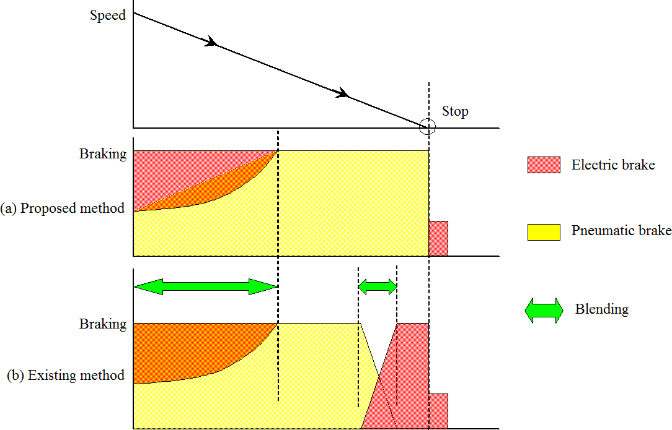

Figure 1. Fully electric brake system

- COMPOSITION OF FULLY ELECTRIC BRAKE SYSTEM

The braking system consists of the inverter, the Pulse-width modulation (PWM) control unit, the vector control unit, the

drive control unit, the speed detection unit. The inverter control the speed of the motor by converting the DC voltage to AC voltage input through a pantograph.
The PWM control unit makes the gate pulse of the inverter. The PWM control unit adjust the traction motor's input circuits voltage and frequency. The vector control unit receives the motor speed and current signals.
The vector control unit determines the inverter voltage inverter frequency. The drive control unit performs the operation command for acceleration, regeneration and braking.
The brake controller controls the parking brake. The speed detection unit detects the rotor speed for the motor control. The inverter for motor control performs function from the start to the stop and the parking brake when the train stops.

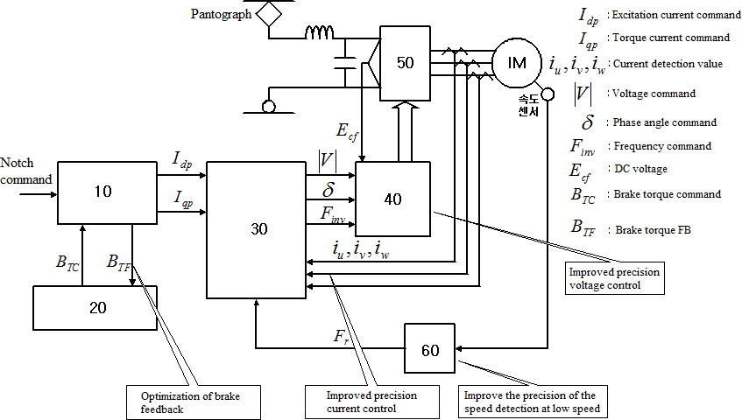

Figure 2. Vector control configuration

The vector control unit receives the motor current detection value and the speed in order to feedback traction power and the speed from the traction motor. And it adjusts the output of the pulse width modulation control unit.
The vector control unit performs feedback control of current and frequency as the vector control in order to respond the reference value of the drive control unit.
In this study, the resolver is used in order to improve the speed detection and the precise control in the low-speed range.
Figure 3 represents the brake control at low speed during deceleration. When the stop signal is detected, the torque current command(Iqp) is achieved to output the braking power.
When the speed of the train reaches the low-speed range (5km / h or less), the electrical braking force is reduced and the torque current command value is reduced gradually. When the train is stopped, the pneumatic brake is done.

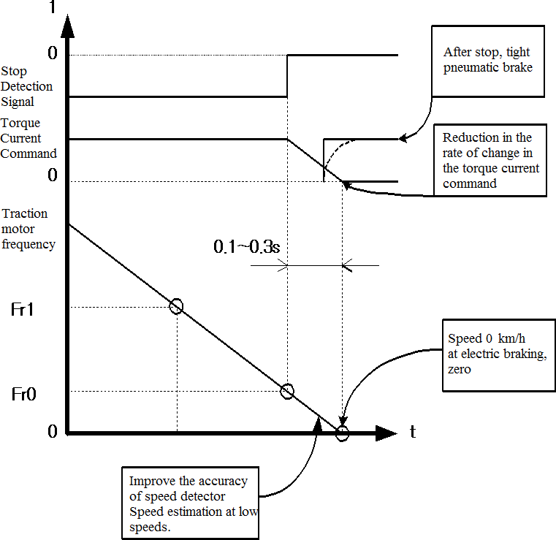

Figure 3. Brake control at low speed during deceleration

- TEST

There are the following conditions to stop the motor.

཰ Prevent rotation after stop.
ཱ Pneumatic brake operation, Whe the braking torque is 0
ི The braking torque is generated in the gradient. The
braking force with pneumatic brake function of ཱ stops the train.
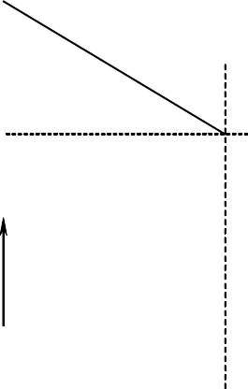
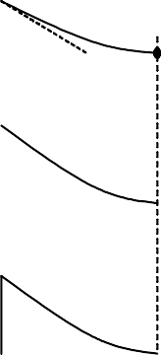
ω
ڄڍڃ
ۋۊۏڮ

ڄڌڃ
ڄڎڃ

ω0

t
T

t

ڿۀۏھۀۏۀڟ ڿ ۀۋێ

t
Figure 4. Braking sequence

The motor was driven for the driving and the regenerative braking. Figure 5 shows that the starting speed of characteristics driving is at 360 [rpm] and the torque is 0 at 800 [rpm]. The braking torque is proportional to the velocity at the moment of the stop.
In Figure 5 and 6, the torque is set as the step change. Gently driving is observed at the stop moment. Figure 6 shows the small torque.

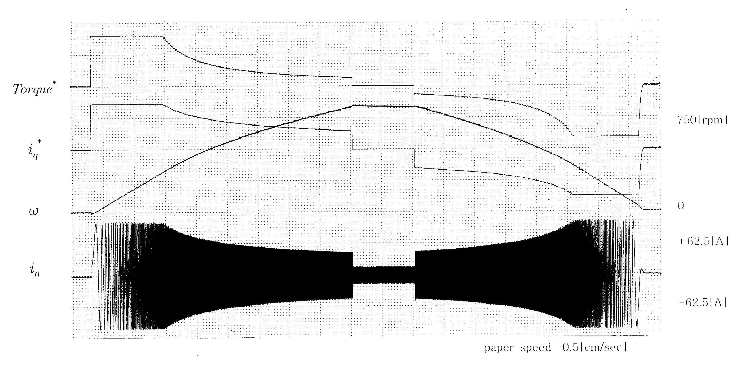

Figure 5. Drive experiments on Inertial load
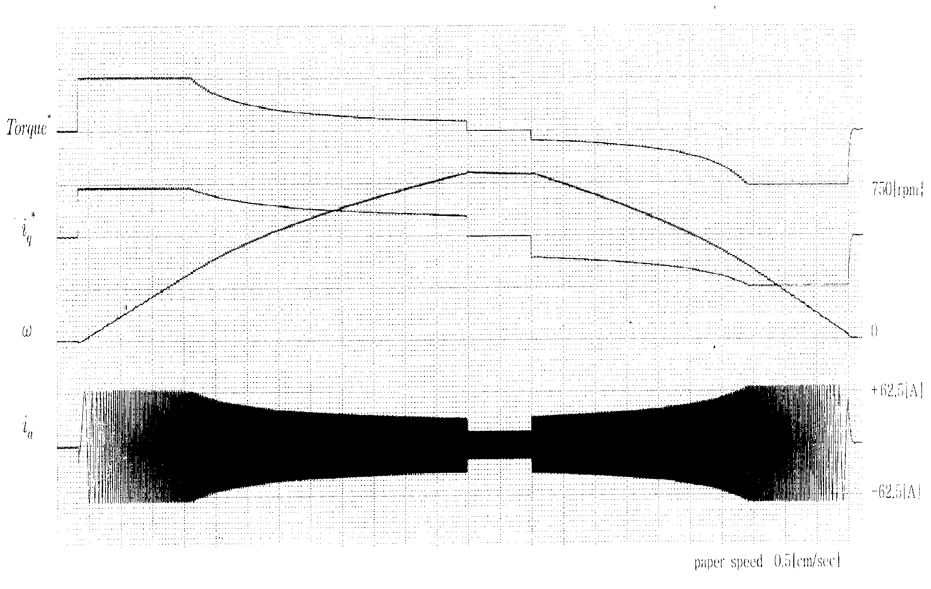
Figure 6. Drive experiments on Inertial load(Torque Variable)

- CONCLUSION

The braking system maintains a combination of the pneumatic brake and the electrical braking. This system is the
major cause of the train noise, and disk brake shoe friction during braking. It causes the environmental pollution. Therefore, this paper presents a way to eliminate environmental pollution such as dust by using the fully electric brake system to zero speed as braking system.
Effects obtained using the fully electric brake system are as follows:
- Reduce the wear of the brake shoe by minimizing the use of the pneumatic brake
- Can reduce braking noise and dust due to mechanical wear
- Brake maintenance cost savings
- Maximizing the use of energy to the expansion of the regenerative braking

REFERENCES

- Hanmin lee, Gildong Kim, Changmu Lee, Euijin Joung, “A study on Braking Control for Pure electric Brake of Electric Train”, The Korean Institute of Electrical Engineers conference, 2012
- Hanmin lee, Gildong Kim, “A Study on Electric Braking System to 0km/h”, The Korean Society for Railway conference,pp.178, 2007
- Sone, Ashiya, "Pure electrical brake of the railway electric vehicles",
Railway cybernetics, vol.34,No.513, pp.194~197, 1997
- Ogasa, Nagai, Watanabe, "Plant-test Result of All Electrical Braking (Report 1)", National convention Record I.E.E.Japan, 1260,pp.5- 389~390, 1998
- Ogasa, Nagai, Watanabe, Toda, "Plant-test of Electrical Breaking to Zero Speed for Railway Vehicle", National Convention Record I.E.E.Japan-Industry Application Society-, No.77,pp.257~262, 1998
- Sato, Iida, Hisatomi, "Pure electric braking system test using stsrt", National Convention Record I.E.E.Japan-Industry Application Society-, No.78,pp.253~2666, 1998

