Physiological System Modeling: Understanding Cardioautonomic Function
- Uma Maheswari^{1*}, A.V.Siva Kumar², Dr.K.Dilara³, Dr. R.Padmavathi⁴
¹Department of Physiology, Saveetha Institute of Medical and Technical Sciences, Chennai, India
² Department of Physiology, Narayana Medical college and Hospital, Nellore, Andhra Pradesh, India
³Department of Physiology,SRMC &RI, Sri Ramachandra Institute of Higher Education and Research (SRIHER) (DU), Chennai, India
⁴Department of Physiology,SRMC &RI, Sri Ramachandra Institute of Higher Education and Research (SRIHER) (DU), Chennai, India
*Corresponding author
Author contacts:
K.Uma Maheswari - E-mail: umakarmegam@gmail.com
A.V.Sivakumar:E-mail:reddy.sivakumar5@gmail.com, asivakumar@narayanamedicalcollege.com
K.Dilara - E-mail: dilarak@sriramachandra.edu.in
R.Padmavathi - E-mail: rpadmavathi@sriramachandra.edu.in

Introduction
The intricate functioning of the human body relies on the harmonious interplay of various physiological systems. One such essential system is the cardioautonomic system, which regulates and maintains cardiovascular function through a delicate balance of sympathetic and parasympathetic influences. The dynamic control of heart rate, blood pressure, and vascular tone is vital for adapting to changing physiological demands and ensuring optimal organ perfusion. The study of cardioautonomic function is of paramount importance, as alterations in autonomic balance can lead to a range of cardiovascular disorders and impact overall health.
In recent years, advances in computational and mathematical modeling have provided researchers with powerful tools to explore the complexities of physiological systems, including the cardioautonomic system. Physiological system modeling offers a systematic approach to unravel the underlying mechanisms and interactions governing cardiovascular regulation, enabling a deeper understanding of normal function and the pathophysiological basis of diseases (1).
This book chapter delves into the fascinating world of physiological system modeling with a specific focus on cardio-autonomic function using dynamic pupilometry. We aim to present an overview of the principles and methodologies involved in creating computational models that simulate the dynamics of autonomic control in the cardiovascular system. By combining knowledge from cardiology, neurophysiology, and computational sciences, this chapter seeks to bridge the gap between theoretical concepts and clinical applications, providing valuable insights for researchers, clinicians, and students interested in cardiovascular physiology and modeling.

DYNAMIC PUPILLOMETRY
Dynamic pupillometry is a technique used to measure changes in the diameter of the pupil over time. It provides quantitative data on how the pupil responds to different light conditions, which can be valuable for various medical and research applications, particularly in assessing the autonomic nervous system (2).
Pupil size is influenced by the autonomic nervous system, which consists of two main branches: the sympathetic and parasympathetic nervous systems. The sympathetic nervous system is responsible for the fight-or-flight response and causes the pupil to dilate (enlarge), while the parasympathetic nervous system promotes rest and relaxation, leading to pupil constriction (reduction in size) (3).
The measurement of pupil size is typically done using optical videography. In dynamic pupillometry, infrared illumination is used to enable accurate measurement even in complete darkness. Infrared light falls within the wavelength range of 700 to 1000 nanometers (nm), which is beyond the visible spectrum for the human eye (300 to 700 nm). Since the retinal cells are insensitive to infrared light, it does not trigger the afferent optical fibers responsible for the pupillary light reflex (PLR) (2).
The pupillary light reflex (PLR) is the normal response of the pupil to changes in light conditions. When exposed to bright light, the pupil constricts, and when in darkness, it dilates. By using infrared illumination, which does not elicit the PLR, it becomes possible to measure the maximum pupil size (peak dilation) even in total darkness (4).
The infrared illumination technique has several advantages (5):
1. Maximum pupil size measurement: By avoiding the pupillary light reflex, infrared illumination allows for the visualization of the largest possible pupil size without the interference of light-induced pupil constriction.
2. Robustness and accuracy: Under infrared illumination, the pupil can be distinguished more reliably from the rest of the iris, improving the accuracy and consistency of pupil diameter assessment.
Dynamic pupillometry can provide valuable information about the autonomic balance in an individual. By analyzing the pupil size changes over time under different light conditions, it is possible to gain insights into the function of the autonomic nervous system. Abnormalities in the pupillary light reflex and pupillary responses can be indicative of various neurological and ophthalmological conditions.
In clinical settings, dynamic pupillometry can be used to assess neurological conditions, monitor changes in brain injury patients, detect autonomic neuropathy, and evaluate drug effects on the autonomic nervous system. Additionally, it has applications in research fields such as psychology, cognitive neuroscience, and human-computer interaction (6, 7).
Overall, dynamic pupillometry using infrared illumination offers a non-invasive, simple, and effective way to quantitatively measure pupil size and study autonomic nervous system function.
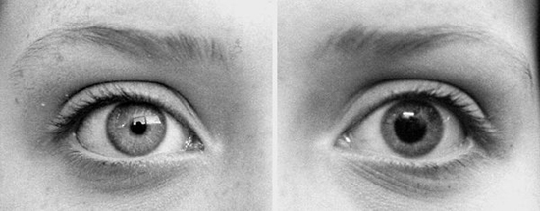
Figure: 1 Effect of visible and infrared light on pupil size
PROOF OF CONCEPT
The proof of concept for dynamic pupillometry using infrared videography was demonstrated through a pilot study. Here are the key steps and components used in the dynamic pupillometry (8):
1. Infrared Web Camera: An infrared web camera was selected for capturing images of the subject's eye. Infrared cameras are sensitive to infrared light, which allows them to capture images even in complete darkness.
2. Setup: The camera was mounted on a stand to ensure stable positioning. The subject's chin was placed on a chin rest, which could be adjusted for individual comfort and positioning.
3. Microcontroller-Based Digital Circuit: A digital circuit based on a microcontroller was used to manage the intensity of both infrared and white light. This circuit was responsible for controlling the light sources and ensuring the appropriate amount of illumination for each scenario.
4. Calibration: The module was calibrated to ensure accurate measurements. This calibration process likely involved adjusting the intensity of the infrared and white light sources and using a standard centimeter-scale at a fixed distance to verify the accuracy of measurements.
5. Image Capture: Participants were randomly assigned to the study and positioned in a dark room. In this setting, the infrared web camera focused on the subject's eye with the help of two IR LEDs, capturing static pupil images. These images were taken to measure the maximum pupil size when the subject's pupils were dilated.
6. White Light Flash: The same protocol was replicated with a white light flash. In this scenario, the white light was used to trigger the pupillary light reflex and cause the pupils to constrict. The camera captured images of the constricted pupils under this condition.
By comparing the images captured in both dark (infrared illumination) and white light conditions, the researchers could validate the precision and accuracy of their pupil measurement system. The difference in pupil size between the two conditions would demonstrate the pupil's ability to respond to changes in light intensity, which is a fundamental aspect of dynamic pupillometry.
This aimed to establish the feasibility of using infrared videography to measure pupil size accurately in total darkness and with the effect of white light stimulation. The success of this proof of concept would support the potential application of dynamic pupillometry in various medical and research contexts, as mentioned in the earlier explanation. 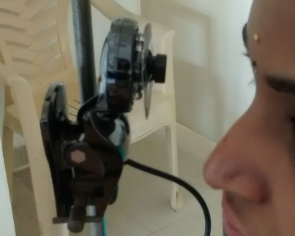
Figure:2 Position of the camera and the subject with chin rest
REAL TIME ANALYSIS
Real-time pupil analysis involves processing pupil images in real-time to obtain various measurements, such as pupil diameter. However, in the case of the mentioned pilot study, the pupil analysis was performed offline using image processing techniques. This means that the images captured during the study were analyzed after the data collection was completed, rather than in real-time (9).
The process of offline image processing for pupil analysis likely involved the following steps:
1. Image Acquisition: During the pilot study, static pupil images were captured using the infrared web camera and the two IR LEDs in the dark room (to obtain maximum pupil diameter) and with a white light flash (to capture minimum pupil diameter).
2. Image Processing with Image J Program: Image J is an open-source image processing software widely used in scientific research. The static pupil images were loaded into the Image J program for further analysis.
3. Pupil Diameter Measurement: In Image J, the researchers likely used various image processing techniques and tools to measure the pupil diameter accurately. These tools may include edge detection algorithms, thresholding techniques, and contour analysis to determine the boundaries of the pupil and calculate its diameter.
4. Data Analysis: The obtained measurements of maximum and minimum pupil diameter from the 20 healthy volunteers were compiled and statistically analyzed to assess the variability and consistency of the results.
5. Encouraging Findings: The findings of the study were described as encouraging, indicating that the image processing techniques applied in the pilot study were successful in accurately measuring pupil diameter. The results demonstrated that offline image processing with Image J can be used effectively for qualitative measurements of pupil size and responses to different light conditions.
While offline image processing has its advantages in allowing researchers more time and flexibility for analysis, real-time pupil analysis would offer more immediate feedback and enable potential applications in real-time monitoring and assessment. If the pilot study's positive results are confirmed, it may open up possibilities for advancing the use of image processing techniques in dynamic pupillometry and further research in the field of pupillary response analysis.
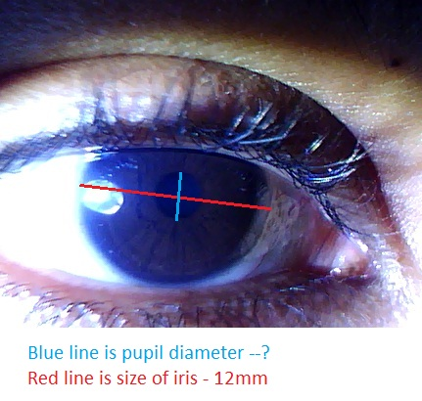
Figure: 3 Captured image of the pupil (Blue line) within the iris (Redline)
COMPUTERIZED PUPILLOMETER DESIGN:
The computerized infrared pupillometer described in Figure 4 represents an advanced version of the previously mentioned pilot study setup. The design aims to automate the pupil diameter measurement process using a computer-controlled system, which offers several advantages over manual analysis. Here are the key features and components of the computerized dynamic pupillometer (10):
1. Standard Web Camera: The system uses a standard web camera (V90 WEBCAM-640x380), which has been modified to remove the infrared filter. By doing so, the camera becomes sensitive to infrared light and can capture images in complete darkness without interference from visible light.
2. Virtual Reality (VR) Box: The web camera is attached to a virtual reality (VR) box, which ensures complete darkness during image capture. This setup eliminates external lighting sources and provides a controlled environment for pupillometry measurements, reducing confounding factors.
3. Infrared Light-Emitting Diodes (LEDs): Two infrared light-emitting diodes (LEDs) with a wavelength of 850 nm are used to provide continuous infrared illumination. The infrared light does not trigger the pupillary light reflex (PLR), allowing the measurement of maximum pupil size in darkness.
4. White LED: In addition to the infrared LEDs, a white LED is placed close to the camera. This LED is used to deliver a bright light stimulus flash lasting 2000 milliseconds, which triggers the pupillary light reflex and causes pupil constriction.
5. Spatial Distance: The camera is positioned at a spatial distance of 7 centimeters from the eye's anterior curvature. This distance ensures that the camera's presence does not initiate a reflex of accommodation, which could interfere with the pupillary response measurement.
6. Microcontroller-Based Electronic Circuitry: To control the intensity and duration of the infrared LED for continuous illumination and the white light flash, the system is connected to a microcontroller-based electronic circuit. This circuitry allows precise control over the light sources, ensuring consistent and accurate measurements.
7. Frame Rate and Resolution: The device operates with a frame rate of 30 frames per second and a resolution of 33.3 milliseconds per frame. This high-speed capture rate ensures that rapid changes in pupil size can be accurately recorded.
8. USB-Powered: The electrical circuit for IR illumination and white light stimulation is powered by the computer's USB cable. This design makes the device easy to use and portable.
9. User-Friendly: The computerized dynamic pupillometer is designed to be user-friendly and compatible with basic machine or laptop operating systems. This user-friendly interface simplifies the process of pupillary data collection and analysis.
By combining these features, the computerized pupillometer offers a robust and automated system for dynamic pupillometry. It provides a more efficient and accurate way to measure and analyze pupil responses to different light conditions, making it suitable for various clinical and research applications.
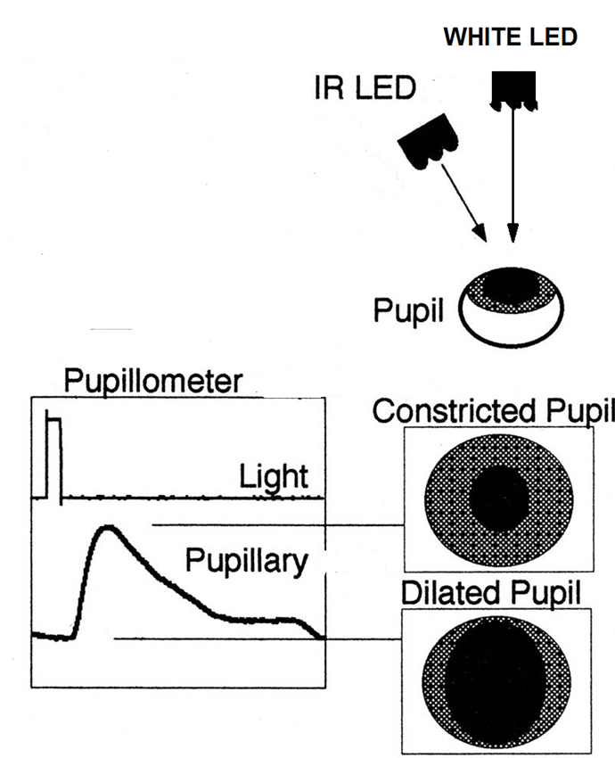
Figure: 4 Design of Computerized Dynamic Pupillometer
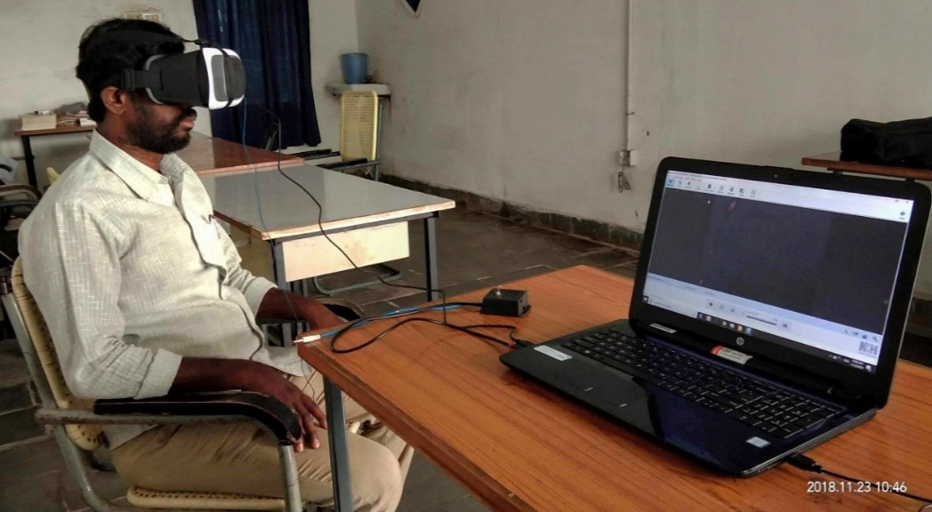
Figure: 5 Arrangement of Dynamic pupillometer
SOFTWARES
The current protocol for dynamic pupillometry relies on open-source freeware software, which offers user-friendly interfaces and secure platforms for recording, splitting, and analyzing pupil responses to light. These software tools play essential roles in different stages of the pupillometry process. Here are the key software components used in the protocol (11):
I) Debut Software:
The Debut software, developed by NCH Software, Inc., is used to record videos of the pupillary light reflex (PLR) on a computer or laptop. It can capture video from various sources, such as a built-in webcam or an external USB device like a digital or web video camera. The software provides an easy-to-use interface for recording videos, and it supports a wide variety of video formats. Users can customize the output settings according to their specific requirements.

II) Video to JPEG Converter:
The Video to JPEG converter software is employed to split the recorded PLR video into individual images (frames). It is a freeware tool that takes the recorded video as input and converts it into JPEG or BMP format images. Users can specify the time interval and frame size for extracting the images from the video. Additionally, the software allows users to define the number of copies of images to be derived from the video. The converted pictures are then saved in a location selected by the user on their PC.
III) ImageJ:
ImageJ is a Java-based image processing platform developed by the National Institutes of Health (NIH) and the Laboratory for Optical and Computational Instrumentation. It offers a powerful set of tools for image analysis and processing. ImageJ is particularly useful in the context of pupillometry, as it enables batch processing of video frames acquired from capturing pupil responses.
ImageJ has an accessible architecture that provides flexibility and efficiency through Java plugins and recordable macros. Users can develop custom acquisition, evaluation, and compilation plugins using the built-in editor and Java developer tools. The versatility of ImageJ has made it a prominent choice in the field of image processing.
In the current protocol, after the pupil responses are recorded and split into individual frames using Debut and the Video to JPEG converter, respectively, the batch processing of these frames is performed using ImageJ applications. ImageJ facilitates the analysis of pupil diameter and response patterns over time, allowing researchers to obtain quantitative measurements and meaningful insights from the collected data.
By utilizing these open-source freeware software tools, the current protocol offers a cost-effective and accessible approach to dynamic pupillometry. Researchers and clinicians can easily implement this protocol for various applications, including medical diagnostics, research studies, and assessment of autonomic nervous system function.
DYNAMIC PUPILLOMETRY METHODOLOGY FOR PLR:
The image processing and analysis steps described in the previous research provide a detailed explanation of how pupil dimensions are identified and measured using the Debut software and ImageJ. The steps ensure accurate and reliable measurements of the pupil area and diameter from the recorded video frames or images. Here is a summary of the image processing steps (12):
1. Image Selection: The video frame or image containing the pupil, iris, and background is chosen for analysis. Automatic pupil size determination may not be possible in all cases, and the image threshold needs to be adjusted as required to ensure clear identification of the pupil edges.
2. Finding Edges: The "finding edges" command in the software is used to establish a clear outline of the pupil. This step highlights sharp changes in intensity, helping to detect the pupil margins.
3. Binarization: The surrounding environment in the acquired image is under continuous illumination of infrared light, which increases the contrast of the background. Binarization is applied to eliminate LED reflections and different colors of the pupil that might have been recorded. This step is crucial to obtain accurate measurements of the absolute pupil size.
4. Filling the Pupil Circle: The binarized pupil circle is filled with dark black color in the selected region to avoid infrared LED reflections, known as the Purkinje phenomenon. This step further enhances the accuracy of the measurements.
5. Finding Outlines: The "find outlines" command is applied to detect the fine edges of the pupil. This step refines the pupil's outline, although there might still be some fluctuations in the threshold along the pupil contour.
6. Noise Elimination and Normalization: The pupil outlines are precisely analyzed and measured by eliminating background noise and normalizing the pupil shape. A complete pupil outline is obtained using the "Analyze particles with true circularity (0 – 1)" command.
7. Displaying Pupil Measurements: The pupil area or diameter is shown in a separate program window, providing the quantitative measurement of the pupil's response to light stimulus.
These image processing steps enable accurate and objective measurements of the pupil size and its response to light stimuli. By analyzing individual frames or batches of images, researchers can obtain valuable data on pupillary dynamics and assess changes in pupil size over time. The combination of the Debut software and ImageJ allows for a comprehensive analysis of pupillary responses, making it a powerful tool for dynamic pupillometry studies.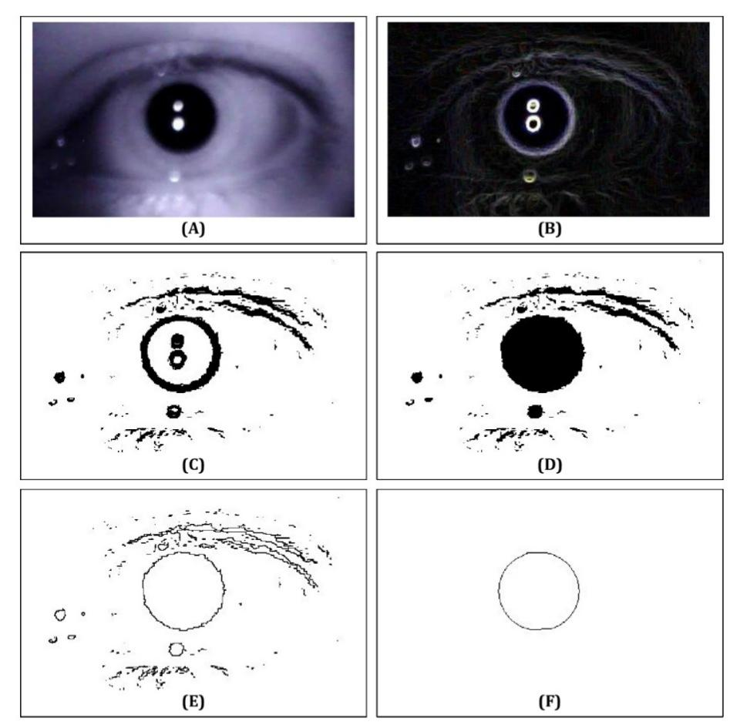
Figure: 6 Steps of pupil image processing and analysis
AUTOMATIC IMAGE PROCESSING:
Indeed, ImageJ's versatility allows users to create custom macro plugin programs to automate batch processing and analysis of pupil images. By creating a javascript program as described, the software can be tailored to identify the pupil area and diameter for an entire cluster of pupil images obtained from a specific pupillary light reflex recording.
The process involves the following steps:
1. Selection of Region of Interest (ROI): Initially, one photo is selected from the set of video frames, and the region of interest containing the pupil is identified manually. This step ensures that the same dimensions and coordinates for the ROI are applied consistently to all the images in the batch.
2. Creating the Macro Plugin Program: The dimensions and coordinates of the ROI are then included in the javascript program to process and analyze the specific portion of all images where the pupil is located within each frame. The macro plugin program uses these predetermined parameters to ensure uniformity in the analysis, eliminating inter-subject variability in pupil measurements.
3. Batch Processing: The video frames are processed using the macro code plugin program in a batch process. This automated approach significantly reduces the manual effort required for individual image analysis.
4. Data Transfer and Graph Plotting: Once the batch processing is complete, the results, including pupil area and diameter measurements, are transferred to an Excel sheet for data storage and further analysis. Graphs can be plotted using the collected data to visualize and interpret the changes in pupil size over time.
By using the automated batch processing with a macro plugin program, the software efficiently processes a large number of pupil images from a single pupillary light reflex recording. This approach increases the accuracy and consistency of the measurements by reducing manual interventions and ensuring standardized analysis for all images.
The combination of ImageJ's image processing capabilities and custom macro programming allows researchers to streamline pupillometry data analysis, making it a valuable tool for studying dynamic pupillary responses and conducting pupillometry-based research.

GRAPHICAL PLOT OF PLR:
The graphical plot of pupillary light reflex (PLR) is represented (Figure: 7) as a time series, where the X-axis shows time in terms of frames, and the Y-axis represents the pupil diameter in millimeters. The plot typically displays the changes in pupil diameter over time in response to different light conditions (9).
Static Variables:
1. BPD - Resting Pupil Diameter: BPD represents the baseline or resting pupil diameter measured in total darkness. This is the initial pupil size before any light stimulus is applied.
2. MPD - Minimum Pupil Diameter: MPD is the minimum pupil diameter observed in response to a flash of light. This measurement indicates the extent of pupillary constriction triggered by the light stimulus.
3. RPD - Recovered Pupil Diameter: RPD is the pupil diameter captured after subsequent light exposure, following the minimum pupil diameter. It indicates the extent of pupillary dilation once the light stimulus is removed.
Dynamic Variables:
1. ACA - Absolute Constriction Amplitude: ACA refers to the absolute amplitude of pupillary constriction. It is the difference between the baseline pupil diameter (BPD) and the minimum pupil diameter (MPD).
2. ADA - Absolute Dilation Amplitude: ADA represents the absolute amplitude of pupillary dilation. It is the difference between the minimum pupil diameter (MPD) and the recovered pupil diameter (RPD).
3. DC - Duration of Constriction: DC is the duration of pupillary constriction, measured from the onset of the light stimulus until the pupil reaches its minimum diameter (MPD).
4. DD - Duration of Dilation: DD represents the duration of pupillary dilation, measured from the removal of the light stimulus until the pupil reaches its recovered diameter (RPD).
5. MCV - Maximum Constriction Velocity: MCV is the maximum rate at which the pupil constricts during the constriction phase.
6. MDV - Maximum Dilation Velocity: MDV is the maximum rate at which the pupil dilates during the dilation phase.
The graphical plot of PLR with these static and dynamic variables resembles a typical muscle curve, divided into different phases: Constriction Phase (A), Shifting Phase (B), and Redilation Phase (C). The plot provides insights into the autonomic nervous system (ANS) activity, as the changes in pupil diameter are influenced by the sympathetic and parasympathetic branches of the ANS.
By analyzing the graphical plot of PLR and measuring these static and dynamic variables, researchers can assess the autonomic balance, evaluate neurological conditions, monitor changes in brain injury patients, and investigate drug effects on the autonomic nervous system. The plot helps in understanding the dynamic response of the pupil to light stimuli, which can be valuable for various medical and research applications. 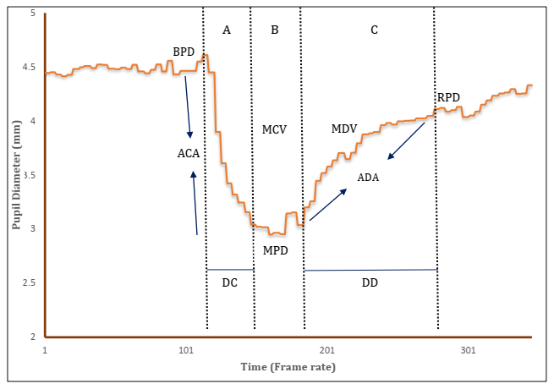
Figure:7 Static and dynamic variables of PLR
SUMMARY
The development of an indigenous and cost-effective dynamic pupillometer using a standard web camera and open-source software represents a significant advancement in pupillometry. The system allows for quantitative assessment of pupillary light reflex (PLR) responses and provides valuable information on the autonomic nervous system (ANS) activity, specifically reflecting sympathetic and parasympathetic function.
The pupillometer's graphical plot of PLR, with its two limbs representing parasympathetic and sympathetic actions, demonstrates the system's capability to identify anomalies in ANS activity that may indicate pathological conditions. The three phases of the plot (A, B, and C) correspond to different stages of the pupillary response, each reflecting specific aspects of autonomic control (9).

The choice of feature-based pupil detection through image processing allows for precise and accurate pupil measurements. The image analysis macro code used in the current protocol shares similarities with previous research (13). This approach allows for the examination of the pupil's exact elliptical contour and facilitates the extraction of physical units, such as pupil diameter in millimeters, which is crucial for meaningful interpretation by clinicians and researchers.
The cost-effectiveness and simplicity of the indigenous pupillometer are particularly advantageous, making this system accessible to a wider range of users. By removing examiner bias and controlling the surrounding illumination with the customizable virtual reality box, the system ensures reliable and consistent measurements of pupil responses.
Comparisons with other automated pupillometers, which are often expensive, highlight the significance of the current protocol in providing a practical and affordable alternative for dynamic pupillometry. By utilizing open-source software and a standard web camera, the system achieves high accuracy and precision comparable to more expensive alternatives.
Overall, the indigenous and cost-effective dynamic pupillometer offers a valuable tool for clinicians and researchers to investigate pupillary responses and assess ANS function in various medical and research applications. The quantitative outcomes, presented in physical units, provide straightforward and meaningful data for evaluation, aiding in the understanding of pupil light reflex patterns and their implications in different clinical contexts.

References:
1. Maheshkumar K, Dilara K, Maruthy KN, Sundareswaren L. Validation of PC-based sound card with biopac for digitalization of ECG recording in short-term HRV analysis. N Am J Med Sci. 2016;8(7):307.
2. Tekin K, Sekeroglu MA, Kiziltoprak H, Doguizi S, Inanc M, Yilmazbas P. Static and dynamic pupillometry data of healthy individuals. Clinical and Experimental Optometry. 2018;101(5):659-65.
3. Hugdahl K. Cognitive influences on human autonomic nervous system function. Curr Opin Neurobiol. 1996;6(2):252-8.
4. Binda P, Pereverzeva M, Murray SO. Attention to bright surfaces enhances the pupillary light reflex. J Neurosci. 2013;33(5):2199-204.
5. Strangman G, Boas DA, Sutton JP. Non-invasive neuroimaging using near-infrared light. Biol Psychiatry. 2002;52(7):679-93.
6. Kumar AVS, Padmavathi R, Mahadevan S, Maruthy KN, Maheshkumar K. Impaired pupillary light reflex indices in Orbital Apex Syndrome–A rare case report. J Fr Ophtalmol. 2021;44(5):718-22.
7. Siva Kumar AV, Padmavathi R, Mahadevan S, Maruthy KN, Maheshkumar K. An impaired pupillary light reflex indices in Orbital Apex Syndrome-A rare case report. J fr ophtalmol. 2021.
8. Kumar AVS, Padmavathi R, Maruthy KN, Sowjanya B, Kumar K. An Innovative Technique to Evaluate Quantitative Pupillary Light Reflex by Dynamic Pupillometry using Infrared Videography. Journal of Clinical & Diagnostic Research. 2019;13(4).
9. Sivakumar AV, Kalburgi-Narayana M, Kuppusamy M, Ramaswamy P, Bachali S. Computerized dynamic pupillometry as a screening tool for evaluation of autonomic activity. Neurophysiol Clin. 2020;50(5):321-9.
10. Maruthy KN, Padmavathi R, Sowjanya B, MaheshKumar K. Quantitative determination of pupil by dynamic pupillometry using infrared videography–Role in evaluation of autonomic activity. Clinical Epidemiology and Global Health. 2020;8(3):728-32.
11. Av SK, Padmavathi R, Maruthy KN, Kumar M. Dynamic Pupillometry–An indigenous non-invasive screening tool for clinical utility. The Journal of Medicine and Science. 2022;1(01):14-6.
12. Siva kumar AV, Maruthy KN, Maheshkumar K, Padmavathi R. Letter to Editor: Dynamic pupillometer to quantify pupil light reflex (PLR). Eur J Ophthalmol. 2022;32(3):NP100-NP1.
13. Ferrari GL, Marques JLB, Gandhi RA, Heller SR, Schneider FK, Tesfaye S, et al. Using dynamic pupillometry as a simple screening tool to detect autonomic neuropathy in patients with diabetes: a pilot study. Biomed Eng Online. 2010;9:1-16.

