SYNTHESIS AND BIOLOGICAL ACTIVITIES OF SOME NEW 5- {[-3-[(6-CHLOROPYRIDIN-3-YL) METHYL]-2-(NITROIMINO) IMIDAZOLIDIN-1-YL] METHYL} 2, 3-SUBSTITUTED PYRIDINE DERIVATIVE
M.B. Deshmukh¹, S.M. Deshmukh², S.R. Yankanchi¹ and B.V. Patil¹*
¹Department of Agrochemicals and pest management, Shivaji University, Kolhapur
²Department of Technology, Shivaji University, Kolhapur
*Mail ID: bvpatil777@gmail.com mobile phone +91 8805948151

Abstract
To discover promising molecules with good insecticidal activities, a set of substituted 2-(nitro imino) imidazolidin-1-yl] methyl}2,3-substituted pyridine derivatives were synthesized, starting with the material imidacloprid and bio-assayed. The structures of the newly synthesized compounds were confirmed by FT-IR,1H NMR,13C NMR, and Mass spectroscopic data. The bioassay tests showed that synthesized compounds Containing chloro (1,3-bis[(6-chloropyridin-3-yl)methyl]-N-nitroimidazolidin-2-imine (2) & 1-[(6-chloropyridin-3-yl)methyl]-3-[(2,6-dichloropyridin-3-yl)methyl]-N-nitroimidazolidin-2-imine (3) and Carboxyl (5-{[(2Z)-3-[(6-chloropyridin-3-yl)methyl]-2-(nitroimino)imidazolidin-1-yl]methyl} pyridine-3-carboxylic acid (4) & 5-{[(2E)-3-[(6-chloropyridin-3-yl)methyl]-2-(nitroimino) imidazolidin-1-yl]methyl}pyridine-2-carboxylic acid (5) substitution showed higher bioactivities than against H.armigera (Hub), Mealybugs (Planococcus citri) and Mango hoppers [Idioscopus clypealis (Lethierry)]. Compounds with substituted patterns with electron withdrawing groups exhibited potential vector control agents having importance in the pest management in Agriculture.
Keywords: -Imidacloprid, Pyridine derivatives, biological activity, pest management

1.1 Introduction
The prevention and control of H. armigera is mainly dependent on chemical pesticides⁵. However, total dependence on the application of synthetic insecticides to control H. armigera has not only achieved the desired success, but has resulted in the unfolding of pesticide resistance, environmental contamination, disruption of ecological stability, and health hazards⁶. Neonicotinoid insecticides are the latest class of synthetic insecticides in the past two decades and the biggest selling insecticide class worldwide such as imidacloprid⁷. Thus, a lot of attempts have been made to find replacement methods for its control. Recently, pyridine moiety was found to be very notable in the discovery of novel insecticides and several modifications around its structure have been made.
New insecticidal molecules have been developed in the present work based on the incorporation of the substructural unit of hydrazone into the backbone of imidacloprid. Based on this hypothesis, imidacloprid derivatives containing substituted pyridine structures have been designed and synthesized (Scheme 2). Biological assays reveals that the synthesized compound exhibits an excellent insecticidal activity against different insect species.
1.2 Synthesis of 1,3-Bis[(6-chloropyridin-3-yl) methyl]-N-nitroimidazolidin-2-imine (2) [Scheme2]

4B.3 1.3.1 Experimental procedure: -
1,3-Bis[(6-chloropyridin-3-yl) methyl]-N-nitroimidazolidin-2-imine (2)
In the solution of imidacloprid (0.255 gm, 1mole) in 10 ml methanol, add 2-3 drops of acetic acid then add 2-chloro 3 chloro-methyl pyridine (0.162 gm, 1 mole), and the reaction mixture was refluxed for 2 hrs. The progress of the reaction was monitored by TLC. After the completion of the reaction, the mixture was extracted in 10 ml ethyl acetate containing 20 ml of water. The organic layer is then washed with the braine solution the organic layer is concentrated by using Rotavapor to get a white solid compound. Compounds 3 to 5 are prepared according to the same procedures.
1.3.2 Spectral characterization of the compounds:
1,3-Bis[(6-Chloropyridin-3-yl)methyl]-N-nitroimidazolidin-2-imine (2)
Yield (0.321 gm, 77%), m.p. 158°C.
IR (KBr, νmax cm⁻¹): 2907(CH₂ str.),1614(C=N str.), 1561(NO₂),1444(CH=CH str.), 758(C-Cl str.), (Fig.No.5)
¹H NMR (CDCl₃, ppm): δ 4.82 (s, H, CH₂), 3.88 (2H, t, J=7.5 Hz, CH₂), 3.92 (2H, t, J=7.5 Hz, CH₂), 7.26-8.31 (M, Ar-H). (Fig.No.6)
¹³C NMR (DMSO-d6, ppm): δ,153,151,146,145,140,139,133,124,50,47 (Fig.No.7)
MASS (C₁₅H₁₄Cl₂N₆O₂), (m/z):382 (M.Wt),380,354,344,255,238,209,125,87,47. (Fig.No.8)
1-[(6-Chloropyridin-3-yl) methyl]-3-[(2,6-dichloropyridin-3-yl) methyl]-N-nitroimidazolidin-2-imine (3)
Yield (73%), m.p. 157°C.
IR (KBr, νmax cm⁻¹): 2907(CH₂ str.), 1614(C=N str.), 1563(NO₂), 1440(CH=CH str.),754(C-Cl str.) (Fig.No.9)
¹H NMR (CDCl₃ IR (KBr, νmax cm⁻¹):, ppm): δ 4.82 (s, 2H, CH₂), 3.88 (t, J=7.5 Hz, CH₂), 3.92 (t, J=7.5 Hz, CH₂), 7.26-8.31 (M, Ar-H). (Fig.No.10)
¹³C NMR (DMSO-d6, ppm): 154,153,151,148,145,140,139,124,121,115,50,47 (Fig.No.11)
MASS (C₁₅H₁₃Cl₃N₆O₂), (m/z):416 (M.wt.), 414, 386, 378, 342, 289, 255, 254, 159, 125, 121, 87, 47. (Fig.No.12)

5-{[(2Z)-3-[(6-Chloropyridin-3-yl)methyl]-2-(nitroimino)imidazolidin-1-yl]methyl}pyridine-3-carboxylic acid (4)
Yield (79%), m.p. 156°C.
IR (KBr, νmax cm⁻¹): 2908(CH₂ str.),1704(COOH).1617(C=N str.), 1563(NO₂),1444(CH=CH str.), 758(C-Cl str.). (Fig.No.13)
¹H NMR (CDCl₃, ppm): δ 4.82 (s, 2H, CH₂), 3.88 (t, J=7.5 Hz, CH₂), 3.92 (t, J=7.5 Hz, CH₂), 7.36-8.30 (M, Ar-H), 11.06 (s, COOH). (Fig.No.14)
¹³C NMR (DMSO-d6, ppm): 167,165,163,153,151,145,139,136,133,127,124,123,56,49,48. (Fig.No.15)
MASS (C₁₆H₁₅ClN₆O₄), (m/z): 390(M.Wt),372,354,363,255,135,125,96,87,47(M+ ). (Fig.No.16)

5-{[(2E)-3-[(6-Chloropyridin-3-yl) methyl]-2-(nitroimino)imidazolidin-1-yl]methyl}pyridine-2-carboxylic acid (5)
Yield (81%), m.p. 158°C.
IR (KBr, νmax cm⁻¹): 2908(CH₂ str.),1706(COOH) 1617(C=N str.), 1563(NO₂),1444(CH=CH str.), 758(C-Cl str.). (Fig.No.17)
¹H NMR (CDCl₃, ppm): δ 4.82 (s, 2H, CH₂), 3.88 (t, J=7.5 Hz, CH₂), 3.92 (t, J=7.5 Hz, CH₂), 7.36-9.07 (M, Ar-H), 11.07 (s, COOH) (Fig.No.18)
¹³C NMR (DMSO-d6, ppm): 166,162,153,148,145,140,139,134,127,123,122,54,50,48, (Fig.No.19)
MASS (C₁₆H₁₅ClN₆O₄) (m/z): 390(M. Wt),372,354,363,255,135,125,96,87,47. (Fig.No.20)

1.4. INSECTICIDAL ACTIVITY^{8,9}:
The standard solutions of standard and synthesized compounds (Sl. No.2,3,4 & 5) were prepared by dissolving them in acetone 1%, DMF 1% with 0.1% Tween-20 solution, to get desired 300, 600 and 800 ppm concentrations. These compounds were treated through the oral route, by dipping the fresh tobacco leaves in different concentrated solutions and then fed to H. armigera (Hub) Mealybugs and Mango hopper nymphs and the mortality data were collected, after 24,48 and 72 hrs. of treatment and presented inTable-1 to 3.
Table-1: Mortality data of treated compounds against sucking insect pests.
Sr.  No. | Compound Name | Concentrations  ppm | Mortality after 24 hrs. of treatment
 |  |  | (Hubner)  H. armigera | Mealybugs Planococcus citri | Mango hoppers Idioscopus clypealis
1 | 1,3-Bis[(6-chloropyridin-3-yl)methyl]-N-nitroimidazolidin-2-imine (2) | 300 | 62 | 58 | 91
 |  | 600 | 98 | 88 | 96
 |  | 800 | 100 | 100 | 100
2 | 1-[(6-chloropyridin-3-yl) methyl]-3-[(2,6-dichloropyridin-3-yl) methyl]-N-nitroimidazolidin-2-imine (3) | 300 | 84 | 88 | 95
 |  | 600 | 100 | 100 | 100
 |  | 800 | 100 | 100 | 100
3 | 5-{[(2Z)-3-[(6-chloropyridin-3-yl)methyl]-2-(nitroimino) imidazolidin-1-yl]methyl} pyridine-3-carboxylic acid (4) | 300 | 76 | 87 | 94
 |  | 600 | 100 | 100 | 100
 |  | 800 | 100 | 100 | 100
4 | 5-{[(2E)-3-[(6-chloropyridin-3-yl)methyl]-2-(nitroimino) imidazolidin-1-yl]methyl} pyridine-2-carboxylic acid (5) | 300 | 82 | 89 | 96
 |  | 600 | 100 | 100 | 100
 |  | 800 | 100 | 100 | 100
5 | Imidacloprid | 300 | 52 | 46 | 90
 |  | 600 | 100 | 100 | 100
 |  | 800 | 100 | 100 | 100
6 | Control (Solvent) {acetone 1% and DMSO 1% with Tween-20 0.1% solution} | -- | 5 | 4 | 8
*Means of six replications
Table-2: Mortality data of treated compounds against sucking insect pests.
Sr.  No. | Compound Name | Concentrations  ppm | Mortality after 48 hrs. of treatment
 |  |  | (Hubner)  H. armigera | Mealybugs Planococcus citri | Mango hoppers Idioscopus clypealis
1 | 1,3-Bis[(6-chloropyridin-3-yl)methyl]-N-nitroimidazolidin-2-imine (2) | 300 | 67 | 62 | 91
 |  | 600 | 100 | 100 | 100
 |  | 800 | 100 | 100 | 100
2 | 1-[(6-chloropyridin-3-yl) methyl]-3-[(2,6-dichloropyridin-3-yl) methyl]-N-nitroimidazolidin-2-imine (3) | 300 | 79 | 71 | 94
 |  | 600 | 100 | 100 | 100
 |  | 800 | 100 | 100 | 100
3 | 5-{[(2Z)-3-[(6-chloropyridin-3-yl)methyl]-2-(nitroimino) imidazolidin-1-yl]methyl} pyridine-3-carboxylic acid (4) | 300 | 86 | 87 | 97
 |  | 600 | 100 | 100 | 100
 |  | 800 | 100 | 100 | 100
4 | 5-{[(2E)-3-[(6-chloropyridin-3-yl)methyl]-2-(nitroimino) imidazolidin-1-yl]methyl} pyridine-2-carboxylic acid (5) | 300 | 87 | 90 | 98
 |  | 600 | 100 | 100 | 100
 |  | 800 | 100 | 100 | 100
5 | Imidacloprid | 300 | 52 | 46 | 90
 |  | 600 | 100 | 100 | 100
 |  | 800 | 100 | 100 | 100
6 | Control (Solvent) {acetone 1% and DMF 1% with Tween-20 0.1% solution} | -- | 5 | 4 | 8

*Means of six replications

Table-3: Mortality data of treated compounds against sucking insect pests.
Sr.  No. | Compound Name | Concentrations  ppm | Mortality after 72 hrs. of treatment
 |  |  | (Hubner)  H. armigera | Mealybugs Planococcus citri | Mango hoppers Idioscopus clypealis
1 | 1,3-Bis[(6-chloropyridin-3-yl)methyl]-N-nitroimidazolidin-2-imine (2) | 300 | 67 | 62 | 91
 |  | 600 | 100 | 100 | 100
 |  | 800 | 100 | 100 | 100
2 | 1-[(6-chloropyridin-3-yl) methyl]-3-[(2,6-dichloropyridin-3-yl) methyl]-N-nitroimidazolidin-2-imine (3) | 300 | 80 | 71 | 94
 |  | 600 | 100 | 100 | 100
 |  | 800 | 100 | 100 | 100
3 | 5-{[(2Z)-3-[(6-chloropyridin-3-yl)methyl]-2-(nitroimino) imidazolidin-1-yl]methyl} pyridine-3-carboxylic acid (4) | 300 | 87 | 87 | 97
 |  | 600 | 100 | 100 | 100
 |  | 800 | 100 | 100 | 100
4 | 5-{[(2E)-3-[(6-chloropyridin-3-yl)methyl]-2-(nitroimino) imidazolidin-1-yl]methyl} pyridine-2-carboxylic acid (5) | 300 | 90 | 90 | 98
 |  | 600 | 100 | 100 | 100
 |  | 800 | 100 | 100 | 100
5 | Imidacloprid | 300 | 52 | 46 | 90
 |  | 600 | 100 | 100 | 100
 |  | 800 | 100 | 100 | 100
6 | Control (Solvent) {acetone 1% and DMF 1% with Tween-20 0.1% solution} | -- | 5 | 4 | 8
*Means of six replications
The mortality rate of H. armigera (Hub), Mealybugs (Planococcus citri) and Mango hoppers [Idioscopus clypealis] against synthesized novel neonicotinoid derivatives are shown in Table-1 to3. The death rate of all insects at 600 & 800ppm was higher than the death rate at other concentrations of synthesized compounds. Biological assays revealed that the most of the synthesized compounds exhibited excellent insecticidal activities against different insect species. Indicated by % death rates.
1.5. ANTIBACTERIAL ASSAY
Insecticidal Activity: -
The mortality rate of H. armigera (Hub), Mealybugs (Planococcus citri) and Mango hoppers [Idioscopus clypealis] by synthesized novel neonicotinoid derivatives are shown in Table-1. The death rate of all insects at 800 ppm conc. solution was altogether higher than the death rate at all other concentrations. Biological assays reveal that most of the synthesized compounds exhibit an excellent insecticidal activity against different insect species. And is of agricultural importance.
Interpretation: - As Shown in the above table the compound shows better insecticidal activity at 800 ppm while low activity at 300 and 600 ppm concentrations.

Antibacterial Assay
An antimicrobial assay was conducted to evaluate the effectiveness of different concentrations of antimicrobial agents against Bacillus megaterium and Pseudomonas solanacearum (tomato & tobacco bacterial wilts) species. Nutrient agar media plates were prepared and inoculated with Bacillus megaterium and Pseudomonas solanacearum. Following the drying of the plates, 6mm holes were created using a cork borer. A series of sample solutions (A, B, C, D, E, and F) were prepared at concentrations of 300 ppm, 600 ppm, and 800 ppm, respectively. Each sample solution was poured into its respective hole on the plates. The plates were then incubated at 35 degrees Celsius for 3 days, and the zones of inhibition were measured. The data obtained from this assay provides valuable insights into the antimicrobial activity of the tested agents against Bacillus megaterium and Pseudomonas solanacearum.
Introduction:
Ralstonia solanacearum formerly Pseudomonas is an aerobic non-spore-forming, Gram-negative, a plant-pathogenic bacterium. R. solanacearum is soil-borne and motile with a polar flagellar tuft. It colonizes the xylem, causing bacterial wilt in a very wide range of potential host plants. It is known as Granville wilt when it occurs in tobacco. Bacterial wilts of tomato, pepper, eggplant, and Irish potato are caused by R. solanacearum, particularly in the humid lowlands. Tomato bacterial wilt commonly occurs in humid conditions with relatively high temperatures. The bacterium moves systemically through the plant xylem, inducing affected plants' terminal leaves to wilt abruptly without leaf yellowing. This is followed by a sudden and permanent wilt of the plant within a short period. They turn brown and sometimes become water-soaked and with hollow veins on the stems. The bacterium survives in field soils and gets ingressed into the roots of young plants through wounds made by transplanting, cultivation, insects, or certain nematodes. It is spread through irrigation water, soil, and infected transplant movement.
Bacillus cereus: It is an aerobic spore-forming bacterium that is commonly found in soil, on vegetables, and in many raw and processed foods. B. cereus food poisoning may occur when foods are prepared and held without adequate refrigeration for several hours before serving, with B. cereus reaching >106 cells/g. Foods incriminated in past outbreaks include cooked meat and vegetables, boiled or fried rice, vanilla sauce, custards, soups, and raw vegetable sprouts. Two types of illness have been attributed to the consumption of foods contaminated with B. cereus. The first and better known is characterized by abdominal pain and non-bloody diarrhea; it has an incubation period of 4-16 h following ingestion with symptoms that last for 12-24 h. The second, which is characterized by an acute attack of nausea and vomiting, occurs within 1-5 h after consumption of contaminated food.
Bacillus megaterium is a gram-positive, spore-forming bacterium commonly found in soil and other natural environments. It is known to cause spoilage in various industries, making it essential to assess the efficacy of antimicrobial agents against this organism. In this study, an antimicrobial assay was performed to determine the zones of inhibition produced by different concentrations of the antimicrobial agents on nutrient agar plates inoculated with Bacillus megaterium and Pseudomonas solanacearum.
Selected bacteria species for antibacterial activity
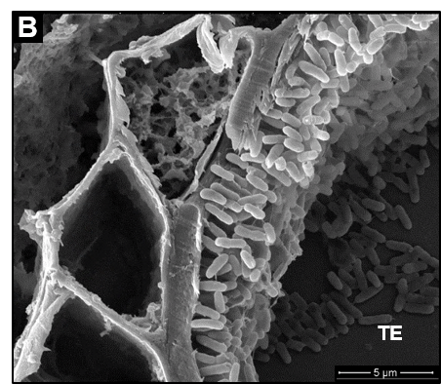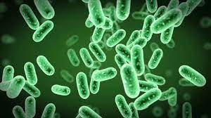
. (A) (B)
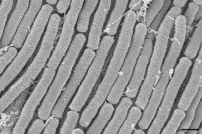

(C)
Figure No. 3.1. Photographs of A) Pseudomonas solanacearum, B) Bacillus megaterium, and C) Bacillus Cereus.
Scientific Classification
Pseudomonas solanacearum Bacillus megaterium Bacillus Cereus
Kingdom: Bacteria Kingdom: Bacteria Kingdom: Bacteria

Phylum: Pseudomonadota Phylum: Bacillota Phylum: Bacillota
Class: Betaproteobacteria Class: Bacilli Class: Bacilli
Order: Burkholderiales Order: Bacillales Order: Bacillales
Family: Burkholderiaceae Family: Bacillaceae Family: Bacillaceae
Genus: Ralstonia Genus: Bacillus Genus: Bacillus
Species: solanacearum Species: megaterium Species: sereus

Materials and Methods:
Preparation of Nutrient Agar Media: Nutrient agar media were prepared following standard protocols.

Composition of Nutrient Agar
Ingredients* | Amount (gm/L)
Beef extract | 3.0 gm
Peptone | 5.0 gm
Sodium chloride | 5.0 gm
Agar | 15.0 gm
Distilled water | 1000 mL
*Formula adjusted, standardized to suit performance parameters
- Dissolve the above ingredients in the appropriate volume of distilled water i.e., 28 gm dehydrated nutrient agar in 1000 mL distilled water.
- Heat with frequent agitation and boil for 1 minute to completely dissolve the powder.
- Sterilize the medium by autoclaving (121°C for 15 min)
- Once the nutrient agar has been autoclaved, allow it to cool but not solidify
- Pour nutrient agar into each plate and leave plates on the sterile surface until the agar has solidified.
Inoculation of microorganism: Bacillus megaterium, Bacillus cereus & Pseudomonas solanacearum was spread by spread plate method evenly onto the surface of the nutrient agar respective plates.
Creation of Holes: Once the plates dried completely, 6mm holes were made using a cork borer, with three holes per plate.
Preparation of Sample Solutions: Sample solutions A, B, C, D, E, and F were prepared at concentrations of 300 ppm, 600 ppm, and 800 ppm.
Pouring of Sample Solutions: 0.1 ml of each sample solution was poured into their respective labeled holes on the nutrient agar plates.
Incubation: The plates were incubated at 35°C for 3 days to allow the growth of Bacillus megaterium, Bacillus cereus, and Pseudomonas solanacearum respectively.
Measurement of Zones of Inhibition: After the incubation period, the zone of inhibition was observed after 3 days surrounding each hole. These were measured using a measuring scale. In Blank as well as control Sample we observed there is no bacterial growth.

Table-4: The antibacterial activity of synthesized compounds and imidacloprid against tobacco and tomato bacterial wilts at 300,600, 800 ppm.
Sr.  No. | Compound Name | Conc. in  ppm | Diameters of Zone of Inhibition MIC after 72 hrs. in mm
 |  |  | P.Solanacearum Bacterial wilt (Tobacco) | Bacillus cereus | Bacillus megaterium
1 | 1,3-Bis[(6-chloropyridin-3-yl) methyl]-N-nitroimidazolidin-2-imine (2) | 300 | 26 | 25 | 26
 |  | 600 | 24 | 25 | 28
 |  | 800 | 38.5 | 37 | 42
2 | 1-[(6-chloropyridin-3-yl) methyl]-3-[(2,6-dichloropyridin-3-yl) methyl]-N-nitroimidazolidin-2-imine (3) | 300 | 27 | 27 | 20
 |  | 600 | 35 | 26.5 | 29
 |  | 800 | 42 | 40.5 | 38
3 | 5-{[(2Z)-3-[(6-chloropyridin-3-yl)methyl]-2-(nitroimino) imidazolidin-1-yl]methyl} pyridine-3-carboxylic acid (4) | 300 | 25 | 20 | 22
 |  | 600 | 28 | 30 | 29
 |  | 800 | 39 | 35 | 39
4 | 5-{[(2E)-3-[(6-chloropyridin-3-yl)methyl]-2-(nitroimino) imidazolidin-1-yl]methyl} pyridine-2-carboxylic acid (5) | 300 | 29 | 18 | 15
 |  | 600 | 27 | 25 | 30
 |  | 800 | 43 | 34.5 | 40
5 | Imidacloprid | 300 | 22 | 21 | 18.5
 |  | 600 | 27 | 26 | 20.5
 |  | 800 | 37.5 | 36.5 | 28.5
6 | Control (Solvent) {acetone 1% and DMF 1% with Tween-20 0.1% solution} | 200 | 0 | 0 | 0
*Means of six replications

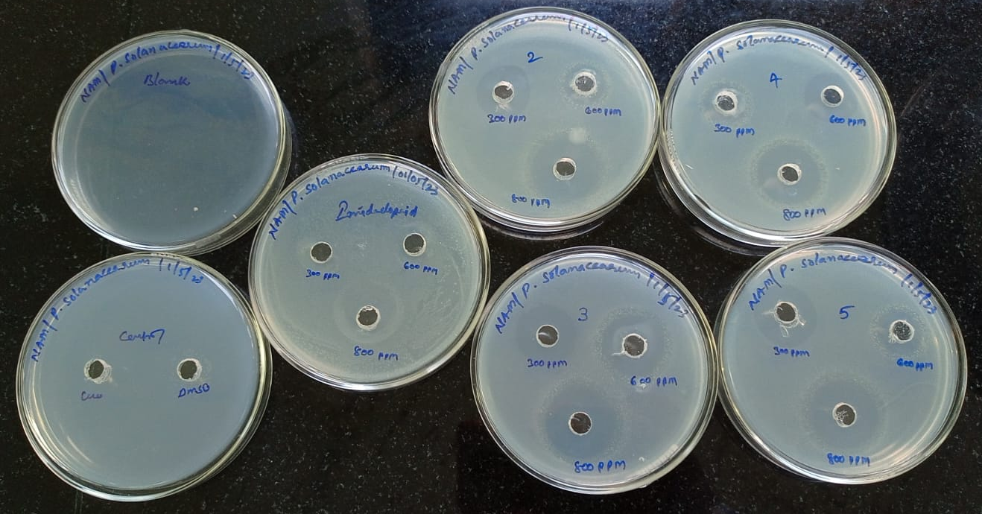
Figure 1.1. Photograph of Antibacterial activity of synthesized compounds against Pseudomonas solanacearum tomato bacterial wilt
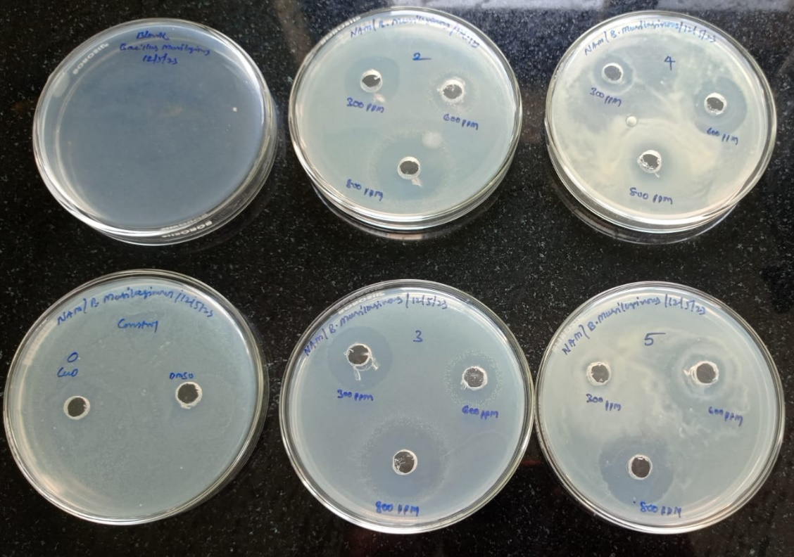
Figure 1.2. Photograph of Antibacterial activity of synthesized compounds against Bacillus cereus

Figure 1.3. Photograph of Antibacterial activity of synthesized compounds against Bacillus megaterium
Antibacterial Activity:
The synthesized molecules were evaluated for their antimicrobial activity against tobacco and tomato bacterial wilts was evaluated by a Disk diffusion method. All synthesized compounds showed more promising activity than Imidacloprid.
4B.6. CONCLUSION
A novel neonicotinoid derivatives 2-chloro-5-{[-2-hydrazinylideneimidazolidin-1-yl]methyl}pyridine were synthesized by the reaction of 1-[(6-chloropyridin-3-yl)methyl]-N-nitroimidazolidin-2-imine (Imidacloprid). . The structure of synthesized compounds was established and characterized by FTIR, ¹H NMR, ¹³C NMR and Mass spectral analysis and their insecticidal as well as antibacterial activities were assessed. The biological screening showed that the title compound shows better insecticidal activities against H. armigera (Hub) Mealybugs and Mango hopper nymphs and screened at 300,600,800 ppm. All synthesized compounds showed higher activity in Imidacloprid, The synthesized molecule also showed promising antibacterial activities against Pseudomonas solanacearum (e.g., Tobacco bacterial wilt and Tomato bacterial wilt) at a dose of 800 ppm. The obtained results are promising, which revealed that this work is useful for the new and effective pesticides useful in vector control management.
4A.6 Acknowledgement
The Authors express their thanks to the Department of Agrochemicals and pest management, Shivaji University, Kolhapur for providing research facilities.

4B.8. REFERENCES
- Jaglan M.S., Khokhar K.S., Malik M.S., Singh R. (1997). Evaluation of neem (Azadirachta indica A. Juss) extracts against American bollworm, Helicoverpa armigera (Hubner) J. Agric. Food Chem., 45,3262–3268
- Deshmukh. M.B., Patil S.H. Shripanwar C.S, (2012).Synthesis and insecticidal activity of some nicotinic acid derivatives, J. Chem. Pharm. Res., 4(1),326-332
- Rahimi V., Hajizadeh J., Zibaee A. (2018).Effect of Polygonum persicaria (Polygonales: Polygonaceae) extracted agglutinin on life table and antioxidant responses in Helicoverpa armigera (Lepidoptera: Noctuidae) larvae. J. Econ. Entomol. 111,662–671
- Arasu M.V., Al-Dhabi N.A., Saritha V., Duraipandiyan V., Muthukumar C., Kim S.J. (2013).Antifeedant, larvicidal, and growth inhibitory bioactivities of novel polyketide metabolite isolated from Streptomyces sp. AP-123 against Helicoverpa armigera and Spodoptera litura. BMC Microbiol. 13,105
- Liao M., Xiao J.J., Zhou L.J., Yao X., Tang F., Hua R.M., Wu X.W., Cao H.Q. (2017).Chemical composition, insecticidal and biochemical effects of Melaleuca alternifolia essential oil on the Helicoverpa armigera. J. Appl. Entomol. 141,721–728
- Abbaszadeh G., Srivastava C., Walia S(2014). Insecticidal and antifeedant activities of clerodane diterpenoids isolated from the Indian bhant tree, Clerodendroninfortunatum, against the cotton bollworm, Helicoverpa armigera. J. Insect. Sci. 14,1-13
- A.Guan, C.L.Liu, X.P.Yang, M.Dekeyser, (2014). Application of the intermediate derivatization approach in agrochemical discovery, Chem.Rev.114, 7079–7107
- H Gupta, (1999) Bio-assay: Insecticides, Toxilogy and uses, Agrotech Publishing Academy; Udaipur. 151-152,
- D Gupta; N Rawlin, (1996) Indian J. Ent. 28, 482-493.
- Wu J, Kang SH, Song BA, Hu DY, He M, Jin LH, Yang S: (2012) Synthesis and antibacterial activity against Ralstonia solanacearum for novel hydrazone derivatives containing a pyridine moiety. Chem. Cent. J.6, 28-10

