A review on the study of physicochemical properties and Application of surfactants
Benvikram Barmanª and Manoj Kumar Banjare^{b}
MATS School of Sciences, MATS University, Pagaria Complex, Pandri, Raipur (C.G.), 492004, India
------------------------------------------------------------------------------------------------
Abstract
This review article discusses the physical characteristics of surfactants and how crucial they are to contemporary science and technology. Surfactants are surface active agents, commonly referred to as "active at the surface." Surfactants are materials with an adsorption capacity at surfaces and interfaces. A distinct class of chemical substances is comprised of surfactants. Chemical surfactants come in a variety of forms and are typically categorised according to the charge of the surface-active molecules, which can be anionic, non-ionic, cationic, or amphoteric. Due to their superior physicochemical features and capacities for effective adsorption, solubilization, dispersion, suspension, and transportation, among other things, surfactants have been the subject of a lot of interest. By mixing the correct additives, such as “salts, polymers, co-solvents, ionic liquids, and other additives,” the characteristics of the surfactant self-assembled nanostructures can be successfully modified for desired applications. They have a “polar head group and a non-polar hydrophobic tail” as part of their structure. These nanostructures have shown a wide range of potential applications, nanoscience, pharmaceutics, including synthesis, catalysis, separation and extraction, etc. The primary capability of surfactant molecules is the formation of self-aggregating micelles, which give rise to the ability to use the surfactants. The study of surfactants opens up a variety of fields for employment, including “food, health, biological systems, and personal care goods, nanotechnology, petroleum and mineral processing” etc.
Keywords: Surfactants, micelle, CMC, self-aggregate, surfactants in biological system.
1.Introduction
Surfactants are “surface active agents”, commonly referred to as "active at the surface." Surfactants are materials with an adsorption capacity at surfaces and interfaces, when any two immiscible phases are connected by an interface and any one phase, such as air, is a gas, the interface is referred to as the surface [1-2]. The following are some illustrations of surfaces and interfaces: Liquid - Liquid, Solid - Solid, and Solid - Solid interfaces Liquid - Vapour (surface), are all possible. Surfactant molecules can lessen the surface tension between two liquids or between a liquid and a solid. These might serve as emulsifiers, dispersants, and wetting agents. A polar head group plus a non-polar hydrophobic tail group make up surfactants.
The following are some illustrations of surfaces and interfaces: Liquid - Liquid, Solid - Solid, and Solid - Solid interfaces Liquid - Vapour (surface), Surfactant monomers can join together to produce micelles, which are colloidal-sized clusters (CSCs) with sizes ranging from 1 to 100 nm, in liquids. Micelle formation occurs within the range of surfactant concentrations referred to as the critical micelle concentration (CMC) [3–4]. The surfactant monomers in the solution scatter below this concentration. Surfactant self-assembled nanostructures, such as conventional micelles, reverse micelles, and micro-emulsions, have major significance because of the broad variety of potential applications in several scientific and technical fields.
Water's surface tension can be decreased by surfactants and other amphiphilic compounds acting as surface active agents. As antiseptics, foaming agents, emulsifiers, dispersants, and corrosion inhibitors, surface-active compounds are often used [5]. Salts, co-solvents, polymers, ionic liquids, and other additives can be used with the right additives to successfully modify the properties of these surfactant self-assembled nanostructures for specific purposes.
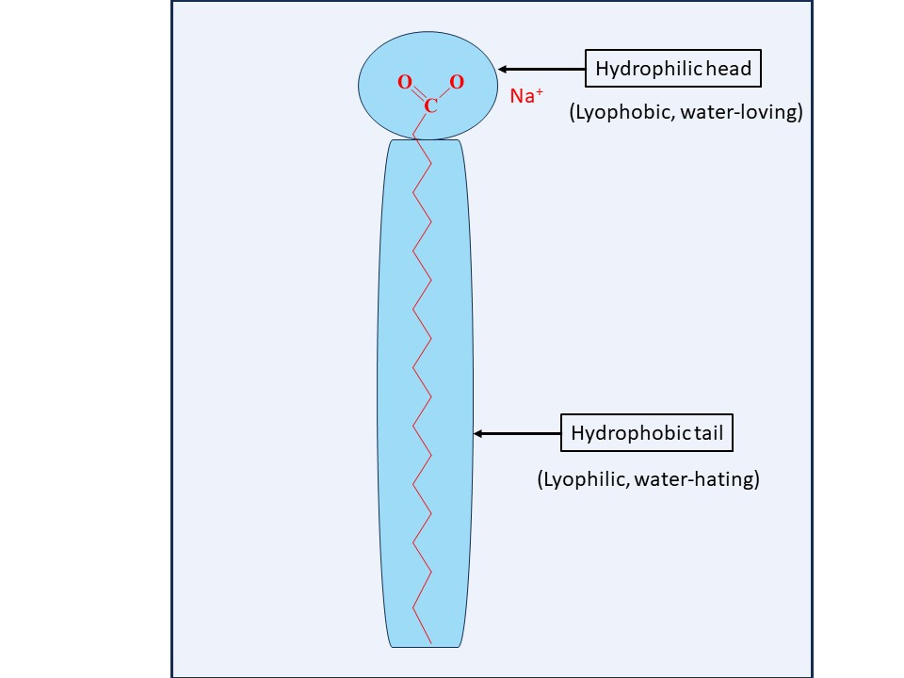

Fig-1 structure of surfactant molecule

2.Classified of surfactants
Surfactants are available in many forms, and are generally classified based on charge of the surface-active molecules such as anionic, non-ionic, cationic and amphoteric.
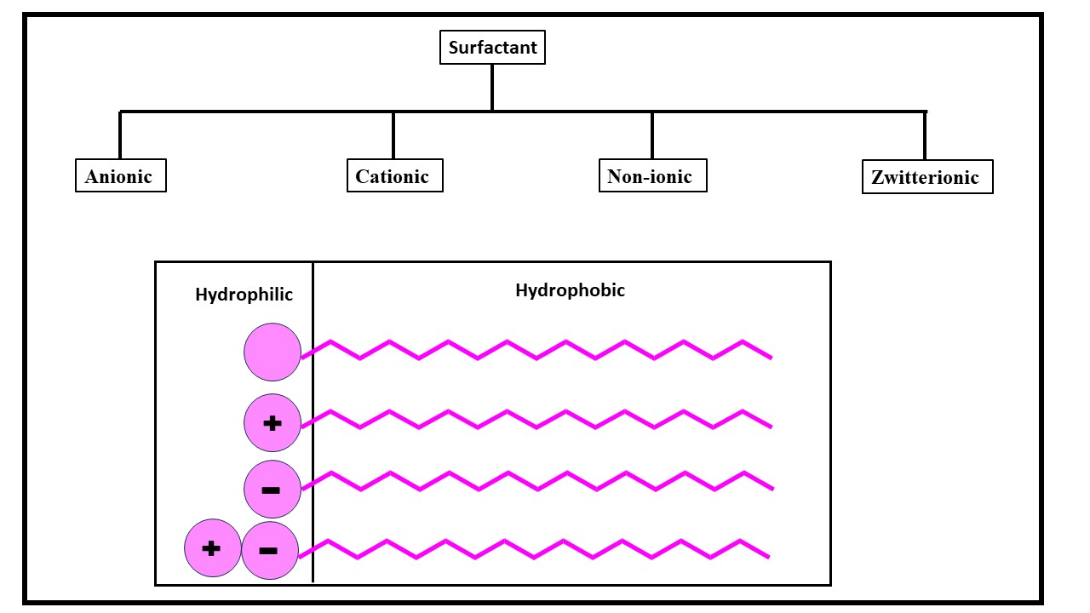
Fig:2 types of surfactants and their structure
2.1 The Anionic surfactants
Anionic surfactants are made up of anionic functional groups like sulphate, sulfonate, phosphate, and carboxylate. The majority of detergent formulations contain anionic surfactants, which we use more frequently than any other kind of surfactant. The best detergency is provided by alkyl and alkyl-aryl chains with a length of C12–C18 [6-7]. Soaps are anionic surfactants produced by saponifying natural oils and fats, making them the most prevalent type of surfactant. The metal salt of an alkali carboxylic acid that was originally generated from plant- or animal-based fats is referred to as "soap" in this context. The bulk of the time, the base of soap bars is a mixture of tallow and coconut fatty acids.
2.2 The Cationic surfactants
In this category, the hydrophilic element is positively charged. It sticks to surfaces and may have softening, antistatic, soil-repelling, antibacterial, or corrosion-inhibiting properties despite the fact that this group doesn't have any wash activity. In many typical uses, they serve as softeners (fabric softeners) and antistatic. The counter ion of cationic surfactants is often a halide or methyl sulphate [8]. The pH affects the primary, secondary, or tertiary amines.
2.3 The Non-ionic surfactants
Non-ionic surfactants contain hydrophilic elements that are not charged. These materials clean effectively and are unaffected by how hard the water is. They come from groups like fatty alcohol polyglycosides and alcohol ethoxylates and are typically discovered in cleaning detergents. Long chain alcohols have certain surfactant characteristics [9]. Fatty alcohols, cetyl alcohol, stearyl alcohol, cetostearyl alcohol (mostly made of cetyl and stearyl alcohols), and oleyl alcohol are the most prevalent types of these.
2.4 The Zwitterionic surfactants
A zwitterionic surfactant is made up of two groups (anionic and cationic) having diametrically opposed charges. Zwitterions are typically referred to as "amphoteric," yet both concepts are distinct. An amphoteric surfactant is one that undergoes a pH change from low to high and changes from a net cation to a net anion via Zwitterion. Only a small pH range allows the molecule to be Zwitterionic since neither the acidic nor basic sites are always charged. The physicochemical behaviour typically matches that of non-ionic surfactants at the isoelectric point [10]. A continuous transition towards the cation or anion character occurs below and above the isoelectric point, respectively. Outstanding dermatological abilities are associated with a subgroup known as Zwitterion. Examples of surfaces and interfaces include the following: Interfaces between solids, liquids, and solid-liquid Liquid - Vapour (surface); they have a mild irritant effect on the skin and eyes. They are perfectly suited for usage in shampoo and other personal care (cosmetic) products. Surfactants that include both cation and anion centres attached to the same molecule are known as zwitterionic (amphoteric) surfactants. The cation component needs to contain primary, secondary, or tertiary amines or quaternary ammonium cations.
Types of surfactants | Example | Uses
Anionic | Alkyl sulfates, soap, calsoft, texapon | 50% of overall industrial production, laundry detergent, dishwashing liquid, shampoos.
Cationic | Quaternary ammonium salts | Used together with nonionic surfactant but not with anionic, softness in textiles, anti-static additives.
Nonionic | Ethoxylated aliphatic alcohol, polyoxyethylene surfactants, triton x-100, span, tergitol. | 45% of overall industrial production, a wetting agent in coatings, food ingredients.
Zwitterionic | Betaines, amphoacetates. | Expensive, special use e.g. cosmetic.

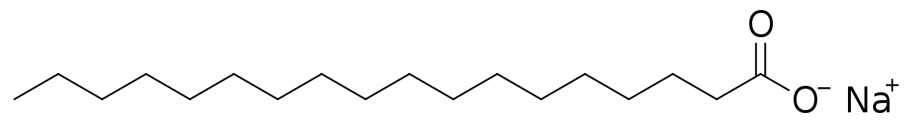

Sodium stearate
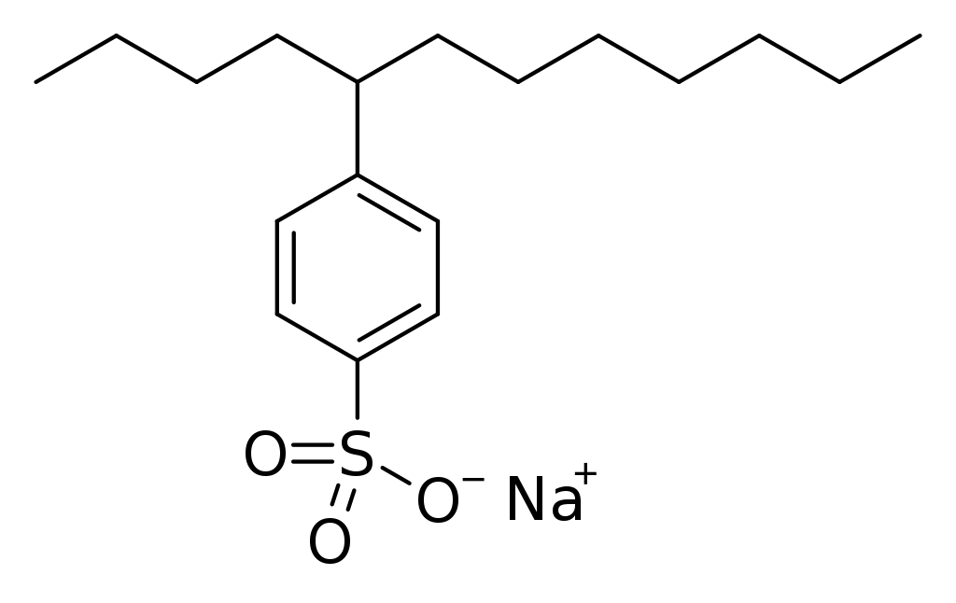
4-(5-Dodecyl) benzenesulfonate

Fig:3 Molecular structure of surfactants
3. Physicochemical properties of surfactants
Surfactant have their excellent physicochemical qualities and capacities for effective solubilization, dispersion, adsorption, suspension, and transportation, among other things, surfactants have drawn a lot of interest.
3.1 Hydrophilicity and Hydrophobicity of Surfactant Molecules
Surfactant molecules' hydrophilic functional group has a high propensity for interacting with polar substances including water, metals, and other ions. Surfactants commonly adhere to metal surfaces, block active areas such those near the exposure to corrosive fluids, and so restrain the attack of corrosion [11]. According to current beliefs, the structure of heterocyclic surfactant molecules dominates the surfactant adsorption mechanism. The surface aggregation concentration is the surfactant concentration at which a monolayer of molecules adheres to and covers a metal surface. The production of surface bilayers or multilayers is encouraged by an increase in surfactant concentration. At the solubility saturation point, surfactant molecules can also aggregate into clusters in the aqueous phase. At this stage, they usually direct their hydrophilic head groups towards water or hydrophilic surfaces and their hydrophobic tails towards other surfactant molecules.
3.2 “Surface Tension”
The end result of cohesive energy in molecules is "surface tension". In aqueous media, water molecules communicate with one another via hydrogen bonds and van der Waals forces. Above the air-water barrier, however, there is insufficient hydrogen bonding. The lack of interacting molecules in the air phase weakens Van der Waals interactions at the contact even further [12]. Because of this, molecules at the air-water interface are less likely to form bonds and have access to more energy than those in the bulk phase. Surface tension is produced by this extra energy. Accordingly, the term "surface-active agent," which reduces surface tension, is where the word "surfactant" originates. Surface tension is predicted to be higher in substances having higher cohesive energies between water molecules at the air-water interface.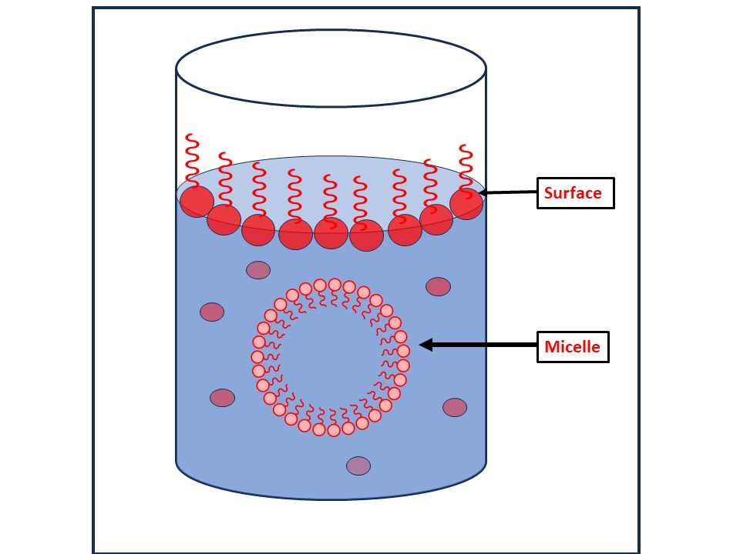
Fig-4 Solution of surfactant

3.3 Krafft point
Examples of surfaces and interfaces include the following: Interfaces between solids, liquids, and solid-liquid (surface) liquid-vapor Below the Krafft point, surfactant molecules in aqueous solutions do not significantly dissolve. Surfactants can form micelles at temperatures over the Krafft point, which considerably increases their overall solubility [13]. 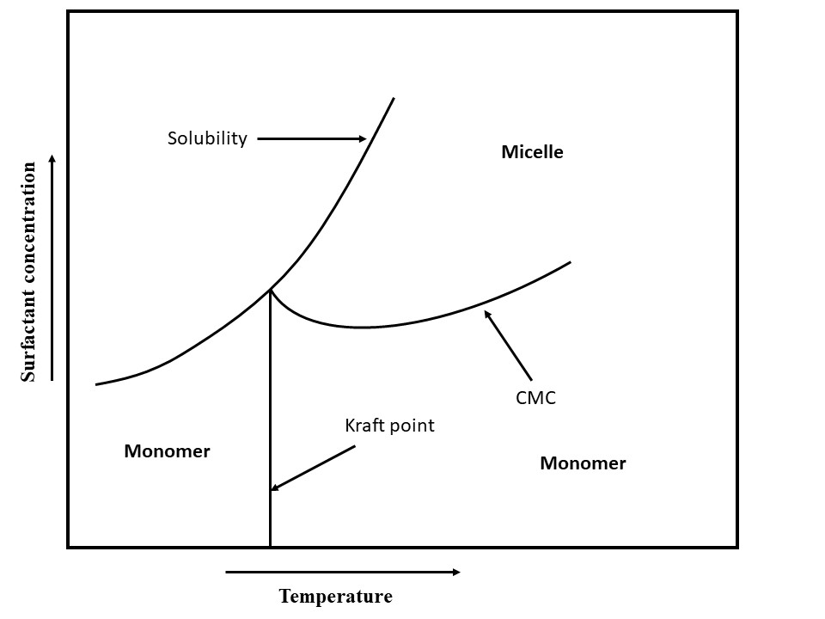
Fig-5 Temperature, total surfactant concentration, and their interactions with surfactant states are all compared. adjacent to the axes, arrows Point at the direction of the increase.
3.4 The Surfactant States
Liquid - Liquid, Solid - Solid, and Solid - Solid interfaces Liquid - Vapour (surface), Surfactants are capable of arranging themselves into several phases or states. Concentration and surfactant phase or condition are frequently closely related. The quantitative relationships between micelle concentration, related cmc, monomer concentration, and total surfactant concentration [14] demonstrate that monomeric surfactants form micelle-like structures when the concentration of the substance rises over the cmc. When a substance reaches the gel temperature, it can also form micelles and gels. The production of liquid crystals is another effect of surfactants. Between the solid and liquid crystal phases is the gel state. Some surfactants' solubility is restricted at high temperatures. There is less hydrogen bonding with water as a result of this drop [15], which is caused by higher energy levels and conformational changes in the surfactant's structure.
3.5 Microemulsions
Fluids that include micelles are similar to microemulsions. They are simply micelles that have been inflated and contain liquid droplets that range in size from 5 to 100 nm. Both an oil continuous phase with oil droplets inside of a water continuous phase with a surfactant shell and an oil continuous phase with water droplets inside of a surfactant shell are possible states in which they can exist. Microemulsions, which combine water, oil, and alcohol with an ionic surfactant, have many uses [16]. A microemulsion is a type of thermodynamically stable emulsion.
3.6 Adsorption at Surface
3.6.1 “Adsorption”
Adsorption of the surfactant is necessary for the surface to be covered with surfactants. a typical explanation for the ionic surfactant's adsorption on negatively and positively charged substrates.
3.6.2 Adsorption Isotherms
The Stern Adsorption model, the van der WaalsStern model, the Temkin model, the Freundlich model, the Frumkin model, the Flory-Huggins model, the Dhar-Flory-Huggins model, the Bockris-Swinkels model, and the Bockris-Devanathan Muller model are the most used adsorption models [17]. Regardless of whether adjacent sites are occupied, the Langmuir adsorption isotherm makes the assumption that all surface adsorption sites are comparable.
3.6.3 Adsorption Kinetics
The surfactant content in aqueous solution decreases with time as a result of desorption. Understanding the adsorption and desorption kinetics of surfactants is crucial in order to regulate the frequency of surfactant injections and ensure effective surfactant adsorption and surface coverage [18]. The extent and pace of adsorption of many surfactants are influenced by both the concentration of the surfactant and the concentration of competing ions. 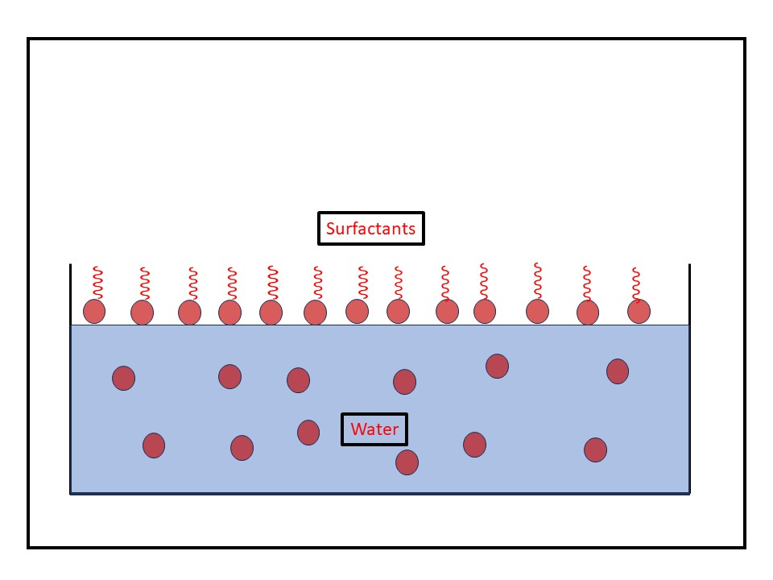
Fig-6 The adsorption of surfactant at the surface of water.

3.7 The Surfactant Partitioning Between Water and Oil
In water, oil, and their mixes, many surfactants molecule types form. Surfactant molecules have been discovered to be in equilibrium in a variety of distinct shapes in an oil and water solution. A surfactant can bind to solid surfaces to form dimers and micelles as well as interact with hydrogen ions or metal ions to produce hydrogenated compounds and metal salts. It can separate into aqueous and oil phases as well [19]. The surfactant monomers may prefer partitioning into the organic liquid until equilibrium between the two liquids is attained when an aqueous surfactant solution interacts with an immiscible organic liquid, such as oil.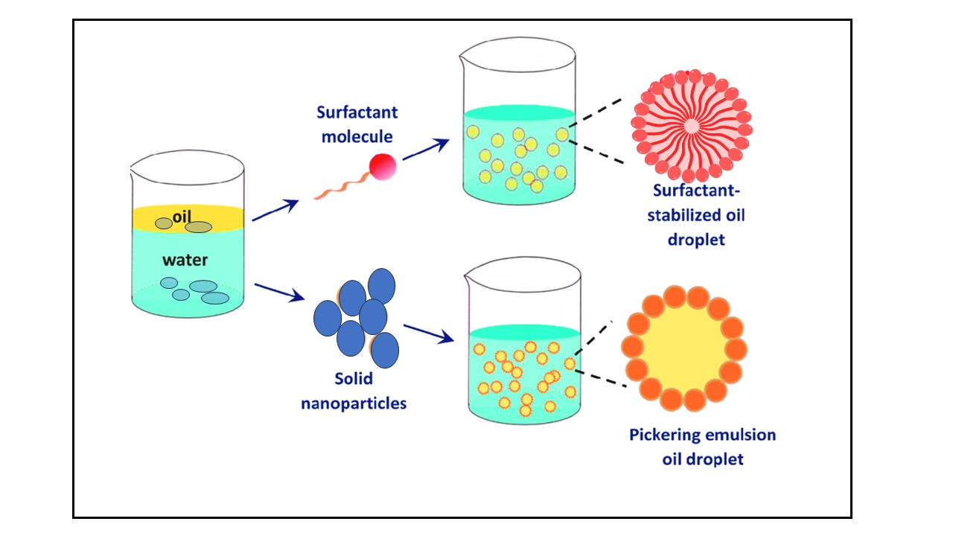
Fig-7 Surfactant as stabilizer oil/water.
3.8 The Surfactant Precipitate and Colloid Formation
Ionic surfactants frequently interact with other ions in solutions. When surfactants come into touch with reactive counter ions, they can react to create precipitates. When specific surfactants, such as carboxylates, interact with hydrogen ions to create carboxylic acid, oil droplets frequently form as a result. Furthermore, carboxylates can mix with positively charged species like calcium or magnesium ions to form colloidal, solid particles that are hydrophobic and behave like tiny wax particles. Water solubility is significantly decreased during the precipitation process that produces neutral molecules. However, nonpolar solvents like oils frequently make the hydrophobic colloidal precipitate particles liquid. Precipitation thus substantially favours the lipophilic or oil phase and has a very noticeable effect on phase partition [20]. Ionic surfactants interact with hydrogen ion, hydroxide ion, and other ions.
3.9 The Salt or Ion Effects on Surfactant Behaviour
Inorganic salt combinations commonly found in the aqueous phase of oil fields have an impact on corrosion inhibition by interfering with surfactant-related activities as aggregation, adsorption, partitioning, surfactant ion pair, and hydration. These procedures don't just contribute to metal corrosion in some ways [21]. In any modelling and experimental evaluation effort, this should be taken into account.
3.10 Micelle
Above the cmc, surfactant molecules are compelled to group together to form micelle-like structures. Usually, tens to hundreds of surfactant molecules make up a micelle. The aggregation number indicates how many surfactant monomers are present in a micelle. Simply multiplying the aggregation number by the molecular weight of the surfactant monomer yields the molecular weight of a micelle. The amount of surfactants that aggregate is influenced by a number of variables, such as temperature, the length of the hydrophobic chain, the characteristics of the head group, and the ionic strength. By lowering the interaction between ionic head groups and improving the hydrophobic tail's attraction to the aqueous medium, increasing ionic strength enhances the propensity for aggregation. Micelles, on the other hand, develop and disperse in milliseconds [22]. But as the surfactant concentration and the surfactant's size and properties change, these time scales drastically alter. Micelle aggregates can take the forms of vesicles, rod-like or cylindrical micelles, spherical micelles, hemimicelles, plate-like micelles, and more. The arrangement of the surfactant's hydrocarbon chain in a micelle is what determines its shape.
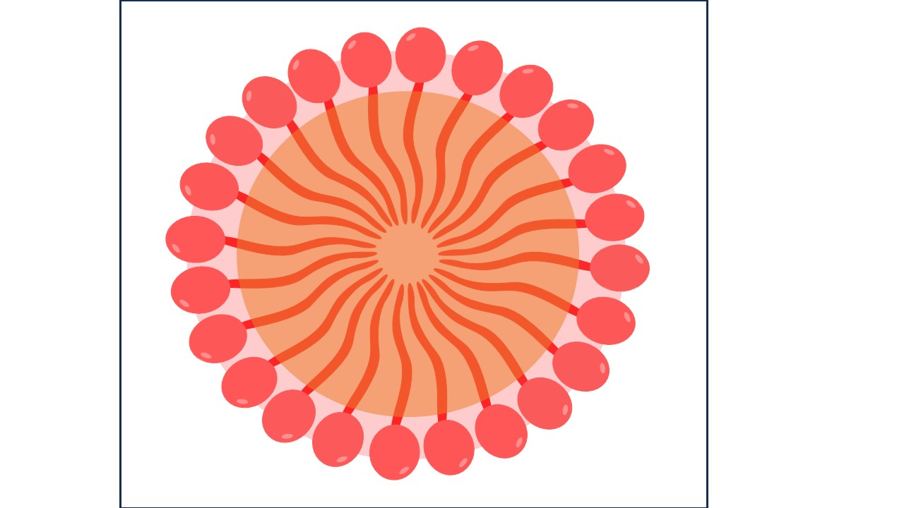
Fig-8 Micelle
3.11 Critical Micelle Concentration (CMC):
The concentration of surfactants (amphiphilic molecules) over which micelles form is known as the critical micelle concentration (CMC). Micelle nanoparticles are 5 to 100 nm in size. An essential quality of a surfactant is its CMC. These molecules begin to form the micellar structure at this concentration thanks to the reduction in free energy driving assembly. Temperature, pressure, and (in some cases strongly) the presence and concentration of additional surface-active compounds and electrolytes all affect the CMC value for a specific dispersant in a given medium [23]. Only at temperatures over the crucial micelle or Kraft temperature do micelles develop. Micelles cannot form below the Kraft temperature.

4. Applications of the “Surfactants”
The surfactant is a crucial component of cleaning, wetting, dispersing, emulsifying, foaming, and anti-foaming agents and is used in a wide range of goods, some of which are listed below:
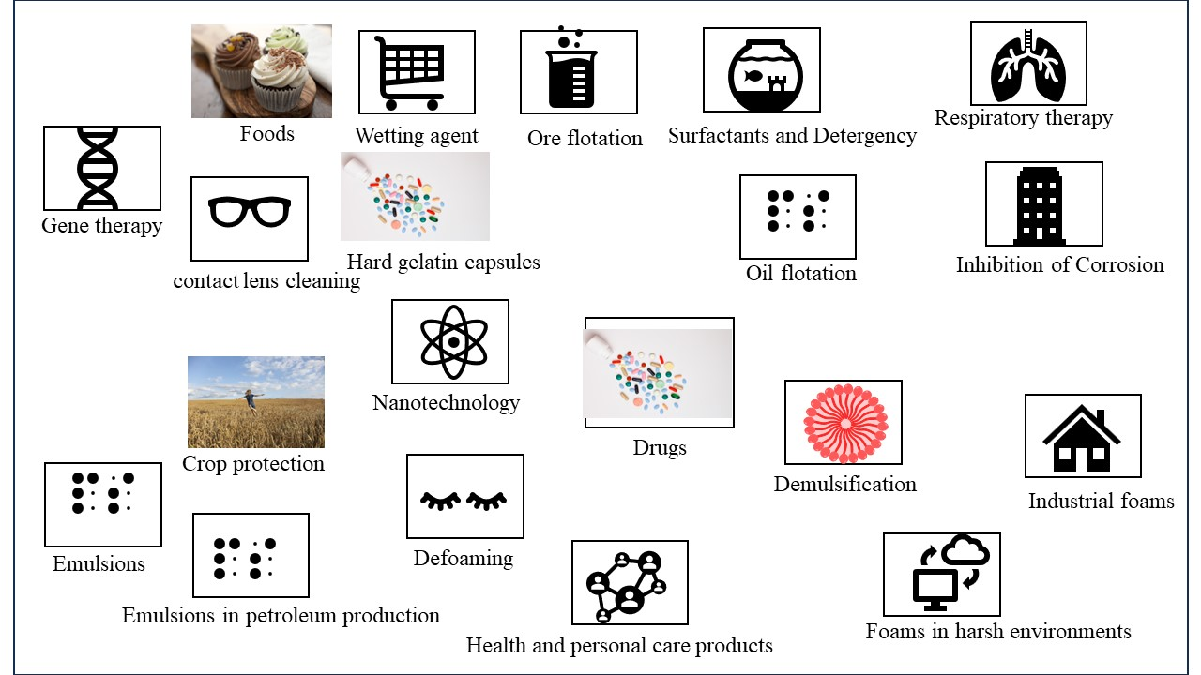
Fig: Application of surfactants
4.1 Surfactants in crop protection
4.2 Surfactants in foods
4.3 Surfactant and wetting
4.4 Ore flotation
4.5 Surfactants and detergency
4.6 Surfactants in respiratory distress therapy
4.7 Surfactants for contact lens cleaning
4.8 Surfactants in hard gelatin capsules
4.9 Solubilization of Drugs
4.10 Inhibition of Corrosion
4.11 Gene therapy
4.12 Surfactant in Nanotechnology
4.13 Surfactants in health and personal care products
4.14 demulsification.
4.15 Industrial foams.
4.16 Oil flotation.
4.17 Foams in harsh environments
4.18 Defoaming.
4.19 Emulsions
4.20 emulsions in petroleum production

4.1 Surfactants in crop protection
Pesticides, herbicides, fungicides, and insecticides are categorised as crop protection products. The stability and effectiveness of pesticides are significantly influenced by their formulation. Crop protection products are now being developed to be stronger, safer for users, less harmful to the environment, easier to use, and more effective when applied. Every application for sprayed materials is impacted by colloidal and interface science. Spray droplets initially strike the leaf's surface, creating a foliar deposit from which the pesticide either enters the leaf or comes into contact with the insect [24]. The spray pattern is affected by the applicator nozzle, the physical properties of the spray fluid, and the velocity of the sprayer vehicle. The effectiveness and retention of the droplets, the length of the deposit, and the readiness of the active component to enter the plant are all influenced by the formulation. Environmental factors like temperature, humidity, wind, sunlight, and rainfall can also affect effectiveness.
4.2 Surfactants in foods
Surfactants, which are also employed in the preparation of many everyday foods, facilitate processes such as the extraction of cholesterol, the solubilization of oils, the liquor emulsification, the avoidance of component separation, and the solubilization of essential nutrients. One well-known example is ice cream, a partially frozen froth that contains 40–50% air (by volume). The first step in creating ice cream is creating an emulsion. The homogenization process forces hot materials (milk fats, milk solids without fat, sweeteners, corn syrup solids, stabilizers/emulsifiers and other dry solids) through minuscule orifices at a moderate pressure (about 15 to 19 MPa). The constancy of droplet sizes results in end products that are smoother and more consistent, better whipping ability, and more stable fat droplets throughout time [25]. The fat droplet sizes shrink to 0.4 to 2.0 micrometres to provide a large surface area for protein adsorption, which in turn stabilises the emulsion to coalescence.
4.3 The surfactant & wetting
If a liquid drop has just a weak affinity for the surface, that is, if its surface tension is higher than the surface's critical surface tension (c), a bead will form on the surface. On the other hand, if it has a significant affinity for the surface, that is, if its surface tension is lower than c, it will spread and create a film. Teflon's essential surface tension is 18 mN m-1, while nylon's is around 46 mN m-1. In commercial settings, surfactants are frequently utilised as wetting agents, especially when applying the wetting liquid to a waxy or "wax-like" surface. In this context, the anionic surfactants are most frequently utilised [26].
4.4 In “Ore flotation”
Surfactants can be used to modify the contact angle, which affects a solid particle's capacity to float on a liquid medium. Making a needle float on the surface of water by coating it in wax is a common experiment in fundamental chemistry. The needle sinks when subsequent household detergent is introduced. The concepts are the same as those used in the flotation process, which treats raw mineral ores by adding a small amount of collector oil during the grinding and slurring stage. The collector oil, an anionic, cationic, or nonionic surfactant, affects the ore particles' capacity to hold moisture [27]. For oxide and carbonate ores, long-chain fatty acids are typically used, but for sulphide ores, organic xanthates and thiophosphates are frequently used. A foaming agent is frequently added to the suspension in practise in order to help the ore particles stick to the air bubbles when air is shot through it. When skimming is employed to extract the ore bits, they float to the surface. Sludge and effluents are purified using this type of flotation as well.
4.5 “Surfactants & The Detergency”
The definition of detergent action is the activity of the surfactants that assists in the removal of foreign material from solid surfaces by adsorbing at interfaces and lowering the energy needed to achieve the removal. At the proper interfaces, the most effective wetting agents frequently rapidly disperse and adsorb. A surface-active fatty acid salt having at least eight carbon atoms is soap, which has a long history of use as a detergent. When glyceride oils and fats are saponified with NaOH or KOH in the past to make soap, glycerol is created as a by-product. Despite the fact that soaps are excellent deodorizers, they are sensitive to acidic pHs and the hardness (Ca2+ and Mg2+ ions) of the water, which leads to soap scum. Synthetic detergents have mostly replaced soaps, yet the use of detergent producers will make up for this drawback [28]. The ingredients that are used to formulate commercial detergents account for the majority of the manufacturing of surfactants.
4.6 Surfactants in respiratory distress therapy
Neonatal respiratory distress syndrome, commonly known as hyaline membrane disease, affects premature newborns, and is treated with surfactant formulations as a replacement therapy. This lung condition, which causes 5000 fatalities annually, affects 20% of the 250,000 preterm infants born in the US each year. A severe lack of endogenous lung surfactant is the primary contributor to the pathophysiology of respiratory distress syndrome [29]. Lung surfactant preparations are used along with more oxygen and mechanical ventilation to improve gas exchange for the prevention or rescue treatment of newborn respiratory distress syndrome. Exogenous surfactants can be produced artificially or derived from animal products.
4.7 Surfactants for contact lens cleaning
Surfactants serve as cleaners by emulsifying lipid, oil, and inorganic deposits that have accumulated on contact lenses. By dabbing a few drops of solution onto the surface of the lens and gently rubbing it back and forth with the thumb and fingers, or by holding the lens in the palm of the hand and gently rubbing with a fingertip (20 to 30 seconds), surfactant agents are used in mechanical cleaning systems. Among the ingredients of these cleaners are frequently a non-ionic detergent, a wetting agent, buffers, and preservatives.
4.8 Surfactants in hard gelatine capsules
Poorly soluble benzoic acid was given as a loose powder by Pennings et al.24, and the same powder was also incorporated to size 00 and size 1 capsules. The size 1 capsule that had the most tightly packed powder broke down the least quickly. By adding 0.5% polyol surfactant to the mixture, this issue can be remedied. They demonstrated how this increased the rate of material disaggregation, which they used to show how the dissolving rate greatly increased as a result [30]. If hydrophobic compounds must be included in formulations due to filling machine requirements, wetting agents, or surfactants, can be added at levels of 0.1-0.5% to prevent their adverse effects on drug release.
4.9 Solubilization of Drugs
Surfactants play a significant part in modern pharmaceutical biotechnology since they are widely used in many therapeutic dosage forms to regulate qualities including wetting, stability, and bioavailability, among others. Regarding their capacity to solubilize hydrophobic medicines and their use in medication delivery, surfactants are crucial. Solubilization is the reversible interaction of a substance with the micelles of a surfactant in water to produce a thermodynamically stable isotropic solution with a decreased thermodynamic activity of the solubilized substance. The ability of surfactants to dissolve pharmaceuticals is influenced by a variety of variables, including temperature, pH, ionic strength, surfactant and drug chemical structures, and many others [31]. Cremophor EL, a non-ionic surfactant that has been utilised to solubilize a wide range of hydrophobic medications including anaesthetics, photo sensitizers, sedatives, immunosuppressive medicines, and anticancer treatments, merits special attention.
4.10 Inhibition of Corrosion
Surfactants' promising prospective use as corrosion inhibitors has been thoroughly researched during the past few years. It is common knowledge that surfactants have a propensity to collect together at interfaces and in solutions. The basic role of the surfactant functional group is to be adsorbed on the metal surface, which is essential for the suppression of corrosion. The capacity of the surfactant to aggregate to form micelles is generally directly tied to the adsorption of the surfactant molecules onto the metal surface, which was discovered to be responsible for the metal's corrosion inhibition [32]. According to the polarisation technique examination, SDS is an effective anodic inhibitor at low anodic overvoltages, and the inhibitor's adsorption followed the Langmuir isotherm.
4.11 Gene therapy
The idea behind gene therapy is to transfect cells with healthy DNA to replace damaged or missing genes. This process is known as transfection. To allow negatively-charged DNA to travel across hydrophobic membranes, many vectors contain a positive charge. It has proven challenging to foresee a vector's efficiency, nevertheless. To allow negatively-charged DNA to travel across hydrophobic membranes, many vectors contain a positive charge [33].
4.12 Surfactant in Nanotechnology
Surfactant molecules can self-assemble into a variety of nanostructures, including spherical/rod-shaped micelles and lamellar sheets, thanks to their amphiphilic nature. It is conceivable to design a surfactant package using surfactant nanotechnology that can solubilize significant amounts of oil while vigorously wetting the casing. Surfactant mixes can be used to create in-situ oil-in-water microemulsions, enabling the wetting of surfaces [34]. This might make it possible to get rid of dangerous chemicals.
4.13 The Surfactants in “Health & Personal Care” products
Detergents also use cationic quaternary ammonium surfactants (quats), which have strong germicidal activity, as fabric softeners. Ditallow dimethyl ammonium chloride (DTDMAC), a fabric softener and antistatic, is the most widely used. Germicides, such as benzalkonium chloride, frequently have a N-alkyldimethylbenzylammonium chloride structure, in contrast to emulsifiers, which frequently have a N-alkyltrimethylammonium chloride or N-alkylimidazoline chloride configuration. What has made "natural" cosmetics so well-liked is the notion that they are more pure, secure, and efficient. While many products claim to be "natural" or "herbal," in reality they just include herbal extracts that have been added for marketing purposes [35–36]. The following requirements—light detergency, good foaming, passable conditioning, adequately maintained—are frequently satisfied when making shampoo. Although there are no requirements for "natural" shampoo, it may have the following ingredients: no toxic chemicals, use of plant- or plant-based surfactants, and only natural additions (such as xanthan gum as a viscosity builder) and preservatives (such as alkylpolyglucosides as an antimicrobial). The term "natural surfactant" can be used to describe a surfactant that was chemically synthesised from one as well as one that was extracted directly from a natural source [37, 38]. New emulsion formulation processes are essential for cosmetic formulations, especially for their preservation capabilities. The incredibly small droplet sizes and exceptional stability of the phase inversion temperature (PIT) emulsion and microemulsion set them apart from other types of emulsions. A transparent, aesthetically pleasing O/W formulation can be made with the use of microemulsions.
4.14 Demulsification.
Occasionally occurring emulsions can be unpleasant. Chemical demulsification is frequently used in process industries to separate water from oil and generate a fluid suitable for further processing. Even within the same business, the precise sort of emulsion treatment need can differ greatly. Identifying the emulsion's nature (O/W, W/O, or multiple emulsion), the amount and kind of immiscible phases, the presence of a protective interfacial layer around the droplets, and the sensitivity of the emulsifiers is the first stage in systematic emulsion breaking. Surfactants are frequently categorised as demulsifiers [39] based on their chemical make-up. Alkylphenol ethoxylates, alkyl sulfonates, alkyl aryl sulfonates, soaps, glyceryl esters, fatty acid esters, fatty alcohols, and other detergents are examples of demulsifier surfactants.
4.15 Firefighting foam
Refineries and offshore production platforms are just two examples of the countless industrial operations that involve the shipping, processing, or handling of flammable petroleum liquids. Firefighting foams have developed into specialised and commonly used systems since their original debut in the early 1900s. By suffocating a fire, preventing air from coming into touch with flammable vapours, separating flames from the fuel surface, and cooling the fuel and its surface, firefighting foams work to put out a fire. The "low expansion" foams that are used to put out fires typically contain between 75 and 97 percent air [40]. Foam is chosen based on its capacity to expand and put out fires as well as more conventional attributes including static half-lives, salt tolerance, toxicity, and resilience against decomposition.
4.16 The “oil flotation”.
Oil and bitumen flotation, which produces an oleic foam, is more reliant on attachment and filmmaking than mineral ore flotation, which depends on wettability alteration and bubble attachment [41]. Surfactants are essential for the separation of bitumen from mineral particles and subsequent flotation of the former in the hot water flotation process used commercially in Canada to recover bitumen from oil sands.
4.17 The Foams in harsh “environments”.
In order to restrict the fluids' movement after injection or to block particular zones or channels, foams can be injected into a petroleum reservoir. As a result, injected fluids are diverted into different sections of the reservoir. A number of gases, including air/nitrogen, hydrocarbons, carbon dioxide, or steam, can be used to form acceptable foams for injection [42].
4.18 Defoaming.
Foam breakers or defoamers are substances that function to lessen a system's foam stability, whereas foam preventatives or foam inhibitors work to stop foam from forming in the first place. Such compounds are many; Kerner 331 lists over a hundred different foam inhibitor and foam breaker compositions. Even if these substances aren't often surfactants in and of themselves, they are nonetheless relevant since in each and every instance the reason for the decreased foam stability can be linked to numerous modifications made to the characteristics of the surfactant-stabilized interface [43].
4.19 Emulsions
A mixture of “oil and water” is called an emulsion when one of the phases, the dispersed phase, is present as a dispersion of droplets inside the continuous phase. The droplet diameters can range from a few nanometers to hundreds of micrometres, but they are commonly in the range of 0.1 to 100 m. The two most popular emulsion types, O/W (oil/water) and W/O (water/oil), are easily distinguishable.
4.20 “Emulsions” in petroleum production.
As part of an improved oil recovery process, chemicals may be injected into oilfields after the primary and secondary cycles of oil recovery. To drive out surplus oil, this procedure may entail creating in-place emulsions in the reservoir [44]. The relative oil and water saturations in a petroleum reservoir are determined by the distribution of pore sizes in the rock.

5. Conclusion
Surfactants hold certain beneficial properties; their use in everyday life becomes nearly indispensable. The wide applications of surfactants such as Surfactants are among the most essential ingredients encountered in laundry detergents, dishwashing detergents, liquid soaps, cleaning products, cosmetic hair care and personal care products etc. these are the main applications of the surfactants.
Acknowledgments
The authors gratefully acknowledge the department of chemistry mats university Raipur (C.G.).

References
1. Attwood D, Florence AT. (1983). Surfactant systems; Their Chemistry, Pharmacy and Biology. London: Chapman & Hall, 1140-1141.
2. R. Azarmi and A. Ashjaran,( 2015). Type and application of some common surfactants, Journal of Chemical and Pharmaceutical Research,7 (2): 632-640.
3. Rosen M. j., kunjappu J. T., (2012), Surfactants and Interfacial Phenomena. 4th ed. John wiley and sun. inc.

4. I. Cattaneo, M.C. Astuto, (2023). Surfactants, anionic and non-ionic, J. Reference Module in Biomedical Sciences.
5. Colby L. Presley, Michelle Militello, Cara Barber, Ryan Ladd, Melissa Laughter, Heather Ferguson, Jesse Dewey, Kayd J. Pulsipher, Chandler W. Rundle, Cory A. Dunnick, The History of Surfactants and Review of Their Allergic and Irritant Properties, Dermatitis, , 32, 5, (289-297), (2021).
6. Juan Wu, Ping Mei, Wu Chen, Zhong‐Bao Li, Qing Tian, Qi‐Xiang Mei, (2019)., Surface Properties and Solubility Enhancement of Anionic/Nonionic Surfactant Mixtures Based on Sulfonate Gemini Surfactants, Journal of Surfactants and Detergents, 22, 6, (1331-1342),
7. Shenyuan. Yang. And khaledi m.g., (1995), Chemical Selectivity in Micellar Electrokinetic Chromatography: Characterization of Solute-Micelle Interactions for Classification of Surfactants,J. analytical chemistry, 67, 3, 499–510
8. Rui A. Gonçalves, Krister Holmberg, Björn Lindman, (2023), Cationic surfactants: A review, j. molliq. 375, (121335).
9. Gary E. Petrowski, John R. Vanatta, (1973), Gas chromatographic determination of hydrophile‐lipophile balance of nonionic emulsifiers, Journal of the American Oil Chemists' Society, , 50, 8, (284-289),.
10. Zhou, M., Li, S., Zhang, Z. et al. Progress in the Synthesis of Zwitterionic Gemini Surfactants. J Surfact Deterg 20, 1243–1254 (2017).
11. Chandrabhan Verma ª, M.A. Quraishi ª, K.Y. Rhee , (2022), Hydrophilicity and hydrophobicity consideration of organic surfactant compounds: Effect of alkyl chain length on corrosion protection, j. advance and colloidal sci. interface, 306,102723
12. Hanae Kawamura, Naoto Yoshino, Kazuyuki Murakami, Hideki Kawamura, Ikumi Sugiyama, Yutaka Sasaki, Takashi Odagiri, Yasuyuki Sadzuka, Yasushi Muraki, (2023), The relationship between the chemical structure, physicochemical properties, and mucosal adjuvanticity of sugar-based surfactants, European Journal of Pharmaceutics and Biopharmaceutics, j.ejpb, 182, (1-11),
13. Tiren Gu, Johan Sjöblom, (1992), Surfactant structure and its relation to the Krafft point, cloud point and micellization: Some empirical relationships, J. Colloids and Surfaces, Volume 64, Issue 1, , Pages 39-46,
14. Daniel Otzen, (2011), Protein–surfactant interactions: A tale of many states, J. Biochimica et Biophysica Acta (BBA) - Proteins and Proteomics,Volume 1814, Issue 5, Pages 562-591,
15. Kurepa, D., Perveen, S., Lipener, Y. et al. The use of less invasive surfactant administration (LISA) in the United States with review of the literature. J Perinatol 39, 426–432 (2019).
16. Wanguo Hou, Jie Xu, (2016,) Surfactant-free microemulsions, J. Current Opinion in Colloid & Interface Science, Volume 25, Pages 67-74,
17. Rosen, M. J. (2004). Surfactants and Interfacial Phenomena. Germany: Wiley, 500.

18. R. Miller, G. Kretzschmar, (1991), Adsorption kinetics of surfactants at fluid interfaces, J. Advances in Colloid and Interface Science, Volume 37, Issues 1–2, Pages 97-121,
19. K. Shinoda, T. Nakagawa, B-I. Tamamushi and T. Isemura,( 1963). Colloidal Surfactants, Some Physicochemical Properties, Academic Press, New York.
20. S. Ross and I. D. Morrison,( 1988). Colloidal Systems and Interfaces, Wiley, New York, NY.
21. Håkan Wennerström, Björn Lindman, (1979), Micelles. Physical chemistry of surfactant association, J. Physics Reports, Volume 52, Issue 1, Pages 1-86,
22. [22] K. Shinoda, T. Nakagawa, B-I. Tamamushi and T. Isemura,( 1963). Colloidal Surfactants, Some Physicochemical Properties, Academic Press, New York.
23. R. J. Williams, J. N. Phillips and K. J. Mysels (1955), The critical micelle concentration of sodium lauryl sulphate at 25° C, J. Trans. Faraday Soc., ,51, 728-737
24. Tatiana Cardoso Damato ª, Letícia D.M. Carrasco ^{b}, Ana Maria Carmona-Ribeiro ^{b}, Ricardo Vagner Luiz ^{c}, Roberta Godoy ^{c}, Denise F.S. Petri ª (2017), The interactions between surfactants and the epicuticular wax on soybean or weed leaves: Maximal crop protection with minimal wax solubilization, J. Crop protection., 91, 57-65.
25. Taiki Miyazawa, Mayuko Itaya, Gregor C Burdeos, Kiyotaka Nakagawa, Teruo Miyazawa, A Critical Review of the Use of Surfactant-Coated Nanoparticles in Nanomedicine and Food Nanotechnology, J. International Journal of Nanomedicine, Volume 16, (3937-3999), (2021).
26. Lilla Landeck, Lynn A. Baden, Swen Malte John, (2019)., Detergents, Kanerva’s Occupational Dermatology, (1131-1143),
27. Somasundaran, P., Wang, D. (2006). Solution Chemistry: Minerals and Reagents. Netherlands: Elsevier Science.
28. Haruhiko Arai, Study of detergency. I. Effect of the concentration and the kind of detergent in hard water, Journal of the American Oil Chemists' Society, 43, 5, (312-314), (1966).
29. M Griese (1999), Pulmonary surfactant in health and human lung diseases: state of the art., J. European Respiratory Journal Jun, 13 (6) 1455-1476;
30. F. H. Pennings, B. L. S. Kwee & H. Vromans (2006) Influence of Enzymes and Surfactants on the Disintegration Behavior of Cross-Linked Hard Gelatin Capsules During Dissolution, J. Drug Development and Industrial Pharmacy, 32:1, 33-37,
31. Amélia M. Silva, Carlos Martins-Gomes, Tiago E. Coutinho, Joana F. Fangueiro, Elena Sanchez-Lopez, Tatiana N. Pashirova, Tatiana Andreani, Eliana B. Souto, Soft Cationic Nanoparticles for Drug Delivery: Production and Cytotoxicity of Solid Lipid Nanoparticles (SLNs), J. Applied Sciences, 9, 20, (4438), (2019)
32. Industrial Applications of Surfactants IV. (2014). United Kingdom: Elsevier Science.
33. Taksim Ahmed, Amany O Kamel & Shawn D Wettig (2016), REVIEW, Interactions between DNA and Gemini surfactant: impact on gene therapy: part I, J. Future medicine, NANOMEDICINE VOL. 11,
34. Marcia Nitschke & Crisiane Aparecida Marangon (2022) Microbial surfactants in nanotechnology: recent trends and applications, J. Critical Reviews in Biotechnology, 42:2, 294-310,
35. [35] JW Mc Bain, ECV Cornish, Bowden RC (1912) Studies of the constitution of soap in solution: sodium myristate and sodium laurate. J. Chem. Soc., Trans., 101: 2042–2056.
36. Xuejiao Wang, Yuting Liu, Tongyue Wu, Biaofeng Gu, Hao Sun, Huanling He, Haiqin Gong, Hu Zhu, (2023)., A win-win scenario for antibacterial activity and skin mildness of cationic surfactants based on the modulation of host-guest supramolecular conformation, Bioorganic Chemistry,134, (106448),
37. L. L. Schramm, E. N. Stasiuk, D. Gerrard Marangoni, (2003). Surfactants: and their applications. Annu. Rep. Prog. Chem., Sect. C, 99, 3.
38. Kenia Barrantes, Mary Fuentes, Luz Chacón, Rosario Achí, Jorge Granados-Zuñiga, María José Alvarado, Luis Somarribas, José Vázquez-Tato, M. Pilar Vázquez-Tato, Julio A. Seijas, Víctor Soto Tellini, (2019), Synthesis and Evaluation of Aromatic Surfactants as Potential Antibacterial and Cytotoxic Agents, J. Letters in Organic Chemistry, 16, 6, (478-484),
39. Surfactants in Personal Care Products and Decorative Cosmetics. (2006). United Kingdom: CRC Press.
40. Sheng, Y., Jiang, N., Lu, S. et al. (2020) , Study of Environmental-Friendly Firefighting Foam Based on the Mixture of Hydrocarbon and Silicone Surfactants. Fire Technol 56, 1059–1075
41. [41] J. P. Tatum, (1988). in Chemicals in the Oil Industry, ed. P. H. Ogden, Royal Society of Chemistry, London, p. 31.
42. Sun L. , Bai B. , Wei B. , Pu w. , Wei P. , Li D. , Zhang C. (2019), Recent advances of surfactant-stabilized N₂/CO₂ foams in enhanced oil recovery, j.fuel, 241, 83-93.
43. Pugh R.J., (1996), Foaming, foam films, antifoaming and defoaming, advances in colloid and interface science, 64,67-142.
44. Bobby Haney, Dong Chen, Li-Heng Cai, David Weitz, Subramanian Ramakrishnan, (2019). Millimeter-Size Pickering Emulsions Stabilized with Janus Microparticles, Langmuir, 35, 13, (4693-4701),

