Transgenic Fish and its Progress
Dr. Bireshwar Bera
Associate Professor
Department of Zoology
St. Joseph's College (University Section), Lebong Cart Road, North Point, Darjeeling, W.B., India. Orcid id: https://orcid.org/0000-0001-6930-9653

Abstract
Transgenic fishes serve as excellent experimental models for basic scientific investigations as well as biotechnological applications. Transgenic fish of both cold water and warm water are fast growing and disease resistant species have been produced in various laboratories throughout the world including India. From the aspect of biotechnological applications, for scientific investigations, environmental toxicology and compensate for human needs the development of transgenic fish can serve as excellent experimental models. In the field of aquaculture and to support economic efficiency GH gene transgenic fish will be of great importance in the field of future biotechnology. For the fish farmers and human being transgenic fish are more economical, efficient food source and recreation.
Introduction:
According to Ponzoni and Nguyen [1], introduction of exogenous genetic material (DNA) into a host genome for its stable maintenance, transmission and expression is termed as Transgenesis. During the period of 1984 and 1985 the first successful production of genetically modified transgenic fish was carried out with rainbow trout and goldfish and more than 35 aquatic animal species have been produced through transgenesis. A transgenic fish is one which contains improved variety one or more desirable foreign gene for the purpose of enhancing desirable fish quality, growth, resistance and productivity. Generally in transgenic process, desirable genes of one or more donor-species are isolated, and spliced into artificially constructed infectious agents, practically act as vectors to carry the genes into the cells of recipient species. The vector carrying the genes inside a cell will insert into the cell’s genome through molecular techniques. From each transformed cell (or egg, in the case of animals) transgenic organism is regenerated which has taken up the foreign genes and a transgenic variety can be bred from that organism. Through this technique, genes of interest can be transferred between distant species, which would never interbreed in nature.
The application in the field of genetic engineering and rDNA technology to animals could provide numerous benefits, including the possibility of a safer, cheaper food supply and medical and industrial research. The transgenic fish as the first marketable transgenic animals for human consumption to increase aquaculture production. Fishes have higher levels of genetic variation and hence more scopes for cultivation and genetic improvement are there than other terrestrial animals.
Through Auto-transgenesis scientists of India are able to develop transgenic fish involving increases the copies of GH genes, leads to increase flesh content of fish. In Auto-transgenesis process generation time is shorter whereas breeding frequency is relatively higher in most of the fish species. The advantage of this process are production of a large number of genetically identical eggs by a single female fish and external fertilization which can be easily controlled by experimentally. Most disadvantage is the scarcity of piscine transgene but more than 8500 genes and cDNA are isolated, characterized and cloned through advanced molecular biology throughout the world [2].
Basic Concept For transgenic fish production following steps to be taken for gene transfer:
(1) Isolation of desired gene sequence of particular characteristics; for example, growth hormone gene.
(2) Later on, the desired gene or gene sequence are inserted into a circular DNA popularly known as plasmid Vector by using enzymes endonucleases and ligases.
(3) Plasmids are take in the bacteria for production billions of copies of gene.
(4) Plasmids are introduced into linear DNA, sometimes called a gene cassette as it contains several sets of genetic material including new inserted gene (e.g., GH gene). To develop individual (e.g., fish), the available technology is to integrate genes in germ line and finally transmitted generation to generation.
(5) Making the stable information, a permanent part of fish’s genetic makeup.
Transgenic Fishes: Gene Transfer Technology
In the field of fish biotechnology, the most commonly used methods are chromosome manipulation and hormone treatments, through which triploid, tetraploid, haploid, gynogenetic and androgenetic fish can be produced. The most acceptable and modern techniques for transfer gene in fish are microinjection, electroporation of sperms and eggs and incubation of sperms.
The principal steps of Gene transfer:
A. Preparation of DNA Construct:
The transgene of desired properties is constructed in plasmid vector called recombinant gene or DNA construct has an appropriate promoter-enhancer and structural DNA sequence.
The foreign genes are introduced with strong genetic signals, promoters and or enhancers enabling to express the foreign genes at very high levels continuously or constitutively and of the transgenic organism resulting from the trans­formed cell.
Transgenes are of three main types according to function:
(1) Gain-of-Function:
In transgenic individual transgenes are able to increase particular function after their expression. GH transgene are produced through growth hormone genes from mammal and fish linked to appropriate promoter-enhancer element and a structural DNA sequence. The expression of GH transgene in the transgenic individuals increases the production of growth hormones which leads to enhanced growth of transgenic animal.
(2) Reporter Function:
These transgenes are able to identify and measure the strength of promoter-enhancer element.
(3) Loss of Function:
The transgene produced in such a way are used for interfering with the expression of host genes not yet used for modification of transgenic fish. These type of promoter-enhancer elements of transgenes are linked to a growth hormone gene of fish, hence transgenic fish contain extra DNA sequences that are originally derived from same species. The constructed gene is then introduced into fertilized egg or embryo, so that transgene be linked to genome of each cell of egg or embryo.
B. Microinjection Procedure of Gene Transfer:
Most successful and widely used technique for gene transfer is Microinjection involves the use of fine injection needle for introducing DNA into cut site in the cell. During this technique it destroys those cells that are in direct contact with the injected DNA. It should be ensure that the integration of the DNA is properly injected to intact cells close to the cut site. The instruments used for microinjection technique comprising a dissecting stereomicroscope and two micromanipulators including one with a glass micro-needle for delivering transgene and other with a micropipette for holding fish embryo in proper place.
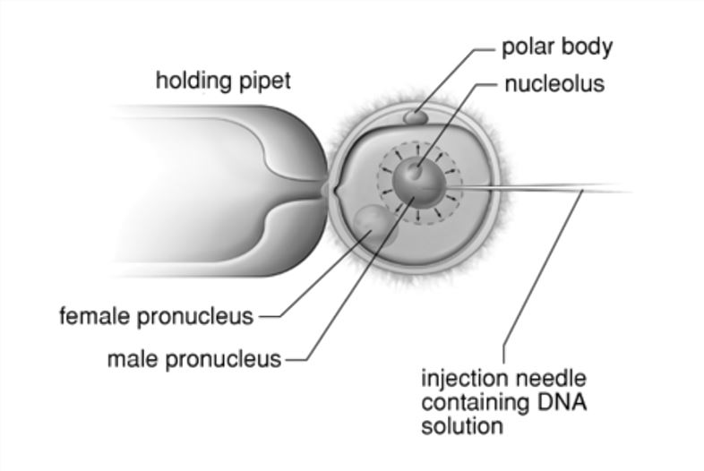
Fig: Micro-injection Apparatus to introduce DNA
By depending upon the chorion of egg membrane, where softness of the membrane facilitates successful microinjection and the thick membrane limits the injection of DNA. The chorion in many fishes gets tough and hard just after the fertilization or to contact with the water and provides a difficulty in injecting the DNA (Atlantic salmon and rainbow trout).
To overcome this problem following methods can be useful:
(1) Insertion of the injecting needle through micropyle of the egg.
(2) Opening on the chorion through microsurgery.
(3) Chorion membrane digestion with enzymes.
(4) Initiation fertilization and softening of chorion by using 1mM glutathione.
(5) The unfertilized eggs will be injected directly.
(6) Intra-nuclear microinjection by using a fine needle to deliver DNA into cell or even nuclei.
Steps of Microinjection Technique:
(1) At the optimum conditions desired eggs and sperms are stored separately.
(2) Initiation of fertilization by adding water and sperms.
(3) Eggs are dechorionated by trypsinization after ten minutes of fertilization.
(4) Microinjection of fertilized eggs done with desired DNA within a few hours of fertilization. Releasing of DNA takes place into the centre of the germinal disc to the first cleavage in dechorionated eggs. The estimated time for microinjection required is first 25 minutes between fertilization and first cleavage.
(5) The embryos are incubated in water after microinjection until hatching takes place.
So, depending of the fish species survival rates of microinjection seems to be 30-80%.
Merits or Advantages of Microinjection Technique:
(1) To increase the chances for integrative transformation optimum quantity of DNA can be delivered per cell.
(2) Precision of DNA delivery into nuclei of target cell improving chances for integrative transformation.
(3) The small structure can be injected.
(4) Host range independent is a direct physical approach.
Demerits or Disadvantages of Microinjection Technique:
(1) Time consuming process as single cell can be injected at a time.
(2) Specialized skills and sophisticated instruments is required.
(3) Injection to more eggs is limited due to restricted time.
(4) Transformation rate is low.
C. Electroporation Process of Gene Transfer:
Electroporation is reliable, easiest, fast and convenient method for transferring gene. Permeation through cell membrane a chain of electrical impulses taken place and thereby allowing the entry of DNA into fertilized eggs. The cell membrane temporarily permeable to DNA by exposing the cells to a short electrical shock. Through electrical shock the desired DNA fragment is placed in direct contact of protoplast membrane. As a result a hole may be created and stabilized by a favourable dipole interaction with electric field.
The survival rate of DNA integration in electroporated embryo is more than 25% which is slightly higher in comparison of microinjected ones.
Merits or Advantages of Electroporation Technique:
(1) Simultaneous entrance of DNA constructs.
(2) Microinjection process is not suitable for very small eggs where it is applicable.
(3) Specialized skills not required.
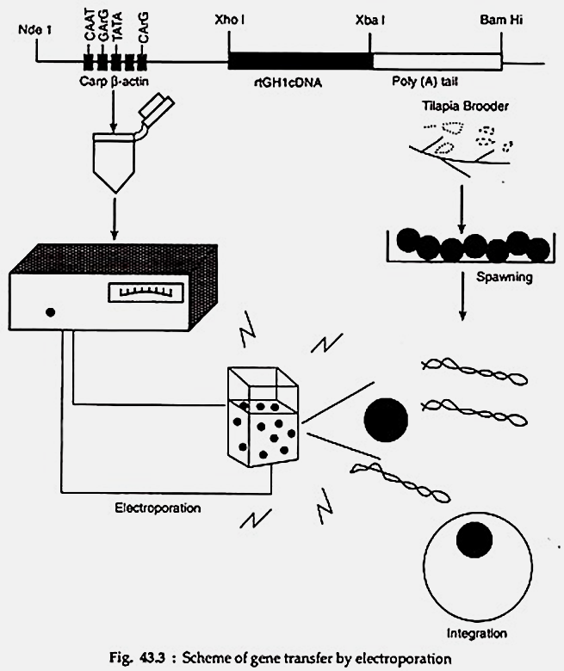
Fig. Electroporation gene transfer Technique [3]
D. Antifreeze Protein Gene Transfer:
The fishes which inhabits in icy marine water of the Polar Regions produce antifreeze glycoproteins (AFGPs) or antifreeze proteins (AFPs) in their sera to protect them from freezing. Without altering the melting temperature this protein acts as to lowers the freezing temperature of solution. The unique property of these proteins is “Thermal Hysteresis” where AFGP and AFP bind with ice crystals to inhibit the growth of ice crystal. There are three types of AFP and one type of AFGP with similar antifreeze properties though there are quite different in their protein structures. In longhorn fourth type of AFP has also been reported.
Salmo salar are unable to survive in sub-zero sea water temperature (below – 0.6 °C to – 0.80 °C) due to lacks of AGFPs or AFPs gene(s) creating major problems of sea cage farming in Northern Atlantic coast. Fletcher et al. [4] developed antifreeze-resistant AFP or AFGP genes in Atlantic salmon through gene transfer technology. They used genomic clone (2A-7) from Pleuronectus amaricanus, used as a candidate for gene transfer encoding the major liver-type AFP (wflAFP-6, previously known as HPLC-6). Type- I AFPs of flounder AFPs are small polypeptides with high alanine content and multi-gene family of 80-100 copies encoding two different isoforms, the liver type and skin type AFPs. The liver type AFPs are synthesized exclusively in the liver as prepro AFPs (such as wflAFP-6 or wflAFP-8 (HPLC-8) whereas the skin-type AFPs are expressed widely in many peripheral tissues as intracellular mature AFPs (including wfsAFP-2 and wfsAFP-3).
E. Growth Hormone Gene Transfer:
Scientists recently have cloned and sequenced growth hormone (GH) and carbonic anhydrase (CA) gene in grass carp and common carp [5]. Grass carp CA gene promoter has been linked to GH-cDNA to form a high efficiency expression vector, pCAZ. So scientists able to develop an “all fish” growth hormone model.
CAT gene used as receptor gene (a pCA grass carp GH) was microinjected into fertilized, non-activated common carp through the micropyle to generate “all fish” transgenic carp. By the reverse transcriptase PCR and Northern blotting technique presence of transgene was confirmed and these transgenic fish showed about 137% high growth rate of the control.
F. Disease-resistance Gene Transfer:
To combat with grass carp haemorrhagic virus (GCHV) disease, scientists piloted a gene contributing resistance against that disease. This gene encoding 11 different gene fragments was cloned and isolated from in vitro translation by using GCHV genomic single gene fragments.
On the basis of information of capsid protein SP6 and SP7 gene cDNA, 3 oligonucleotides were synthesized and fused with SV40 MT promoter and transferred into grass carp cytokine-induced killer (CIK) cells by a constructed expression vector and transfected with GCHV. Consequently this newly formed gene reduced the mortality rate from GCHV infection.
Applications of Transgenic Fish:
For the following purposes Transgenic Fish may be used:
1. Increasing fish production rate to compensate the demand of protein food with increasing human population.
2. Fish originated product for pharmaceutical and other industrial purposes.
3. For aquarium purposes development and propagation of transgenic native glow fish.
4. To monitor aquatic pollution as fish acts as biosensor.
5. For isolation of genes, promoters and synthesis of effective gene constructs.
6. For researches in embryonic stem cells and in-vitro embryo production.
7. For production of anti-freeze protein.
Transgenic Fishes Development:
In the present scenario, transgenic fish development and research has focused mainly on salmon, trout, carp, tilapia etc., primarily provide sources of protein. Many of these fishes are being modified to grow faster than their wild or traditionally bred aquaculture siblings. Recently throughout the world, about 40 or 50 labs are engaged on the transgenic fish development.
Usually, fish growth hormone gene is transferred from one species of fish into another to accomplish faster growing fish production. These fishes reach marketable size in a shorter time period and feed more efficiently. Growth hormone (GH) from trout was used to produce transgenic carp for production in earthen ponds with improved dressing properties.
Transgenic Salmon:
There are two varieties of salmon, the Atlantic salmon and pacific salmon where Atlantic salmon is engineered with a Pacific salmon growth hormone driven by the Arctic Antifreeze Promoter Gene. This transgenic Salmon is not growing rapidly by introduction of GH. Later on research scientists developed new GH gene, in which all the genetic elements were derived from sockeye salmon has modified the growth hormone gene in Coho salmon, Oncorhynchus kisutch [6]. Transgenic Coho salmon grew faster, on average 11 times faster than unmodified fish and the largest fish grew 37 times faster by successful construction of the new GH gene.
The level of GH are high throughout the year in this transgenic fish without falling off in the winter as occurs in ordinary salmon [7]. In contrast to standard salmon this transgenic salmon reach marketable size after one year whereas, standard farmed salmon taken at least three years.
Transgenic Zebra Fish:
Zebra fish (Bmchydanio rerio) is genetically modified aquarium fish known as Goldfish to produce fluorescent red pigment. This zebra fish without any regulatory approval is available for sale from 05.01.2004 in United States.
Newly developed transgenic novel varieties of zebra fish with three living colour fluorescent proteins viz., green fluorescent protein(GFP), yellow fluorescent protein(YFP) and red fluorescent protein (RFP or dsRed), were expressed under a strong muscle-specific mylz2 promoter in stable lines[8]. Under both daylight and ultraviolet light in dark these fluorescent proteins can be seen with naked eyes. From the jellyfish (Aequorea tictoria), the green fluorescent protein (GFP) is isolated originally. In India, Madurai Kamaraj University (MKU), Centre for Cellular and Molecular Biology (CCMB), Hyderabad and National Matha College, Kollam initiated research on transgenic fish in collaboration with foreign scientists. Indian scientists from Madurai Kamaraj University (MKU) generated first transgenic fish in 1991. Recently, Indian Scientist has developed transgenic of rohu fish, zebra fish, catfish and singhi fish experimentally.
Indigenous origin of genes, promoters and vectors are now available from rohu and singhi for engineering growth. Madurai Kamaraj University has produced transgenic rohu which is eight times larger than the control siblings attains 46 to 49 grams body weight within 36 weeks of its birth.
Conclusion
In the field of genetic engineering, the application of its commercial use has increased in scientific investigations. For aquaculture development and commercial production, aquatic animals are being engineered in various laboratories throughout the world. Through proper utilization with efficient and safe management the production and applications of transgenic fish technology solved major problems and drawbacks in aquaculture as well as biomedical research. Further progress and careful research work should be taken when DNA sequences of fish is utilizing to increase public acceptance and avoid sequences of bacterial or viral origin. This technology is rapidly developing but consumers and environmentalists remain cautious to ensure the safe use of transgenic technology and thus increase public blessings.
Acknowledgements
The author acknowledges the facilities provided by the Department of Zoology and Principal of the St. Joseph’s College (Univ. Section), North Point, Darjeeling, West Bengal, India.
REFERENCES
[1] R. W. Ponzoni and N.H. Nguyen.2008. Transgenic fish: Risks and benefits. Global Aquaculture Advocate. 2008.
[2] T.J. Pandian. Transplanting the fish. Current Science, 85(9), pp: 1258-1259, 2003.
[3] T. T. Chen. Application of Transgenic Fish Technology in Aquaculture. In: Reciprocal Meat Conference Proceedings, vol 51, 1998.American Meat Science Association, 2001. https://api.semanticscholar.org/CorpusID:212530493
[4] G. L. Fletcher, M. A. Shears, M. J. King, P. L. Davies and C. L. Hew. Evidence for Antifreeze Protein Gene Transfer in Atlantic Salmon (Salmo salar). Canadian Journal of Fisheries and Aquatic Sciences, vol 45(2), 1988. https://doi.org/10.1139/f88-042
[5] S. Du, Z. Gong, G. Fletcher, et al. Growth Enhancement in Transgenic Atlantic Salmon by the Use of an “All Fish” Chimeric Growth Hormone Gene Construct. Nat Biotechnol, vol 10, pp. 176–181, 1992. https://doi.org/10.1038/nbt0292-176
[6] R.H.Devlin, C.A. Biagi, and T.Y.Yesaki. Growth, viability and genetic characteristics of GH transgenic coho salmon strains. Aquaculture,Vol 236, Issues 1–4, pp. 607-632,2004.
[7] R.Devlin, C. Biagi, T. Yesaki, T. et al. Growth of domesticated transgenic fish. Nature 409, 781–782 (2001). https://doi.org/10.1038/35057314
[8]. Z. Gong, H. Wan, T. L. Tay, H. Wang, M. Chen, T. Yan. Development of transgenic fish for ornamental and bioreactor by strong expression of fluorescent proteins in the skeletal muscle. Biochemical and Biophysical Research Communications, Vol 308, Issue 1, pp: 58-63, 2003.
https://www.creative-biolabs.com/drug-discovery/therapeutics/dna-microinjection.htm
https://www.yourarticlelibrary.com/fish/genetics-fish/transgenic-fishes-meaning-development-and-application/88723/
https://surendranathcollege.ac.in/new/upload/
https://gcwgandhinagar.com/econtent/document/1587533170
http://www.uop.edu.pk/ocontents/Lec
https://www.espn.com/outdoors/tv/columns/story
https://www.i-sis.org.uk/TFC.php

