Tourism Policy and Schemes in India and Challenges of India
(Content Analysis of Social Aspect)
Dr. Rajesh M. Sosa, Satuluri Padma
- Assistant Professor, Department of Sociology, L.R.Valia Arts and P.R.Mehta Commerce College, Bhavnagar (Gujarat)
- Associate Professor, Amity Business School, Amity University- Maharashtra

Introduction
The tourism and hospitality industry are considered as one of the fastest growing industries in the world, that contributes to around 10% of the world’s GDP. The growth in the Indian tourism and hospitality industry has seen a remarkable boom in recent year. In addition, it encompasses a diverse range of establishments as well as services including railways, accommodation, food and drink, airlines, ships, hotels, bars, motels, and restaurants. Furthermore, the industry is experiencing higher growth with the boom of tourism and travel resulting in the establishment of a large number of international hotels in India. In addition, over the past 10 years, a compounded annual growth of 6% has been evident due to the arrival of many foreign tourists. This certainly resulted in tourism earning the position of 2nd highest foreign exchange earner of India along with the significant inputs towards total employment. On the other hand, there are also some critical issues, including financial issues, environmental issues, global uncertainty as well as other relevant issues requiring immediate action for developing significant solutions in the Indian context.
Furthermore, specifically in this particular field of the domain, very limited research studies have been conducted in the past years which focus on challenges and solutions in the hospitality industry altogether, and more so, specifically in India. Therefore, these were the motivating factors leading to the proposed study. Tourism emerged as the largest global industry of the 20th century and projected to grow even faster in the 21th century. India has immense possibilities of growth in the tourism sector with vast culture and religious heritage, varied natural attractions, but a comparatively small role in the world tourism scene. Tourism policy strengthens the tourism sector and envisages new initiatives towards making tourism the catalyst in employment generation, environmental regeneration, development of remote areas and development of women and other disadvantaged groups in the country. It would lead to larger foreign exchange earnings and create conditions for more foreign direct investment.
Statement of the research:
Problem It has been well analyzed that there has been significant growth in the tourism and hospitality industry of India. The country also has potential aspects that are needed to further influence the growth of the local economy. However, there are several factors that are degrading the growth of the industry, such as the crash in the global economy. Hence, there is a huge need for the tourism and hospitality industry to analyze and comprehend the challenges associated with the tourism and hospitality industry and implement as a matter of urgency, a number of remedial measures to mitigate the negative aspects and issues. Based on such a context, this study intended to analyze the challenges and develop solutions to counter them which would certainly benefit the tourism and hospitality industry in India.
Objectives of the study:
- To identify the major challenges associated with the tourism and hospitality industry of India.
- To explore and develop potential solutions to mitigate the issues associated with the successful development of the tourism and hospitality industry in India.
- To Know the Government Tourism Policy and Schemes in India.
- To Know the Impact of Government Tourism Policy and Schemes in India.
- To identify the Issues of Indian Tourism.
Review of Literature
Foreign arrivals expected to rise post pandemic:
- During 2019, foreign tourist arrivals (FTAs) in India stood at 10.89 million, achieving a growth rate of 3.20% y-o-y.
- Growth in tourist arrivals has been due to flexible Government policies, developed rail & road infrastructure, ease in availability of tourist Visa to foreign tourists. In 2019, arrivals through e-Tourist Visa increased by 23.6% y-o-y to 2.9 million.
- The Government is working to achieve 1% share in world's international tourist arrivals by 2020 and 2% share by 2025.
- In 2020*, FTAs in India stood at 2.46 million.
- The Covid-19 pandemic has greatly disrupted the Tourism industry. Considering this scenario, Mr. Rajesh Magow, MakeMyTrip CEO has pointed out that for a black swan event like Covid-19, the country must look to build and grow domestic travel as international tourism will take some time to recover.
- Amid the relaxation provided by the government, the Indian Association of Tour Operators (IATO) has urged the government to finalist a roadmap for resumption of international flights and facilitate e-visas and tourist visas.
- Subsequently in November end, India introduced a graded relaxation of its visa and travel restrictions for more categories of foreign nationals and Indian nationals.
- Mr. Dipak Deva, Managing Director of destination management firm Travel Corporation India (TCI), stated that the inbound business is estimated to start returning from October 2021 with normalcy levels being restored only by 2022.
Tourism Policy in India:
Tourism planning in India was started after Independence. The conscious and organized efforts to promote tourism in India were made in 1945, when the Government under the leadership of Sir John Sergeant, then Educational Adviser to the Government of India set up a committee. Thereafter systematic tourism development took place in India. The tourism planning approach has been evolved in Second and Third five-year plans. The sixth five-year plan emphasizes tourism as an instrument for economic development, integration and maintains social harmony. After 1980s tourism activity gained momentum as employment generator, source of income, foreign exchange earnings and as a leisure industry.
Tourism policy 1982:
1.The policy emphasis that development of tourism is connected to central, state and district level, public sector and private sector. 2.The policy encourages individuals to participate in tourism development and create interest in local youth. 3.The policy encourages public private partnership for tourism growth. 4.Realizing that tourism is a multi-spectral activity the policy ensures intergovernmental linkages and coordination. 5.The policy states that tourism development depends on private sector. Private sector has to build and manage tourist facility, preserve it, maintain it, involve local community, build security etc. to develop tourism. 6.The role of voluntary agencies and volunteers in tourism development is recognized by the policy. 7. The policy implies to facilitate larger funds to tourism infrastructure. 8.The policy recognizes that high quality standards in services, hotels and tourism related industries are required of foreign investment. 9.The policy suggests giving priority to technological advancement especially to information technology. 10.The policy suggests for safety and security of tourism sector. 11.Through government agencies the policy provides facilities like obtaining visas, immigration checks, fees etc. 12.The policy creates tourism economic zones, circuits and tourism areas. 13.The policy introduces prospective plans, conservation of natural environment and cultural heritages, cost effectiveness etc. In brief this policy has succeeded in providing a strong policy foundation for Tourism Development in the country focusing on co-ordination of all tourism related activities, Public Private Partnership, Voluntary Organizations, Infrastructure Development, Foreign Direct Investment, Information Technology, Creation of Tourism Economic Zones and Sustainable Tourism development.
National Action Plan for Tourism (1992):
The Objectives of the new action plan for tourism are delineated below:
1. Socio-economic development of areas
2. Increasing employment opportunities
3. Developing domestic tourism especially for the budget category
4. Development of international tourism and optimization of foreign exchange earnings
5. Diversification of the tourism product
6. Increase in India’s Share in world tourism
The strategy for achieving the objectives is outlined below:
- Improvement of tourism infrastructure
- Developing areas on a selective basis for integrated growth along with marketing of destination to ensure optimal use of existing infrastructure
- Restructuring and strengthening the institutions for development of human resources
- Evolving a suitable policy for increasing foreign tourist arrival and foreign exchange earnings

Schemes and Guidelines:
1. Swadesh Darshan Scheme (2014-15):
India’s rich cultural, historical, religious and natural heritage provides a huge potential for development of tourism and job creation in the country. There is a great scope and need to develop tourist circuits on specific themes to attract the tourists having special interest in visiting such places. This can be achieved only through an integrated approach by providing engaging experiences for distinct categories of tourists i.e., Domestic and International. Various themes, which are unique and specific to the area, can include beaches, culture, heritage, wildlife etc. Such theme-based tourist circuits should be developed in a manner that supports communities, provides employment, fosters social integration without comprising upon the environmental concerns, and provides unique experiences to the tourists. In due recognition to this the Government of India, Ministry of Tourism (MoT) launched the Swadesh Darshan Scheme (Central Sector Scheme)– for integrated development of theme-based tourist circuits in the country in 2014-15. This scheme is envisioned to synergies with other Government of India schemes like Swachh Bharat Abhiyan, Skill India, make in India etc. with the idea of positioning the tourism sector as a major engine for job creation, driving force for economic growth, building synergy with various sectors to enable tourism to realize its potential.
Scheme Objectives
- To position tourism as a major engine of economic growth and job creation;
- Develop circuits having tourist potential in a planned and prioritized manner;
- Promote cultural and heritage value of the country to generate livelihoods in the identified regions;
- Enhancing the tourist attractiveness in a sustainable manner by developing excellent infrastructure in the circuit /destinations;
- Follow community-based development and pro-poor tourism approach;
- Creating awareness among the local communities about the importance of tourism for them in terms of increased sources of income, improved living standards and overall development of the area.
- To create employment through active involvement of local communities;

2. PRASHAD Scheme:
Pilgrimage Rejuvenation and Spiritual Augmentation Drive has called PRASHAD. Pilgrimage tourism is a form of tourism motivated. India is a land of many religions like Hinduism, Buddhism, Jainism, Sikhism and Sufism having their major pilgrimage centers in different parts of the country. In the budget speech 2014-15 the government therefore, decided to launch a National Mission on Pilgrimage Rejuvenation and Spiritual Augmentation Drive with an initial provision of 100 cr. for the current financial year.
To identify and develop pilgrimage tourist destination on the principles of high tourist visits, competitiveness and sustainability in an integrated manner by synergizing efforts to focus on needs and concerns of all stakeholders to enrich religious/spiritual tourist experience and enhance employment opportunities.
3. CBSP Scheme (2018):
Trained human resource is an important component of the tourism infrastructure. Presently, the FCIs, IHMs and other tourism related educational/ training institutes in the private sector are providing education and training in tourism and hospitality related fields. These institutions, however, are catering mainly to the organized sector. There is no formal training and certification mechanism for the un-organized sector and several categories of service providers in the organized sector. A large number of tourism service providers in the organized/ un-organized sector also require basic training and certification to provide better service standards and consumer satisfaction. At the same time, there is an equally important need to further up-skill or build capacities of the service providers already trained. These trained service providers could be engaged in providing service directly to the tourist or involved in the important task of teaching, administering or planning. The Ministry of Tourism, Government of India therefore plans to provide education, training and certification to the tourism service providers at every level through the CBSP Scheme. The main objectives of this initiative are to train and up-grade manpower at every stratum of service in order to I) capitalize on the vast tourism potential of the country to the fullest, and ii) provide professional expertise to the local populace as well as create fresh opportunities for employment generation in the tourism sector both in urban as well as rural areas.
Training programmed for the following shall be covered under the Guidelines including development of a system for Certification:
(I) Skill Development in general for fresh candidates;
(ii) Specialized skill development, including language courses for fresh as well as existing
service providers;
(iii) Training of teachers, administrators and planners;
(iv) Basic Skill up-gradation in general for existing service providers;
(v) Training of Trainers programmed;
(vi) Awareness Programmed;
(vii) Awareness of tourism benefits / knowledge in the rural areas.
4. Marketing Development Assistance (MDA):
Tourism is one of the largest service industries in the country and its importance lies in being an instrument for economic development and employment generation across the country. Inbound tourism plays an important role in earning valuable foreign exchange for the country, overall development of tourism including augmenting tourism infrastructure and facilities. 2. The Ministry of Tourism undertakes promotion of tourism to the country from the overseas mar est. through its overseas offices, Global Media Campaign and in partnership with stakeholders in tourism industry.
Recognizing the key role played by the stakeholders in the tourism Industry in enhancing foreign tourist arrivals to the country, the Ministry of Tourism under its Overseas promotion & Publicity (OPP) also known as (Restructured Scheme of Overseas Promotion and publicity including Marketing Development Assistance - OPMD), extends financial assistance to the State Governments / Union Territory Administrations (UTs) and approved Tourism Service Providers (TSPs) across the country for undertaking promotion and marketing of tourism to India from the overseas markets. The Marketing Development Assistance (MDA) Scheme guidelines, a sub-scheme of the Overseas Promotion & Publicity scheme, were last revised on 01.04.2017.
The global outbreak of COVID-19 in 2020 has been an unprecedented global health emergency with tremendous impact on societies and livelihoods. Travel and Tourism has been among the sectors most affected by this crisis with complete curtailment of all travel – domestic and international. When the situation eases, every country will compete with each other to get a fair share of the global tourist traffic. Thus, it is imperative that the focus of the Ministry would be to revive the inbound tourism to the country.
In view of the extraordinary situation as mentioned, the Guidelines of the sub-scheme, of Market Development Assistance (MDA) under OPP Scheme are being modified to enhance the scope and reach of the Scheme, to provide maximum benefits to the stakeholders in the tourism industry.
The objectives of the Scheme are:
(I) To motivate stakeholders to promote tourism to the country from the overseas markets.
(ii) To enhance the visibility of brand Incredible India in the overseas markets.
(iii) To augment foreign tourist arrivals to the country.
5. Loan Guarantee scheme for Covid Affected Tourism Service Sector:
Hon’ble finance minister announced guarantee/collateral free loan guarantee scheme for tourism sector. Tourism launched ‘Loan Guarantee Scheme for Covid Affected Tourism Sector. (LGSCATSS). The Scheme aims at extending loan to the distressed tourism sector to help them discharge their liabilities and restart their business affected due to Covid-19 pandemic. Validity of the said scheme is till 31/03/2022 or till the guarantee of Rs. 250.00 corers are issued under the scheme.
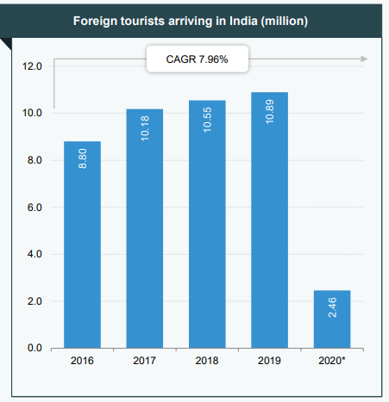
Domestic consumers to lead growth:
- Domestic travel revenue is estimated at US$ 215.38 billion in 2019 and is anticipated to further increase to US$ 405.8 billion by 2028F.
- While the pandemic brought the tourism industry to a halt, the government is at the moment trying to begin with reviving domestic tourism.
- On January 26, 2021, Maharashtra Chief Minister Mr. Uddhav Thackeray inaugurated Balasaheb Thackeray Gorewada International Zoological Park in Nagpur. It is India’s largest zoological park spread over 564 hectares and expected to attract ~2.5 million tourists a year.
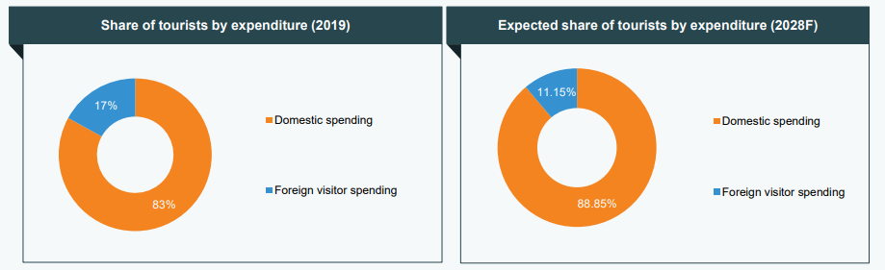
Rise in foreign exchange:
- Tourism is an important source of foreign exchange in India similar to many other countries.
- During 2019, India earned foreign exchange of US$ 29.96 billion from tourism, recording a y-o-y growth of 4.80%. Foreign exchange earnings (FEEs) from tourism in India witnessed growth at a CAGR of 8.96% between 2007 and 2019.
- In 2020*, India earned US$ 6.15 billion in foreign exchange of from tourism.
Rising revenues from leisure and business segments:
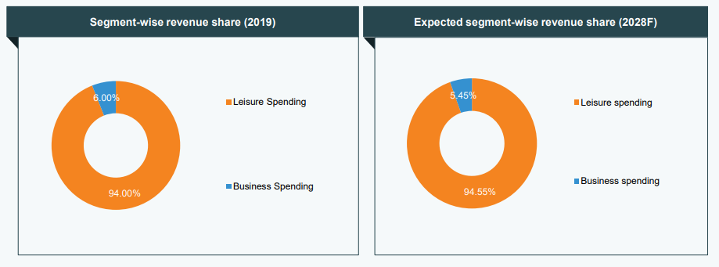
- Share of revenue from leisure travel to total tourism stood around 94.8% in 2019.
- Leisure travel spending reached US$ 234.16 billion in 2019 and is expected to reach US$ 432.3 billion by 2028F.
- Business travel revenue was US$ 12.84 billion in 2019 and is projected to increase to US$ 24.4 billion by 2028F.
Research Methodology
In relation to the scope of the present study, the researcher developed a positivistic approach due to its significance as objective reality, which is independent of human consciousness. In addition, through such an approach, the researcher has developed a significant framework for validating the scope of the study as well as considered secondary information to maintain the appropriateness of the study. With such intent and consideration, a significant architecture has been developed by the researcher based on challenges and solutions for the development of the tourism and hospitality industry in India by comprehending the causal relationships between theories and phenomena and evaluating these explicitly against the observations. Such a view or approach could not be attained through the viewpoint of a realist, critical or interpretive philosophy, as it is strictly based on logic and methods of verifications and reproducibility.
Research design:
Based on the scope of the present study, the researcher utilized an exploratory research design as the entire data collected would be based on secondary resources. This design has guided the researcher to formulate an effective idea based on both qualitative and quantitative sets of data. As stated by Kolb (2012), an exploratory research study offers flexibility at an extensive rate by eliminating impractical concepts. Other than that, both explanatory and descriptive designs are inappropriate for the present study as both quantitative and cause-effect relationship would not be applicable.
Research approach:
The researcher utilized an inductive approach for conducting the present study in order to obtain qualitative data as well as to develop an efficient system based on credible resources. Furthermore, through the use of an inductive approach, the objective and scope of the study would be certainly fulfilled by using ancillary resources such as pre-published journals, books, articles, and websites. Hence, the viability of such an approach would also assist the researcher to validate and prove the objectives of the study, contrary to the deductive approach. The deductive approach focuses on the quantitative aspect of the data which is inappropriate based on the scope of the present study (Kothari, 2014).
Result/Findings:
In relation to another credible source (Sanjeev et al. 2013), it has been identified that there are significant financial challenges associated within the Indian tourism and hospitality industry including eroding margins, high financing costs, working capital issues, a multiplicity of taxes charged as well as licensing and legal issues. The researchers in the study assimilated such qualitative information through the use of structured interviews from a spectrum of hotels in India. The findings of the study also revealed significant solutions towards such issues including enhanced policies and tax exemptions on facilities of the tourism and hospitality industry in India in order to attain significant development in the particular field. In addition, it has also been demonstrated in the study that it is significant for developing sustainable measures in order to maintain growth in the industry as well as in efforts to safeguard the natural environment. The research study does not include quantitative analysis, however, the findings of the study revealed critical issues associated within the particular sector. Based on a study conducted by Goyal, (2010), it has been understood that there are ten top issues that pose significant challenges towards the tourism and hospitality industry in India. The study revealed global uncertainty, branding issues, human resources, financial viability, customer issues, operating cost creep, supply, safety, and security, as well as distribution channel management, are the major issues which are affecting the viability of the tourism and hospitality industry in India. Furthermore, the researchers also proposed a significant solution based on the identified issues which integrate efficient training to employees for developing their skills and abilities, effective retention techniques for retaining top talent in the industry, building greenfield infrastructures, enhancing political infrastructure as well as identifying and fulfilling customer needs and demands, which concurs with the stakeholder authority, Nicolaides (2015). It has also been identified by the researcher that the number of foreign investors is critically increasing in the Indian tourism and hospitality industry which reinforces the domestic partners to enhance their infrastructure and offer quality services in order to attract and retain potential tourists from the market. On the other hand, a study conducted by Jauhari and Sanjeev (2012) certainly revealed that in order to mitigate the financial issues in the tourism and hospitality industry in India, it is significant to develop cost management and land management policies. In addition, talent and risk management issues need to be addressed as well by an effective branding strategy that would certainly contribute towards the growth and development of the particular industry. The methodology adopted by the researcher includes the findings of the theme issues in the domain of strategy and finance. Therefore, such analysis highlighted key issues affecting the development of the tourism and hospitality industry in India. It has been significantly suggested by the researcher, that the issues associated with financial aspects in tourism and hospitality industry could be certainly mitigated through appropriate framing of policies by governmental bodies as well as via the development of effective guidelines for developing the sector.
Hence, it can be stated that there are several challenges that are associated with the development of the tourism and hospitality industry in India that require immediate attention. Furthermore, the solution that has been proposed in the past research studies based on the selected articles, highly demonstrates that the mitigation techniques towards such a cause are likely to succeed.
Recommendations
Based on the journal analyses and literature reviewed, it has been ascertained that there are critical challenges in the development of the tourism and hospitality industry in India which require immediate attention. In relation to this context, one of the major solutions is to develop and frame effective policies and guidelines that would assist the firms in the tourism and hospitality industry to grow and further embrace and comprehend the need for sustainability. In addition, it is also significant that talent and risk management strategies need to be incorporated in a particular sector through effective training and quality employee retention techniques. On the other hand, an effective branding strategy and fulfillment of the needs and demands of customers is also highly relevant and essential for the industry to attain a competitive edge in the global marketplace. Lastly, it depends on both government and firms in this particular sector to align their objectives for the successful development of the tourism and hospitality industry in India.
Conclusion
After analysis of the entire paper, it has been found that financial issues are the major challenge that is holding back the development of the tourism and hospitality industry in India. In addition, issues including high financing costs, working capital issues, branding and multiplicity of taxes charged are the major financial issues associated with the particular sector that needs to be mitigated at almost immediately for development to occur. On the other hand, other strategic issues including global uncertainty, branding issues, human resources, financial viability, and customer issues, operating cost creep, supply, safety, and security are also significant challenges associated with the development of the tourism sector in India. The rate of competition due to increasing foreign investors along with the changing demands of customers also highly impacts the scalability of the industry in terms of economic growth and revenue structure. Based on the literature, the growth in foreign tourists is expected to escalate in the forthcoming years which would positively impact the development of the tourism and hospitality industry in India if sustained. Hence, it is significant to address and mitigate each issue and the challenges associated with the particular sector in order to attain growth and prosperity in the Indian economy as this particular industry has a significant contribution to make in it.
Reference
- Bharwani, S. & Butt, N. (2012). Challenges for the global hospitality industry: an HR perspective. Worldwide Hospitality and Tourism Themes
- Inversini, A. & Masiero, L. (2014). Selling rooms online: the use of social media and online travel agents. International Journal of Contemporary Hospitality Management
- Jauhari, V. (2009). "The hospitality and tourism industry in India: conclusions and solutions", Worldwide Hospitality and Tourism Themes
- Jauhari, V. & Sanjeev, G.M. (2012). Responding to the emerging strategic and financial issues in the Indian hospitality industry. Worldwide Hospitality and Tourism Themes
- Tourism.gov.in. (2019). [online] Available at: http://tourism.gov.in/
- www.Googlescholar.com
- International Journal of Heritage Studies.Volume14,Issue 3, May 2008,Pages 268-280
- Bischoff, I. J. Meckl,2008.Endowment effect theory , public goods and welfare .Journal of Socio-Economics, Volume 37,Issue 5,pp.1768-1774
- Bolton R.n., Lemon K.N.1999.A dynamic model of customers’ usage of services: Usage as an antecedent and consequence of satisfaction/Journal of Marketing Research,36(2),pp.171-186.
- And economic changes//World Applied Sciences Journal. Volume 27, Issue 13,2013, Pages 15-19. Kirshin I.A., Gabdullin N.M., Kuttubayeva T.A. Ishchuk L.V.2013.Analysis of Consumer Behavior Impact on Human Capital Development Through the Example of the Altai Republic. -World Applied Sciences Journal. -2013.No 27.-P.207-211
- Nelson. 1970.Information and consumer behavior/Journal of Political Economy, 78(2)
- , pp.311-329.
- Spennemann, D.H.R.2007.Of great apes and robots: Considering the future(s) of cultural heritage//Futures. Volume 39, Issue 7, September 2007, Pages 861-877.
- Affleck, J., Kvan, T. 2008.A Virtual Community as the Context for Discursive Interpretation: A Role in Cuktural Heritage Engagement//
- International Journal of Heritage Studies.Volume14, Issue 3, May 2008, Pages 268-280

