LDR AND IR BASED AUTOMATIC STREET LIGHT CONTROLLER
¹Mrs.Vineela Madireddy , ²Divya Sai Leela Amrutha, ³Guntupalli Sai Sanjay
¹Assistant Professor, ²UG Scholar,³UG Scholar
^{1,2,3}Department of COMPUTER SCIENCE ANENGINEERING(AI&ML)
¹vineela.madireddy@gmail.com,²divya.sai.leela.amrutha.26@gmail.com,³saisanjayguntupalli@gmail.com
Vignan Institute of Technology and Science

ABSTRACT
Electricity cannot be continuously provided to consumers since power production is currently lower than the utility of electric energy. Instead of producing more energy, it might be wiser to conserve electrical energy. Saving energy is more cost-effective than creating electricity. to install an automatic street light controller based on LDR and IR that can be used to prevent manually turning on and off streetlights and to effectively conserve energy. This study suggests switches that automatically turn on and off. a switch mechanism. An LDR (Light Dependent Resistor) is employed where there is an IR (Infrared Radiation) to detect vehicle movement. An Arduino Uno microcontroller is needed to operate the entire process and detect the presence and absence of light. By using this technique, electricity consumption is decreased. The Arduino IDE software is used in this study. The suggested approach is efficient and requires no human intervention.
I.INTRODUCTION
All cities and roads must have street lights since they serve to prevent robberies and unwanted thefts. Thousands of lighting have been installed alongside the main thoroughfares and highways. However, the main problem is that these street lights are responsible for 25–30% of the city's total energy use. The creation of a "Smart Street light system" that uses less electricity is the main objective of this paper. The conventional streetlights typically utilise a lot of electricity and beam brightly. However, if there are any cars or pedestrians on the road, a smart street light system will glow brightly. If not, the lights won't change much. Another advantage of this system is that street lights will turn on automatically at dusk and turn off automatically at dawn (when it is sunny). By using this strategy, we can save enough electricity and cash, and the extra electricity we save can be used to light a few more isolated dwellings.
II.MOTIVATION
Smart cities and green technology are increasingly on the global agenda as we get ready for a better future. The smart street lighting system is one of the technologies that helps with work in the green, environmental sector. The growth of wireless communication and low-energy street lighting has advanced technology, which is the foundation for the development of smart cities.

Smart city technologies offer for improvement in response and maintenance since faults or breakdowns within the deployment area may be seen in almost real-time, allowing for quick action from the appropriate individual. Additionally, this contributes to the pursuit of a better future. Street lighting, one of the most important elements of a city's infrastructure, serves the principal function of illuminating the city's streets at night. Road lighting systems should be designed with a number of factors in mind, such as maintaining the safety of drivers and pedestrians at night, providing accessible public lighting, lowering crime rates, and minimising environmental effect. The majority of the time, street lights are left on all night and off during the day, but if there is no traffic, nighttime street lights are not necessary. Due to the limited supply of energy resources today, saving energy is essential.
Affordable Ness, clarity and simplicity of the programming environment, open source and expandable software, and extensible hardware are some advantages of the Arduino microcontroller system. The Arduino microcontroller was chosen as the system's controller for this reason. A rapid gadget, the Arduino microcontroller system can run hundreds of lines of code per second.
III. PROBLEM STATEMENT
Streetlights are a large energy consumer when they are left on all night, which is quite normal. There is a fairly high level of daily power consumption. Unlike the main city streets, some streets don't always have people on them; on sometimes, they are completely empty for a while.
In order to improve the street lighting management system and guarantee that the streetlight can operate effectively, street lighting was observed based on the problem. It is feasible to reduce both electrical waste and energy consumption by using this method. Therefore, it's important to comprehend how to lower streetlight power usage. To address this problem, we are developing an efficient, trustworthy LDR and IR sensor based automatic streetlight regulating System.
IV. LITERATUE SURVEY
The method presented in this work, known as StreetLight Glow, makes use of cutting-edge lighting innovations, including LED lamps, to detect vehicle movement with the use of a sensor. Additionally, it is utilised to maintain wireless connection between lampposts and control terminals using the ZigBee Wireless protocol, regulate the automated switching of streetlights depending on light intensity, and produce flow-based dynamic control statistics using infrared detection technology. It also incorporates a variety of technologies, such as photodiodes, LEDs, power transistors, a timer, and information on traffic volume. For the purposes of this study, the system operates in automatic mode and regulates the streetlight in accordance with an algorithm that controls brightness, dimmer settings, and light output. Control can be put into place to account for seasonal variance.
It has a time-out function. The design of a traffic-based street light control system that effectively uses solar energy in 2015 is described in this paper. They made use of a renewable energy source, specifically solar energy, which is employed for city lighting. They have used Instead of using ordinary bulbs, microcontrollers from the 8052 family should be utilised because they reduce power consumption by three times. There are sensors put on both sides of the road, which track vehicle movement and transmit instructions to switch on and off the microcontroller that controls the lights while they are off. There is still every street light here. it was switched off, and

V.OBJECTIVE

To develop a smart street lighting system that better utilizes vehicle identification sensors to cut down on electricity consumption.

VI.IMPLEMENTATION

Arduino
Micro
Controller

5v 5v
IR
Transmitter
LDR

Receiver
Fig1.Block Diagram of the proposed system
Power
Supply
LED

Fig. 1 above displays the block diagram. The main objective is to decrease the energy consumption of street lights, which currently seem to be switched on in the evening and off in the morning along national routes. However, it is actually when it is absolutely dark that these street lights are turned ON. In this method, some electricity will be squandered. This paper offers the best choices for cutting down on power waste.

The analogue pin of the Arduino is linked to an LDR, which controls the LEDs by determining whether or not sunlight is present. The Arduino receives high analogue output values from the LDR and automatically shuts off all the LEDs (streetlights) when there is adequate sunshine since the LDR serves as an insulator and delivers high resistance. The LDR senses dark in the absence of light, delivers low resistance, and functions as a conductor. In this instance, the Arduino analysed the LDR's Low analogue input values and turned on the LEDs (streetlights) automatically. The IR sensor also began operating at the same moment and began detecting any moving cars or pedestrians. Four IR sensors that are attached to the Arduino's digital pins are used in this paper. Additionally, we use 5 LEDs, each of which is connected to an Arduino's PWM pin, to symbolise the streetlights. Two LEDs are managed by each IR sensor. Any IR sensor's output changes to LOW(0) when it detects the presence of a human or vehicle. The Arduino then received the sensor's low output value and used the Pulse Width Modulation (PWM) technology to boost the light intensity of two LEDs. The IR sensors' output changes to High (1) when no vehicles or people are in range of them. The Arduino then read the sensor's high output value. Now, the Arduino uses the Pulse Width Modulation (PWM) approach to reduce the LEDs' light output.

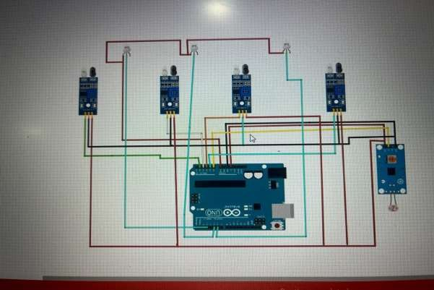
Fig 2: Schematic Diagram

VII. HARDWARE IMPLEMENTATION
The hardware architecture of the entire system has been implemented exactly as expected.
One by one, the implemented subsystems are displayed.
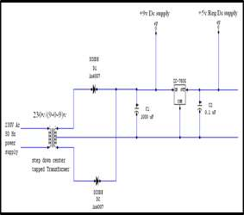

FIG 3:Circuit for a Regulated Power Supply
A step-down center-tapped transformer (9-0-9) V, 500mA, is given a 230V AC 50 Hz supply, as can be seen in the aforementioned Fig. 3. In this case, the voltage is decreased from 230V to (9-0-9) V, rectified using a two-diode full wave rectification circuit to produce pulsing DC, passed via a capacitive filter to remove any ripple, and then sent to the 7805 regulator IC to produce a regulated power supply of 5V DC, 500mA. A suitable heat sink is used in the process to dissipate the heat produced.
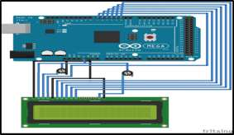

Fig4:LCD to Arduino interface circuit

An LCD (20x4) connected to an Arduino MEGA is shown in Figure 4. The two potentiometers on the LCD can be used to change the contrast and brightness. Alphabetically coded characters are displayed on the LCD. In order to connect the Arduino and LCD, four-bit data transmission is used. Only write operations are used by sending a low signal to the LCD's read/write interface.
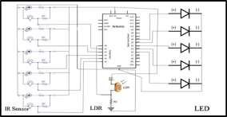
Fig 5.Implemented Circuit
The paper's objective is to design a street light control system that automatically switches on or off the streetlights by sensing the movement of vehicles and depending on the intensity of sunlight because the resistance of the LDR is high in the dark and the voltage drop across the LDR is high. In order for the IR sensor to continuously receive infrared rays, it must be placed in line of sight with the IR receiver.
The experimental setup for the suggested notion is shown in the following:

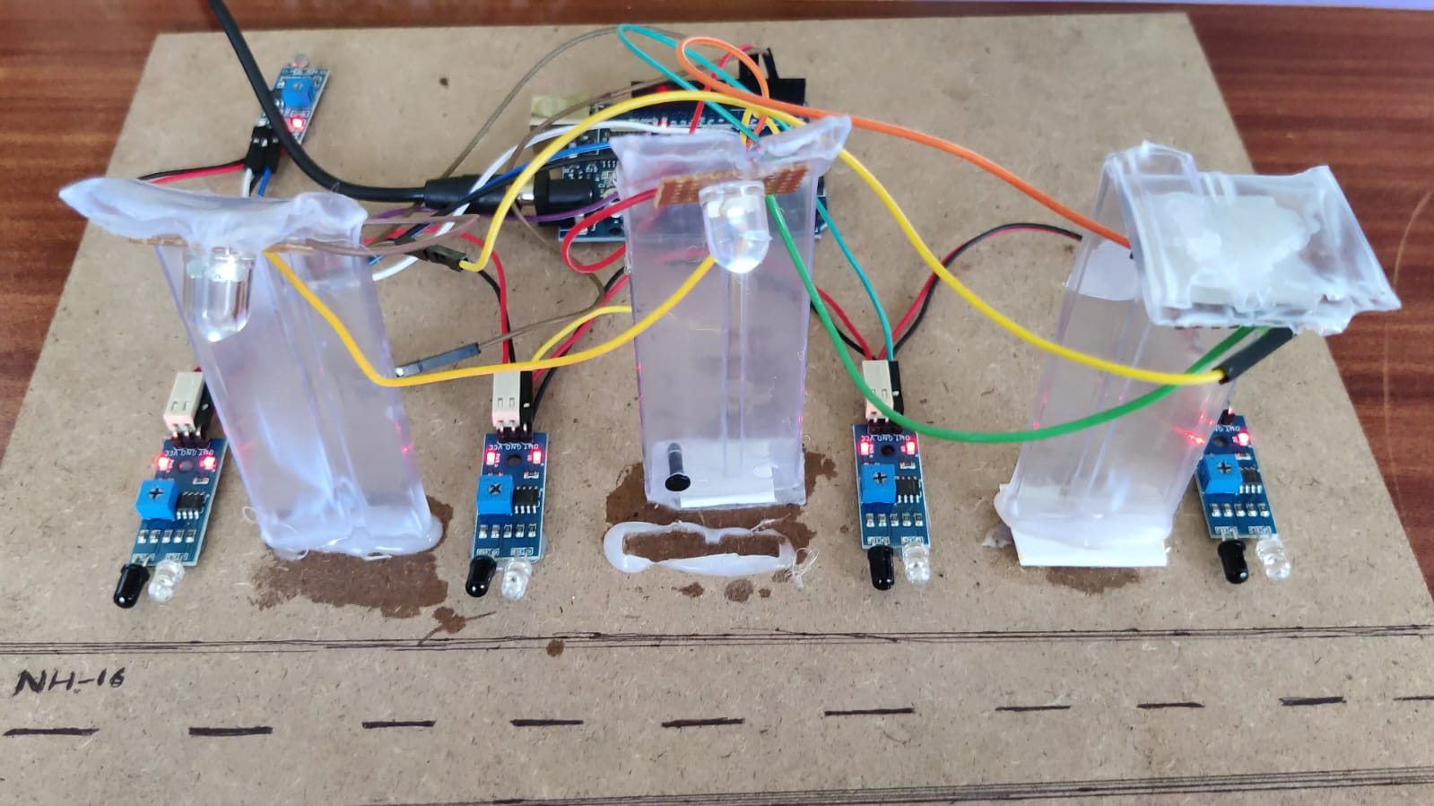
Fig 6:ExperimentalSetup

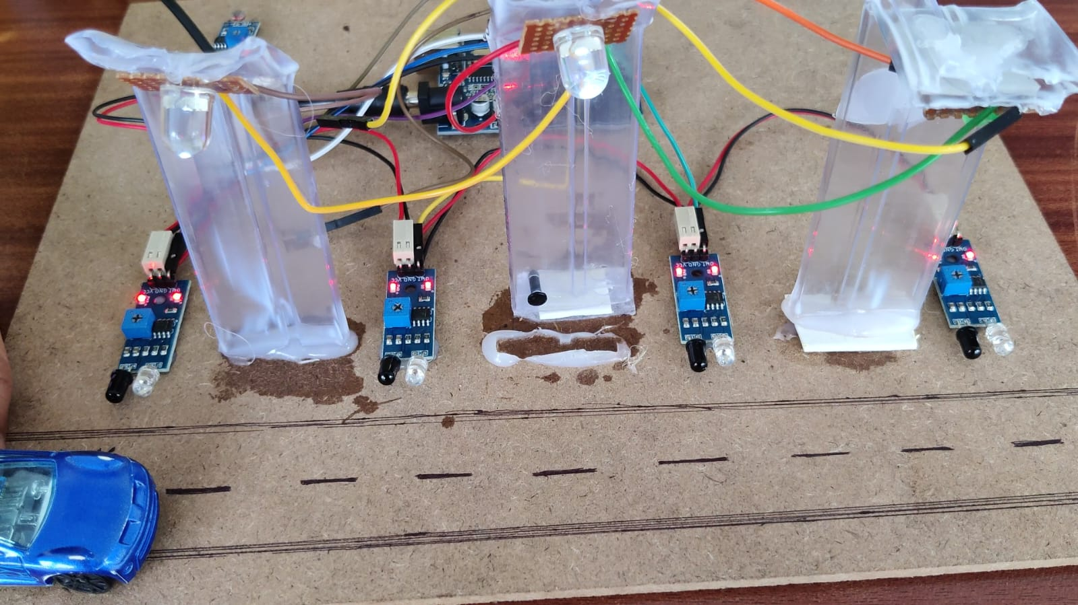

Fig 7: Working Model

VIII. RESULTS

The outcomes of turning on the streetlights are shown in the following tabulated statistics.

SI.No. | LDR1 | LDR2 | StreetLightState
1. | Lowlight | Lowlight | ON
2. | Lowlight | Denselight | OFF
3. | Highlight | Lowlight | OFF
4. | Highlight | Highlight | OFF
Table 1: Result of the working model

The results of light activation due to the presence of a vehicle are shown in the tabulated data below.

SI.NO | LDR1 | LDR2 | IR  Sensor1 | StreetLights  100%ON | StreetLights  75%ON
1. | Low  light | Low  light | ON | Street  light2 | Street  light1,3,4,5,6
Table2:The result of the light being activated in
the presence of a vehicle

SI.NO | LDR1 | LDR2 | IR  Sensor2 | Street  Lights100%  ON | Street  Lights75%ON
1. | Low  light | Low  light | ON | Street  light5 | Street  light1,2,3,4,6
Table3:Resultsin the presence of vehicle

IX.CONCLUSION

This actualized concept explains the setup and development of the Smart Street Lighting Control Framework Circuit. Circuit sets expectations for ON/OFF switching of the traffic light. controls the road light in accordance with the circuit's predetermined planning. In order to meet all requirements, the two sensors—IR and LDR—must be present.

An effective and affordable solution for managing urban lighting is offered by the paper for an autonomous street light controller built on LDR and IR technology. The system optimises energy usage, improves safety, and requires less maintenance by combining LDR and IR sensors with a microcontroller-based control mechanism. By activating street lights based on ambient light levels and vehicle presence, this clever technology assures proper illumination, resulting in significant energy savings and better overall efficiency in urban contexts.

X.REFERENCES

Suganya, S., Sinduja, R., Sowmiya, T., & Senthilkumar, S. (2014). Street light glow on detecting vehicle movement using sensor. International journal for advance research in Engineering and technology.

Dheena, P. F., Raj, G. S., Dutt, G., & Jinny, S. V. (2017, December). IOT based smart street light management system. In 2017 IEEE international conference on circuits and systems (ICCS) (pp. 368-371). IEEE.

Dheena, P. F., Raj, G. S., Dutt, G., & Jinny, S. V. (2017, December). IOT based smart street light management system. In 2017 IEEE international conference on circuits and systems (ICCS) (pp. 368-371). IEEE.

Roobini, M. S., Helen, L. S., Mary, A. V. A., Selvan, M. P., & Jancy, S. (2021, March). Automatic Motion Triggered Street Light Using IoT. In Journal of Physics: Conference Series (Vol. 1770, No. 1, p. 012029). IOP Publishing.

Suseendran, S. C., Nanda, K. B., Andrew, J., & Praba, M. B. (2018, October). Smart street lighting system. In 2018 3rd International Conference on Communication and Electronics Systems (ICCES) (pp. 630-633). IEEE.

Kumar, P. (2021). IOT based automatic street light control and fault detection. Turkish Journal of Computer and Mathematics Education (TURCOMAT), 12(12), 2309-2314.

